Organisational Culture Report

Student Name: Valentin Alexandru Florea
Student ID: 2321160
Programme: BA (Hons) Leadership and Management Skills for the Workplace
Module: Organisational Culture (LCLM5005)
University: University of Wales Trinity Saint David
Submission Date: 16 March 2026
Word Count: Approximately 3000 words

TABLE OF CONTENTS
- Introduction
- Influence of Organisational Culture on Structure and Decision-Making
- Identifying Organisational Culture Using Cultural Frameworks
3.1 Schein’s Model of Organisational Culture
3.2 Hofstede’s Cultural Dimensions
3.3 Handy’s Cultural Types
- Adapting Organisational Culture to External Environmental Influences
- Organisational Culture as an Enabler or Barrier
- Impact of Organisational Culture on Organisational Performance
- Charts and Figures
- Recommendations
- Conclusion
- Reference List

1. Introduction
Organisational culture is considered one of the most important factors influencing how organisations operate, make decisions and manage employees. Culture within an organisation represents the shared beliefs, values and behaviours that guide the way work is performed. According to Mullins and Christy (2016), organisational culture reflects “how things are done around here” and has a direct influence on decision-making processes, employee motivation, organisational structure and management practices.
In global organisations, culture plays an even more significant role due to workforce diversity, international operations and changing external environments. Companies must ensure that their organisational culture supports collaboration, adaptability and consistent service quality across different regions and departments.
British Airways is one of the largest and most recognised airline companies in the world and the national airline of the United Kingdom. The airline operates flights to more than 180 destinations worldwide and employs thousands of employees across different operational areas including flight operations, engineering, customer service and administration. The aviation industry is highly competitive and heavily regulated, meaning that organisational culture plays a crucial role in ensuring operational efficiency, safety and service quality.
This report critically evaluates the organisational culture of British Airways and analyses how culture influences the company’s structure and decision-making processes. The report also applies recognised frameworks such as Schein’s model of organisational culture, Hofstede’s cultural dimensions and Handy’s cultural types in order to identify the prevailing culture within the organisation. Furthermore, the report examines how British Airways adapts its organisational culture to external environmental influences and evaluates whether culture acts as a barrier or an enabler to organisational effectiveness. Finally, the report assesses the impact of culture on company performance and provides recommendations for improvement.

2. Influence of Organisational Culture on Structure and Decision-Making

Organisational culture significantly influences how companies structure their operations and how management decisions are made. According to Schein (2010), culture shapes the behaviour of employees, the leadership style of managers and the way organisations respond to internal and external challenges.
British Airways operates in the aviation industry, which is characterised by strict safety regulations, operational precision and international competition. Due to these requirements, the company follows a relatively hierarchical organisational structure. In hierarchical organisations, authority and responsibilities are clearly defined and decisions follow a structured chain of command.
This type of structure is common within aviation organisations because safety and operational control require clear accountability. For example, flight operations, engineering departments and aircrew must follow strict procedures that ensure passenger safety and regulatory compliance.
The organisational culture of British Airways emphasises professionalism, safety and customer service excellence. These cultural values influence the way employees behave and how management approaches decision-making. Safety is considered a fundamental organisational value and therefore affects operational decisions at every level of the organisation.
However, organisational culture within British Airways has also experienced challenges over time. During periods of organisational restructuring and cost reduction, conflicts between management and employee unions have occurred. Labour disputes between British Airways management and cabin crew unions during the late 2000s demonstrate how organisational culture can influence relationships between employees and leadership (Turner, 2018).
These conflicts illustrate the importance of effective communication and cultural alignment between management and employees. When organisational values are not perceived as fair or supportive by employees, tensions can emerge that may affect decision-making processes and organisational performance.
Overall, British Airways maintains a culture that supports operational efficiency and structured decision-making, although maintaining positive employee relations remains an important organisational challenge.

3. Identifying Organisational Culture Using Cultural Frameworks
In order to better understand organisational culture within British Airways, it is useful to analyse the organisation using recognised theoretical frameworks.

3.1 Schein’s Model of Organisational Culture
Schein (2010) proposed that organisational culture exists at three different levels: artefacts, espoused values and underlying assumptions.
Artefacts represent the visible elements of organisational culture such as dress codes, company logos, workplace design and employee behaviours. In the case of British Airways, artefacts include the airline’s branding, the professional uniforms of cabin crew and the visible emphasis placed on customer service and safety procedures.
The second level of culture consists of espoused values. These represent the official values and principles that organisations promote internally and externally. British Airways promotes values such as safety, teamwork, professionalism and customer satisfaction. These values are reinforced through training programmes, company policies and leadership practices.
The deepest level of organisational culture consists of underlying assumptions. These are the beliefs that employees take for granted and rarely question. In aviation organisations, one of the most important underlying assumptions is that safety must always be prioritised above all other considerations.
Applying Schein’s model suggests that British Airways has developed a strong organisational culture centred on safety, service quality and operational reliability.

3.2 Hofstede’s Cultural Dimensions
Hofstede’s cultural dimensions theory provides a useful framework for analysing how national culture influences organisational behaviour (Hofstede, 2011).
British Airways operates globally and employs staff from a wide range of cultural backgrounds. As a result, understanding cultural differences is essential for effective management.
One important dimension is power distance, which refers to how organisations manage authority and hierarchy. In aviation organisations, moderate power distance is necessary because decisions related to safety and operations require clear authority structures.
Another relevant dimension is uncertainty avoidance. Aviation companies generally display high uncertainty avoidance because strict regulations and procedures must be followed to minimise risk.
Therefore, the culture of British Airways supports structured processes, risk management and operational control.

3.3 Handy’s Cultural Types
Handy (1993) identified four main types of organisational culture: power culture, role culture, task culture and person culture.
British Airways largely reflects characteristics of role culture. In role cultures, organisations are structured around clearly defined roles, responsibilities and procedures. Employees perform specific tasks within a structured organisational framework.
Role cultures are common in large organisations where stability and predictability are important. In the case of British Airways, role culture helps ensure consistent operations across departments such as flight operations, engineering, customer service and administration.

4. Adapting Organisational Culture to External Environmental Influences
Organisations must continuously adapt their culture in response to external environmental changes such as technological developments, economic conditions and global competition.
The airline industry is particularly sensitive to external influences including fuel prices, global economic trends and international travel regulations. The COVID-19 pandemic significantly affected the aviation industry and forced many airlines, including British Airways, to restructure their operations.
During this period, British Airways had to implement major organisational changes including workforce reductions, operational adjustments and cost management strategies. These changes required cultural adaptation and strong leadership in order to maintain organisational stability.
Technological developments have also influenced organisational culture within British Airways. Digital innovation, online booking systems and mobile applications have transformed how airlines interact with customers.
British Airways has invested heavily in digital transformation to improve customer experience and operational efficiency. This demonstrates how organisational culture can evolve to support innovation and technological change.

5. Organisational Culture as an Enabler or Barrier
Organisational culture can act either as a facilitator or as a barrier to organisational success.
Within British Airways, the strong emphasis on safety and professionalism serves as an enabler of operational excellence. Employees understand the importance of following procedures and maintaining high standards of service.
However, highly structured organisational cultures can sometimes limit flexibility and innovation. Employees working within strict hierarchical systems may feel less empowered to suggest new ideas or challenge existing practices.
Previous labour disputes within British Airways illustrate how cultural tensions between management and employees can create barriers to organisational effectiveness.
Therefore, maintaining a balance between operational control and employee empowerment remains important for the long-term success of the organisation.

6. Impact of Organisational Culture on Organisational Performance
Organisational culture has a direct impact on organisational performance. A positive culture can improve employee engagement, productivity and customer satisfaction.
British Airways’ emphasis on professionalism, safety and service quality contributes to its strong global brand reputation. Employee training and development programmes help reinforce organisational values and maintain high service standards.
However, organisational performance can be negatively affected when cultural issues lead to employee dissatisfaction or poor communication between management and staff.
Ensuring that organisational culture supports collaboration, engagement and innovation is therefore essential for maintaining long-term organisational performance.

7. Charts and Figures

Figure 1 – Dominant Organisational Culture Types
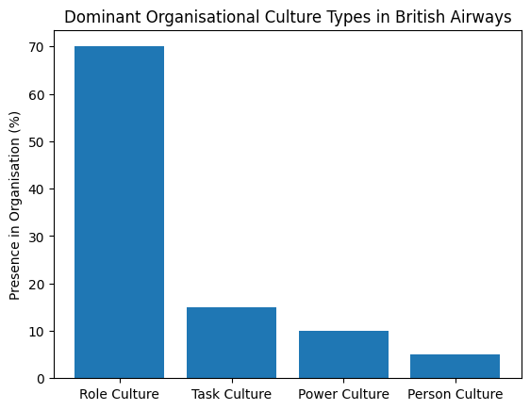

This chart shows the presence of different cultural types within British Airways based on Handy’s model. Role culture is dominant, reflecting the structured nature of airline operations.

Figure 2 – Schein’s Levels of Organisational Culture

This chart represents Schein’s three levels of organisational culture: artefacts, espoused values and underlying assumptions. The model highlights how deeper cultural beliefs influence organisational behaviour and decision-making.
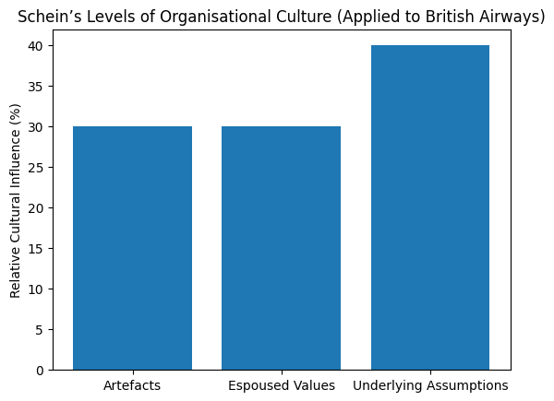
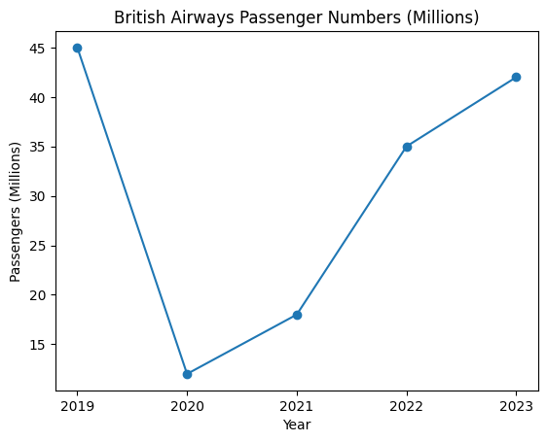
Figure 3 – British Airways Passenger Numbers.
This chart illustrates the change in passenger numbers between 2019 and 2023. The sharp decline in 2020 reflects the impact of the COVID-19 pandemic, followed by gradual recovery in the following years.

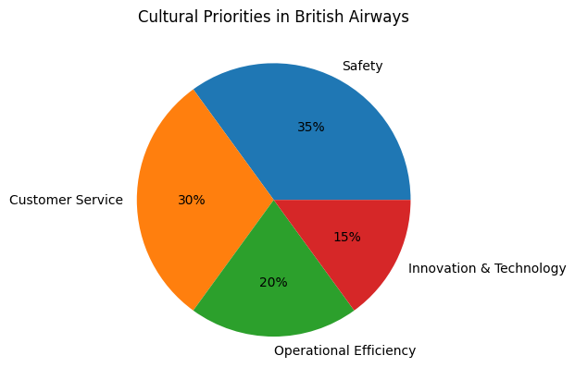
Figure 4 – Cultural Priorities in British Airways

Figure 5 illustrates the key cultural priorities within British Airways. The chart highlights that safety (35%) and customer service (30%) represent the most significant priorities within the organisation’s culture.
Operational efficiency accounts for 20%, reflecting the importance of maintaining reliable airline operations. Innovation and technology represent 15%, highlighting the increasing role of digital transformation and technological development within the aviation industry.
These cultural priorities demonstrate how British Airways balances safety requirements with service quality and operational performance.

8. Recommendations
Based on the analysis, several recommendations can be proposed.
First, British Airways should continue strengthening employee engagement programmes. Improved communication between management and employees can help prevent organisational conflicts and increase trust.
Second, the organisation should encourage greater innovation within its culture. While safety procedures must remain strict, promoting creative thinking can improve operational efficiency and customer service.
Third, leadership development programmes should focus on diversity management and cultural awareness. As a global airline, British Airways must ensure that managers can effectively lead multicultural teams.

9. Conclusion
Organisational culture plays a critical role in shaping the operations and performance of British Airways. The company’s culture is strongly influenced by the requirements of the aviation industry, particularly the emphasis on safety, professionalism and operational efficiency.
Using frameworks such as Schein’s model, Hofstede’s cultural dimensions and Handy’s cultural types, it can be concluded that British Airways demonstrates characteristics of a structured role culture supported by strong organisational values.
Although this culture supports operational reliability and service quality, maintaining employee engagement and organisational flexibility remains essential for long-term success.
Overall, organisational culture acts largely as an enabler for British Airways, although continuous development is required to ensure that cultural strengths support innovation, adaptability and employee satisfaction.

Reference List
British Airways (2024) Annual Report and Accounts.
Handy, C. (1993) Understanding Organisations. London: Penguin.
Hofstede, G. (2011) Dimensionalizing cultures: The Hofstede model in context.
Johnson, G., Whittington, R. and Scholes, K. (2017) Exploring Strategy. Pearson.
Kotter, J. (2012) Leading Change. Harvard Business Review Press.
Mullins, L. and Christy, G. (2016) Management and Organisational Behaviour. 11th ed. Pearson.
Robbins, S. and Judge, T. (2017) Organizational Behaviour. Pearson.
Schein, E. (2010) Organizational Culture and Leadership. 4th ed.
Cameron, K. and Quinn, R. (2011) Diagnosing and Changing Organizational Culture.
Deal, T. and Kennedy, A. (2000) Corporate Cultures.
Griffin, R. (2016) Management Principles and Practices.
Turner, B. (2018) British Airways: The Inside Story.

