p
project planning and management in work place
BMSK5004


Hena Begum (1706182)

Introduction
“Project management has evolved to plan, coordinate and control the complex and diverse activities of modern industrial, commercial and management change and IT projects. All share one common characteristic – the projection of ideas and activities into new endeavours” (Lock, 2007, p. 1).
Project management tools and techniques are important for managing a project within the workplace in order to plan and structure the project, identify potential threats and risks, and to guide the timeline of the project. It is also important because it focuses the main aims of the project.
The aim of this report is to critically assess the project management tools used within workplace practice. This will include a brief description of the workplace practice, the project that was undertaken, and the plans that were made. The report will also consider the communication with the stakeholders of the project, and how the project plan was implemented. Finally, the report will provide a critical evaluation of induvial ability of managing the project and recommendations for future self-development and improvements will be made.

Workplace Project
The project placement was allocated in Dyfatty Community Centre in Swansea to promote / design poster and plan an event on IT, Maths and literature, for Communities for Work (CFW). CFW support people to get back to work with building CV for position in work placement and also Citizen Advice Bureau and financial debt. (Work, 2018)

Project Management tools and Techniques
Project Management is a framework to build the foundation of a project, with overall different factors on objectives, benefits, budget, risk before getting to start a project and able to achieve goals. By completing the project with the objective, the project management monitors the activity from the start to the deadline by delegating the tasks and thereby reducing stress on team members (Mind Tools, 2019).

Project Scope
The first tool used for a project should look at the overall project to keep thise involved on track with the main aim of the project. Scope is a good tool to provide this overview, as it describes what the project is, when it needs to be completed, why the project is important, how the project will be delivered, who is involvoled in the project and who the project will benefit.
As a project manager, understanding and being able to define project scope will give you a focus and sense of purpose when executing the project. Understanding the scope provides you with the foundations for managing project change and risk management. It enables goal setting and a timeline to work towards, as well as key points for reporting on the progress of the project to senior management and other stakeholders (CIO 50, 2019).

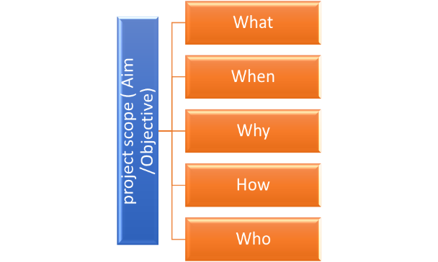
Within the project, defining the scope was used by defining what, when, why, how and why. This helped to set a timeline for the project, set up goals and allocate resources. This gave direction to the project team to allow them to deliver the project on time and within the set budget. This tool was used in an optimal way for the project as it gave guidelines and a focus.

Project Cycle
Project Life Cycle is a tool of activities which is essential for accomplishing project and targets. Project cycle helps to map out the structure by using phases within the project life cycle, including initiation and planning, execution or implantation, and monitoring and reviewing. Once these phases have been completed, the project can then be closed (Guru99, 2019).

Project cycle

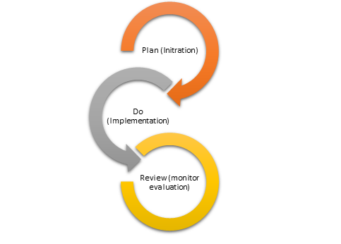

The initiation and planning phase of the project involved the team member meeting in Dyfatty community centre with the engagement offices and brainstorming the idea. This included analysing the project to enable the team to gain success toward the project. In the execution and implementation phase, the team was to design the poster to attract the public. A risk assessment was carried out in order to complete the project and avoid any risk that can cause a loss to the organisation. During the monitoring phase, the team mentor decided to an arrange the main event to distribute the handouts on the 11th June 2019. The engagement office had booked Swansea town centre from the council for £40, and the event lasted two hours. When reviewing the event, the project managers were satisfied with the outcome of the event and how the project was run. This saw the project close.
Using the project cycle as a tool was helpful with managing the project as it allowed us to see the different phases of the project. Experienced managers often keep information in their head as they are familiar with the process, but for the team on placement, it was a very useful tool to keep on track with the project stages.

Quad charts
A quad chart is a table divided into four sections describing the purpose, goals, customers and measures of success. Some businesses use quad charts to communicate research ideas quickly to team members (Warburton, 2013).
A quad chart should address what the aims of the project are, what the challenges might be, who the project will benefit, how the impact will be measured, the cost, timescale and how the progress can be measured.
Quad Chart
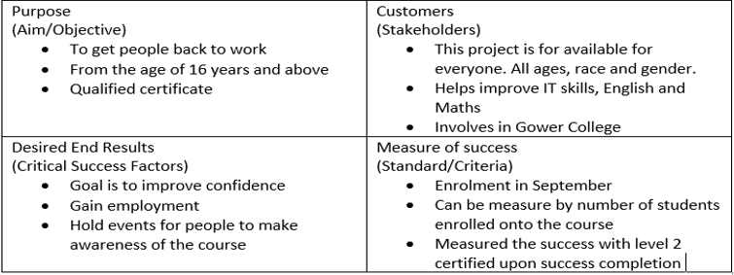 Quad Chart was used on the project by providing a framework on the aim/objective, stakeholders that benefit and what the project involves. The quad chart was then used to outline how to measure the end results and the success of the project when achieved. The structure helped the team to focus on the awareness of what can be affected and what is gained after the achievement of the project. Quad Chart is a document describing the project with bullet points of element that it involves. This give the team a clear vision when reviewing and was fit for purpose.

Working Breakdown Structure (WBS)
The Work Breakdown Structure (WBS) is a tool in project management and a foundational concept. “It is an enabler that ensures clear definition and communication of project scope while performing a critical role as a monitoring and controlling tool” (Norman, et al., 2010, p. 3).

WBS
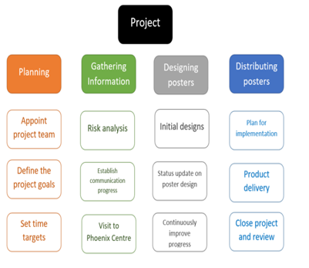
WBS was used within the project as a way to break down the task and give the team something to focus on. It was also used as a guide for how to go about completing the project and the step-by-step order of how to complete it. It was effective because it gave the team the steps needed to complete the project, but it would have been more effective if the team had more time to complete the project. This is because each step had a tight schedule, so if a member of the team was absent, it had to be completed by another member or the project would have fallen behind. More time would have allowed more focus on each of the steps and not having to rush any aspect of the project.
Iron Triangle
To evaluate a project, the ‘Iron Triangle’ can be used to analyse the time, cost and quality of the project. The Iron Triangle shows that product, cost and time are equally important, and each point affects the other (Lock, 2007).
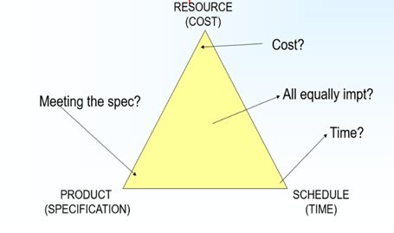

The iron triangle a tool to consider the three elements of time, cost and the quality. This was a helpful reminder during the project that all three are essential for success but also that the focus may shift from one to another at different points of the project. The framework helps fix or amend the points of the triangle to create balance. The triangle helps to promote the event of the project by considering all three points. In the project, time was the essential factor in order to gain the highest success and it was important for the team members to complete the event with in the timescale of the hired location. The triangle could have been used more effectively if all team members had an awareness of the different factors of the triangle, but the cost was kept within management team.

Risk Management

Risk analysis involves project objectives and outcomes that might change during the duration of the event. Once the risks are identified by analysing the potential impacts, the appropriate steps are outlined to mitigate the risks (Project Management Institute, 2008).

Risk Management
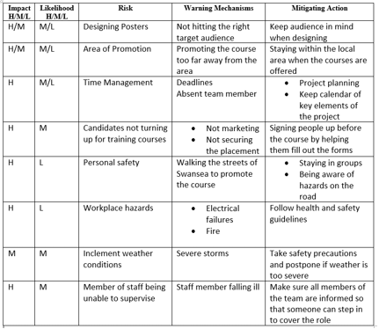
Risk management enabled the team to estimate the potential issues related to the project. The risks were categorised into high, medium and low risks that can occur during the project or while the event was taking place. The team had experienced bad weather on the day of the event and had decided to continue rather than postpone to another date. This factor was a medium impact due to weather warning, but this impacted the project and the team eventually had rearrange the event. This was because of the rainstorm preventing the team from being able to hand out leaflets as the ground was wet, slippery and dangerous for the team members. The risk management was an effective tool because it outlined potential risks that could happened while the project was taking place and provided action points for each eventuality. This tool would have been more effective if all members took note of the action points, as cover was not provided during staff absence even though it was noted on the risk assessment.

Gantt Chart
A Gantt chart is a structure to allow an easy way to schedule tasks and track the progress of a project against a deadline. It is a framework of planning to shows the beginning and finish dates of individual tasks with horizontal bar graphs (Tran, 2015).

Gantt Chart
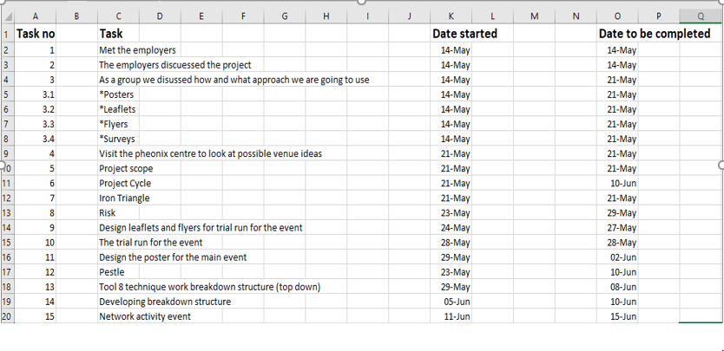
The Gantt chat enabled the team to work out all the tasks and the maximum time schedule for the team to complete the task. This involved writing down the tasks and the date that they needed be done by. The Gantt chart is an overview of the project to link with the task and also keep the team informed of the progress. The team members had failed to complete the trail run due to festive celebration, but the main event was completed despite the fact of bad weather. The Gantt chart was effective as it covered everything that needed to be included, but it would have been more effective if it was presented in coloured bars to give a visual representation of timescales, and to log when each task had been completed.

PESTLE Analysis
The PESTLE Analysis is used as a tool of situational analysis for business evaluation and projects. It is one of the most used models in evaluating the impacts that could affect an organisation or project (Perera, 2017).

PESTLE

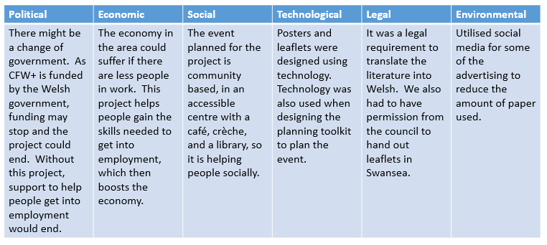
PESTLE was used in the project to show how each aspect was involved in the project and the impacts. Each aspect of PESTLE was equally important as each other, as they are all things that could impact the project.

SWOT Analysis
A SWOT analysis identifies action points that should be followed, or avoided, when planning a project (Fine, 2011).

SWOT

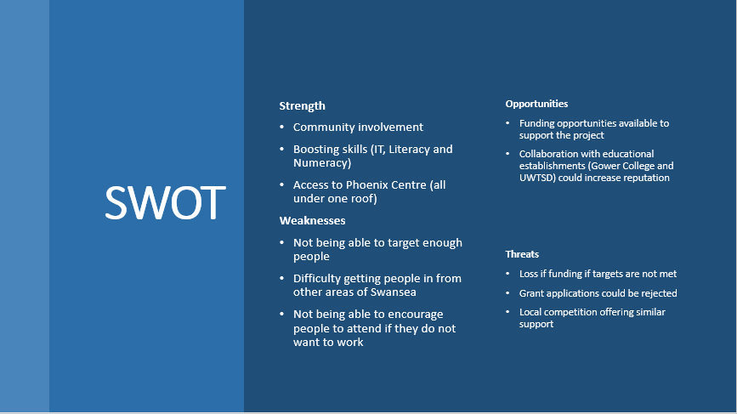
SWOT was used within the project by identifying the strengths and weaknesses as well as highlighting the potential threats. It also allowed the team members visualise the opportunities for the project. SWOT benefitted the project because it allowed all four aspects to be viewed in one document.

Stakeholder Communication
Stakeholders of a project are the people who have input or interest in the project. This could be people who support the project with investment and resources, people who will be affected by the project, or people directly involved in the project. Stakeholder communication is “the process of engaging with these people, and maintaining good relationships with them... Communicating with each one in the right way can play a vital part in keeping them ‘on board’” (Thompson, 2019).
The main stakeholders for the project were the team members, the local community, the partners and collaborators, and financiers.
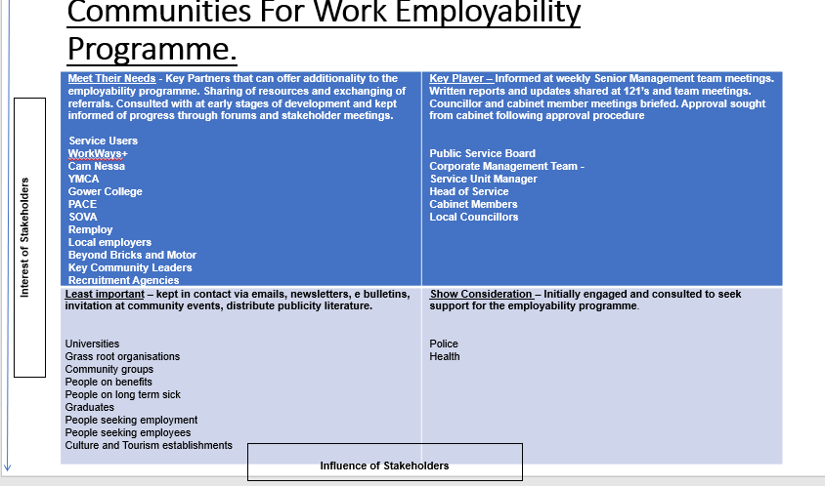
As part of the project, the team drew up a ‘Community Job’s Fayre Draft Plan’. This outlined the plans to communicate the project to the local clients who will be impacted by the project.

Self-development plan
Existing skills | Skills gaps | Action for Improvement
Communication skills | Not firm enough when communicating | Develop a more persuasive approach to communicating whilst still considering other people’s opinions.
Commitment to the project | Not 100% effort due to Ramadan | Develop task management skills to handle the project and juggle with other commitments

Conclusion
Overall the project was managed will with a few complications. The team worked together well, and the project was implemented according to plan, with a few alterations to account for mitigating circumstances. Improvements to individual performance could be putting in more effort to improve focus on the project. Lack of focus was due to other commitments at the time of the project, so task management skills would help to be able to juggle all commitments. Another improvement would be developing stronger communication skills to be more persuasive with the rest of the team instead of having a more laid-back approach. This would have resulted in improved leadership skills and being taken more seriously as a leader.

References
CIO 50, (2019). How to define the scope of a project. [Online]
[Accessed 1 July 2019].
CIPD (2019) PESTLE Analysis, Available at: https://www.cipd.co.uk/knowledge/strategy/organisational-development/pestle-analysis-factsheet (Accessed: 16th June 2019).
Communities for Work, (2019). Communities For Work, Swansea: Communities for work.
Fine, L. (2011) The SWOT Analysis. London. Kick It
Guru99,((2019). Project Management Life Cycle:Complete Guide. [Online]
Available at: https://www.guru99.com/initiation-phase-project-management-life-cycle.html
[Accessed 2nd 07 2019].
Lock, D., (2007). Project Management. 9th ed. Aldershot: Gower.
Mind Tools,(2019). What is Project Management. [Online]
Available at: https://www.mindtools.com/pages/article/newPPM_00.htm
[Accessed 30 06 19].
Norman, E., Brotherton, S. & Fried, R., 2010. Work Breakdown Structures: The Foundation for Project Management Excellence. 2nd ed. London: John Wiley & Sons.
Project Management Institute, 2008. Risk Management and management. [Online]
Available at: https://www.pmi.org/learning/library/risk-analysis-project-management-7070
[Accessed 03 07 2019].
Thompson, R., (2019). What Is Stakeholder Management: Planning Your Stakeholder Communications. [Online]
Available at: https://www.mindtools.com/pages/article/newPPM_08.htm
[Accessed 3 July 2019].
Tran., L., (2015). The importance of the Gantt Chart and the critical path for project Management. [Online]
Available at: https://www.inloox.com/company/blog/articles/the-importance-of-the-gantt-chart-and-the-critical-path-for-project-management/
[Accessed 1st 07 2019].
Warburton, M., (2013). Quad charts promote faculty research to DoD. [Online]
Available at: https://research.unl.edu/researchnews/May2013/quad-charts-promote-faculty-research-to-dod/
[Accessed 3 July 2019].

