9a(3) Exercises for lists in Python (2)

2a. Using floats

Create an empty list to hold some temperatures.

temps = []

2b. Allow the user to enter 6 temperature readings into your list. Use .append() and a for loop.
Hint: Just do one temperature reading to start – you can add the for loop in afterwards

Sample output:

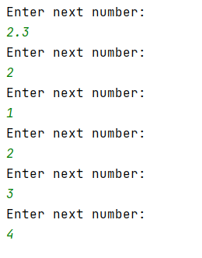

2c. Print out the numbers entered by the user in 2b above – nicely as shown below.

Sample output:

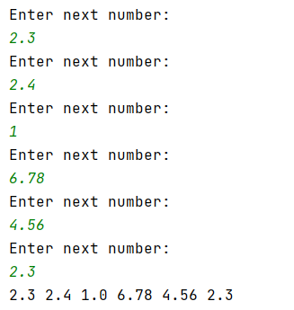

2d Print the item at index 3 of the list on the screen:

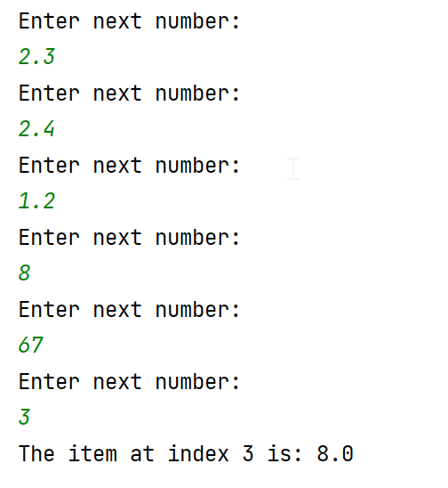

2e. Following on from 2d), this time, allow the user to choose which index they require:

Sample output:

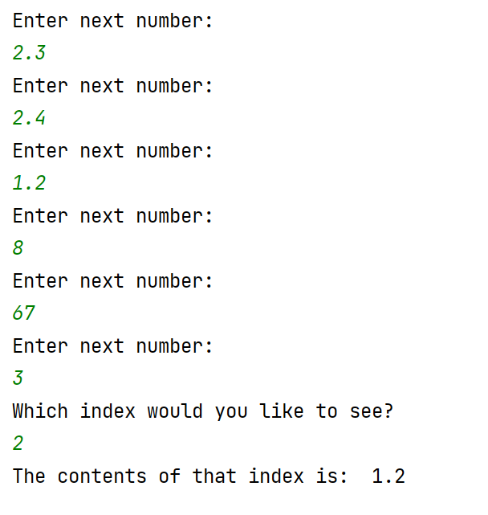

3a Create a program with the following list:

theNumbers = [2, 4, 3, 7, 3, 1, 3, 8, 9]

3b Multiply every list item by 2 and print the result on the screen. Use a for…in range loop to help you:

Sample output:

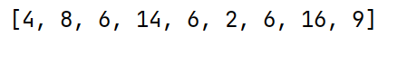

3c (Harder) – Find the average of the following list (ie add the contents of the list – preferably using a loop – and then divide by the number of entries in the list)

Hint: set a variable, total=0, before you start your loop, and then add to total on each iteration of your loop.

theNumbers = [2, 4, 3, 7, 3, 1, 3, 8, 9]

Sample output:

4a. Create 2 lists, one of strings and one of integers with 8 entries. The string list will hold names, the integer list will hold telephone extension numbers eg. 4234, 6545

4b. Print the lists on the screen as shown in the sample output below, using a for…in range loop (Do not use a for…each loop as 2 lists are involved.)

Sample output:

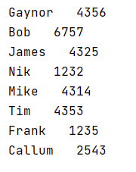

4c (Harder) Allow the user to enter a name. Look through the list and find the name. When you find it, print out the number associated with that name.

Sample output:



