BSCHSC BMHP5014 Changemakers: Creativity and Value Creation
E-Portfolio.

Jazmin Dawes
Lectura: Dr Azora Hurd
Student number: 2015980

Contents Page
Page 3: Introduction
Page 4: Front of Flyer
Page 5: Back of Flyer
Page 6: Flyer Description
Page 7: Flyer Description
Page 8: Elevated Pitch
Page 9: Elevated Pitch
Page 10: References

Introduction
In this e-portfolio, I have decided to develop a new and unique service. I have identified there is a gap in the market, for an accessible housing association developed to facilitate wheelchair accessible homes and reduce the long waiting time for individuals that need accessible housing.
I have chosen to advertise and bring awareness to this issue by Using artifact 4 a flyer and artifact 3 an elevated pitch.

Front of Flyer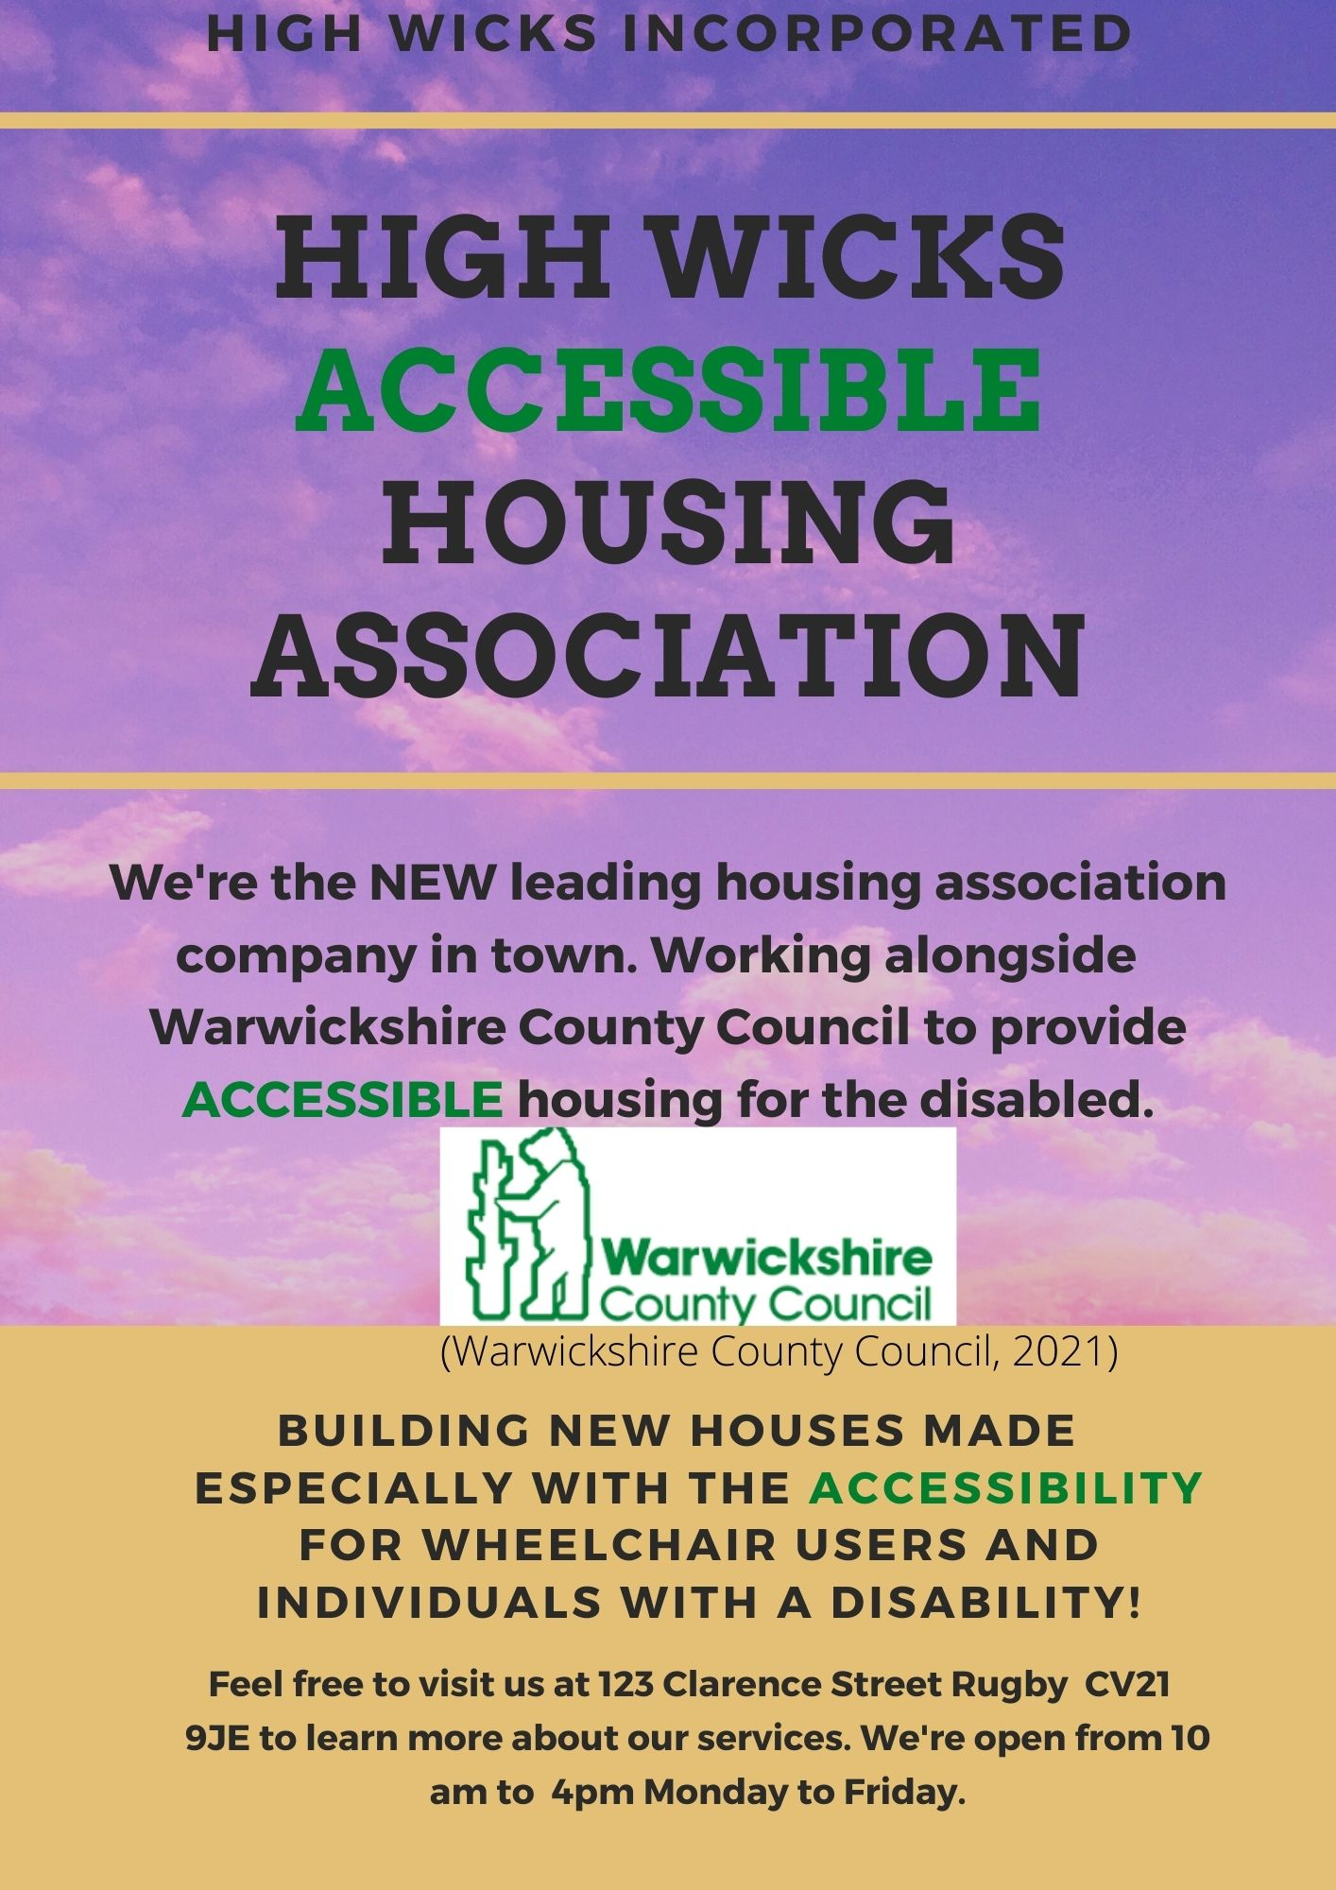

Back of Flyer

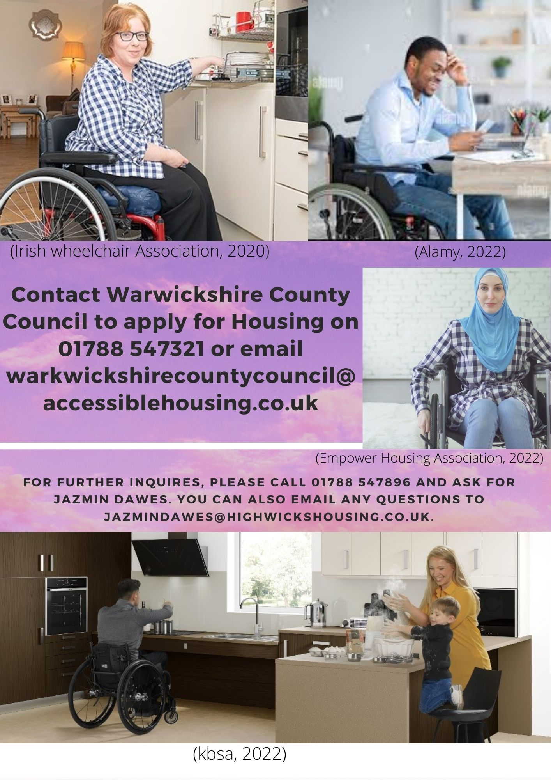
Flyer Description
I have created this flyer using a design website called Canva, I chose a layout I liked and felt would represent what I envisioned for my leaflet. I have decided to create a flyer about accessible housing for the disabled because I'm passionate about reducing the amount of time they are waiting for housing and feel this is a step in that direction.
I first chose the background with a light bright violet cloud effect which I felt would stand out to the readers and then I also mixed this with the orange background which I felt blended nicely together and made the leaflet eye-catching.
I chose the name High Wicks housing association and made the lettering in bold black and in capital letters to stand out. I highlighted the word “accessible” green and in capitals throughout the flyer to highlight to the reader further the message I'm trying to get across regarding accessible housing to make sure that it stands out and it also matched with the colours of the council's logo.
I have then spoken about that we are a new company and made the letters NEW in bold and in capital letters to stand out to the reader that we are a new service to the area and that we are working alongside the Warwickshire County Council which will be recognizable and familiar company to the reader.
I have also attached Image 1 which is the council logo which I feel will make the readers believe that we are a trustworthy company because we are working in partnership with the council's housing department, and not a fly-by-night company.
I have then used bold capital letters to describe that the homes will be wheelchair accessible and for individuals with a disability, I felt that using bold capital letters specifically to highlight paramount details i.e., “wheelchair” to grasp the reader and make them aware of my target audience.
The address of my company is bold and black the times and days in which we are open, making the readers aware that they can come in and receive further information regarding the housing association and the services we provide.
On the back of the flyer, I have attached an image 2 and 3 of a lady and a male in a wheelchair in a kitchen and study that is accessible for their needs. I chose these pictures because they show diversity and give an idea of the types of designs that would be available in the new homes, I also chose this picture because there smiling to show they are happy with their new home.
Lettering is bold black to give the information of Warwickshire's council's contact details and email address, so the readers know how to apply for the housing, and just below that, I have put in slightly smaller black capital letters the company's contact details and email address as another source of contact. I attached an image of a female Muslim in a wheelchair to show further inclusion to all.
The last image that I have used is image 4 which portrays a happy family in a kitchen all being able to participate in cooking a family meal which I feel shows the readers how happy they could be in a new accessible home like this.

Elevated Pitch
Good morning, everyone, and thank you for taking the time out to come and see me to listen to my speech today it means a lot to me to have so many professionals and council members and the MP for Warwickshire here to discuss this important topic.
Today I'm going to be discussing an important issue accessible housing for the disabled and how most of the housing that is being built today in 2022 is inadequate for many wheelchair users and individuals with disability yet not a lot is being done to support or fund change to this issue.
According to the information I obtained by ITV News from the department for housing, 119,621 disabled or physically vulnerable individuals were on the waiting list for accessible housing with their local council in (2018/19) up over 10% from (2016/17) figures of 108,858 (Hewitt, 2020).
These figures are shocking and to think that the issue is only getting worse is mind-blowing that in the 21st century we are living in today and all the technological advances we have made in this country, for building accessible housing to be such an issue is absurd and is something that has been overlooked for far too long.
Approximately 20% of the adult population in the United Kingdom is disabled (equivalent to an estimated 10.3 million people) over half of the disabled adults are under the age of 65 (IPSOS MORI Social research institute. 2016).
The reason I became so passionate about trying to create some sort of solution to this problem was when I was speaking with my cousin who has cerebral palsy, and he was expressing the frustrations that he was experiencing in being able to move in with his fiancé who is in a wheelchair because there was no adequate housing that could facilitate both their needs in rugby currently and have been on the waiting list for a long time with the council also.
Hearing this inspired me to set up the High Wicks Housing association and create crowdfunding that has helped develop the company to be able to provide capital to buy land and build homes in Warwickshire pacifically for the disabled to reduce the waiting times. There are only 22% of councils that have an accessible housing register (Housing and disabled people: England statistics, 2014) these are the types of statistics that High Wicks housing association is working on increasing in the years to come because these figures are not acceptable as I'm sure you would all agree with me on.
The bigger plan is to bring High Wick housing association into all areas of the UK and with the help of some of the individuals in this very room to help support and generate the funding and spread the word by handing out the flyers to spread the word to drive this new era of accessible housing for the disabled around the UK.
Thank you for your time and for joining me today, and if there are any questions, I'm happy to answer them.

References
Alamy. (2022). Black male in wheelchair. (online) Available at: <https://www.alamy.com/search.html?page=3 (Accessed 23 February 2022).
Canva. (2022). Flyer design. (online) Available at: <https://www.canva.com/design/DAE4X_JOnEM/vt498aPn9xb7QkzapHHPuw/edit> (Accessed 20 February 2022).
Empower Housing Association. (2022). Specialist Housing Provider for People with Disabilities. (online) Available at: <https://empowerhousing.org.uk/> (Accessed 23 February 2022).
Equality and Human Rights Commission. (2014). Housing and disabled people: England statistics. (online) Available at: <https://www.equalityhumanrights.com/en/housing-and-disabled-people-england-statistics#:~:text=The%20need%20for%20accessible%20housing,adaptation%20in%202014%20to%202015.> (Accessed 22 February 2022).
Hewitt, D. (2020). A number of people with disabilities and medical conditions on housing waiting list rises by almost 11,000 in two years. (online) ITV news. Available at: <https://www.itv.com/news/2020-02-07/number-of-people-with-disabilities-and-medical-conditions-on-housing-waiting-list-rises-by-almost-11-000-in-two-years> (Accessed 22 February 2022).
IPSOS MORI Social research institute. (2016). Accessible Housing Survey Public perceptions of accessible housing. (online) Available at: <https://www.ipsos.com/sites/default/files/publication/1970-01/sri-housing-accessible-housing-survey-2016.pdf> (Accessed 22 February 2022).
Irish wheelchair Association. (2020). Accessible homes. (online) Available at: <https://www.iwa.ie/accessible-homes-in-bellmullet/> (Accessed 22 February 2022).
kbsa. (2022). Accessible Kitchens. (online) Available at: <https://www.kbsa.org.uk/inspiration/kitchen/accessible-kitchens/> (Accessed 21 February 2022).
Warwickshire County Council. (2021). (online) Available at: <https://www.warwickshire.gov.uk/news/article/2574/green-man-junction-coleshill-signalisation-road-safety-scheme> (Accessed 16 February 2022).

