A report on problem solving and decision making

Student no 2026171
Dhirendra Jadhav
Module BMSW4004
SOBAN SADIQ

CONTENTS
1} INTRODUCTION
2} THE PROBLEM
3} PSOOIBLE SOLUTION
4}FINAL SOLUTION
5}MONITORING PLAN
6} CONCLUSION
7}REFERENCES

INTRODUCTION
THIS REPORT IS MADE TO DEFINE MY PROBLEM – SOLVING TOOLS AND TECHNIQUES and proposed different solutions to a specific problem developed in my workplace.
For this report I will be using a problem that happened in my current workplace. I will explain the problem and all the consequences that it can bring.
I will analyse furtherly the problem to be able to find the root of it to start developing solutions using the told learned through this module.
Once the solution is defined, I will create a plan to monitor the solution to make sure it is successful, and the problem doesn't occur again, or anyone faces this again
THE PROBLEM
A present unsuits a factory state that needs to be changes to a desired state as soon as possible.
Types of problems encountered at workplace
A} human institutions
B} attitude problem
C}communication problem
D} ethical problem
E} poor performance
F} discrimination
G} politics {ref-problems at work guide I Peninsula uk}

This are various types of problem in some workplaces
Let's start by my own workplace place problem that was related to bad communication, poor performance, this will classify as a complex problem is when a situation is not showing the desired results and it needs to be changed to get where the company wants it to be.
At my own work place I had face kind of situation which was simple but the impact of that was very huge and was not looking good for organisation and for individuals as well. The problem related to improper communication or not communication properly or not sharing or discussing issues that affecting work and organisation. The supervisor from my team at workplace had some personal issues that she was not sharing but because of that the ability of handling of pressure work was losing and at sometimes she was totally not manageable the work she uses to do brilliantly. Due to her personal problems the work was getting affected and she could not focus what is priority and what to do how to organise.

The main problem here was bad communication, which was bringing lack of organisation, bad management and unhappy staff and the whole team and company was getting affected by this
The total miss management at work at every day task very difficult to handle and the work was not getting done on time and as expected. delays in making rotas no proper delegation
so, she was not focusing as usual to get her work done properly, she was upsetting shifts short notices, not organised any more that was creating so many problems that staff was not sure what to do. Ultimately company started losing some contracts for cleaning offices.
Everywhere was problem because of her personal problem at workplace.
With the help of other team member at least we could find that this is the issue, then as manager we thought we can help her to bring back normal routine for her and for workplace.to
So, we called for meeting to have formal discussions so we can get what problem or what casing her so is not focusing on work. After giving her chance to speak she said that she come to know that she is diagnosed with cancer and doctor has advised her few things, so she can get the right treatment but because of her commitments she could not afford whatever doctor has asked for. Then doctor gave few months' timeline for her to think and comeback. But hopelessly she could not find any help anywhere so that started work problems and on life as well

effectively solve problems at the workplace the skills required for that
soft skills are general traits or characteristics that can help individuals thrive personally and professionally. Soft skills refer to interpersonal and behavioural skills and are sometimes called nontechnical skills since they are transferable across all jobs and industries some examples of soft skills
- Emotional intelligence
- Adaptability
- Leadership
- Decision making
- Attention to detail
- Negotiation s

Possible solutions
There is a wide range of possible solutions to this specific problem that have been proved to work.
There are countless approaches that have been developed for problem solving. Some of the approaches are very simple and others are complicated. Some of these include:
Trial-and-error method: One solution after another is tried until the problem is resolved or appears to be improving
Experimentation: A theory is tested to enhance knowledge, understanding or prediction
Affinity map: A tool used to identify problems
Various problem-solving models

Fishbone Analysis for our problem and total process to solve the issue

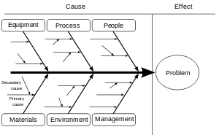
This Photo by Unknown Author is licensed under CC BY-ND
It is usually the first option to speak to the people above this supervisor to try and get to talk with these people give them chance to discuss the problem she is facing what can they offer to help with problem she has so it stops all problems in company. Give them some solutions after knowing the problem set up some goals for her to follow and track her progress to determine if this behaviour can be changed for the better, as the easiest alternative is to try and solve the problem internally or at first stage. If this does not work and this person is still presenting bad organisation and doing wrong things, it will be necessary to do further action form the current. Position
After discussing the problem, we found out that she had diagnosed with cancer and that mental stress of that causing all the issues for her work life and personal life
The final solution is that she takes some break of the work, and we try and cover her for some time until she gets back normal to do her job efficiently and proactively. As she was doing this by herself without having any help and always on time good with organisation.

With this final solution both problem and she Gona gets out of trouble benefiting no things. Teamwork will be positive under new command for change, somebody get chance to prove, will not lose any further contracts and more manpower

When she comes back to join her work again. Will put her on some monitoring plan which will enable us to discuss further if necessity arise.
Madjoski{2016}, tell us the first step to ensure that our new solution works and succeed is to set targets. It is very important to make sure that these targets are measurable. Otherwise, the target is useless. It is crucial to determine our key performance indicators, as well known as KPIs. As this is what we will be controlling. Customer churn. Employee fluctuation. Employee satisfaction

Swot analysis
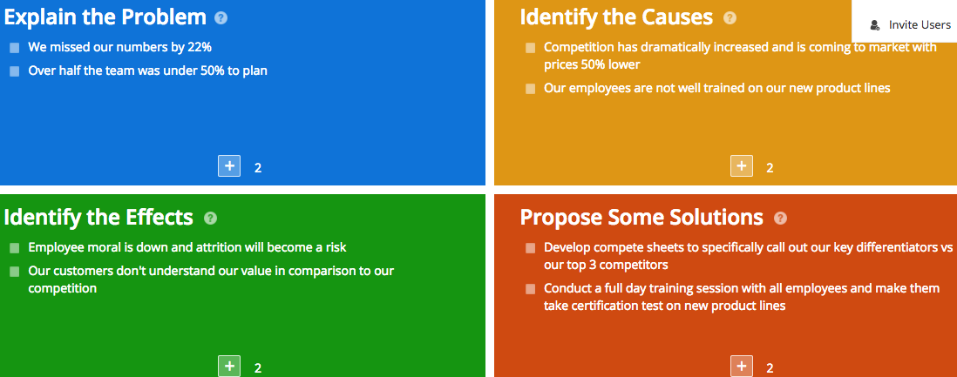

conclusion
With this method I come to know the problem-solving technics identification of the problem, structuring the problem through the use of some forms of representation and looking for possible solution, often through various thinking. So, understand the issue then followed soe guidelines to help both the level to solve the problem. To help both sides

references
Zeigenfuses, James London:; Thousand Oaks, Calif. ;SAGEc2002.
Mayer, Richard E.San Francisco :WH Freeman1983.
Proctor, Tony, Tony Proctor author Fifth edition. Boca Raton, FL :Routledge[2018].

AK model is what you need to take a look at if you want to know more about your learning style. V AK, expanded as Visual, Auditory and Kinaesthetic, is comparatively easy to learn and can help you in understanding your own personality and thoughts.
VAK Learning Styles: Understanding How Team Members Learn
www.cleverism.com/vak-learning-stylunderstanding-ho…
- Collaborate - an analysis that involves multiple perspectives will deliver a better outcome.
- Use expertise and resources that are already available within the organisation.
- Use SWOT analysis in conjunction with other techniques, such as PESTLE analysis.
More items...

SWOT Analysis | Factsheets | CIPD
www.cipd.co.uk/knowledge/strategy/organisational-development/swot-analysis-…

