E-PORTFOLIO
Learning in the Digital Era
Requested by: Christian Felices
On: 01.09.2023
Maher Ibrahim
2214235

Contents
Executive summary..........................................................................................................
Terms of Reference....................................................................................................2
Procedure...................................................................................................................2
Introduction................................................................................................................3
Main finding................................................................................................................4
- academic writing.............................................................................................5
- Critical writing.................................................................................................6
- Sense of Place and Identity..............................................................................7
Conclusion....................................................................................................................8
Reference List................................................................................................................9

Terms of Reference
Requested by Christian Felices on 7th August 2023. This report includes the tasks required for the e-portfolio which includes the importance of academic writing, critical writing, and a sense of place and identity. This work was written by me Maher Ibrahim (2214235). and submitted on 19th August 2023.

Procedure
Textbooks, websites, and Journal articles.

Introduction:
Academic writing, as defined by Scribber, is a formal style of writing that is employed in academic journals and educational institutions. It can be found in academic books and journal articles, and it is necessary for your essays, research papers, and dissertation. Academic writing follows certain rules for its content, organisation, and style even if it follows the same writing process as other types of publications. Academic writing's main goal is to deliver information in an objective manner. Arguments ought to be supported by the evidence under consideration, not by the author's prejudices. All claims must be supported by relevant data.

Main findings:
According to Bas Swaen (27 October 2016) Revised on 25 October 2022 by Tegan George.
A results section is where you report the main findings of the data collection and analysis. You should report all relevant results concisely and objectively, in a logical order. Do not include subjective interpretations of why you found these results or what they mean – any evaluation should be saved for the discussion section.
When conducting research, it is crucial to present the findings before discussing how you might interpret them. This keeps the data itself apart from your personal interpretation of it and gives your reader a clear understanding of what you discovered.

Academic Writing:
According to (Sheldon Smith,24July2022)
Academic writing is that communicates ideas, information, and research to the academic community, there are two types: student research method, which is used as a form of assessment at university and in schools to get ready for university studies and expert academic writing meant to be for publication in an academic journal or book. Both types of academic writing (student and expert) are expected to involve to the same standards, which can be difficult for students. Academic writing different from other types of writing in general due to its exceptional qualities.
According to UEFAP, Andy Gillett (Since 29th April 1999) updated, (1st January 2023).
Academic writing has a recognizable academic style.
Academic writing is formal. In general, this means that avoiding everyday language in an essay.
Academic writing makes clear the connections between the text's relationships, it is the responsibility of the English author to make it clear to the reader how various parts of the text are related. These relationships can be made using different signal words.
Academic writing involves precise use of vocabulary. There are words with limited, specific meanings for most of the subjects. The terms "phonetics" and "phonemics" are distinct in linguistics, but everyday English does not. Academic writing is well planned. It usually takes place after research and evaluation, with a clear purpose and plan in mind.

According to Oxford Brooks University:
The main benefit of writing in a formal academic style is that it helps you to develop your thinking. You must write your ideas out fully, and you cannot rely on assume.
Academic writing usually has a clear structure with an introduction, main points in a logical order, and a conclusion. Let your reader know how you are structuring your work.
Jeffrey R. Wilson, Harvard University (2022)
said:
Typically, the act of "writing" is thought of as the expression of thought. Writing is defined in this piece as the act of thinking. Writing is not what you do with your thoughts. As you write, consider. Academic writing, a fundamental course in interpretation, promises to help people live better lives.
Most schools teach it because it is a necessary life skill. There are many things in our world that deserve scrutiny. Using his coursework from the Writing Programme at (Jeffrey R Wilson-202.

Similarity matchs is 45% for this report which is too high.
Higher score indicate greater similarity, I will do my best to score better on my next assessment. is taken from the plagiarisim tool that call Turnitin. The above screenshot
Reducing similarity can also accomplished by paraphrasing and summerising in my own words.
I will try my best to improve my writing.

Critical Writing:
University of Hull (May 5, 2023) said that critical thinking requires you to carefully evaluate not just sources of information, but also the ideas within them and the arguments they develop. This is an essential part of being a student at university. You cannot simply believe everything you read or are told. For some people, this can feel uncomfortable as this requires you to critique published authors and notable academics. While this may feel unsuitable, it is one of the foundations of academic debate. Indeed, for any given topic or issue, there are many equally valid academic positions. To be effective in your critical thinking, you need to use both scepticism and objective to be successful.
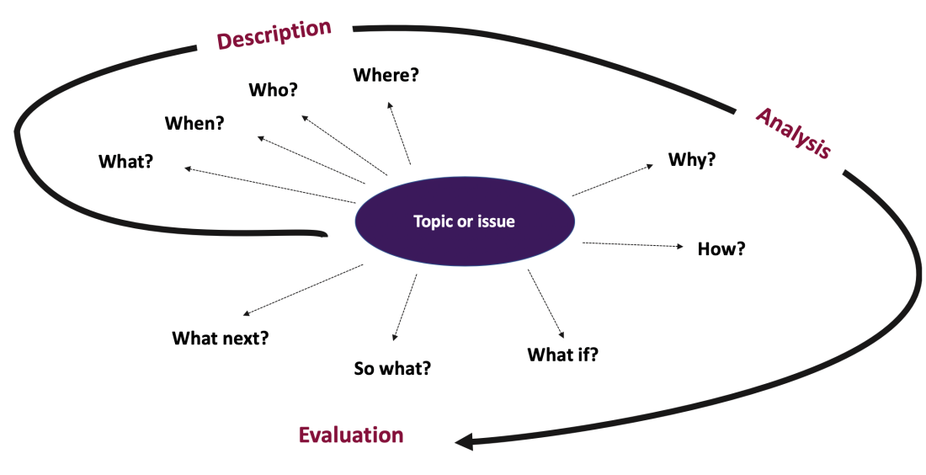

Critical writing involves:
analysing information to understand a problem or topic from more than one perspective.
Making logical connections between ideas; providing your own viewpoint on the subject based on your assessment of the evidence that is available.
Identifies the significance of what happened

Questions existing explanations of a situation and examines alternative explanations.

Evaluates the strengths and weaknesses of the evidence supporting the theory or argument.

Explains how ideas or perspectives are connected to each other and to the overall topic.

Evaluates the diverse options and explains which option is best and why.

Aims to provide the writer’s perspective on the topic and encourage the reader to think more deeply about their own perspective. (UTS).
To write critically, you need to use a range of sources to develop your argument. You cannot rely solely on your own ideas; you need to understand what others have written about the same topic. Additionally, it is not enough to use just an only source to support your argument, for example a source which agrees with your own view, since this could lead to a biased argument. You need to consider all sides of the issue.

Video on Sense of Place and Identity:

https://www.canva.com/design/DAFr3XVhIis/xHW6Az9etALSlTyzXYM2dA/view?utm_content=DAFr3XVhIis&utm_campaign=designshare&utm_medium=link&utm_source=recording_view

Conclusion:
Academic writing and critical writing are essential elements of scholarly communication, people can communicate their idea by writing professionally.
Critical thinking raises the stander of work.
Critical thinking and academic writing are vital skill for successful communication and academic performance.
Academic writing and critical writing work together to improve the quality of reports.
Reading more books help to improve writing.

Reference:
- Published on 27 October 2016 by Bas Swaen. Revised on 25 October 2022 by Tegan George.
- (Sheldon Smith 24 July 2022).
- Sheldon Smith is the founder and editor of EAPFoundation.com.

Using English for Academic Purposes
For Students in Higher Education
- (Since 29th April 1999)
- Andy Gillett
© Andy Gillett, 2023
- updated: 1st January 2023.
- Oxford Brookes U
- Jeffrey R. Wilson is a teacher-scholar at Harvard

What is critical writing? - Hull University Library
- 
- University of Hull
- https://libguides.hull.ac.uk › ... › Critical writing
- University of Technology Sydney https://www.uts.edu.au › support › helps › academic skills
- (Sheldon Smith- 06 January 2022).
- EAP Foundation.com, 2013- present by Sheldon C H Smith.
- EAPFOUNDATION.COM Website Copyright © 2013-present by

- (Edward Relph, Place and Placelessness,1976).
- (Charlee Iddon 08/12/2022).
- Shamai (1991) Robinson (2006) UNESCO University.

EAPFOUNDATION.COM Website Copyright © 2013-present

