11/23/2017
Abigail Davies (1503169)
Dissertation
HOW DOES THE TENDERING PROCESS IMPACT ON THE NHS?
Research proposal
Background
Justification
Aims and Objectives
Methodology

Contents
Introduction 2
Background 2
Justification 4
Aim and Objectives 5
Methodology 6
Schedule 7
Systemic review 7
Ethics 7
APPENDIX A 8
APPENDIX B 9
Appendix C 10
Appendix D 11
References 12
Bibliography 14

Introduction

Background
Aneurin Bevan revolutionised healthcare in 1948 by forming the National Health Service (NHS). When the NHS was formed it was to be free at the point of delivery for everyone. Its aim was to treat alike based on need, not the ability to pay. In the initial years changes happened sporadically such as 1952 when a charge of one shilling was introduced for prescriptions, then in 1962 saw Enoch Powell’s Hospital Plan and the first hip replacement was performed. Later during the 1970s the NHS delivered its first Invitro Fertilisation (IVF) baby. 1987 the first heart, lung and liver transplant were carried out by Papworth Hospital in Cambridgeshire. It wasn’t until 1990 when it saw the first Act come into place which was the NHS Community Care Act. It was in 2012 that The Health and Social Care Act (HSCA) was introduced which has caused controversy ever since. The basis for compulsory procurement in the UK is based on this act. The HSCA required commissioners to put out to tender everything that could be provided by an organisation other than the NHS. This process has had a direct impact on the NHS as an organisation, the patients it cares for, the people that work in it and there has also been an impact financially.
There are a few areas that this has impacted on over the years. GPs were made the guardians of their budgets, something that by their own admission they have no skills to deal with effectively Katie Gardener a GP at Marybone practice in Liverpool states in an article in the BMJ that ‘many NHS employees do not fully understand the system’ (Gardner, 2012). The GPC has had serious concerns regarding the impact this has had on patient care, it argues that ‘more and more organisations involved in a patients care, the harder it becomes to ensure good communication, adds greater amount of bureaucracy, and makes it more difficult to provide holistic care for patients’ (Lacobucci, 2013), In contrast though Lord Howe would suggest that ‘ such concerns were misplaced, as they would encourage greater innovation, improve performance in the health service and drive up the quality of care’ (Lacobucci, 2013). The NHS has become the UKs biggest business. It was reported by the British Medical Journal (BMJ) that ‘redundancy payments were the single most expensive cost of implementing the Health and Social Care Act, accounting for 40% (435m) of the £11bn cost of the changes’ (Kmietowicz, 2013). This seems an enormous amount to be paying out to simply re-employ people however in contrast the BMJ justifies that ‘competitive tendering provides an opportunity to improve inefficient, outdated services’ (BMJ, 2015).
Pre HSCA saw a concentration on health and the wellbeing of the patient as well as many areas of medical improvements and milestones as opposed to post 2012 and the introduction of the act that saw a concentration on tendering to the highest bidder. The NHS bureaucracy is shown in Appendix A which contrasts with the new bureaucracy as shown in Appendix B.
The costs of the tendering process to the NHS should also be acknowledged at this point. One of the biggest stories that was introduced prior to the HSCA was the introduction of Private Finance Initiative (PFI) which is ‘The Private Finance Initiative (PFI) means that banks, such as RBS and HSBC, have controlling stakes in NHS hospitals and it has been reported that HSBC even owns three NHS hospitals outright’ (El-Gingihy, 2017). PFI is said to have cost the NHS in repayments a staggering 11 times the amount of the initial borrowing. ‘The PFI companies which hold the NHS hospital contracts have made £831m in pre-tax profit over the past 6 years’ (CPHI, 2017). The impacts as can be seen here have been debated over and over however how has this impacted the service user themselves?
Since the HSCA was implemented there has been four years to evaluate the impact on the public. Much discussion on the financial weight of the HSCA has been conversed over these years as has the impact on the organisation and the staff who work within the sector but what of the service users? Ruth Cartwright is the manager of the British Association of Social Workers in England argues that ‘service users have always been susceptible to market forces, but you have to wonder if that does result in the best care for service users’ (Drinkwater, 2011). This was echoed by Gareth Lacobucci when he wrote of his concern in an article in which he queried ‘how will these services work together for the good of patients when they are constantly eyeing up each other’s business?’ (Lacobucci, 2013).

Justification
To ensure quality and governance in the NHS it is important to constantly update and change the way it works, however sometimes this may not always be the best for everyone concerned in this process which ultimately could negatively impact on the service users themselves. This has been a topic of debate not just in the news but also in parliament with the tendering process costing the NHS millions more than it was expected. PFI is costing the government sometimes up to 11 times more than the actual cost of borrowing the money.
Brexit is the hottest topic in recent months and this may mean another big change for the NHS. Knowing the impacts would be of benefit for this process. How will this leave the UK when the UK leaves the European union? An article in the Kings Fund asses that ‘the impact of EU competition and procurement rules on the NHS is contentious’ (McKenna, 2016).
The NHS is having to constantly change due to the rising costs and people are living longer which costs the NHS more and more to provide free healthcare for all. Dementia is more prevalent now than it has ever been and is set to be the fastest rising illness due to people living longer. This being the case how will tendering these services to any qualified provider impact the dementia patient? ‘Research suggests that approximately one in four patients in acute hospitals have dementia – and that these needs are not currently well responded to’ (Prince, et al., 2014).

Aim and Objectives
The aim of this dissertation is to see what the impact of the HSCA tendering process has had on the NHS.
The objectives are;
- To analyse the relevant secondary research and discuss the results
- To distinguish how the tendering process impacts the NHS
- To distinguish how the tendering process has impacted the people who work for the NHS, namely GPs.
- To distinguish how the tendering process has impacted on patients and patient care.
- To study and scrutinise The Health and Social Care Act of 2012 and the impact it may have had on the tendering process
- To observe how it has impacted the people that work in the NHS?
- To understand the financial impact on the NHS

Methodology

The methodology being used in the search for research that will be appropriate for the dissertation is devised from the CASP methods. A PRISMA method was considered for this research and would have been appropriate however due to the large amount of questions relating to the PRISMA methodology the CASP method was utilised. The CASP methodology was a more streamlined approach that simplified the process down to a more manageable process.
See Appendix C for the methodology.

Schedule

See Appendix D

Systemic review

A systemic review is a system approach to evaluating relevant research previously carried out. Denscome describes a systemic review as something that is worthy of inclusion and will ’allow the researcher to prioritise those aspects of the situation to be observed’ (Denscome, 2003). The British Medical Journal supports this by stating that ‘Systematic reviews and meta-analyses are essential tools for summarising evidence accurately and reliably’ (British Medical Journal, 2017).

Ethics
Due to the research already being secondary research and there being no primary research ethics have already been discussed in the primary research.

APPENDIX A
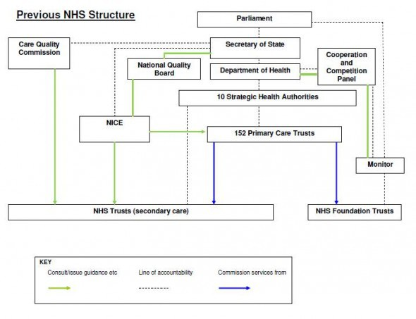
(Socialist Health Association, 2017)

APPENDIX B
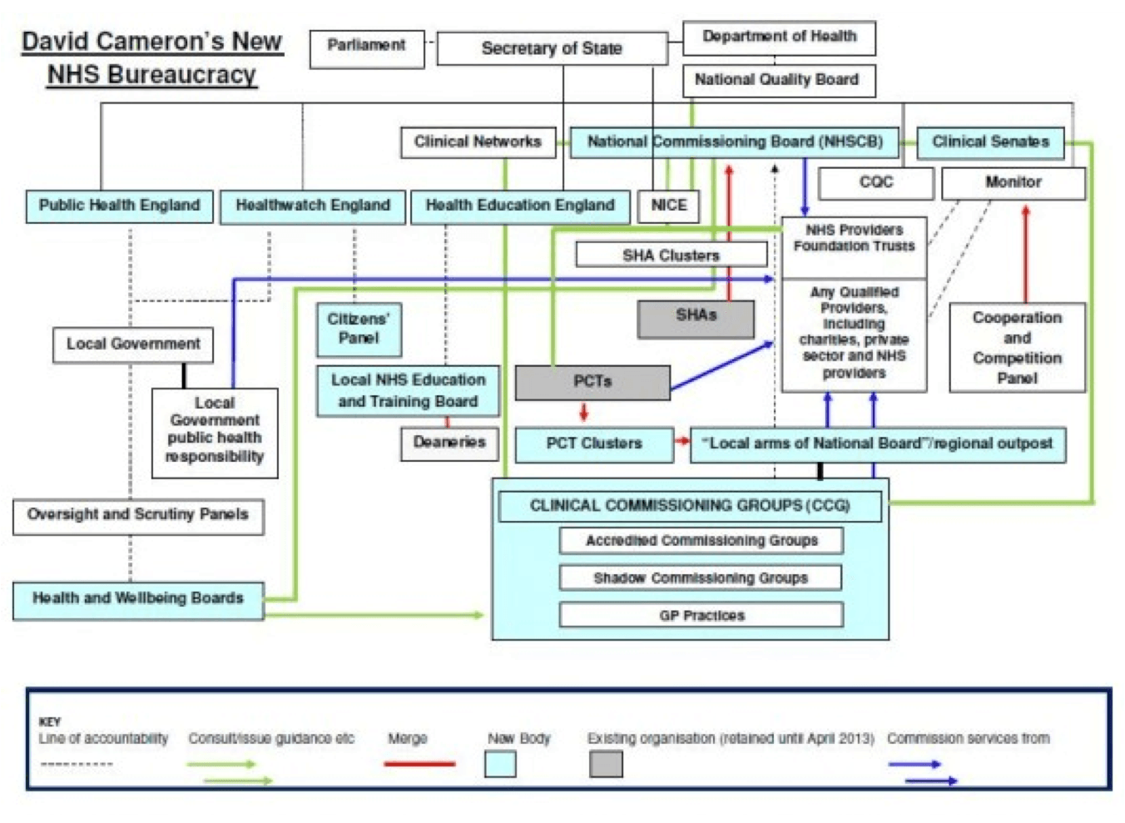
(Socialist Health Association, 2017)

Appendix C

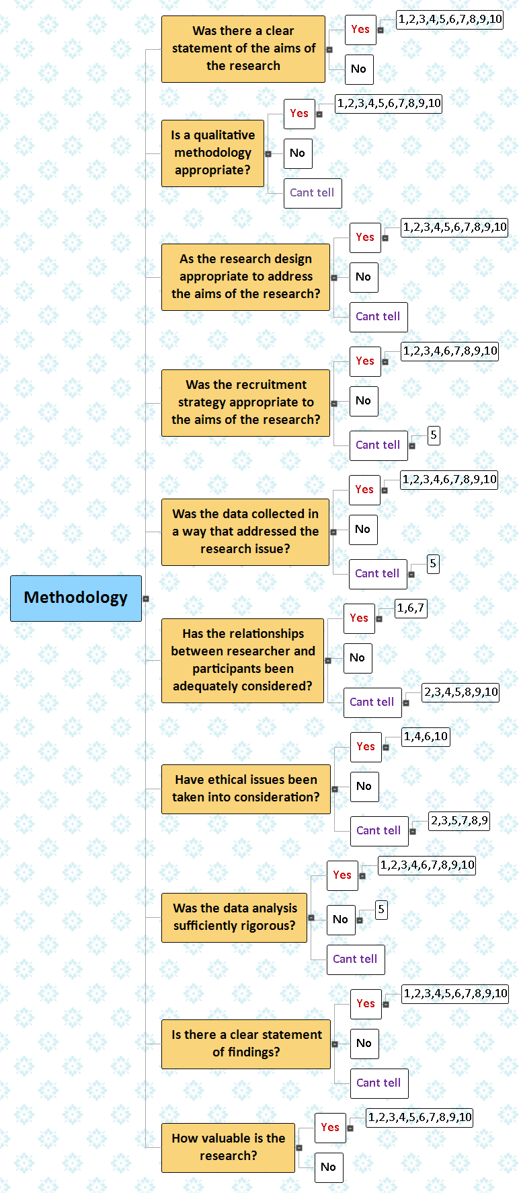

Appendix D
Column1 | Column2 | Column3 | Column4 | Column5 | Column6 | Column7 | Column8
 | 24/11/2017 | 08/12/2017 | 15/02/2017 | 01/03/2017 | 10/03/2017 | 12/03/2017 | 19/03/2017
Introduction
Chapter two
Chapter three
References
Bibliography
Proof reading
Finish/Hand in

References
(Baumeister & Leary, 1., Bem, 1. & Cooper, 2., 1997. Writing narrative literature reviews. Review of General. s.l.:s.n.
Anon., 2017. Cochrane.org. [Online]
Available at: http://consumers.cochrane.org/what-systematic-review
[Accessed 07 11 2017].
Anon., n.d. [Online]
Available at: https://healthcarebids.co.uk/bidmanagement/nhs-tendering-process-explained/
Anon., n.d. [Online]
Available at: https://healthcarebids.co.uk/bidmanagement/nhs-tendering-process-explained/
[Accessed 01 11 17].
Anon., n.d. Healthcare bids. [Online]
Available at: https://healthcarebids.co.uk/bidmanagement/nhs-tendering-process-explained/
[Accessed 02 11 2017].
BMJ, 2015. Nhs can perform well against the private sector without compromising its core values. British Medical Journal.
British Medical Journal, 2017. British Medical Journal. [Online]
Available at: http://www.bmj.com/content/339/bmj.b2700
[Accessed 19 11 2017].
CHPI, 2017. P.F.I. Profiting From Infirmaries, London: CHPI..
Denscome, M., 2003. The Good Research Guide. second ed. Maidenhead: Open University Press.
Drinkwater, M., 2011. Community Care. [Online]
Available at: http://www.communitycare.co.uk
El-Gingihy, Y., 2017. How the ‘humanitarian’ crisis in the NHS is paving the way for private healthcare. The Independent, 12 Jnuary.
Ewen Speed, J. G., 2013. The health and social care act 2012; The extension of 'new professionalism', Essex: Sage Publications Journal.
Fletcher, R., 1990. Competative tendering; a move for efficiency or an attack on the NHS?, Glasgow: Scottish Government Yearbook 1990.
Gardner, K., 2012. Tendering out general practice is bad for doctors- and patients, Liverpool: BMJ.
Jason Glynos, E. S. K. W., 2014. Logics of marginalisation in health and social care reform; integration, choice, and provider-blind provision, Birmingham: Sage Publications Journal.
Journal, British Medical, 2015. Any qualified provider; a qualitative case study of one community NHS trust's response, London: British Medical Journal.
Kath Checkland, S. H. S. S. I. M. A. C., 2012. Commissioning in the English National Health Service; whats the problem, Cambridge: Cambridge University Press.
Keith Gray, M., 2008. Non-Price competition in NHS secondary care contracting; empirical results, Emerald group publishing group: Emerald.
Kevin Morgan, M. M. A. R., 2017. Local economic development opportunitiesfrom NHS spending; evidence from Wales, Cardiff: Sage Publications Journal.
Kmietowicz, Z., 2013. NHS paid £95m to dismiss managers who were later re-employed. BMJ.
Lacobucci, G., 2013. Health department approves more than 100 private firms to run NHS services. BMJ.
Loader, K., 2017. Small - and medium sized enterprises and public procurement; A review of the UK coalition governments policies and their impact, York: Sage Publications.
McKenna, H., 2016. The Kings Fund. [Online]
Available at: http://www.kingsfund.org.uk
NHS, 2017. The History Of The NHS. [Online]
Available at: https://healthcarebids.co.uk/bidmanagement/nhs-tendering-process-explained/
[Accessed 01 11 2017].
Pauline Allen, D. O. S. A. C. N. P. E. G. L. W., 2017. Commissioning through competition and cooperation in the English NHS under the Health and Social Care Act 2012; evidence from a qualatative study of four clinical commissioning groups, London: BMJ.
Prince, M. et al., 2014. Dementia UK: Second edition – Overview, s.l.: Altheimers Society 2014.
Rebecca Kolins Givan, S. B., 2007. Workforce responses to the creeping privatisation of the UK National Health Service, London: Interbational Labor and Working Class History.
Socialist Health Association, 2017. Socialist Health Association. [Online]
Available at: https://www.sochealth.co.uk/national-health-service/griffiths-report-october-1983/national-health-service-management-in-the-1980s/
[Accessed 04 11 2017].
UK Government, n.d. Gov.uk. [Online]
Available at: https://www.gov.uk/government/uploads/system/uploads/attachment_data/file/283506/BriefingNoteDec13.pdf
[Accessed 12 nov 2017].
Weaver, M., 2003. PFI The issue explained. The Gaurdian, 15 January, p. 1.

Bibliography
(Baumeister & Leary, 1., Bem, 1. & Cooper, 2., 1997. Writing narrative literature reviews. Review of General. s.l.:s.n.
Anon., 2017. Cochrane.org. [Online]
Available at: http://consumers.cochrane.org/what-systematic-review
[Accessed 07 11 2017].
Anon., n.d. [Online]
Available at: https://healthcarebids.co.uk/bidmanagement/nhs-tendering-process-explained/
Anon., n.d. [Online]
Available at: https://healthcarebids.co.uk/bidmanagement/nhs-tendering-process-explained/
[Accessed 01 11 17].
Anon., n.d. Healthcare bids. [Online]
Available at: https://healthcarebids.co.uk/bidmanagement/nhs-tendering-process-explained/
[Accessed 02 11 2017].
BMJ, 2015. Nhs can perform well against the private sector without compromising its core values. British Medical Journal.
British Medical Journal, 2017. British Medical Journal. [Online]
Available at: http://www.bmj.com/content/339/bmj.b2700
[Accessed 19 11 2017].
CHPI, 2017. P.F.I. Profiting From Infirmaries, London: CHPI.
Denscome, M., 2003. The Good Research Guide. second ed. Maidenhead: Open University Press.
Drinkwater, M., 2011. Community Care. [Online]
Available at: http://www.communitycare.co.uk
El-Gingihy, Y., 2017. How the ‘humanitarian’ crisis in the NHS is paving the way for private healthcare. The Independent, 12 Jnuary.
Ewen Speed, J. G., 2013. The health and social care act 2012; The extension of 'new professionalism', Essex: Sage Publications Journal.
Fletcher, R., 1990. Competative tendering; a move for efficiency or an attack on the NHS?, Glasgow: Scottish Government Yearbook 1990.
Gardner, K., 2012. Tendering out general practice is bad for doctors- and patients, Liverpool: BMJ.
Jason Glynos, E. S. K. W., 2014. Logics of marginalisation in health and social care reform; integration, choice, and provider-blind provision, Birmingham: Sage Publications Journal.
Journal, British Medical, 2015. Any qualified provider; a qualitative case study of one community NHS trust's response, London: British Medical Journal.
Kath Checkland, S. H. S. S. I. M. A. C., 2012. Commissioning in the English National Health Service; whats the problem, Cambridge: Cambridge University Press.
Keith Gray, M., 2008. Non-Price competition in NHS secondary care contracting; empirical results, Emerald group publishing group: Emerald.
Kevin Morgan, M. M. A. R., 2017. Local economic development opportunitiesfrom NHS spending; evidence from Wales, Cardiff: Sage Publications Journal.
Kmietowicz, Z., 2013. NHS paid £95m to dismiss managers who were later re-employed. BMJ.
Lacobucci, G., 2013. Health department approves more than 100 private firms to run NHS services. BMJ.
Loader, K., 2017. Small - and medium sized enterprises and public procurement; A review of the UK coalition governments policies and their impact, York: Sage Publications.
McKenna, H., 2016. The Kings Fund. [Online]
Available at: http://www.kingsfund.org.uk
NHS, 2017. The History Of The NHS. [Online]
Available at: https://healthcarebids.co.uk/bidmanagement/nhs-tendering-process-explained/
[Accessed 01 11 2017].
Pauline Allen, D. O. S. A. C. N. P. E. G. L. W., 2017. Commissioning through competition and cooperation in the English NHS under the Health and Social Care Act 2012; evidence from a qualatative study of four clinical commissioning groups, London: BMJ.
Prince, M. et al., 2014. Dementia UK: Second edition – Overview, s.l.: Altheimers Society 2014.
Rebecca Kolins Givan, S. B., 2007. Workforce responses to the creeping privatisation of the UK National Health Service, London: Interbational Labor and Working Class History.
Socialist Health Association, 2017. Socialist Health Association. [Online]
Available at: https://www.sochealth.co.uk/national-health-service/griffiths-report-october-1983/national-health-service-management-in-the-1980s/
[Accessed 04 11 2017].
UK Government, n.d. Gov.uk. [Online]
Available at: https://www.gov.uk/government/uploads/system/uploads/attachment_data/file/283506/BriefingNoteDec13.pdf
[Accessed 12 nov 2017].
Weaver, M., 2003. PFI The issue explained. The Gaurdian, 15 January, p. 1.

