Application Development Assignment 2
Game Design
kieran perrin - PER09098703
Contents
Introduction/Project Proposal 2
Project Aims 2
Game Features 2
Design Limitations 2
Design 3
Characters 3
Player Spaceship 3
Enemy Aliens 3
Player Bases 3
Storyboards 3
Flowchart 6
Graphical Content 6
Animations 7
Sound and Music 8
Development 8
Running Demonstration 8
Testing 8
Failed test 10
Conclusion 12
Version 2 12

Introduction/Project Proposal
As part of the assignment, it is up to me to design and develop a game. The first part is to create an idea of what kind of game I would like to design and select a relevant platform and programming language to develop on.
I wanted to create a game that resembles space invaders, so a 2d arcade fixed shooter. With my current knowledge and understanding of programming languages, I chose to use App Game Kit to develop my game. I chose AGK(App Game Kit) due to its simplicity and ease of use.

Project Aims
The aim of this project is to have a functioning game that works similarly to the arcade game Space Invaders.

Game Features
When thinking of the features that should be included in my game I decided on the following:
- Title/Splash screen with play and instructions buttons.
- Instructions page telling the player how to play with a button to go to the title page
- Persistent high score to keep track of the users highest score.
- Score that keeps track of the users score while playing and putting that into the high score if the player beats the old high score.
- Lives that keep track on how many lives the player has.
- Game over screen that shows when player reaches 0 lives. Shows if the player reached a new high score and allows for the player to try again or go to the title screen.
- Player ship on the bottom of the screen that can move left and right (with animation) and shoot a laser at enemies. Only one player laser can be on the screen at a time.
- If the player laser hits an enemy, the enemy is destroyed.
- Rows of enemies that move across the screen(with animation) until they reach the edge then move down the screen a little and change direction.
- Enemies speed up a small amount every time they reach the edge of the screen.
- Enemies randomly shoot the player with a laser, only one enemy laser can be on the screen at one time. If the player gets hit by an enemy laser, they lose a life. The player ship is destroyed and put back in the starting position after a short pause.
- If the enemies reach the player, the game over screen is shown.
- If an enemy is killed, the score increases.
- 4 Bases along the screen above the player that can block the player and enemy lasers.
- If all enemies on the screen are destroyed, the wave counter increases, and a new wave of enemies are loaded onto the screen.
- The game will go on forever until the player has died
- The aim of the game is to beat your previous high score.

Design Limitations
One of the major limitations in the design and development of this game is the time constraint. Because the project needs to be completed by the assignment deadline, there can only be so much that can be created within that time frame. Because of this reason, some of the features I would have liked to add, will not be added.
Because the game I am making is a take on a pre existing IP(intellectual Property) there are possible restrictions on the artwork and even perhaps the mechanics of the game due to copyright laws. The way to make sure not to come across this is to use my own artwork and try to make the game feel different enough from the original.

Design

Characters
The game I am designing has multiple different characters that are on two sides of a conflict. On one side of the conflict is the character the player takes control of which is a spaceship. This spaceship is fighting against an invasion of aliens which are the other side of the conflict. The aliens are trying to invade a planet and take over.

Player Spaceship
The player spaceship is controllable by the player to move left and right and shoot a laser gun. The spaceship’s motivation is to push back the advances of the alien invasion. When the player presses the left or right arrow key, the spaceship can move in the that direction at a speed of 5 pixels per second. When moving, the spaceship has thrusters that flare until the ship comes to a stop.

Enemy Aliens
The alien’s motivation is to invade the planet and take over and to do this need to destroy the spaceship that is stopping them. There are 3 different types of aliens that are attacking. The aliens attack in a wave of 80 at a time with 4 rows of 16 aliens moving in unison. The aliens move across the screen 15 pixels at a time until they reach the border and change direction and get closer to the player. As the aliens move closer to the player, they speed up not by moving a larger distance but by moving the 15-pixel step at a more frequent interval. This interval is multiplied by 0.25 times every step closer to the player. The aliens can also shoot at the player, but only one alien can shoot at a given time.

Player Bases
The player bases are 4 small safe areas across the screen that are not movable in any way. These bases are invulnerable to laser shots, so it stops the player being able to shoot the enemy but also stops the enemy being able to shoot the player.

Storyboards
To make storyboards for the game design, I made a template and printed it out. I then hand drew the game out with the idea of how it would look and run with annotation underneath each drawing explaining what is happening in the drawing. Below are the storyboards I made: 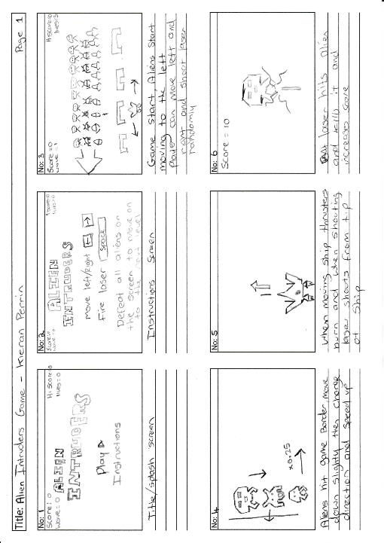
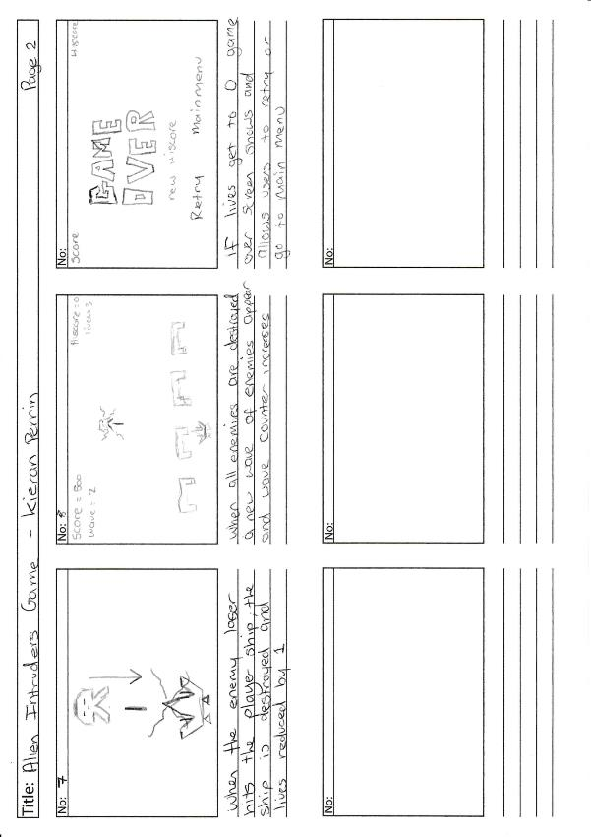

Flowchart
Below is a flowchart I made to go through the processes of the game.
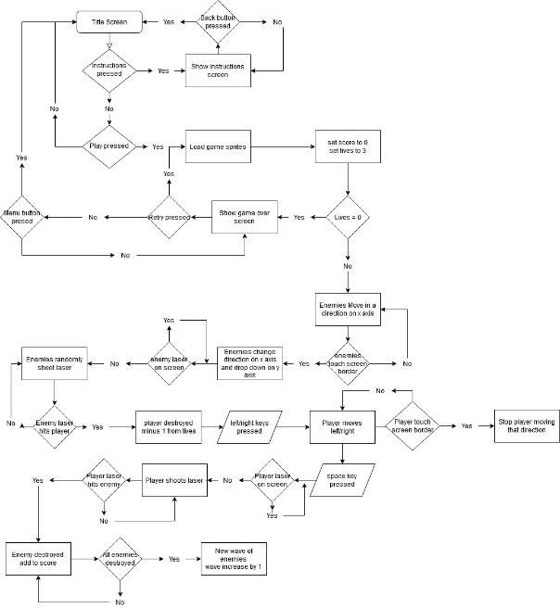

Graphical Content
All the graphics used in the game were made by me using photoshop. Some of the graphics resemble the original graphics of the space invaders game but I have made them different enough to be okay. For the text in the game, I downloaded a custom font which I have sent a request to be able to use and am waiting for a response. Below are the images of the graphics used in my game:
Top Alien

Middle Alien

Lower Alien
Player Base
Enemy Laser
Player Laser
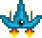
Player Ship

Title screen logo

Game over screen text

Animations
Some of the sprites in the game are animated to make them look like they are really moving. All the aliens are animated, switching between two different images as they move to give the illusion of them floating across the screen. The other animation is the player spaceship which has thrusters flare as the player moves the ship. This animation is done by using 5 images that slowly make the flame of the thruster bigger using a loop to cycle through each image. Below show these images next to each other in their progression through the animation:
Top Alien Animation

Middle Alien Animation

Lower Alien Animation
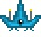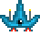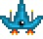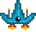
Player Spaceship Animation

Sound and Music
So far, the only sound being used in my game is that of a laser gun that is played whenever the player or the enemies shoots. I got this sound from a website that has a library of free sound effects that can be used in any commercial or non-commercial projects as long as they are credited by putting the URL to their website(freesfx.co.uk) in the project.

Development

Running Demonstration
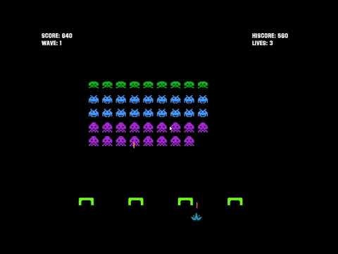

Testing
Test Description |  | Game Menu system works
Preconditions |  | Game installed on the user’s system
Step | Procedure |  | Expected Result | Actual Result
1 | Title screen shows |  | When the game starts the game title screen should be shown. The title logo, play button and instruction button should be loaded along with the score, high score, wave and lives text. | Works as expected.
2 | Instructions button pressed |  | Play button and instruction button made invisible and instructions image and back button shown. | Works as expected.
3 | Back button pressed |  | Instructions image and back button made invisible and play and instructions button shown. | Works as expected.
4 | Play button pressed |  | The title logo and play button and instructions button made invisible. Wave set to 1 and lives set to 3. Enemies, bases and player loaded onto screen. | Works as expected.
Test Description |  | Gameplay loop works
Preconditions |  | Play button pressed
Step | Procedure |  | Expected Result | Actual Result
1 | Game sprites loaded |  | All 80 enemies, 4 bases and player spaceship load onto screen. | Works as expected.
2 | Enemies move |  | All enemies after loading in start to move to the left on the x axis until they reach the side of the screen. | Works as expected.
3 | Enemies change direction |  | Once enemies reach edge of screen, they change direction and move down by 10 pixels. Enemies also speed up by 0.25 pixels per second. | Works as expected.
4 | Enemies shoot |  | A random enemy will shoot a laser downwards if there is not already an enemy laser on the screen and if the enemy is still alive. | Works as expected.
5 | Left Key pressed |  | Player spaceship moves to the left at a speed of 5 pixels per second. The spaceship thrusters animate while moving and stop when the spaceship stops moving. | Works as expected.
6 | Spaceship reaches the edge of screen |  | Spaceship is stopped from moving off the screen. | Works as expected.
7 | Right key pressed |  | Player spaceship moves to the right at a speed of 5 pixels per second. The spaceship thrusters animate while moving and stop when the spaceship stops moving. | Works as expected.
8 | Spacebar pressed |  | If there is not a player laser on screen already the laser will shoot out the top of the player spaceship and move upwards at a speed of 8 pixels per second. | Works as expected.
9 | Laser hit base |  | If a laser hits any of the bases the laser is stopped and disappears. | Works as expected.
10 | Enemy destroyed |  | If a player laser hits an enemy, that enemy is destroyed, and player score is increased | Works as expected.
12 | Player destroyed |  | If an enemy laser hits the player spaceship, the spaceship is destroyed and put back to it is starting location. Player lives are reduced by 1. | Works as expected.
13 | Enemy wave all destroyed |  | IF all the enemies on the screen are destroyed, the wave increases by 1 and a new set of enemies will load in the starting location and start moving and shooting. | Works as expected.
14 | Enemies reach the bottom of screen |  | Game stops and game over screen shows. | Failed, game over happens too soon.
15 | Player lives reach 0 |  | If the player lives reduce to 0 the game stops and the game over screen is shown. All sprites onscreen are deleted. Game over sprite, retry button and main menu button are shown. | Works as expected.
16 | Score higher than high score |  | New high score text shown on game over screen and the new score is saved in high score. | Works as expected.
17 | Retry Pressed |  | The game over sprite, retry button and main menu button are removed and score is set to 0, lives set to 3 and wave set to 1. Game starts from the start. | Works as expected.
18 | Main menu pressed |  | The game over sprite, retry button and main menu button are removed and title screen logo, play button and instructions button are shown. | Works as expected.

Failed test
The test that failed was in the game play loop. When the aliens reach the players level on the game is when the game is supposed to go to game over. The game enters game over way too early when the enemies reach a point higher above the player than intended.
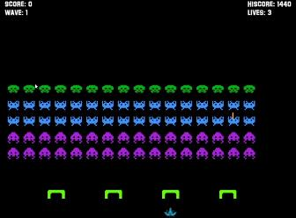
Level the enemies cause game over
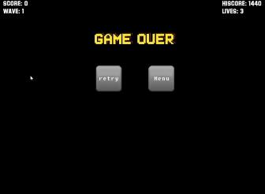
Game over right after the enemies reach the level above

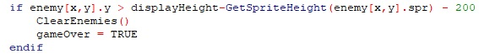
Code causing the enemies to stop the game too high

Code that fixes the problem

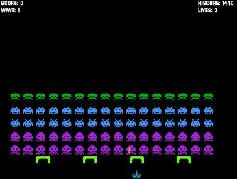
Proof of the fix

Conclusion
Overall, I find the process of developing this game has been an interesting one. As someone who has never done game design before and never using the AGK language I found it a challenge which is why I chose to recreate a game that already existed and I had familiarity in how it worked. To create this game, I had to learn game design techniques such as storyboarding and making a flowchart, which I found rather easy to pick up. I then had to learn how to use AGK and write code using its language. Because I have done a fair amount of programming previously, I had an idea on how to code the game using loops and if statements etc which are standard in coding but I also had to learn how the game engine worked. To learn this I found the AGK guide website to be helpful, anything I needed to understand how to do, it had it on there such as loading sprites, collision detection and adding buttons on the screen via virtual buttons. Because I had the learning curve, I found myself not adding some of the features I would have liked to add but they could be added if I were to make a version 2.

Version 2
As I said some features did not make it into the game because of technical knowledge or time constraints. If I had the time or knowledge, I would add the following features:
- When enemies shoot, only the lowest enemy in that column will shoot.
- Flying saucer will fly across the top of the screen at random times to give the player large amount of points.
- The game gets harder after every wave either by the enemies shooting more or moving faster.
- Bases can have incremental damage by the player and enemy lasers so lasers can be shot through them.
- Adding a way for the player to have power ups to increase laser fire rate or adding lives.

