

Task 1 – Reading Task Template
Upload your photo of your A3 in-class notes here:
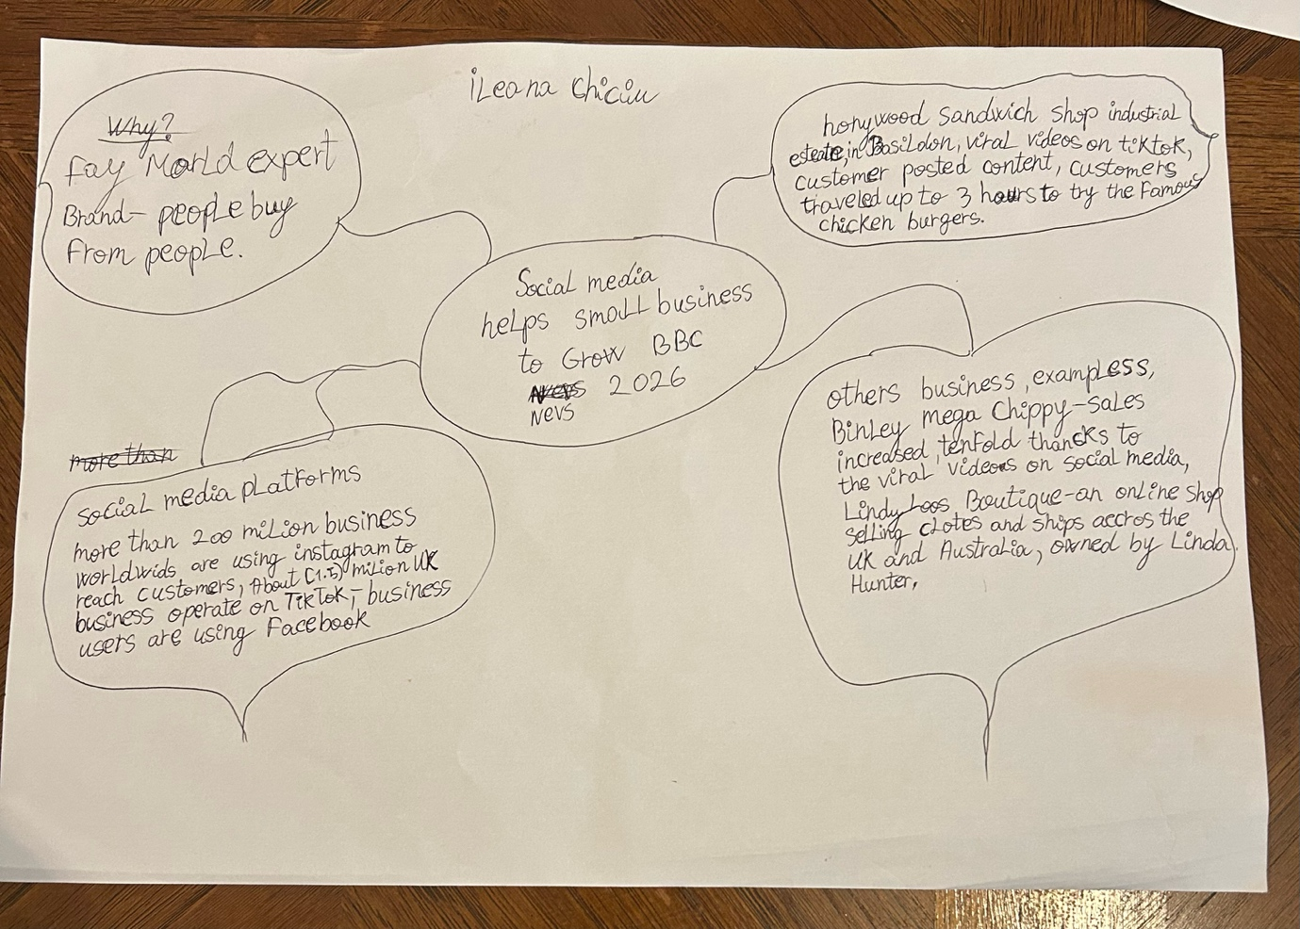

1. Answer these questions using the sentence starters below
a. What is the main idea of the text?
The main idea: A sandwich shop in basildon become popular
after customers shared of its food on tiktok, attracting people From a long distance.
b. What are two key points? One key point, is that customers have travelled for several to try the shop’s famous chicken burger.

Another key point , is that social media, especially Tik-Tok, helped the business grow by spreading customer videos online.
c. What part of the text did you find most important? Why?
The most important part, is how customers posts on tiktok increased the shop’s popularity because it shows the power of social media in helping small businesses to grow
d. Was anything unclear or difficult to understand?
I was not sure about this
e. How did your group help you understand the text better?
I was on my own
3. One sentence reflection
was many but not sure which one to say
Question: What did you find challenging about this task?
The hardest part was , how to upload the assessment on the right place.

