Student Name: Subhan Mohammed
Student ID: 2527096
Course name: CertHE Computing Skills for Workplace
Module name: Computer Architecture and Operating Systems
Module code: ACCA4022
Assignment title: Operating Systems Assignment

Contents
Introduction 3
Task 1 – Key functions of general operating systems: 4
Task 2 – Use of Windows OS CLI commands: 9
Task 3 – Use of Linux OS CLI commands 19
Task 4 – Use of Windows OS scripts 23
Task 5 – Use of Linux OS scripts 27
Linux unhatched badge: 31
IEEE References list: 32

Introduction

In this report, I will be talking about the key functions of general operating systems, use of Windows OS CLI commands, use of Linux OS CLI commands, use of Windows OS scripts, and use of Linux OS scripts in computing with detail and screenshots. In Task 1, I have included the Key functions of general operating systems with examples such as Task Manager, Add or Remove Programs, File Explorer, Device Manager, and Windows Security, with screenshots and benefits of them all, including the references. Using both Linux and Microsoft Windows, this project examines a variety of fundamental operating system ideas and useful system administration techniques. Gaining a grasp of how operating systems facilitate user interaction, manage hardware and software resources, and support application execution is the aim of this project. System information is examined, files are managed, network connectivity is monitored, user accounts are examined, and system configuration is analysed using a range of built-in Windows tools and PowerShell commands throughout the evaluation. Additionally, by writing straightforward scripts that make use of variables, user input, arithmetic operations, and control structures like loops, Linux Bash scripting is used to illustrate automation. To show how each activity was completed successfully, screenshots and explanations are given. By finishing these tasks, the assignment shows that you have a practical understanding of command-line administration, operating system capabilities, and fundamental scripting approaches. These abilities are essential for IT workers because they allow them to effectively manage computer systems in various operating system environments, automate tedious operations, and troubleshoot systems.

Task 1 – Key functions of general operating systems:

Software platforms known as general-purpose operating systems (OS) control computer hardware and offer services to users and applications. Canonical Ubuntu Linux, Apple macOS, and Microsoft Windows are examples of popular operating systems. Despite their different designs, they perform many of the same crucial tasks. Through effective CPU time allocation, process management enables the operating system to run numerous applications concurrently. The operating system prioritises processes, schedules tasks, and keeps apps from interfering with one another. The distribution of Random Access Memory (RAM) among programs is managed via memory management. It prevents software from accessing memory allocated to other processes while ensuring that each application has enough memory to operate. When physical RAM runs out, modern operating systems also make use of virtual memory (1).

- Task Manager app

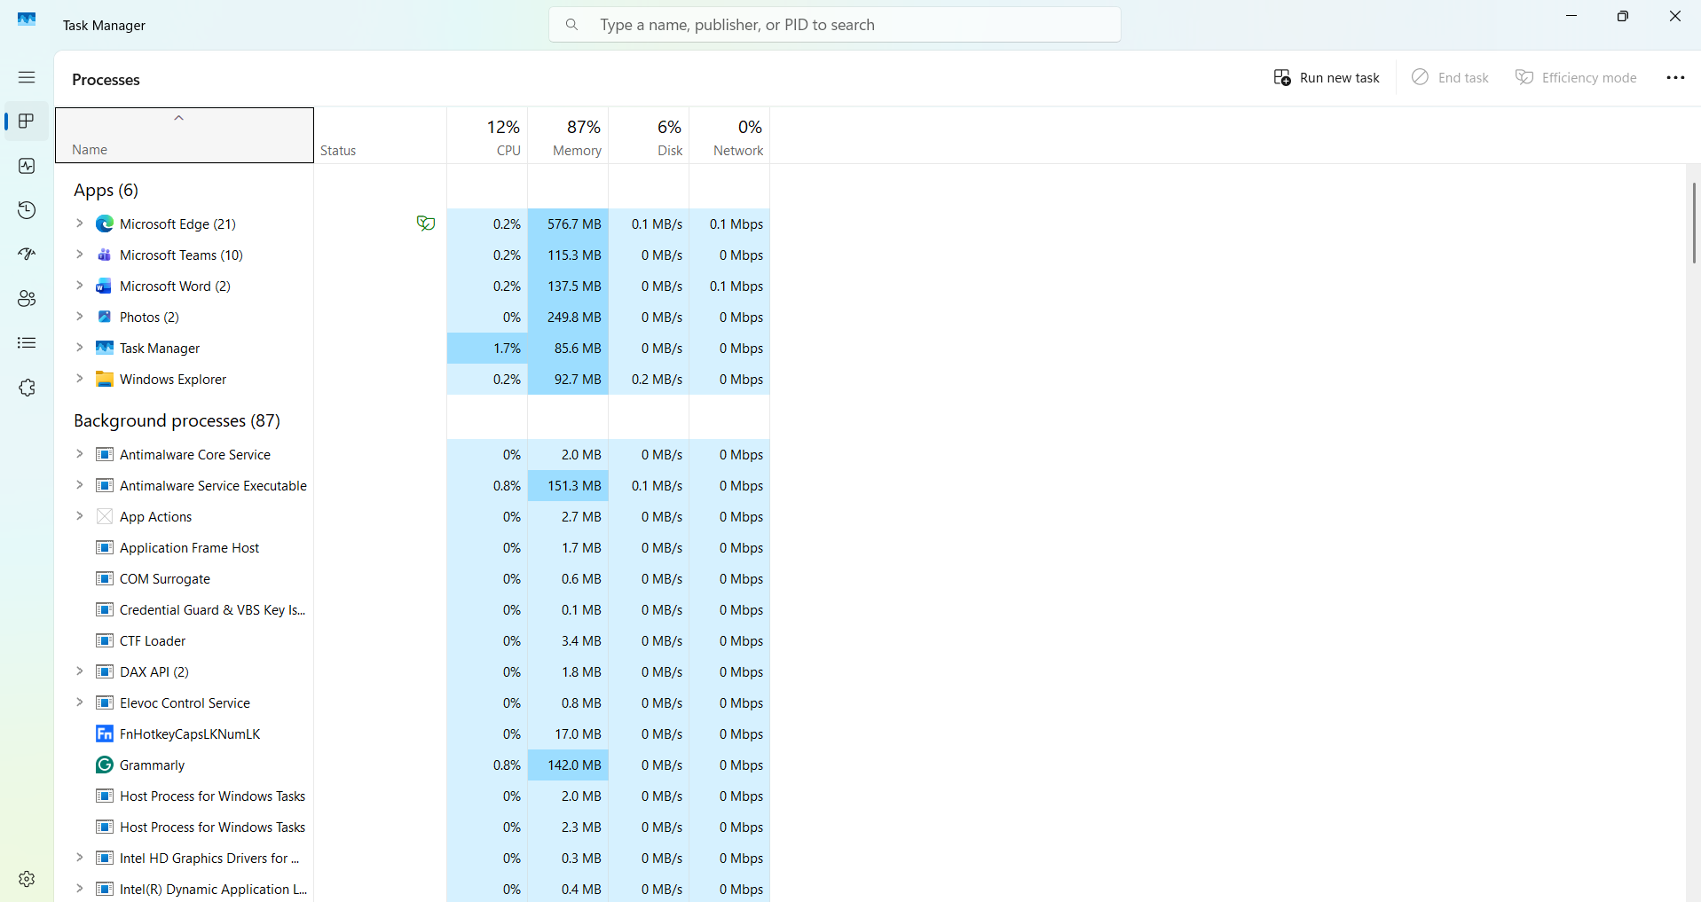
Windows Task Manager is an integrated tool that lets users manage open apps, keep an eye on system performance, and diagnose computer issues. One of its main functions is monitoring running processes. This is when it shows every running Windows service, background process, and application. It also displays the amount of CPU, RAM, disk, network, and GPU utilised by each process. Furthermore, it enables users to spot applications that are consuming too many system resources. Task Manager is a crucial Windows tool that allows users to evaluate system resource utilisation, control launched programs, monitor performance, manage applications and processes, and troubleshoot performance issues. It offers up-to-date data that helps keep the operating system stable and effective (2).

- Add or remove programs
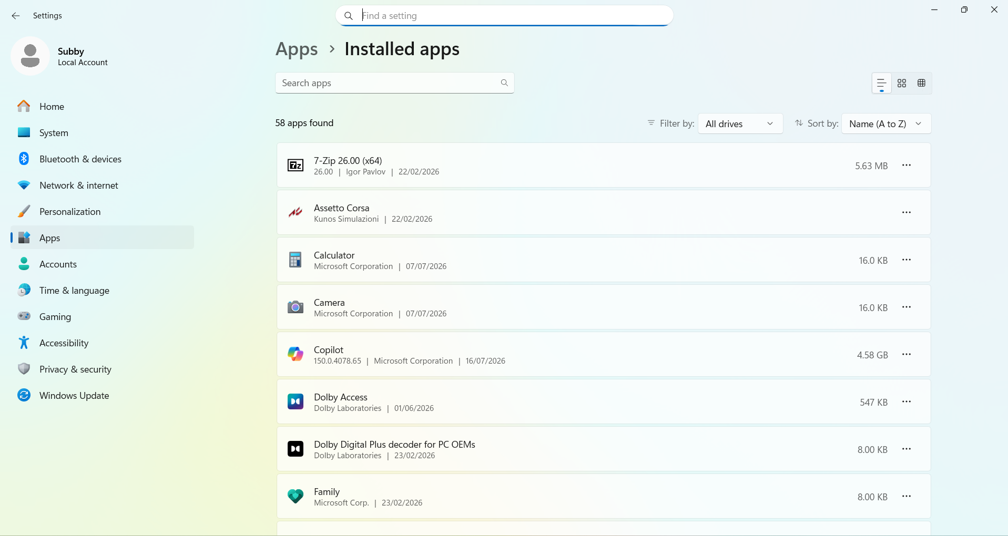
Software management is one of a general-purpose operating system's primary features. The Add or Remove Programs function (referred to as Apps & Features in Windows 10 and Windows 11) enables users to install, update, repair, and remove software. This feature assists users in controlling the software that is installed on the computer, freeing up storage space by deleting unnecessary programs, and troubleshooting issues by fixing or restarting certain programs. Users can use the Control Panel → Programs and Features or Settings → Apps → Installed Apps (or Apps & Features) to access this capability. Along with details like the application name, publisher, installation date, and storage capacity, the operating system shows a list of installed programs. If the program allows it, users can choose to change or remove an application. By enabling the removal of superfluous software, lowering storage utilisation, and minimising program conflicts, this feature enhances system performance. By allowing users to remove out-of-date or potentially dangerous apps, it also improves system security. This feature, which offers a central area for software administration, is integrated with both traditional desktop programs and Microsoft Store applications in modern versions of Windows (3).

- File Explorer
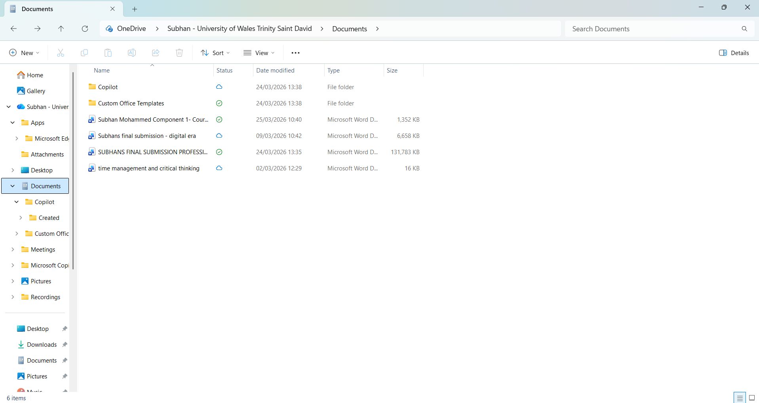
Organising, accessing, and managing files and folders on local drives, external storage devices, and network locations is made possible by File Explorer, a fundamental component of the Windows operating system. Creating, copying, moving, renaming, deleting, and searching for files and folders are all made easier by its graphical user interface (GUI). Additionally, File Explorer lets users manage storage devices, check file properties, alter folder layouts, and compress files into ZIP folders. Using their names, types, or dates, users can easily find documents, photos, videos, and other files using the search tool. Users can also alter permissions on files and folders as needed, pin commonly used folders to Quick Access, and customise folder displays. By offering a straightforward method of navigating the computer's file system, this feature promotes productivity and is crucial for effective data organisation. Additionally, File Explorer allows users to synchronise and view files across different devices by integrating with cloud storage services like OneDrive. The operating system enhances usability while preserving control over data organisation and storage by offering an easy-to-use file management interface (4).

- Device Manager
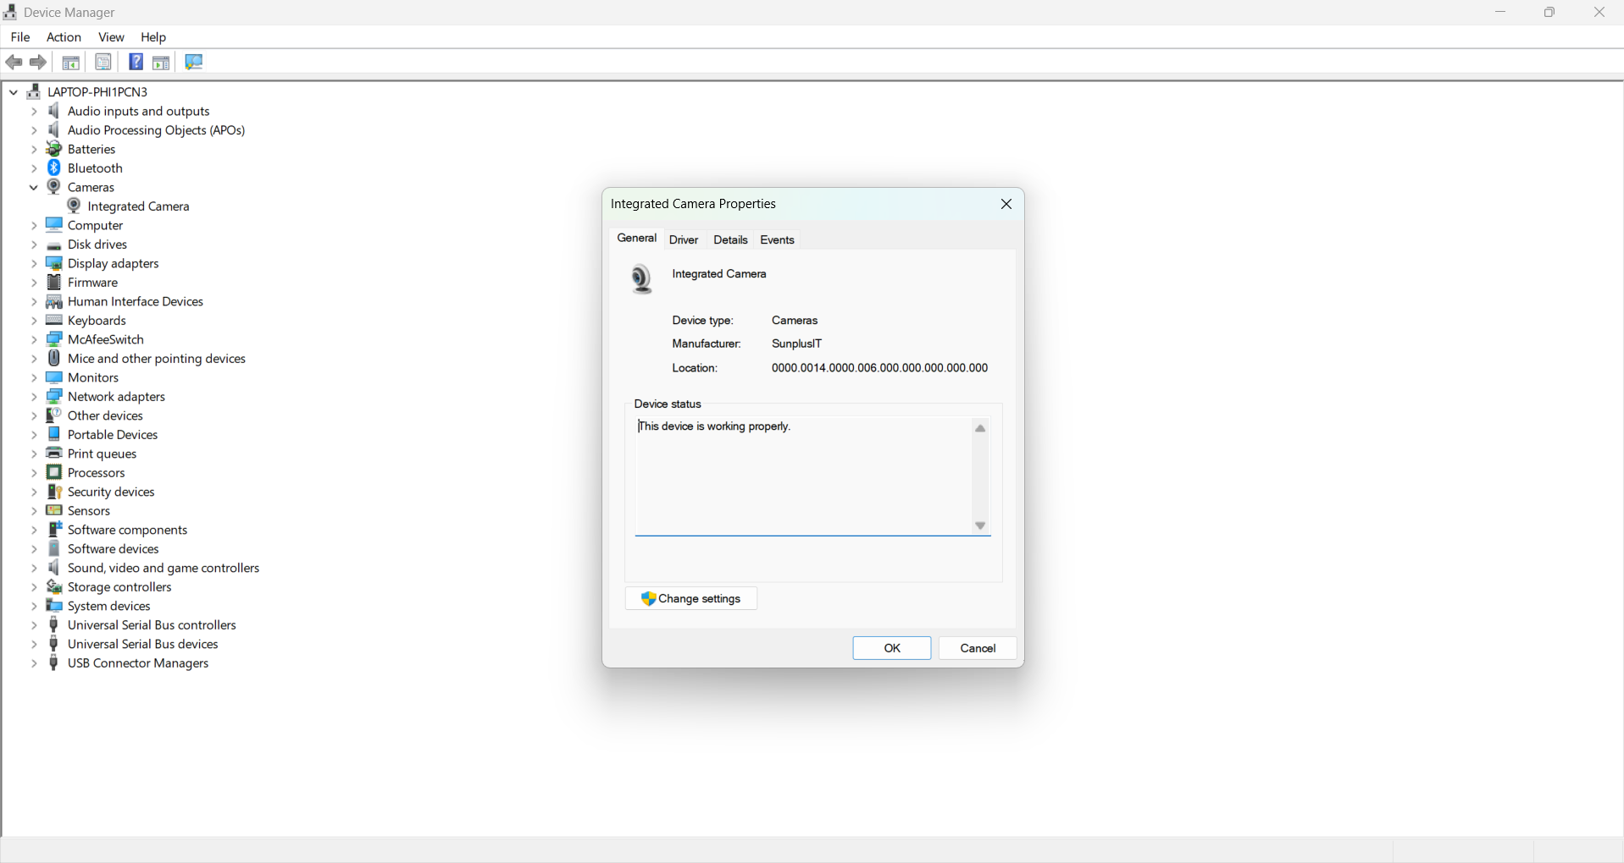
A built-in Windows tool called Device Manager lets users see, keep an eye on, and control the hardware devices that are connected to a computer. Processors, disk drives, display adapters, network adapters, keyboards, printers, USB devices, and audio gear are just a few of the components for which it offers comprehensive information. Device Manager is used by the operating system to make sure that hardware devices are properly communicating with the right device drivers. To fix hardware problems or enhance compatibility, users can update, roll back, deactivate, enable, or uninstall device drivers using Device Manager. Additionally, when a device is malfunctioning or a driver is missing or corrupted, the application shows warning symbols, such as a yellow exclamation point. Because of this, Device Manager is a crucial troubleshooting tool for identifying hardware issues and preserving system stability. Device Manager assists the operating system in ensuring effective communication between software and hardware by controlling hardware resources and device drivers. Updating device drivers can boost security, facilitate support for new hardware features, and improve system performance (5).

- Windows security
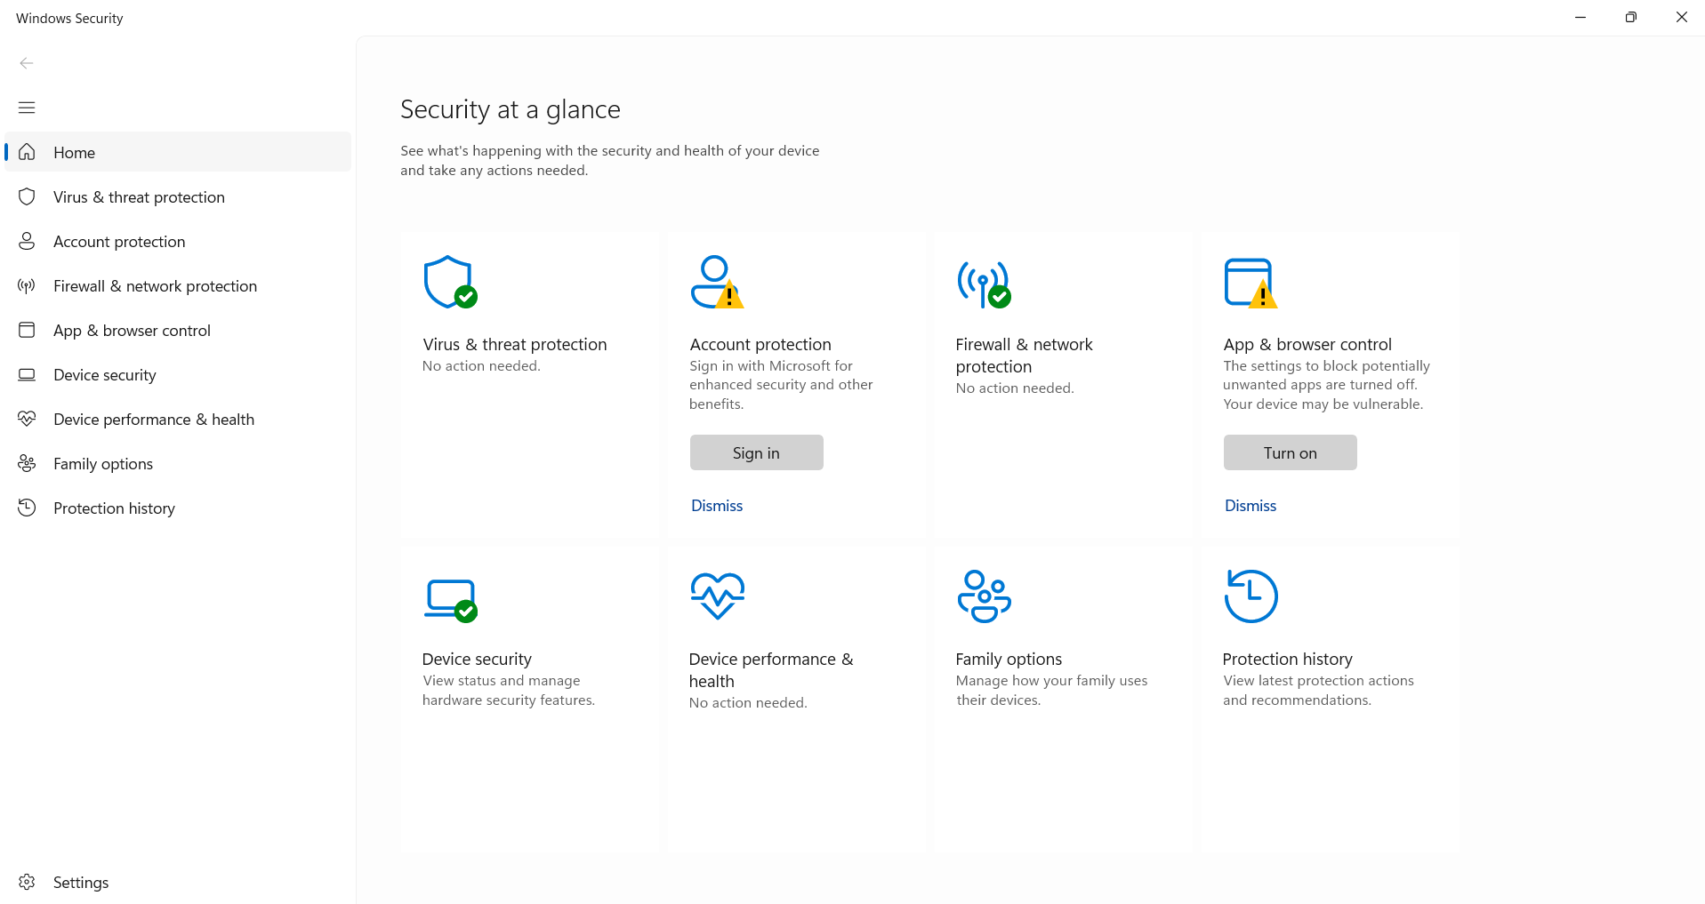
The operating system is shielded from viruses, malware, ransomware, and other online dangers by Windows Security, an integrated security program. Microsoft Defender Antivirus, Firewall and Network Protection, Account Protection, Device Security, App and Browser Control, and Virus and Threat Protection are just a few of the security functions that are integrated into one UI. Together, these features protect user data and the machine. Through real-time scans, file checks, and suspicious activity detection, the operating system continuously searches the system for possible security threats. Additionally, users may adjust firewall settings, configure ransomware protection, examine protection history, and run quick, full, or custom malware scans. Security intelligence updates are routinely applied to Windows Security to identify newly identified threats and enhance security. Windows Security uses features like Windows Hello, safeguard Boot, and device encryption (on compatible devices) to assist in safeguarding user accounts in addition to protecting against malware. These security features lessen the possibility of hostile assaults and unauthorised access while preserving the availability, confidentiality, and integrity of system resources (6).

Task 2 – Use of Windows OS CLI commands:

Command Prompt (CMD) and PowerShell are two robust command-line interfaces offered by Windows that let users and system administrators carry out a variety of administrative operations effectively. Command-line tools, in contrast to graphical user interfaces (GUIs), enable users to carry out commands rapidly, automate tedious activities, and more precisely manage system resources (7). Process monitoring and control, file and directory management, network configuration, user account administration, and automated task scheduling are all possible with Windows CLI commands. This section shows how the Windows command-line interface facilitates efficient system management and automation through the practical application of twelve Windows Batch and PowerShell commands, together with pertinent parameters and switches (8).

Example 1 – Command tasklist:
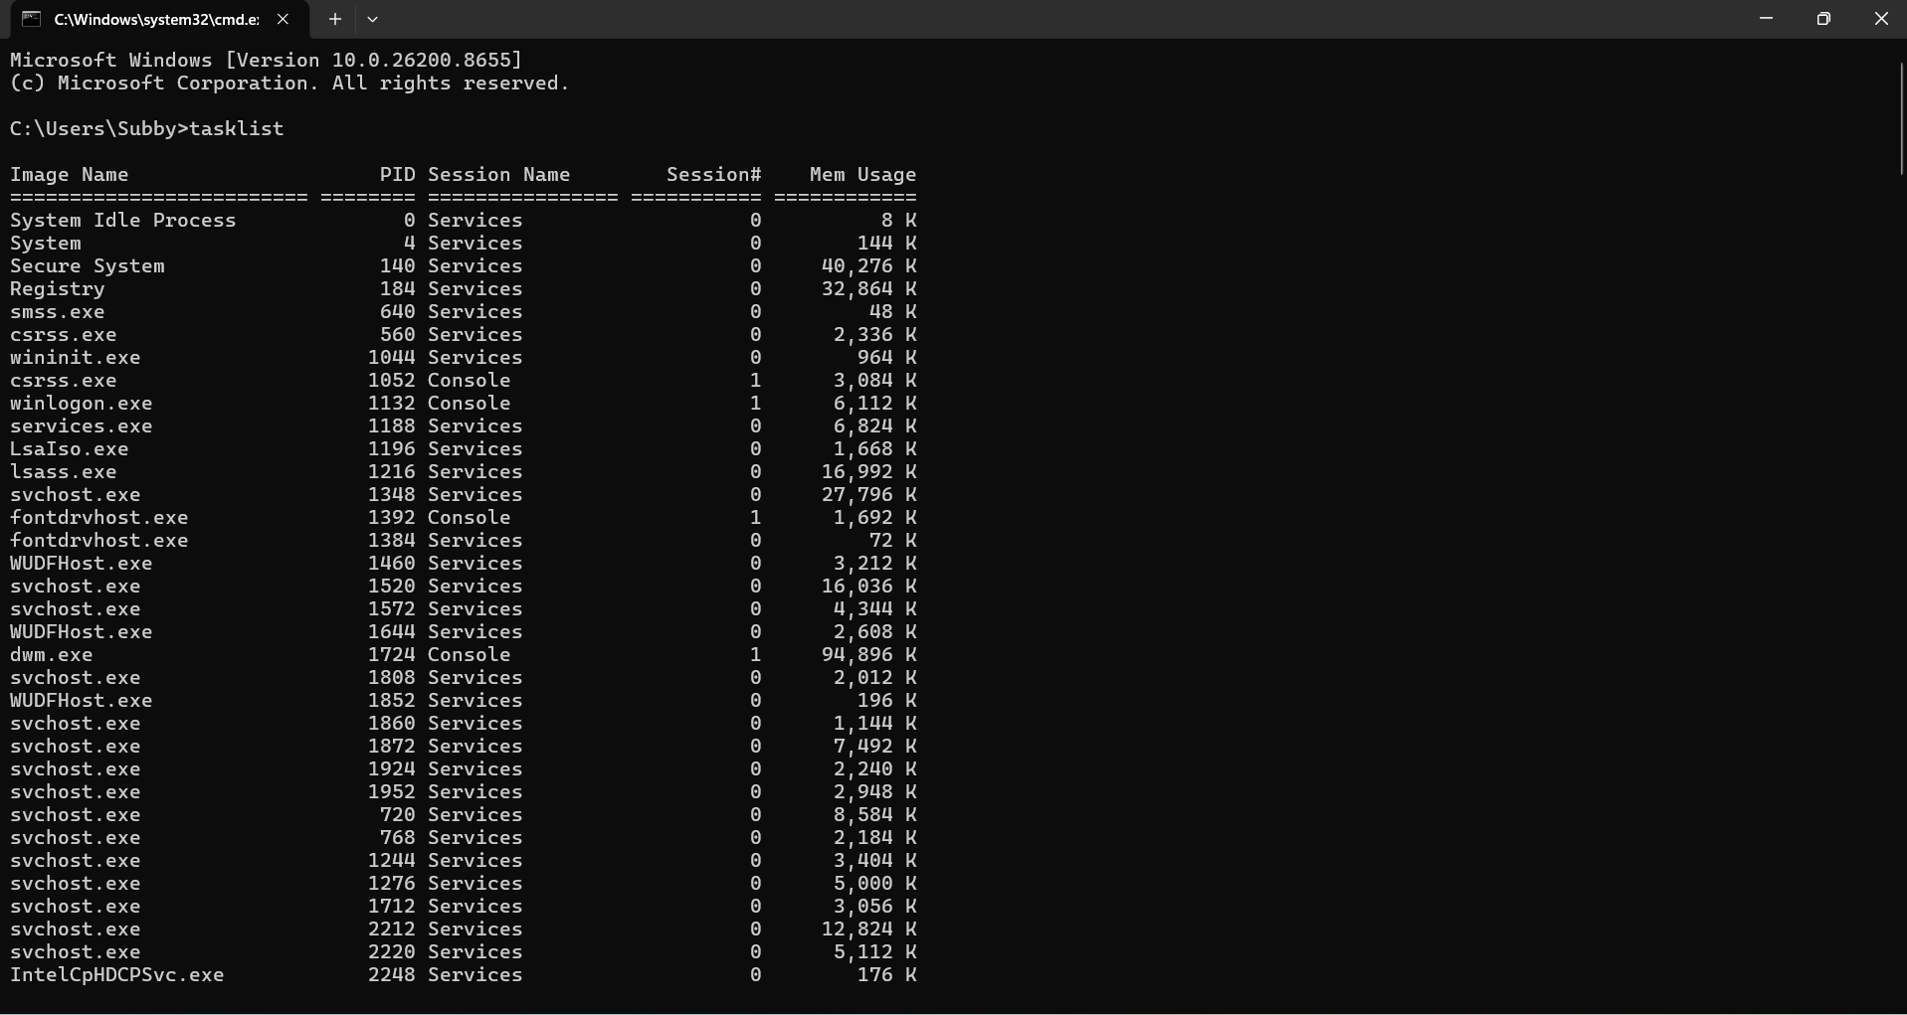
The tasklist command at the Windows Command Prompt was successfully executed, as seen in the screenshot. To see every process that is active right now on the Windows operating system, use the tasklist command. It offers comprehensive details on every process, such as the Image Name (process name), Process ID (PID), Session Name, Session Number, and Memory Usage. System, Registry, wininit.exe, services.exe, lsass.exe, and many copies of svchost.exe are among the crucial Windows system programs that are shown in the screenshot. Additionally, the output shows how much memory each process is using, which aids managers in identifying resource-intensive programs and keeping an eye on system performance (9).

Example 2 – command dir:
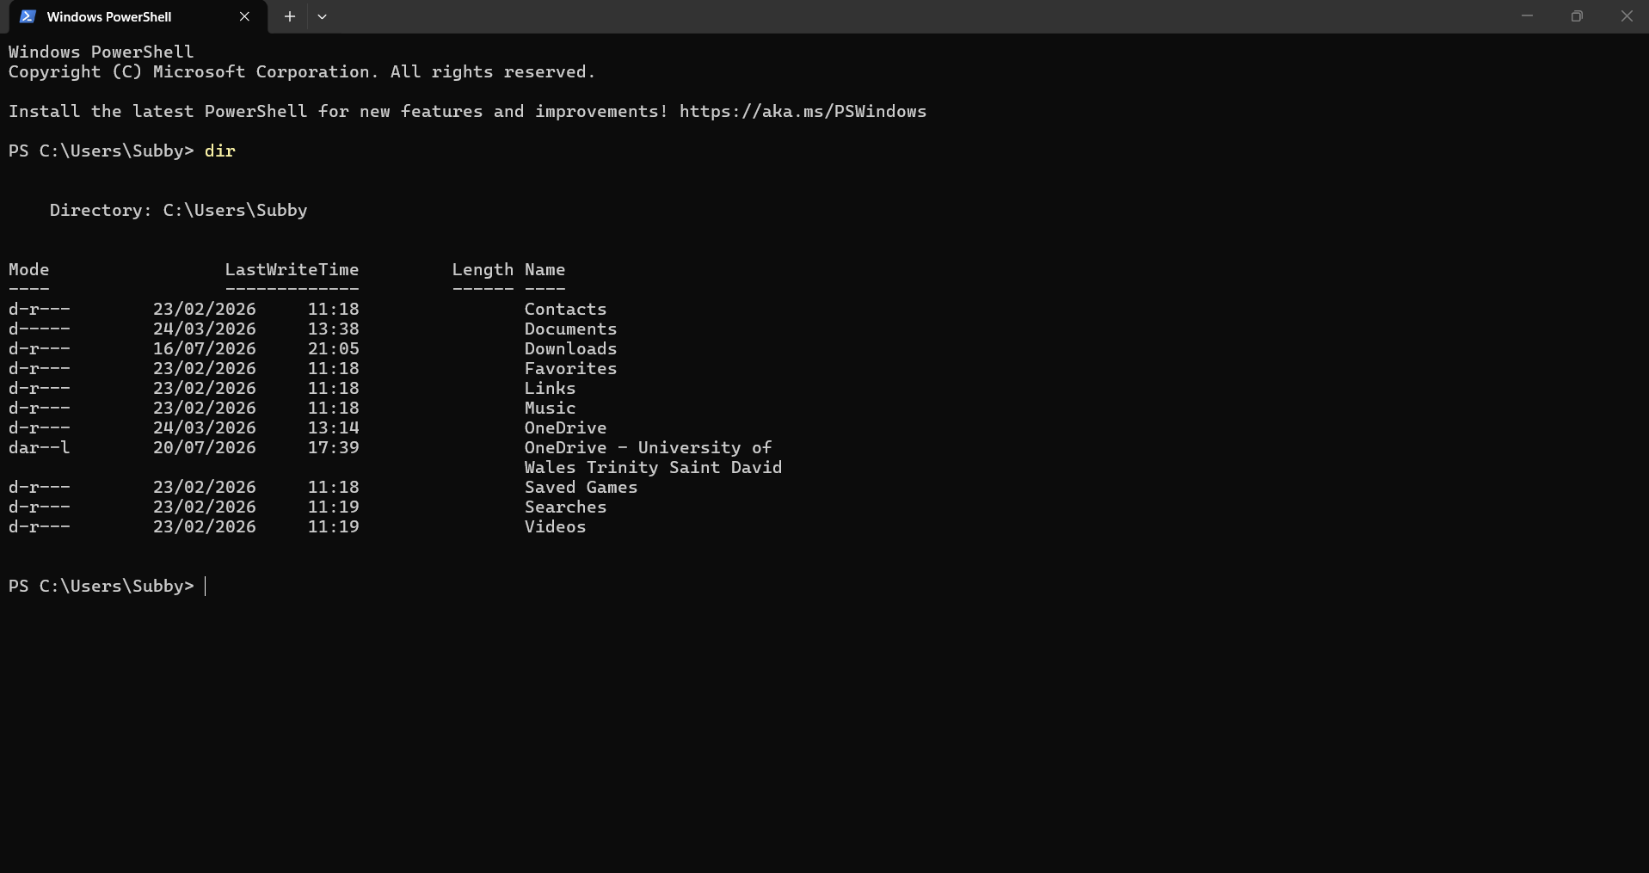
The screenshot demonstrates the successful execution of the dir command in Windows PowerShell. The dir command is used to display the contents of the current directory, including files and folders. It offers helpful details like the name of the file or folder, the time and date of the last modification, the size (for files), and characteristics that show if an object is a file or a directory. In this example, the command lists the contents of the C:\Users\Subby directory. Contacts, Documents, Downloads, Music, OneDrive, Saved Games, Searches, and Videos are among the visible folders. The result also includes the LastWriteTime column, which displays when each folder was last edited and the Mode column, which identifies the type and attributes of each item. System administrators and regular users utilise the dir command, a crucial file and directory management tool, to swiftly discover files or folders, browse the Windows file system, and confirm the contents of directories. PowerShell is especially helpful for scripting and command-line automation since it offers a quicker and more effective way to examine and manage directory contents than File Explorer (10).

Example 3 – command mkdir TestFolder:
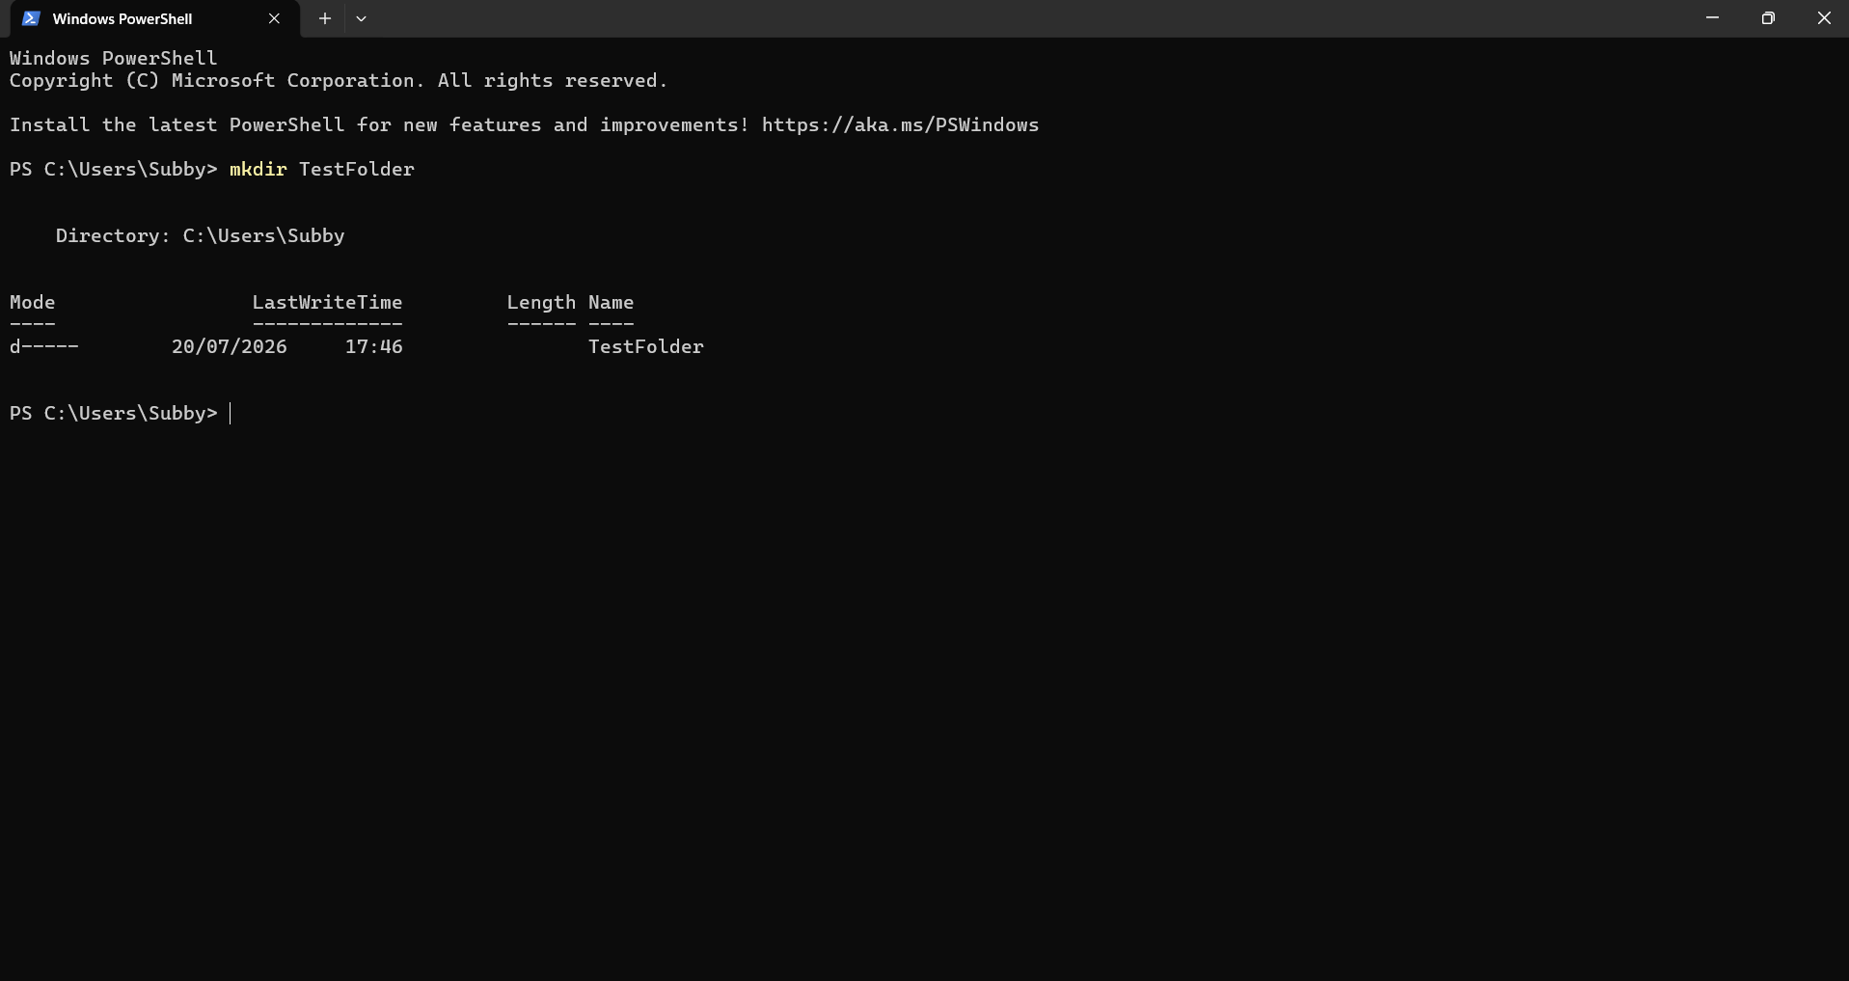
The screenshot demonstrates how the mkdir (Make Directory) command in Windows PowerShell was successfully executed. To create a new directory (folder) at the current working location, use the mkdir command. One of the most often used commands for managing files and directories, it enables users and system administrators to arrange files and make folders to store documents, programs, or backups. The command mkdir Test Folder in this example creates a new folder called Test Folder in the C:\Users\Subby directory. The newly formed folder's Mode (directory properties), LastWriteTime (the date and time the folder was created), and Name (Test Folder) are all immediately shown by PowerShell once the command is run. The successful creation of the directory is confirmed by the lack of any error messages. In Windows system administration, the mkdir command is frequently used to organise project folders, prepare directory structures before transferring or saving files, and automate file management activities with scripts. This command shows how the Windows command-line interface is a crucial tool for command-line administration and automation since it can effectively complete activities that would otherwise need several steps using the graphical File Explorer (11).

Example 4 – command ipconfig/all:
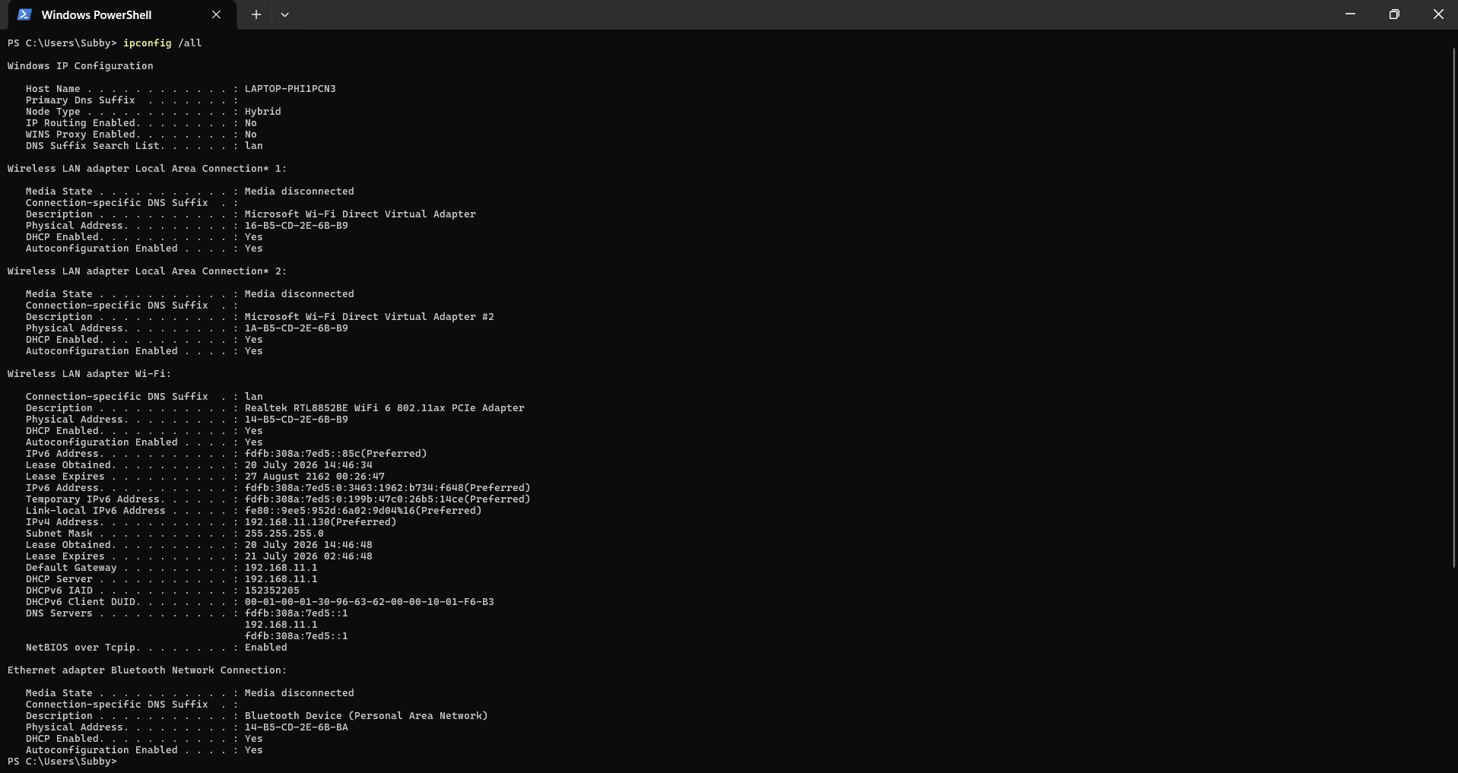

The screenshot demonstrates the successful execution of the ipconfig /all command in Windows PowerShell. For every network device that is installed on the computer, the ipconfig /all command shows comprehensive network setup details. It is a crucial command for network testing and monitoring, assisting system administrators and users in confirming network configurations and resolving connectivity problems. The output in this example shows data for many network adapters, such as Bluetooth and wireless LAN adapters. Important network information for the active Wi-Fi connection is provided by the command, including the IPv4 and IPv6 addresses, subnet mask, default gateway, DHCP and DNS servers, and the physical (MAC) address of the network device. Additionally, the output displays lease details for the provided IP address and indicates whether DHCP is enabled. Other adapters that aren't connected right now are labelled "Media disconnected," meaning they're installed but not in use. To troubleshoot network issues, confirm IP address assignments, validate DNS and gateway settings, and make sure a device has received the proper network configuration, the ipconfig /all function is frequently utilised. The /all switch is a useful tool for troubleshooting and managing Windows network connections via the command line since it offers far more detailed information than the conventional ipconfig command (12).

Example 5 – command ping google.com:

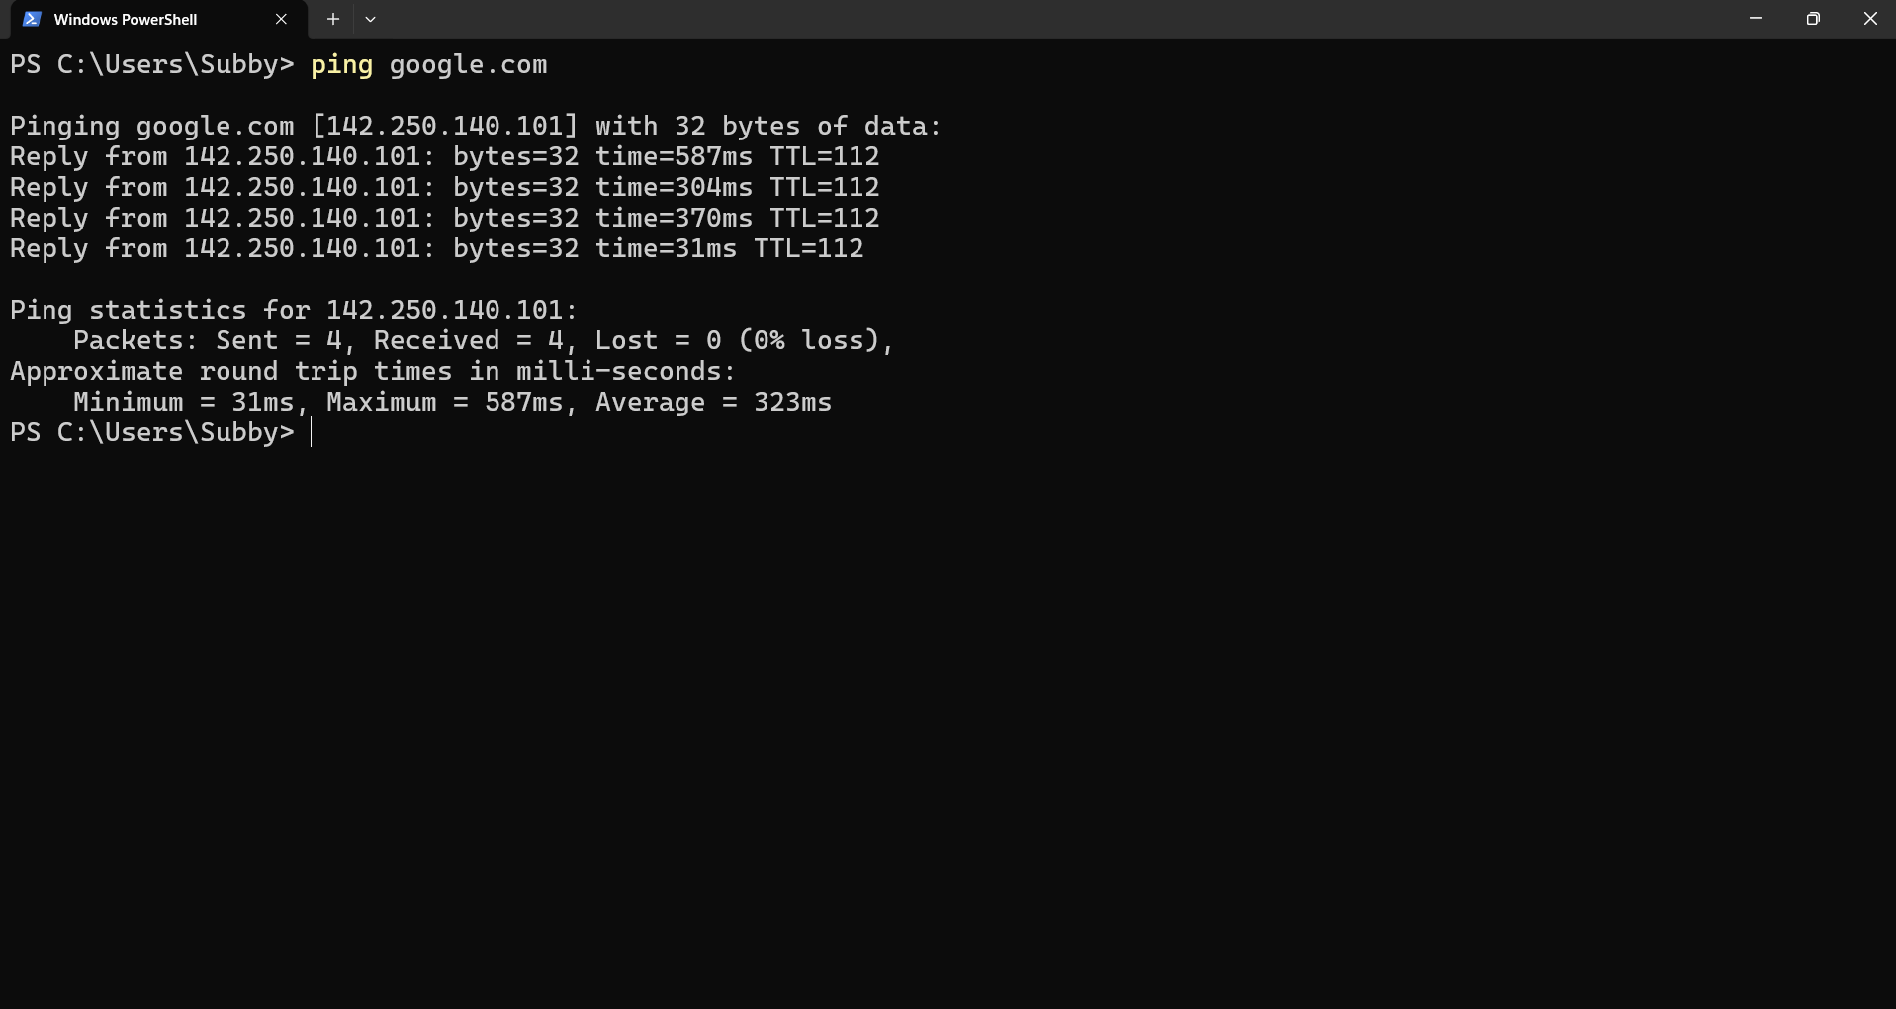
This screenshot shows how to test network connectivity between the local computer and the website google.com using the ping command in Windows PowerShell. The program waits for a response after sending Google's server four Internet Control Message Protocol (ICMP) echo requests. The output verifies that the PC has a functional internet connection and is able to communicate with the distant server since all four packets were sent and successfully received with 0% packet loss. While the TTL (Time to Live) value indicates how long each packet will last before being deleted, the response times (31 ms to 587 ms) reflect how long it took for each packet to travel to the server and back. The minimum, maximum, and average response times are among the helpful network data found in the summary at the bottom. Network administrators and users frequently use the ping command to assess network latency, confirm that a remote server is reachable, and troubleshoot internet connectivity (13).

Example 6 – command netstat -ano:
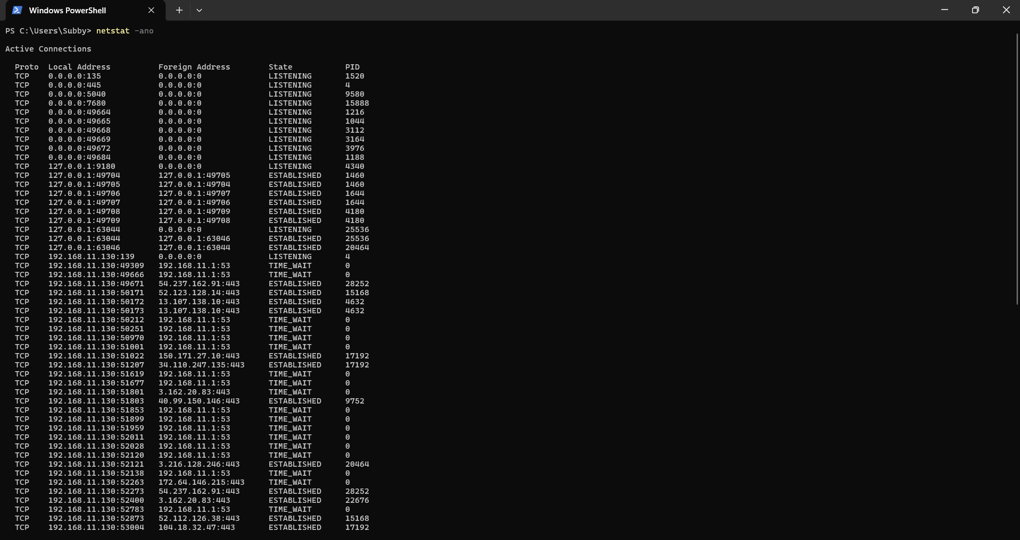
This screenshot shows how to utilise Windows PowerShell's netstat -ano command. The command shows all the computer's listening ports and active network connections, along with the Process ID (PID) linked to each connection. Multiple LISTENING ports, which indicate services awaiting incoming connections, and multiple ESTABLISHED connections, which verify active communication between the machine and distant servers, are seen in the screenshot. Additionally, there are TIME_WAIT connections, which stand for recently ended network sessions that are momentarily kept open, guaranteeing that all data has been transferred accurately. For system administrators and IT specialists, the netstat -ano command is a useful monitoring and troubleshooting tool. By associating connections with process IDs, it assists in identifying active network connections, determining which apps are utilising network resources, resolving connectivity problems, and looking into unusual or suspected network activities (14).

Example 7 – command net user:
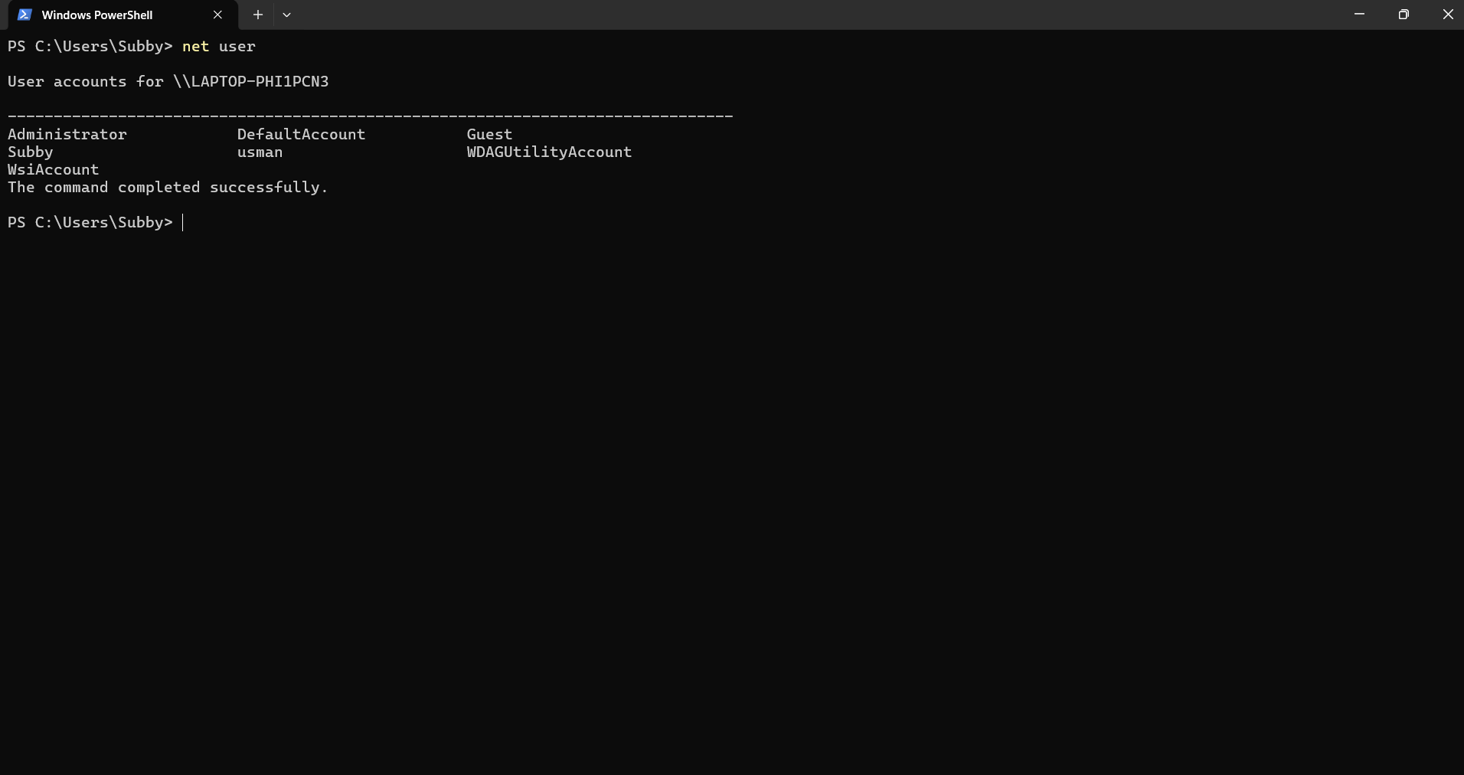
This screenshot shows how to utilise Windows PowerShell's net user command. A list of every user account on the local computer can be shown by using this command. For controlling user accounts and confirming which accounts are accessible on a Windows system, this administrative function is helpful. The result displays several user accounts that are set up on the system, including personal user accounts like Subby and Usman as well as the built-in Administrator, Guest, Default Account, and WDAGUtilityAccount. Some of these accounts are regular user accounts, while others are system accounts that Windows uses for security and administration (15).

Example 8 – command schtasks /query /fo LIST /v:
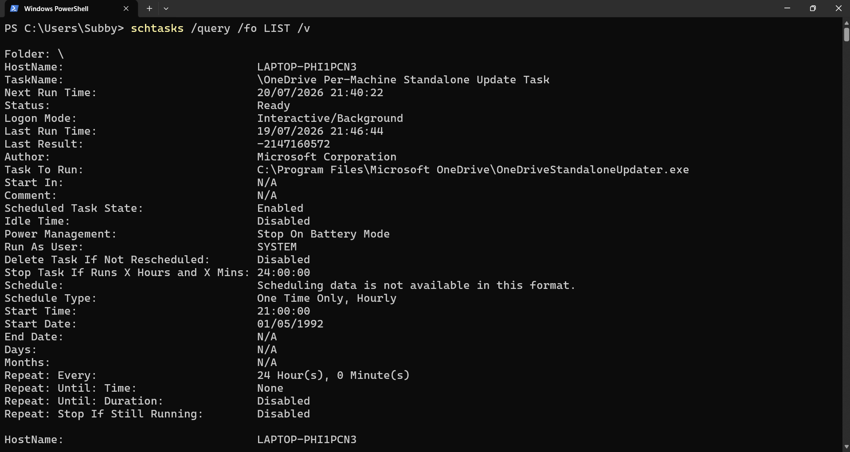
The command schtasks /query /fo LIST /v is being executed by Windows PowerShell, as seen in this screenshot. The program shows a comprehensive list of every scheduled task that is set up on the machine. The /v option offers verbose information, the /fo LIST option formats the output as a readable list, and the /query option fetches the scheduled jobs. Windows scheduled tasks can be seen, monitored, and troubleshot with this command. It enables users and administrators to confirm if tasks are enabled, find out when they are scheduled to run, ascertain which account is responsible for carrying them out, and examine the programs or scripts connected to each job (16).

Example 9 – command systeminfo:
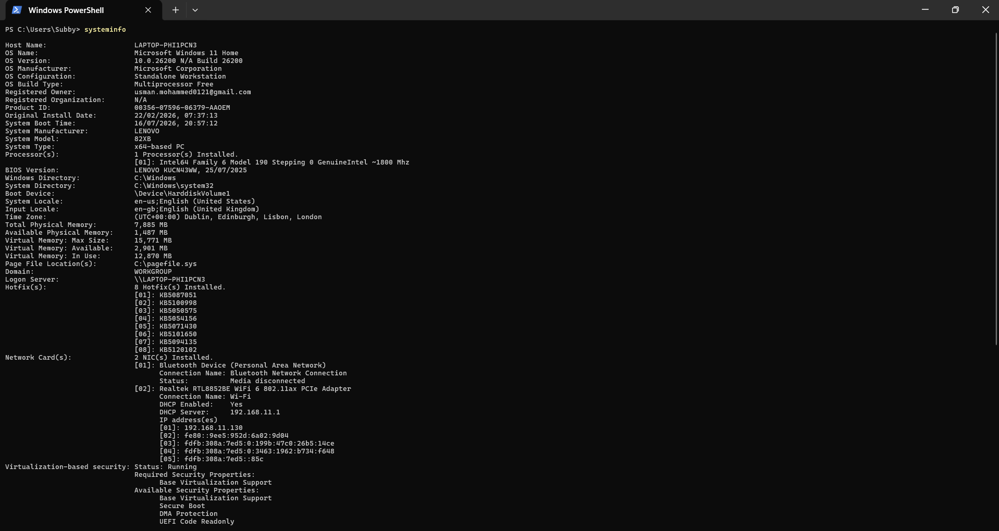

The screenshot displays Windows PowerShell running the systeminfo command. This command shows comprehensive details on the hardware, operating system, and network setup of the computer. IT specialists and system administrators frequently use it to validate system settings, troubleshoot problems, and check system specifications. All things considered, the systeminfo command offers a thorough overview of the computer's settings, which makes it helpful for troubleshooting issues, recording system details, and verifying that the hardware and operating system are set up appropriately (17).

Example 10 – command hostname:
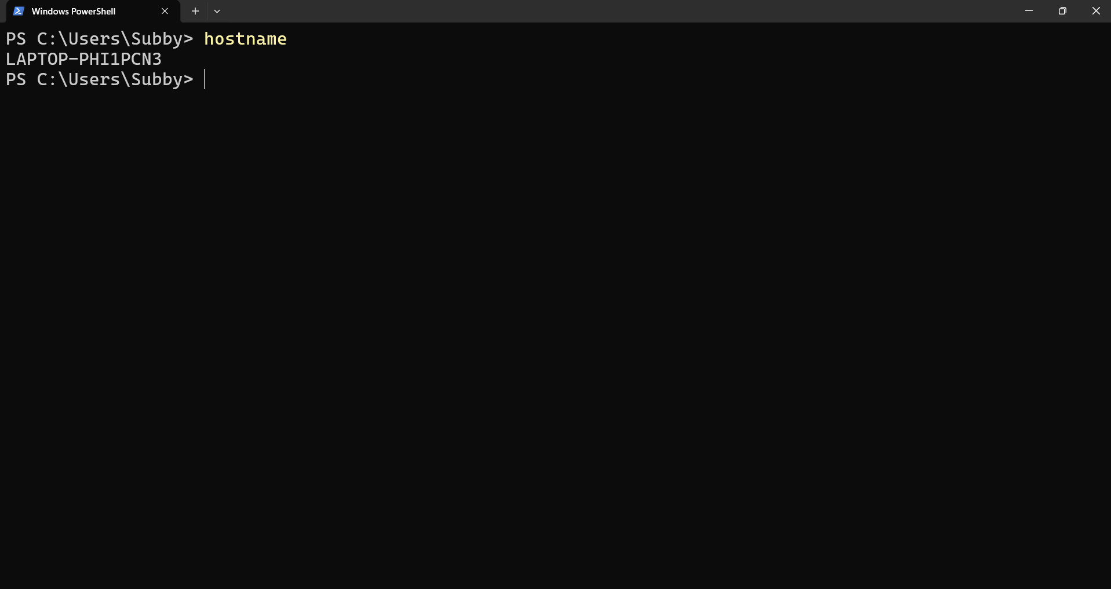
The hostname command in Windows PowerShell is displayed in the screenshot. This command shows the computer on the network's unique name. When interacting with other computers, gaining access to shared resources, or overseeing systems on a network, the device is identified by its hostname. The command confirms the device's hostname by returning the machine name LAPTOP-PHI1PCN3 in the output. When troubleshooting network problems, setting up remote access, or recording system information, this command is simple and helpful for confirming the computer's identity.
All things considered, the hostname command is a straightforward yet crucial networking utility that aids administrators and users in locating a machine within a local network or domain (18).

Task 3 – Use of Linux OS CLI commands

The Linux operating system is well known for its robust command-line interface (CLI), which makes it possible for system administrators and users to effectively carry out system management activities. A versatile environment for running commands, automating tedious chores, and controlling system resources is offered by the Linux shell, usually Bash (Bourne Again Shell) (19). The CLI is a crucial tool for server management, software development, and cybersecurity because it provides more speed, accuracy, and control than graphical user interfaces. To accomplish tasks such as process management, file and directory management, network testing and monitoring, user management, and task scheduling, this section shows how to use twelve frequently used Bash commands along with pertinent options and switches. These examples show how Linux CLI commands enhance operational efficiency and facilitate efficient system administration (20).
The screenshot shows how to use the su (substitute user) command, which enables a user to do administrative activities by switching to a different user account, usually the root account. Because the plus sign is not an acceptable syntax in Bash, the command is first entered incorrectly as +su, which causes the error message -bash: +su: command not found. After that, the right command, su, is successfully run. The system asks for the password of the root user after the right command has been entered.
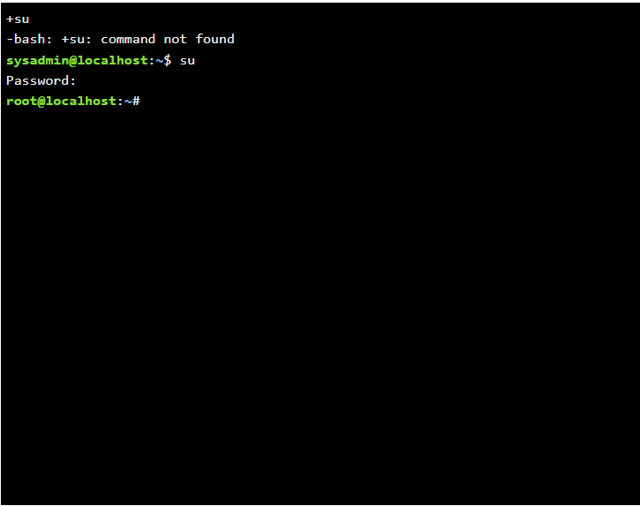
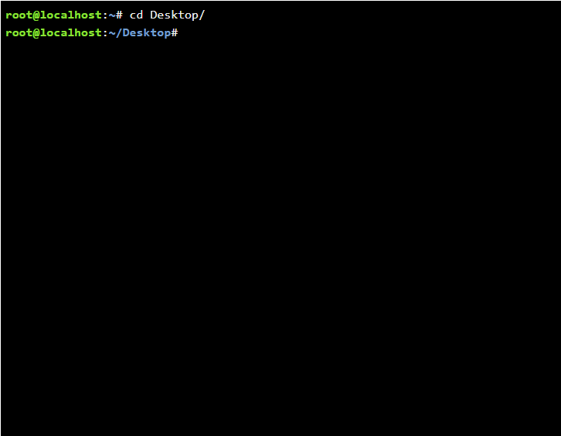
The graphic shows how to use the Linux Bash terminal's cd (change directory) command. To browse from the current working directory (/root) to the Desktop directory, use the command cd Desktop/. The command prompt changes from root@localhost:~# to root@localhost:~/Desktop# when the command is successfully run, indicating that the Desktop folder is now the current working directory.

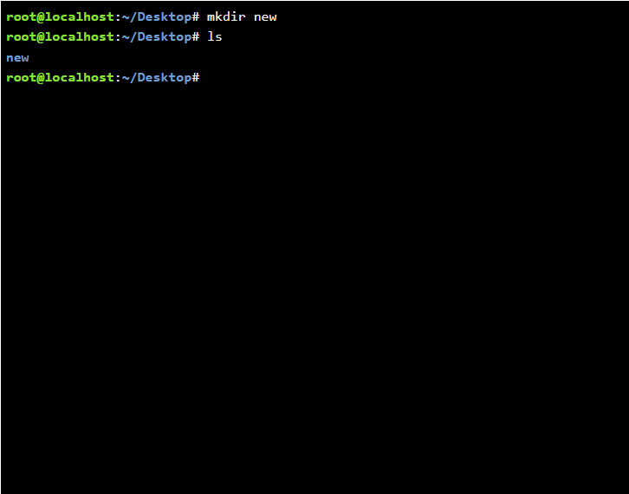
The screenshot shows how to handle files and directories in the Linux Bash terminal using the mkdir and ls commands. In the current working directory (~/Desktop), the command mkdir newly creates a new directory called new. The ls command is used to show the contents of the current directory once the directory has been created. The output, which appears in the list of files and directories, confirms that the new directory was successfully created.

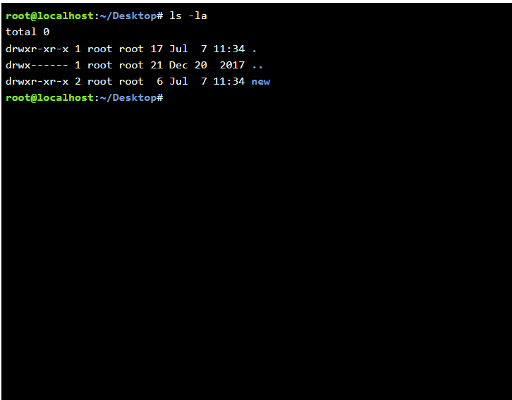
The screenshot shows how to use the Linux Bash terminal's ls command with the -la arguments. A thorough list of all the files and directories in the current directory, including hidden files and directories, is shown with the command ls -la. The output in this example displays the contents of the Desktop directory, including the newly formed directory called new, the parent directory (..), and the current directory (.).

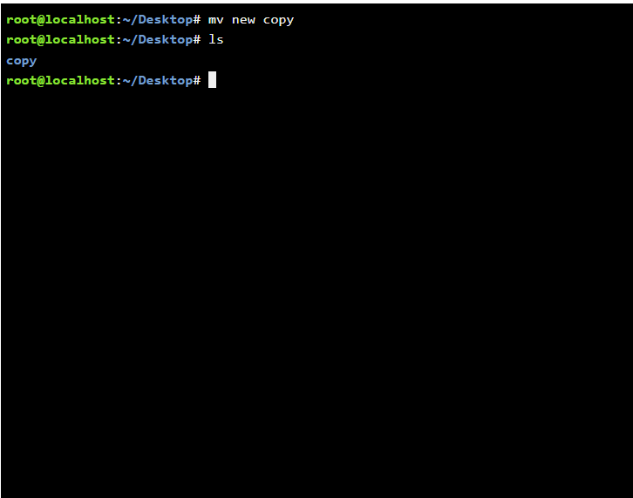
In Linux, files and directories can be moved or renamed with the mv (move) command. Since both things are in the same directory, in this case it renames the file or directory named new to copy. The contents of the current directory are listed using the ls command after the command has been executed. The result verifies that the rename process was successful and that the original name new has been replaced by the copy that currently exists. In Linux system management, this command is frequently used to move files between directories, rename documents, and organize files without making duplicate copies.

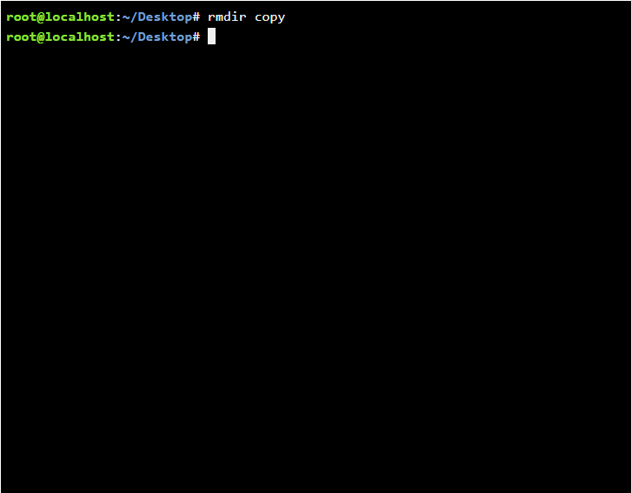
To remove an empty directory from the file system in Linux, use the rmdir (remove directory) command. The command in this example eliminates the copy directory from the current working directory. The command indicates that the directory was empty and was successfully erased because it runs without displaying an error message. Only folders with no files or subdirectories can be deleted with the rmdir command. Linux will return an error like "Directory not empty" if the directory is not empty. Instead, the rm -r command would be needed to delete a directory and everything in it.

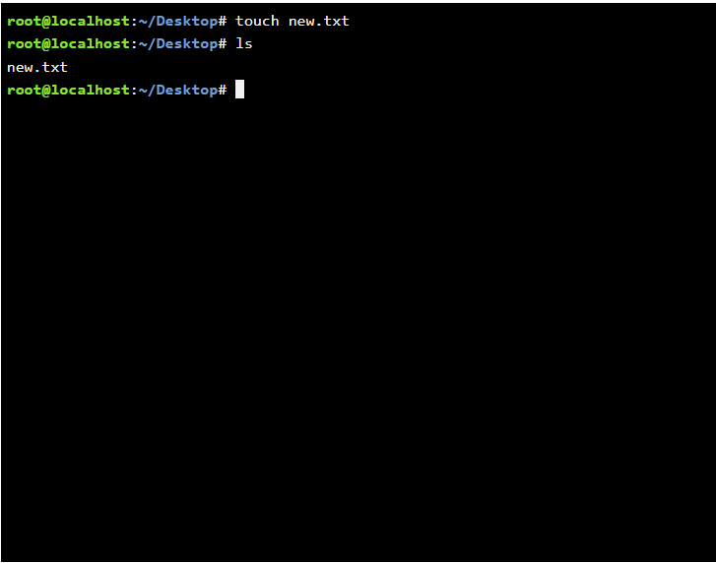
In Linux, the touch command can be used to change the timestamp of an existing file or create a new, empty file. The command in this example generates a new, empty text file called new.txt in the current directory. The contents of the directory are shown using the ls command after the command has been executed. The successful creation of the file is confirmed by the output, which displays new.txt. To quickly create placeholder files, log files, configuration files, or test files without using a text editor, Linux users and system administrators frequently utilize the touch command.

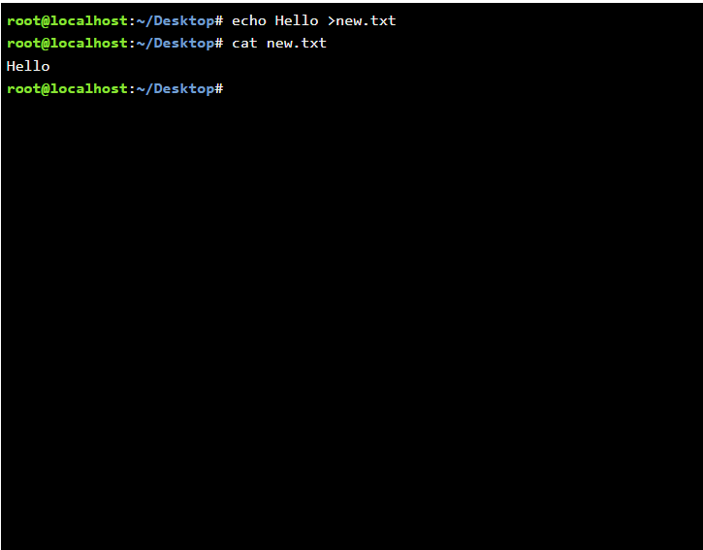
The screenshot demonstrates that the echo Hello > new.txt command successfully writes the text "Hello" to the file new.txt. The contents of the file are then displayed using the cat new.txt command, and the terminal produces "Hello" to verify that the text was written correctly. The fact that both commands executed successfully and produced no error messages shows that they both performed as intended.

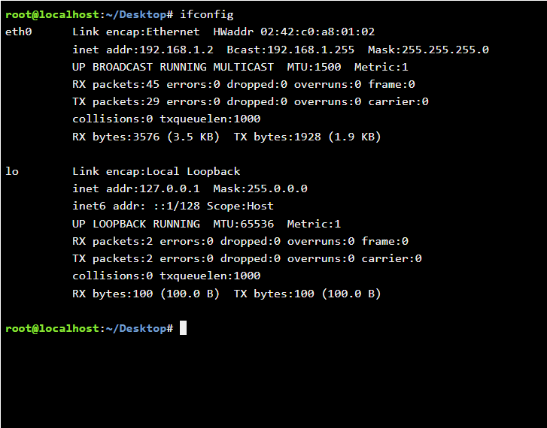
The screenshot shows that the ifconfig command was executed successfully. IP configuration, hardware addresses, interface status, and network traffic statistics are among the comprehensive details about the active network interfaces that are displayed. This data can be used to identify possible networking problems and confirm that the system is properly connected to the network.

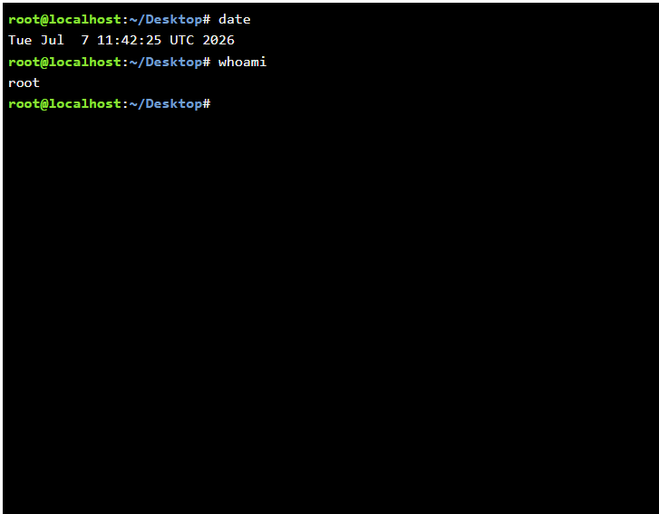
The screenshot shows that the date and whoami commands were executed successfully. The whoami command identifies the active user as root, whereas the date command verifies the current system date and time. These commands are frequently used to confirm system data and make sure the right user credentials are being utilized for administrative operations.

Task 4 – Use of Windows OS scripts

One easy way to automate repetitive chores in the Windows operating system is to use Windows Batch Scripting. Batch scripts enable users and system administrators to carry out several operations automatically without the need for human intervention. They are composed of a set of command-line instructions that are stored in a.bat file. Numerous administrative functions, such as file and folder administration, system upkeep, user contact, and simple computations, can be carried out by these scripts. Batch scripts increase productivity, decrease human error, and streamline routine system administration by utilising programming capabilities like variables, user input, arithmetic operations, loops, and conditional statements. Two useful batch scripts that illustrate how Windows command-line automation may be used to efficiently carry out routine administrative operations are presented in the next section (21).

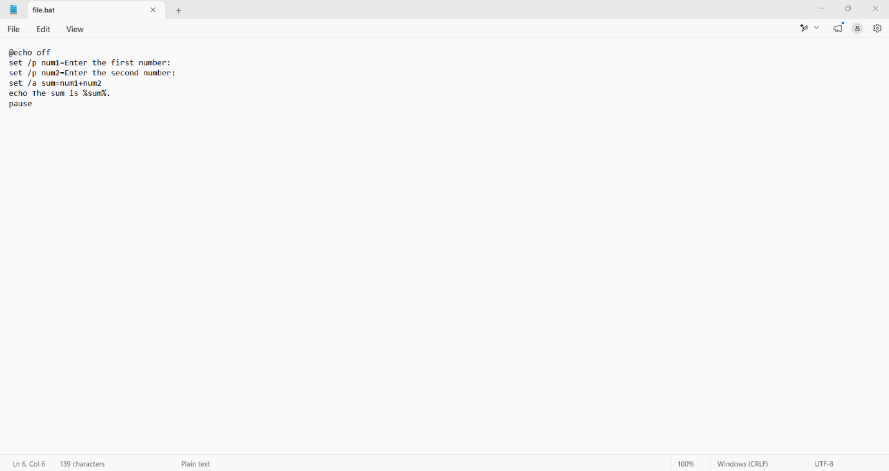
The source code of a Windows Batch script is displayed in the screenshot. By asking the user for two integers and displaying the result, the script is intended to automate a basic addition calculation. A cleaner output is produced by using the @echo off command to stop the script commands from being shown while they are being executed. The script asks the user to enter the first and second integers using the set /p command, then stores the results in the variables num1 and num2. The total of the two numbers is then calculated using the set /a command, and the result is stored in the variable sum. Lastly, the pause command allows the user to examine the output by keeping the Command Prompt window open until a key is pressed, whilst the echo command shows the user the computed result. This script illustrates several important Batch scripting ideas that are necessary for the assignment, such as the use of variables, user input, and mathematical operations. It offers a real-world illustration of how Windows Batch scripts can analyse user input and carry out computations automatically, automating repetitive activities, increasing productivity, and decreasing human labour (22).

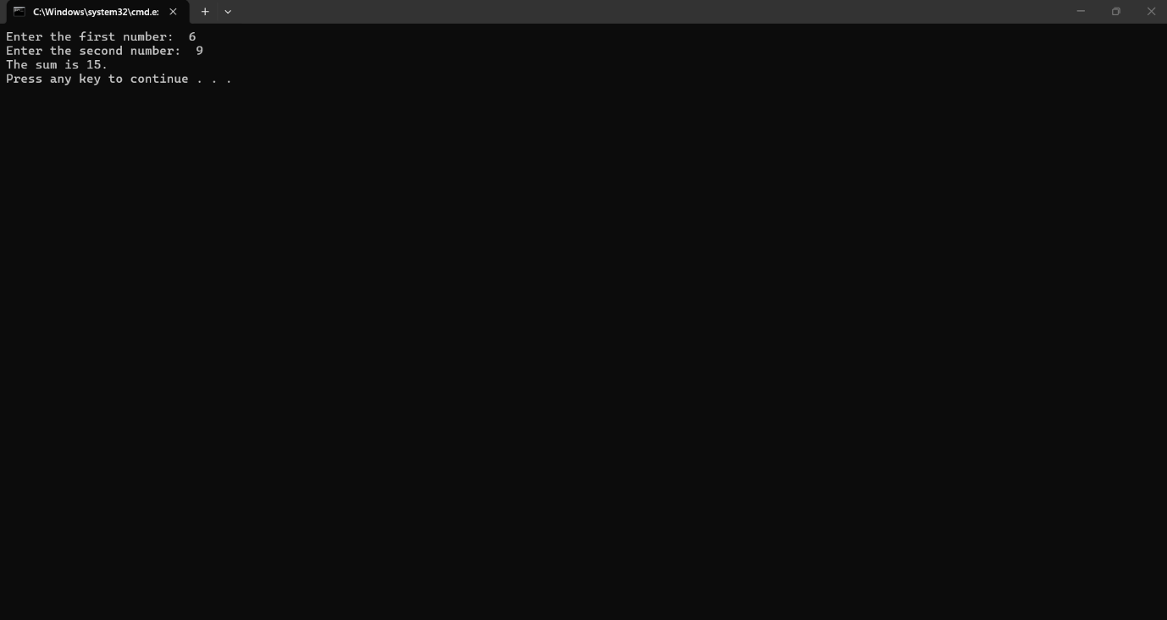
The screenshot demonstrates that the Windows Batch script was executed successfully. The user is prompted to enter two digits when the script is executed on the Windows Command Prompt. The user inputs 6 as the first number and 9 as the second in this example. The set /a command is then used by the script to do an arithmetic computation, and the outcome is shown as "The sum is 15." The output verifies that the user's input was correctly accepted by the script, which then stored the data in variables, carried out the mathematical operation, and presented the computed result. In order to allow the user to examine the output, the last pause command prevents the Command Prompt window from shutting instantly by displaying "Press any key to continue..." By combining user input, variables, mathematical calculations, and command-line automation, this screenshot shows that the Batch script performs as expected and satisfies this task's requirements. It demonstrates how basic computational processes may be automated using batch scripting, increasing productivity and decreasing the need for human calculations (23).

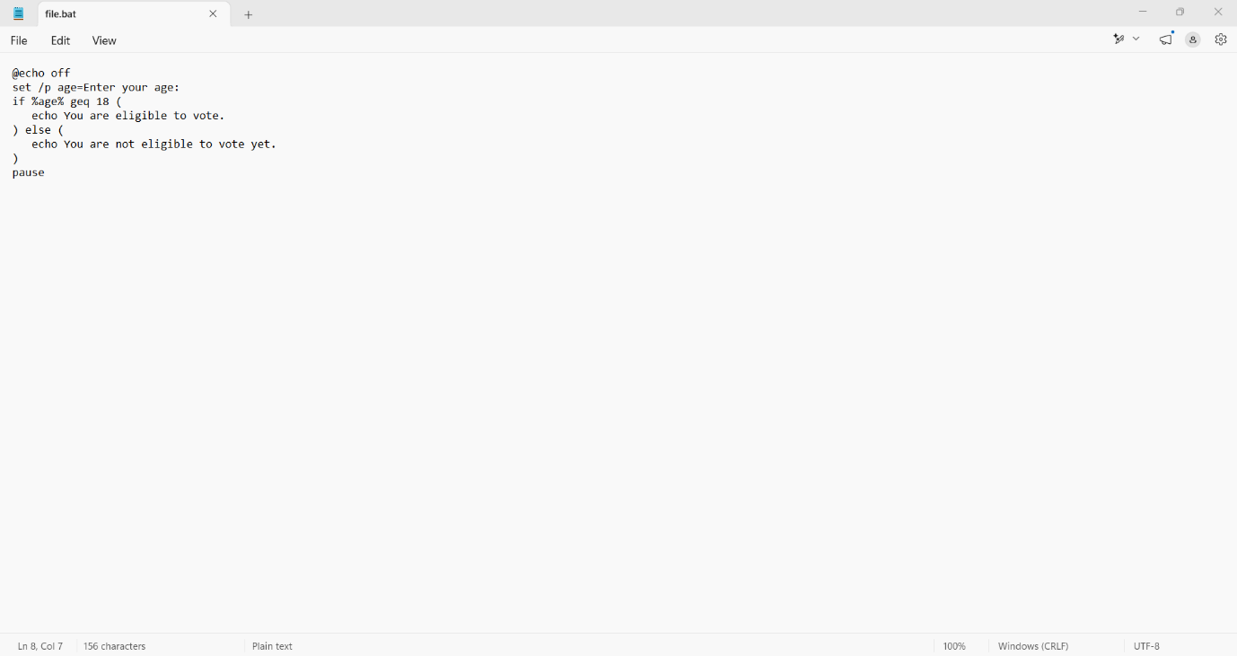
A Windows Batch script's source code is displayed in the screenshot. The script's purpose is to ascertain a user's eligibility to vote based on their age. It illustrates how to use variables, user input, and conditional statements—all crucial components of batch programming for automating processes involving decision-making. The script starts with the @echo off command, which makes the output cleaner by preventing each command from being shown while it is being executed. The user is prompted to enter their age with the set /p command, which then saves the result in the variable age. Next, the if statement uses the geq (greater than or equal to) comparison operator to compare the entered number with 18. The script says, "You are eligible to vote," if the user is at least eighteen years old. If not, the else statement runs and shows the message "You are not eligible to vote yet." The script concludes with the pause command, which keeps the Command Prompt window open so the user can view the outcome before the program ends. This script shows how conditional logic can be used in Windows Batch scripting to automate basic decision-making procedures. It highlights the value of batch scripting for common system and user management chores by offering a real-world example of how administrative scripts may verify user input and provide various outputs depending on predetermined circumstances (24).

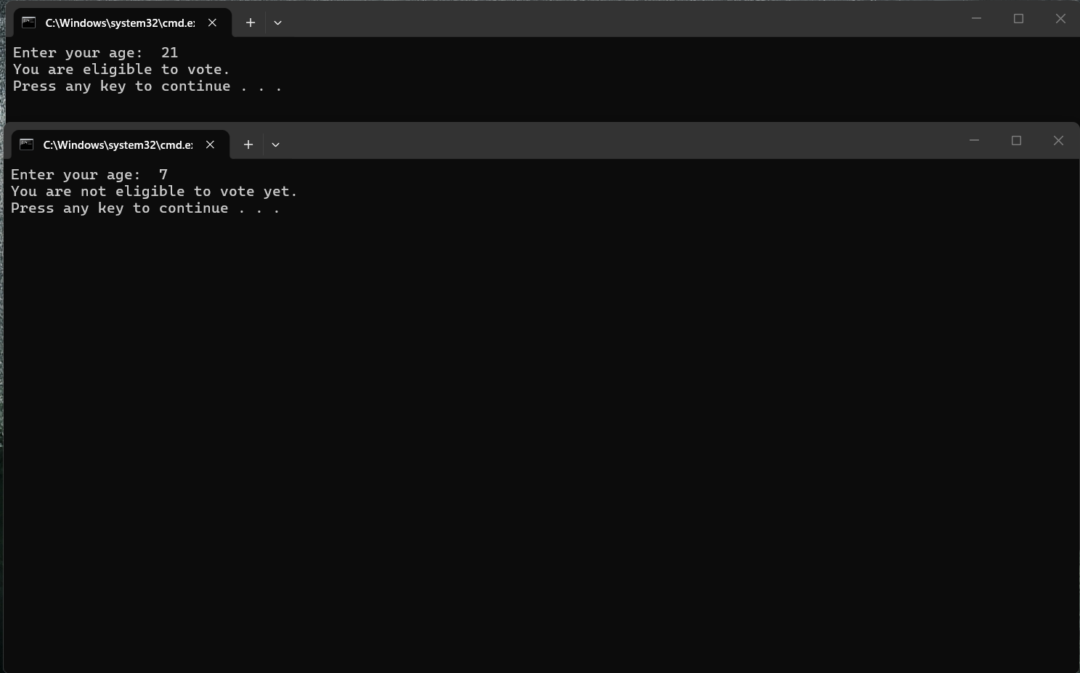
The screenshot demonstrates how the Windows Batch script was executed successfully. After asking the user to enter their age, the script determines whether or not they can vote using a conditional if...else statement. To illustrate both potential results, two distinct script executions are displayed. The user inputs 21 as their age in the first case. The script runs the first condition since this value is greater than or equal to 18, and it shows the message "You are eligible to vote." The user puts 7 as their age in the second example. The else statement is run since this value is less than the voting age of 18, which results in the notice "You are not eligible to vote yet." The pause command allows the user to read the output before dismissing the Command Prompt window when it displays the proper result. By analysing user input and generating various outputs depending on a predetermined condition, this screenshot verifies that the Batch script operates as intended. It highlights how straightforward scripts can automate decision-making duties and boost productivity in standard administrative procedures by showcasing the useful application of variables, user input, and conditional statements in Windows Batch programming (25).

Task 5 – Use of Linux OS scripts
Because Linux Bash scripting makes it possible to automate repetitive processes and increases system management efficiency, it is a crucial ability for IT professionals and system administrators. The Linux shell executes a set of commands known as bash scripts, which enable users to carry out tasks like file management, user interaction, and system monitoring with little to no manual input. Bash scripts can automate repetitive tasks while lowering the possibility of human error by utilising programming concepts including variables, user input, arithmetic operations, loops, and conditional statements. The creation of two straightforward Bash scripts that highlight basic Linux scripting concepts is demonstrated in this job. To demonstrate how Bash can be used to address real-world issues and automate administrative activities, each script contains instances of user interaction and control flow. Each script's functionality and successful operation are illustrated with screenshots of both the script code and the execution output (26).

Example 1 – Bash script addition calculator:
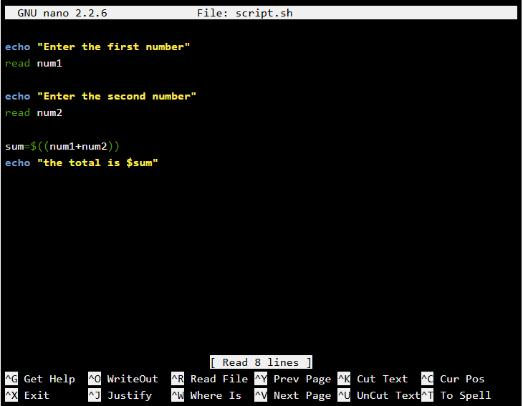
In the screenshot, a basic Bash script is being developed on a Linux computer using the GNU Nano text editor. The script illustrates how to use variables, user input, arithmetic operations, and output—all of which are essential Bash scripting principles. The script starts by using the echo command to ask the user to enter the first number, and then it uses the read command to store the input in the variable num1. After that, it stores the value in the variable num2 and continues the procedure for a second number. The expression sum=$((num1+num2)), which adds the two integers together and stores the outcome in the variable sum, is used by the script to do an arithmetic computation. Lastly, the computed result is shown when the statement "the total is" is displayed by the echo command. This script shows how Bash may communicate with the user via the command line while automating basic computations. It is a helpful illustration of beginner-level Linux scripting since it presents the fundamental programming principles of variables, user input, arithmetic expressions, and output (27).
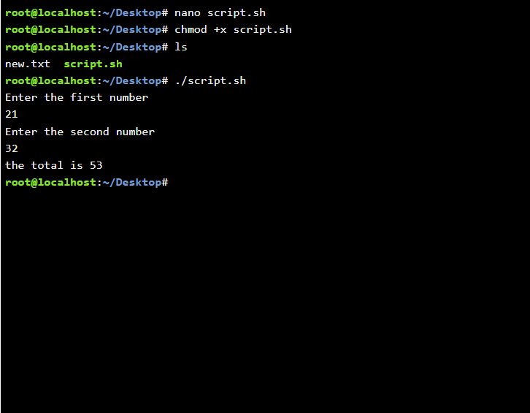
The screenshot demonstrates how a Bash script was successfully run on a Linux terminal. The user creates the file (nano script.sh), makes it executable with the command chmod +x script.sh, then uses the ls command to verify that the file is in the current directory before executing the script. The command ./script.sh is then used to launch the script, which asks the user to enter two digits. The user inputs 21 as the first number and 32 as the second in this example. To prove that the calculation was successful, the script adds the two values together and displays the result, "the total is 53". This example illustrates a few important Bash scripting techniques, such as running scripts from the terminal, using the read command to receive user input, storing values in variables, carrying out arithmetic operations, and using the echo command to display output. It also emphasises how crucial it is to use chmod +x to grant execute permissions before executing a Bash script (28).

Example 2 – Bash script loop counter:
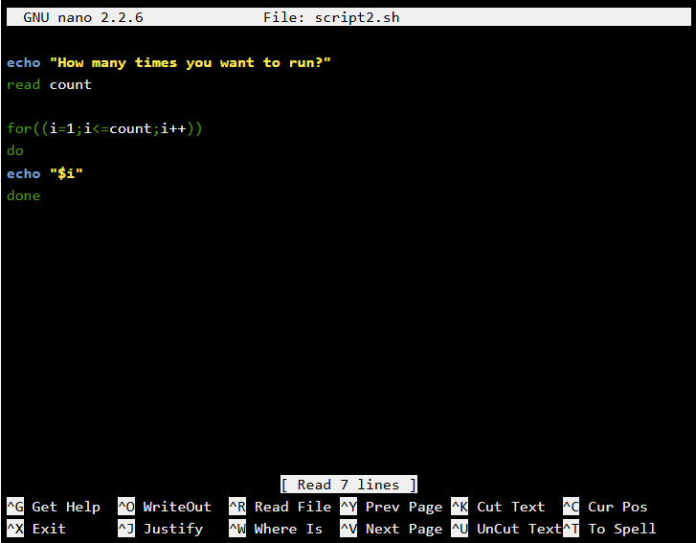
In the screenshot, a second Bash script is being written on a Linux system using the GNU Nano text editor. This script shows how to control the repeated execution of commands using variables, user input, and a for loop. The script starts by utilising the echo command to ask the user, "How many times do you want to run?" The read command is used to store the user's response in the variable count. The variable i is then initialised at 1 using a for loop, which continues to run until i is equal to or less than the value the user input. After each iteration, i is increased by one (i++). The echo "-i" command shows the current value of i on the screen for each loop iteration. This script uses a loop to repeat a task a certain number of times, illustrating a basic control flow approach in Bash programming. It is a useful illustration of fundamental Linux scripting since it shows how user input may be integrated with variables and looping structures to automate repetitive tasks (29).
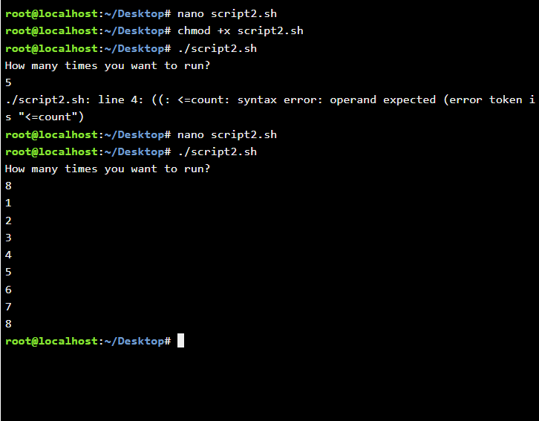
The second Bash script (script2.sh) is executed and tested in a Linux terminal, as seen in this screenshot. The script is first executed after being made executable using the chmod +x script2.sh command. When the user enters 5 on the first try, the script gives a syntax error because the for-loop condition has an improper variable reference (count instead of $count), which stops the loop from executing. The mistake is then fixed by the user editing the script with the nano text editor. The script is run once more after the modifications have been saved. When the user inputs the number 8 this time, the updated script completes the for loop and displays the numbers 1 through 8 sequentially. This illustrates how to use variables, user input, and a for loop to control the number of times the loop runs. It also shows how to find, correct, and test a scripting issue (30).

Linux unhatched badge:



IEEE References list:
(1) W. Stallings, Operating Systems: Internals and Design Principles, 9th ed.
(2) A. Silberschatz, P. Galvin and G. Gagne, Operating System Concepts, 10th ed.
(3) Microsoft Learn, Install or uninstall apps in Windows.
(4) Microsoft Learn, File Explorer in Windows.
(5) Microsoft Learn, Use Device Manager to manage devices in Windows.
(6) Microsoft Learn, Windows Security documentation.
(7) Microsoft Learn, "Windows commands," Microsoft, 2025.
(8) Microsoft Learn, "PowerShell documentation," Microsoft, 2025.
(9) Microsoft. (2025) Command-Line Reference. Microsoft Learn. Accessed: 20 July 2026.
(10) Microsoft. (2025) Windows PowerShell Documentation. Microsoft Learn. Accessed: 20 July 2026.
(11) Microsoft. (2025) systeminfo. Microsoft Learn. Accessed: 20 July 2026.
(12) Microsoft. (2025) hostname. Microsoft Learn. Accessed: 20 July 2026.
(13) Microsoft. (2025) ipconfig. Microsoft Learn. Accessed: 20 July 2026.
(14) Microsoft. (2025) ping. Microsoft Learn. Accessed: 20 July 2026.
(15) Microsoft. (2025) netstat. Microsoft Learn. Accessed: 20 July 2026.
(16) Microsoft. (2025) tasklist. Microsoft Learn. Accessed: 20 July 2026.
(17) Microsoft. (2025) net user. Microsoft Learn. Accessed: 20 July 2026.
(18) Microsoft. (2025) schtasks. Microsoft Learn. Accessed: 20 July 2026.
(19) A. Silberschatz, P. B. Galvin and G. Gagne, Operating System Concepts, 10th ed. Hoboken, NJ, USA: John Wiley & Sons, 2018.
(20) GNU Project, "Bash Reference Manual," 2025.
(21) Microsoft, Windows Commands Documentation.
(22) Microsoft Learn, Command Prompt (CMD) and Batch Files.
(23) Microsoft Learn, set (Command).
(24) Microsoft Learn, if (Command).
(25) W. R. Stanek, Windows Command Line Administrator's Pocket Consultant
(26) W. Shotts, The Linux Command Line: A Complete Introduction
(27) R. Blum and C. Bresnahan, Linux Command Line and Shell Scripting Bible
(28) GNU Project, Bash Reference Manual. Free Software Foundation, 2024.
(29) M. G. Sobell, A Practical Guide to Linux Commands, Editors, and Shell Programming,
(30) The Linux Foundation, Introduction to Linux. The Linux Foundation, 2022.

