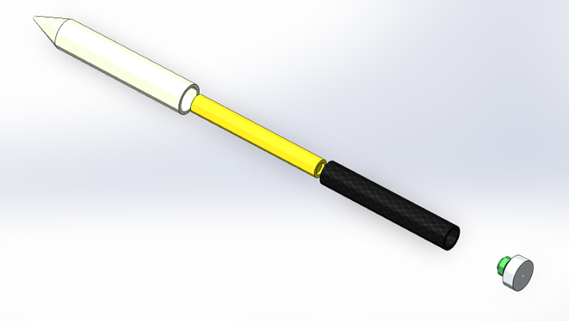

Systems Engineering: Design Report
  - Project Obscura – Team 4
Fraser Goodwin | ACDA5021 | 27/5/2025

Contents
Figures 1
Introduction 3
Design Brief 3
The Target 3
Design Methodology 3
Requirements 3
REquirement Gathering 3
Rationalising Requirements 4
Functionality 5
Use Case 5
QFD 1 6
Concept Derivation 7
Function Means Analysis 7
Concept Selection 7
System Breakdown 8
Final Use Case 8
Final concept 9
Critical Components 10
HE Manufacturing Route 11
Noises and Control Factors 12
system 12
High Explosive Warhead 14
Conclusion 16
References 17

Figures
Figure 1 - Target room from outside 3
Figure 2 - Stakeholder Requirements 4
Figure 3 - Rationalised Requirement Set 5
Figure 4 - Functional Importances 6
Figure 5 - Function Means Analysis 7
Figure 6 - Systems Pugh Matrix 8
Figure 7 - Final Concept Use Case 9
Figure 8 - Final Concept Model 9
Figure 9 - Jackal Drone Launch Platform 10
Figure 10 - Feature Importances Graph 11
Figure 11 - HE Manufacturing flow 12
Figure 12 - System P-Diagram 13
Figure 13 - System Noise Factors 13
Figure 14 - System Control Factors 14
Figure 15 - HE P-diagram 15
Figure 16 - HE Noise Factors 15
Figure 17 - HE Control Factors 16

Introduction

Design Brief
A requirement was raised to develop an explosive device which can neutralize a hostile communications centre, located in a room within the second floor of an office block building. The proposed design had to be capable of accurate delivery into the room from a distance of at least 100 metres and that collateral damage to adjacent rooms by the payload should be minimized.

The Target
The target room in question is on the second floor of an office block with the dimensions of the room bring 10m x 8m x 4m, with the outside facing wall being the 10m one and the rest of the walls are internal to the building. The outside wall has three windows which are equally spaced along the wall and measure 2m x 1m each which can be seen in Figure 1 with the grey area being the wall and the yellow sections the windows.
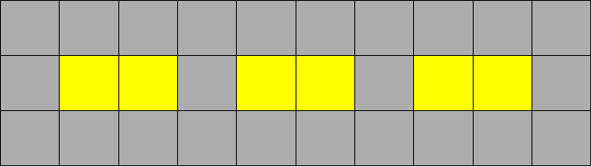
Figure 1 - Target room from outside
The externals walls of the building are constructed of rendered filled cavity block and the internal walls are soft block constructed with plasterboard over baton facings. The windows are double opening standard UPVC double glazed units and there are normally six operatives in the room operating at three terminals.

Design Methodology
The cohort were split into small design teams to develop a solution to the design brief using a set of established systems engineering processes and tools. Each member of the team took on a particular design role respective to their specialties with me taking on product safety for the design. Other areas explored by members of the team were manufacturing, safety and governance, trials and testing, and disposal.

Requirements

REquirement Gathering
To gather a complete set of requirements that meets the design brief, the first activity was to identify all stakeholders involved in or impacted by the system. For our system, it was identified that the main stakeholders were the main customer, end user, project manager, and legislator. By including all these stakeholders’ requirements, it ensured that everyone involved was aligned and that the project was kept on track reducing the risk of delays or unexpected costs. [1] The list of requirements for project Obscura can be seen in Figure 2.
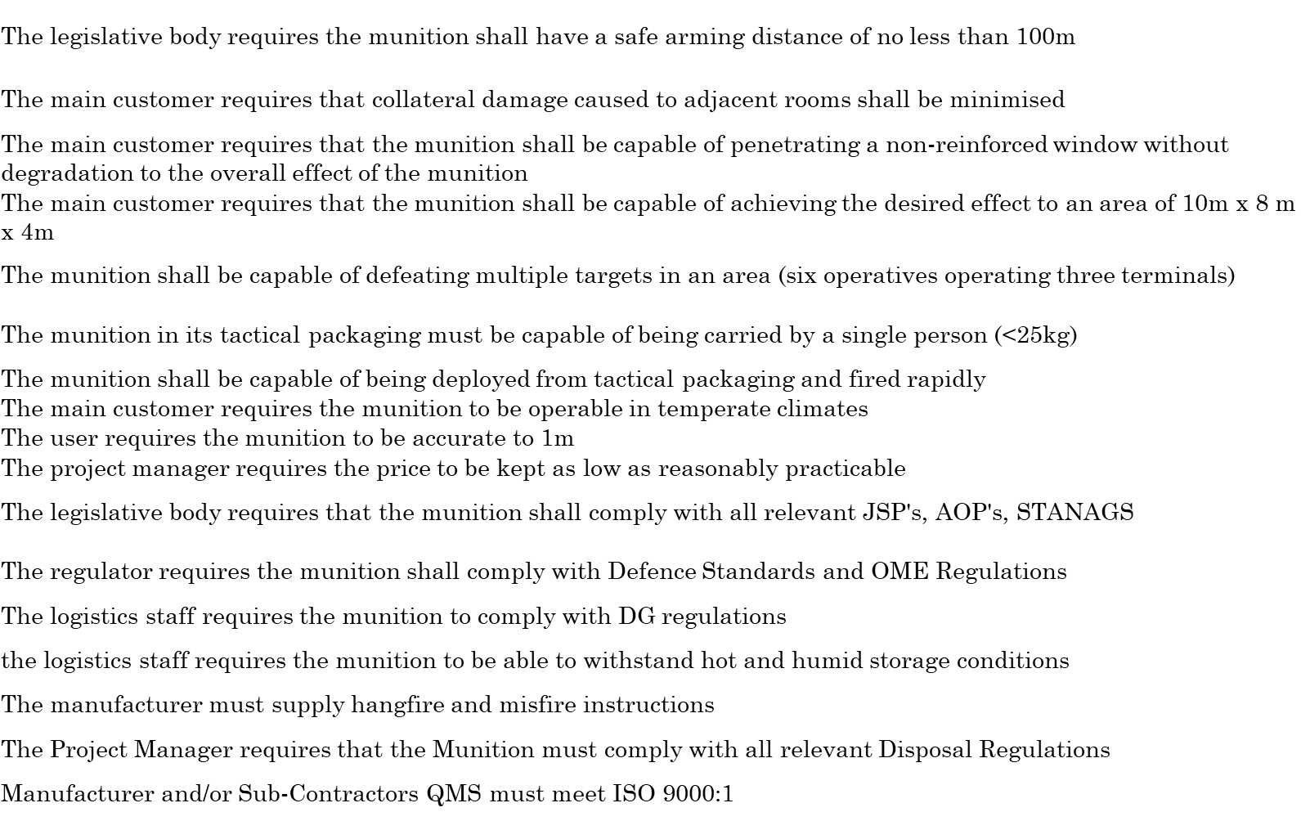
Figure 2 - Stakeholder Requirements

Rationalising Requirements
To identify what our most important requirements were, a Pairwise comparison was used. This is a systematic technique which is used to rank requirements by comparing them with each other in pairs. It involves taking each requirement and comparing it directly against every other requirement to assess the most important. This method is used to gain a thorough evaluation of the requirement set and remove bias that may be present when evaluating requirements individually. The outcome of the Pairwise comparison is seen in Figure 3.
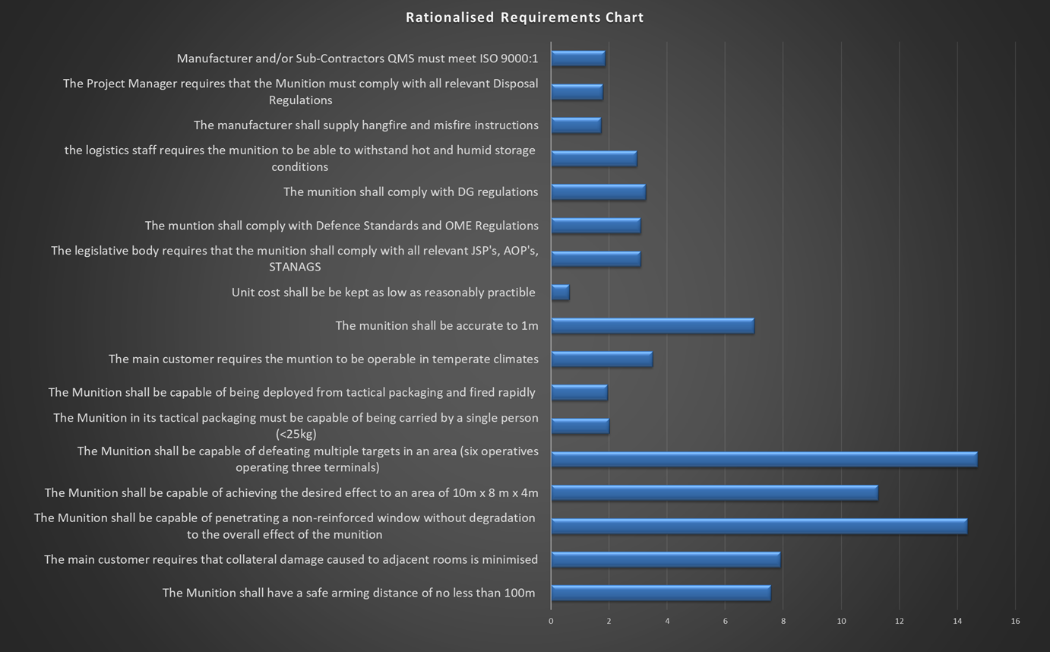
Figure 3 - Rationalised Requirement Set
From the graph in Figure 3, the requirements that scored the highest and therefore deemed the most important were ‘The Munition shall be capable of defeating multiple targets in an area (six operatives operating three terminals)’ and ‘The Munition shall be capable of penetrating a non-reinforced window without degradation to the overall effect of the munition’. This then allowed us to put our initial focus into these critical requirements and cater the functionality of the product towards them. [2]

Functionality

Use Case
A general use case was then developed for the munition in the form of a list of basic functions that the munition will need to perform to meet its end goal for which the means of achieving them were not yet considered. The general use case that was developed is as follows:
- Unpack the munition
- Load the munition
- Identify target
- Acquire target
- Arm the munition
- Provide Motive Force
- Stabilise the Projectile
- Track to target
- Defeat target
- Clear Launch Platform

QFD 1
QFD 1 is a tool used to translate customer requirements into specific design requirements. The requirements are fed into the QFD 1 matrix along with their relative importance taken from the Pairwise comparison in Figure 3 and are ranked against the general use case in pairs. This is done to discover which of the functions are the most relevant to the requirements and therefore becomes a critical function which more time and resource can be spent on the design of components or subsystems delivering the function. Figure 4 shows the functional importances achieved from QFD 1.
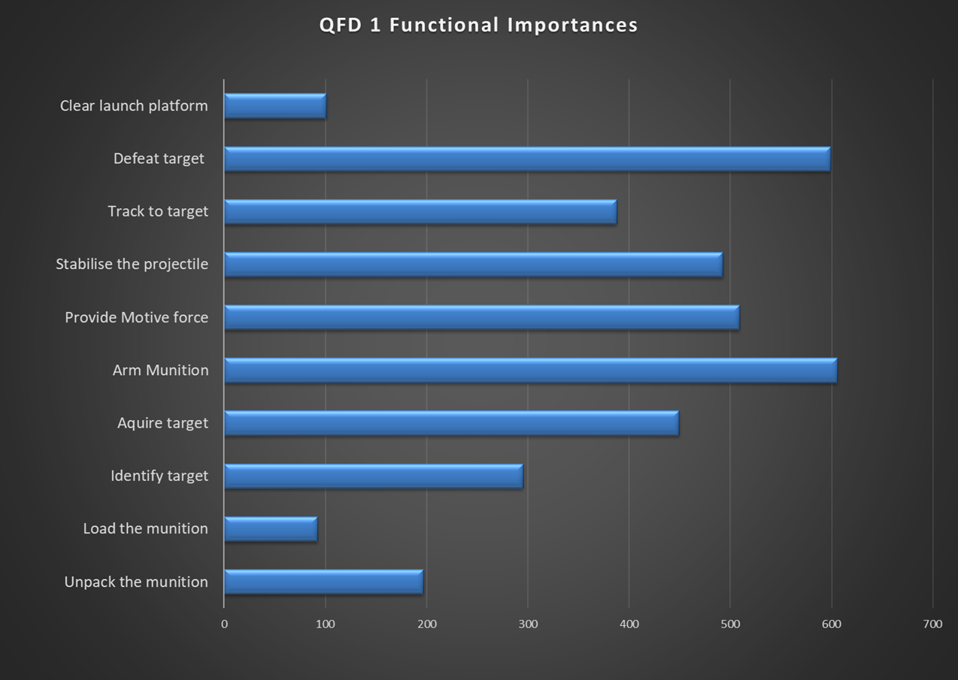
Figure 4 - Functional Importances
From the graph in Figure 4 based on our customer requirements, the defeating of the target and the arming of the munition ranked the highest making them the most important functions.

Concept Derivation

Function Means Analysis
Function Means Analysis is a structured approach to generating, selecting and documenting system design concepts. It firstly starts with all the functions from the use case then all the means that of delivering that function are considered no matter the practicability of the solution. This is put into a table which is used to show all potential design options simultaneously, making it easier to select or deselect criteria when generating concept solutions. [3]
After listing all possible means of delivering each function, 3 concepts were selected all with fundamentally different launch platforms. One fired from a drone, one fired from a robot and a shoulder launched munition which can be seen in Figure 5 with the corresponding colour coding at the bottom of the image.
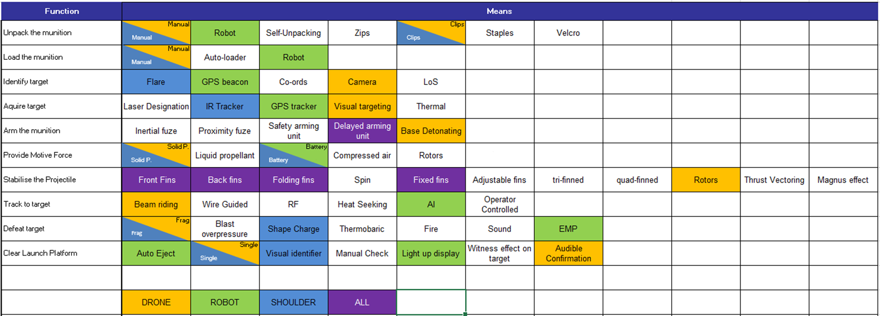
Figure 5 - Function Means Analysis

Concept Selection
The next step was to select a design concept which was best suited to our stakeholder requirement set. This was done by using a Systems Pugh Matrix which uses the rankings of the requirements from the Pairwise comparison to rank them against the means of delivering each function from the Function Means Analysis. The Systems Pugh diagram can be seen in Figure 6.
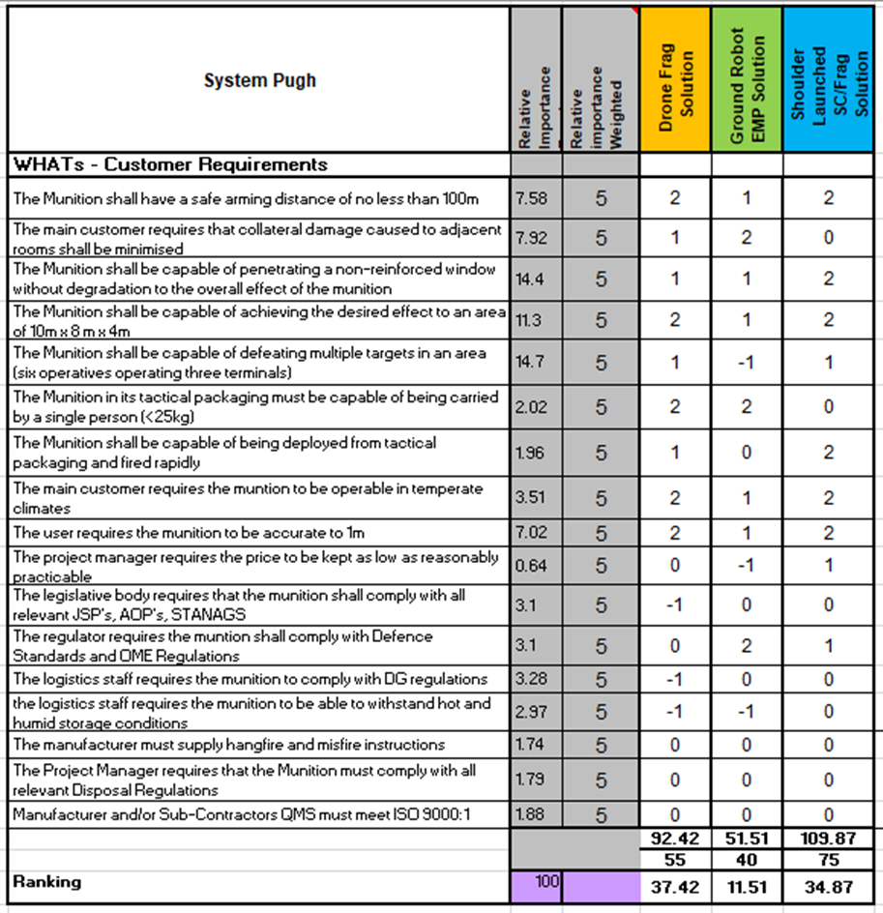
Figure 6 - Systems Pugh Matrix
From Figure 6, it shows that the drone fired frag solution came out on top with the shoulder launched shaped charge solution closely behind. The EMP solution came in last, but this may be due to one of our most critical design requirements expressed by the main customer that the munition had to be capable of defeating human operatives as well as communication systems. After careful consideration of these concepts, it was decided that the High Explosive fragmenting munition fired from a drone would be the solution that was taken forward to manufacturing.

System Breakdown

Final Use Case
Once the design concept was chosen which was the High Explosive fragmenting munition fired from a drone launch platform, the next step was to create a more detailed use case of how the munition will operate from start to finish incorporating our means to delivering each function from our design concept. This allowed us to go through each individual function that the munition will have to perform to reach the desired goal and would indicate if there was any component, subsystem or process that needs to be added or removed. The final design use case can be seen in Figure 7.
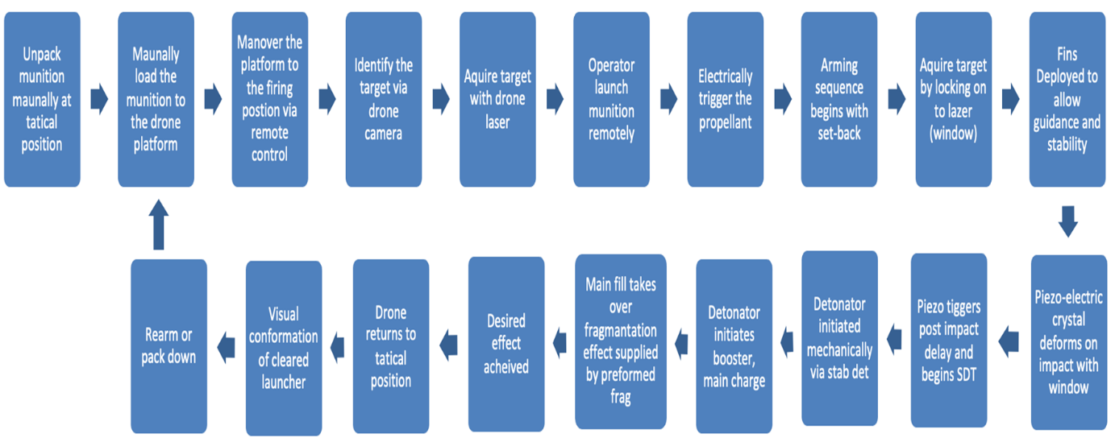
Figure 7 - Final Concept Use Case

Final concept
Through completing thorough design analysis, we arrived at a final concept and created a model of what the munition may look like which is seen in Figure 8. To label Figure 8 the white section is the outer body of the munition, the yellow section is the High Explosive (HE) fill, the black section is the fragmentation sleeve, and the silver and green section is the base detonating arming unit.

Figure 8 - Final Concept Model
The main effect that is designed to eliminate the enemy communication devices is the HE fragmentation effect. This is made of a steel fragmentation sleeve with preformed fragments of roughly 10mm³ capable of travelling within the target area whilst reducing collateral damage. The munition will be drone mounted and released and will use a platform that already exists and is in use called the Jackal drone seen in Figure 9.
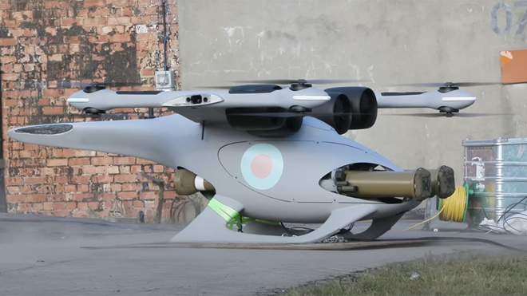
Figure 9 - Jackal Drone Launch Platform
The munition would be beam-riding to the target with adjustable fin stabilization with an operator override available to use on the operator controls. The total mass of the munition would be 14kg with a Net Explosive Quantity (NEQ) of 0.5kg but this will be tested in the trial stage to determine the outcome.

Critical Components
From the output from QFD 1, shown in Figure 4, the two functions that scored the highest and therefore became critical functions was the arming of the munition and the defeating of the target. Using the Function Means Analysis matrix in Figure 5, it was decided that our design would include a delayed arming unit and a high explosive fragmenting charge to achieve these functions. These critical functions are crucial to the function of the system where the failure of any of these would lead to the desired effect not being delivered.
The QFD 2 matrix was then used to compare the functions from the general use case to the means of delivering the function in pairs. This was done to see the relationship between the features and functions to find out what the most important features are. It is expected that there would be general trend as each function is expected to have a strong relationship with the means of achieving it but through doing this it also allowed us to see if there were any outliers where it wasn’t originally realized that a component has a large effect on several functions and therefore become a critical feature. The results from QFD 2 are seen in Figure 10.
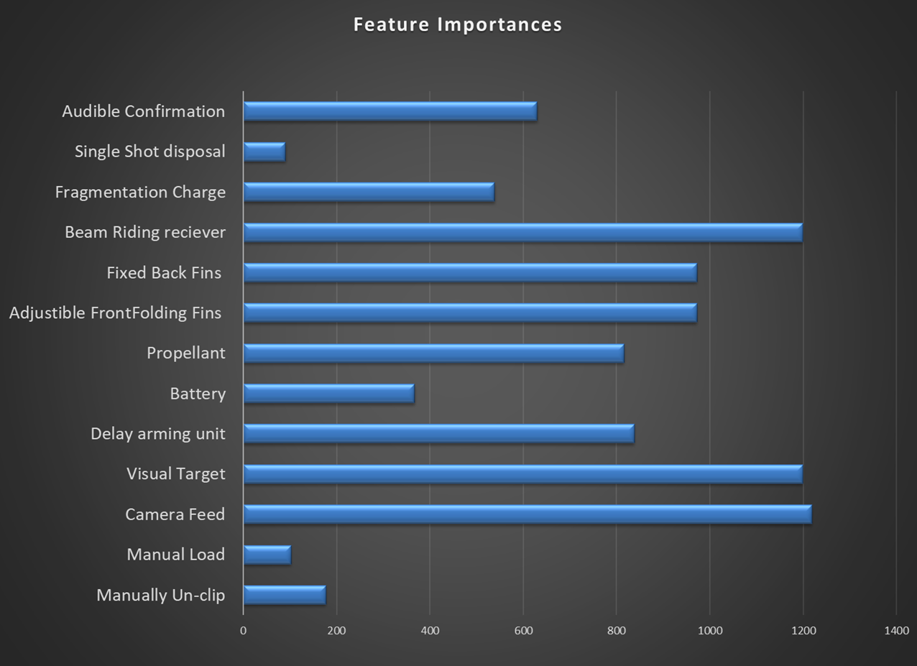
Figure 10 - Feature Importances Graph
From Figure 10 the three highest scoring features was the Beam Riding Receiver, Visual Targeting and the Camera Feed. These are all features which contribute towards the munition getting to the target rather than its performance, so it was decided that the critical subsystem that we were going to focus on and analyse manufacturing routes for was the High Explosive Fragmenting charge.

HE Manufacturing Route
As the HE fill was chosen as a critical component, the manufacturing route was developed for it. To do this, a manufacturing logical flow was created for the HE fill taking it all the way from raw materials to finished product. This allows to see the process in full and all the different steps required to do it ensuring no steps are missed and that every production stage is accounted for. By separating out each stage it also allowed us to add in control measures required at each stage which can be regulative, legislative, business or design driven. Having this manufacturing flow also allowed for planning of how big a space was needed for manufacturing, how different processes needed to be separated, and when exactly different components need to be introduced to the production chain. The production cycle for the manufacture of the HE fragmenting charge is shown in Figure 11.
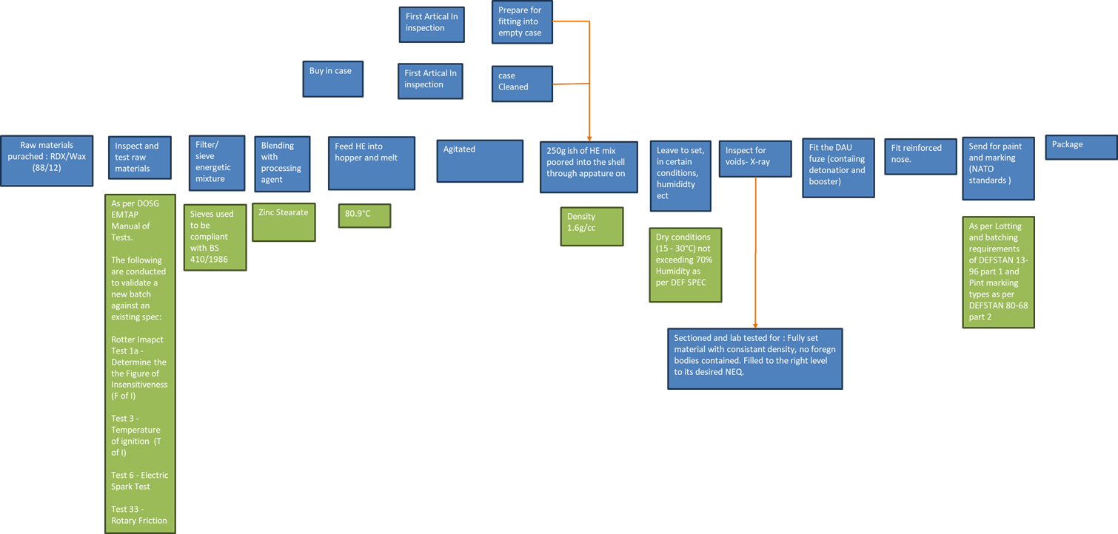
Figure 11 - HE Manufacturing flow

Noises and Control Factors

system
The next task was to evaluate all the potential sources of variation in the system. This was done through using a P-diagram followed by a What-Why table. A P-diagram starts with the system in the middle with the inputs on one side being the factors that go into the system such as materials and the outputs on the other which is the desired result of the system. The control factors for the system are then listed which are all the variables that can be manually adjusted to ensure performance, then the noise factors are listed. There are three different types of noise factors, and they are external influences that can affect the systems performance but are not controlled. The three types of noise factors analysed were unit to unit, deterioration, and external. [4] The P-diagram for the system can be seen in Figure 12.
Figure 12 - System P-Diagram
A What-Why table was then used to see which of our noise factors would have the most effect on the system and which control factors are most relevant to the noise factors meaning that the most time and resource can be put into developing these control factors. The outcome of the system What-Why table is shown in Figures 13 and 14.
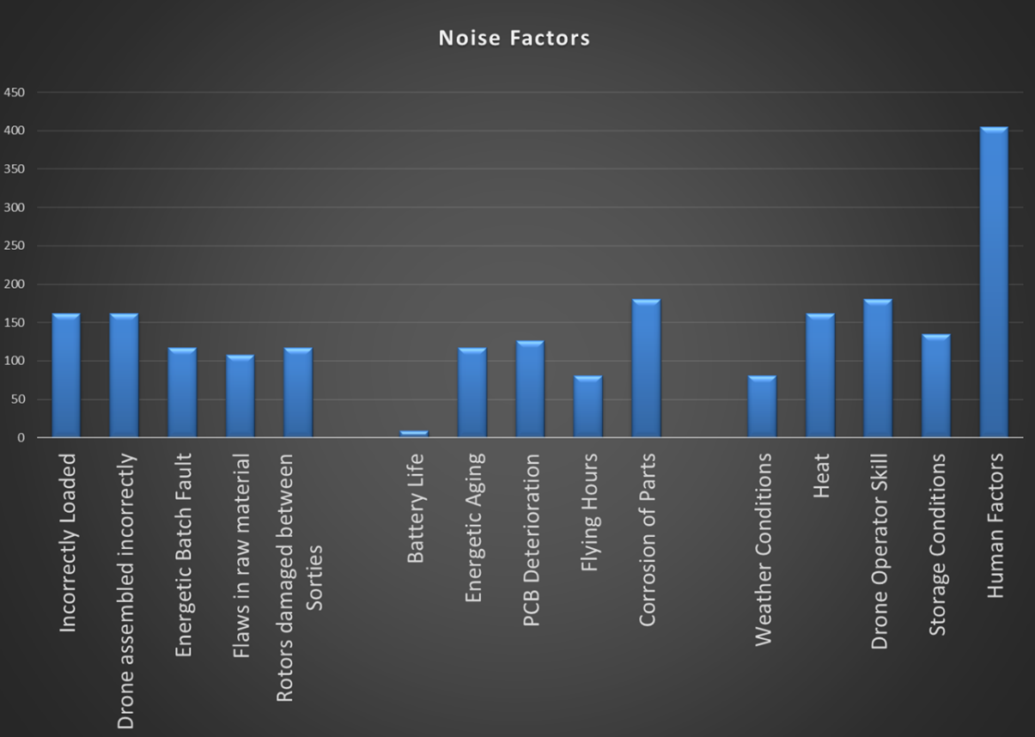
Figure 13 - System Noise Factors
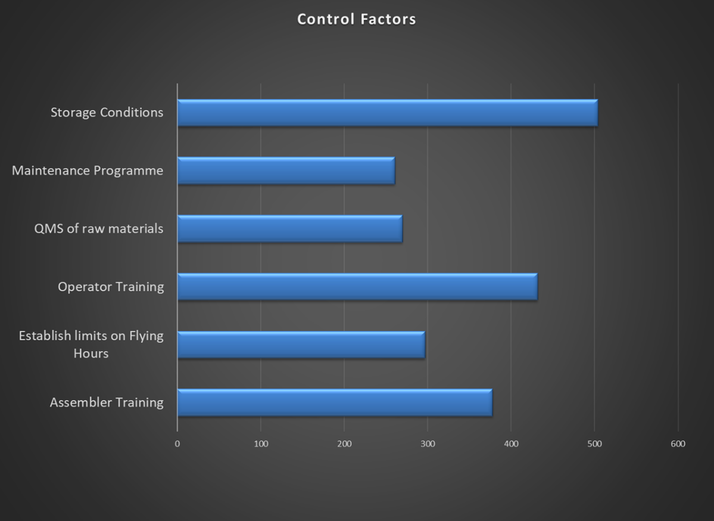
Figure 14 - System Control Factors
In Figure 13, it is split into the 3 different sections all corresponding to the different type of noise factor. From left to right it reads Unit to Unit, Deterioration, then External. As expected, the highest scoring noise factor was Human Factors because humans are involved in essentially every step of production and are always going to make mistakes. From Figure 14, the most important control factor was storage conditions. This could be as it is energetic and sometimes unstable compositions that we are dealing with, they usually need to be kept in a specified temperature and humidity environment to ensure stability and reliability.

High Explosive Warhead
The P-diagram and What-Why table were also completed for the production of the HE warhead to determine the most abundant noise and control factors. The P-diagram and results of the What-Why table can be seen in Figures 15, 16 and 17.
Figure 15 - HE P-diagram

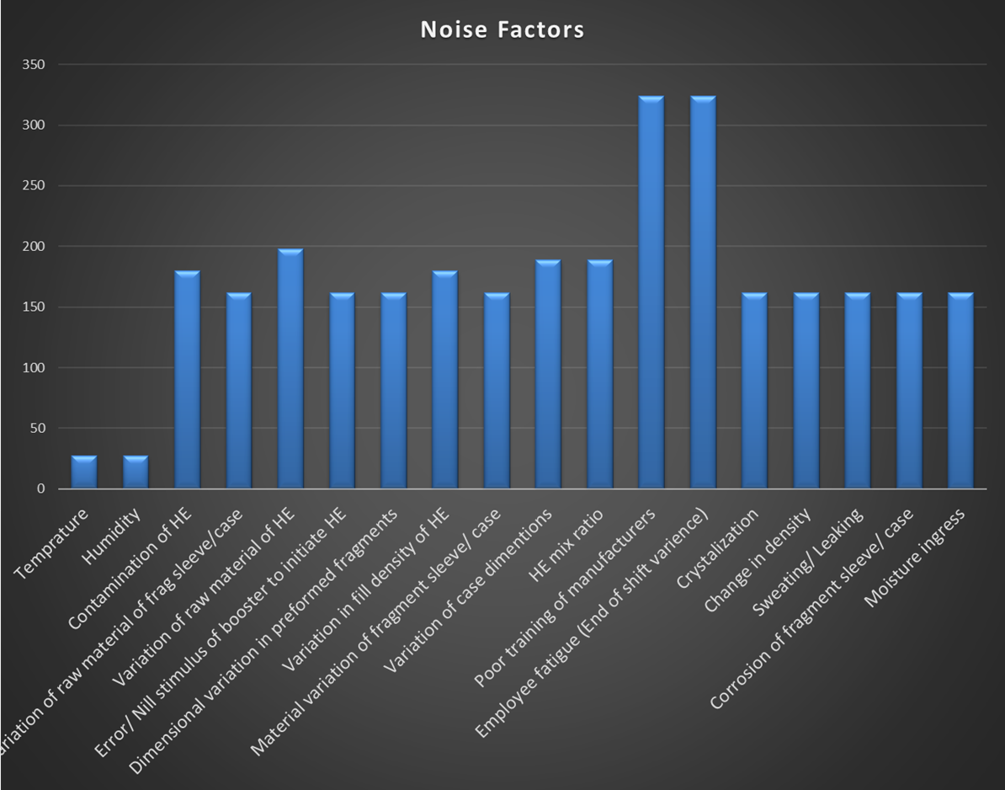
Figure 16 - HE Noise Factors
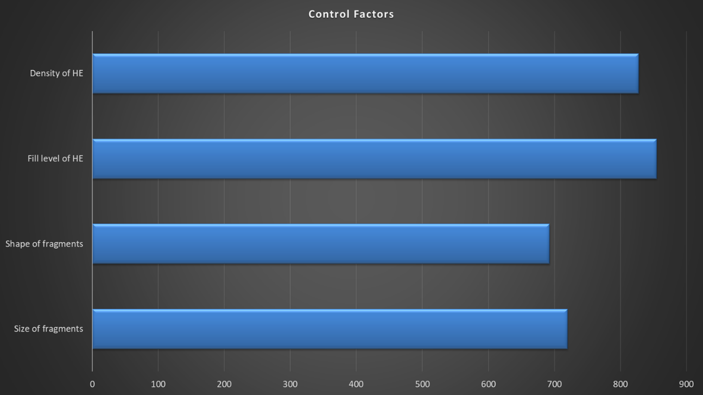
Figure 17 - HE Control Factors

From Figure 16 it shows that the two most abundant noise factors were ‘poor training of manufacturers’ and ‘employee fatigue’. Once again these are both human factors related so it would be expected to be the most relatable to control factors as these are usually either undertaken by humans or integrated by them. Figure 17 shows the scorings of the control factors from the What-Why table, where the fill level of HE in the shell was the most abundant. This control factor can be regulated through the automation of the filling process and independent inspection of this process.

Conclusion
To conclude, Quality Function Deployment (QFD) is an effective method of taking effectively defined customer requirements and converting them into detailed engineering specifications and plans to produce products that fulfil those requirements. Using QFD places the emphasis on the customer and focuses on what they want and need rather than what the company thinks they want. The QFD process applied all the way from machine level to system, sub-system and components with the design specifications monitored throughout all stages to ensure the customer requirements are met. By focusing on customer requirements at the beginning of the design process, QFD allows organisations to save time and resources by preventing the likelihood of late design changes and the addition of design features which add no value. [5]
For project Obscura, QFD was used from the very beginning where we were only supplied with a few main customer requirements and the rest developed by the design team. Using this process gave us a systematic approach to turning these requirements into a product which was capable of meeting them. The product is now ready to begin the manufacturing phase with minimal setback due to the thorough approach that QFD takes.

References

[1] | N. Uzenabor, "Requirements Gathering : Examples & Step-by-Step Process Explained," 14 November 2024. [Online]. Available: https://paceai.co/requirements-gathering-examples-process/#:~:text=Requirements%20Gathering%20Techniques%201%20Interviews%20Interviews%20with%20stakeholders%2C,...%208%20Use%20Case%20Analysis%20...%20More%20items. [Accessed 27 May 2025].
[2] | "Paired Comparison Analysis: A Practical Tool for Evaluating Options and Prioritizing Solutions," [Online]. Available: https://citoolkit.com/articles/paired-comparison/. [Accessed 27 May 2025].
[3] | S. Dr Burge, "The Systems Engineering Tool Box," Burge Hughes Walsh, 2006.
[4] | S. McDaniel, "Improve System Reliability and Performance with a P-Diagram," 28 February 2025. [Online]. Available: https://blog.minitab.com/en/p-diagram. [Accessed 27 May 2025].
[5] | "Quality Function Deployment (QFD)," [Online]. Available: https://quality-one.com/qfd/. [Accessed 27 May 2025].

