
sOFTWARE constructs and the development of software
Software Development – DUM4005

sTEVEN jAMES
sj153398
Tutor – Daniel Davies

Table of Contents
Introduction 2
Section 1 2
Part A 2
1. What is a variable and why are they important in writing programs? 2
2. Explain the term “Code Block” 3
3. Describe the boolean operations that can be used 4
4. Why a for loop can be referred to as a counting loop and why are they used? 6
Part B 7
Part C 11
Exercise 1 11
Exercise 2 12
Exercise 3 12
Section 2 13
Part A 14
1. Arrays 14
2. Functions 15
Part B 16
1. 16
2. 17
3. 17
A. What is causing these problems? 17
B. Test Simulation 19
Part C 20
Exercise 1 20
Exercise 3 20
Exercise 4 21
Bibliography 22

Section 1

Part A

What is a variable and why are they important in writing programs?

A variable is simply a name given to a data value, which is then stored in RAM. Once the data value is stored, it can be referenced through the variable name. Variables are designed to label data and then store it in memory. [1]
To declare a variable, you’ll need a data type that is relevant to the data & a suitable variable name which follows good naming conventions. A data type is chosen based on the range of value required, data types are split into numeric data types and non-numeric data types.

Numeric data types

Data Type | Storage | Range of Value
Byte | 1 byte | 0 to 255
Integer | 2 bytes | -32,768 to 32,677
Long | 4 bytes | -2,147,483,648 to 2,147,483,648
Single | 4 bytes | -3.402823E+28 to -1.401298E for negative values  1.401298E to 3.402823E+38 for positive values
Double | 8 bytes | -1.79769313486232e+308 to – 4.94065645841247E-324 for negative values  4.94065645841247E-324 to 1.79769313486232e+308 for positive values
Curreny | 8 bytes | -922,337,203,685,477,5808 to 922,337,203,685,477,5807
Decimal | 12 bytes | +/- 79,228,162,514,264,337,593,543,950,335 if no decimal is used  +/- 7.9228162514264337593543950335 (28 decimal places)

Non-Numeric data types

Data type | Storage | Range of Value
String(fixed length) | Length of string | 1 to 65,400 characters
String(variable length) | Length + 10 bytes | 0 to 2,000,000,000 characters
Date | 8 bytes | January, 1 , 100 to to December, 31, 9999
Boolean | 2 bytes | True or False
Object | 4 bytes | Any embedded object
Variant(numeric) | 16 bytes | Any value as large as double
Variant(text) | Length + 22 bytes | Same as variable-length string

After assigning the correct data type, a variable name must be decided. Following good naming conventions is advised when naming a variable. One of the main reasons for this is to allow the code to be easily interpreted. Derek M Jones stated in his report “Operand names influence operator precedence decisions” that “meaningful names will provide information to subsequent readers of the code that will reduce the effort needed to comprehend that code.” [2]
Variable data type
Example of a variable
Variable name

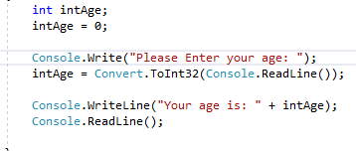
Applying variable to code
Variable declaration
Variables are important within programming for multiple reasons, variables add convenience, flexibility & ease of understanding to programs. A program that would require hundreds of mathematical equations would demand every single bit of data to be programmed and calculated every time without variables. Variables would allow you to calculate those mathematical equations 10 times faster which makes them convenient. Variables are also important as they make our programs more flexible and advanced, for example variables can be used to calculate equations such as the Fibonacci sequence [3].
Despite variables being relative to almost all programming languages, each language will have minor differences. Variables in C# have a few specifics that is not present in all programming languages. C# is case sensitive meaning when variables are declared, the names “number” & “Number” will be classed as two different variables due to upper case letters. In C# the first letter of a variable name must be a letter, although it is acceptable to have digits in a variable name, the first character must always be a letter. Another rule within C# is that variable names may not use any C# keywords, this includes keywords such as “long” or “double”. C# as a programming language is designed to be “type-safe” meaning any variables that are stored must be the appropriate data type, it is also designed to that variables must be specified during declaration.

Explain the term “Code Block”

Code blocks are the grouping of statements within a program into a single statement. Also known as block statements, it’s simply a section of code which is grouped together and enclosed in braces. In some situations where you’re required to use one statement, a code block with multiple statements will be classed as one statement and can be used in such situations. C# uses {} to define its code blocks and is capable of nesting one code block in another code block. Programming languages such as C# which are capable of nesting blocks are called “Block-structured programming languages”.

Example of a Code Block

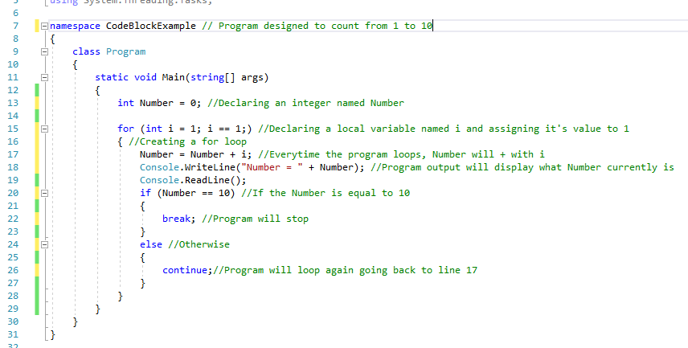
The following program is designed to count from 1 to 10, every time the user presses enter, the number increases by 1. The code block that performs the application has been highlighted, as you can see each code block begins with a “{“ and ends with an “}”.

Describe the Boolean operations that can be used
A Boolean in software development is an expression that returns the values true or false depending on the evaluation. While the IDE will display a true or false value, this translates into 0’s and 1’s which represent true or false. Booleans are used to control the flow of a program, this is done using an if statement. The if statement will take a condition and if the condition is met, it will come back as true. If the condition is not met, an else statement can be used, and it will come back as false. A Boolean mainly uses operators and operands, operands being the objects that are getting manipulated, operators being the symbols representing a specific action.
Several different operators exist within C#, this includes:
- Arithmetic operators
Arithmetic operators are used for mathematical operations
- Increment and decrement operators
Increment and decrement changes the value of an operand of variable by 1
- Assignment operators
Assignment operators are used for assigning a value to a variable
- Relational operators
Relational operator evaluates the relationship between operands, if the evaluation is true, it returns a 1. If the evaluation is false, it returns a 0.
- Logical operators
Logical operators will return a 1 or a 0 based on the expression being returned true or false.

Table of arithmetic operators
Operator | Meaning
+ | Addition
- | Subtraction
* | Multiplication
/ | Division
% | Remainder after division

Table of increment and decrement operators
Operator | Meaning
++ | Increases value by 1
-- | Decreases value by 1

Table of assignment operators
Operator | Meaning
= | Assigns value from left operand to right operand
+= | Adds right operand to left operand then assigns value to the left operand
-+ | Subtracts right operand from left operand then assigns value to left operand
*= | Multiplies right operand with left operand then assigns value to left operand
/= | Divides right operand with left operand then assigns value to left operand
%= | Takes modulus from two operands then assigns value to left operand

Table relational operators
Operator | Meaning
== | Equal to
> | Greater than
< | Less than
!= | Not equal to
>= | Greater than or equal to
<= | Less than or equal to

Table of logical operators
Operator | Meaning
&& | Logical AND, True if all operands are true
|| | Logical OR, True if only one operand is true
! | Logical NOT, True only if operand returns 0

Here is an example of the Boolean operation being used:
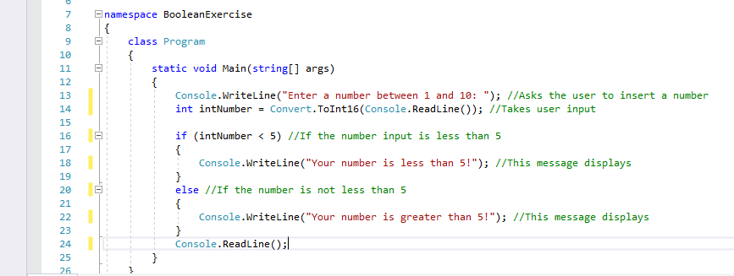
I’ve commented the code to show what is going on. The program asks the user to insert a number, and then checks whether that number is greater than 5. If the number is less than 5, it will return true and display the first message. If the number is not less than 5, it will return false and display the second message.

Why a for loop can be referred to as a counting loop and why are they used?
A for loop is a loop within C# that will continuously loop if the condition is met. When declaring a for loop, at first a local variable can be initialized, then you can input the condition and then input the increment or decrement. A counting loop works in a similar fashion, a counting loop will take a counter and compare it to the limit. Depending on the condition, if the counter is lesser than or greater than the limit, it will either increment or decrement, this will loop until the limit has been reached and the counting loop will end. For loops and counting loops are almost identical which is why one can be referred to as the other.
While loops in general are used mainly to perform actions repetitively, the for loop is also generally used to control the flow of a program.
Condition that will determine whether the loop continues

Example of for loop
Declaring local varibale named intNumber
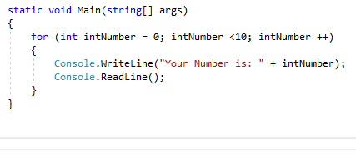
Output
Increment, occurs if condition is not met

Part B

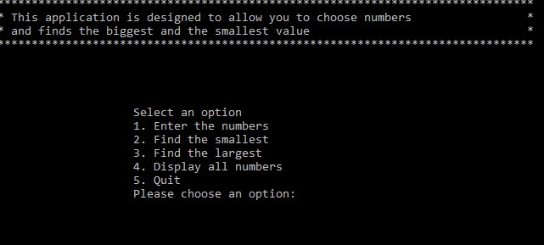
The following program is designed to allow the user to input numbers and then perform actions on those numbers such as finding the min, finding the max & displaying all the numbers. After starting the program, the main menu is displayed, the main menu contains a header giving us a brief example of what the application does. Below that, we have our options. Each option can be selected by entering the number associated with that option. Before the application can figure out minimums or maximums, we must first enter our numbers. This is done by pressing “1”.
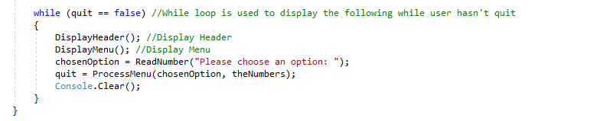
The header and menu is constantly displayed using a while loop and a Boolean.

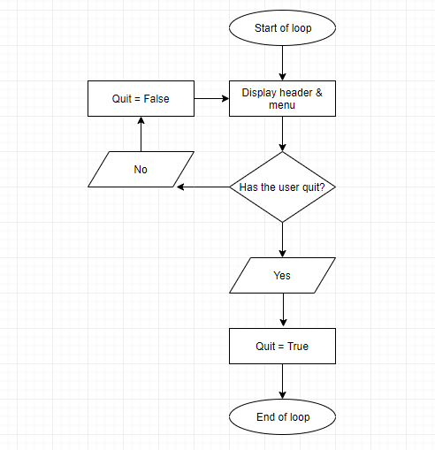
The while operates just as the flowchart demonstrates. The header and menu will display while the user hasn’t quit the program. Once the user quits the program, quit will become true and the header and menu will stop displaying.
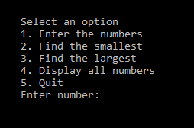
After pressing the first options, we are giving the chance to enter our numbers. After we do this, our numbers get stored in an array.
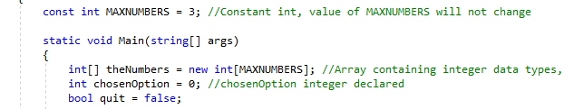
The array which stores the numbers entered is called theNumbers. The array uses a constant integer named MAXNUMBERS to determine the array length. MAXNUMBERS is set to 3 which means the array length will also be 3, this only allows 3 integers to be stored inside the array.
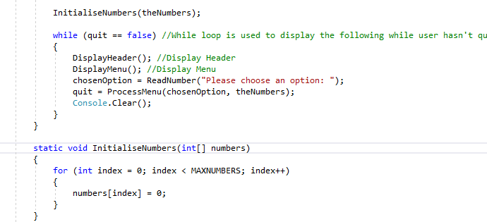
We initialise the numbers entered using the InitialiseNumbers method. This creates a new array called numbers which references the theNumbers array that uses MAXNUMBERS as the array length. In the InitialiseNumbers method, a for loop is used to determine which position in the array each number gets stored in.

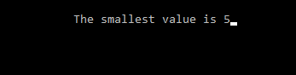
After the numbers are entered and stored in an array, the first action we can do with the application is find the smallest value within that array by entering “2”.
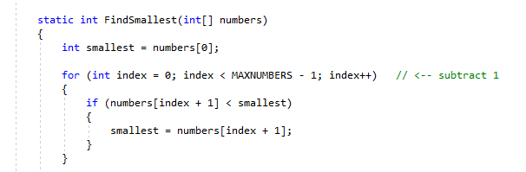
We find the smallest value by using the FindSmallest method. This uses the array where the numbers are stored and by default sets the 0 position in the array as the smallest number. A for loop is then used to compare position 0 to the other positions to determine which is the smallest number. In the for loop, the condition uses the local variable “Index”, and the constant integer “MAXNUMBERS” to check the next position in the array. Because an array starts at 0, MAXNUMBER gets subtracted by 1 so MAXNUMBERS will be 2 instead of 3. Within the for loop, an if statement is then used to compare the current position in the array, which is decided by the index to see if it’s smaller than the default position set by int smallest. If the position is smaller, our “smallest” integer gets updated and the for-loop repeats until our index is equal to or greater than MAXNUMBERS, which is the amount of numbers in our array.

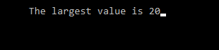
We can also find the largest value of the numbers entered by inserting “3”.
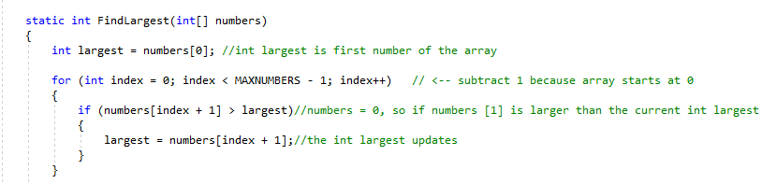
To find the largest value, the same process is used to find the smallest value. Except a new integer is created called “largest”. And within the if statement, instead of checking if the value is less than, the value is checked whether it’s greater than.
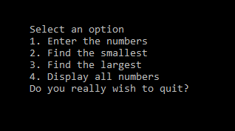
Besides finding the maximum an finding the minimum, we also have an option to display all the numbers, this is option 4. When number 4 is entered by a user, the application asks if we wish to quit, this is due to an error within the code.
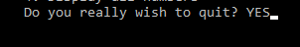
The last option is accessed by pressing 5 on the keyboard, this is the option which allows us to quit the program. Once this option is accessed, the prompt will say “Do you really wish to quit?” the only way to quit the programme is to type “YES” in capital letters.
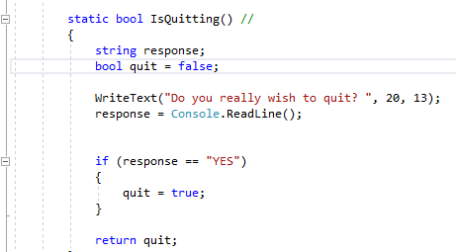
Once “YES” is entered, the IsQuitting function will change the quit Boolean from false to true. This will impact the while loop which keeps the header and menu displayed, meaning the display will shut down and the application will quit.
The entire application is based around user input, the program gives the user the ability to decide what numbers to enter and what the user wants to do with those numbers. This is done using a switch statement.

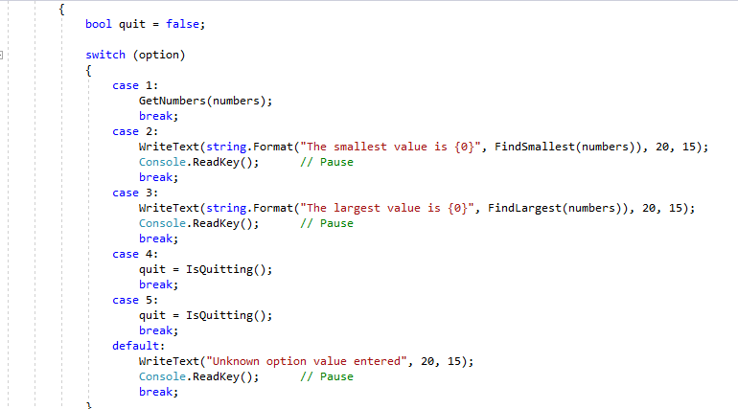
The switch statement has a list of numbers, just like the menu. Once the user enters 1, the GetNumbers method is called and it will allow the user to enter their numbers. Just like when 2 or 3 is entered, the FindSmallest or FindLargest methods are referenced and the program will either find the max or the min. The application is set so when 4 or 5 is entered, the IsQuitting method is called the quit Boolean gets changed from false to true, which will end the program.

Part C

Exercise 1
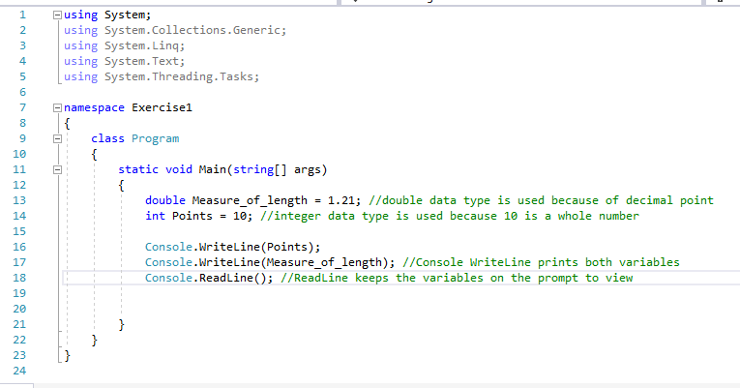
In this exercise I created a double called Measure_of_length and assigned the value 1.21 to it, and I also created an integer called Point and assigned the value of 10 to it. I then output both values by referencing the variables.

Exercise 2
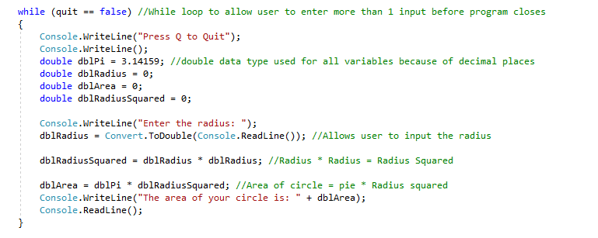
For this exercise I created a program that could calculate the area of a circle. I did this by using double data types as decimal points were involved. I assigned a value of 3.14159 to the double representing Pi, I then allowed the user to input the radius. The program will then square the radius and the results will be assigned to the RadiusSquared double, the area is then achieved by multiplying the RadiusSquared with Pi.

Exercise 3

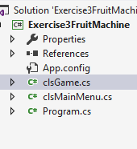
I created the fruit machine using multiple classes, to represent the game, the main menu and the program.

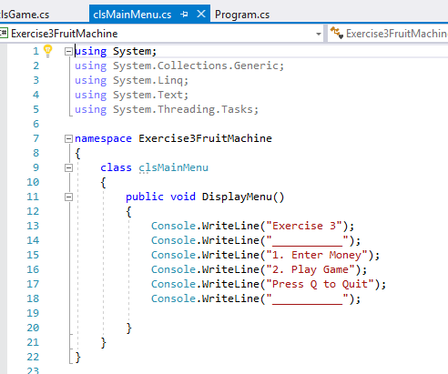
The main menu included outputs which gave the user instructions on how to start the game.

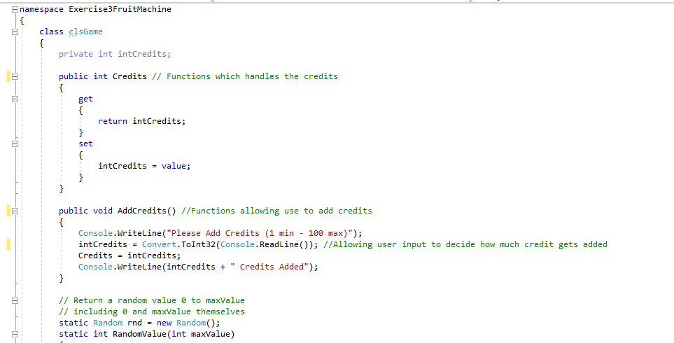
The game class is where all the functions are coded which make the game work.
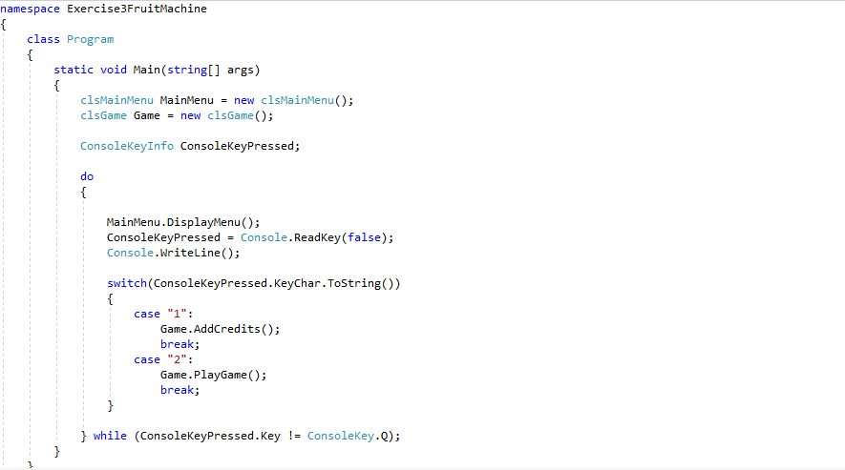
The program class is where both other classes are referenced and the options for the main menu are coded.

Section 2

Part A

Arrays
When creating variables that serve the same purpose, it’s possible to create as many variables as we like, but it’s impractical. Instead of creating hundreds of variables, we can create one array which can hold all these variables. An array is a collection of variables that are the same data type. Creating 100s of variables would be time consuming compared to creating 1 array, but there are many more features to an array besides being more convenient. Using arrays would allow you to sort & shuffle the data stored, perform calculations, find max/min, find averages.
Example of an array
Initializing the array & setting the array length to 4
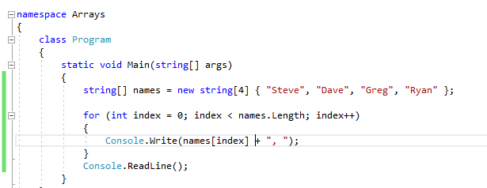
Using a for loop to print all the array values
Array values
Declaring an array of strings called names
Rather than creating 4 variables with strings, assigning values to them separately and then inputting each variable into the for loop to display, we are able to do it in less time and using less code with arrays.
When initializing an array, we can set the length of the array. This determines how many values the array will be able to hold. We are also able to set a width for the array, by doing this we create a multidimensional array. When we need to create an array that requires the values the have values of our own, we could possibly create more arrays, just like we could create each value in an array a variable. Just like it’s easier to create an array rather than 10 variables, it’s easier to create a multidimensional array rather than 10 arrays. [4]

Example of a multi-dimensional array
Initializing multidimensional array
Declaring multidimensional array using [,]
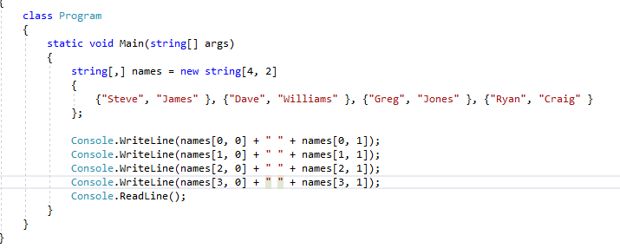
Assigning values to each dimension
The following example shows the effectiveness of multi-dimensional arrays. Rather than making 1 array for first names, then another array for second names, we can make 1 multi-dimensional array to include both.

Functions
Functions in C# are often referred to as methods, they are code blocks encapsulated within braces with an access modifier, a return type and a parameter. Functions enable us to call one piece of code from the program into another piece of code, this can be useful when 2 areas of a program are identical and use the same code. Rather than repeating ourselves, we can reference a function and the same code will be applied to wherever the function is referenced. Functions are heavily used in high level programming as they help with solving large problems and subdivide them. Many programs will have separate classes, one class for the program itself, and one class for all the functions. The program class will then reference each function in order to make a fully functioning program.
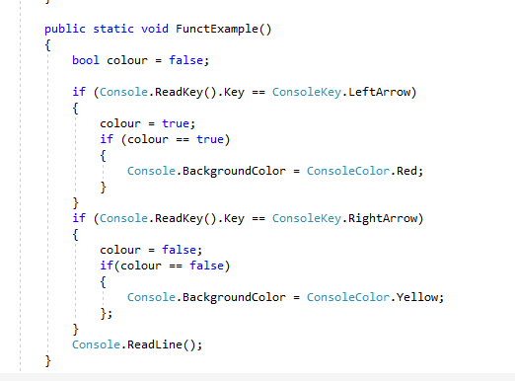
I created a simple program to demonstrate functions, the following functions will change the colour of a background depending on the input from the user. This function can then be referenced anywhere else in the program and it will always allow me to change the colour of the background in the application.

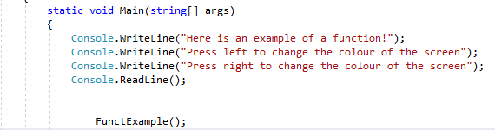
The function to change the colour of a background is then referenced in the main method which will allow the function to be accessible throughout the program.
Functions enable us to subdivide large problems as functions allow us to focus on one area at a time. A program which would allow 2 users to play a game of connect 4 could be programmed entirely without using functions, but this might produce a lot of issues. Functions would enable us to create a function for the players, create a function for the board, the pieces & the input/output. Doing this and subdividing a large problem into smaller problems makes everything a lot easier, if there is an error, we can jump straight to the corresponding function that is producing this error and fix the problem immediately.

Part B

I attempted to input the word “one” instead of the number in the menu. After I input the number, the program closed and an error message reading “System.FormatException ‘input string was not in a correct format’”

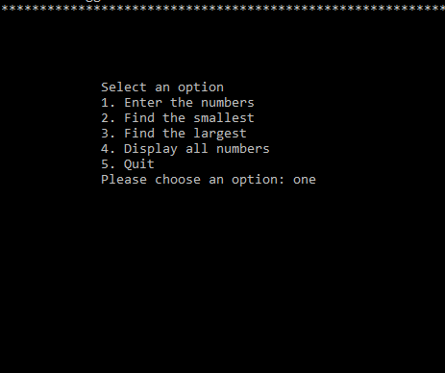
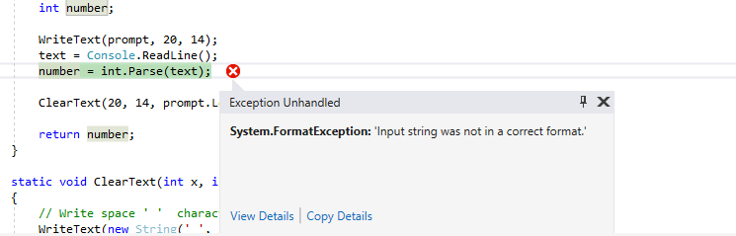

2.
When attempting to quit the application, I input other variation of “YES” such as “Y”, the program doesn’t recognize this therefore does not quit the program.
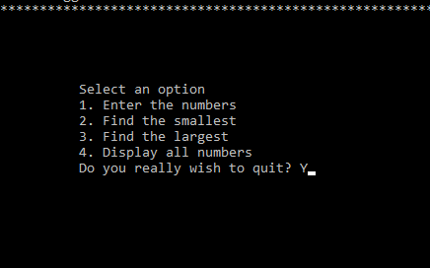

3.
When attempting to enter all the numbers, number 4 does not do what the program says it should. The application states that pressing 4 should display all the numbers which the user has entered, in fact the program instead asks if the user wants to quit.

What is causing these problems?
- Only numbers are a valid way of choosing options within the application because our switch statement is made up of integers and not characters or strings. If we enter a letter or a word, the program crashes because the switch statement does not recognize these inputs.

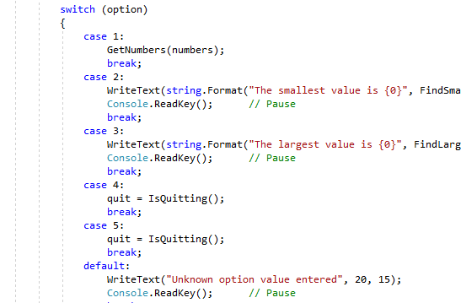
For letters or words to work when selecting options, we would need to code the cases in the switch statement in order to accept strings and characters instead of only integers.

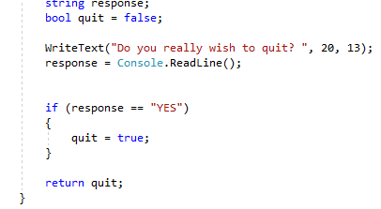
- The issue lies in the IsQuitting function. In the if statement, “YES” is the only answer that is valid.

The response variable within the if statements parameter would need to include other variations of “YES” for them to work within the application. Currently, the program only recognizes “YES” as a valid input to quit the program.

- The problem with displaying all the numbers is there being no function that can display all the numbers. When number 4 is pressed, the application is not referencing any function to display the numbers because there isn’t one.
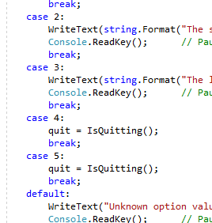
In the switch statement, instead of case 4 referencing a function that displays the numbers, instead if references the IsQuitting function, which is why the application asks if we wish to quit once option 4 is entered.

Test Simulation

Test Number | What is being tested | Results | Actions required
1 | Entering text instead of Numbers in the menu | The program crashes as the menu does not recognize the values entered | Allow the program to be able to understand strings as an input when selecting options in the menu
2 | Quitting with other variations of yes | The program does not accept any other variations other than the one assigned in the program | Input code which allows the quit option to accept other variations of yes
3 | Displaying all the numbers entered | When pressing option 4, the program attempts to quit | Create a function which allows the user to display all the numbers and then reference the function in option 4 of the switch

Part C

Exercise 1

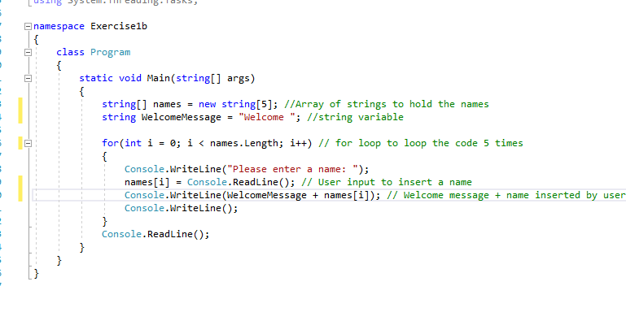
I used an array and a for loop to allow a user to insert a name, and for each name the program will loop displaying the name and a welcome message.

Exercise 3
While testing in part B I managed to correct 2 of the errors.
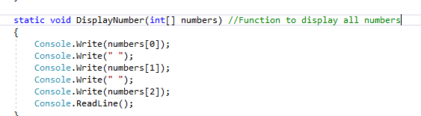
The program is now able to display all the numbers when option 4 is pressed. I did this by creating a function called DislayNumber and allowed to program to print out each number in the array.
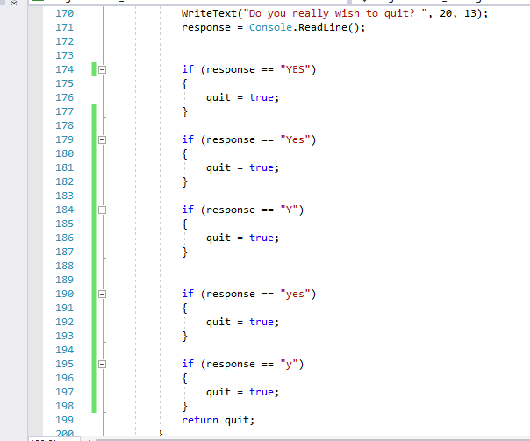
I also managed to make the program quit by using other variations of “YES” i inserted more if functions which would change the boolean quit to true if other variations were inserted such as “yes”, “Y” and “y”.

Exercise 4
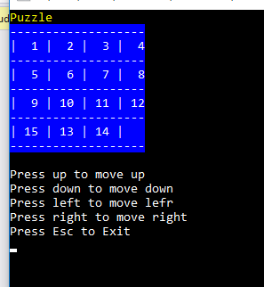
I managed to create a puzzle game grid using a multi-dimensional array. I wasn’t able to get any of the pieces to move.

Bibliography

[1] | B. L. Jones, SAMS teach yourself C# in 21 days, SAMS, 2001.
[2] | D. M. Jones, “Operand names influence operator precedence decisions,” 2007.
[3] | Javatpoint, “Javatpoint,” [Ar lein]. Available: https://www.javatpoint.com/fibonacci-series-in-csharp.
[4] | A. Hejlsberg, The C# Programming Language.

