Module Name: Scripting and Programming Concepts
Module Code: ACCA 5036
Student Name: Joao Paulo Borges Straioto
Student ID:2430803
Lecturer’s Name: Koushik Modak

Code Link GitHub: https://github.com/Joaopaulobstraioto/Smart-Home-Device-Manager.git
University of Wales Trinity Saint David
London campus
SPC Assignment on
Smart Home Device Manager System for Bright Minds Academy
Table of Contents
Introduction 2
Main Body 3
1. Analysis 3
o Requirements Analysis 3
o Functional Requirements 3
o Add New Devices: 3
o Update Device Status: 4
o View Device List: 4
o Simple Search: 4
o User-Friendly Interface: 4
o Scalability: 5
o Non-Functional Requirements 5
o Reliability: 5
o Performance: 5
o Security: 6
o Accessibility: 6
2. Software Design and Development 7
Flowcharts: 7
Pseudo-code 8
Implementation Decisions 10
Programming Constructs: 10
GitHub Repository: 12
3. Testing and Debugging Report 14
a) Importance of Programme Testing 14
b) Types of Errors 14
c) Test Cases 15
Testing Screenshots and Commentary 16
4. Evaluation 19
o Challenges Faced 19
o Future Improvements 19
o Self-Reflection 19
Conclusion 20
References 21

Introduction

Bright Minds Academy is a small private tutoring centre that has recently begun introducing smart classroom devices into its day-to-day operations. As part of a broader effort to modernise its learning environment, the academy has started installing a range of connected devices across its classrooms, including smart lights, thermostats, and projectors, with the intention of creating a more efficient and technology-friendly space for both staff and students.
However, despite having these devices physically in place, the academy has not yet put a proper system in place to manage them. At present, everything is handled manually. Staff members rely on memory, informal notes, or word of mouth to keep track of which devices are installed in which rooms, whether a particular device is currently working, and when it was last checked or used. As the number of devices continues to grow, this approach is becoming increasingly difficult to maintain. Devices are sometimes left in an unknown state, flagged as working when under maintenance, or simply forgotten about altogether. This lack of structure not only wastes time but also increases the risk of disrupting lessons and causing unnecessary frustration for staff.
The need for a solution is therefore clear. This project addresses that need by designing and developing a Smart Device Manager — a Python-based programme built specifically for the academy's situation. It allows staff to add new devices, update their status, view the full device list, and search for a specific device by name, all through a straightforward numbered menu that requires no specialist technical knowledge to operate. The development followed a structured approach, moving through analysis, design, implementation, and testing to deliver a lightweight but effective tool that brings order to the way Bright Minds Academy manages its growing collection of smart classroom devices.

Main Body

1. Analysis

Requirements Analysis
Before any code was written, it was essential to take a step back and carefully analyse the problem that the Smart Device Manager is intended to solve. A clear understanding of what the system needs to do and how well it needs to do it is the foundation of any successful software project. Without this analysis, there is a real risk of building something that does not actually meet the needs of the people who will use it every day [1].
To structure this analysis, the requirements have been divided into two categories. Functional requirements describe the specific features and actions the system must be able to perform. Non-functional requirements describe the broader quality standards the system must meet to be considered reliable, accessible, and fit for purpose in a real working environment [2]. Together, these two sets of requirements define the full scope of what the Smart Device Manager is expected to deliver.

Functional Requirements
Functional requirements define the specific features that the Smart Device Manager must provide to staff. Each requirement below was identified directly from the challenges described in the project scenario and reflects a genuine operational need at Bright Minds Academy [2].

Add New Devices:
Staff must be able to register new classroom devices into the system at any time. When adding a device, they are required to provide two pieces of information: the name of the device, such as "Smart Light A1" or "Projector B2", and the room in which the device is located, such as "Room 101". Once a device is registered, it is automatically assigned a default status of "offline", and the exact date and time of registration is recorded without requiring any manual input from the user. The system must also prevent the same device from being added twice by checking whether a device with that name already exists before saving the new entry.

Update Device Status:
As devices are used, repaired, or taken out of service, their status needs to reflect their current condition. Staff must be able to update the status of any registered device at any time. To maintain consistency and prevent inaccurate data from being stored, only three status values are accepted by the system: online, offline, and under maintenance. If a staff member enters anything other than one of these three options, the system will reject the input and display a clear error message explaining what went wrong. Every time a status is successfully updated, the timestamp is automatically refreshed to record when the change was made.

View Device List:
Staff must be able to view a complete list of all devices currently registered in the system at any time. This list is displayed in a structured, easy-to-read table format that shows each device's name, room location, current status, and the date and time it was last updated. If no devices have yet been added to the system, a clear informational message is displayed rather than an empty or confusing output, ensuring the experience remains straightforward for the user.

Simple Search:
Rather than scrolling through the entire device list to find one specific device, staff must be able to search for it by name. The search function is designed to be forgiving of minor capitalisation differences for example, searching for "smart light a1" will still find a device stored as "Smart Light A1". If the device is found, its full details are displayed immediately. If no match is found, the system informs the user clearly, so they are not left wondering whether something went wrong.

User-Friendly Interface:
The system must be straightforward enough for any member of staff to use confidently, regardless of their level of technical experience [1]. All interactions take place through a simple numbered menu, and every message displayed whether a success confirmation, an error, or a piece of information is written in plain, clear English. No commands or technical knowledge are required at any point.

Scalability:
Although the current version of the system stores data in memory using Python's built-in data structures, the modular design of the programme makes it straightforward to expand in the future. Additional features, such as saving data to a file or database, filtering devices by room or status, or adding a graphical interface, could all be introduced without needing to rewrite the existing code from scratch [1].

Non-Functional Requirements
In addition to its core features, the Smart Device Manager must also meet a set of broader quality standards that determine how well the system performs in practice. These non-functional requirements are just as important as the functional ones, because a system that works correctly but is slow, unreliable, or difficult to use will not be adopted by staff in a real workplace environment [2].

Reliability:
Above all else, the system must be dependable. Staff need to trust that the information they see on screen accurately reflects what has been entered, and that nothing is lost or corrupted between one interaction and the next. To support this, input validation has been built into every function that accepts user input. Blank fields are rejected before they can be saved, duplicate device names are blocked, and only the three accepted status values can be applied to a device. These checks work together to ensure that the data held in the system remains accurate and consistent at all times, regardless of what a user types [2].

Performance:
The system must respond instantly to every action a staff member takes, whether they are adding a new device, updating a status, viewing the full list, or searching for a specific device. Because all data is stored in memory during the session using Python lists and dictionaries, there is no need to read from or write to an external file or database, which means there are no delays caused by input and output operations. Even as the number of registered devices grows over time, the response time of the programme is expected to remain immediate and consistent throughout the session [1].

Security:
Although the Smart Device Manager does not connect to a network or use a database, it is still important that the data entered by staff is handled responsibly. The validation checks in place serve a security purpose as well as a functional one. by refusing blank inputs and invalid status values, they prevent incomplete or nonsensical data from being stored in the system. This reduces the risk of accidental data loss or corruption caused by user error and ensures that the device records remain meaningful and trustworthy for everyone who relies on them [1].

Accessibility:
The system has been designed with accessibility in mind from the very beginning. All interactions take place through a clear, consistently formatted text menu that presents options in a logical and predictable order. Error messages, success confirmations, and informational notices are all written in plain English, avoiding technical jargon that might confuse non-technical staff. The numbered menu structure means that users only need to press a single key to navigate the system, making it genuinely accessible to all members of staff regardless of their level of experience with computers or software [2].

2. Software Design and Development
The flowchart below provides a graphical overview of how the Smart Device Manager operates from start to finish. Once the programme launches, it displays the main menu and waits for the user to enter a choice. Depending on the number selected, it calls the corresponding function add device (), update status (), view devices (), or search device (). After the function completes, the programme loops back to the menu, allowing staff to continue using the system. If the user selects option 5, the programme displays a goodbye message and terminates.

Flowcharts:
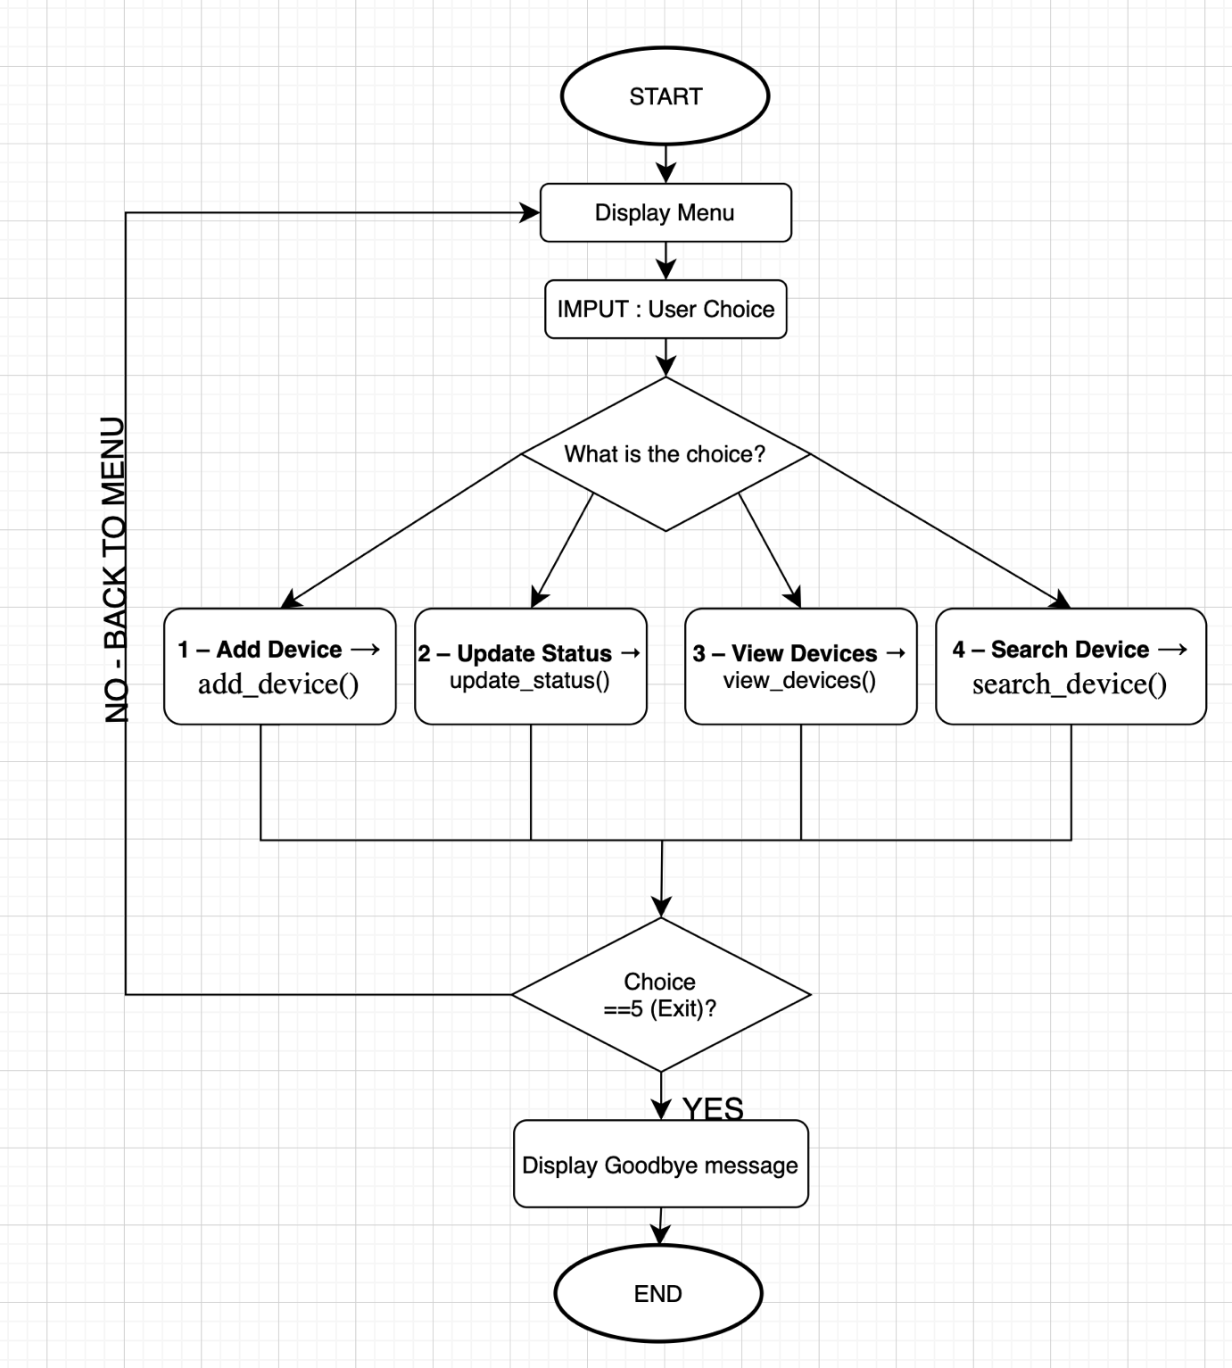
Figure 1 Main Program Flowchart — Smart Device Manager

Pseudo-code
- SmartDeviceManager
BEGIN
devices ← empty list
DISPLAY welcome message
REPEAT
DISPLAY menu (1. Add Device, 2. Update Status,
3. View Devices, 4. Search Device, 5. Exit)
INPUT choice
IF choice = 1 THEN
INPUT name, room
IF name or room is empty THEN
DISPLAY "Fields cannot be empty" → RETURN
END IF
IF device name already exists THEN
DISPLAY "Device already exists" → RETURN
END IF
new device ← {name, room, status: "offline", timestamp: NOW}
APPEND new device TO devices
DISPLAY "Device added successfully"
ELSE IF choice = 2 THEN
INPUT name, status
IF status NOT IN [online, offline, under maintenance] THEN
DISPLAY "Invalid status" → RETURN
END IF
IF device NOT found in devices THEN
DISPLAY "Device not found" → RETURN
END IF
UPDATE device[status] ← status
UPDATE device [last updated] ← NOW
DISPLAY "Status updated successfully"
ELSE IF choice = 3 THEN
IF devices is empty THEN
DISPLAY "No devices registered"
ELSE
FOR EACH device IN devices DO
DISPLAY name, room, status, last updated
END FOR
END IF
ELSE IF choice = 4 THEN
INPUT name
IF name is empty THEN
DISPLAY "Please enter a device name" → RETURN
END IF
FOR EACH device IN devices DO
IF device[name] = name (case insensitive) THEN
DISPLAY name, room, status, last updated → RETURN
END IF
END FOR
DISPLAY "Device not found"
ELSE IF choice = 5 THEN
DISPLAY "Goodbye"
EXIT
ELSE
DISPLAY "Invalid choice, try again"
END IF
UNTIL choice = 5
END

Implementation Decisions
Data Structures: For this project, a list of dictionaries was chosen as the main data structure to store all device information. A Python list was used because it allows new devices to be added at any time, keeps them in the order they were registered, and makes it easy to loop through all entries [3]. Each device is stored as a dictionary inside that list, with four keys: 'name', 'room', 'status', and 'last updated'. Dictionaries were chosen because they let each piece of information be accessed by a clear label rather than a number, making the code much easier to read and understand [4].
The table below describes the main variables used in the solution:
Variable | Type | Description
devices | List | Stores all registered device dictionaries
name | String | The name of the device entered by the user
room | String | The room location of the device
status | String | The status of the device (online, offline, under maintenance)
last updated | String | The date and time the device was last added or updated
choice | String | The menu option selected by the user
valid statuses | List | Contains the three accepted status values used for validation

Programming Constructs:
The following programming constructs were used in the Smart Device Manager and were chosen because they best matched the needs of each part of the system [3].
- While loop:
A while True loop was used in the main function to keep the programme running until the user decides to exit. This was the right choice because the number of times the menu will be shown is not known in advance it depends entirely on how long the staff member uses the system.
- For loops: For loops were used in the add device (), update status (), and search device () functions to go through each device in the list one by one. They are clean, easy to read, and ideal for iterating over a collection of items [3].

- If/Elif/else statements:
These were used throughout the programme to handle menu navigation and decision-making inside each function. They allow the programme to respond differently depending on what the user types, which is essential for a menu-driven system.
- Functions:
Each of the four features was built as a separate function. This keeps the code organised, avoids repetition, and makes it easy to find and fix any part of the programme without affecting the rest [1].
- Error handling and validation:
Instead of letting the programme crash on bad input, validation checks were added inside each function. Blank fields are rejected, duplicate device names are blocked, and any status value that is not online, offline, or under maintenance is refused. This ensures the system stays reliable and the data stored remains accurate at all times [2].
Python Modules and Libraries: Only one built-in Python module was used in this project:
- Datetime:
The datetime module is part of the Python Standard Library, which means it comes installed with Python by default and does not require any additional packages to be downloaded [4]. It was used to automatically record the exact date and time whenever a device is added to the system or its status is updated. This timestamp gives staff a useful record of when each change was made, without them having to type anything manually.
The method used was datetime. datetime.datetime.now().strftime("%Y-%m-%d %H:%M:%S"), which formats the current date and time into a clear, readable string such as 2025-03-15 10:45:32.
No third-party libraries were used in this project. This was a deliberate decision to keep the programme lightweight and easy to run on any computer that has Python installed, without requiring any setup or installation steps [5].
- Source Code:
The full source code for the Smart Device Manager is available in the GitHub repository below. The code is organised into user-defined functions, follows consistent indentation, and includes comments throughout to explain the logic of each section [6].
GitHub Repository: https://github.com/Joaopaulobstraioto/Smart-Home-Device-Manager.git

The screenshots below show the key functions of the programme as written in Thonny, with annotations to highlight the most important parts of the code.
This screenshot shows the add device () function, which allows staff to register a new device. It includes two validation checks: one to prevent blank fields and another to block duplicate device names before adding the new entry to the devices list.
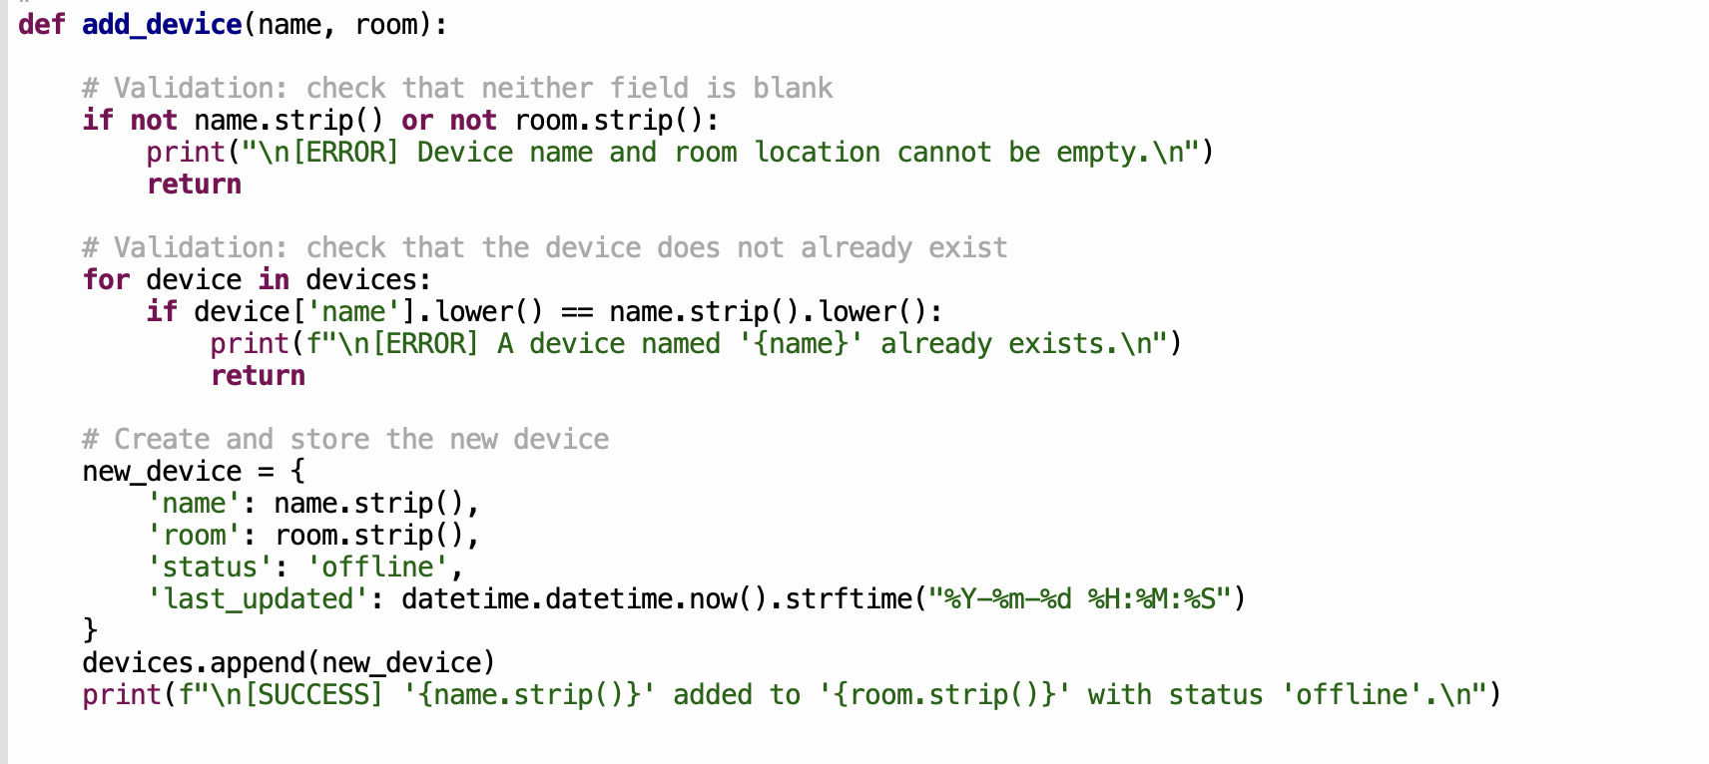
Figure 2 add device() Function — Input Validation and Device Registration

This screenshot shows the update status () function. It first checks that the status entered is one of the three valid options — online, offline, or under maintenance — and then searches the list for the device and updates its status and timestamp.
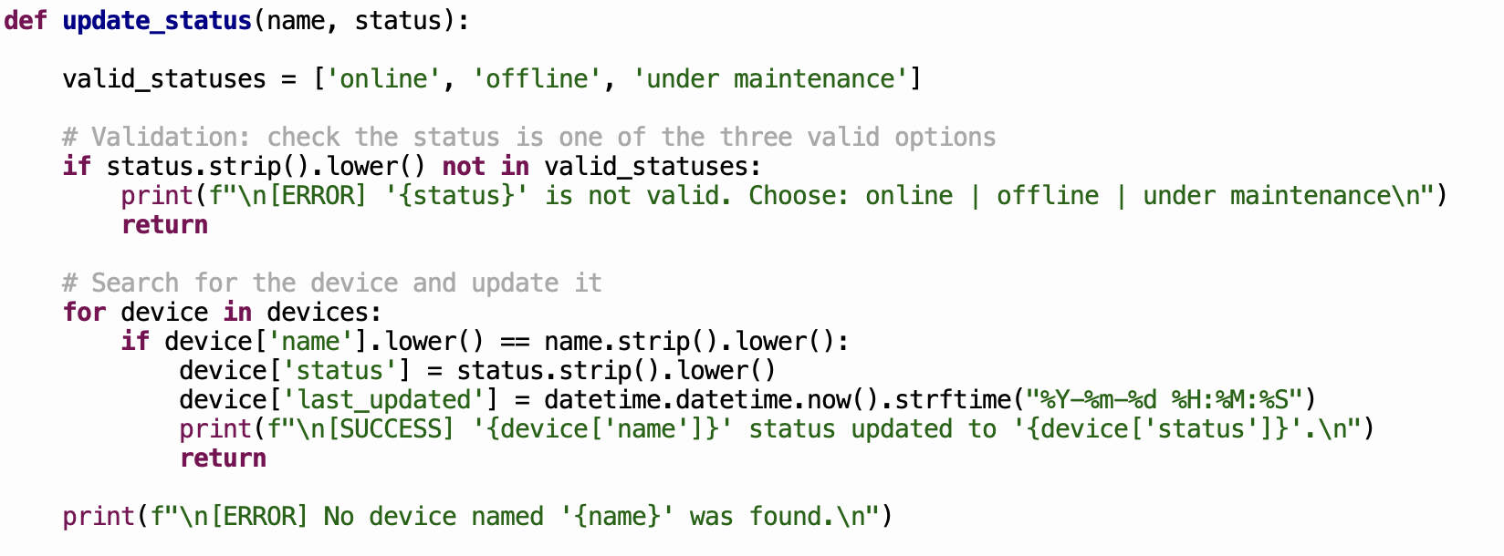
Figure 3 update status () Function — Status Validation and Device Update

This screenshot shows the view devices () function, which displays a formatted table of all registered devices, including their name, room, status, and the date and time they were last updated. If no devices exist, an informational message is shown instead.
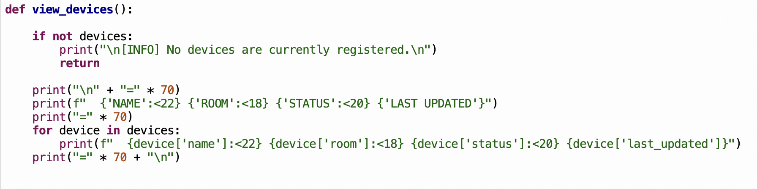
Figure 4 view devices () Function — Displaying All Registered Devices in a Formatted Table

This screenshot shows the search device () function. It validates that the input is not blank, then loops through the devices list looking for a name match. The search is case-insensitive, meaning staff do not need to worry about capitalisation when typing the device name.
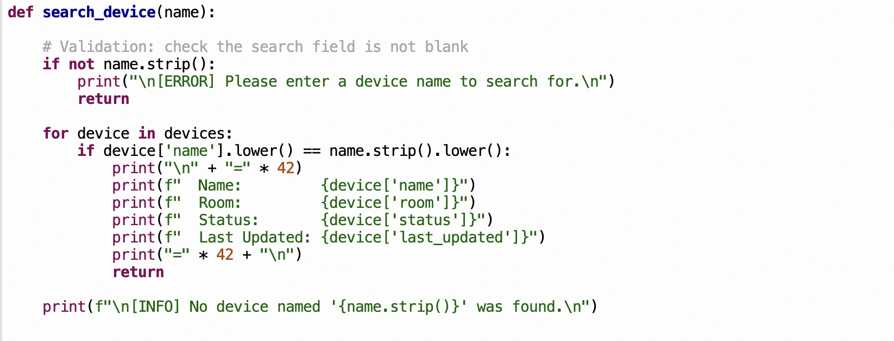
Figure 5 search device() Function — Case-Insensitive Search and Device Details Display

3. Testing and Debugging Report

a) Importance of Programme Testing
Testing is an essential part of software development because it ensures the programme works correctly before it is used by real people. Without testing, errors can go unnoticed and cause the system to produce wrong results or crash unexpectedly [7]. For the Bright Minds Academy Smart Device Manager, testing is especially important because the system is used by non-technical staff, meaning any unexpected behaviour could lead to incorrect device data being stored. Testing also confirms that all validation checks work as intended, giving confidence that the programme handles both correct and incorrect inputs reliably [6].

b) Types of Errors
- Syntax Errors: These happen when the code breaks the rules of the Python language, such as a missing colon or incorrect indentation. Python catches these before the programme runs and points to the line where the problem is. They are the easiest errors to fix.
- Logic Errors: These occur when the programme runs without crashing but produces the wrong result. For example, if the search function compared names without using. lower (), it would fail to find a device if the capitalisation did not match. These errors require careful testing to detect since Python does not flag them [6].
- Runtime Errors: These happen while the programme is running and cause it to crash. For example, calling a method on an empty value would produce a runtime error. In this project, input validation was used to prevent these situations from occurring [7].

c) Test Cases
The table below shows the test cases used to verify the validation and functionality of the Smart Device Manager. Screenshots follow each group of tests.
ID | Description | Input | Expected Output | Result
TC01 | Add valid device | Name: "Smart Light A1", Room: "Room 101" | Device added successfully | Pass
TC02 | Add duplicate device | Name: "Smart Light A1" (already exists) | Error: device already exists | Pass
TC03 | Add – empty name | Name: "", Room: "Room 101" | Error: fields cannot be empty | Pass
TC04 | Add – empty room | Name: "Projector B2", Room: "" | Error: fields cannot be empty | Pass
TC05 | Update to valid status | Device: "Smart Light A1", Status: "online" | Status updated successfully | Pass
TC06 | Update to invalid status | Status: "broken" | Error: invalid status | Pass
TC07 | Update non-existent device | Device: "Ghost", Status: "online" | Error: device not found | Pass
TC08 | View all  populated list | -- | Formatted table displayed | Pass
TC09 | View all – empty list | -- | Info: no devices registered | Pass
TC10 | Search existing device | Name: "Smart Light A1" | Device details shown | Pass
TC11 | Search non-existent device | Name: "Ghost Device" | Info: device not found | Pass
TC12 | Search – empty input | Name: "" | Error: please enter a name | Pass
TC13 | Invalid menu choice | Choice: "9" | Error: invalid choice | Pass
TC14 | Case-insensitive search | Name: "smart light a1" | Device found correctly | Pass
TC15 | Status input with spaces | Status: " online " | Status accepted and trimmed | Pass

Testing Screenshots and Commentary
The screenshot below demonstrates the system successfully registering a new device. The staff member entered the device name and room location, and the programme confirmed the addition with a success message.
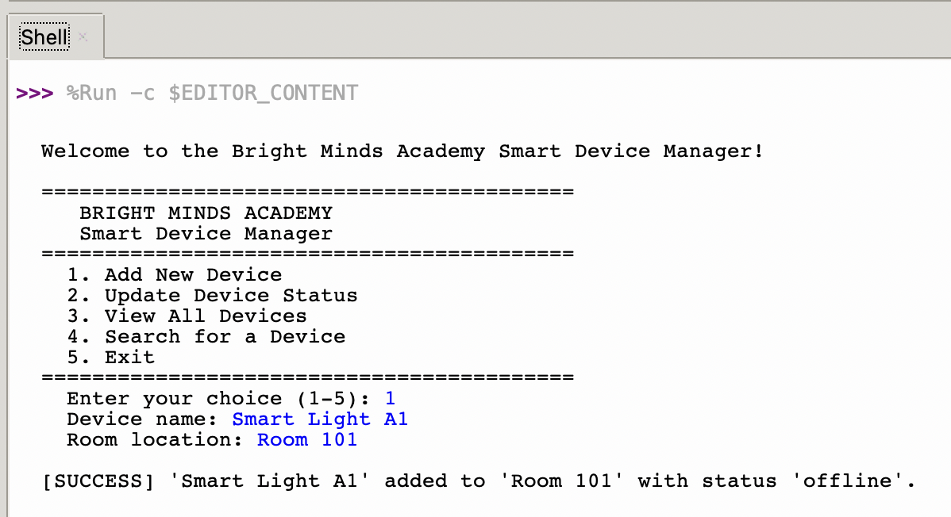
Figure 6 TC01 — Successfully adding a new device to the system

The screenshot below shows the system correctly blocking a duplicate entry. When the same device name was entered a second time, the programme detected it and displayed an error message without saving the record again.
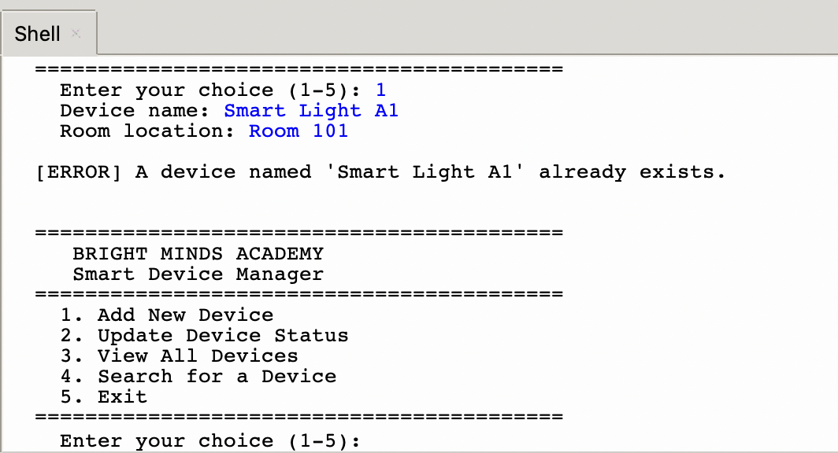
Figure 7 TC02 — Duplicate device entry correctly rejected

The screenshot below demonstrates the empty field validation. When the device name was left blank and the Enter key was pressed, the programme refused to continue and displayed a clear error message.
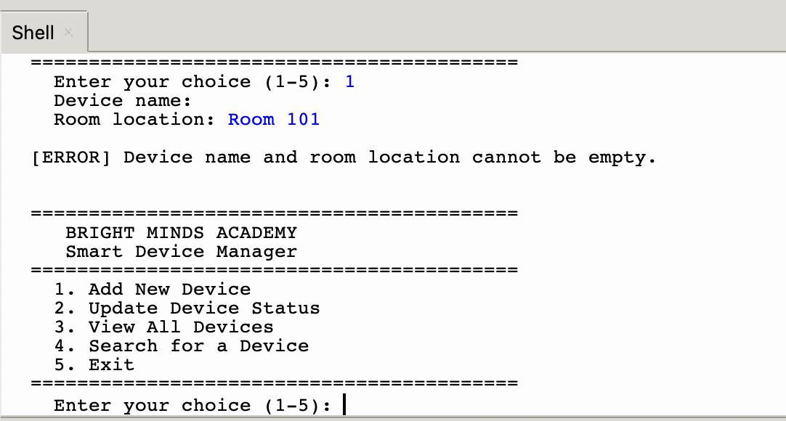
Figure 8 TC03 — Empty device name field correctly rejected

The screenshot below shows the update status feature working correctly. The staff member entered a valid status value, and the programme confirmed the update with a success message.
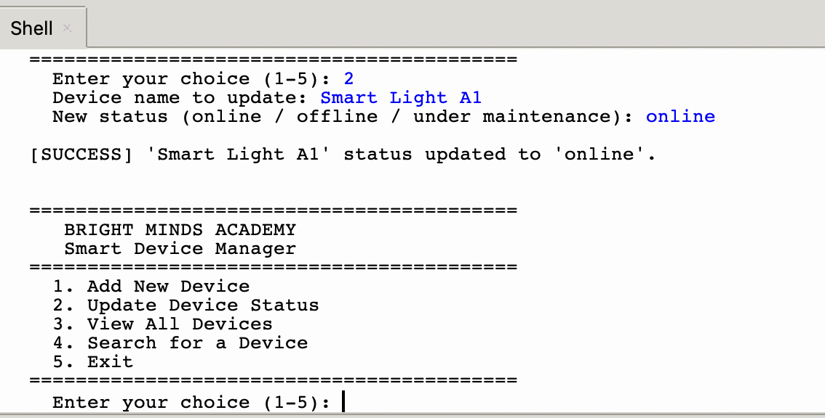
Figure 9 TC05 — Device status successfully updated to "online"

The screenshot below demonstrates the status validation in action. When an invalid status value was entered, the programme rejected it and reminded the user of the three accepted options.
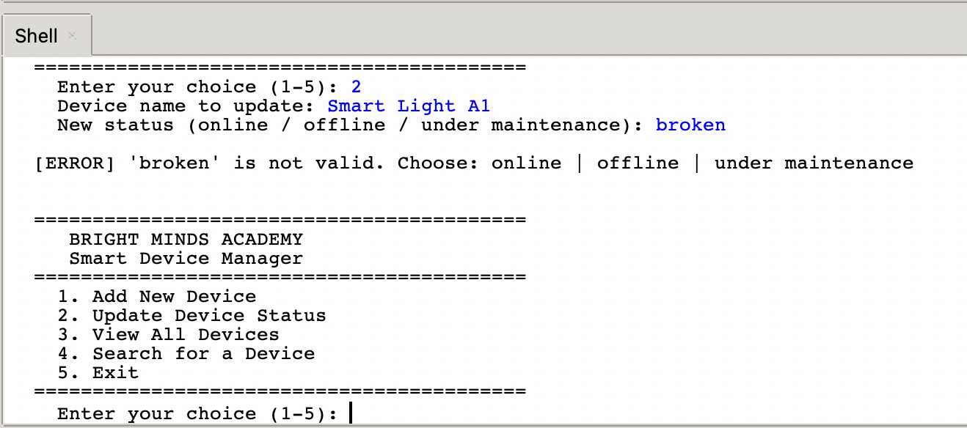
Figure 10 TC06 — Invalid status value correctly rejected

The screenshot below shows the view all devices feature displaying a formatted table of all registered devices, including their name, room location, current status, and the date and time they were last updated.
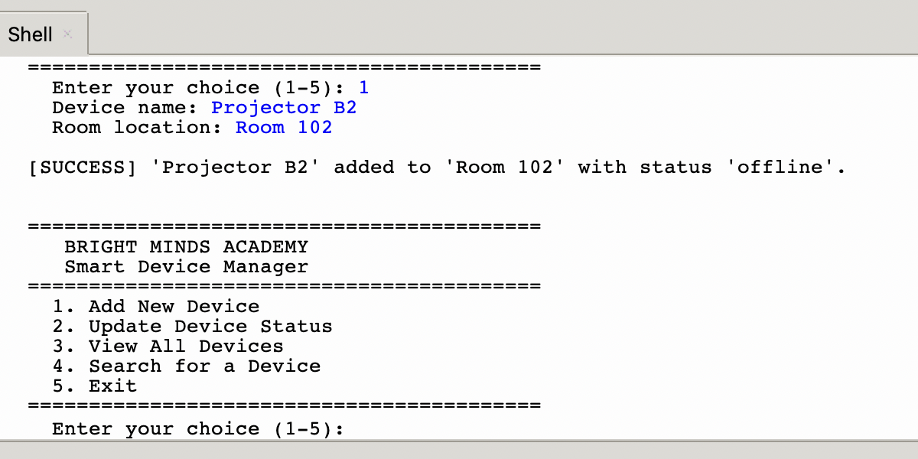
Figure 11 TC08 — All registered devices displayed in a formatted table

4. Evaluation

Challenges Faced
One of the biggest challenges I faced during this project was making sure the validation logic worked correctly for every possible input. At first, the search function was case-sensitive, which meant that typing "smart light a1" would not find a device stored as "Smart Light A1". I fixed this by converting both the input and the stored name to lowercase before comparing them. Another challenge was preventing duplicate entries I had to loop through the entire list each time a new device was added to check if the name already existed. Working through these problems helped me understand how important it is to think about what users might type, not just what they are supposed to type.

Future Improvements
There are several improvements that could make this system more powerful in the future. First, connecting the programme to a database such as SQLite would allow device data to be saved permanently, so it is not lost when the programme closes. Second, adding a feature to filter devices by room or by status would make it easier for staff to find specific groups of devices quickly. Third, a graphical user interface could replace the text menu, making the system more accessible and visually appealing for non-technical users. Finally, adding a login system would ensure that only authorised staff can make changes to the device records.

Self-Reflection
This project taught me a great deal about how to plan and build a working programme from scratch. Before starting, I had to analyse the problem carefully and break it down into smaller, manageable parts something I had not done in such a structured way before. I also learned how important it is to validate user input, as I realised early on that users do not always type exactly what is expected. Writing separate functions for each feature helped me keep the code organised and made it much easier to test and fix individual parts without affecting the rest. Overall, this project made me more confident as a developer and gave me a much better understanding of how real software is planned, built, and tested.

Conclusion

This project successfully delivered a simple, functional, and well-structured Smart Device Manager for Bright Minds Academy. What began as a straightforward problem — staff struggling to keep track of their growing collection of smart classroom devices — has been addressed through a Python programme that brings order, clarity, and reliability to a process that was previously managed by hand.
The programme allows staff to register new devices along with their room location, update device statuses to reflect real-time conditions, view a complete and clearly formatted list of all registered devices, and search for any specific device by name. All of these features are accessible through an easy-to-use numbered menu that requires no technical knowledge to operate, making the system genuinely practical for everyday use in a busy tutoring centre.
Throughout the development process, deliberate decisions were made to keep the solution as simple and maintainable as possible. The use of Python lists and dictionaries as the primary data structure kept the programme lightweight and easy to understand, while the modular approach of separating each feature into its own function made the code clean, organised, and straightforward to test. Input validation was built into every part of the system that accepts user input, ensuring that the programme handles unexpected or incorrect entries gracefully rather than crashing or storing inaccurate data.
The project met all of the functional requirements identified during the analysis stage and successfully passed all fifteen test cases, covering both correct and incorrect user inputs. The result is a reliable, user-friendly tool that solves the problem it was designed to address and provides a solid foundation that could be expanded with additional features in the future, such as permanent data storage or a graphical interface, as the needs of Bright Minds Academy continue to grow.

References

[1] I. Sommerville, "Software Engineering, 10th Global ed," 2016,
[2] R. S. Pressman and B. R. Maxim, Software engineering: a practitioner's approach, McGraw-Hill New York, 2005.
[3] M. Lutz, Learning python: Powerful object-oriented programming, " O'Reilly Media, Inc.", 2025.
[4] E. Matthes, Python crash course, no starch press San Francisco, CA, 2019.
[5] J. Burns et al., , "Transforming digital phenotyping raw data into actionable biomarkers, quality metrics, and data visualizations using cortex software package: tutorial," vol. 26, pp. e58502, 2024,
[6] J. Kasurinen, "Software test process development," 2011,
[7] L. Luo, "Software testing techniques," vol. 15232, no. 1-19, pp.19, 2001,

