Louise Caygill  15/01/2025 | Word Count  2706
UWTSD
Implementation and Analysis of NBFM Jamming Techniques and RTL-SDR Receiver Design Using GNU Radio
Advanced Digital Signal Processing ACDA6018

Contents
List of Tables 2
Table of Figures 3
Introduction 4
Task 1: Jammer Techniques Using GNU Radio 5
Background Research 6
Ethics and Impact 7
NBFM and FHSS Methodologies 7
NBFM Block Diagram 8
Implementation 9
Simulation Images 11
NBFM Formulas and Expressions 13
Results and Analysis 13
Discussion 14
Task 2: Design and Analysis of an RTL-SDR Receiver in GNU Radio 15
WBFM Methodology 16
Block Diagram 16
Implementation 16
Signal Analysis and Visualisation 19
Formulas and Expressions 21
Ethical and Societal Impacts 21
Conclusion and Future Recommendations 22
References 23
Annex 1 25
Annex 2 26

List of Tables
Equation 1: WBFM Transmission Formula 13
Equation 2: NBFM Expression 13
Equation 3: Jamming Signal Expression 13
Equation 4: Expansion of Xj(t) Expression 13
Equation 5: FHSS Expression 13
Equation 6: SNR Formula 13
Equation 7: RTL-SDR Signal Equation 16
Equation 8: Complex Baseband I/Q Expression 21
Equation 9: I'(t) Expression 21
Equation 10: Q(t) Expression 21
Equation 11: Expanded Z(t) Expression 21

Table of Figures
Figure 1: Example of AM and FM 6
Figure 2: NBFM Modulation Block Diagram 8
Figure 3: NBFM Demodulation Block Diagram 8
Figure 4: FHSS Implementation Block Diagram 8
Figure 6: High-Level NBFM Block Diagram 9
Figure 5: Jammer Signal Block Diagram 9
Figure 7: NBFM Modulator and Demodulator With Jamming Element 9
Figure 8: Example of Waterfall Sink with FHSS 10
Figure 9: Modulated Signal Visualisation - NBFM 11
Figure 10: Source Signal Visualisation – NBFM 11
Figure 11: Demodulated Signal Visualisation - NBFM 12
Figure 12: Channel 1 With (right) and Without Noise (left) 12
Figure 13: Channel 4 With (right) and Without Noise (left) 12
Figure 14: WBFM Block Diagram 16
Figure 15: RTL-SDR Programme 16
Figure 16: Sample Rate Global Variable 17
Figure 18: Low Pass Filter Settings 17
Figure 17: Soapy RTLSDR Source Properties 17
Figure 19: WBFM Receive Block Settings 18
Figure 20: Rational Resampler Settings 18
Figure 21: Multiply Constant Settings 18
Figure 22: Source Signal Visualisation: 96.2 - Andover FM 19
Figure 23: Filtered Signal Visualisation: 96.2 - Andover FM 19
Figure 24: Demodulated Signal Visualisation: 96.2 - Andover FM 20
Figure 25: Constellation Diagram of Source, Filtered and Demodulated Signal 20

Introduction
Task 1 of this report documents the design, implementation and analysis of a NBFM modulation and demodulation system with frequency hopping capabilities. The system is evaluated through the addition of a jamming signal. Task 2 describes the design and creation of a WBFM receiver using an off the shelf SDR.
Sections for Task 1 include Background Research, a discussion on the Ethics and Impact, followed by Methodologies, Block Diagrams and Flowcharts, Implementation, Simulation Images, Formulas and Expressions, Results and Analysis, Discussion. Task 2 includes sections on the WBFM Methodology, Block Diagrams, Implementation, Signal Analysis and Visualisation of the results, Formulas and Expressions, followed by Ethical and Societal Impacts, and finally a Conclusion covering both tasks.

Task 1: Jammer Techniques Using GNU Radio

Background Research
Low frequency transmissions (300KHz and below [1]) require a huge amount of amplification for transmission and an equally large antenna [2]. To reduce the costs and power consumption the signal is modulated prior to transmission. This involves mixing a source signal with a carrier wave [2]. The main methods of modulation are Amplitude Modulation (AM) and Frequency Modulation (FM), the subject of this report. In FM the waveform is modulated with a carrier wave alternating in frequency with the amplitude of the original signal. Seen in Figure 1 [3] below, the original waveform (b) is mixed with a carrier wave (a) producing an AM or FM signal (c and d). FM is less susceptible to interference than AM, and capable of larger bandwidths [3].
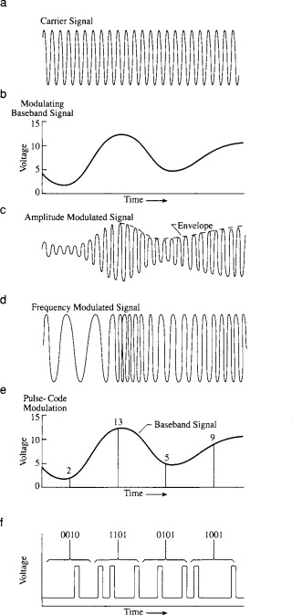
A jammer generates noise or interference on specific target frequencies. There are three types of jammers currently in use; spot, barrage or swept [4]. When using a spot jammer, a single frequency is targeted, concentrating all its power on that frequency. This type of jammer is ineffective against Frequency Hopping Spread Spectrum (FHSS) targets or agile networks. Alternately, a swept jammer will sweep across multiple frequencies from one end of its range to the other incredibly fast, making it more effective against FHSS targets. Lastly, barrage jamming transmits interference over an entire frequency range at once. Meaning it is not able to be as powerful as a spot or swept jammer [4]​.
Figure 1: Example of AM and FM
FHSS is the continuous hopping of the carrier frequency to reduce interference [5]. The concept being that should a frequency be targeted by a jammer or interference of any kind the radio is able to switch onto another carrier frequency to avoid it.

Ethics and Impact
The use of jammers in the UK is illegal under the Wireless Telegraphy Act 2006 [6]. However, specialist use cases may be granted, such as in prisons, by law enforcement [7], or for military experiments [8]. The main reason jamming is illegal is that the effect may be far larger than intended [9]. For example, the transmission may block emergency services channels, either on purpose or through spurious signals [10].
Therefore, the use of jammers should be carefully considered to reduce the impact. For example, Ofcom, the UK Spectrum regulatory body, specify that experiments using jammers should be “sufficiently remote, shielded, or low power that there is no likelihood of interference external to the test area” [7].
Non-ethical use of a jammer may be considered the blocking of free-speech or information, GPS services, or Electronic Warfare (EW) attack rather than defence. For example, the Chinese governments use of the FireDrake jammer to block foreign radio stations [11], and the disruption of essential communication services by an aggressor, rather than defending party.
The jammer may also fall into the non-ethical category through poor design. Here the jammer may leak noise over unintentional frequencies, which may affect the emergency services, GPS, or essential communication between two parties.
FHSS allows the party experiencing jamming a technique to continue communication securely. Without FHSS the information could be lost, and important information not relayed, resulting in the loss of resources and time.

NBFM and FHSS Methodologies
This report uses GNU Radio, a free, open-source software toolkit that uses processing blocks to create software radios [12]. Narrow Band Frequency Modulation (NBFM) utilises a smaller bandwidth than with Wide Band FM (WBFM), hence Narrow Band [13].
The input signal is a .WAV audio file. The carrier frequency by default is set to 20KHz, remaining Very Low Frequency (VLF), with a default modulation index of 0.5, able to be altered during the simulation from 0 to1. The bandwidth of the system is 40KHz.
The FHSS aspect of the NBFM modulator and demodulator is designed so that the carrier frequency is multiplied by the number in the channel selected by the QT GUI Chooser. The jammer functions the same way. The hop is done by the user rather than automatically due to software limitations in GNU Radio.

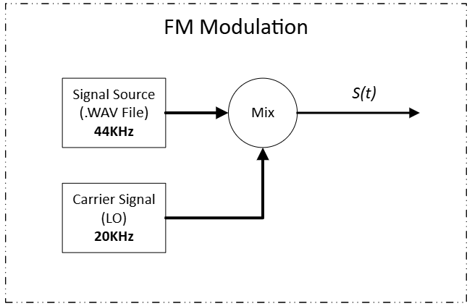
NBFM Block Diagram
Figure 2: NBFM Modulation Block Diagram
Figure 2 above shows the block diagram for NBFM modulation, producing the transmit signal S(t), followed by the demodulation of S(t) producing the complex signal Z(t), seen in Figure 3 below
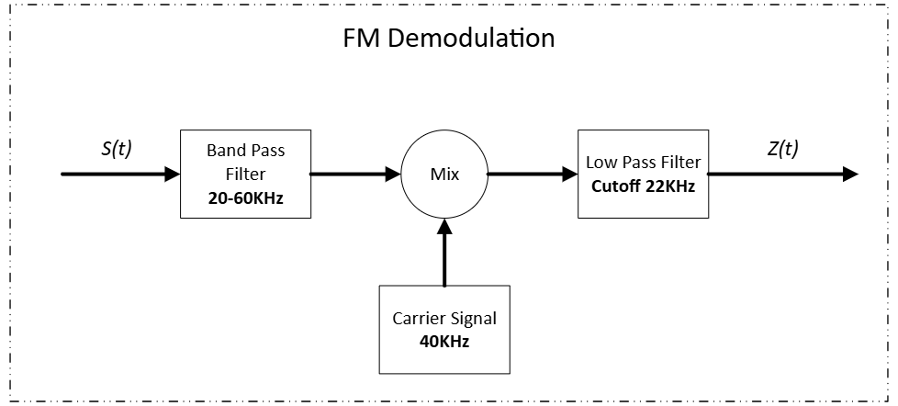
Figure 3: NBFM Demodulation Block Diagram

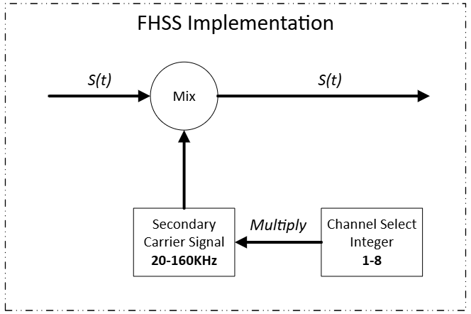
Figure 4 below is the block diagram for FHSS implementation, which is added to the S(t) signal to add additional frequencies for hopping.
Figure 4: FHSS Implementation Block Diagram
Finally, below in Figure 5 is the jammer signal block diagram which is added to the transmitted S(t) signal as well.
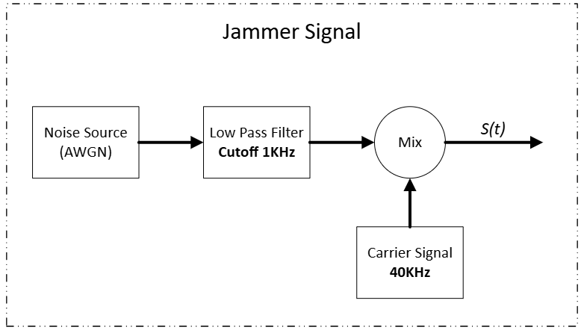
To better understand the flow with the two additional elements, the diagram in Figure 6 may be used.
Figure 6: High-Level NBFM Block Diagram
Figure 5: Jammer Signal Block Diagram

Implementation
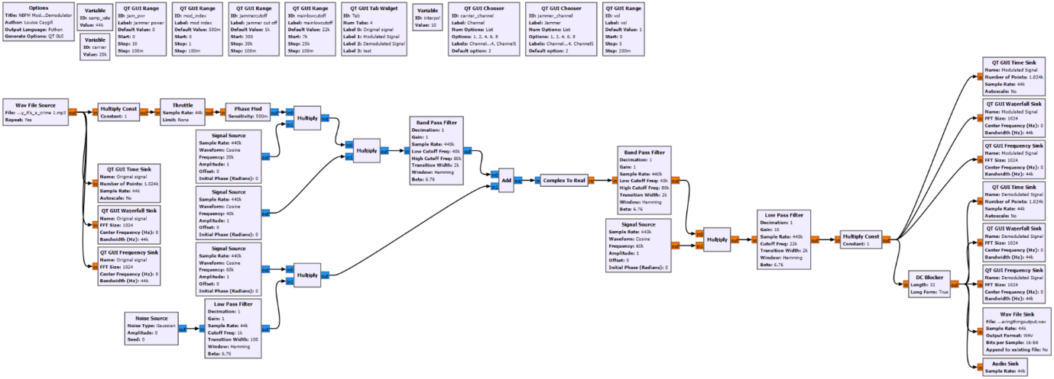
The block diagram for the NBFM flow in GNU Radio may be seen below in Figure 7 below (a larger image is in Annex 1).
Figure 7: NBFM Modulator and Demodulator With Jamming Element
The signal source is a 44KHz .WAV file, which enters a multiply constant, throttle and phase mod block, before being multiplied by a 20KHz carrier wave for modulation. The resultant signal is multiplied by a second stage carrier wave ranging from 20-160KHz, providing the additional frequencies for FHSS. This signal then enters a band pass filter to filter out unwanted signals and reduce the bandwidth to the desired narrow band of 40KHz. Thus, the signal enters the transmit channel where it encounters a jamming signal. This jamming signal is multiplied by a 40-320KHz carrier signal for modulation, alterable in the same manner as the source signal. This signal enters a second band pass filter, again with a bandwidth of 40KHz to remove any unwanted signals added by the jammer. The remaining signal is mixed with a 40KHz carrier wave to separate the carrier from the original signal. Finally, it enters a low pass filter to remove unwanted high frequencies, leaving the demodulated signal.
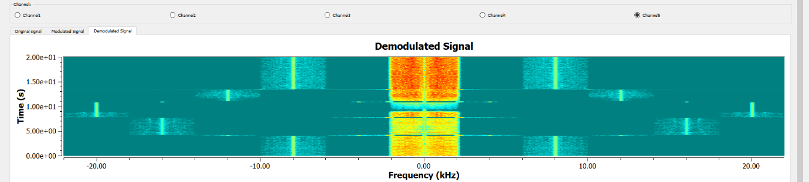
FHSS in implemented by selecting one of 5 channels in the simulation, seen at the top in Figure 8 above. In each of these channels is an integer of 1, 2, 4, 6, and 8 respectively. This integer is multiplied by the 20KHz starting frequency to provide alternate frequencies for the original source to avoid the jammer. For instance, on Channel 1, the 20KHz carrier is multiplied by 1, whilst in channel 3 it is multiplied by 4. The jammer functions in the same manner and may change channel to jam the signal when it has hopped. This hopping is demonstrated using the waterfall sink of the demodulated message in Figure 8 above, where the channels are selected consecutively, moving the sidebands out and in again.
Figure 8: Example of Waterfall Sink with FHSS

Simulation Images
Following are images from the simulation in GNU Radio. Figure 10 below shows the original signal.
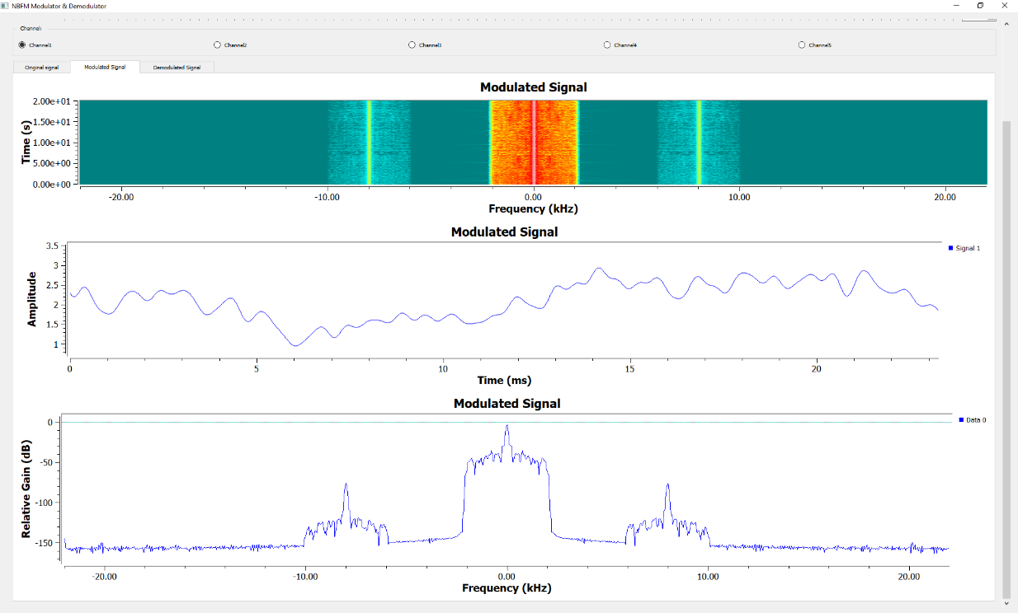
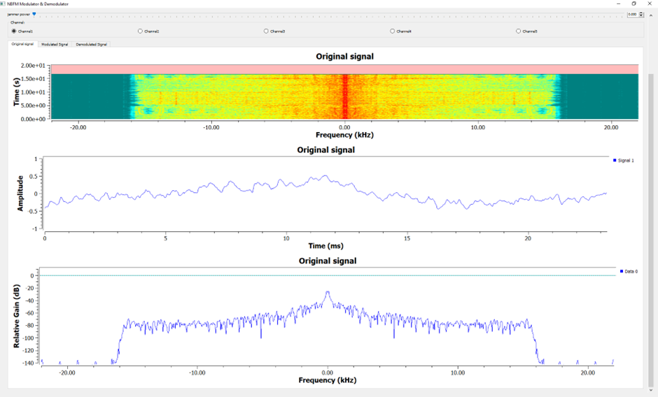
Figure 9 below shows the modulated transmission signal. It may be seen that the bandwidth has been reduced, and two side bands added.
Figure 9: Modulated Signal Visualisation - NBFM
Figure 10: Source Signal Visualisation – NBFM

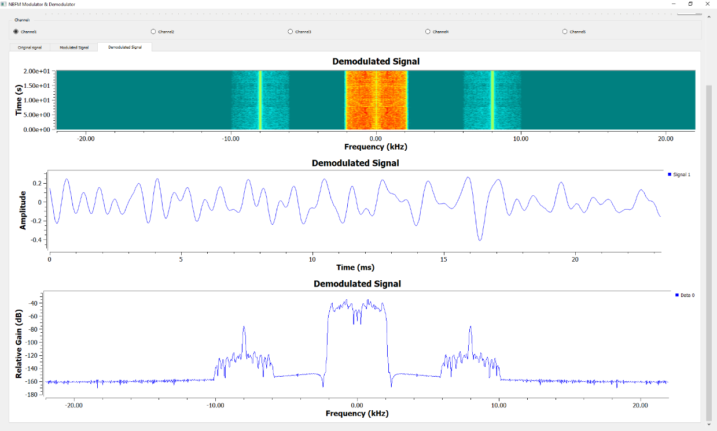
Figure 11 above shows the demodulated signal. It may be seen that the signal has noise, but still a good Signal to Noise Ratio (SNR).
Figure 11: Demodulated Signal Visualisation - NBFM
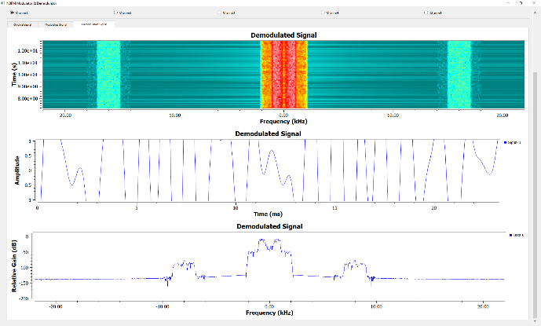
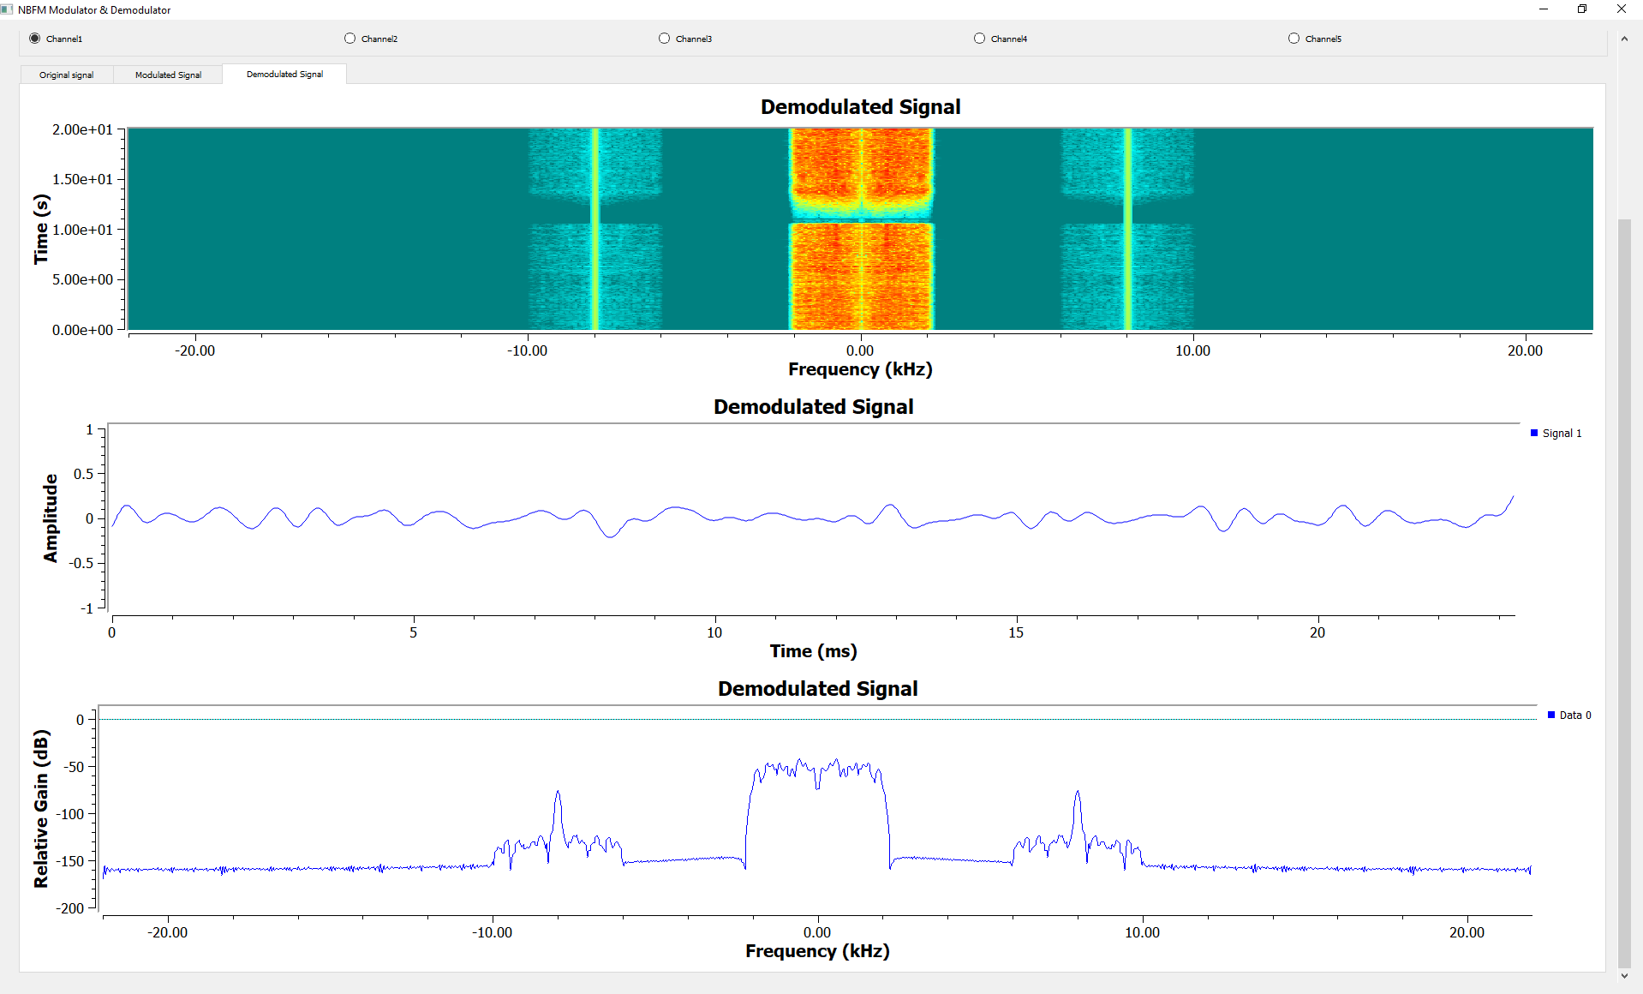
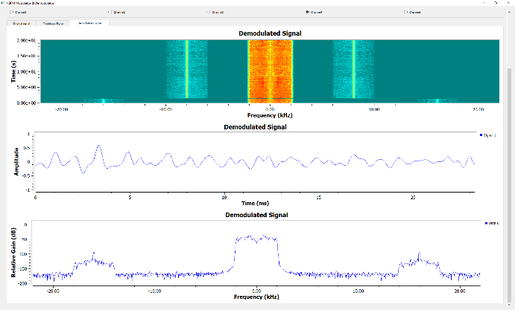
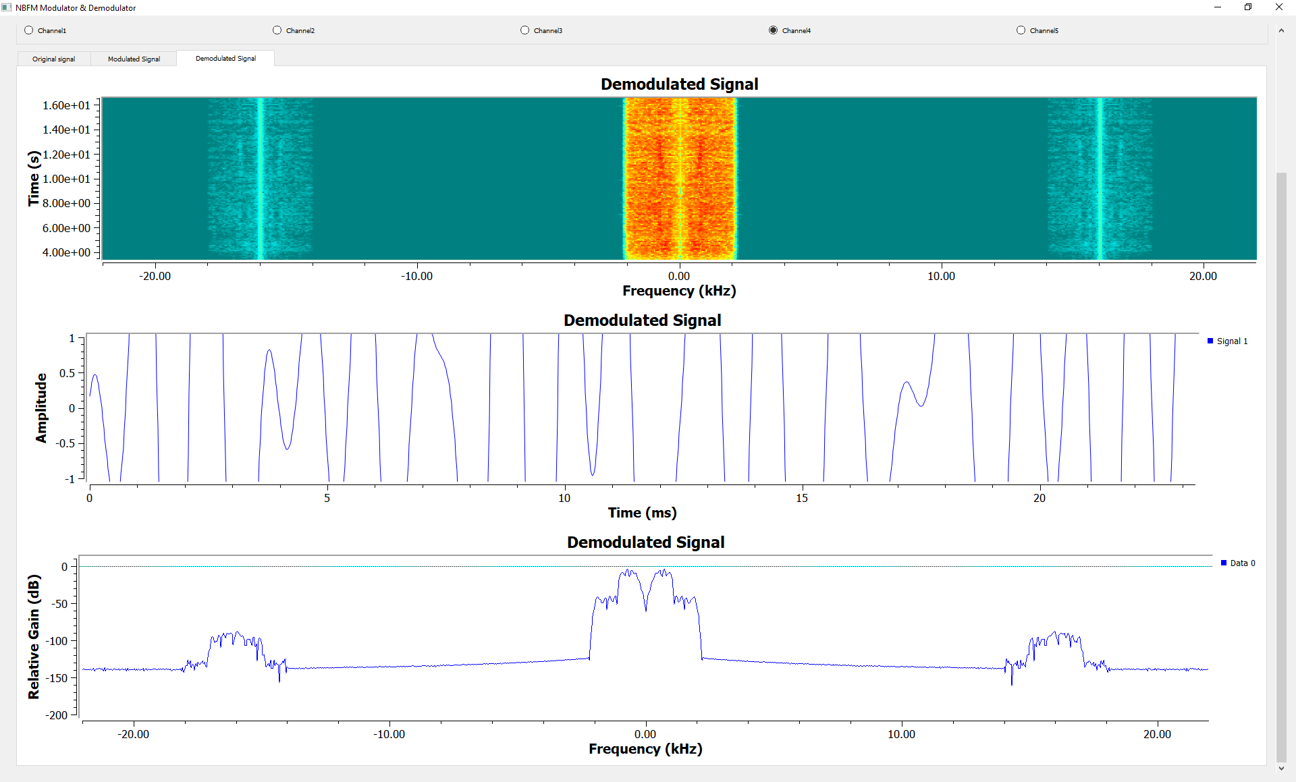
Figure 12 above and Figure 13 below show the effects of the jammer on the demodulated signal. The left-hand images show the clear modulated signal on Channel 1 and Channel 4, and the right-hand images show the demodulated signal with the jammer active on the same channel. It may be seen on the amplitude graph that the signal has been overwhelmed, and the original signal lost.
Figure 12: Channel 1 With (right) and Without Noise (left)
Figure 13: Channel 4 With (right) and Without Noise (left)

NBFM Formulas and Expressions
For FM application the following formula for WBFM is used
$${S\left(t\right)= A}_{C}Cos [2πf_{c}t+β\sin{2πf_{m}}t]$$
Equation 1: WBFM Transmission Formula
To obtain a narrow band, the β must be small compared to a radian [14]. Therefore, after expansion and simplification becomes
$$s\left(t\right)≈A_{c}\cos\left(2πf_{c}t\right)-βA_{c}\sin\left(2πf_{c}t\right)sin⁡(2πf_{m}t)$$
Equation 2: NBFM Expression
Which will produce the approximate form of NBFM wave [14].
The jammer signal may be defined broadly by the following [15]
$$r\left(t\right)= x_{j}(t)+x_{tg}(t)+n(t)$$
Equation 3: Jamming Signal Expression
Where $r\left(t\right)$ is the received signal, $x_{j}(t)$ the jamming signal, $x_{tg}(t)$ the target signal and $n(t)$ the AWGN. $x_{j}\left(t\right)$ is expanded as
$$x_{j}\left(t\right)= A_{j}cos [2π\left(f_{c}t+∆_{j}\right)t+b_{j}\left(t-n_{j}\right)\frac{{π(t-n}_{j})}{2T}+φ_{j}]$$
Equation 4: Expansion of Xj(t) Expression
With $x_{tg}(t)$ having the same formula, simply replacing $j$ values with $tg$ values. In the above expression $φ_{j}$ is the phase of the signal, $f_{c}$ the carrier frequency, $∆_{j}$ the jammer frequency and $n_{j}$ the timing offset.
For this report, the additional frequencies that the signal is able to hop to through FHSS may be represented simply by
$$F_{HOP}=f_{ca}*x_{ch}$$
Equation 5: FHSS Expression
Where $f_{ca}$ is the frequency of the carrier wave, and $x_{ch}$ the integer held by the chosen channel. The jammer hopping may be represented by the same formula, with the carrier frequency being replaced by the jammer frequency.

Results and Analysis
Without jamming the system functions well, the audio quality could be improved, but the original signal elements are present, and the correct information conveyed. With jamming introduced, depending on the jammer power, the original signal becomes overwhelmed and no longer discernible, as seen in the right-hand images of Figure 12 and Figure 13 previously.
SNR is the ratio of signal power to noise power, the formula for which is as below[16].
$$SNR= \frac{Signal Power}{Noise Power}$$
Equation 6: SNR Formula
The system displays a good SNR without jamming. The signal is able to be heard and understood. However, it could be improved in clarity. When adding the jammer, the SNR rapidly decreases as the jammer power is increased, eventually overwhelming the original signal. A good SNR is able to be regained by frequency hopping to a different channel.

Discussion
As demonstrated in this report, FHSS is an effective anti-jamming method, it gives the signal agility and the ability to change frequency to avoid being jammed, whilst retaining source signal information. During simulation a new channel may be selected by the user for the modulated signal and the jammer. This channel selection works well, and there is no bleed from the jammer into the next channel, signifying appropriate filtering and that the frequency hopping is implemented correctly with no additional loss of signal clarity.
In real-life applications frequency hopping is done automatically, with multiple hops happening per second [17]. It is a design limitation of GNU Radio that this is not able to be implemented automatically and must be done by manually switching the channel.

Task 2: Design and Analysis of an RTL-SDR Receiver in GNU Radio

WBFM Methodology
A Software Defined Radio (SDR) is an electronic, wireless device configurable through software, capable of RF transmissions from FM radio to 5G plus [18]. This report uses a Nooelec NESDR Mini SDR [19] as a receiver.
The design for the WBFM is done so as to be as simple as possible to ensure the clearest signal quality utilising the RTL-SDR. Again, the design makes use of GNU Radio with global variable block; samp_rate set to 2.048MHz. The working frequency is set by the range GUI and by default is set to 9.59MHz, Andover FM (later altered to 96.2 for signal clarity), able to be tuned between 85-110MHz encompassing all commercial radio stations.

Block Diagram
The block diagram for the WBFM operation may be seen below in Figure 14.

Implementation
Figure 14: WBFM Block Diagram
The design of the receiver is seen below in Figure 15 (a larger image is in Annex 2), which represents the following.
$$s\left(t\right)=i\left(t\right)+jq\left(t\right)$$
Equation 7: RTL-SDR Signal Equation
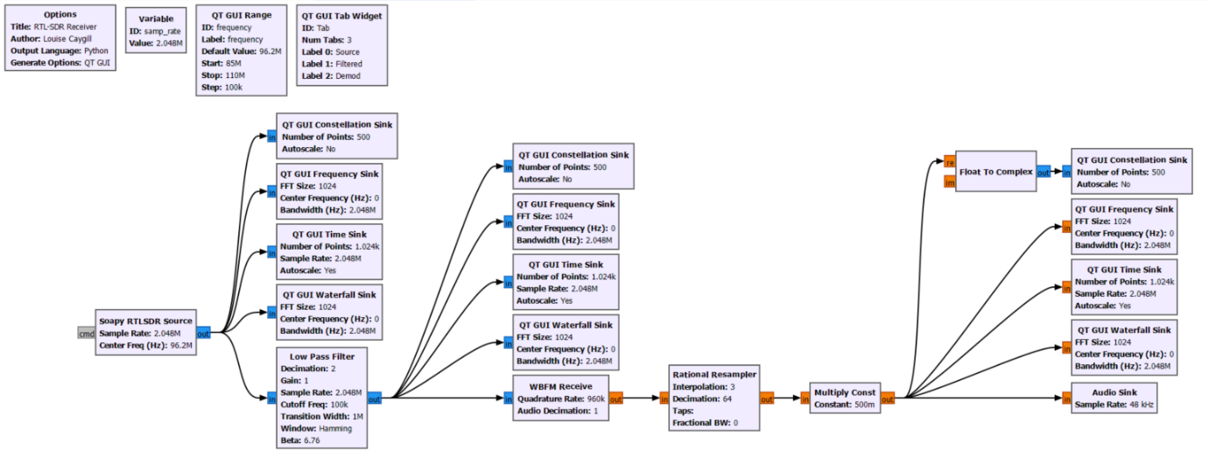
Figure 15: RTL-SDR Programme
The global variable for sample rate is seen in Figure 16 overleaf.
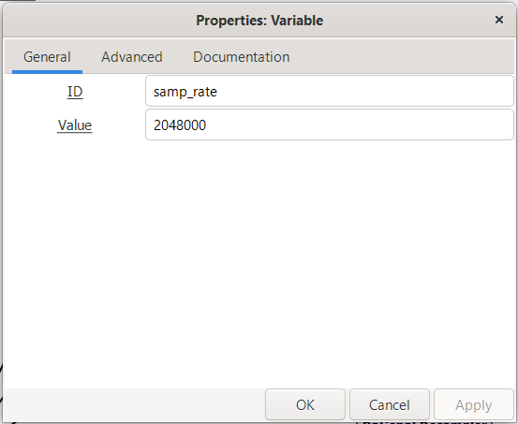
The signal is introduced by the Soapy RTLSDR block on the left of Figure 15, which reads the input from the SDR USB. The properties for this block are seen in Figure 17 below.
Figure 16: Sample Rate Global Variable
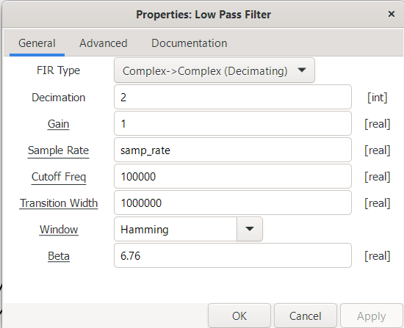
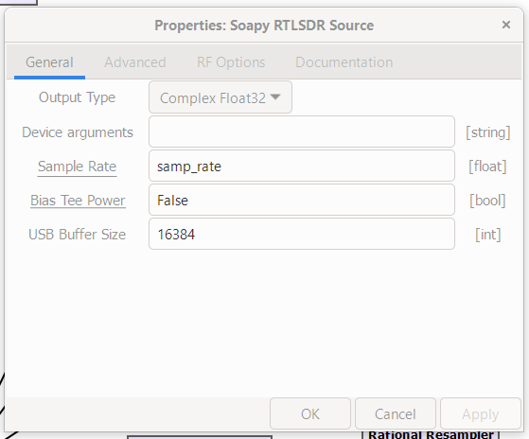
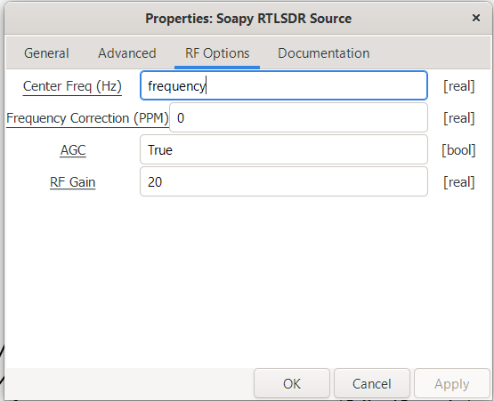
The signal passes through a low pass filter to remove noise and interference, seen in Figure 18 below. It has a decimation level of 2, gain of 1, cut off frequency of 100KHz, and a transition width of 1MHz. Decimation in this case meaning to the reduce the sampling rate, also known as down-sampling [20], reducing the bandwidth and removing unwanted high frequency noise. The gain is set to 1, meaning the input and output of this block are of the same power.
Figure 18: Low Pass Filter Settings
Figure 17: Soapy RTLSDR Source Properties
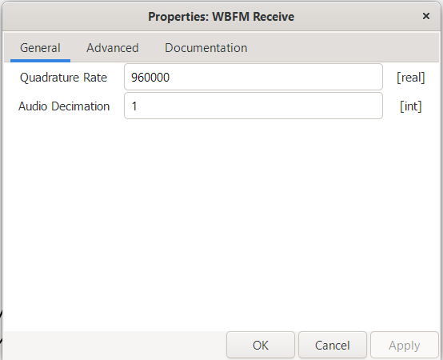
Here the signal enters a WBFM Receive block, seen in Figure 19 below. This demodulates the received signal, removing the carrier wave. The quadrature rate is the input sample rate, in this case 960KHz, and the decimation rate is set to 2, here meaning how much the quadrature rate is decimated [21].
Figure 19: WBFM Receive Block Settings
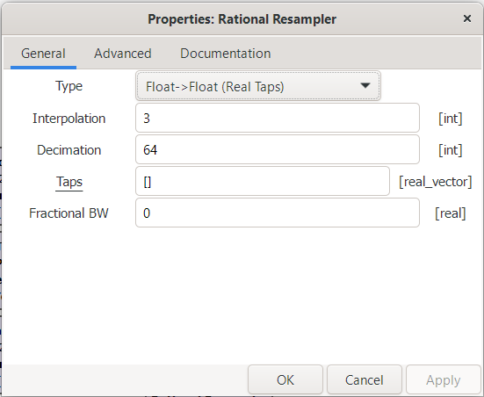
Next, the signal enters a Rational Resampler Block, altering the sample rate by interpolating (multiplying) and decimating (dividing) the signal. The 960KHz received is interpolated by 3 and decimated by 64, producing a sample rate of 45KHz.
Figure 20: Rational Resampler Settings
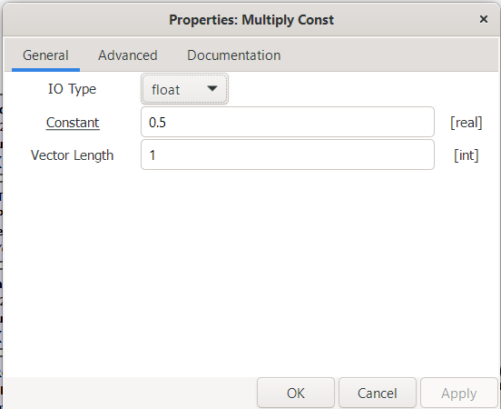
Finally, the signal is passed through a multiplication block, forming the modulation index. In this case it is multiplied by a constant of 0.5, meaning the signal is halved.
Figure 21: Multiply Constant Settings

Signal Analysis and Visualisation
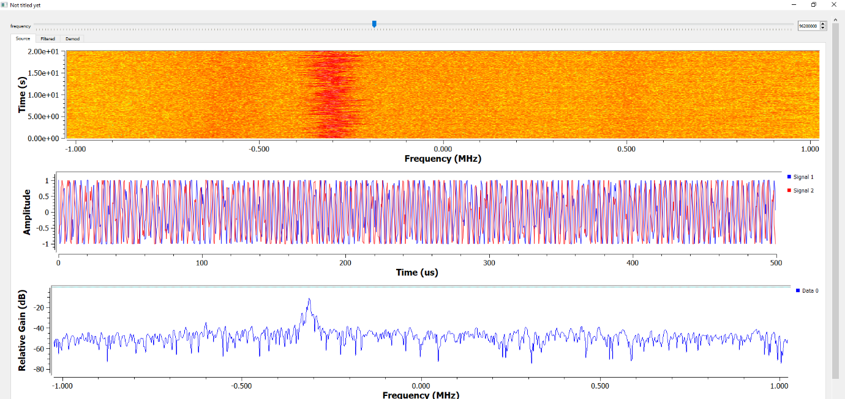
Figure 22 below shows a visualisation of the source signal. It is seen that there are two signals, the source and carrier signal.
Figure 22: Source Signal Visualisation: 96.2 - Andover FM
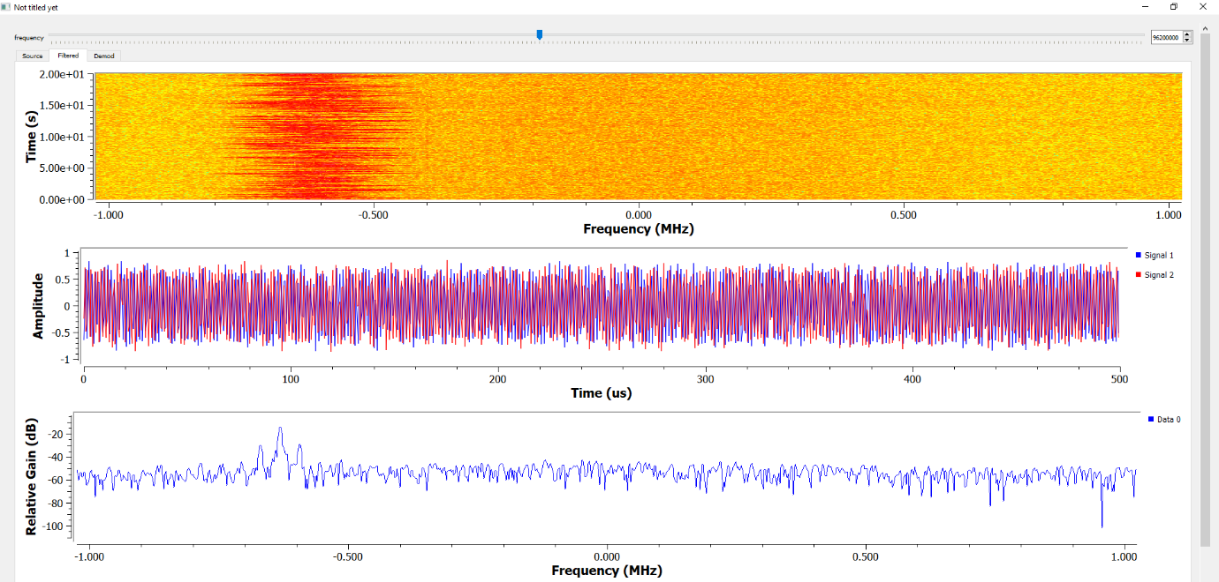
Figure 23 below is post filtering, the bottom graph demonstrates that the signal is more linear, and the signal peak has shifted slightly in frequency by ~0.75Mhz. The amplitude also appears tighter and less uniform.
Figure 23: Filtered Signal Visualisation: 96.2 - Andover FM
Finally, in Figure 24 overleaf is the demodulated signal. The signal is clean, with minimal noise, appearing uniform, and peaking at the centre frequency. Also shown is that there is no second signal in the middle graph, demonstrating that the carrier wave has been removed.
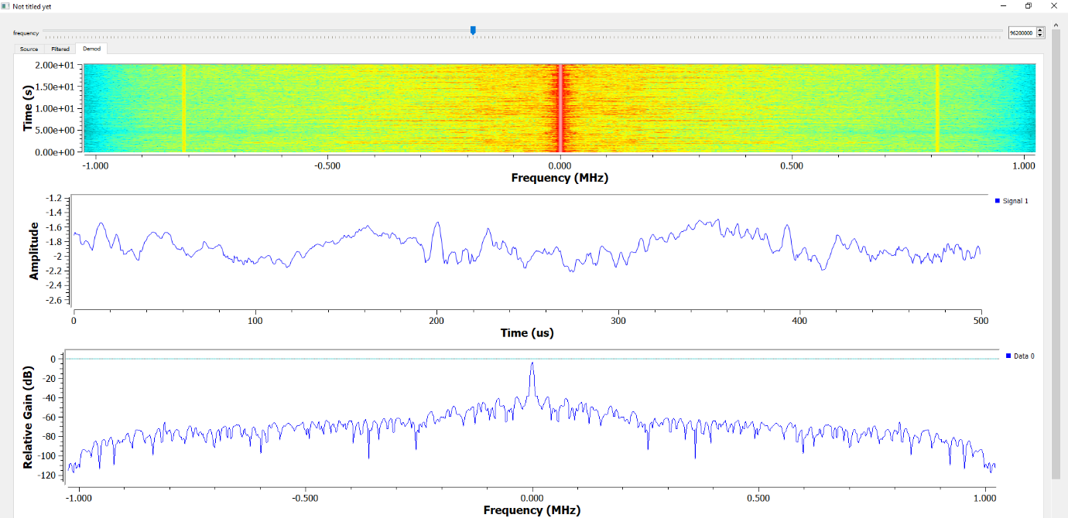
To discuss the SNR constellation diagrams have been used, seen below in Figure 25 for the source, filtered and demodulated signal. It is seen that the source (top), has poor SNR, causing the constellation loop to be loose and poorly defined. Whilst after filtering (middle) the loop is tighter and more defined, demonstrating that the filter has removed interference. Lastly, after demodulation (bottom) it is seen that the phase has shifted, and the diagram is represented in a straight, tight line, demonstrating a strong SNR.
Figure 24: Demodulated Signal Visualisation: 96.2 - Andover FM

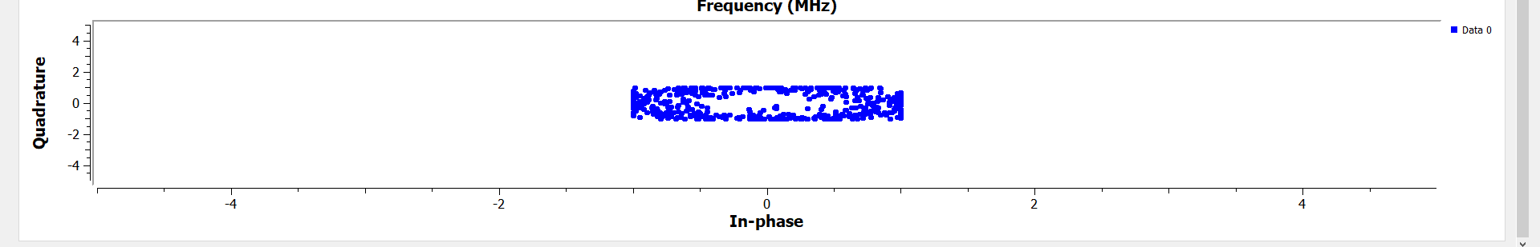
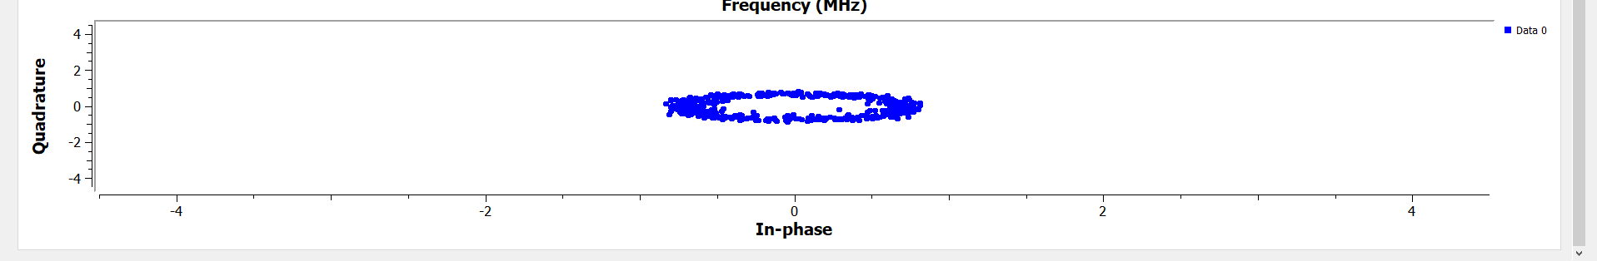
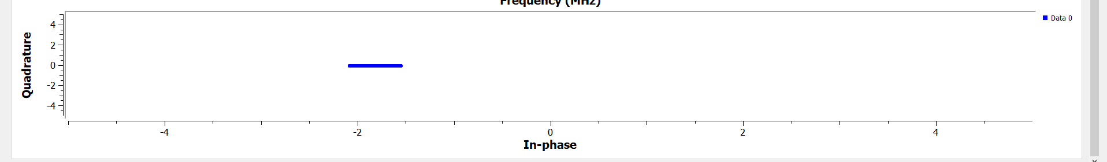
Figure 25: Constellation Diagram of Source, Filtered and Demodulated Signal

Formulas and Expressions
The formulas in this section comprise of the expressions after the low pass filter, creating a complex signal $Z\left(t\right)$. The expression for $Z\left(t\right)$ is as follows [22]
$$Z\left(t\right)=I'\left(t\right)+jQ'(t)$$
Equation 8: Complex Baseband I/Q Expression
Where $I^{'}(t)$ is expressed as
$$I^{'}(t) =\frac{A}{2}\left[cos2π(f_{m}-f_{o})t+φ\right]$$
Equation 9: I'(t) Expression
And $Q^{'}\left(t\right)$ is expressed as
$$Q^{'}\left(t\right)=-\frac{A}{2}\left[ -sin\left[2π\left(f_{m}-f_{o}\right)t+φ\right]\right]$$
Equation 10: Q(t) Expression
Which when substituted into the original formula becomes
$$Z\left(t\right)=\frac{A}{2}\left\{\left(cos2π(f_{m}-f_{o})t+φ\right)+jsin\left(2π\left(f_{m}-f_{o}\right)t+φ\right)\right\}$$
Equation 11: Expanded Z(t) Expression
Here $f_{o}$ is the frequency of the local oscillator, $f_{m}$ the frequency of the mixer and $φ$ the phase.

Ethical and Societal Impacts
SDRs may be purchased for ~£30 [23], and easily used through free software such as GNU Radio. Meaning it is widely available to the general public with no conditions of purchase. This also means that they may be used for a variety of purposes which may raise ethical concerns. For example, purchasing an SDR kit to build a radio does not raise any ethical concerns by itself. However, using that radio to listen in to conversations or broadcasts that are not expecting to be overheard is unethical. Additionally, the use of an SDR to transmit becomes unethical when doing so illegally or with ill intent, for example, when used to transmit propaganda or misinformation. It may also interfere with or listen to emergency services communications, which in itself is unethical, as there may be sensitive or identifying information.
However, also means that it is more widely accessible, allowing a wider variety of users from different backgrounds. This again may be a “double edged sword” in that by allowing a wider user base through reduced costs, it also increases the likelihood of bad actors (whether intentionally or through lack of knowledge) purely by increasing the number of users the system is available to.

Conclusion and Future Recommendations
In conclusion it may be seen through this report that FHSS is a potent antijamming technique allowing the signal to be agile and avoid being jammed effectively. There are some design limitations inherent within GNU Radio, which mean that some aspects of FHSS are unable to be implemented, such as speed and automation. However, it is still an effective solution to the addition of noise-based interference.
The WBFM Receiver produces a clean and clear signal, showing that inexpensive SDRs may be used to create receiver radios, able to be tuned to any frequency. They may also be used to create personal radio stations, or personalised jamming systems, making the ethics surrounding the ownership and use of SDRs unclear.
In the future it may be pertinent to analyse the SDR with different antennas to evaluate the performance. It may also be beneficial to implement an automatic version of FHSS utilising a different software toolkit. Additionally, the channel selection may be randomised, so that the user must find an open and clear channel. Similarly, the user may be using the jammer to find and block the transmitted signal.

References
- Amphenol RF. Frequency Range Chart [Online]. Available: https://www.amphenolrf.com/frequency-range-chart
- E. Forester. (-10-22). How does modulation work? [Online]. Available: https://www.taitradioacademy.com/topic/how-does-modulation-work-1-1/
- M. Plonus. "CHAPTER 9 - digital systems," in Electronics and Communications for Scientists and Engineers, Ed. 2001, Available: https://www.sciencedirect.com/science/article/pii/B9780125330848500203. DOI: 10.1016/B978-012533084-8/50020-3.
- JEM Engineering (2019). An Introduction to Jammers and Jamming Techniques [Online]. Available: https://jemengineering.com/blog-an-introduction-to-jammers/
- K. Terrell Hanna and J. Burke. What is frequency-hopping spread spectrum (FHSS)? [Online]. Available: https://www.techtarget.com/searchnetworking/definition/frequency-hopping-spread-spectrum
- UK Parliament. Wireless telegraphy act 2006. Section 68. [Online]. Available: https://www.legislation.gov.uk/ukpga/2006/36/section/68
- Ofcom (2023, July 10). Rules on Using Radio Equipment [Online]. Available: https://www.ofcom.org.uk/spectrum/radio-equipment/radio-spectrum-and-the-law/
- Ofcom (2023, July 21). GPS jamming exercises – Military [Online]. Available: https://www.ofcom.org.uk/spectrum/frequencies/gps-jamming-exercises/
- Phantom Technologies. Legality of Jammers Around the World [Online]. Available: https://phantom-technologies.com/legality-of-jammers/
- Everything RF. What are Spurious and Harmonics? [Online]. Available: https://www.everythingrf.com/community/what-are-spurious-and-harmonics-signals
- Sigid Wiki. Chinese Firedrake Jammer [Online]. Available: https://www.sigidwiki.com/wiki/Chinese_Firedrake_Jammer
- GNU Radio. About GNU Radio [Online]. Available: https://www.gnuradio.org/about/
- Farnell. Narrow Band FM Definition [Online]. Available: https://uk.farnell.com/narrow-band-fm-definition
- S. Haykin and M. Moher. Introduction to Analog and Digital Communications (2nd ed.) Hoboken, NJ, USA: John Wiley & Sons, 2007.
- T. Collins, C. Anderson and A. Wyglinski. Wireless Communications and Mobile Computing 1616(18), pp. 3201–3211. pp. 3201–3211. 2016. Available: https://onlinelibrary.wiley.com/doi/abs/10.1002%2Fwcm.2751. DOI: 10.1002/wcm.2751.
- Analog Devices. Signal-to-Noise Ratio as a Quantitative Measure for Optical Biosensors [Online]. Available: https://www.analog.com/en/resources/design-notes/signaltonoise-ratio-as-a-quantitative-measure-for-optical-biosensors.html
- P. Zhang. "CHAPTER 10 - industrial control networks," in Advanced Industrial Control Technology, Ed. 2010, Available: https://www.sciencedirect.com/science/article/pii/B9781437778076100105. DOI: 10.1016/B978-1-4377-7807-6.10010-5.
- MathWorks. What Is Software-Defined Radio (SDR)? [Online]. Available: https://uk.mathworks.com/discovery/sdr.html
- Nooelec. Nooelec NESDR Mini SDR & DVB-T USB Stick (RTL2832 + R820T) w/ Antenna [Online]. Available: https://www.nooelec.com/store/sdr/sdr-receivers/nesdr/nesdr-mini.html
- National Instruments. Decimation (Digital Filter Design Toolkit) [Onilne]. Available: h https://www.ni.com/docs/en-US/bundle/labview-digital-filter-design-toolkit-api-ref/page/lvdfdtconcepts/dfd_decimation.html
- GNU Radio. WBFM Receive [Online]. Available: https://wiki.gnuradio.org/index.php/WBFM_Receive
- J. Deveraj (2024). Advanced Digital Signal Processing Lecture 12: SDR [PowerPoint Slides]. Available: https://moodle.uwtsd.ac.uk/mod/resource/view.php?id=631870
- Amazon. NESDR Mini 2 USB RTL-SDR & ADS-B Receiver Set, RTL2832U & R820T2 Tuner, MCX Input. Low-Cost Software Defined Radio Compatible with Many SDR Software Packages. R820T2 Tuner & ESD-Safe Antenna Input [Online]. Available: https://www.amazon.co.uk/NESDR-Mini-Receiver-Compatible-Packages/dp/B00P2UOU72?source=ps-sl-shoppingads-lpcontext&ref_=fplfs&psc=1&smid=A1TIGMJ4AZ1K1A

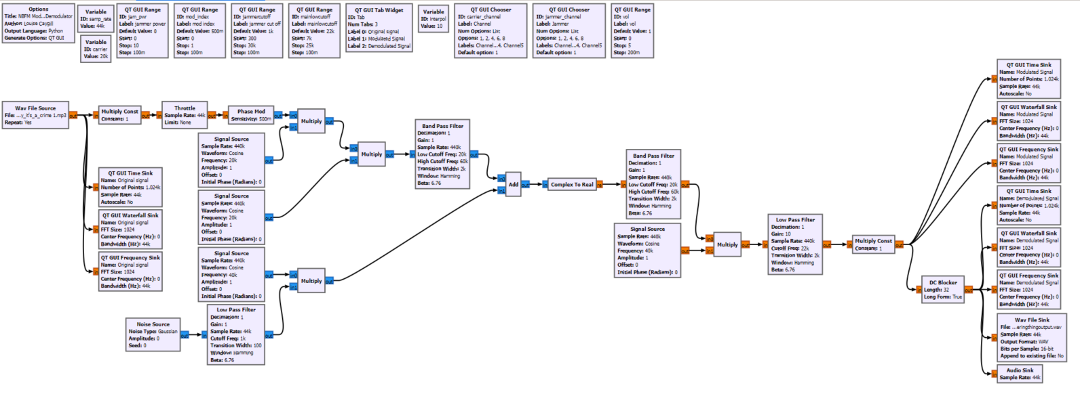
Annex 1

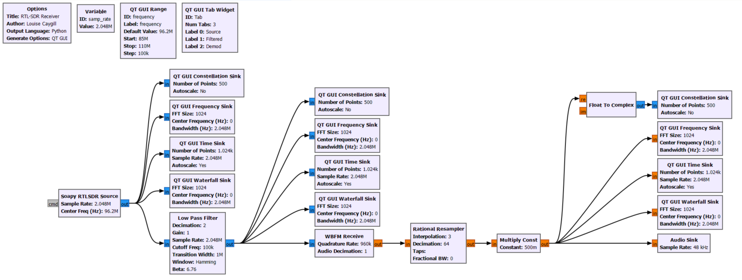
Annex 2

