Nicoleta Angheluta - 1914622

International Financial mANAGEMENT

Assignment Title: Nestle – Financial evaluation
Module Lecturer’s Name: Hossein Shokri
Contents
Introduction 3
Company backgound 4
International Finance Management 4
Dividend Distribution Policy 7
Efficient Market Hypothesis 8
Project Appraisal Methods 9
Conclusion 10
References 11

Introduction
The company's internal financial management is the concept that has been analysed in this report to understand how Nestle has regulated this mechanism to provide the information on the international trade and market that improves their performance in compliance with the achievements of their basic goals and the objectives. The report summarizes the details about the major business on distribution policy that it follows and the project appraisal techniques and methods. These are conducted to regulate the management related method and the techniques in the conduct of the company's basic operations. The Financial review contains certain financial performance measures that are used by management to assess the financial and operational performance of the Group (Nestle, 2021)

Company background
Nestle being, founded in 1866, is a Swiss multinational food and drink production company. The company is headquartered in Switzerland and has been developed as the leading company in the production industry sector. Company in recent times has developed as a major business in the country. The company deals in various products, including baby food, medical food, cosmetics and processed food (Nestle, 2021). The company has also developed its operation in more than 189 countries. The company's performance in recent years has been on the decreasing trend. However, the company still possesses the major market in terms of the loyal customer base and the regulated structure of the employees and the professionals.



International Finance Management
The field of international financial management addresses financial decision facing corporate managers regarding trade and investment across national borders according to Bekaert (2013).
Therefore, international financial management is the process through which multinational companies identify and plan the strategies through which a company sale their produce into a different country.
International finance in any company is an accumulation of the funds, cash and assets that the business generates from the various transactions and the agreement entered by the company with foreign countries and companies (Madura, 2020). So, international financial management had developed techniques, used by the company to make crucial decisions about investments, capital structure, dividend policies and working capital management. Thus, the IFM is the management technique used to regulate international trade and business financial decisions. The risk that is associated with the international trade is the exchange risk involved in conducting international financial transactions.
Importance of the International Financial Management
International financial management is important even to companies that have no international business because these companies must recognize how their foreign competitors will be affected by movements in exchange rates, foreign interest rates, labour costs, and inflation (Madura, 2020)
We can say that the importance of the IFM in the conduct of business activities and international trade can be classified as below:
Through intensive research and investment can achieve development of specific goods and services for the foreign market by encouraging market and local producers
Creates new chances and opportunities in new open economies.
The company can achieve a competitive advantage in globalization techniques (Madura, 2020).
It enables the companies to develop newer segments and related business opportunities.
World trade growth to a level that generates the most international developments.
We focus our energy and resources where unlocking the power of food can make the greatest positive impact on the lives of people and pets, the environment, and our shareholders and other stakeholders (Nestle,2021).
The major challenges that the company has been facing in recent time that impacts the international financial market of the company include the following-
Different perspectives: The headquarters and the subsidiaries, as the different segments associated with the main company, possess the perspective and the decisions about foreign operations channels, but each regulates in a different direction and does not regulate the same perspectives.
The issue outside: Nestle deals with different countries as a multinational corporation. Thus, the different environments associated with the different countries' economies may affect the scope of the conduct of business activities in the financial market. That impacts and poses challenges to the company dealing with the different networks (Nestle, annual Report, 2021).
The recent challenge developed in the business structure relates to Covid 19 as the global pandemic that has impacted the basic conduct of the business activities at the core levels. The closure of the business units and the reduction in the total revenues and operating profits have posed many challenges to the company.

Dividend Distribution Policy
Division policy is the determination of the proportions of profits fade out to shareholders- usually periodically Glen (2013). The dividend distribution policy of the nestle company has been developed in terms of the constant pay-out ratio. The constant pay-out ratio is developed based on the earnings that have been achieved over the period and thus shall vary with the change in the period's earnings (Nestle, annual Report, 2021). Therefore, with the increase in the company's earnings per share, the dividend, considering the constant pay out percentage, will increase the company's dividend per share. Earnings per share are defined as the net earnings allocated to each share in the company (Khuen, 2020). Further dividend per share is the declared dividend per ordinary share outstanding for the period. As a developed multinational company, being the nestle company has secured its projects and the operation for the year and the future year to come. Thus, the need to allocate the retained earnings to different objectives is not possessed in the case of the nestle company (Khuen, 2020). Thus, the company follows as their major technique of allocating their majority of the retained earnings to the company's shareholders and stakeholders.
The details of the last ten years' data can be presented in the form of the closing share price and the dividend per share:
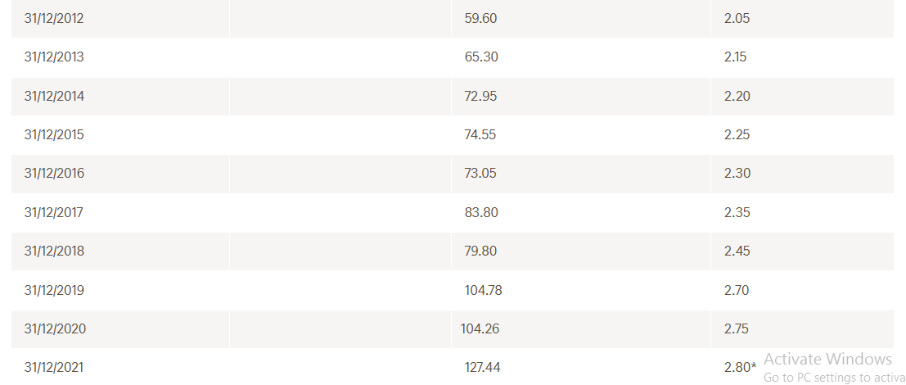
Source: Nestle.com
Efficient Market Hypothesis
The Efficient Market Hypothesis (EMH) implies that if new information is revealed about a firm, it will be incorporated into in the share price rapidly and rationally with respect of the direction of the share price movement and the size of that movement (Glen, 2013).
Nestle is a developed company in the market, that has always shown significant changes and improved the performance of the comp and provided a valuable return to the shareholders. In analysing the EMH, the market for such a company can be seen as very dynamic, where investors do not always outtake rational decisions. One way that has been analysed with the aspect of the same is to record the share price movement and the earnings per share (Wall St, 2020). The same has been analysed to provide the Nestle is the balances and the developed stock; concerning future growth, the minimum increase in the EPS led to a significant change in the company's share price.
Project Appraisal Methods
The project appraisal method is the decision that involves the comparison of the amount of cash put into investment with the amount of cash returned (Glen, 2013) The project appraisal methods used by the company to evaluate the project findings and the performance for the future years, the common in this aspect can be classified as the PERT, CPM, IRR and NPV. These are conducted as a part of the various techniques used to evaluate the project from the long-term perspective, classified in terms of technical, economical and finance appraisal. The company projects about greenhouse emissions in recent years, large scale projects for landscape development, advancing the regeneration of the water cycles, zero carbon emission and other management projects are developed by applying the capital budgeting techniques and the methods about the present value methods (Nestle, annual Report, 2021). The net present value for any project is described and determined as the positive difference of the net cash inflows that the project may generate over the initial cost of the investment at the present value (Woodruff, 2019). The company development on such thus is taken as a regular project to evaluate the future performance of any company and the related project from the long-term perspective. The company overlooks and conducts such proves only in consideration of generating future returns.
Therefore, the project appraisal techniques that form part of the above explanation are part of the financial analysis. Other than the financial analysis, it includes the economic analysis and the market analysis that the company considers evaluating the project in terms of what factors it contributes economically and the effect on the share price of the markets. So, the discussion on analysing the project is followed by many aspects. For a company like Nestle, various management techniques for analysing the various projects for a particular period are analysed to regulate various appraisal techniques.

Conclusion
The report on this company’s financial management has illustrated how various financial theories are applied in daily activities in order to achieve performance and expansion on foreign markets. Analysing the annual report and the theories we are able to understand how through careful planning and continuous involvement Nestle is able to return and blossom shareholders’ investment. The company's finances and the other aspects of the period have been analysed to comment on the distribution policy methods that the company has been using over the periods and the challenges that the company is facing in the international financial market. The internal finance market of the company has been developed to provide the requirements it fulfils to achieve the targets and the objectives of the company regarding international trade and transactions.

References
Bekaert, GJ and Hodrick, RJ, (2013) International financial management, Pearson, p 50
Nestle, Annual Report, 2021, [online]. Available at: https://www.nestle.com/sites/default/files/2022-03/2021-annual-review-en.pdf
Glen, A. (2013). Essential of corporate financial management, Pearson, pp 61-436
Khuen, LW 2020. Nestle maintains 95% dividend pay-out policy despite challenging environment. Available at: https://www.theedgemarkets.com/article/nestle-maintains-95-dividend-payout-policy-despite-challenging-environment [Accessed 02 April 2022].
Madura, J., 2020. International financial management. Boston, Cengage Learning.
Wall St, S., 2020. Shareholders Of Nestlé (VTX: NESN) Must Be Happy with Their 64% Return. Available at: https://finance.yahoo.com/news/shareholders-nestl-vtx-nesn-must-082427304.html [Accessed 12 April 2022].
Woodruff, J., 2019. Future Value vs. Present Value. Small Business - Chron.com. Available at: https://smallbusiness.chron.com/future-value-vs-present-value-77714.html [Accessed 11 April 2022]

