University of Trinity St David Swansea
School
Ysgol (blank)

Mike Davies (Business)
2/3/2015

Contents
1.0 Project Justification 3
1.1 Background 3
1.2 Project Aim 3
1.3 Project Objectives 3
1.4 Initial Ideas 3
1.5 Rational 3
1.6 Scope and Exclusions 4
1.7 Constrains and Assumptions 4
2.0 Business Caseand Approach 5
2.1 Potential benefits and outcomes 5
2.2 Potential Issues 5
2.3 Approach 6
3.0 Proposed Research Strategies 6
4.0 Project Management 7
5.0 Quality Management Strategy 8
6.0 Communication Management Strategy 8
7.0 Project Plan 10
8.0 Project Controls 10
9.0 Project Reporting 11
10.0 References 12
11. Appendices 13

1.0 Project Justification

1.1 Background
Ysgol (blank) is a school based in Swansea which is maintained by the Local Authority. The school caters for a range of learning need pupils and has a unit for autistic pupils. The pupils ages from three to nineteen years. The school has developed a skill based curriculum which caters for every individual’s academic and social needs (Ysgol XXXXX).
Ysgol (blank) inspires all pupils to believe in their ability to achieve. Their aim is “to develop all pupils to their full potential, both educationally and socially in a safe and purposeful environment” (Estyn, 2013 ).

1.2 Project Aim
The aim of this project is to examine and critically evaluate the present physical education system at Ysgol (blank) in Swansea.

1.3 Project Objectives
- To analyse current practises in the school and compare to similar schools in Swansea such as Ysgol XXXXX.
- Conduct an official inspection within the school which is called an audit.
- To make recommendations on how the school can make improvement.

1.4 Initial Ideas
The initial ideas for this project are to improve lessons, develop the knowledge of the teaching staff as the main PE teacher specialises in Design Technology. Although the school is already linked to different organisations such as 5x60 and Swansea City football club, this project aims to develop a consistent relationship with these organisations as well as bring others into the school.
Finally there are hopes to introduce stronger links with outside clubs for children to meet new friends, help develop social and emotional skills.

1.5 Rationale
There are less sporting opportunities for special needs children in Wales which means it is important to find out if the school is doing all it can to introduce children into sport and physical education. There are many barriers to taking part in PE and sport for pupils with disabilities which include inaccessible facilities, equipment and staff without adequate training. In 2011 Whizz-Kidz found that 57% of disabled pupils took part in PE but 33% didn’t. Of those who didn’t take part in PE felt that it was because of their disability. This is very unsettling as physical education has a huge role to play in the overall growth and development of the vast majority of pupils with special educational needs (Whizz Kidz , 2011). Taking part in regular physical activity has been shown to reduce the risk of heart disease, high blood pressure and type two diabetes (Chatzisarantis Nikos, 2005 ).

1.6 Scope and Exclusions
This project intends to help the improvement of physical activity within the school. It hopes to increase student/parent engagement within sports in school and plans to have variety of different activity in place for children to enjoy. The project will compare with different schools to give desired recommendations. However this project only focuses on physical education inside the school and no other subject areas.

1.7 Constrains and Assumptions
As a student time is going to be a huge constrain especially when working to a specific deadline. With any project there are going to be assumptions of what the researcher expects, therefore assuming staff are going to have time to talk is going to be a major assumption. Likewise, staff will not always be truthful when interviewing because they may be afraid of saying something they should not. In the case it will have to be made clear to staff that everything said is private and confidential.

2.0 Business Case and Approach

2.1 Potential benefits and outcomes
• Children gain more from their P.E lessons
• Improved opportunities
• Confidence building
Potential benefits and outcomes will be the children will become more willing to participate and develop their team skills. This will lead to the children enjoying the lessons and allowing them to get more out of physical education in school. There will be more opportunities for the children, such as tournaments, competitions and events. These will lead to the children having more confidence which will allow links to outside club, thus increasing communication skills and friendship building.

2.2 Potential Issues
- Parents
- Transport
- Funding
Parents can sometimes be an issue when it comes to sport for all children. Having a child with limited ability, parents sometimes want to wrap them up in" cotton wool" and not encourage any activity which could potentially lead to injury.
In a lot of cases if parents are not interested in sport then nor will the child because they would not have been bought up with a focus on sporting activities.
If suitable transportation is not made available then pupils will not be able to participate in activities outside their school environment. If the school relied solely on parents then this would not work due to parents own commitments and possible lack of transport.
Finally funding has allowed a small number of teachers gain qualifications in PE, through staff training, unfortunately due to this only limited equipment and resources have been purchased. Therefore this has meant equipment cannot be improved or replaced if necessary .

2.3 Approach
To overcome parent problems, the aim will be to get parents more involved with sporting activities in school. Firstly, aims are to put more events on in the school which will allow the parents to see how the children are improving but most importantly to get them involved with their child and have fun. Secondly transport will have to be worked out within the school by looking at their budgets to see what would be the smartest ideas to benefit the children. Thirdly funding in the school will have more support off 5x60 in Swansea to help fund events in the school and have adequate trained staff to put on activities in school.

3.0 Proposed Research Strategies
Methodology is very important when carrying out a project, it can be defined as “how research questions are expressed and its effect is a claimed about significance” (Clough & Nutbrown , 2013).
When carrying out an investigation, there are two main types of research strategies, these are qualitative and quantitative research.
Qualitative research looks at how people interpret their genuine life experiences, not something which could be classed as “made up”(Merriam, 2009). Whereas, quantitative research looks at numerical data which can be turned into statistics therefore allows defined variables, opinions and behaviours to be identified (Aliaga, 200 ).
Research strategies which will be used:
- Observation
- Interviews
- Questionnaires
This project will mainly focus on using qualitative research to get an in-depth understanding into the ‘goings on’ within the school. There will be an observation of a physical education lesson. Observation is a research method which involves the direct observation of occurrence in someone’s natural setting(Babbie, 2013). Observation will be used so the research can have an accurate understanding of how a typical physical education lesson runs within the school.
Followed by the observation there will be an interview carried out with the teacher in charge of the lesson. In addition to this there will be an interview supported by the head master and other members of staff. The interviews will be semi structured to allow the interviewees to give their own opinions and outlook on P.E in school. Interviewing is excellent for gathering information because it produces better response rates due open questions, therefore participants can say what they want without the hassle of writing it down (Lynn Silipigni, 2013 ).
Finally to understand how the children feel there will be questionnaires completed which is classed as quantitative research. These questionnaires will be carried out using symbols via Sim Writer, which allows the 16-19 year olds to understand and answer the questionnaire on their own without help so they can give their own opinion. These questionnaires will be hard copies and will go out to all children aged between 16-19. Questionnaires allow clear and valid results which will lead to a better understanding of what the children want (Phellas, Bloch, & Sea, 2011).

4.0 Project Management
For any organisation to run well there must be a logical approach to planning and controlling, especially the roles of staff within in an organisation allowing matters to run smoothly(Fox , 2009).
Below shows the structure of roles within the school;
- Maintained by: City and County of Swansea (Local Authority)
- Governing body
- Head Teacher: Mr (blank)
- Deputy Head Teacher: Mr (blank)
- Teachers

The Local Authority maintains the upkeep and main running of the school. They have a legal duty to guarantee that every child fulfils his or her educational potential (Local Government Association , 2015 ). The Governing Bodies are the ones who set aims and objectives for school, run budgets, support staff and set standards of school discipline. From this the Head Teacher, has a responsibility for the internal organisation, control and the management of the school. It is his job to implement the strategic framework set up by the governing body. The Deputy Head’s role is to be in close partnership with the Head Teacher to make sure the running of the school goes smoothly. Finally you have your teachers, these people are there to educate, communicate and help children to learn.

5.0 Quality Management Strategy
A quality management strategy can be defined as “a formal record of an organisations method of managing the quality of its product and services” (Beckford, 2010). It is used to make sure companies are content with how the project goes.
The client will have certain exceptions and standards which the research must bind behind. In this case any information gathered will but kept in confidence and will not be shown to any other parties. Likewise any information teachers speak out about; their names will be disclosed and not mentioned in the final report. From this information recommendations which will be made will only be shown to the head mater so he can do as he wishes with the information.

6.0 Communication Management Strategy
Communication within this project is very important because without communications from the school it will be extremely hard to carry out the research. In order to make sure communication happens on a regular basis with the school, there will be three key communication channels:
- Emails, on a weekly basis
- In person meetings, which will happen when scheduled
- Phone calls if any urgent information is required
These communication channels in place will allow for quick questions and answers related to the project, but also if the school has anything to discuss it is a great way to quickly communicate.
The meetings will be held with the Head Teacher and the PE staff, these will be important to discuss any new information and update the staff ensure everyone knows what is going on.
  - Project Time scale
Below is a Gantt chart which shows the project time scale, for more information see Appendix 1.
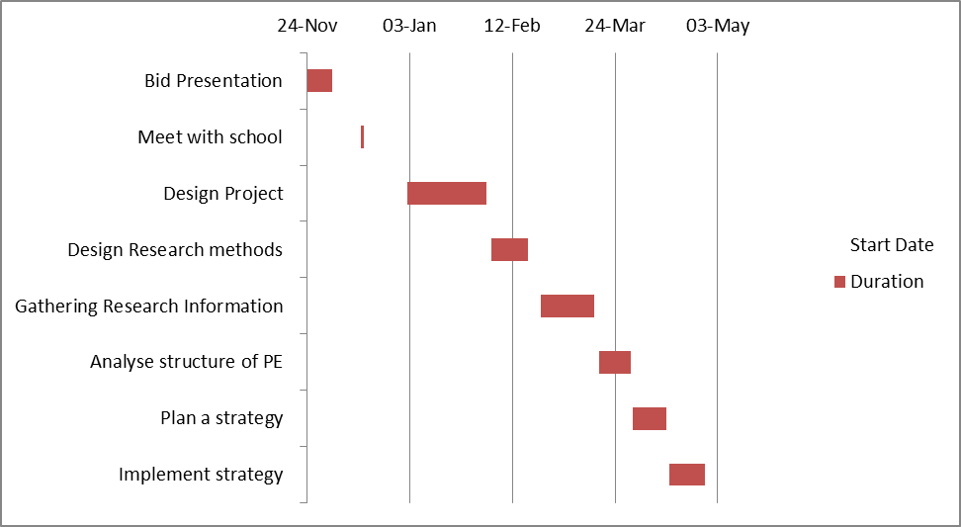

7.0 Project Plan
The plan for this project will stretch between presenting the project in December 2014 to the end of April 2015 when the consultation document will be completed.
Firstly research will be carried out on the school to have a better understanding on the structure of physical education at the school as well as to find out the relevant information needed to carry out this project. From this the plan will be to communicate with the teaching staff, so they can give their views and opinions. This will be done to gain an in-depth account not only to the school but also to what the teaching staffs thinks. The information submitted will give an indication of what physical education consists of at the school. Since this project is benefiting the children, they will be able to give their own opinions on what sports they like and dislike helping to conclude the report.
Once this has happened, an analysis and summary will be carried out on the way physical education is taught. By having a high quality physical education curriculum in school it enables all pupils to enjoy and succeed in all kinds of physical activities it is important this analysis is in-depth.
Finally there will be a report given on improvements and recommendations which will benefit the school and the children.

8.0 Project Controls
In each stage of the project there will be different methods which will help identify the projects progress and the control the researcher has over the project. These controls will help prevent any failure to the project through stage boundaries, reporting and set tolerances.
As this project is following a certain time scale obviously there could be errors if research cannot be gathered by a certain date or if meetings are rescheduled. In case of this a two to five day additional allowance will be made. After this point if goals have not been finalised an immediate review will take place with the consultant to see if the project can carry on, especially within the given time slot.

9.0 Project Reporting
Prior to this document there was a meeting set up with the Head Teacher on Monday November 3rd 2014 followed by a meeting with the Deputy Head. This meeting was held to establish goals the school wanted to achieve. In this meeting there was an introduction to members of staff as well as a tour around the school. From this a plan was made of how research was going to be carried out and possible ways to help improve the physical education system within the school.
This meeting was recorded for private information only, so researchers could refer back to it if needed. In addition with this all evidence of meetings will be presented in meetings logs which will be signed by all who were present, also there will be a log of emails which will also be included in the report. After each meeting there will be a short summary written up of what was discussed and any decisions which were made.

10.0 References
Aliaga, G. (200 ). Interactive Statistics+Studnet. New Jersey : Prentice Hall .
Babbie, E. (2013). The Basics of Social Research. USA: Cengage Learning.
Beckford, J. (2010). A Critical Introduction, Third Edition . London : Routledge.
Chatzisarantis Nikos, M. H. (2005 ). Social Psychology of Exercise and Sport. New York: CIP .
Clough, p., & Nutbrown , C. (2013). The Students guide to methodology. London: Sage.
Estyn. (2013 ). A report on Ysgol (blank) . Wales : Education and Training Wales .
Fox , W. M. (2009). The Management Process: An Integrated Functional Approach. London : IAP .
Local Government Association . (2015 , January 22). Education . Retrieved January 31 , 2015, from Local Government Association : http://www.local.gov.uk/schools-and-education
Lynn Silipigni, C. R. (2013 ). Basic Research Methods for Librarians. USA : Greenwood.
Merriam, S. B. (2009). Qualitative Research: A Guide to Design and Implementation. San Fransico : Josse Base .
Whizz Kidz . (2011). Retrieved Febuary 02 , 2015 , from Whizz Kidz : http://www.whizz-kidz.org.uk/
Wyse, S. E. (2011). What is the Difference between Qualitative Research and Quantitative Research. London : Snap .
Ysgol (blank) . (2015 , January ). Ysgol (blank) . Retrieved January 26 , 2015 , from Swansea Edunet: https://swansea-edunet.gov.uk/en/schools/PenYBryn/Pages/Default.aspx

11. Appendices
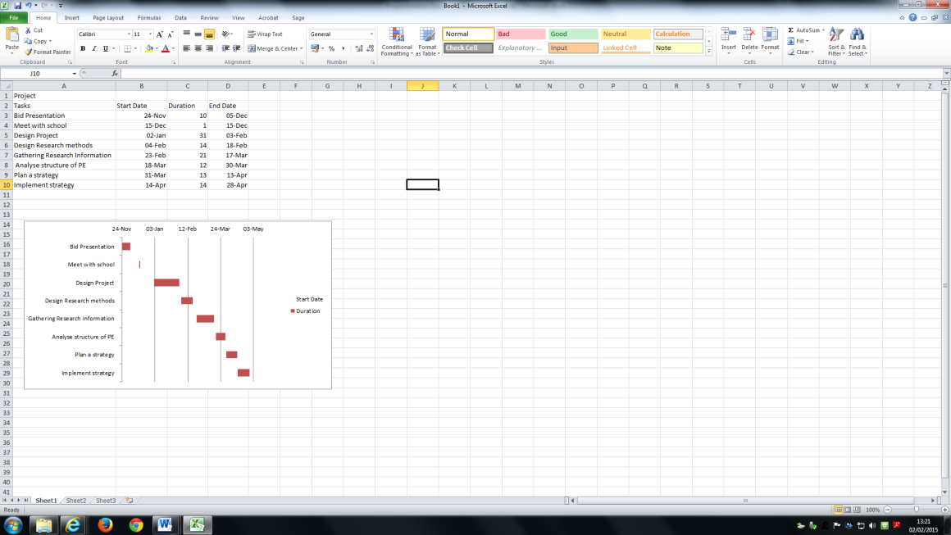
Appendix 1

