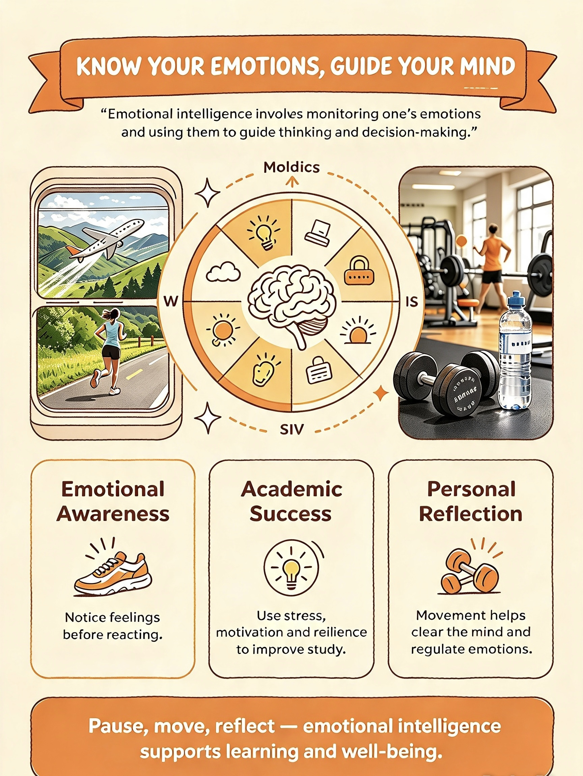
This is my poster for developing emotional intelligence in the workplace . Eomotinal intelligence refers to ways some people manage their emotions to make better decision

