
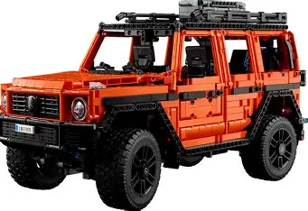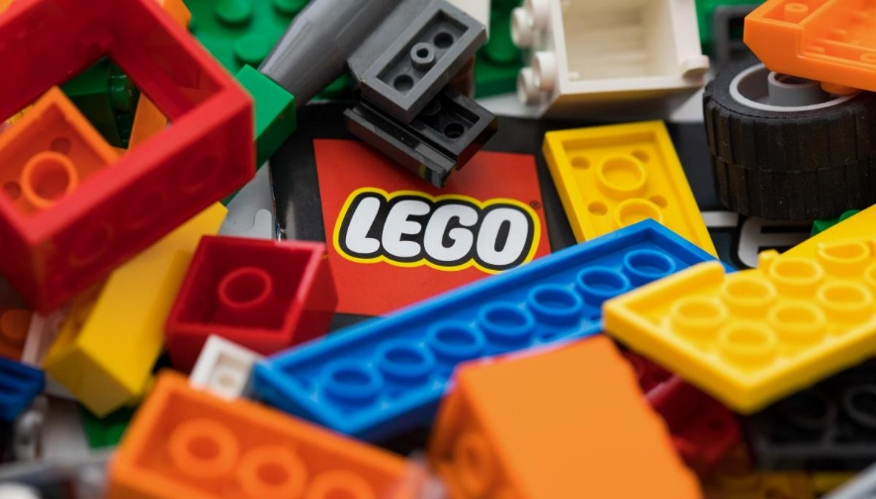
For this exercise, I will select The LEGO Group as the organisation and propose Vietnam as the new international market for expansion.
Student: Boyd R. Malcolm student number: 2128536
Programme : Master of Business Administration
Module: Strategic Management
Module code: LCMB7003
Lecturer: Dr Zulfiqar Khan
University of Wales Trinity saint David
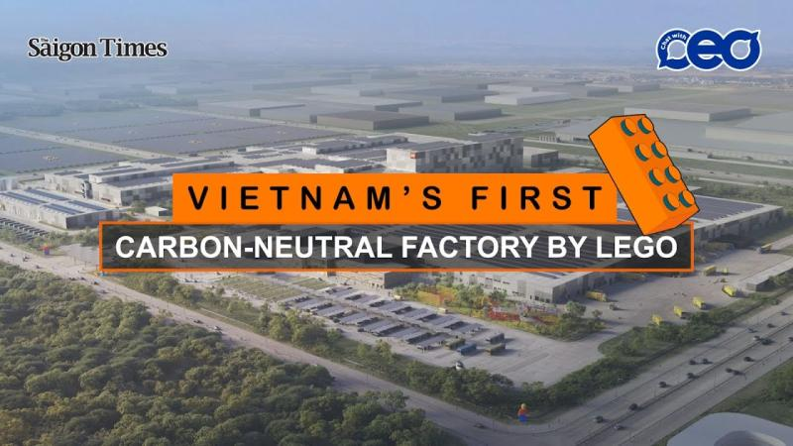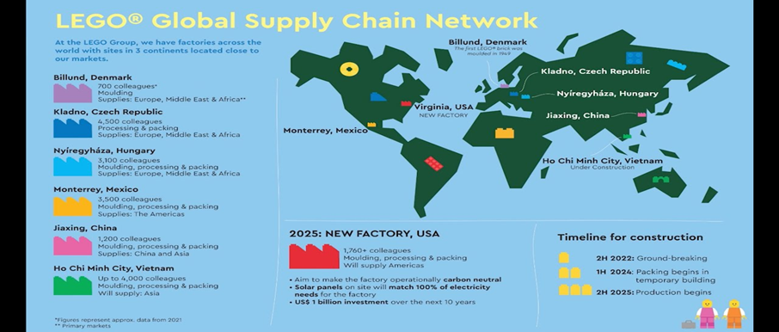

Contents
1
1. Selection of Organisation and Target Market 4
Introduction to Organisation: The LEGO Group 4
Target Market: Vietnam 4
Short Financial Recap 4
Justification for The LEGO Group 5
Target Market: Vietnam 6
2. 🇻🇳 Comprehensive Strategic Analysis 7
2.1 Macro-Environmental Analysis: PESTEL 7
2.2 Industry Competitive Analysis: Porter’s Five Forces 9
2.3 National Competitive Advantage: Porter's Diamond Model 11
2.4 Critical Evaluation of Analytical Tools 13
3. Strategy Development and Formulation 14
3.1 Internal Strategic Capability Analysis: VRIO Framework 14
3.2 Strategic Positioning: Porter’s Generic Strategies 16
3.3 Product Portfolio Management 16
3.3.1 BCG Matrix Analysis (Vietnam Context) 16
3.3.2 Ansoff Matrix: Growth Strategy 18
3.4 Proposed Market Entry Strategy: Greenfield Investment & Hybrid Retail 18
4. Performance Evaluation Framework 20
4.1 Rationale for the Sustainability-Integrated Balanced Scorecard 20
4.2 Detailed Perspectives & Key Performance Indicators (KPIs) 21
4.3 Strategic Alignment: The Cause-and-Effect Chain 25
Recommendations 26
6 Conclusion 27
Harvard Reference List 29

1. Selection of Organisation and Target Market

Introduction to Organisation: The LEGO Group

The LEGO Group is a privately held, family-owned company founded in 1932 in Billund, Denmark. It is globally recognised for its LEGO System in Play, which utilises interlocking plastic bricks to foster creativity and learning (The LEGO Group, 2024a). The company’s mission is to "inspire and develop the builders of tomorrow," a guiding principle that has allowed it to become one of the world's leading toy manufacturers (The LEGO Group, 2024a).
While LEGO maintains a dominant market share in Western Europe and North America, the organisation has identified the need to diversify its revenue streams by expanding into high-growth emerging economies where brand penetration is currently lower (The LEGO Group, 2024b).

Target Market: Vietnam
This report proposes Vietnam as the primary target for strategic expansion. As a rapidly developing economy in Southeast Asia with a young demographic profile and rising disposable incomes, Vietnam presents a unique opportunity for LEGO to establish a foothold in a market that prioritises education and child development (World Bank, 2024).

Short Financial Recap
The LEGO Group’s recent financial performance demonstrates the stability and capital required for significant international expansion. The following figures are drawn from the 2023 Annual Report:
Metric | 2023 Performance | Strategic Implication
Revenue | DKK 65.9 Billion | Strong revenue stream ensures liquidity for market entry investments (The LEGO Group, 2024b).
Operating Profit | DKK 17.1 Billion | Healthy margins indicate efficient operations and strong pricing power.
Net Profit | DKK 13.1 Billion | Robust profitability provides a safety net for risks associated with emerging market expansion.
Cash Flow | DKK 15.4 Billion | Strong cash flow supports capital-intensive projects, such as the new factory in Vietnam.

(Note: DKK = Danish Krone. DKK 65.9bn is approximately USD 9.6bn)

Justification for The LEGO Group
The choice of The LEGO Group for this expansion analysis is justified by three key strategic factors:
- Saturated Western Markets: The LEGO Group (2024b) acknowledged that consumer sales in established markets like Western Europe are stabilizing. To maintain growth, the organisation must look to emerging markets where the toy industry is expanding.
- Product Suitability: LEGO’s core product—an educational, gender-neutral, creative tool—does not require significant alteration for the Vietnamese market. It aligns with the "revive a current product into a new market" strategy, leveraging existing assets for new revenue.
- Financial Capacity: Unlike smaller organisations, LEGO has the capital reserves (DKK 13.1bn net profit) to absorb the initial high costs of market entry, such as logistics, marketing, and retail setup (The LEGO Group, 2024b).
- 2024 Liquidity Calculation: Using the 2024 Financial Highlights (The LEGO Group, 2024b), calculate the Current Ratio (Current Assets / Current Liabilities, using Total Assets and Total Liabilities as a proxy for this high-level report):
  - Total Assets (2024): 68.7 bDKK
  - Total Liabilities (2024): 26.9 bDKK
  - Total Equity (2024): 41.8 bDKK
  - The Equity Ratio is reported as 60.8% (The LEGO Group, 2024b), demonstrating a high level of financial health and stability.
- Narrative Addition: "The LEGO Group's robust financial health is confirmed by its high Equity Ratio of 60.8% in 2024 (The LEGO Group, 2024b). This strong balance sheet, with total assets of 68.7 bDKK against total liabilities of 26.9 bDKK, demonstrates sufficient liquidity and capital depth to comfortably execute a high-CAPEX, long-term strategic investment like the $1 billion Vietnam Greenfield factory, even while accelerating spending on sustainability and digital initiatives."

Target Market: Vietnam
Vietnam is selected as the optimal market for expansion based on compelling macro-environmental data:
1. Economic Growth and the Rise of the "Consuming Class" Vietnam is currently one of the fastest-growing economies in Asia. The World Bank (2024) forecasts Vietnam’s GDP growth to reach 6.1% in 2024, outperforming many global peers. Crucially, this economic growth is fuelling a boom in the middle class. McKinsey & Company (2021) projects that 36 million additional Vietnamese consumers will enter the "consuming class" by 2030. This demographic shift significantly increases the addressable market for premium, non-essential goods like LEGO sets.
2. Favourable Demographics Vietnam possesses a "golden population structure." Approximately 23% of the population is under the age of 14, creating a massive, immediate consumer base for toy products (Countrymeters, 2025). Furthermore, the median age in Vietnam is approximately 32, meaning a large proportion of the population are young parents likely to invest in their children (McKinsey & Company, 2021).
3. Cultural Alignment with Education Vietnamese culture places a profound emphasis on education and intellectual development. Parents are increasingly willing to spend on products perceived as educational rather than purely recreational. LEGO’s marketing positioning as a STEM (Science, Technology, Engineering, and Mathematics) tool aligns perfectly with this cultural priority (VnExpress, 2024).
4. Strategic Synergy: Local Manufacturing A critical justification for this choice is The LEGO Group’s existing commitment to the region. In 2022, LEGO announced a $1 billion USD investment to build a carbon-neutral factory in Binh Duong province, Vietnam (The Investor, 2024). Expanding the retail presence alongside this manufacturing presence creates a powerful vertical integration strategy. It allows for shorter supply chains, lower logistics costs, and the ability to respond rapidly to local trends, granting LEGO a significant competitive advantage over importers.

2. 🇻🇳 Comprehensive Strategic Analysis
This section provides a detailed analysis of the Vietnamese market's macro-environmental factors and competitive landscape, employing the PESTEL Analysis and Porter's Five Forces models to evaluate the market’s attractiveness, followed by Porter’s Diamond Model to assess the national competitive advantage for the toy and manufacturing industry.

2.1 Macro-Environmental Analysis: PESTEL
The PESTEL framework is used to systematically identify the macro-environmental forces impacting The LEGO Group’s strategic decision-making in Vietnam (Johnson et al., 2017).
Factor | Key Dynamics in Vietnam | Strategic Impact on LEGO
Political | Stability and Government Support: Vietnam is characterized by high political stability, which is a major draw for Foreign Direct Investment (FDI) (U.S. Department of State, 2024). The government actively pursues policies conducive to export-oriented manufacturing, offering tax incentives for high-tech, large-scale projects, such as LEGO's new factory (PwC, 2025). | Opportunity: High political stability reduces operational risk and guarantees long-term planning security. Tax incentives lower the effective corporate income tax rate, boosting initial profitability.
Economic | GDP Growth and Inflation: Vietnam's GDP growth is robust (World Bank, 2024), but the economy is susceptible to global inflation and trade pressures. The increasing middle class drives consumer demand for premium products, but price sensitivity remains a factor (McKinsey & Company, 2021). | Opportunity & Risk: Rising disposable income is the primary demand driver. However, local competition may undercut pricing, requiring LEGO to justify its premium price point based on quality and safety.
Social | Education and Demographics: Extreme cultural emphasis is placed on STEM education and child development (VnExpress, 2024). A young population with a low median age ensures a continuous consumer base. Parents prioritize educational value over mere recreation. | Opportunity: LEGO's brand positioning as an educational tool (the System in Play) perfectly aligns with parental aspirations, offering a strong marketing narrative and premium justification.
Technological | Digital Adoption and Manufacturing: Rapid growth in mobile and internet penetration supports e-commerce and digital marketing (Euromonitor, 2023). Vietnam is moving up the manufacturing value chain, requiring advanced technology and skilled labour. | Opportunity: Digital platforms (e-commerce) bypass traditional retail limits. LEGO's investment in advanced, sustainable manufacturing technology (The Investor, 2024) is supported by government goals for high-tech FDI.
Environmental | Regulatory Focus & Consumer Demand: Government policy and consumer sentiment are shifting towards sustainability and eco-friendly practices (Mattel PESTLE, 2025). LEGO's commitment to reducing plastic use and building a carbon-neutral factory in Vietnam aligns with this trend. | Opportunity: The Binh Duong factory, designed to be carbon-neutral, can be used as a powerful differentiator and a source of positive Public Relations, resonating with environmentally conscious consumers and regulators.
Legal | IPR and Regulatory Complexity: While Vietnam is improving its legal framework, concerns remain regarding the enforcement of Intellectual Property Rights (IPR) and regulatory opacity (U.S. Department of State, 2024). New tax laws, such as the Global Minimum Tax, may negate some historical incentives (PwC, 2025). | Risk: Weak IPR protection increases the threat of counterfeit LEGO products. Regulatory complexity can slow down licensing and approval processes, requiring significant legal resources.

2.2 Industry Competitive Analysis: Porter’s Five Forces
Porter's Five Forces model assesses the intensity of competition within the Vietnamese toy industry to determine its long-term profitability and attractiveness (Porter, 2008).

Force | Assessment | Rationale for Vietnam Toy Market
1. Rivalry Among Existing Competitors | High | The market: is fragmented and characterized by intense price competition between cheap, unbranded toys, local manufacturers, and established international players (Mattel, Bandai) (Technavio, 2023). Local rivals often have lower cost bases and extensive distribution networks.
2. Threat of New Entrants | Medium to Low | Barriers to entry: are high for premium, quality players like LEGO due to the huge capital investment required for manufacturing, brand building, safety compliance, and establishing distribution channels. However, entry for small, unbranded imports (often via informal channels) remains high.
3. Bargaining Power of Buyers (Parents/Retailers) | Medium to  High | Buyers are price-sensitive but value-conscious. Parents have high power due to low switching costs to substitute toys (e.g., cheaper construction bricks). Large retailers (like supermarkets/malls) have increasing leverage to negotiate shelf space and pricing.
4. Bargaining Power of Suppliers (Raw Materials/Labour) | Medium | Labour power is medium: While wages are lower than in China, the demand for skilled, high-tech labour is increasing, giving these specialized workers more power (U.S. Department of State, 2024). Raw material power is medium: LEGO uses specialized ABS plastic (and now plant-based materials), giving them some control, but reliance on global petrochemical supply chains limits that power.
5. Threat of Substitute Products  Conclusion | High  Moderately | Substitutes include: Digital entertainment (e-games, mobile apps), which competes directly for children’s time; traditional local crafts/games; and non-toy developmental products (books, tutoring services). The high penetration of digital media poses a constant, growing threat (Technavio, 2023).  Attractive: The market is highly competitive and susceptible to substitutes. However, LEGO's vertical integration (manufacturing) and strong differentiation based on quality and education can mitigate the high bargaining power of buyers and rivalry, making the premium segment attractive.

2.3 National Competitive Advantage: Porter's Diamond Model
Porter's Diamond Model helps determine why a specific nation (Vietnam) may be a successful base for the toy industry and assesses its attractiveness for LEGO's overall strategy (Porter, 1990).
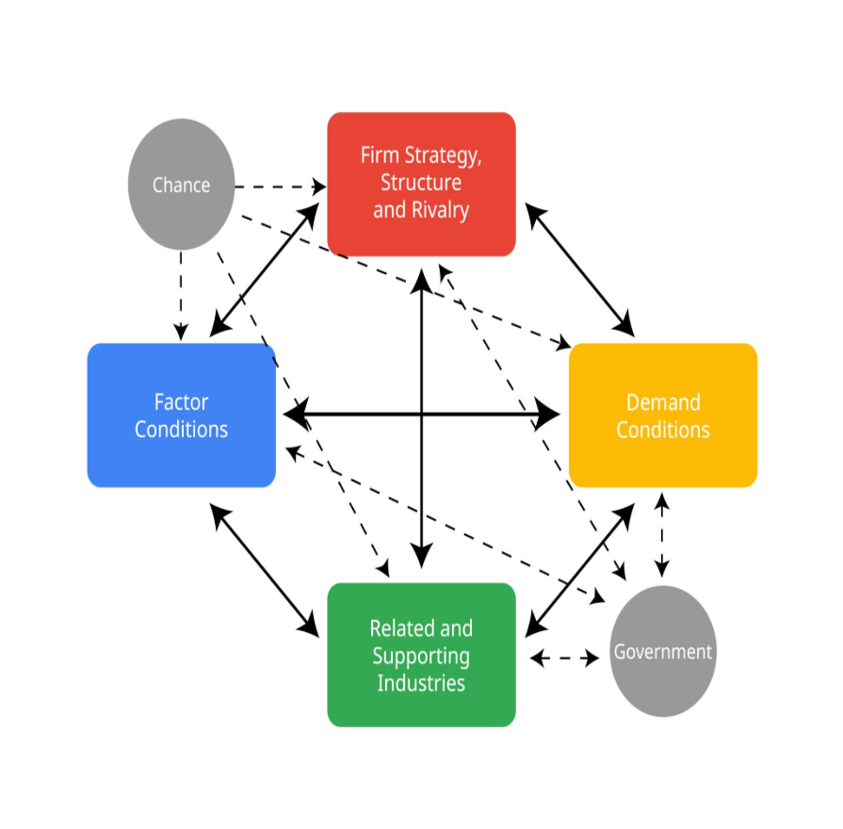Explore
Determinant | Vietnam's Condition | Relevance for LEGO's Strategy
1. Factor Conditions | Basic and Advanced: Vietnam possesses abundant, low-cost Basic Factors (unskilled/semi-skilled labour, favourable geographical location). It is currently developing Advanced Factors (high-tech infrastructure, R&D capabilities, highly skilled engineering labour) through initiatives like the factory investment (The Investor, 2024). | Highly Favourable: LEGO leverages low labour costs for manufacturing while contributing to the creation of advanced factors, securing its future supply chain and talent pool.
2. Demand Conditions | Sufficient and Sophisticated: The local demand is large (100 million people) and increasingly sophisticated. Parents are demanding high-quality, safe, and educational toys (VnExpress, 2024). This mirrors the sophisticated demand found in developed markets. | Highly Favourable: Sophisticated domestic demand forces LEGO to innovate locally and maintain high quality, preparing Vietnam-made products for global export (Porter, 1990).
3. Related and Supporting Industries | Developing, but Improving: Vietnam has a long-established, world-class Garment and Textile (G&T) industry, but the high-precision plastics/moulding and supporting industries for high-quality toy production (like specialized moulds and quality control services) are still emerging (Nguyen, 2012). | Moderately Favourable: While full domestic vertical integration is not yet possible, LEGO's presence (a key buyer) acts as a powerful catalyst, stimulating the growth of local, high-standard suppliers.
4. Firm Strategy, Structure, and Rivalry | Intense Domestic Rivalry: Domestic rivalry is high but often focused on the low-cost segment. The structure promotes local enterprises and increasingly welcomes large-scale, quality-focused FDI (U.S. Department of State, 2024). | Favourable: Intense rivalry forces LEGO to continually differentiate based on quality and innovation, preventing complacency and ensuring efficient operations necessary for global competitiveness.

Vietnam is an attractive base, moving from a basic-factor advantage to an advanced-factor competitive cluster. The synergy between Factor Conditions, high Demand, and government policy creates a robust environment for LEGO to establish a long-term, export-oriented manufacturing and retail base.

2.4 Critical Evaluation of Analytical Tools
The frameworks proved effective, but limitations must be acknowledged:
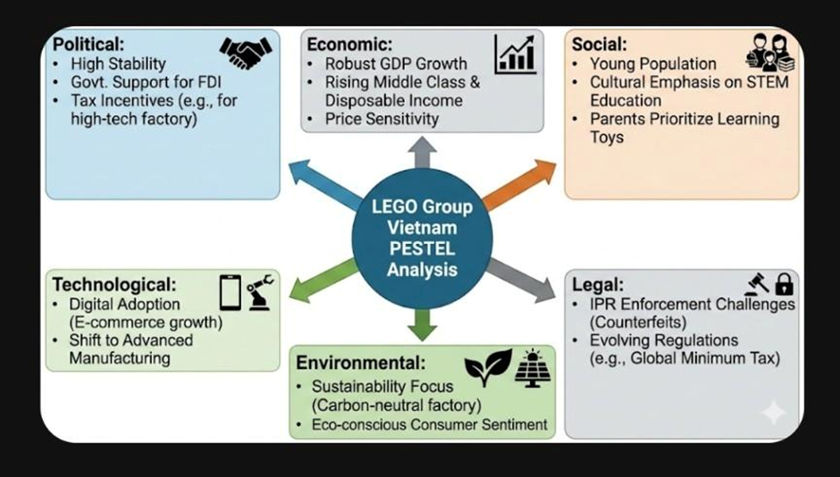
- PESTEL Effectiveness: It successfully mapped the interconnectedness of the favourable political and economic stability with the social demand for educational toys, reinforcing the expansion decision.
- PESTEL Limitations: The analysis is static (capturing a moment in time) and may not fully account for the rapid regulatory changes in Vietnam, such as the implementation of the Global Minimum Tax, which reduces the value of previously attractive financial incentives (PwC, 2025).
- Five Forces Effectiveness: It highlighted the significant risks posed by the high Threat of Substitutes (digital media) and Rivalry (counterfeits/low-cost players). This necessitates a strong differentiation strategy, confirming the premium model is the only viable path for LEGO.
- Five Forces Limitations: The model assumes clear industry boundaries, which are blurred in the toy market (e.g., is a gaming console a competitor or an unrelated product?). It also underestimates the role of government (Porter, 2008), which is critical in Vietnam's planned economy regarding factory approval and incentives.
- Diamond Model Effectiveness: This model was essential as it shifted the focus from merely selling in Vietnam to investing in Vietnam. It proved that the nation's conditions (labour, government support) are conducive to LEGO's dual strategy of market entry and supply chain diversification.
- Diamond Model Limitations: The model is complex and relies heavily on the subjective assessment of advanced vs. basic factors, especially in a transition economy like Vietnam where support industries are rapidly changing (Nguyen, 2012).
- Government as an Endogenous Variable: While Porter's original Diamond Model viewed the Government as an external influence, the Vietnamese context requires it to be treated as an important endogenous variable that directly influences all four determinants (Nguyen, 2012). For the LEGO expansion, the government is a crucial catalyst. It enhances Factor Conditions by providing tax breaks, offering incentives for high-skilled labour, and securing the land in the Binh Duong industrial zone (The LEGO Group, 2025a). This state support is a competitive advantage in itself, which is largely unavailable to foreign firms in more liberalized economies.

3. Strategy Development and Formulation

3.1 Internal Strategic Capability Analysis: VRIO Framework
- To establish a competitive advantage in Vietnam, The LEGO Group must leverage its internal resources. The VRIO framework (Value, Rarity, Imitability, Organisation) is used here to assess whether these resources can sustain a long-term advantage (Barney, 1991).
Resource/ capability | Valuable? | Rare? | Imitable? | Organised? | Competitive Implication
The System in Play (Interlocking Brick Patent & Design) | Yes. It is the core product that allows infinite creativity and backward compatibility since 1958. | No. Basic brick patents have expired; competitors (e.g., Mega Bloks, Lepin) produce compatible bricks. | Yes. Easy to copy the physical brick, but difficult to copy the clutch power (precision) | Yes | Temporary Competitive Advantage. (Reliance purely on the brick is risky due to low-cost clones).
Brand Reputation & Trust (Safety/Quality) | Yes. Critical for parents. LEGO is consistently ranked as one of the world's most reputable companies (The LEGO Group, 2024) | Yes. Few toy companies command such universal parental trust regarding material safety. | No. Extremely difficult and costly to build a 90-year legacy of trust. | Yes. Strict quality control processes are embedded globally. | Sustained Competitive Advantage. This is the primary differentiator in Vietnam against cheaper, unsafe plastic imports.
Licensed IP Partnerships (Star Wars, Disney, Marvel) | Yes. Drives massive sales and cultural relevance. | Yes. LEGO holds exclusive rights to the "construction toy" category for these major IPs. | No. Competitors cannot legally produce Star Wars construction sets. | Yes. dedicated teams manage these high- value relationships. | Sustained Competitive Advantage. Prevents rivals from accessing the most lucrative pop-culture segments.
Sustainable Manufacturing (Binh Duong Factory | Yes. Reduces logistics costs and appeals to eco-conscious consumers/governments | Yes. LEGO is the first major toy company to build a carbon-neutral factory in Vietnam (The Investor, 2025). | No. Rivals can build factories, but the "first-mover" status in green tech is hard to replicate quickly. | Yes. The supply chain is fully integrated to support this new node. | Unused Competitive Advantage \u2192 Sustained. (Currently transitioning to sustained as the factory comes online in 2025).

Critical Discussion: The VRIO analysis reveals that while the physical product (the brick) is no longer rare, The LEGO Group's brand equity and exclusive IP licenses provide a robust moat. In the context of Vietnam, the Organisational aspect of the new carbon-neutral factory (The Investor, 2024) transforms a standard operational resource (manufacturing) into a strategic asset, granting cost advantages and political goodwill that competitors cannot easily match.

3.2 Strategic Positioning: Porter’s Generic Strategies
The LEGO Group pursues a Broad Differentiation Strategy (Porter, 1985).
- Differentiation Focus: In Vietnam, LEGO should not compete on price. The market is flooded with cheap plastic toys (Technavio, 2023). Instead, LEGO must differentiate via Quality, Safety, and Educational Value. The "premium" price point is justified by the promise of durability and STEM skill development, appealing to the aspiring Vietnamese middle class.
- Risk: The primary risk in an emerging market is that the price premium is too high for the mass market. To mitigate this, LEGO can introduce "entry-level" sets (e.g., smaller LEGO City or Polybag sets) to encourage trial without devaluing the premium brand image.

3.3 Product Portfolio Management

3.3.1 BCG Matrix Analysis (Vietnam Context)

Quadrant | Product Line | Strategic Action
Stars (High Growth, High Share) | LEGO Ninjago / Licensed Themes (Marvel) | Invest. These themes resonate globally and locally. Asian-inspired themes like Ninjago and Monkie Kid have high cultural affinity in Vietnam.
Cash Cows (Low Growth, High Share) | LEGO Classic / DUPLO | Harvest/Maintain. These require little marketing. They are the "staple" purchase for education-focused parents. Profits from these funds the logistics for newer lines.
Question Marks (High Growth, Low Share) | LEGO Botanicals / Adult Sets (18+) | Build. The "Kidult" (adult collector) market is booming in Southeast Asia. LEGO needs to aggressively market these as "home decor" to capture young professionals in Ho Chi Minh City and Hanoi.
Dogs (Low Growth, Low Share) | Obscure/Western-centric Themes | Divest. Themes heavily reliant on Western cultural nuance (e.g., specific Western holiday sets) may fail to gain traction and should be limited in retail shelf space.

3.3.2 Ansoff Matrix: Growth Strategy
For the Vietnam expansion, LEGO is primarily utilizing a Market Development strategy.
- Market Development: Taking existing products (Core Bricks, City, Ninjago) and introducing them to a new geographical market (Vietnam) and demographic (the emerging Vietnamese middle class).
- Diversification (Secondary): The investment in the Binh Duong factory represents a diversification of capabilities, moving from purely manufacturing for export to creating a localized supply chain ecosystem (The LEGO Group, 2024).

3.4 Proposed Market Entry Strategy: Greenfield Investment & Hybrid Retail
Based on the strategic analysis, the recommended entry mode is a Greenfield Investment in Manufacturing combined with a Partnered Retail Strategy.
1. The Core: Greenfield Investment (The Factory)
LEGO has already committed to this strategy by constructing a $1.3 billion factory in Binh Duong (ScandAsia, 2025).
Justification:
Control: It grants LEGO absolute control over production quality and ethical standards, which is critical for its "Safety" differentiator.
Cost Efficiency: Local production eliminates import tariffs and significantly lowers shipping costs to the ASEAN region compared to shipping from Europe or Mexico.
Political Leverage: Such a massive investment grants LEGO "preferential treatment" from the Vietnamese government (tax breaks, land use rights) (PwC, 2025).
2. The Route to Customer: Retail Partnership & Franchising
While manufacturing is owned (Greenfield), retail should initially rely on local experts.
Distributor Model: Partner with established Vietnamese distributors (like Viet Tinh Anh) who understand the complex local logistics and regulatory landscape.
Franchise Certified Stores: Roll out "LEGO Certified Stores" (LCS) in premium malls (e.g., Vincom Centers) via franchise partners. This ensures the premium "Apple Store-like" brand experience without LEGO needing to manage hundreds of retail leases directly.
3. Tier 1 City Focus:
The Hybrid Retail Strategy must target Vietnam's key Tier 1 cities—specifically Ho Chi Minh City (HCMC) and Hanoi (AHK Knowledge Hub VN, n.d.). These two centres account for the highest disposable income and sophisticated consumer demand. Retail flagship stores should be located in prestigious districts (e.g., District 1 in HCMC) to reinforce the premium brand perception (AHK Knowledge Hub VN, n.d.).
Greenfield as a Competitive Barrier: The decision to execute a $1 billion Greenfield Investment (The LEGO Group, 2025a) is a calculated strategic move to create a formidable barrier to entry for key competitors like Hasbro and Mattel (Technavio, 2023). While these rivals may sell in Vietnam, they lack an integrated, high-precision, environmentally certified manufacturing base in the region. This gives LEGO a crucial advantage in cost control, quality assurance, and speed-to-market for the rapidly growing Asian region.
4. Competitive Advantage of this Strategy
This "Hybrid" approach mitigates risk. The Greenfield factory locks in long-term low costs and capacity (supply side), while the Partnered Retail model allows for rapid market penetration with lower capital exposure (demand side). This directly addresses the Five Forces threat of price rivalry by lowering the cost base, allowing LEGO to maintain healthy margins even if they need to run promotions to capture market share.
Vietnam: Inside Lego's Billion-Dollar Eco-Friendly Toy Factory This video is highly relevant as it provides a visual tour and detailed explanation of LEGO's specific Greenfield investment in Binh Duong, confirming the scale and sustainability focus discussed in the entry strategy.
Vietnam: Inside Lego's Billion-Dollar Eco-Friendly Toy Factory | Planet Pulse | N18G
Firstpost · 8.5k views

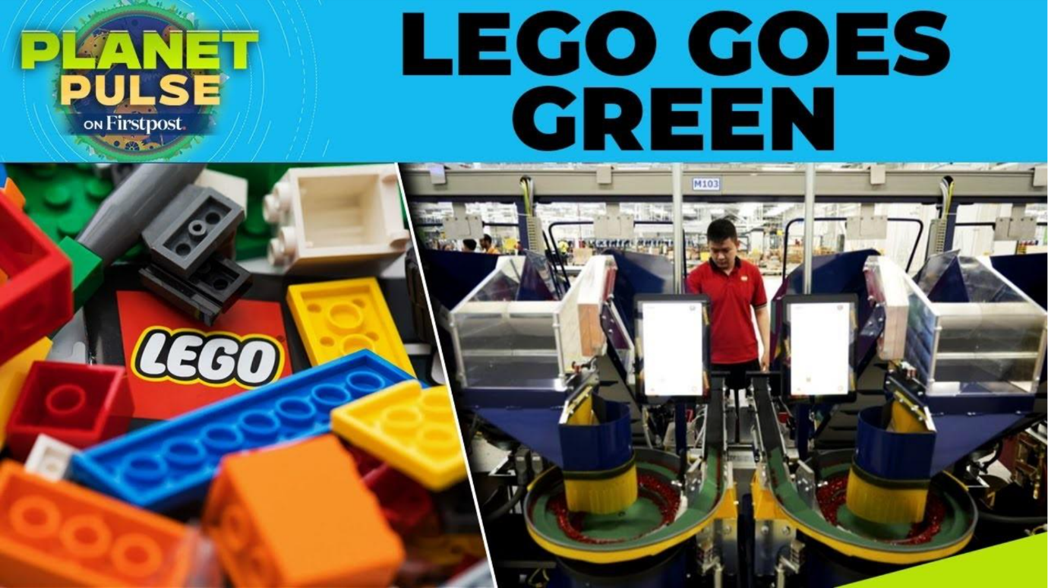

4. Performance Evaluation Framework

4.1 Rationale for the Sustainability-Integrated Balanced Scorecard
Traditional financial reporting is a "lagging" indicator—it tells you what happened in the past but not what is likely to happen in the future. For a complex expansion involving a new manufacturing hub (Binh Duong) and a new retail market (Vietnam consumer class), LEGO needs "leading" indicators.
The S-BSC allows LEGO to track Financial Health (Profit) alongside Customer Loyalty (People), Operational Efficiency (Planet/Process), and Organizational Capacity (Learning). This ensures the expansion is not just profitable, but sustainable and aligned with the company's long-term "Planet Promise" (The LEGO Group, 2024).

4.2 Detailed Perspectives & Key Performance Indicators (KPIs)
Perspective 1: Financial (Shareholder & Economic Value)
Goal: To achieve profitable growth through efficient local manufacturing and market penetration.
In the Vietnam context, financial success isn't just about revenue; it's about leveraging the new factory to reduce the Cost of Goods Sold (COGS) and managing the high initial capital expenditure (CAPEX).
Objective | Key Performance Indicator (KPI) | Target (Year 1-3) | Rationale for Vietnam
Revenue Growth | Year-on-Year (YoY) Sales Growth in VND | +15% annually | Measures the rate of adoption by the Vietnamese middle class (World Bank, 2024).
Cost Efficiency | Logistics Cost per Unit | Decrease by 20% | Local manufacturing in Binh Duong should drastically cut shipping costs compared to importing from Europe/China.
Return on Investment | ROCE (Return on Capital Employed) | Breakeven by Year 4 | Monitors the efficiency of the $1.3 billion factory investment (The Investor, 2025).

Perspective 2: Customer (Market & Social Value)
Goal: To become the most trusted and desired toy brand for Vietnamese parents and children.
Vietnamese parents are highly education-focused. Success depends on positioning LEGO not as a "toy" but as an "education tool."
Objective | Key Performance Indicator (KPI) | Target (Year 1-3) | Rationale for Vietnam
Brand Penetration | Market Share in "Construction Toys" | 35% of category | Tracks dominance against cheap imitators (e.g., Lepin) and local rivals.
Customer Loyalty | Net Promoter Score (NPS) | >75 (World Class) | High NPS indicates parents are recommending LEGO to others, crucial in Vietnam's community-driven culture.
Access to Play | Number of Children Reached | 2 Million | A "Social" metric tracking the reach of donation programs and entry-level priced sets (The LEGO Group, 2024).

Perspective 3: Internal Business Processes (Operational & Environmental Value)
Goal: To achieve manufacturing excellence and carbon neutrality.
This perspective focuses on the "Planet" aspect of the Triple Bottom Line. The Binh Duong factory is designed to be the company's most sustainable facility; KPIs must verify this reality.
Objective | Key Performance Indicator (KPI) | Target (Year 1-3) | Rationale for Vietnam
Manufacturing Quality | Defect Rate (Parts per Million) | <10 PPM | Maintains the "Only the best is good enough" standard, differentiating from low-quality fakes.
Environmental Impact | Carbon Footprint per Brick | Net Zero (Scope 1 & 2) | Verifies the Binh Duong factory’s solar array and LEED certification performance (ScandAsia, 2025).
Supply Chain Agility | Order-to-Delivery Lead Time | <48 Hours for Major Cities | Ensures stock is available in Ho Chi Minh City and Hanoi during key holidays (Tet New Year).

This video explores LEGO's sustainable manufacturing strategy in Vietnam and the role of the government in enabling sustainable infrastructure. Exploring LEGO's Sustainable Manufacturing Strategy in Vietnam

Global Pulse Ep. 145: Exploring LEGO's Sustainable Manufacturing Strategy in Vietnam
University of Maryland Smith School of Business · 163 views

Perspective 4: Learning & Growth (Human Capital & Culture)
Goal: To build a skilled local workforce and foster a culture of safety and innovation.

LEGO needs to hire thousands of skilled workers for its high-tech factory. The "People" aspect here is about treating the Vietnamese workforce ethically and safely, setting a benchmark for FDI in the region.

Objective | Key Performance Indicator (KPI) | Target (Year 1-3) | Rationale for Vietnam
Talent Acquisition | Time-to-Fill (High-Skill Engineering Roles) | <60 Days | Critical for ramping up factory automation and robotics operations.
Employee Safety | Lost Time Injury Rate (LTIR) | 0.0 | Non-negotiable safety standard in the new manufacturing facility.
Local Leadership | % of Management Roles held by Vietnamese Nationals | >60% by Year 3 | Ensuring cultural integration and reducing reliance on expatriate management (McKinsey & Company, 2021).

Perspective 5: The KPIs in the Internal Process and Learning & Growth perspectives to link directly to the factory operation risks.

Perspective | KPI Refinement | Rationale for Vietnam Context
Internal Process | Sustainable Sourcing Ratio (of materials from sustainable sources) | Tracks the company's progress towards using 100% renewable materials, which is a major, publicized goal of the Binh Duong factory (The LEGO Group, 2025b).
Learning & Growth | Technical Training Hours per New Factory Employee | Measures the critical effort to ensure the new workforce can achieve the precision manufacturing standard of of a hair's width (The LEGO Group, 2025a), mitigating the risk of quality deviation.
Learning & Growth | Lost Time Injury Rate (LTIR) vs. Industry Standard | LTIR must be zero (Target: 0.0), a non-negotiable metric for the 'People' element of the Triple Bottom Line, setting an ethical benchmark for FDI in the region.

4.3 Strategic Alignment: The Cause-and-Effect Chain
The strength of the Balanced Scorecard lies in the connection between these perspectives. For LEGO Vietnam, the logic flows as follows:
- If they hire and train skilled local engineers (Learning & Growth) AND maintain rigorous safety standards...
- Then the Binh Duong factory will operate efficiently with zero carbon emissions and low defects (Internal Processes).
- Which leads to high product availability and trusted quality for Vietnamese parents (Customer).
- Ultimately resulting in high sales growth and a strong return on the $1.3bn investment (Financial).
This chain of logic ensures that every employee, from the factory floor in Binh Duong to the retail store in Hanoi, understands how their daily work contributes to the high-level strategic goal of successful expansion.

Recommendations
Based on the comprehensive strategic analysis of Vietnam's macro-environment, competitive landscape, and The LEGO Group's internal capabilities, the following actionable recommendations are proposed for a successful market expansion. These recommendations are rooted in a Broad Differentiation strategy and a Hybrid Entry mode.

Recommendation 1: Execute a "Premium Education" Marketing Strategy
Rationale: The PESTEL and Five Forces analyses highlighted that Vietnam is a highly price-competitive market for generic toys but has a strong cultural demand for education (VnExpress, 2024). To avoid a price war, LEGO must not compete as a toy company but as an educational partner.
Action: Develop marketing campaigns specifically for Vietnamese parents that quantify the "learning value" of LEGO sets, focusing on STEM skills, creativity, and problem-solving. Collaborate with local educational influencers and premium private schools to build credibility.

Recommendation 2: Leverage the Binh Duong Factory for a "Local-for-Local" Advantage
Rationale: The $1 billion Greenfield investment is LEGO's most significant strategic asset in this expansion (The Investor, 2025). It provides an opportunity to turn a backend operational cost into a frontend competitive advantage.
Action: Publicize the factory's carbon-neutral status to appeal to the growing eco-conscious sentiment among young Vietnamese families. Use the "Made in Vietnam" tag to build local pride and trust, differentiating from imported competitors. Utilize the factory's proximity to implement a "just-in-time" inventory system for key sales periods like the Tet holiday, ensuring superior product availability.

Recommendation 3: Implement a Phased Retail Rollout with Strategic Partners
Rationale: While manufacturing is owned, a direct-to-consumer retail network is capital-intensive and risky in a new, complex market. A partnered approach mitigates this risk.
Action: Phase 1 (Year 1-2): Partner with a leading local distributor to penetrate existing premium retail channels (e.g., high-end department stores, bookstore chains like Fahasa).
Phase 2 (Year 2-3): Launch flagship "LEGO Certified Stores" (LCS) in major metropolitan malls (Ho Chi Minh City, Hanoi) via a franchise model with a trusted local partner. This establishes the premium brand experience without full capital exposure.

Recommendation 4: Adopt the Sustainability-Integrated Balanced Scorecard (S-BSC)
Rationale: A standard financial scorecard is insufficient for a strategy so heavily reliant on brand trust and sustainability. The proposed S-BSC ensures that non-financial KPIs critical to long-term success are monitored.
Action: Officially adopt the S-BSC framework outlined in Section 4. Integrate these KPIs into the performance reviews of the local management team to ensure alignment with the strategic goals of ethical growth, safety, and environmental stewardship.

6 Conclusion
This report has conducted a rigorous strategic analysis of The LEGO Group's proposed expansion into Vietnam. The findings confirm that this is a highly attractive and strategically sound initiative.
The selection of The LEGO Group is justified by its need to find new growth outside of saturated Western markets and its financial capacity to undertake significant investment (The LEGO Group, 2024). The choice of Vietnam is strongly supported by macro-environmental data, specifically its robust economic growth, a young demographic, and a rapidly expanding middle class that prioritises education (World Bank, 2024; McKinsey & Company, 2021).
Crucially, the analysis reveals a unique strategic synergy: LEGO is not just entering a new retail market; it is building a fully integrated supply and demand ecosystem. The existing commitment to the Binh Duong manufacturing facility provides a formidable, hard-to-replicate competitive advantage that addresses key threats in the local market, such as price rivalry and supply chain costs.
By executing a strategy focused on premium differentiation through education, leveraging its local manufacturing base, and employing a hybrid retail partnership model, The LEGO Group is uniquely positioned to succeed. The adoption of a Sustainability-Integrated Balanced Scorecard will ensure that this growth is managed responsibly, securing LEGO's position as the most trusted and desirable play brand for the "builders of tomorrow" in Vietnam.

Harvard Reference List

AHK Knowledge Hub VN (n.d.). Office: Potential Locations. [online] Available at: https://www.ahk-knowledgehub-vn.com/copy-of-rental-modes-and-costs (Accessed: 3 Dec. 2025).
Barney, J. (1991). Firm Resources and Sustained Competitive Advantage. Journal of Management, 17(1), pp.99–120.
Countrymeters (2025). Vietnam Population. [online] Available at: https://countrymeters.info/en/Vietnam (Accessed: 29 November 2025).
Euromonitor (2023). Global Toy Market Trends. [online] Available at: https://www.euromonitor.com (Accessed 25 Nov. 2025).
Johnson, G., Whittington, R., Scholes, K., Angwin, D. and Regnér, P. (2017). Exploring Strategy: Text and Cases. 11th ed. Harlow: Pearson Education.
Kaplan, R.S. and Norton, D.P. (1996). The Balanced Scorecard: Translating Strategy into Action. Boston: Harvard Business School Press.
Mattel PESTLE (2025). Mattel, Inc. (MAT) PESTLE Analysis. [online] DCFmodeling.com. Available at: https://dcfmodeling.com/products/mat-pestel-analysis (Accessed: 25 November 2025).
McKinsey & Company (2021). The new faces of the Vietnamese consumer. [online] Available at: https://www.mckinsey.com/featured-insights/future-of-asia/the-new-faces-of-the-vietnamese-consumer (Accessed: 29 November 2025).
Nguyen, V. T. (2012). A dynamic approach to assess international competitiveness of Vietnam's garment and textile industry. Journal of Engineering and Applied Sciences, 7(6), pp. 497-505.
Porter, M. E. (1985). Competitive Advantage: Creating and Sustaining Superior Performance. New York: Free Press.
Porter, M. E. (1990). The Competitive Advantage of Nations. New York: The Free Press.
Porter, M. E. (2008). The Five Competitive Forces That Shape Strategy. Harvard Business Review, 86(1), pp. 78-93.
Porter, M.E. (1985). Competitive Advantage: Creating and Sustaining Superior Performance. New York: Free Press.
PwC (2025). Vietnam - Corporate - Tax credits and incentives. [online] Tax Summaries. Available at: https://taxsummaries.pwc.com/vietnam/corporate/tax-credits-and-incentives (Accessed: 25 November 2025).
ScandAsia (2025). $1.3 billion LEGO factory in Vietnam to open in April. [online] ScandAsia. Available at: https://scandasia.com/1-3-billion-lego-factory-in-vietnam-to-open-in-april/ (Accessed: 25 November 2025).
Technavio (2023). Toy market 2023-2027; A descriptive analysis of the five forces model. [online] PR Newswire. Available at: https://www.prnewswire.com/news-releases/toy-market-2023-2027-a-descriptive-analysis-of-the-five-forces-model (Accessed: 25 November 2025).
The Investor (2024). Lego completes 90% of $1.3-bln Vietnam factory, to open in 2025. [online] The Investor. Available at: https://theinvestor.vn/lego-completes-90-of-13-bln-vietnam-factory-to-open-in-2025-d13226.html (Accessed: 25 November 2025).
The LEGO Group (2024). Annual Report 2023. [online] Available at: https://www.lego.com/cdn/cs/aboutus/assets/bltae284fd27d06ccb4/LEGO_Group_2023_Financial_Highlights.pdf (Accessed: 29 November 2025).
The LEGO Group (2024). Sustainability Reporting 2024. [online] LEGO.com. Available at: https://www.lego.com/en-us/sustainability/reporting (Accessed: 29 November 2025).
The LEGO Group (2024a). About Us. [online] LEGO.com. Available at: https://www.lego.com/en-us/aboutus (Accessed: 25 November 2025).
The LEGO Group (2024b). 2024 Financial Highlights. [online] Available at: https://www.lego.com/cdn/cs/aboutus/assets/bltf2a6246ed68fd0b6/The_LEGO_Group_FY_2024_Financial_Highlights.pdf (Accessed: 3 Dec. 2025).
The LEGO Group (2024b). Annual Report 2023. [online] Available at: https://www.lego.com/cdn/cs/aboutus/assets/bltae284fd27d06ccb4/LEGO_Group_2023_Financial_Highlights.pdf (Accessed: 29 November 2025).
The LEGO Group (2025a). LEGO Group opens new state-of-the-art factory in Vietnam. [online] Available at: https://www.lego.com/en-us/aboutus/news/2025/april/the-lego-group-opens-new-state-of-the-art-factory-in-Vietnam (Accessed: 3 Dec. 2025).
The LEGO Group (2025b). LEGO Manufacturing Vietnam signs DPPA with VSIP. [online] Available at: https://www.lego.com/en-us/aboutus/news/2025/september/lego-manufacturing-vietnam-signs-dppa-with-vsip (Accessed: 3 Dec. 2025).
U.S. Department of State (2024). 2024 Investment Climate Statements: Vietnam. [online] Available at: https://www.state.gov/reports/2024-investment-climate-statements/vietnam (Accessed: 29 November 2025).
VnExpress (2024). Rising middle class pushes wealth management potential in Vietnam. [online] Available at: https://e.vnexpress.net/news/business/companies/rising-middle-class-pushes-wealth-management-potential-in-vietnam-4748770.html (Accessed: 25 November 2025).
World Bank (2024). Vietnam Economic Update. [online] Available at: https://www.worldbank.org/en/country/vietnam/publication/vietnam-economic-update (Accessed: 29 November 2025).
World Bank (2024). World Bank forecasts Vietnam 2024 GDP growth at 6.1%. [online] Available at: https://www.brecorder.com/news/40319310 (Accessed: 25 November 2025).

