Design of Dynamic Website for Our Lady of Lourdes Charity Shop - Technical Report

Gabriel Avbenake (1902228)

Lecturer: Gaynor Thomas

University of Wales Trinity Saint David

2020

Table of Contents

Table of Contents 2
Table of Figures 2
1 Introduction 3
2 Web Accessibility 5
2.1 Perceivable 6
2.2 Operable 8
2.3 Understandable 8
2.4 Robust 9
3 Web Security 9
4 Scalability 10
5 Usability 11
6 Conclusion 12
References 12

Table of Figures

Figure 1: News and Events Page of the website 3
Figure 2: Upcoming Events Page of the website 3
Figure 3: Home Page of the website 4
Figure 4: Searching for Products 5
Figure 5: Displaying some products for sale 5
Figure 6: Displaying the page where the administrator uploads photo for the gallery 6
Figure 7: Displaying the page where a user can search for items in the store 7
Figure 8: Displaying the page where a user has several options for viewing the photo gallery 8
Figure 9: Showing a sample error message on a form 9
Figure 10: Showing Scalability by using Load Balancer that scales out the load 11

1 Introduction
The Project is an interactive website for Our Lady of Lourdes Charity Shop, Townhill, Swansea. It is a dynamic website with a frontend and backend interacting with a database. The website was designed using HTML, CSS, JavaScript and PHP. I also employed the use of jQuery, Bootstrap and CKEditor. The database was done in MySQL. The website does the following, amongst other things:
- Gives information about the shop, their activities, upcoming events, etc.
- Showcases the items available for sales in the shop by categories as well as the ability to search for items
- Has an administrator’s interactive interface where the web administrator could add and manage contents on the site.
Below are some screenshots of the website:

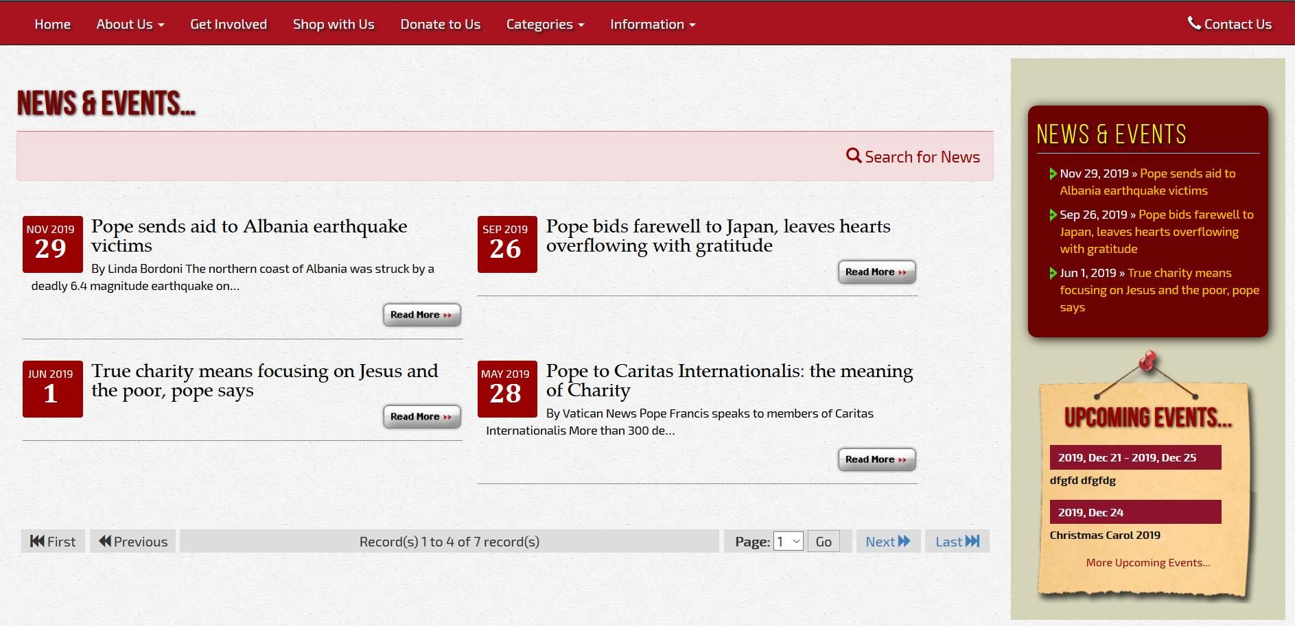
Figure 1: News and Events Page of the website

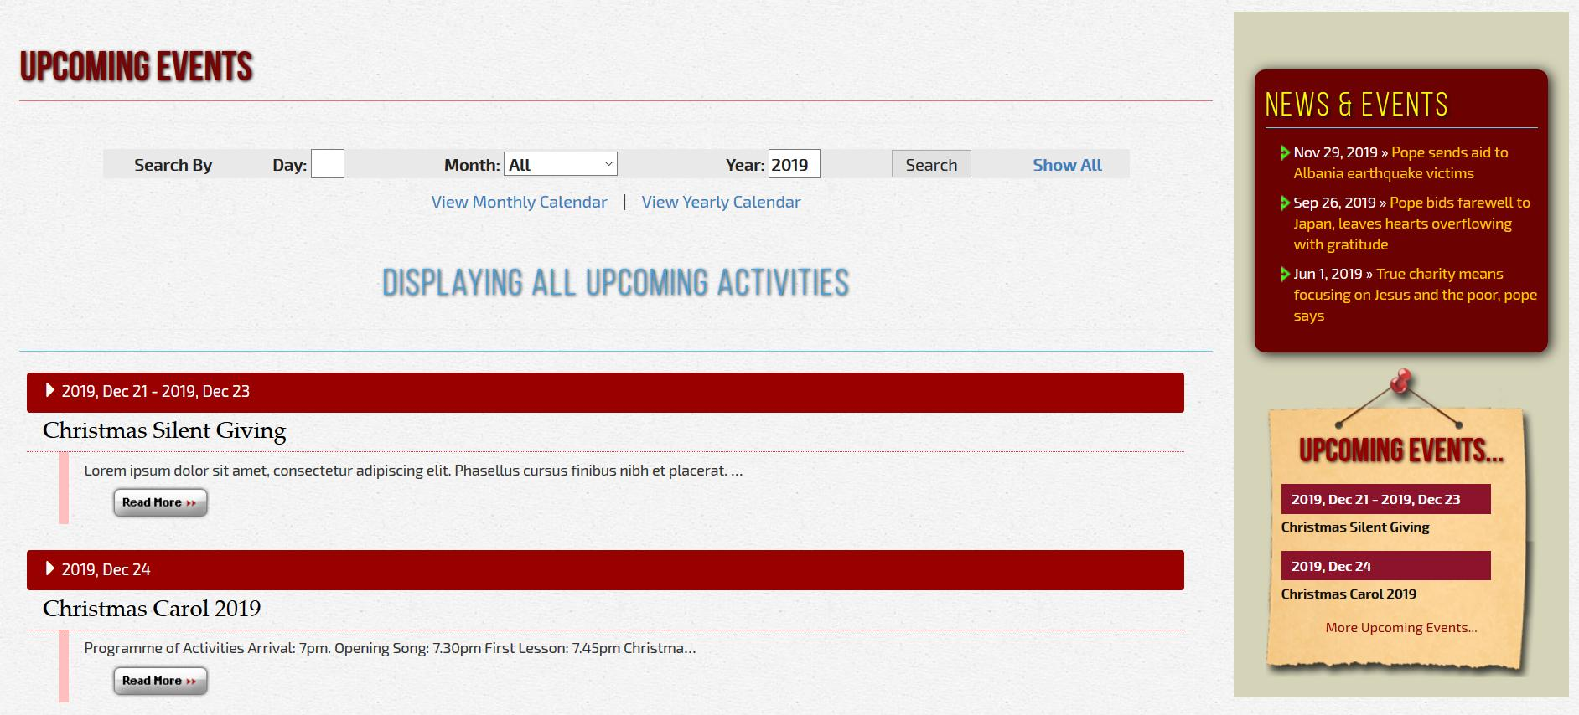
Figure 2: Upcoming Events Page of the website
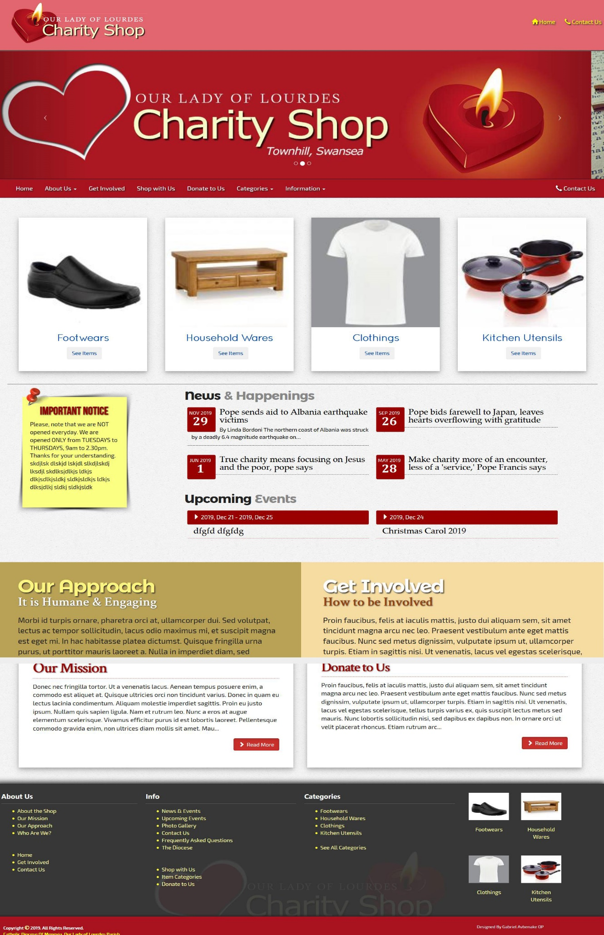
Figure 3: Home Page of the website
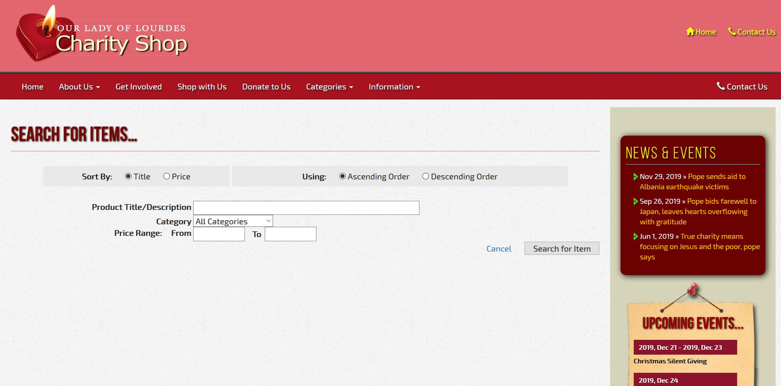
Figure 4: Searching for Products

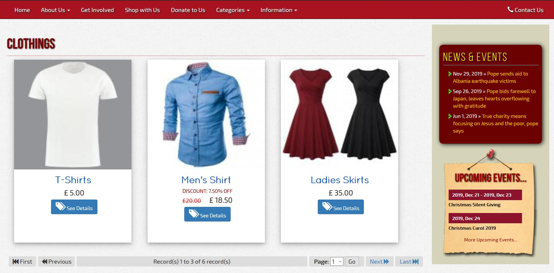
Figure 5: Displaying some products for sale
There are certain standards to be met in web designing. Any serious website of our time must address the following issues, amongst others: Security, Scalability, Usability and Accessibility. This report shall show how I have addressed these issues and what is left to be done.

2 Web Accessibility
Websites must be properly designed so that even people with disabilities can use them. If there are accessibility barriers on a website, it makes it difficult or impossible for some people to use. The Web is fundamentally designed to work for all people, whatever their hardware, software, language, location, or ability [1]. It is important to note also that Web accessibility also benefits people without disabilities, e.g. people using mobile phones etc or those using a slow Internet connection.
There are international web standards that define what is needed for accessibility. Web Content Accessibility Guidelines (WCAG) is one of such [2]. WCAG 2.0 was published on 11 December 2008. WCAG 2.1 was published on 5 June 2018.
There are also governmental laws and policies relating to web accessibility in countries round the globe. Usually, these laws and policies would be based on WCAG. Here in the United Kingdom, it is the Equality Act 2010. [3] Certainly, this document covers more than web accessibility. However, for web accessibility, it uses WCAG 2.0. [4]
WCAG 2.0 and WCAG 2.1 have 12-13 guidelines that are organized under 4 principles: perceivable, operable, understandable, and robust [2][5]. I shall go through these 4 principles and show how my website project compiles with them.

2.1 Perceivable
The first guideline here states that text alternatives must be provided for non-text content. I complied with this. The alt attribute of the <img> element was always entered with a descriptive caption. More so, I made provision for the web administrator to enter a caption anytime a photo is to be uploaded to the website. When such captions are provided, they are automatically used as the alt attribute of the uploaded image. Well, I can only encourage the web administrator to use very good descriptive caption, not just captions such as photo1, photo2, etc.
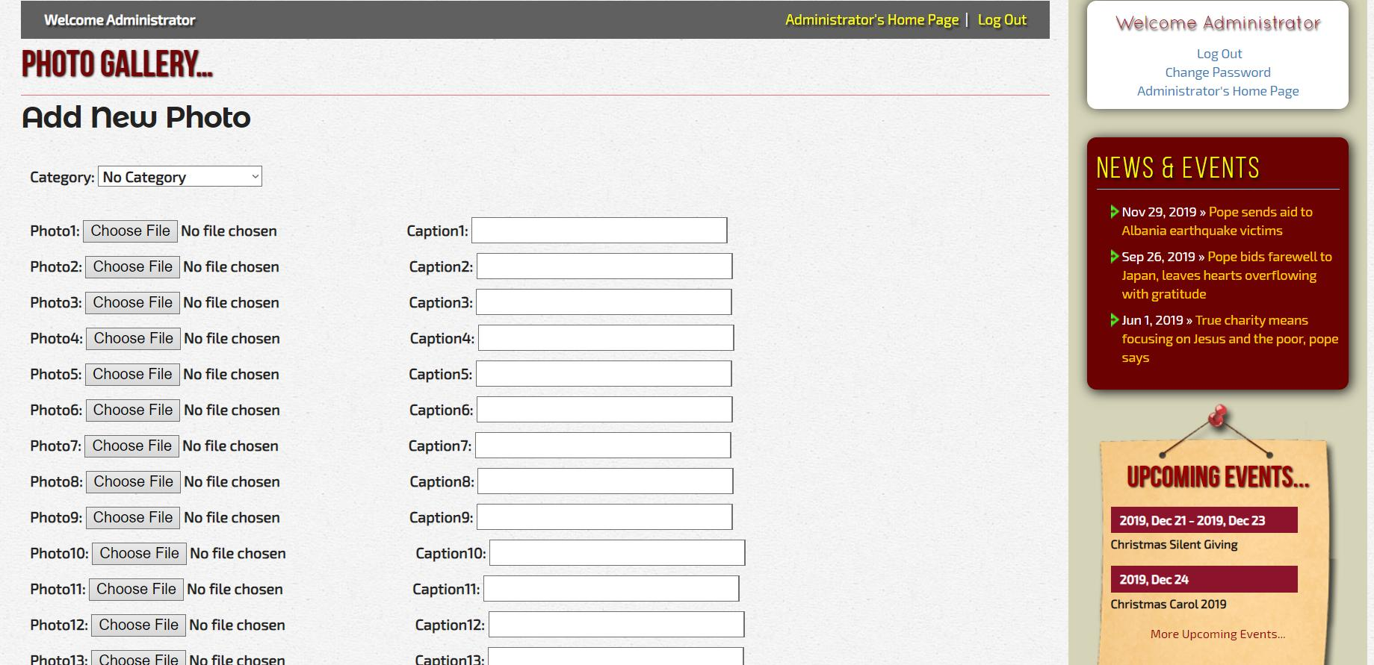
Figure 6: Displaying the page where the administrator uploads photo for the gallery
I also have appropriate labels for form controls, input, and other user interface components.
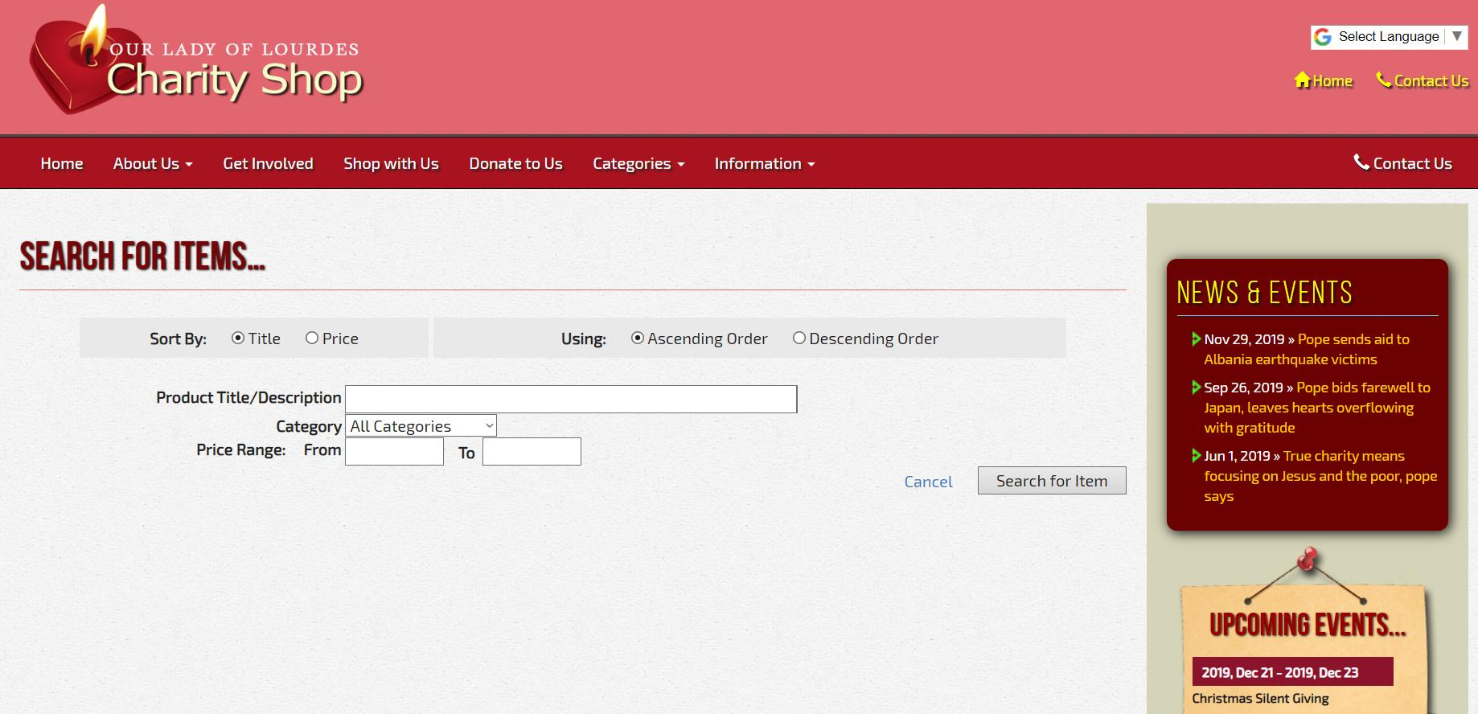
Figure 7: Displaying the page where a user can search for items in the store

Other requirements include: [5]
Other WCAG 2.1 Perceivable guideline | Steps I took to compline
Colour is not used as the only way of conveying information or identifying content | I avoided using colour alone as my means of conveying information or identifying content
Default foreground and background colour combinations provide sufficient contrast | That was the crust of my design to ensure text are readable by clear colour contrast.
- When users resize text up to 400% or change text spacing, no information is lost  - Text reflows in small windows (“viewports”) and when users make the text larger | The website is responsive, so it can adjust to text adjustments while still presenting the whole text on the screen.
Images of text are resizable, replaced with actual text, or avoided where possible | I did not use any image of texts. However, if the web administrator were to do that, the CKEditor that I used allows for images to be resized.
Background audio is low or can be turned off, to avoid interference or distraction | No background audio was used on the website.

2.2 Operable
I made all functionality available from a keyboard, especially the navigation bar. It was designed using Bootstrap which is a well-known CSS framework and it complies with web accessibility. The menu bar is accessible using the Tab key.
There are no time limits on the website, thereby giving users enough time to read and use content.
I did not use any flashing content on the website. Though a sliding animation is used for the photo gallery, there is the option to turn it off and other options of viewing it without any sliding animation.
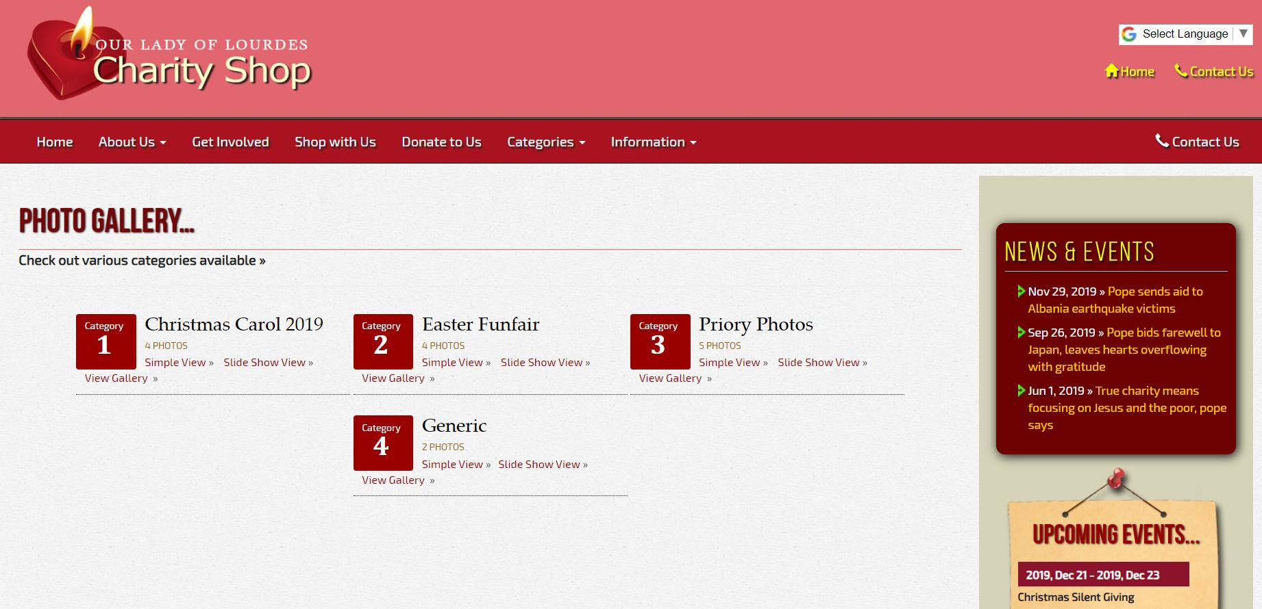
Figure 8: Displaying the page where a user has several options for viewing the photo gallery

I have ensured that contents are well organized to help users orient themselves and navigate effectively. There is more than one way to find pages. I have a navigation bar at the top of the webpages as well as a site map at the base of the webpage to navigate as well. All webpages clear headings, except of course, the home page. [6]

2.3 Understandable
One of the principles here requires that text be made readable and understandable [5, 6]. I ensured that the font-size of the text are big enough. Of course, the basic language of the website is English, but with Google Translate Software at the top of each webpage should a visitor require a translation to any other language.
Many people rely on predictable user interfaces and are disoriented or distracted by inconsistent appearance or behaviour. On this website, contents appear and operate in predictable ways [6]. I used the usual webpage layout, with the mast banner at the top, followed by the navigation bar, then the content of the page with a sidebar of links to informative pages. At the bottom of the page is the sitemap, to give easy access to the rest of the website as well as give an idea of how the website is organized.
More so, users are helped to avoid and correct mistakes [5, 6]. JavaScript programming was used to assist users fill form appropriately. For example, a field that requires only numbers, JavaScript was used to prevent users from type alphabets there. Whenever an error occurred at form submission, a very descriptive message is given with clear indication of where the problem occurred.
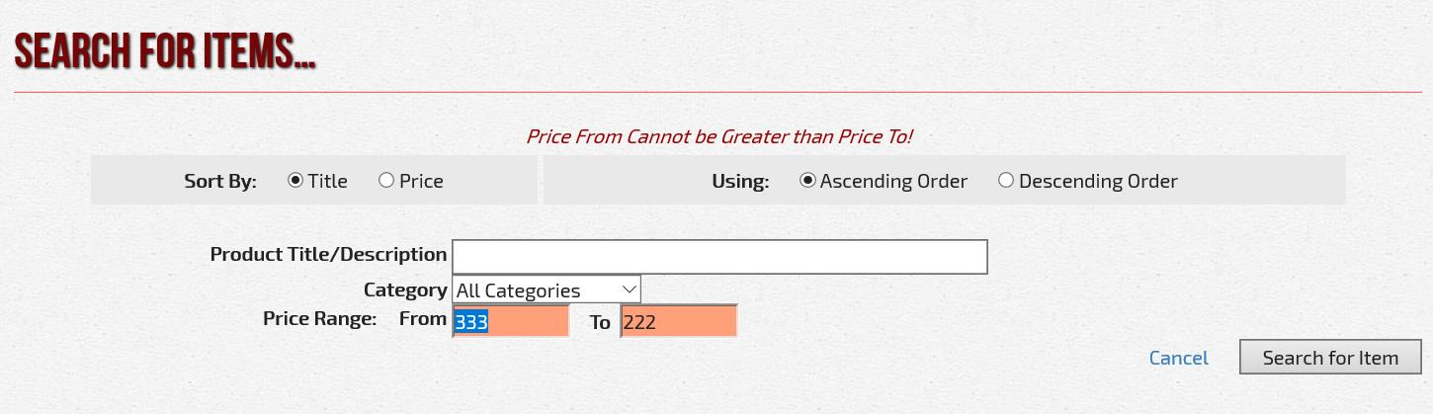
Figure 9: Showing a sample error message on a form

2.4 Robust
The robust parameter dictates that websites maximize compatibility with current and future user tools. [5] The website is a responsive site which fits into various devices: desktop, tablets and phones. More so, I took time to optimize it for various browsers. I looked at it on the various popular browsers and it works very well on them.

3 Web Security
Web Security is very critical and an ongoing issue. There is a lot to be concerned about. There are security risks that affect the Web servers, as well as visitors to web sites. Furthermore, both end-users and Web administrators need to worry about the confidentiality of the data transmitted across the Web. The TCP/IP protocol was not designed with security in mind; hence it is vulnerable to network eavesdropping. [7]
On the issue of the confidentiality of data transmitted between the website and web browsers, I shall ensure that the website would be hosted on a webserver with a HTTP Secured Socket Layer (SSL). Some web hosts like Inmotion Hosting provide a Free SSL included in the hosting fees. More so, their hosting fees is quite competitive. See the information on https://www.inmotionhosting.com/cheap-hosting. The SSL provided is pretty sufficient for our website since there is no online shopping or individual registration on the website.
The other issues of web servers and web browsers security are complex. Some of the common security vulnerabilities and threats include, but are not limited to:
- SQL Injection
- Cross Site Scripting
- Broken Authentication and Session Management
- Cross Site Request Forgery
To prevent SQL Injection and other security issues, prepared statements where used especially where user inputs are used in respect to the database. Prepared statements prevent SQL injections [8]. Cross Site Scripting (XSS) is prevent on the site by escaping all outputs with htmlentities and ENT_QUOTES [9]. For Broken Authentication and Session Management, I ensure that when a login session ends, the authentication cookies are all rendered invalid [10]. On Cross Site Request Forgery (CSRF), since the website did not have users’ login, other than the web administrator, CSRF should not be much of a trouble. Nonetheless, I implemented some measures against it like a CSRF Tokens, where a value is embedded in a form and validated against the one saved on the database. This value is changed from time to time.

4 Scalability
Certainly, websites would be expected to grow and attract more visitors. Scalability is about thinking of future problems that a website might face in future as its workload increases and designing in such a way that would be easier to upgrade later without much problems. The degree of complexity in scaling up/out depends on how well the websites were designed from the very beginning. [11]
Scalability involves a lot of issues. However, since this is a brief report, I would touch on just two critical ones. The first is Hardware Limitations. To forestall this issue, the website would be hosted on Web Hosts that provide Platform as a Service (PaaS). With this is kind of service, I only worry about the Website Design: Frontend and Backend. The other issues of Runtime, Middleware, Software Upgrades, Operating System, Virtualization, Servers, Storage and Networking are managed for me. Furthermore, I can scale up anytime I want, when my users or products increase and I need more space or more processing power.
The second is the issue of Architecture and Sustainable design. An app architecture makes a big difference in scalability [11]. The software should be designed in such a way as to avoid problems with scalability in the future. The method that I used was that of containers. By containers, I mean that various components are put in small scripts and connected together using the PHP include function. In this way, it is easy to rework small sections of the website without tearing down the own thing. The containers allow for such level of virtualization.
Of course, I don’t pretend that these are all that scalability is about. No. A web application is said to be scalable if by adding more hardware, application can linearly take more requests than before [14]. Application architecture is scalable if each layer in multi layered architecture is scalable; as shown in diagram below. We should be able to linearly scale by add additional box in Application Layer or Database Layer (Database Splitting, Partitioning or Sharding). Of course, all of these are very advanced for a simple charity shop website. So, I did not do any of these.
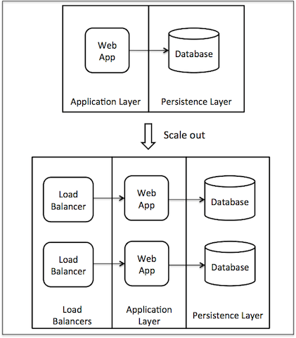
Figure 10: Showing Scalability by using Load Balancer that scales out the load

5 Usability
Good usability ensures that users can find what they are looking for quickly. It is important for websites to be usable regardless of users' language and culture [12]. Thus, we have a Google Translate Software at the top banner of the website. The navigation system of the website is pretty straightforward with a site map at the base of every page. More so, the most sought-after things such as location, opening hours and contact information are clearly displayed and easy to find. There is a contact us button at the top of every page.
In today’s world, mobile usability is very crucial because mobile devices are ubiquitous. With so many different mobile devices with their screen sizes and make, it is crucial to consider how such users accomplish their task on a small screen [12]. To boost the usability of the website, I made the website mobile friendly. It is a fully responsive website.
Furthermore, I used interfaces that don’t require instructions, or even a long process of trial and error to figure them out. I created a new website using what is easy to learn and some of the interface that people are already used to, such as Bootstrap, CKEditor, etc. This way, I help the users reach their goals more quickly [13].

6 Conclusion
Designing a web site is a complex process. It involves more than just design the frontend and backend using the various web technologies available: HTML, CSS, JavaScript, PHP, MySQL etc. Even as one writes the code using these languages, one has to pay attention to various standards that are to be met. Such standards must pay serious attention to Web Security, Scalability, Usability and Accessibility. Without paying attention to these issues, the web site would be at best a child’s play. Of course, it is difficult, if not impossible, to achieve a 100% compliance. So, the quality of the website would depend, to a very large extent, on the percentage scored on these various points. There are various professional tools out there to measure these percentages. I was not able ascertain the percentage scored by my website. This report only shows what I could do towards meeting the various standards of web security, web scalability, web usability and web accessibility.

References
[1] W3C Web Accessibility Initiative (WAI), “Introduction to Web Accessibility”, Online source: https://www.w3.org/WAI/fundamentals/accessibility-intro/ (accessed 11/12/2019)
[2] W3C Web Accessibility Initiative (WAI), “Web Content Accessibility Guidelines (WCAG)”, Online source: https://www.w3.org/WAI/standards-guidelines/wcag/ (accessed 11/12/2019)
[3] Legislation.Gov.UK, “Equality Act 2010”, Online source: http://www.legislation.gov.uk/ukpga/2010/15/contents (accessed 11/12/2019)
[4] W3C Web Accessibility Initiative (WAI), “United Kingdom: Law and Policies”, Online source: https://www.w3.org/WAI/policies/united-kingdom/ (accessed 11/12/2019)
[5] W3C Web Accessibility Initiative (WAI), “WCAG 2.1 at a Glance”, Online source: https://www.w3.org/WAI/standards-guidelines/wcag/glance/ (accessed 11/12/2019)
[6] W3C Web Accessibility Initiative (WAI), “Accessibility Principles”, Online source: https://www.w3.org/WAI/fundamentals/accessibility-principles/ (accessed 28/12/2019)
[7] The World Wide Web Security FAQ, “3. General Questions”, Online source: https://www.w3.org/Security/faq/wwwsf1.html (accessed 29/12/2019)
[8] PHP Manual, “Prepared Statements”, Online source: https://www.php.net/manual/en/mysqli.quickstart.prepared-statements.php (accessed 29/12/2019)
[9] Portswigger Web Security, “Cross-site scripting”, Online source: https://portswigger.net/web-security/cross-site-scripting (accessed 29/12/2019)
[10] Guru99, “10 Most Common Web Security Vulnerabilities”, Online source: https://www.guru99.com/web-security-vulnerabilities.html (accessed 29/12/2019)
[11] JustCoded, “How to make a successful scalable web application?”, Online source: https://justcoded.com/blog/how-to-make-a-successful-scalable-web-application (accessed 30/12/2019)
[12] Wikipedia, the free encyclopedia, “Web usability”, Online source: https://en.wikipedia.org/wiki/Web_usability (accessed 30/12/2019)
[13] The Daily Egg, “5 Key Principles Of Good Website Usability”, Online source: https://www.crazyegg.com/blog/principles-website-usability (accessed 30/12/2019)
[14] High Scalability, “4 Architecture Issues When Scaling Web Applications: Bottlenecks, Database, CPU, IO”, Online source: http://highscalability.com/blog/2014/5/12/4-architecture-issues-when-scaling-web-applications-bottlene.html (accessed 30/12/2019)

