Programme: BSc Health and Social Care
Module: Protecting and Supporting Families in Health and Care
Module code: BMHP5021
Lecturer Name: Gillian weaver
Assignment Title: Component 2: Written Report
Student Name:Patiecia Malongo
Student ID:2333371

AN EXAMINATION AND ANALYSIS OF HOW THE EARLY HELP SYSTEM IS SIGNPOSTED TO UK FAMILIES BY LOCAL AUTHORITY WEBSITES

TABLE OF CONTENTS
Introduction 3
Explanation of the Early Help System 3
Explanation of Multi-Agency Working 4
Evaluation of Three Local Authority Websites 5
Leeds City Council Website 5
Norfolk County Council Website 6
Tower Hamlets Council Website 6
Comparative Analysis 7
Conclusion and Recommendations 8
Reference List 9

Introduction
Early Help is an orbiting component of the protective machinery within the United Kingdom, designed in such a way that it provides support to kids and families during the early phase when the challenges are at a tender level, before the challenges become complex issues. The construct is based on the topic of early problem recognition and enables a quick intervention, thus allowing families to obtain the appropriate support with the help of legally available child protection departments. The main goal of the Early Help services is to mitigate the outcomes of children by resolving the problems of parenting deficits, financial insecurity, mental well-being deficiencies, difficulty attending school, and family discord.
The delivery and coordination of Early Help services would not be possible without the local authorities. Besides direct services they employ, they take care of the information on the available support being easily available to families and professionals. The local authority web site can be seen as one of the prime tools of information dissemination; these types of sites serve as a crucial storehouse of information about those parents, carers, and professionals, who need guidance or help.
In this report, the researcher provides an analysis of how three local authorities UK websites communicate about the Early Help system and family support services it provides. The counsel chosen to be assessed include Leeds City Council, Norfolk County Council and Tower Hamlets Council. The report describes the Early Help system and its aims according to the national guidance and then writes about the idea of multi-agency collaboration in the context of safeguarding.

Explanation of the Early Help System
Early Help defines a system of assistance provided to the children, the youth and the families at the earliest stage in which the problems arise. The purpose of Early Help is to prevent the further development of challenges into even more significant problems that may require legal intervention by social care services. The Early Help System Guide indicates that by intervening early in families professionals have an opportunity to address their behavioural issues, struggles with school attendance, emotional welfare issues, and family conflict to an extent that they do not escalate (gov.uk, 2023).
The early assist services hinge on the notion that support offered at the earliest possible stage is more effective and useful as compared to response after issues have already escalated. Early case identification, backed by the professionals, will help to identify the issue and consult with the families to identify feasible solutions and improve the outcome of children. The Early Help services can include the parenting support programmes, counseling, young people services, family support worker, and referrals to education and health services (gov.uk, 2023). The aim of these services is to ensure that families are empowered and their ability to cope with challenges made stronger.
The other notable thing about Early Help is that it is voluntary and supportive in nature and not investigative or punitive. Families are motivated to freely participate in the services and professionals aim at developing beneficial relations based on trust and collaboration. The method will allow families to feel threatened and accepted instead of being judged, which may lead to greater engagement and more successful results.
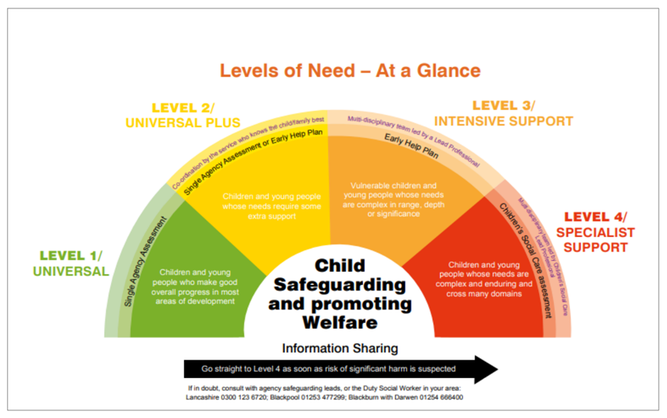
Figure 1: Early Help
(Source: greatwood.lancs, 2023)
Early Help has a very important role to play in the wider system of safeguarding too. Safeguarding involves security of the children against harm and ensuring their wellbeing. Early Help helps in the protection by reporting the risks at an early age and solving them before they lead to severe damages or neglect (Roy, 2022).

Explanation of Multi-Agency Working
Multi-agency working is a key point in the safeguarding system and is central to the Early Help service delivery. It refers to the collaboration of the heterogeneous experts or organisations that collaborate to support children and families. Working Together to Safeguard Children (2023) provides the information about safeguarding when the cooperation of the agencies, including social care, education, health services, and the police, and information sharing and cooperation are used to protect children and support their welfare (Selwyn, 2022).
The requirements of both children and families are often complicated and cannot be satisfied by an individual professional or institution. An example of this is a child who may face problems in school but also face the problems at home, health related issues or the money situation at home. Multi-agency working allows the team of professionals of various fields to exchange knowledge and experience, which will provide a more in-depth understanding of the circumstances of the family. Through collaboration, agencies will be able to come up with consistent plans that will meet the entire gamut of requirements facing the child and family.
Usually in the context of Early Help, multi-agency implication includes the schools, health visitors, family support worker, youth services, and voluntary organisations. Every professional has unique roles and views (Neto et al., 2024). The teachers might notice issues with the behaviour or attendance of the child, the health professionals might detect developmental or mental problems, and the social workers might be the means of further support of the family when the help is needed.
Successful multi-agency collaboration is based on a clear operation, joint accountability, and strong leadership of safeguarding collaboratives. An initial risk detection and proper address require an information exchange among the agencies in particular since it allows identifying a risk as early as possible (Geddes et al., 2023). Lack of proper cooperation could mean that important information is ignored, which can postpone the assistance to children and families.

Evaluation of Three Local Authority Websites

Leeds City Council Website
The website of the Leeds City Council has a whole section dedicated to the Early Help and family services. It can be easily found on the children and families services page of the site when it comes to information about Early Help. The site explains the meaning of Early Help and outlines the way families can receive support in case of challenges (Corliss et al., 2022). The language that is used across the site is mostly easy to understand and follow, which makes them comprehensible to parents and carers who might lack professional knowledge pertaining to safeguarding.
The distinct asset of the Leeds site is the availability of information about the diverse help services. The site provides information on family hubs, parenting programmes, youth services and information on how professionals may refer families to receive Early Help support. The provision of contact information and referral details is rather beneficial, as it allows families and professionals to understand how the assistance can be obtained.
However, there are some weaknesses observable. In other parts, the text is posted in long paragraphs which can hinder the rapid identification of essentials by the users. Further, the site has valuable materials, yet it might be enhanced with more visual materials like diagrams or video, which will make the Early Help process more clear (Jacobs, 2022). In spite of these limitations, the Leeds site provides a fairly clear and informative understanding of the Early Help services.

Norfolk County Council Website
The Early Help services and family support are also on the Norfolk County Council site. The site provides the mission of Early Help and reasons that the service targets the families in the initial stages before the situation turns to be more severe. The words used are usually simple and are meant to be understood by a parent or carers who are in need of help.
The presentation of information in the Norfolk site is organised which is one of its strengths. The site also isolates facts into various compartments so as to make it easier to navigate by a visitor (Arden et al., 2024). The information on how the families can be referred to obtain the Early Help support by professionals is also provided on the site thus demonstrating the manner in which the service is run within the broader safeguarding system.
The Norfolk site however has a bit less detailed information as compared to the Leeds site. Although the site gives an understanding of the Early Help concept, some of the descriptions of the services offered are very short. To get the entire picture about the available support, families might be required to scroll more pages (Barrett and Davidson, 2024). Nevertheless, the site provides practical advice and contact details on seeking help albeit with this shortcoming.

Tower Hamlets Council Website
On the Tower Hamlets Council website, children and families section the information about Early Help services as well as family support can be found. The site elaborates on the fact that Early Help is a service designed to supply support of a troubled family and the escalation of problems into more serious safeguarding issues (Batty et al., 2022).
One of the strengths of the Tower Hamlets site is its concentration on being accessible. The site has included headings and short sections making it convenient to the users. Besides, the site has contact details on support services, which is also necessary during the time that families require help.
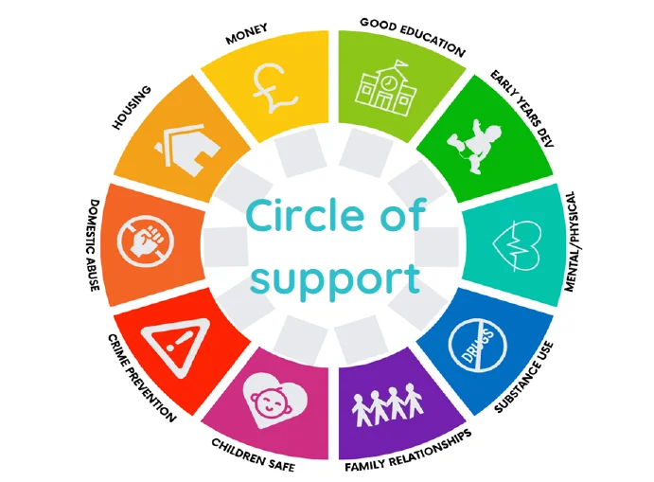
Figure 2: Circle of support
(Source: shropshire, 2023)
However, in comparison with the Leeds site, the Tower Hamlets site has fewer detailed mechanisms of describing the process in which the Early Help system functions. Although the site is able to provide information on the support services available, it does not always provide a detailed explanation on how to take Early Help (Bond et al., 2024). Therefore, individual users might need more instructions or professional help in order to understand how the system can be used.

Comparative Analysis
Comparing the three websites of local authorities, one can note some similarities and differences. The three websites contain details about Early Help services and recognise the significance of designating intervention promptly as a means of assisting families (Churchill and Dunn, 2023). They also offer the contact information or referral networks through which the families or the professionals can get help. This shows that every council appreciates the importance of providing easy access to information concerning family support services.
However, there are differences in the degree of detail and clarity. The most informative site on Early Help services is Leeds City Council. It provides understandable details of support programmes available and contains details of both families and professionals hence ensuring effective user understanding of the manner in which the Early Help system works and how support can be received (MacAlister, 2022).
The Norfolk County Council site is clear and only lacks a little detail on the offered services. Although the design of the website is clear and structured, to get in-depth knowledge of the services provided, the user might have to go through more pages, which might make it less accessible to those families that have not studied the system of safeguarding thoroughly (Hickling et al., 2024).
Tower Hamlets Council site provides succinct and clear information, but it has less detailed descriptions regarding how the Early Help process works. Even though the site is user friendly, more content on where to refer to and support services are needed to improve user knowledge.

Conclusion and Recommendations
The report has explored the three local authority websites that spread information regarding the Early Help system and family support services. Early Help is an essential part of the system of safeguarding since it allows providing professionals with the authority to detect and solve issues in their initial stage. The Early Help services have a goal of averting and enhancing the results of children by providing timely assistance to their families, thus ensuring that challenges do not escalate.
The analysis of the websites has demonstrated that each of the three councils includes the information on the Early Help services, although the amount and level of clarity differs. The Leeds city council site provides the most profound amount of information and specifies how families may obtain the support as well. The Norfolk and Tower Hamlets websites are also useful but need more information and descriptions.
The local authority websites could be improved in a number of ways. To begin with, the websites might provide more explicit step-by-step guidance on ways in which families might access Early Help services. Second, visual applications of diagrams or videos should be implemented, as it may make information more understandable. Lastly, councils might make the descriptions of the support programmes more detailed in order to allow families to know more about the assistance available.

Reference List
Arden, M., Humphreys, H., Wilcockson, H., Paddock, D., Thorneloe, R., Rutkauskas, L., and Millings, A. (2024). Behavioural science: Increasing uptake of family hub services.
Barrett, M. D., and Davidson, M. K. (2024). Child Protection and Safeguarding Policy 2024–25. Policy, 2024, 25.
Batty, E., Crisp, R., Gilbertson, J., Martin, P., Pardoe, J., Parkes, S., ... and Wilson, I. (2022). Working well early help: final annual report 2022.
Bond, A., Smith, G., Bryant, E., Wilkinson, K., Summers, B., Axford, N., ... and Berry, V. The integration of financial wellbeing support within family services: A mixed methods exploration in England. Available at SSRN 6144177.
Churchill, H., and Dunn, H. (2023). Parental participation and community family support:‘family support hubs’ in Northern Ireland and ‘family hubs’ in England. International Perspectives on Parenting Support and Parental Participation in Children and Family Services, 268-283.
Corliss, C., Addis, S., El-Banna, A., Maxwell, N., Scourfield, J., Warner, N., and Williams, A. (2022). The views of local authorities in England on how to prevent children being in care. Child Care in Practice, 28(4), 576-592.
Geddes, E., Harford, T., Hill, D., O'Keefe, R., and Skinner, A. (2023). Evaluation of the Early Help services provided as a part of the Cluster Collaborative in Leeds. Leeds Beckett University.
gov.uk, (2023), Supporting Families: Early Help System guide, [Online] Available from: https://www.gov.uk/government/publications/supporting-families-early-help-system-guide [Accessed 05 March, 2026]
gov.uk, (2023), Working together to safeguard children, [Online] Available from: https://www.gov.uk/government/publications/working-together-to-safeguard-children--2 [Accessed 07 March, 2026]
greatwood.lancs, (2023), Early Help, [Online] Available from: https://www.greatwood.lancs.sch.uk/wp-content/uploads/2023/02/Early-Help.png [Accessed 11 March, 2026]
Hickling, L. M., Dabrowski, J., and Williams, S. (2024). Expanding the early intervention offer: A new care pathway for children’s wellbeing practitioners in a south London child and adolescent mental health service. Clinical child psychology and psychiatry, 29(1), 155-167.
Jacobs, N. (2022). Practice examples: Reorganisation enhances Westminster early help support. Children and Young People Now, 2022(9), 44-45.
MacAlister, J. (2022). The independent review of children’s social care. UK: UK Government, 29-40.
Neto, E. D. A. L., Bailiss, J., Finke, A., Miller, J., and Cosma, G. (2024). Identifying early help referrals for local authorities with machine learning and bias analysis. Journal of Computational Social Science, 7(1), 385-403.
Roy, J. (2022). Signs of safety: The view from early help. Child Care in Practice, 28(3), 482-498.
Selwyn, R. (2022). Early help for children and families. Paediatrics and Child Health, 32(3), 81-87.
Shropshire, (2023), Circle of support, [Online] Available from: https://next.shropshire.gov.uk/media/hzyg5t2m/cofs-diagram.png?format=webp&quality=85&v=1da802947847b10 [Accessed 09 March, 2026]

