

DATA SECURITY, GOVERNANCE AND COMPLIANCE
ACCA7028 Assessment Report
Student Name: Gopika Virakan Valappil
Student ID: 2436585
Program: MSc. Cybersecurity & Digital Forensics
Submitted To: Dr. Dipo Dunsin

Table of Contents
- Introduction
- Organisational Context and Security Challenges
- Review of Security Frameworks and Models
3.1 ISO/IEC 27001 and the ISO 27000 Family
3.2 NIST Cybersecurity Framework (CSF)
3.3 COBIT 2019
3.4 Information Technology Infrastructure Library (ITIL)
- Comparative Analysis of Security Frameworks
- Designed Security, Governance, and Compliance Approach for NG
5.1 Governance and Strategic Security Planning
5.2 Compliance, Legal, and Ethical Considerations
5.3 Security Policies
5.4 Risk Management Approach
5.5 Security Management Models and Practices
5.6 Contingency Planning and Business Continuity
5.7 Protection Mechanisms
5.8 Service Level Agreements (SLAs)
- Importance of Continuous Updates to Regulations and Standards
- Conclusion
- References

1. Introduction
In the contemporary digital landscape, information security has become a fundamental concern for organisations operating at a global scale. The widespread adoption of cloud computing, wireless networking, and online service delivery has significantly increased organisational dependence on digital technologies, while simultaneously expanding exposure to cyber threats, regulatory risks, and operational disruption. Effective information security governance is therefore essential to protect sensitive data, maintain service availability, and ensure regulatory compliance.
NatureGreen (NG) is a globally recognised organisation within the healthy living sector, with an extensive international presence and a strong reliance on cloud-based services to support its workforce and customers. It is estimated that approximately 95% of the organisation’s network infrastructure is wireless, and NG maintains a significant online and social media presence to support brand engagement and commercial activities. In response to operational pressures and changing working practices, the organisation has also expanded support for Bring Your Own Device (BYOD) access for both staff and customers. While these technologies enable flexibility and scalability, they also introduce substantial risks related to data protection, identity management, and intellectual property security.
Despite recognising information security as a strategic priority, NG currently lacks formally defined security policies, governance structures, and risk management processes. This absence increases the likelihood of data breaches, regulatory non-compliance, and reputational damage, particularly given the organisation’s responsibility to protect personal data and high-value intellectual property. This report therefore examines established security frameworks and standards, including ITIL, ISO/IEC 27001, the NIST Cybersecurity Framework, and COBIT 2019, and applies them to design a structured, risk-based approach to information security, governance, and compliance tailored to NatureGreen’s operational environment. It also evaluates the importance of continually updated regulations and standards in maintaining an effective security posture.

2. Organisational Context and Security Challenges
NatureGreen (NG) operates on a global scale with a large workforce and an internationally distributed customer base, resulting in a complex and highly interconnected information environment. The organisation’s heavy reliance on cloud services for IT service delivery, combined with a predominantly wireless network infrastructure—estimated at approximately 95%—significantly expands its cyber-attack surface. In addition, NG maintains an extensive online and social media presence to support brand engagement and business growth, further increasing exposure to cyber threats such as data leakage, account compromise, and reputational harm.
The increasing demand to support Bring Your Own Device (BYOD) access for both staff and customers introduces additional risks related to device security, identity management, and data protection. Protecting personal data and high-value intellectual property is therefore a critical concern for NG, particularly in the absence of formally defined security policies, governance structures, and risk management processes. Collectively, these challenges highlight the need for a structured, standards-based information security framework that integrates governance, risk management, and technical controls to ensure confidentiality, integrity, and availability of organisational assets.

3. Review of Security Frameworks and Models

3.1 ISO/IEC 27001 and the ISO 27000 Family
Organisations operating across digital and regulatory environments require formal governance mechanisms to manage information security risks consistently. The ISO/IEC 27000 family addresses this requirement by providing management-focused standards that support structured security governance, accountability, and continuous oversight.
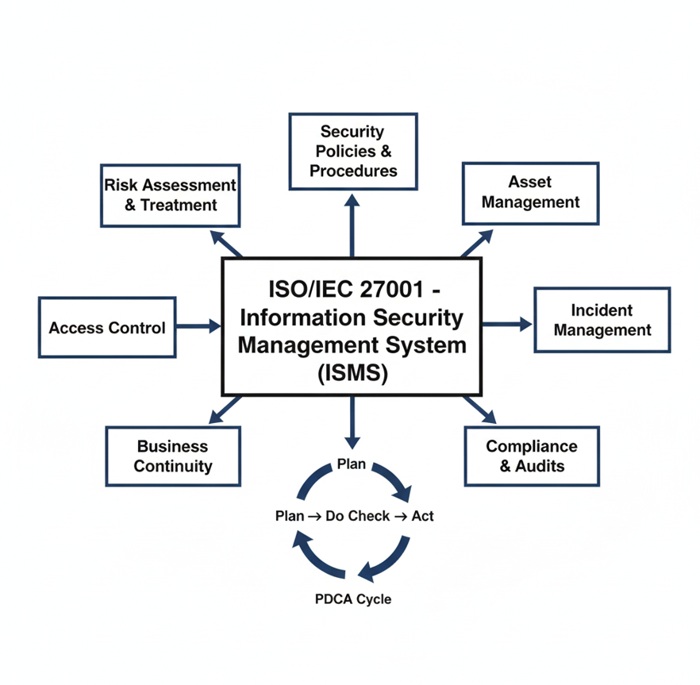Figure 1: ISO/IEC 27001 Information Security Management System (ISMS) illustrating the Plan–Do–Check–Act (PDCA) cycle and core security control domains.
ISO/IEC 27001 is a critical framework for NatureGreen (NG) as it provides a formal, internationally recognised, and risk-based approach to managing information security. Given NG’s responsibility to protect sensitive customer data, staff information, and high-value intellectual property, the standard enables the establishment of a structured ISMS supported by documented policies, defined roles, and continuous improvement processes. It ensures that security risks are systematically identified, assessed, and treated, while also demonstrating compliance with regulatory and contractual obligations across multiple jurisdictions. The implementation of ISO/IEC 27001, supported by ISO/IEC 27002 security controls, enables a formally governed security management system with continual improvement and regulatory assurance [1], [2].

3.2 NIST Cybersecurity Framework (CSF)
To manage cybersecurity risks effectively, organisations require a framework that connects strategic objectives with operational security activities. The NIST Cybersecurity Framework structures cybersecurity management into functional stages that support visibility, protection, incident handling, and organisational recovery.
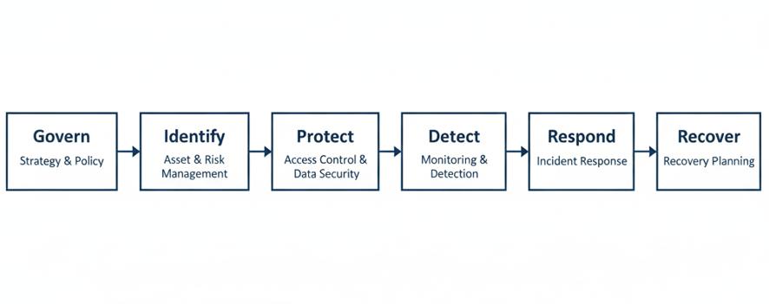
Figure 2: NIST Cybersecurity Framework showing the Identify, Protect, Detect, Respond, and Recover functions for managing cybersecurity risk.

The NIST CSF complements ISO/IEC 27001 by offering detailed operational guidance for the implementation of technical and procedural security controls, including continuous monitoring, threat detection, and incident response capabilities. It is particularly well suited to NatureGreen’s operational environment, which includes a predominantly wireless infrastructure and widespread BYOD usage. By translating high-level security objectives into actionable technical and operational controls, the NIST CSF enhances organisational capability to identify, detect, respond to, and recover from cybersecurity incidents within complex operational environments [3].

3.3 COBIT 2019
At an enterprise level, effective information security depends on clear governance structures and executive oversight. COBIT 2019 provides a governance-oriented framework that enables organisations to balance value delivery, risk management, and regulatory compliance within information and technology management.
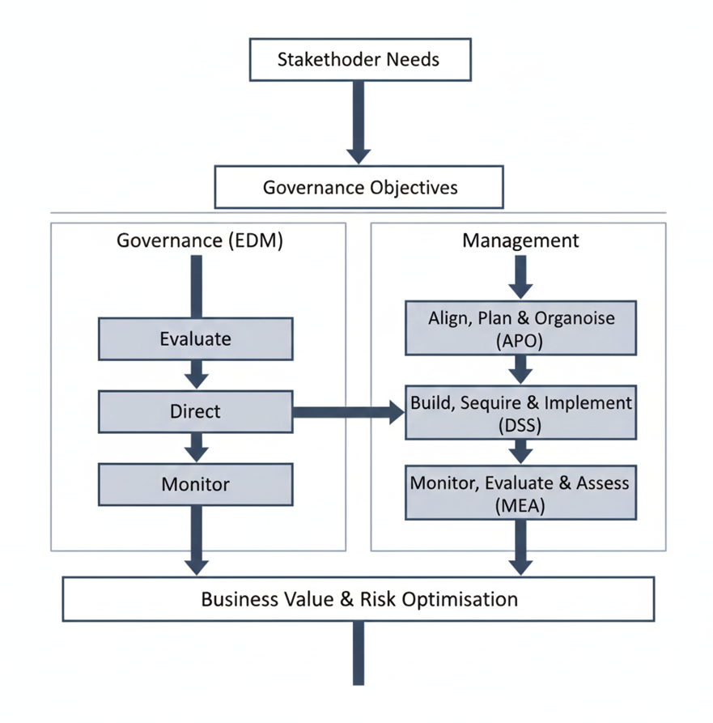
Figure 3: COBIT 2019 governance and management framework illustrating the relationship between governance objectives and management domains.
For NatureGreen (NG), COBIT 2019 is particularly valuable in supporting board-level oversight of information security. It ensures that security initiatives are aligned with organisational objectives, risk appetite, and compliance priorities, while enabling informed decision-making regarding security investments. By adopting COBIT, NG can bridge the gap between technical security controls and executive governance, ensuring that information security is treated as a strategic business enabler rather than a purely technical concern [4].

3.4 Information Technology Infrastructure Library (ITIL)
In complex digital organisations, effective service management plays a critical role in maintaining operational stability and service quality. The Information Technology Infrastructure Library (ITIL) provides a structured approach for managing IT services in a way that supports organisational objectives, resilience, and accountability.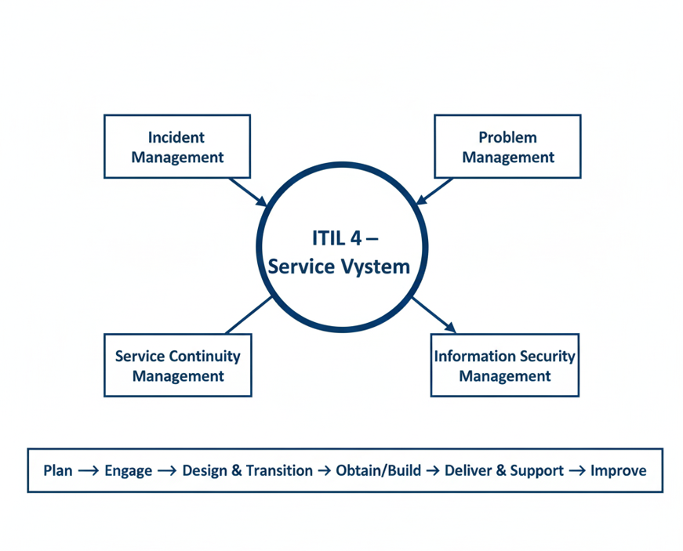
Figure 4: ITIL 4 Service Value System highlighting secure service management processes and continual improvement.
For NatureGreen (NG), ITIL supports the integration of security within everyday IT service management processes. This is particularly important given the organisation’s reliance on cloud-based services and third-party providers. By embedding security considerations into service management practices and supporting measurable Service Level Agreements (SLAs), ITIL enables NG to maintain operational resilience and consistent service delivery aligned with organisational objectives [5].
Figures 1 to 4 illustrate the core structure and focus of the ITIL 4 framework, ISO/IEC 27001 ISMS, NIST Cybersecurity Framework, and COBIT 2019 governance model, providing visual context to support the comparative analysis presented in this section.

4. Comparative Analysis of Security Frameworks
Table 1 provides a comparative overview of the key security frameworks reviewed in this report, highlighting their primary focus and relevance to NatureGreen’s information security, governance, and operational requirements.
Table 1: Comparative Analysis of Security Frameworks
Framework | Primary Focus | Strength for NatureGreen (NG)
ITIL | IT service management | Structured incident handling, service continuity, and security-focused Service Level Agreements (SLAs)
ISO/IEC 27001 | Information security management | Policy-driven, risk-based Information Security Management System (ISMS)
NIST CSF | Cybersecurity operations | Enhanced threat detection, incident response, and recovery capabilities
COBIT 2019 | Governance and control | Strategic alignment, accountability, and board-level oversight of security initiatives

Each framework addresses different aspects of information security management. When applied in isolation, they provide partial coverage; however, when integrated, they offer a comprehensive and layered approach that supports governance, risk management, operational security, and continual improvement.

5. Designed Security, Governance, and Compliance Approach for NG

5.1 Governance and Strategic Security Planning
NatureGreen (NG) should establish a formal information security governance structure that clearly defines roles, responsibilities, and accountability across the organisation. This structure should include board-level oversight of information security, the appointment of a Chief Information Security Officer (CISO), designated risk owners, and clearly assigned data protection responsibilities to ensure effective decision-making and accountability.
Security objectives must be strategically aligned with NG’s business goals, including the protection of brand reputation, maintenance of customer trust, safeguarding of high-value intellectual property, and compliance with applicable regulatory and contractual requirements. By embedding information security within corporate governance and strategic planning processes, NG can ensure that security initiatives are prioritised appropriately, adequately resourced, and continuously monitored for effectiveness.
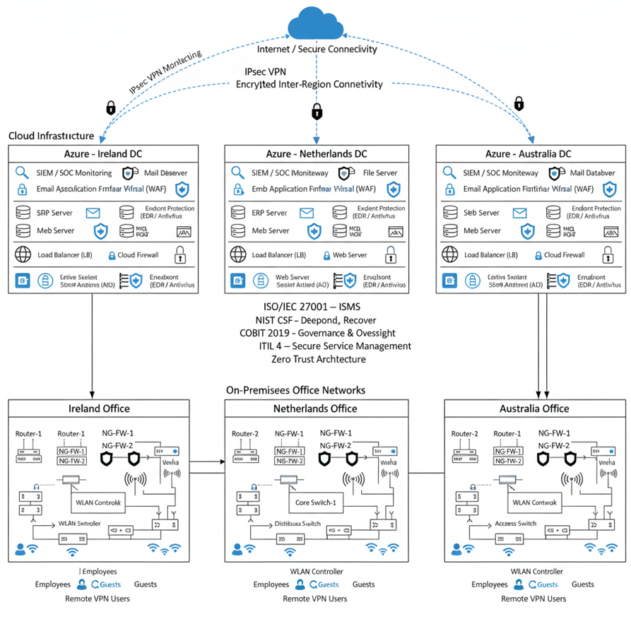Figure 5: Global secure cloud and network architecture for NatureGreen (NG) across Ireland, the Netherlands, and Australia.
Figure 5 illustrates the proposed global hybrid cloud and network security architecture for NatureGreen (NG). The diagram presents three geographically distributed Azure cloud data centres located in Ireland, the Netherlands, and Australia, interconnected through encrypted IPsec VPN tunnels over secure internet connectivity. Each cloud region hosts critical enterprise services, including web and mail servers, ERP systems, databases, load balancers, cloud firewalls, and endpoint protection mechanisms, all centrally monitored through SIEM and SOC capabilities to support threat detection and incident response.
The architecture demonstrates the application of ISO/IEC 27001–aligned Information Security Management System (ISMS) principles, supported by NIST Cybersecurity Framework (CSF) functions for detection, response, and recovery, COBIT 2019 for governance and oversight, and ITIL 4 for secure service management. A Zero Trust security model is reflected through layered controls such as web application firewalls, multi-factor authentication, and continuous monitoring across all regions.
Beneath the cloud infrastructure, the diagram depicts on-premises office networks in each country, incorporating dual routers, next-generation firewalls, VPN gateways, core and access switching, WLAN controllers, and segmented wireless access for employees and guest users. Remote VPN access is provided to support secure workforce connectivity. Collectively, the figure highlights a resilient, standards-based, and globally governed security architecture designed to protect sensitive data, ensure regulatory compliance, and maintain operational continuity across NatureGreen’s international operations.

5.2 Compliance, Legal, and Ethical Considerations
NatureGreen (NG) must ensure compliance with applicable data protection legislation, contractual obligations, and recognised ethical standards in the management of information security. This includes the lawful and transparent processing of personal data, appropriate safeguards for cross-border data transfers, and the implementation of accountability mechanisms to demonstrate compliance with regulatory and contractual requirements.
In addition to legal compliance, ethical considerations such as fairness, data minimisation, and respect for individual privacy should be embedded within NG’s security policies and operational practices. Adopting a compliance-driven yet ethically informed approach to information security supports regulatory adherence, reduces legal and financial risk, and reinforces trust among customers, partners, and stakeholders.
Failure to comply with data protection legislation, such as the UK GDPR, may result in financial penalties, legal action, and reputational damage, particularly given NG’s international customer base. Compliance with the UK General Data Protection Regulation and the Data Protection Act 2018 is essential to ensure lawful, transparent, and accountable processing of personal data across NatureGreen’s global operations [7].

5.3 Security Policies
NatureGreen (NG) should implement a comprehensive set of information security policies to establish consistent and enforceable security practices across the organisation. Key policies should include an Acceptable Use and Bring Your Own Device (BYOD) Policy, an Access Control and Identity Management Policy, a Data Classification and Encryption Policy, an Incident Response Policy, and a Logging and Monitoring Policy.
These policies provide a formal framework for defining acceptable behaviour, protecting sensitive information, and ensuring that security controls are applied consistently across NG’s cloud, wireless, and BYOD-enabled environments. When supported by staff awareness training and regular policy reviews, these policies contribute to improved compliance, reduced risk of security incidents, and a stronger organisational security culture.

5.4 Risk Management Approach
NatureGreen (NG) should adopt a formal, risk-based approach to information security in line with recognised international standards. Risk management should involve the systematic identification, analysis, and treatment of risks to organisational assets, taking into account the likelihood and potential impact of security threats. A central risk register should be maintained to document identified risks, associated controls, and residual risk levels, thereby supporting informed decision-making and accountability.
Residual risks should be formally accepted, mitigated, or transferred by designated risk owners based on NG’s defined risk appetite. This risk-based approach aligns with ISO 31000 principles, ensuring consistent identification, assessment, and treatment of information security risks [6].
Table 2 illustrates an example information security risk register for NatureGreen, demonstrating how organisational assets, threats, risk levels, and mitigation controls can be systematically documented and managed.
Table 2: Example Information Security Risk Register
Asset | Threat | Impact | Likelihood | Existing / Proposed Controls
Customer data | Data breach | High | Medium | Encryption, access control, monitoring
Intellectual property | Cyber espionage | Very High | Medium | Network segmentation, logging, threat detection
Wireless network | Unauthorised access | High | High | WPA3-Enterprise, Network Access Control (NAC)

5.5 Security Management Models and Practices
NatureGreen (NG) should implement an Information Security Management System (ISMS) aligned with ISO/IEC 27001 and organised around a continuous improvement life cycle Plan–Do–Check–Act (PDCA). The PDCA model enables NG to systematically plan security controls based on risk assessment, implement and operate those controls, monitor and measure their effectiveness, and take corrective actions where necessary.
Regular internal audits, continuous security monitoring, and periodic management reviews are essential components of effective ISMS operation. These practices allow NG to adapt to emerging threats, address identified weaknesses, and ensure that security controls remain aligned with organisational objectives, regulatory requirements, and changes in the threat landscape.

5.6 Contingency Planning and Business Continuity
Effective contingency planning and business continuity management are essential to ensure organisational resilience and the uninterrupted delivery of critical business operations in the event of security incidents, system failures, or disruptive events. NatureGreen (NG) should implement a structured approach that integrates contingency planning, disaster recovery, and business continuity planning (BCP). This includes regular data backups, documented disaster recovery procedures, and clearly defined Recovery Time Objectives (RTOs) and Recovery Point Objectives (RPOs) for critical systems and services.
In addition, NG should develop and maintain incident response and business continuity playbooks that clearly define roles, responsibilities, communication channels, and escalation procedures. Regular testing, validation, and review of business continuity and disaster recovery plans are essential to confirm their effectiveness, identify gaps, and ensure preparedness for real-world incidents. Collectively, these measures reduce downtime, limit operational and financial impact, and support compliance with recognised business continuity and security resilience standards.

5.7 Protection Mechanisms
To mitigate the risks associated with NG’s predominantly wireless, cloud-based, and BYOD-enabled environment, a layered set of technical and administrative protection mechanisms should be implemented. Strong wireless security controls, including WPA3-Enterprise and IEEE 802.1X authentication, are essential to prevent unauthorised network access and protect data transmitted over wireless networks.
In addition, network segmentation combined with Zero Trust security principles—where no user or device is implicitly trusted—should be adopted to limit lateral movement and reduce the potential impact of a security breach. The use of multi-factor authentication (MFA), endpoint detection and response (EDR) solutions, and mobile device management (MDM) for BYOD devices further strengthens access control, enhances threat detection, and ensures that only compliant devices are permitted to access organisational resources.

5.8 Service Level Agreements (SLAs)
Service Level Agreements (SLAs) play a critical role in formalising security expectations between NatureGreen (NG) and its internal service providers, cloud vendors, and third-party partners. Security-focused SLAs should clearly define incident response timeframes, patch management and vulnerability remediation timelines, system availability and uptime requirements, and obligations relating to log retention and security monitoring.
By incorporating measurable security metrics and performance indicators within SLAs, NG can ensure accountability, support regulatory compliance, and maintain consistent security standards across its IT and cloud service ecosystem. Clearly defined SLAs also enable effective oversight of third-party risk and support continuous service improvement through regular performance review and reporting.
While the implementation of comprehensive security frameworks and controls requires financial and operational investment, the cost of prevention is significantly lower than the potential financial, legal, and reputational impact of a major data breach or service disruption. A risk-based prioritisation of controls enables NG to balance security effectiveness with business efficiency.

6. Importance of Continuous Updates to Regulations and Standards
The rapid evolution of digital technologies and adversarial techniques requires regulatory and standards-based controls to remain adaptable and responsive. Static security regulations quickly lose effectiveness when faced with emerging threats, modern cloud architectures, and decentralised working practices such as BYOD and remote access.
Updated regulations and security standards allow organisations to incorporate emerging threat intelligence, lessons learned from security incidents, and advances in defensive technologies. Without periodic revision, standards risk reinforcing outdated practices that fail to address contemporary challenges such as identity-based attacks, cloud configuration weaknesses, and supply-chain compromise.
However, the continual evolution of regulations and standards also presents challenges, including increased compliance costs, resource constraints, and implementation complexity. Organisations must invest time, expertise, and financial resources to interpret and adopt new requirements. Despite these challenges, the absence of regular updates would expose organisations to far greater financial, legal, and reputational damage resulting from security breaches and regulatory non-compliance. Consequently, the benefits of updated regulations significantly outweigh the associated costs.
Overall, maintaining current regulations and standards supports proactive risk management, enhances stakeholder trust, and ensures that information security practices remain aligned with evolving threat landscapes, legal expectations, and organisational operating environments.

7. Conclusion
NatureGreen (NG) operates within a complex, highly connected, and risk-intensive digital environment that demands a structured and standards-driven approach to information security, governance, and compliance. The organisation’s extensive reliance on cloud services, wireless networking, and BYOD access significantly increases its exposure to cyber threats, regulatory obligations, and operational vulnerabilities. Without clearly defined policies and governance mechanisms, these risks pose a serious threat to the confidentiality, integrity, and availability of sensitive organisational and customer data, as well as high-value intellectual property.
This report has demonstrated that the integrated adoption of recognised frameworks—including ITIL, ISO/IEC 27001, the NIST Cybersecurity Framework, and COBIT 2019—provides a comprehensive and balanced approach to addressing NG’s security challenges. Together, these frameworks support effective governance and strategic oversight, structured risk management, robust operational controls, and continual improvement. Furthermore, the ongoing review and updating of regulations and security standards are essential to ensuring organisational resilience, regulatory compliance, and sustained stakeholder trust within an evolving cyber threat landscape. By implementing the proposed approach, NG can establish a mature, adaptive, and sustainable information security programme aligned with its global business objectives.
By adopting this integrated and adaptive approach, NatureGreen can transform information security from a reactive technical function into a strategic business enabler that supports trust, resilience, and long-term organisational sustainability.

8. References (IEEE Format)
[1] ISO/IEC, ISO/IEC 27001:2022 Information security, cybersecurity and privacy protection — Information security management systems — Requirements, International Organization for Standardization, Geneva, Switzerland, 2022.
[2] ISO/IEC, ISO/IEC 27002:2022 Information security, cybersecurity and privacy protection — Information security controls, International Organization for Standardization, Geneva, Switzerland, 2022.
[3] NIST, Framework for Improving Critical Infrastructure Cybersecurity, Version 2.0, National Institute of Standards and Technology, Gaithersburg, MD, USA, 2024.
[4] ISACA, COBIT® 2019 Framework: Governance and Management Objectives, ISACA, Schaumburg, IL, USA, 2019.
[5] AXELOS, ITIL® 4 Foundation: IT Service Management Best Practice, TSO (The Stationery Office), London, UK, 2019.
[6] ISO, ISO 31000:2018 Risk management — Guidelines, International Organization for Standardization, Geneva, Switzerland, 2018.
[7] UK Government, UK General Data Protection Regulation (UK GDPR), Data Protection Act 2018, London, UK.

