
Moynul Ali | 2205390 | ACAA5003
The Senedd

Introduction
An instance from modernity that illustrates democracy, sustainability, and cultural appropriateness is the Wales Assembly located beautifully by the Cardiff’s Bay. Visionary help from architect Richard Rogers led to the creation of Senedd – legislative wing of the National Assembly for Wales. This essay looks at every element of the Senedd’s architecture genius, how it has been structurally innovative, materials used, layout, movement, gardens, sustainable options, in-depth designs to see why this all add up something very significant.

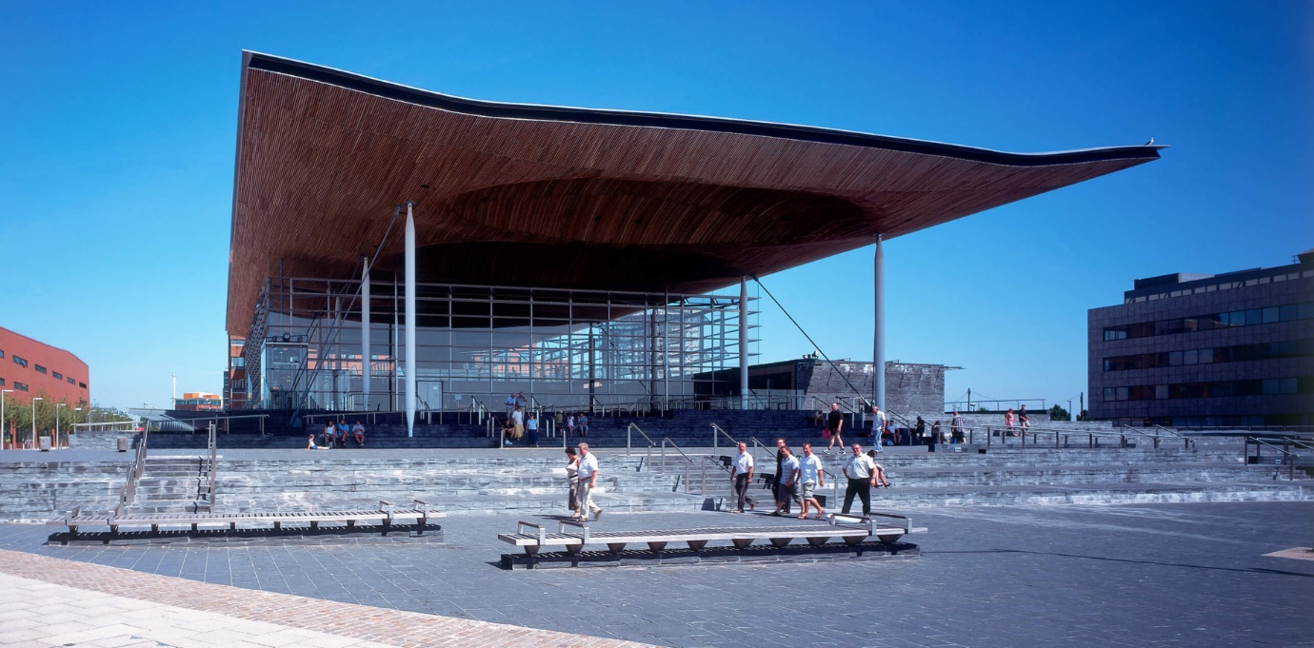
Figure 1: The Senedd ©RSHP

Harmony in Landscaping
The way of settling the building in the environment reflects an intentional attitude towards placemaking. Landscaping does not stand as an additional feature for the site; it is integrated into the overall layout. Integration of the surrounding water environment in such a way that there is a visual bonding between the structure and nature (Rogers and Brown, 2017). From the concrete foundation to adjoining buildings that mark the end of development on this section of the bay. A series of terraces are arranged down the front of the building, running over to the harbour wall delineated with differentiated lower slate walls (Rshp, no date). The Old Dock breaks the monotony of the wall, thereby enabling the expansion of the terraces to the waterscape with the continuity extending through the wall to the elongated boardwalk (Con-Figurations, 2021). The layout of this structure creates a harmonious integration between it and Cardiff Bay where individuals can enjoy the scenery as they participate in the democratic processes by passing along the streets. Specifically, locally sourced materials such as slate were intentionally chosen to help blend with the surroundings and enhance harmony of the overall appearance (Rshp, no date).

Flow within the Circulation
Involvement and accessibility are intended to be enhanced by navigating the Senedd, inside as well as outside. Approach to the building is the choreography of the journey in which the visitors walk along a trail that unwinds the architectural story. There is an entry that defines itself through transparency and openness with the idea of it being a welcome threshold for residents to enter and take part in the democratic processes within. Flowing circulation inside the building creates a link between the spaces and makes thoughts and ideas flow naturally from one person to another (The Senedd - a landmark building, 2021). Locally sourced slates were deliberately chosen for this purpose, aiming at a uniform aesthetics across the landscape.
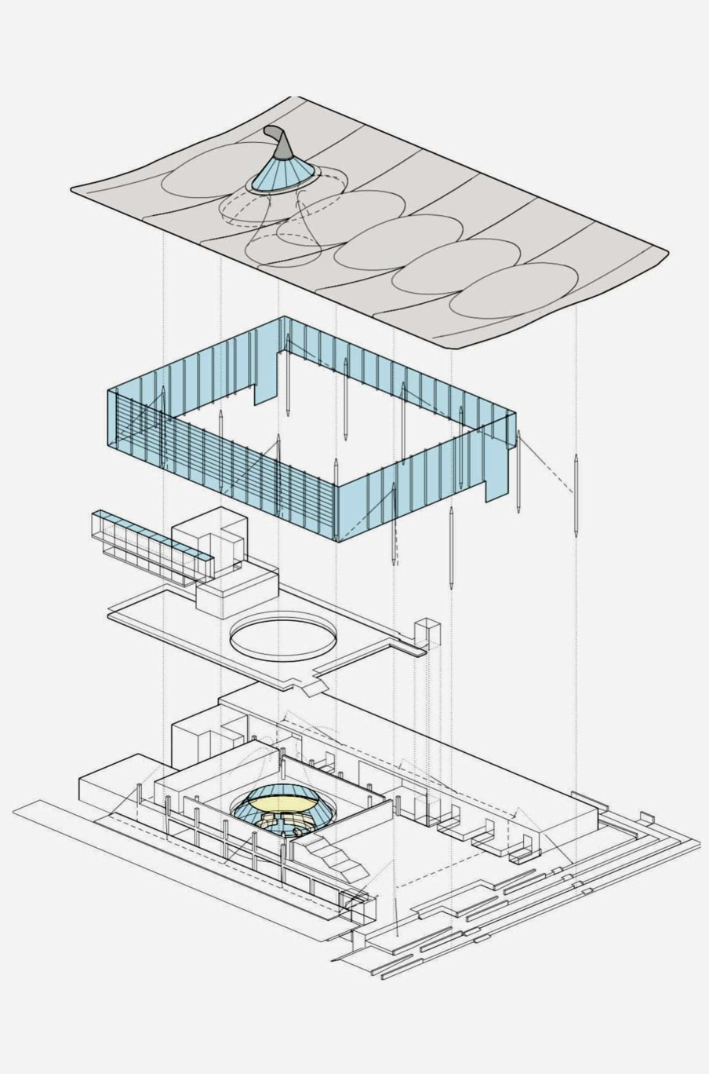
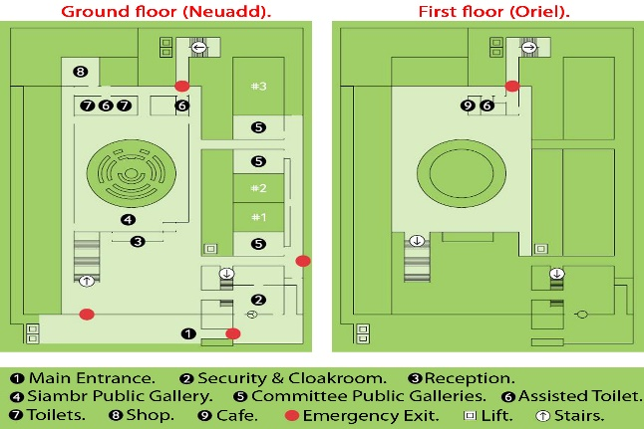
Figure 2: Space within the flow ©Naif Alghamdi

Figure 3: Exploded Axonometric ©RSHP

Floor Plans and Spatial Layout
Democratic values, transparency and functionality are represented in the layout of the Senedd’s floor. Circular shaped chamber of the debate does not have hierarchical seating configuration for equal participation by members of assembly. They have an unconventional circular design that differs from conventional parliamentary practices, and they create an environment that fosters cooperation and dialogue. Prominence and sunlight are provided to the debate chamber on account of its symbolic importance as a demonstration of openness associated with democratic processes. Other venues within the Senedd also contribute to the accessibility of the political method. Public galleries and conference rooms are placed appropriately such that the public observers can link with their politicians. The space structure conforms to the principles of democracy whereby the design should express the concepts for which it stands.
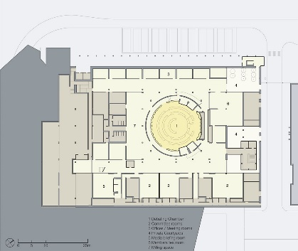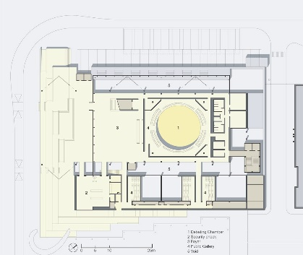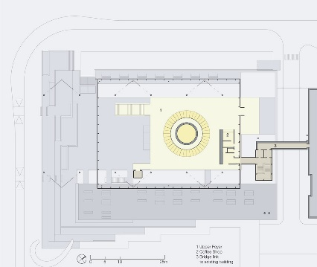
Figure 4: Plans ©RSHP

Cultural Representation and Materiality
The structure and materials applied for the design of Senedd are in appreciation of traditions of Welsh culture. The local Welsh slate and Welsh oak become part of the main scene, positioning it in both its natural and cultural contexts. The reutilization of local materials is more than just an expression of respect for historical patterns; it gives off a tangible connection between the Senedd and the Welsh terrain. Slate combined with the large glass façade forms a dialogue among contemporary elements and the historic ones that confirm Senedd’s position as a bridge between them (The Senedd - a landmark building, 2021).

Initiatives for Sustainability
The design brief additionally stipulated that the following sustainable requirements be met:
- 100-year design life.
- utilisation of indigenous materials.
- Reduce energy use and waste.
- use of renewable technology.
- must be "exemplar" in terms of sustainability.

Senedd’s construction intertwines architectural sustainable principles, depicting an acknowledgement about the environment protection. Natural light penetrates this arrangement giving more room to use of natural than artificial lighting in the structure orientation. Widespread usage of glass enables the phenomenon of solar heating, which reduces energy consumption. Roof based rainwater harvesting systems collect rain to be used for irrigations and toilets thereby reducing dependence on external water sources (Rshp, no date). The central funnel to the Oriel is an integral part of the building’s ventilation process used to regulate air temperatures within the walls and floors. A positive action is generated by the movement of the top cowl with the wind that reduces the internal pressure within the chamber thus sucking the hot air away from the chamber to be replaced with cold fresh air from beneath (Rshp, no date). Natural light enters through a lantern from above the funnel. The outermost part of the funnel is also red cedar wood while the ceiling is wood as well. It has a natural preservative known as self-oil that will not require treatment for more than one hundred years. The outside canopy is becoming grey in colour as the result of natural weathering while the inside of the house is still made from brown-coloured timber. The building design features an integrated geothermal system that harnesses the thermal energy from the planet’s surface for warm and cool air (The Senedd - a landmark building, 2021). The system allows for the heating of the building in late summer when earth holds heat, and its counterpart is also useful on a sunny day to cool the building in spring. Few solar panels on the roof reflect modern architectural trends, making Senedd a leader in architecture with environmentally friendly features, which can act as a blueprint for future projects.

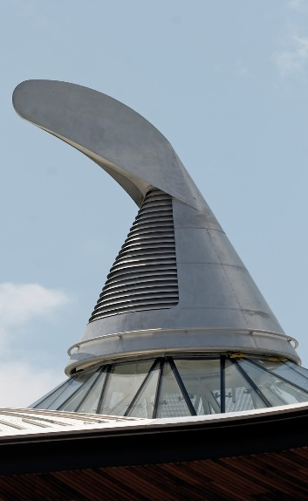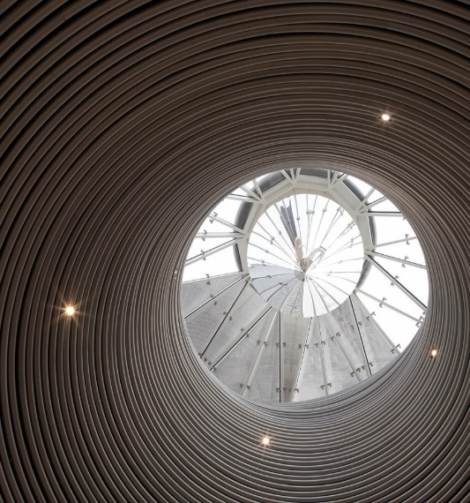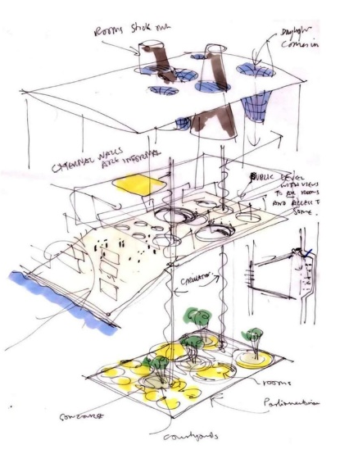
Figure 7: Exploded Axonometric ©RSHP

Figure 6: The cowl inside ©RSHP
: The Senedd ©Michael Cane

Figure 5: The cowl ©RSHP

Design of Structures
Senedd stands on a concrete substructure composed of a column-and-beam-slab structure. More than 16,700 tonnes of concrete form this significant base. Given the resilience and thermal properties it provides, concrete is very durable. For this project, the company decided to cast the concrete directly on site as opposed to the conventional method used in other projects which involves pouring the material onto formwork made of timber (Rshp, no date). The resulting surface has been pol The construction is intentionally visible in numerous parts of the building and contributes to enhancing the overall aesthetic architecture. Senedd’s structural design is an engineering achievement based on its architectural idea which has been successful. A network of steel trusses intricately designed to combine form and structural performance, able to withstand Welsh’s unstable weather conditions houses the sail like roof an architectural marvel. In a certain way, this sail shaped roof reminds of Bagsvaerd Church built by Jorn Utzon in Denmark (see figure 9). Due to this circular shape of the debating chamber, which symbolizes equal opportunities, the construction of exacting and ingenious solutions is required. Using the natural born Welsh slate increases diversity demanding a meticulous balance between beauty and utility (The Senedd - a landmark building, 2021). The structural design of Senedd represents the perfect blend of architectural vision and engineering expertise.
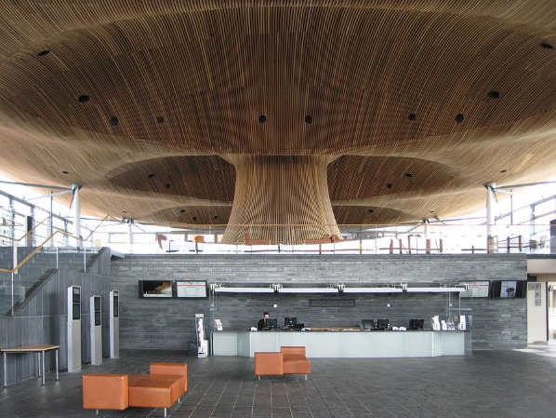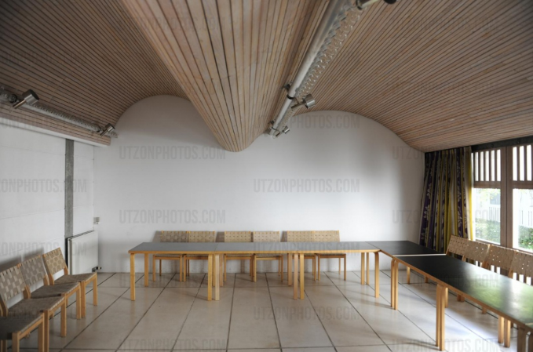
Figure 9: Bagsvaerd Church ©UtzonPhotos.com

Figure 8: Reception ©RSHP

Discussions of Elements and Architectural Nuances
The Senedd’s architectural brilliance goes beyond the design to include details that enhance the overall experience. Apart, from its appeal the roof with its sail shape serves a practical purpose by reflecting the dynamic Welsh sky (Rogers and Brown, 2017). This unique feature does not add to the buildings charm but also represents how democracy is adaptable and responsive. The transparent glass facade, along with shading mechanisms has been cleverly incorporated to regulate temperature and reduce glare (The Senedd - a landmark building, 2021). These elements demonstrate a consideration, for both style and functionality ensuring that the architectural aesthetics complement efficiency and sustainability than hinder them.

Conclusion
Each piece harmonises to build a structure symbolising democracy, sustainability, and cultural continuity in the orchestration of the Welsh Senedd's architectural symphony. The Senedd emerges as a model of modern architectural brilliance, from its seamless integration with the landscape to its precisely planned circulation, from the materials used to honour Welsh heritage to the sustainable initiatives defining environmental responsibility. The Senedd transcends its physical form, embracing the concepts it houses and serving as a futuristic paradigm for building. It serves as an inspirational model, exhibiting how ecological architecture, cultural representation, and democratic principles can all come together to create a structure that is not only representative of its period but also foresees a more enlightened and responsible future. When admiring the architectural grandeur of the Welsh Senedd, one is intrigued by its seamless combination of design, sustainability, and cultural identity. The structure is a monument to the ability of architecture to transcend its practical role and become a living narrative of a nation’s beliefs. The comprehensive portrait of the thorough attention to landscape, circulation, floor plans, materials, sustainability, detail explanations and structural designs creates a structure that reflects its time as well as seeks for shaping up mindful harmonious future. The ability of the Senedd to blend architectural materials into a symphony resonating with democratic principles and environmental care which leaves an everlasting stamp on the architectural landscape.

References –
Con-Figurations, V.A.P.B. (2021) Making Parliament Buildings: architects in conversation. https://con-figurations.com/2021/02/21/making-parliament-buildings-a-conversation-with-architects/ (Accessed: December 14, 2023).
Rogers, R. and Brown, R. (2017) A place for all people: Life, Architecture and the Fair Society. Canongate Books.
Rshp (no date) Senedd Cymru, Welsh Parliament – Civic – Projects – RSHP. https://rshp.com/projects/civic/senedd-cymru-welsh-parliament/ (Accessed: December 14, 2023).
The Senedd - a landmark building (2021). https://senedd.wales/visit/our-estate/the-senedd-a-landmark-building/ (Accessed: December 16, 2023).

