
APPENDIX GA36c

LEVEL 6 ASSESSMENT SPECIFICATION

Student name: |  | Student ID number:
Programme: | Primary
Module: | Principles of Pedagogy
Module code: | M6X01438/C | Contribution to Overall Module Assessment (%): | 100%
Lecturer: | Siân Brooks | Internal Verifier: | Siân Brooks
Assignment Title: | ‘Describe a learning event which has happened during your recent school experience. Reflect upon what took place, connecting events to theories of learning and teaching. Make recommendations about how you could improve your own practice in the light of this. Produce a poster to illustrate how you would develop the elements of an effective learning environment.’ | Word count (or equivalent): | 5,000 or equivalent.
Submission deadline: | 17/10/18 (23.59) | Return date of provisional marks & written feedback: | 14/11/18
Submission method: | All written assessments, where practical and possible, must be submitted via Turnitin unless otherwise instructed by the Lecturer. (Please DO NOT put this assessment specification into Turnitin or it will match many similarities with other students’ submissions.)  Alternative submission method (if applicable):  Late submission of the assessment will result in a late penalty mark. Penalties for late submission: Up to one week late, maximum mark of 40%. Over one week late, 0%. Only the Extenuating Circumstances Panel may approve a change to submission dates.
Academic honesty / referencing: | Academic honesty is required. In the main body of your submission you must give credit to authors on whose research and ideas your work is based. Append to your submission a reference list that indicates the books, articles, etc. that you have used, cited or quoted in order to complete this assessment.

Module Learning Outcomes
(from module syllabus)
1. understand, synthesise and evaluate the main theories that underpinning learning, behaviour and assessment in the primary school
2. reflect critically on how learning theories inform the planning and provision of high quality learning environments, demonstrating a clear understanding of how theory and practice are interrelated
3. organise knowledge and learning through the use of a range of information sources, and present work appropriately.

TASK DESCRIPTION

Title: ‘Describe a learning event which has happened during your classroom observation. Reflect upon what took place, connecting events to theories of learning and teaching. Make recommendations about how you could improve your own practice in the light of this, and produce a digital poster to illustrate how you would use all of this information to develop the elements of an effective learning environment.’

Word count:
5,000 words including 1,500 word equivalence for the digital poster and commentary. This means that the written assignment should be 3,500 words (or 10% above or below) and the digital poster and commentary should be 1,500 or equivalent.

This assignment requires you to:
- critically reflect on key theories underpinning physical, social and cognitive development.
- show how you are able to apply these theories to classroom contexts.
- demonstrate your own reflective development when you describe and evaluate what you have observed. Remember that this assessment asks you to do more than just describe the critical incident.
- show that you can consider what you observed in an analytical and evaluative way, and that you demonstrate how this has impacted on your awareness as a teacher through the creation of your own ideal.

Essential Reading

This assignment requires that you show knowledge and understanding of theories and key readings underpinning the particular focus you have chosen in the critical incident. Readings have been provided on Moodle and you could also use other readings that you identify independently.

Assignment Structure:
This section provides a suggested structure for your assignment although please note that it is guidance only; you should therefore not allow the guidance to limit your writing.

Introduction and conclusions.

Include BRIEF introduction and conclusions where you outline the context in which you carried out your observation – showing an awareness of ethical issues you have considered eg anonymity. When you conclude, summarise the key points that you wish the reader to be aware of (approx. 500 words).
TIP – referring back to the aims of the assignment and explaining how you have met these will focus the reader’s attention.

Part 1: Observe.

Complete a vignette (a retelling of something that happened) to describe a learning experience, behavioural incident or social interaction that took place during your classroom observation. Explain why you selected this as a significant event, relating to module content eg exploratory talk; metacognition; inclusive practices (approx. 1500 words).
TIP – ensure that you move from the purely descriptive. For example, explain the reasons for the choosing specific tools eg checklists/ written records or time sampling for completing the observations. Evaluate the strengths and limitations of the selected approach.

Part 2: Connect.

Using the lens of a particular learning theory or theories, explain how consideration of these has helped you to understand what went on during this event, and how this could impact on outcomes for pupils in your future practice (approx 1500 words).
TIP – ensure that you connect to relevant theories and theorists, but that you also reflect on the critiques that have been made of some theories. Ensure that you cite references appropriately.

Part 3: Reflect and Innovate.

Create a digital poster that exemplifies your ideal learning environment, and submit a commentary to explain and justify the pedagogical principles underpinning this provision (equivalent to 1500 words).
TIP - Ensure that you refer to your observations and research in order to justify your decisions within your ideal environment. Present your poster professionally.

GUIDANCE FOR STUDENTS IN THE COMPLETION OF TASKS

NOTE: The guidance offered below is linked to the five generic assessment criteria overleaf.

- Engagement with Literature Skills
Your work must be informed and supported by scholarly material that is relevant to and focused on the task(s) set; you should make use of scholarly reviews and primary sources, where appropriate (for example, refereed research articles and/or original materials appropriate to the discipline). You should provide evidence that you have accessed a wide range of sources, which may be academic, governmental and industrial; these sources may include academic journal articles, textbooks, current news articles, organisational documents, and websites. You should consider the credibility of your sources; academic journals are normally highly credible sources while websites require careful consideration/selection and should be used sparingly. Any sources you use should be current and up-to-date, mostly published within the last five years or so, though seminal/important works in the field may be older. You must provide evidence of your research/own reading throughout your work, using a suitable referencing system, including in-text citations in the main body of your work and a reference list at the end of your work.

Guidance specific to this assessment:
Use the essential and recommended readings on the theories underpinning teaching and learning that are provided on Moodle and apply these to your discussion. You might also use other relevant sources independently. Make sure you reference by following the University referencing guide (Harvard). Welsh Government or Estyn documentation and publications in relation to the developing curriculum could also be useful.

- Knowledge and Understanding Skills
At level 6, you should be able to demonstrate coherent and detailed knowledge and a systematic understanding of the subject area, at least some of which is informed by the latest research and/or advanced scholarship within the discipline. You should be aware of the uncertainty, ambiguity and limits of knowledge. Your work must demonstrate the growing extent of your knowledge and systematic understanding of concepts and underlying principles associated with the subject area. Knowledge relates to the facts, information and skills you have acquired through your learning. You demonstrate your understanding by interpreting the meaning of the facts and information (knowledge). This means that you need to select and include in your work the concepts, techniques, models, theories, etc. appropriate to the task(s) set. You should be able to explain the theories, concepts, etc. meaningfully to show your understanding. Your mark/grade will also depend upon the extent to which you demonstrate your knowledge and understanding; ideally each should be complete and detailed, with comprehensive coverage.

Guidance specific to this assessment:
You need to show that you are aware of the theories of learning. You will also need to show understanding of key aspects of your chosen focus within the literature. You will need to show that you understand how the curriculum is evolving in Wales and consider how this might have implications for the critical incident you observed.

- Cognitive and Intellectual Skills
You should be able to: critically evaluate evidence, arguments, assumptions, abstract concepts and data some of which are at the forefront of a discipline (and that may be incomplete) to devise and sustain arguments, to make judgements and/or solve problems; describe and comment upon particular aspects of current research, or equivalent advanced scholarship, in the discipline Your work must contain evidence of logical, analytical thinking, evaluation and synthesis. For example, to examine and break information down into parts, make inferences, compile, compare and contrast information. This means not just describing what! But also justifying: Why? How? When? Who? Where? At what cost? At all times, you must provide justification for your arguments and judgements. Evidence that you have reflected upon the ideas of others within the subject area is crucial to you providing a reasoned and informed debate within your work. Furthermore, you should provide evidence that you are able to make sound judgements and convincing arguments using data and concepts. Sound, valid conclusions are necessary and must be derived from the content of your work. Where relevant, alternative solutions and recommendations may be proposed.

Guidance specific to this assessment:
You should show that you can consider differing perspectives/theories/arguments around your chosen focus and its relationship to teaching and learning. You should also ensure that you justify judgements you might make about your chosen focus and its relation to teaching and learning, by referring to evidence (e.g. things that may have happened in school/lessons) or educational research.

- Practical Skills
At level 6, you should be able to apply the methods and techniques that you have learned to review, consolidate, extend and apply your knowledge and understanding, and to initiate and carry out projects. You will deploy accurately established techniques of analysis and enquiry relevant to the discipline, and apply them in complex and unpredictable contexts, to devise and sustain arguments and/or to solve problems. You should be able to frame appropriate questions to achieve a solution - or identify a range of solutions. You should be able to demonstrate how the subject-related concepts and ideas relate to real world situations and/or a particular context. How do they work in practice? You will deploy models, methods, techniques, and/or theories, in that context or circumstances, to assess current situations, perhaps to formulate plans or solutions to solve problems, or to create artefacts, some of which may be innovative and creative. This is likely to involve, for instance, the use of real world artefacts, examples and cases, the application of a model within an organisation and/or benchmarking one theory or organisation against others based on stated criteria. You should show awareness of the limitations of concepts and theories when applied in particular contexts.

Guidance specific to this assessment:
For your commentary on your digital poster and your conclusion, it is suggested that you use a Reflective Model to guide your reflection and analysis. In your conclusion and commentary, you should be able to identify areas for further development.

- Transferable Skills for Life and Professional Practice
Your work must provide evidence of the qualities and transferable skills necessary for graduate-level employment requiring the exercise of initiative and personal responsibility and decision-making in complex and unpredictable circumstances. This includes demonstrating: the learning ability for professional development to advance existing skills and acquire new competences of a professional nature that will enable you to assume significant responsibility within organisations; that you can initiate and complete tasks and procedures, whether individually and/or collaboratively; that you can use appropriate media to effectively communicate information, arguments and analysis in a variety of forms to specialist and non-specialist audiences; fluency of expression; clarity and effectiveness in presentation and organisation. Work should be coherent and well-structured in presentation and organisation.

Guidance specific to this assessment:

This should be a well written and referenced work which brings together information from the wider research literature as well as personal experience which includes a creative and well-presented poster which conveys information in an engaging and informative manner. As a possible future teacher you should ensure that work is grammatically correct, with professional, precise and accurate use of language.

STUDENT FEEDBACK FORM

This section details the extent to which the assessment criteria are demonstrated by you, which in turn determines your mark. The marks available for each category of skill are shown. Lecturers will use the space provided to comment on the achievement of the task(s), including those areas in which you have performed well and areas that would benefit from development/improvement.

Generic Assessment Criteria | Marks available | Marks  awarded
1. Engagement with Literature Skills
.
2. Knowledge and Understanding Skills

3. Cognitive and Intellectual Skills

4. Practical Application Skills

5. Transferable Skills for Life and Professional Practice

Assessment Mark (Assessment marks are subject to ratification at the Exam Board. These comments and marks are to give feedback on module work and are for guidance only until they are confirmed. ) | Late Submission Penalties (tick if appropriate) |  | %
 | Up to 1 week late (40% Max) |  | %
 | Over 1 week late (0%) |  | %

GENERIC ASSESSMENT CRITERIA

Level 6
In accordance with the Framework for Higher Education Qualifications, at the end of Level 6 students should have coherent and detailed knowledge and a systematic understanding of their subject area, at least some of which is informed by the latest research and/or advanced scholarship within the discipline. They will be able to accurately deploy established techniques of analysis and enquiry within a discipline, using their conceptual understanding to devise and sustain arguments and/or to solve problems. They should be aware of the uncertainty, ambiguity and limits of knowledge. They should be able to critically evaluate evidence, arguments, assumptions, abstract concepts and data (that may be incomplete), to make judgements, and to frame appropriate questions to achieve a solution - or identify a range of solutions. They will apply the methods and techniques that they have learned to review, consolidate, extend and apply their knowledge and understanding, and to initiate and carry out projects. They will have the ability to manage their own learning, and to make use of scholarly reviews and primary sources (for example, refereed research articles and/or original materials appropriate to the discipline). They will demonstrate the qualities and transferable skills necessary for employment requiring: the exercise of initiative and personal responsibility; decision-making in complex and unpredictable contexts; the learning ability needed to undertake appropriate further training of a professional or equivalent nature.

Level 6 | FAIL | MARGINAL FAIL | SATISFACTORY | GOOD | VERY GOOD | EXCELLENT
Category | F | E | D | C | B | A
Engagement with literature (including reading, referencing,  academic conventions and  academic honesty) | Little or no evidence of reading and/or reliance on inappropriate sources.  Views and findings mostly unsupported and non-authoritative.  Referencing conventions used incoherently or largely absent. | Poor engagement with essential reading. No evidence of wider reading. Reliance on inappropriate sources, and/or indiscriminate use of sources. Heavily reliant on information gained through class contact. Inconsistent and weak use of referencing. | Engagement with a limited range of mostly relevant and credible sources. Some omissions and minor errors.  Referencing conventions evident though not always applied accurately or consistently. | Engagement with an appropriate range of research-informed literature, including sources retrieved independently. Some over-reliance on texts. Referencing may show minor inaccuracies or inconsistencies. | Engagement with a wide range of research-informed literature, including sources retrieved independently.  Selection of relevant and credible sources. Very good use of referencing, with no/very few inaccuracies or inconsistencies. | Engagement with an extensive range of relevant and credible literature, informed by the latest research. Consistently accurate application of referencing.
Knowledge and understanding (Coherent and detailed knowledge and systematic understanding of the subject area, at least some of which is informed by the latest research and/or advanced scholarship within the discipline.) | Major gaps in knowledge and systematic understanding of the subject matter. Substantial inaccuracies. No awareness of knowledge of the latest research and/or advanced scholarship within the discipline. | Gaps in knowledge, with only superficial systematic understanding. Some significant inaccuracies and/or irrelevant material. No awareness of knowledge of the latest research and/or advanced scholarship within the discipline. | Limited knowledge and systematic understanding of the relevant concepts and principles within the subject area which to some limited extent, is informed by current research and scholarship. | Knowledge is reasonably detailed, accurate with a good systematic understanding of the field of study and to some extent, current research and scholarship. | Knowledge is reasonably extensive coherent and detailed. Exhibits very good understanding of the breadth and depth of established views, and the work is, at least in part, well-informed by current research and scholarship. | Excellent coherent and detailed knowledge and systematic understanding of the principles and theories of current research and scholarship. Clear awareness of challenges to established views and the limitations of the knowledge base.
Cognitive and intellectual skills  (Conceptual and critical thinking, analysis, synthesis and evaluation of research, assumptions, abstract concepts and data (that may be incomplete); logic, argument and judgement.) | Wholly or almost wholly descriptive work. Little or no analysis, synthesis or evaluation.  Failure to develop arguments, leading to illogical or invalid judgements. Unsubstantiated generalisations, made without use of any credible evidence. | Largely descriptive work, with superficial use of critical evaluation. Weak development of arguments and judgements. Information accepted uncritically, uses generalised statements made with scant evidence and unsubstantiated opinions. Ideas sometimes illogical and contradictory. | Limited attempt at critical thinking, analysis, synthesis and evaluation, tending towards description.  Some evidence to support emerging arguments and judgements but these may be underdeveloped or with a little inconsistency / mis-interpretation.  Asserts rather than argues a case. | Some critical thinking, analysis, synthesis and evaluation. Can analyse new and/or abstract concepts and data without guidance.  An emerging awareness of different stances and ability to use evidence (that may be incomplete) to support the argument.  Mostly valid arguments and logical judgements. Some tendency to assert/state opinion rather than argue on the basis of reason and evidence. | Sound critical thinking, analysis, synthesis and evaluation demonstrating critical thinking. Ability to devise and sustain persuasive arguments, and to review the reliability, validity and significance of evidence (that may be incomplete) to make mostly appropriate and valid judgements. | Excellent critical thinking, analysis, synthesis and evaluation. Ability to investigate contradictory or incomplete information and make strong, persuasive, arguments and sophisticated judgements. Some evidence of independent thought and ability to ‘see beyond the question’, suggesting a grasp of the broader field and wider concepts.
Practical skills  (Apply/deploy accurately established tools and techniques; initiate and carry out projects; formulate solutions to solve problems in complex and unpredictable contexts.) | Limited or no use of methods, materials, tools and/or techniques.  Little or no appreciation of the context of the application.  Limited understanding of the application of theory to practice or making appropriate links between the two.  Very weak problem-solving skills in complex and unpredictable contexts. | Rudimentary application of methods, materials, tools and/or techniques but without consideration and competence. Flawed appreciation of the context of the application.  Weak understanding of the application of theory to practice, with only occasional evidence of making appropriate links between the two. Weak problem-solving skills in complex and unpredictable contexts. | An adequate awareness and mostly appropriate application of well-established methods, materials, tools and/or techniques.  Basic appreciation of the context of the application. Theoretical knowledge and understanding applied in practice, but not always making logical links between the two.  Can identify problems and propose basic solutions in complex and unpredictable contexts without fully appreciating the complexity. | A good and appropriate application of standard methods, materials, tools and/or techniques.  Clear appreciation of the context of the application. Mainly consistent, accurate and logical application of theory to practice, making appropriate links between the two  Can identify problems and propose mostly appropriate solutions in complex and unpredictable contexts. | A very good application of a range of methods, materials, tools and/or techniques.  Very good consideration of the context of the application, with perceptive insights. Can identify problems and propose appropriate solutions in complex and unpredictable contexts.  Evidence of some innovation and creativity. | An advanced application of a range of methods, materials, tools and/or techniques.  The context of the application is well considered, and insightful.  Application and deployment extend beyond established conventions. Can identify complex problems and propose excellent solutions. Innovation and creativity evident.
Transferable skills for life and professional practice  (Exercise of initiative and personal responsibility; professional development; initiate and complete tasks and procedures: individually and/or collaboratively; use appropriate media to communicate effectively; fluency of expression; clarity and effectiveness in presentation and organisation.) | Communication medium is inappropriate or misapplied.  Work is poorly structured, disorganised and/or confusingly expressed. Very weak use of language and/or very inappropriate style. Little or no evidence of autonomy (or collaboration, where relevant) in the completion of tasks. Little or no evidence of the skills required in graduate employment. | Communication medium is poorly designed and/or not suitable for the audience.  Work is poorly presented in a disjointed manner. It is loosely, and at times incoherently, structured, with information and ideas often poorly expressed. Weak use of language and/or inappropriate style. Weak independent initiative (or collaboration, if relevant). Limited evidence of the skills required in graduate employment. | Can communicate in a suitable medium but with some room for improvement.  Mostly ordered presentation and structure in which relevant ideas / concepts are reasonably expressed. Work may lack coherence in places. Can work as part of a team, but with limited involvement in group activities.  Demonstrates the basic skills required in graduate employment, with some areas of minor weakness. | Can communicate effectively in a suitable format, but may have minor errors.  Mostly coherent, organised work, in a suitable structure and is for the most part clearly expressed. Can work effectively independently and/or as part of a team, with clear contribution to group activities.  Demonstrates the skills required in graduate employment, with some areas of strength and some of minor weakness. | Can communicate well, confidently and consistently in a suitable format.  Work is coherent, fluent, well-structured and organised. Can work very well autonomously and/or as part of a team, with very good contribution to group activities.  Demonstrates very good graduate employment skills, with just occasional minor weakness. | Can communicate professionally confidently and consistently in a suitable format.  Work is coherent, very fluent and is presented professionally. Can work autonomously with initiative. Where relevant can work professionally within a team, showing leadership skills as appropriate, managing conflict and meeting obligations. Demonstrates excellent graduate employment skills and an appetite for further development.

THIS DOCUMENT IS ALSO AVAILABLE IN WELSH

Introduction

In this assignment I will be assessing the effective use of AFL within a classroom environment through the process of an observation. Using varied techniques and reflecting on different theories and practitioners, I will aim to not only assess its effectiveness but use that information to inform my own practice and design my ideal learning environment.

My observation took place in an English medium primary school in South Wales. There were 568 children between the ages of three and eleven on roll at the time. Approximately 20% of those children were eligible for free school meals. Thich figure is lower than the current national average of approximately 18%. At the time of my observation the school identified as a ‘Lead school’. This means they have particular expertise in global learning and share their knowledge to support development education, and information about creating change within a school setting with their Network. During my observation I adhered to the British Educational Research association (BERA) guidelines and therefore kept the name of the school, and any personal details of the learners I observed anonymous, including name and date of birth etc. My observation took place in a year 5 classroom.

Observation
My observation took place during a group AFL activity between the children and their class teacher. At this point in time I was observing the second part of the class AFL process as the children had already completed their task and were now in the process of reviewing and editing their work. The original learning objective, or ML (my learning) was to ‘ Use the success criteria to write a draft of a diary entry’. The children had written diary entries on the thoughts and feelings of a child during the time of the Three Day Blitz. The children had used a planning structure which collated all their prior knowledge of the topic allowing them to then create a draft of a diary, using other success criteria including using first person, past tense and emotion/powerful vocabulary. In this session the children were partaking in self and peer assessment using their success criteria checklist which I have included later on in this section.

The class teacher and the children then showed me the full AFL process used on a daily basis by the classroom. Before beginning a new process the class teacher used a mind map or similar activity to determine the children's prior knowledge. These tasks were graded in ‘Chillies’ from 1-3 which determine the level of difficulty of the task. These were sometimes assigned by the teacher, appropriate to their known ability ,or chosen by the children themselves, allowing them to take ownership of their own learning and challenge. After completing the piece of work the children then self assessed their work, using number markers from the SC checklist against their work. This was then passed to a peer who checked the work in the same manner, and also left constructive comments on where and how to improve. The children then wrote in their book a message to their teacher acknowledging what ‘Zone’ they were in during this piece of work. The zones were rated as comfort, stretch and danger. This clearly linked to the ‘Chili’ they had chosen and allowed the teacher to advise on a change of level of challenge or set a new one for a future task. An example of this kind of feedback might be ‘ Dear Sir, I was in the comfort zone for this piece of work because I understood the success criteria and only had to ask for help with some spelling’. Before entering their ‘Publishing’ phase where the children present their final piece of work the class teacher implemented a more traditional way of assessing and marked their books with DINS (do it now) to correct any remaining errors.

Having observed AFL in this school and in several others throughout my time in schools I believe this to be the most comprehensive and effective method I have seen. The process covers all types of assessment and it was evident within the class that each and every child, regardless of ability had a clear idea of what they needed to do to produce their best piece of work.

The initial mind map and gauging of understanding task is one that is essential in any form of learning process and gave both the teacher and the child a clear idea of their starting point. This closely links to a Bruner's theory of a ‘spiral curriculum’ where themes or topics are presented and then revisited in order to reinforce understanding.As a result the children, or teacher could then confidently assign a ‘chilli’ level to best suit their ability or preferred challenge level. The success criteria checklist was also highly effective and gave each child a clear and defined list of elements to include in their work, and should they find something missing gave them a clear idea on what to include to develop their work for the future. The peer assessment section not only reinforces my previous point but also gives a chance for students assessing others to improve on their judgement making skills, which can be argued is an essential skill for lifelong learners. The final portion of the process was also effective as it gave children a chance to write back to their class teacher and understand their strengths and limitations, coupled with the then formal marking process before a final piece of work gave the children a fully rounded experience of assessing their work and also set the ethos within the class that everyone is capable of development and success.
In this classroom I believe the assessment process had been refined and perfected to a point that it was seamless, reliable and effective. However there are some aspects of the process that may cause problems if not implemented correctly. Firstly the self chosen ‘chilly’ system may bring up some difficulty if children over or under evaluate themselves, this could lead to a child always working in ‘The danger zone’ where they find the task to difficult and then are not experiencing the learning growth they should be, or a child with low self esteem working constantly in ‘the comfort zone’ where they never challenge themselves for fear of failing. This however is counteracted by the feedback to the teacher, and the teachers knowledge of the children who can evaluate work and address the situation accordingly. Peer assessment in this instance might also be a cause of concern, as children may be influenced by friendships or rivalries to mark or assess in a certain way. It may also be the case that children may not be confident in assessing each other and therefore provide a generalised grade that does not truly reflect the work being done. In this school however the clear aspects of the success criteria mean that children do not need to be subjective and can simply find the particular evidence of the success criteria in the piece of work they are assessing.

Below I have attached examples of the various steps of the schools AFL assessment.
Step 1: Pictured are two ‘Understanding prior knowledge tasks, the first of which acted as a plan for the children's diary entry and shows evidence of the Chilli grading system. This one is particular is a Chilli 3, the hardest level of work, which includes success criteria such as Sandwich sentences and if, if then sentences, which the other chilli levels will not have included.

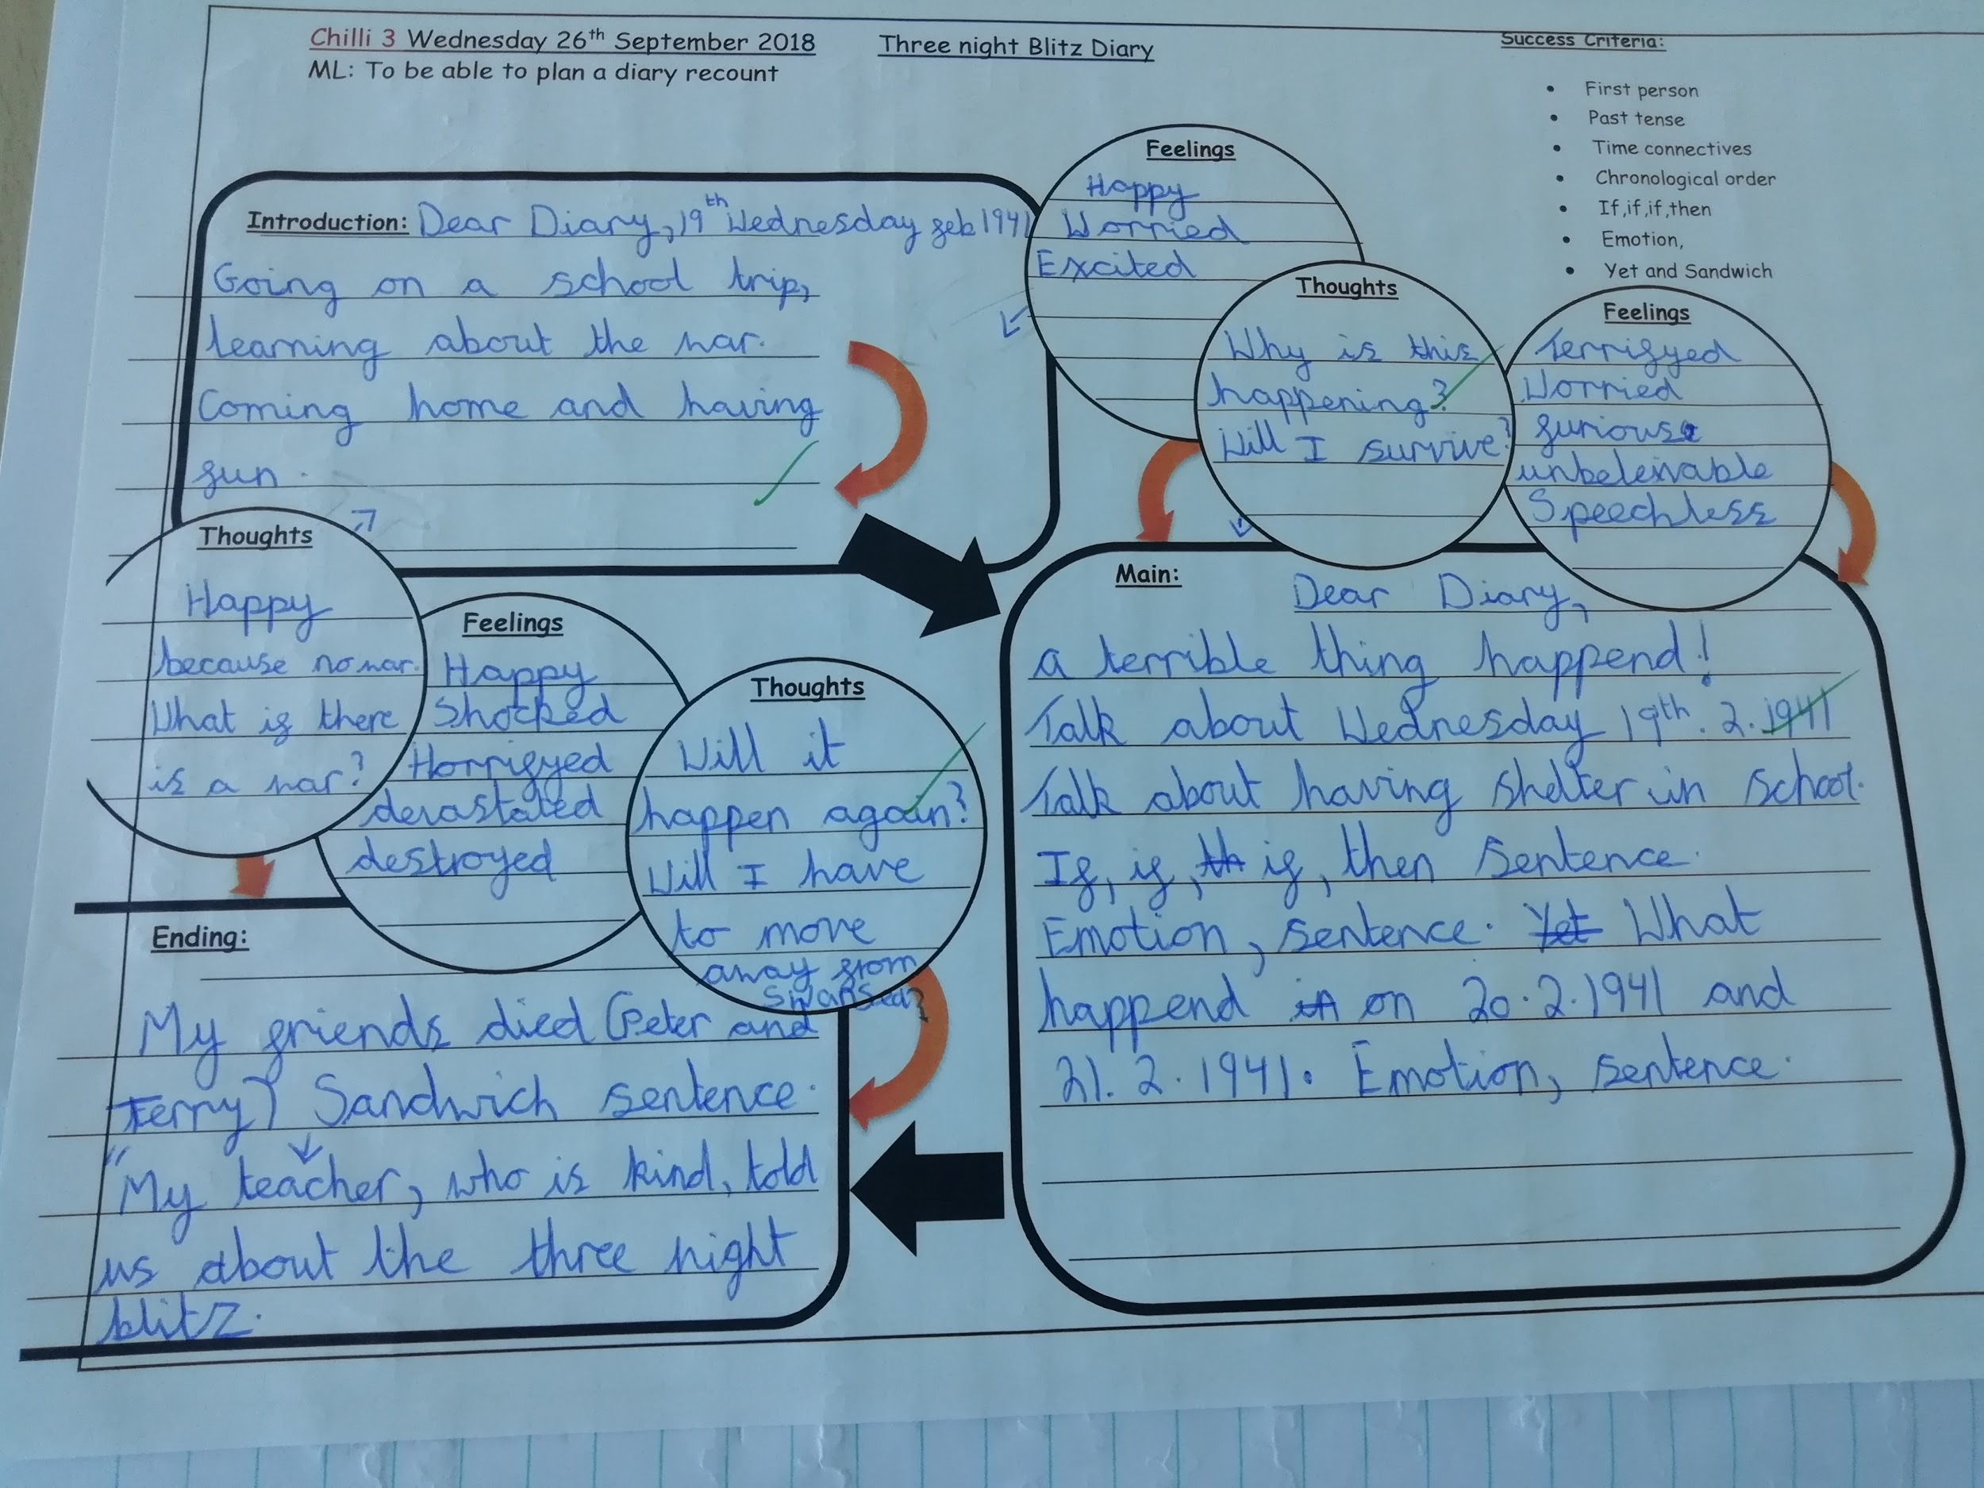

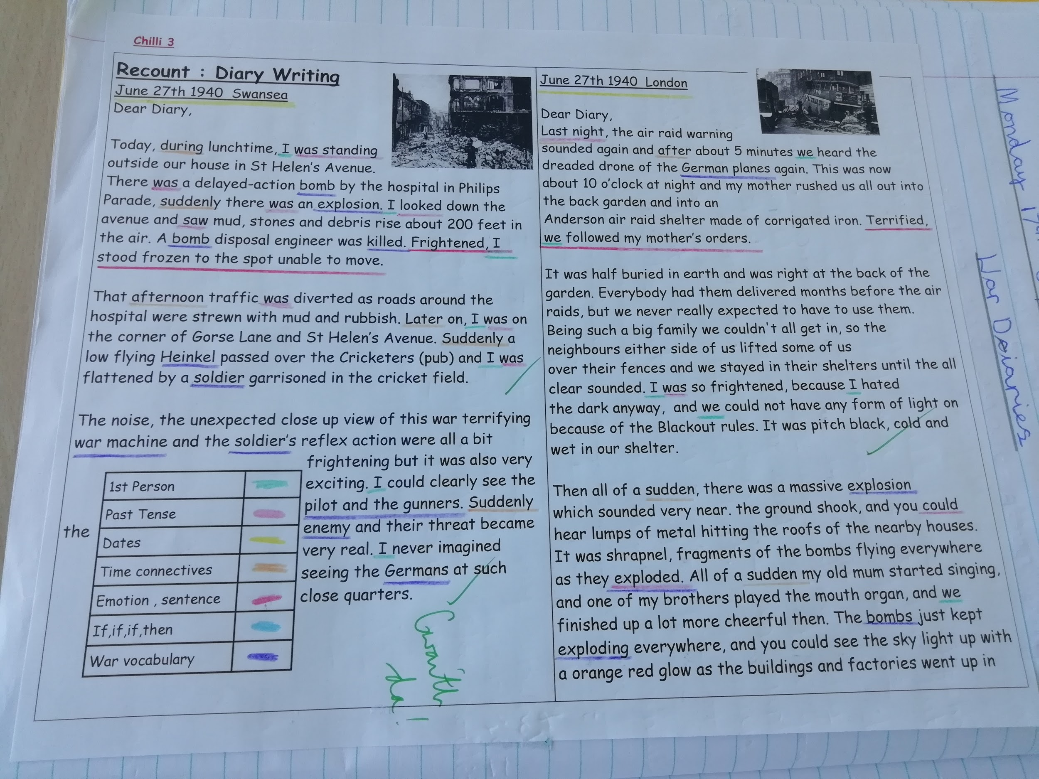
Step 2 - Below is shown the success criteria checklist which includes the sections for self and peer assessment. In this particular example you can see a series of ticks where both the self and peer have determined that those aspects were present in the work, and some dots. The dots represent that these elements are not present in the work. In this example we can see an example of where the child has edited between their self and peer assessment and has included the elements they had previously missed. We can also see in the second photo the number markings placed on the work, done by the child themselves to correspond with their success criteria checklist.
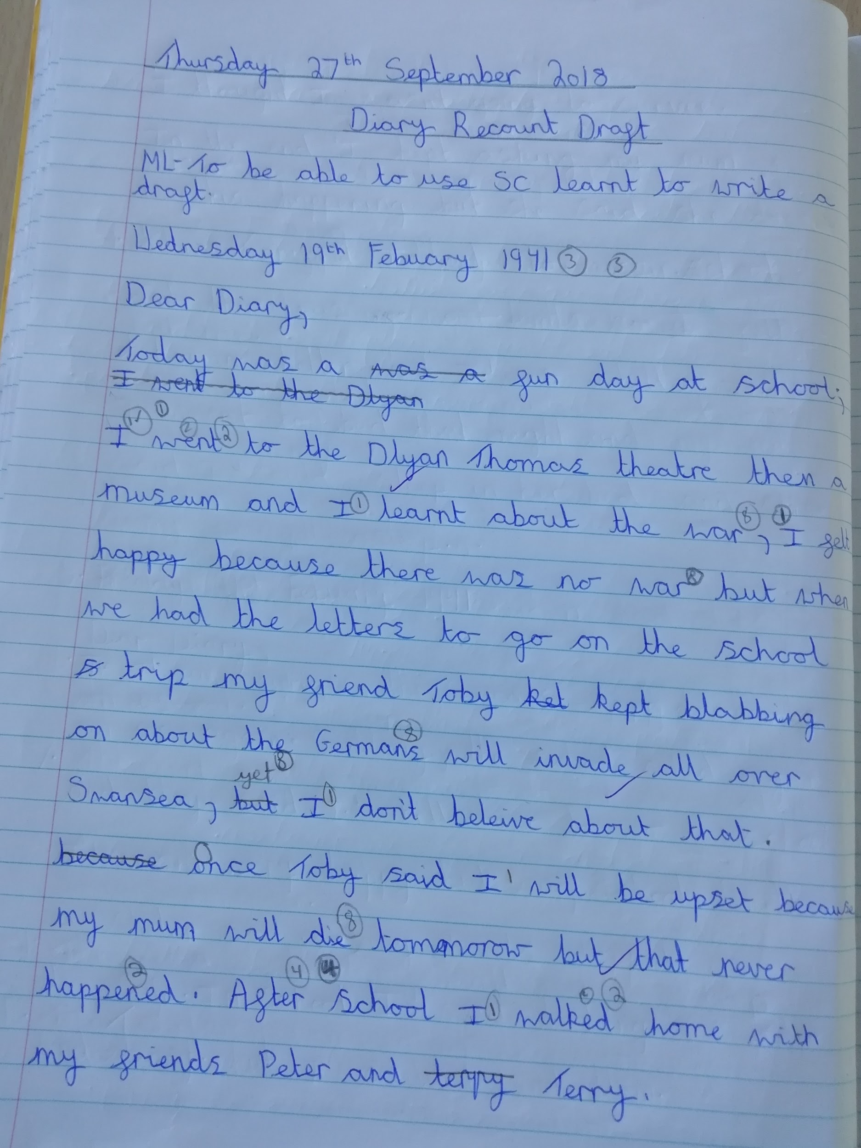
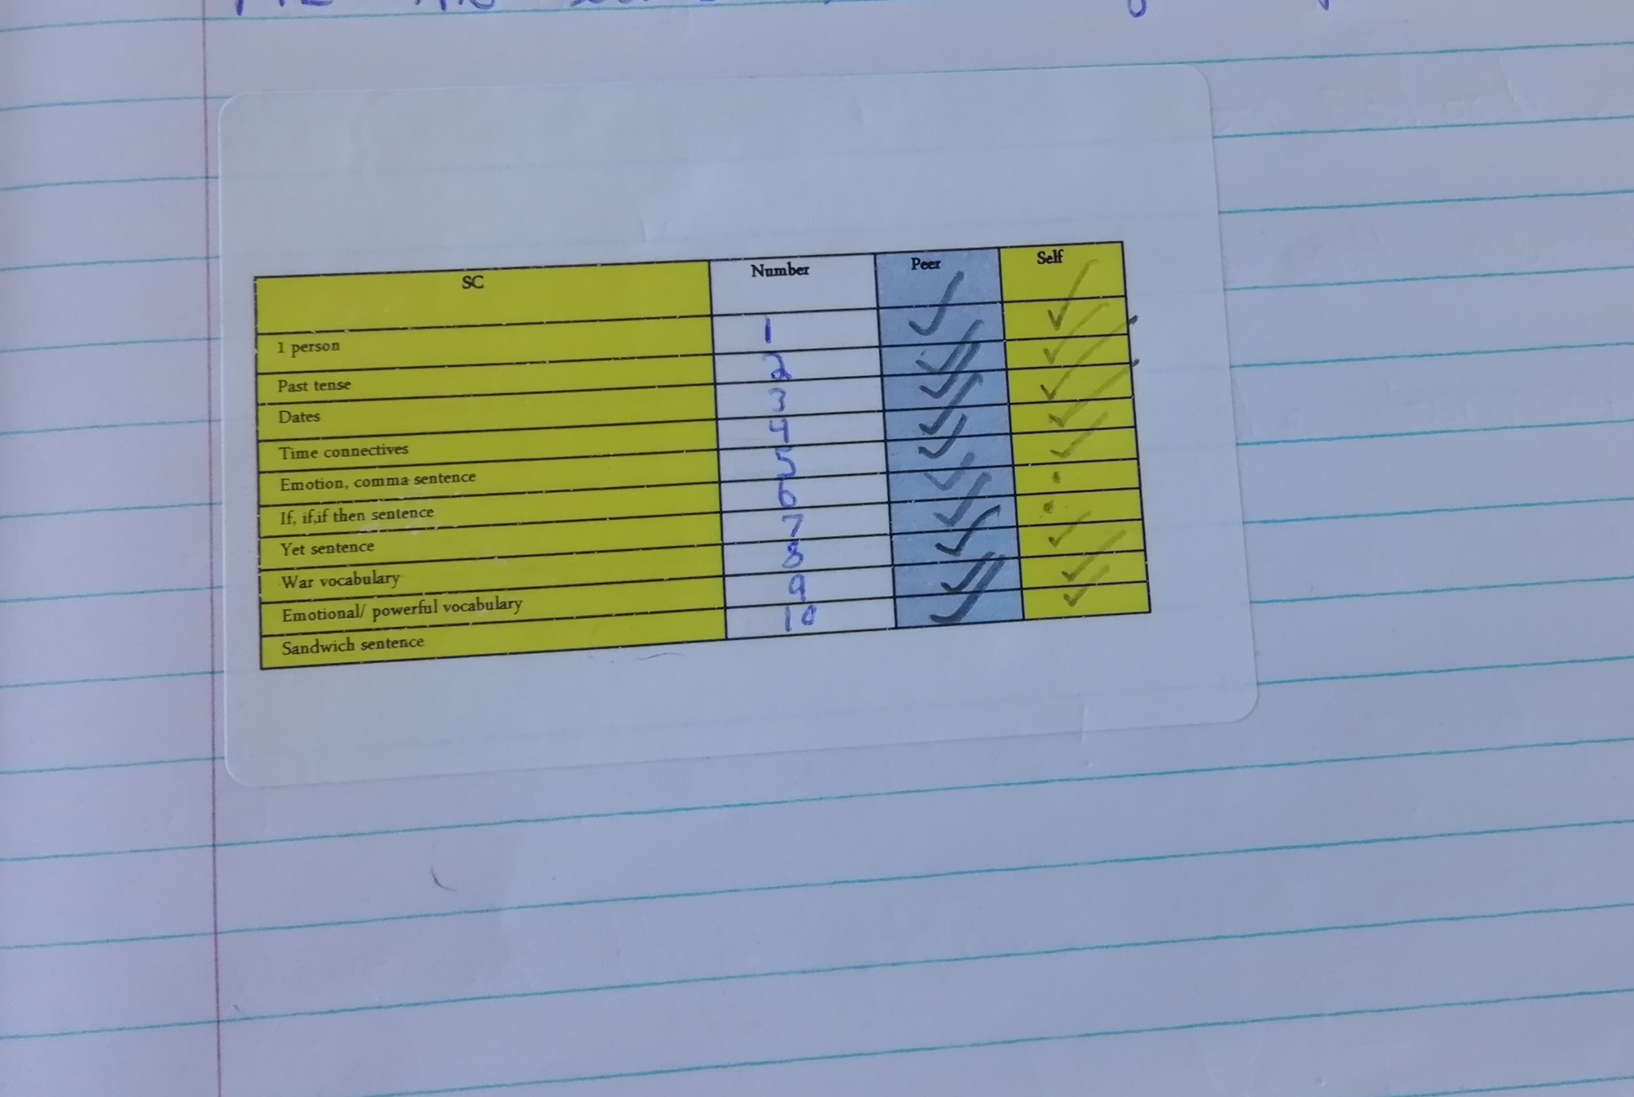

Step 3 - At the time of my observation step 3, where the child has written to the teacher and the teacher has formally marked and assessed their work had not occurred. I have therefore attached below an example of the final part of the assessment process which include the evaluation of ‘zones and the process of DINS before publishing commences.
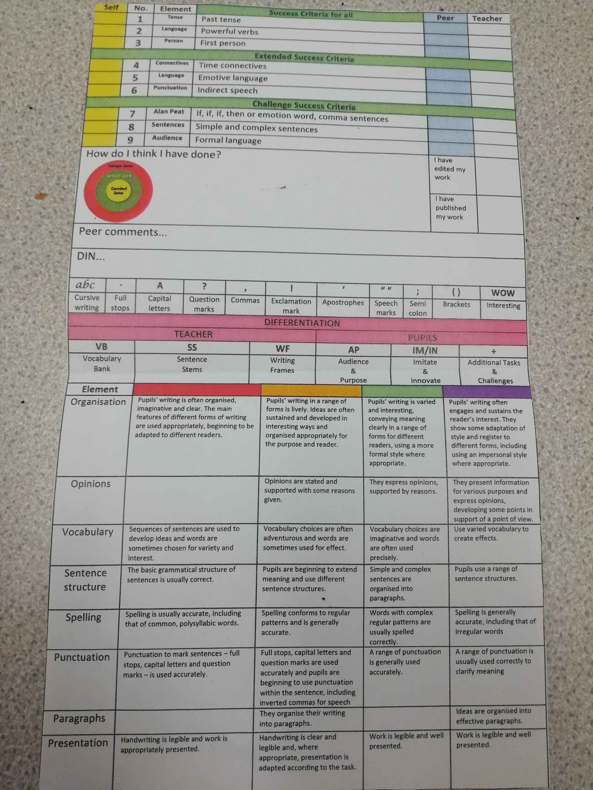

Section 2
Having looked closely at assessment for learning in my learning event I will now demonstrate how the considerations of certain theories and their critics have helped me understand what went on during my learning event, why it was effective and what I might do in my future practise to impact the learning of my pupils.

Jean piaget was arguably the first theorist to look into how children learned. Piaget believed that children used information from objects and people in their environment and constructed their own knowledge by making meaning of them. Many other theorists of the time saw children's cognitive development as either extrinsic (from the environment) or intrinsic (from the child themselves), however ‘Piaget believed that neither fully expressed learning and it was the child's interactions with the environment that generated learning’ (Mooney,2000). He developed the theory of ‘schemas’ and ‘stages of development’ where he believed children move through stages of development at a set rate, where each stage acts as a building block for the other. In these stages children gain their knowledge from the environment (assimilation), then meet challenges or discrepancies where knowledge from a previous schema must be developed to cope with the new situation (accommodation). Lastly children would hopefully according to Piaget achieve a state of equilibrium, where the child's current schema is able to cope with most of the information provided from the environment. Piaget saw this process as a continued cycle needing an active learner whose ‘own curiosity would drive their learning’ (Aubrey and Riley 2016).

Despite Piaget's work being a massive driving force in the way educators and psychologists looked at learning there were many who readily critiqued him. For many Piaget's research methods were the main source of disquiet, as his work was often carried out on his own children, causing unreliability in his methods. Although Piaget only referenced to ages that each stage of cognitive development would occur theorists such as Flannagan (1998) believed that a more fluid approach to the stages should be applied, stating that in a more modern world than Piaget's children were reaching emotional and intellectual maturity sooner. The main critique of Piaget's work was the notion that children learn in isolation, whereas Vygotsky, a contemporary of Piaget believed that ‘With the right social interaction the child would achieve developmental readiness earlier than they would otherwise’ (Aubrey and Riley 2016), and it was Vygotsky who built upon the theories of Piaget's to discover a form of learning that we are more familiar with in our modern day classrooms.

Vygotsky believed that learning was an inherently social activity and stressed the importance of both cultural and environmental factors to help children understand their world. He believed a child's social and cultural background were responsible for shaping their cognitive development. One of Vygotsky's most recognised theories was the ‘Zone of proximal development’, his theory refers to the difference between the tasks learners are able to undertake on their own and the tasks that they are able to do with the guidance of a more skilled or ‘Knowledge other’ (Vygotsky 1980). The more knowledge other can be a teacher or a more able peer and it is the social action of speech that develops an effective movement through the ZPD. Vygotsky also stressed the importance of interaction with peers and said that it was an effective way of building learning strategies. This was clearly occurring throughout my learning event as the children would only seek help from the teacher if they had exhausted all forms of peer support, therefore proving that the interaction they were getting from their peers was effective in moving on their learning. Vygotsky also suggested that teachers use the notion of the ZPD and place less able learners with their more skillful peers to assist them. This was also evident within the school setting I observed as the majority of the class were placed in mixed ability groups, most working on different ‘Chilly’ levels in order to develop that sense of peer support. A term that has become well known alongside the theory of the ZPD and is also a prominent part of AFL process is the term Scaffolding, although it is closely linked to the ZPD it was never mentioned by Vygotsky, but by Wood, Bruner and Ross (1976). ‘Vygotsky did not stipulate what happened within the ZPD for development to take place’ (Keenan, 2002) therefore it was up to Bruner and his colleagues to develop the theory further. ‘Scaffolding is the nature of assistance the child has from and with the adult or more ‘capable peer’ to undertake a task or solve a problem’ (Soott, 2008). It is another active and social interaction that often involves discussion where the level of guidance aims to produce successful learning. The support that is given by the more capable other is then slowly reduced and the learner is encouraged to go and complete more complex tasks alone. This is in the hope to build confidence and more advanced problem solving skills within the learner. This aspect was present in my observation classroom, where the class teacher began the lesson with particular students who needed additional support to get them engaged, before retreating slowly to allow them to work together with their peers, before returning to keep them on track. The class teacher stated that for some of their children this form of scaffolding was essential as they were so under confident that they would simply sit and not engage with peers for fear or seeming incompetent. With the initial ‘push’ and period of support those pupils were developing a sense of perseverance and independence in completing, or trying to complete their work to the best of their ability. It has been noted that ‘The vital aspect of successful scaffolding is that the adult should know the child and their capabilities and be responsive to their needs’ (Keenan 2002), this was evident in the observation as the class teacher knew how much time to spend with each group, and what additional resources each group might need.

Both Vygotsky work on the Zone of Proximal Development and the notion of Scaffolding put forth by Bruner and others have been widely regarded within education and have had a huge impact on how schools, and educators think about learning. That does not mean that the theories come without their misgivings. Firstly the notion of the ZPD posed a problem, measuring the difference between what a child can do independently and then on their own is a challenge in itself and as Wood (1998) stated ‘it is difficult to gauge weather the help of an adult can be accurately differentiated to meet the particular needs of the child's ZPD’ he went on to say that there was a danger that the adult may ‘Go beyond, or indeed, undervalue the child's potential. (Wood 1998). Further concern has been raised about the notion of scaffolding as it has not been made clear what role the child has to play in the process, with this in mind individuals such as Rogoff (1990) worry that the process may become ‘one sided and directed by the adult’.

In considering a way in which to improve learning and thinking within the classroom I want to look at the advantages and disadvantages of AFL as a whole and also explore what can be done to combat these issues. To do this i thought it important to look at one of the most influential research studied into AFL, done by Black and William in 1998. From their research they identified five key points that would allow effective assessment for learning to occur

- Learners can confidently assess themselves and their peers
- Learners are actively involved within their learning
- Effective feedback that is based on clear learning outcomes or success criteria
- The self esteem of pupils.
- Teachers are adaptive and can change their teaching to fit the needs of their class.

Peer and self assessment it was noted by Back and William is ‘an essential component of assessment for learning’. Some may argue that children may be under or over critical of themselves and others resulting in unreliable assessment, therefore what is considered paramount at this stage is ‘The need for a trusting relationship between student and teacher’ (Petty 1998, Dennick 2008). The effect of good peer and self assessment will be the creation of ‘reflective practitioners who will have the confidence to learn, and continue to learn from their experiences’ (Aubrey and Riley 2016).This particularly social task shows and links directly to Donaldson's aim of developing ‘Confident capable learners ready to learn for the rest of their lives’ (Donaldson 2015)

Learners being actively involved in their learning will also be essential to my future practice as it currently is in the classrooms I have observed. The classroom I observed has chosen their particular subjects based around an overarching theme which meant every child was engaged and enthuses about what they were learning as they felt they had ownership over it.

Feedback and questioning techniques by teachers are also an essential part of AFL. An often very unproductive way of assessing is questions asked by the teacher. Black and William noted that often children were not given enough time to respond or could be subconsciously steered towards the correct answer by the teacher. To combat this Black and William suggested methods as in giving reflective time, asking pupils to discuss in small groups or pairs. This technique has been prevalent in the schools I have visited in the form of ‘Think Pair Share’ and ‘Thinking time’. Teachers should be schooled in the art of questioning to ensure that dialogue between them and their pupils is ‘thoughtful, reflective, focused to evoke and explore understanding, and conducted so that all pupils have an opportunity to think and to express their ideas’ (Black and Wiliam 1998).This could be achieved through PPD which Black and Wiliam noted there was a distinct lack of in our school environments.

Several studies of classrooms in the UK and abroad have stated that most children are happy to ‘get by’. Many educators have argued that it is the classroom ethos of positive and negative reinforcement, where stars and stickers are awarded for good work and correct answers, children tend to focus on gaining these rewards and take no interest in developing their learning. It is important therefore that myself and others as educators foster a positive classroom environment where all pupils have the opportunity to succeed, and do not worry about just gaining the correct answers, which might result in a constant feeling of failure and incapability. When used effectively Black and Wiliam say that AFL can be ‘A powerful weapon’ which ‘ Yields particularly good results with low achievers by concentrating on specific problems with their work and giving them a clear understanding of what is wrong and how to put it right’ Black and Wiliam (1998).

And finally to conclude with Black and Wiliam’s point on making sure we are adaptive teachers, willing to change our methods and practises to best fit our class. Many would argue that as teachers we do this every year with the introduction of a new class, but it is the capability of a teacher to change within a system that they have already set up that shows where the creation of true assessment for learning begins, as along with the pupils learning from mistakes and assessing their weaknesses the class teacher is actively assessing their own learning and capability. It is also essential that teachers believe in the longer process of AFL, if they believe that knowledge can be transmitted and the children will develop their learning later then there is no hope, teachers must believe that the risks they are taking in changing routines and spending time will yield the best results for them and their students.

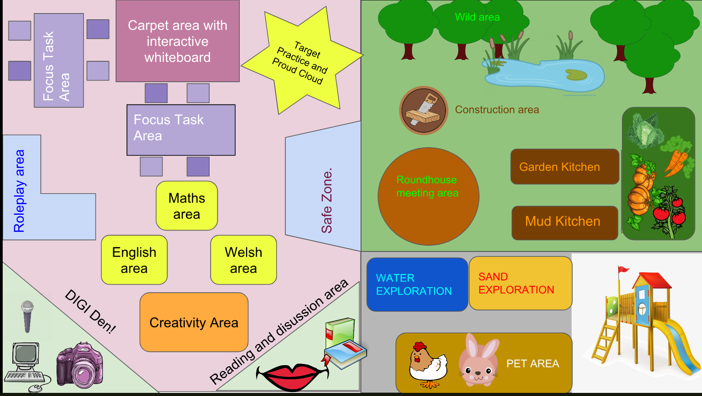
Section 3 - My ideal learning environment
In this section of my assignment I will discuss my ideal learning environment that I have presented using a digital poster. In creating my ideal learning environment I have taken into consideration many different theorists and approaches that we have looked at in the module and have also reflected upon the changes that are currently occurring in the curriculum, under the recommendation of Professor Graham Donaldson.

My ideal learning environment is a classroom for the foundation phase., however it would also be appropriate for a year 3 class with the appropriate leveling of resources. This aligns with Donaldson's theory of ‘Progressions steps’ within the school system, which aims to make learning less fractured and promote a theory of ‘flow’ ensuring that each child progresses with a ‘Sound foundations in learning as the best basis for progression’ (Donaldson 2015.)

I have given special consideration and thought to the introduction of an ‘outdoor learning area’ in my learning environment as it is something I professionally and personally feel very strongly about. The main feature of my outdoor area would be ‘The Wild Area’, which will include a wooded and open area, pond and other natural features. This area which will give the children a chance to explore and experience an environment that they may not have encountered before. This area will also be important because it will give the children the chance to be free and take ownership of their experience and learning. The outdoors naturally has a sense of freedom to it, where the children can simply enjoy being themselves, with nothing to prove or no need to explain themselves.

The outdoor learning environment will also be essential in helping children develop an awareness of risk and challenge. Gill argues that ‘Childhood is becoming undermined by risk aversion’ ( Gill 2007). It can be argued that in an ever changing society where risk aversion has become the norm that children are being kept from developing a sense of independence, which goes directly against one of Donaldsons purposes for the new curriculum which is to create ‘Healthy, confident individuals who are ready to lead fulfilling lives as valued members of society.’ (Donaldson 2015). This has also been supported by Cook and Heseltine (1994:4) who said ‘It is essential to their healthy growth and development. Children need to learn about risk, about their own capabilities’. Building this type of confidence and independence will also aid the children to holistically reinforce their view on challenge, which they can apply then within the classroom and in later life. Within my outdoor area I would also like to include a vegetable patch from which the children can develop environmental concepts, as well as science, and learning to care and do something that will benefit others, allowing them to become the ‘ethically informed citizens’. The Royal Horticultural Society (RHS) assessed the impact of gardening in the school setting an found that a number of benefits included ‘ improvements in eating patterns, with a greater willingness amongst children to try new things and to eat a wider range of fresh vegetables and fruit – a willingness that extended into their lives outside school’
A construction area will also be present where children can experience using tools and materials to create pieces and elements to input in their outdoor learning space such as flower beds, or fences, allowing them to develop fine motor skills and again develop a sense ‘reasonable risk’ and to be self regulatory with their safety. At the centre of my outdoor area will be a roundhouse meeting area, where key activities and lesson aims can be discussed. Some might disagree and suggest that having this ‘classroom’ like structure outside is simply learning outdoors, and not outdoor learning, when in fact it is quite the opposite. Research conducted by Sylva et al (1980) and Smith and Connelly (1981) discovered that children found it harder to settle and concentrate in large open spaces. The roundhouse would combat this by giving children that familiar sense of the classroom, allowing them to concentrate on the objectives of their outdoor session before continuing to enjoy the benefits of the outdoors.

Within my ideal learning environment i have also included a yard space that will include a climbing frame and climbing wall to encourage the development of gross motor skills such as balance, climbing and jumping. Within this are I have also included an element of continuous provision in the form of my sand and water exploration area which will be readily adaptable for particular learning outcomes, topics and skills that I wish to incorporate in the children's daily experiences. Within my yard area I have also introduced a pet area where I would love the opportunity to keep chickens or rabbits. This will foster a sense of care, responsibility and an understanding of living things.

In my indoor classroom will be a space that concentrates on the development of digital competence. This will be known as the ‘Digi Den’. Within this area I would include high quality equipment and tasks to really stretch the children's digital capabilities. Computers and Ipads will be used to allow children to research and create pieces of digital work. Recording equipment such as video cameras, radio michs and a sound booth with green screen will allow the children to experience complex and engaging pieces of technological equipment that can be used cross curricularly to create performances, such as scenes, radio broadcasts and stop animation work. By providing this high level of technological equipment I hope to move away from the assumption that children are digitally literate if they are able to swipe aimlessly on an ipad and foster a thirst for high level and engaging use of technology.

My role play area will be another vital area in my learning environment where children will develop their learning and understanding of the world around them and develop other skills such as communication and creativity. Much research has been done into the role of play in early childhood and it has been agreed that is essential to children's development. George Dorsey stated that ‘Play is the beginning of knowledge’ and Dewey acknowledged the importance of experiential learning, emphasising that the a vocational and academic curriculum, delivered side by side were in the best interests of the learner (Dewey J. 1916) this area will also be essential in aiding topic based work and could be changed throughout the year to fit the topic and give the children a more immersive experience of the work they are conducting. One excellent example I observed in my Bridging school was a role play are that had been turned into a bears cave to match with the class’ topic of Day and Night and their class book which was ‘Can't you sleep little bear’ by Martin Waddell.

Donaldson has placed great emphasis on the importance of literacy and numeracy within the classroom and I have taken this into account in my learning environment. In addition to the focus area where children will complete certain tasks with myself as a teacher they will also have three individual areas where they are able to explore their Numeracy, english and Welsh skills independently. This will allow them to build confidence in their own skills and could be used for assessment, children will have targets they need and want to achieve and will have time to work on them here. I have purposely separated the Welsh and the English literacy sections as along with viewing them personally as equally valid we have discussed in many lectures how some children may find it difficult to combine languages which are inherently different because of their phonetic properties. These areas will also act as low level intervention areas, where skills are continuously practised and developed in small increments to achieve better results for pupils overall. Along with these areas will be a reading and discussion are where children can go and not only learn to enjoy books and reading, and develop their abilities, but also enter into in depth discussion about what they have been reading, or about a class topic. I will further emphasise this with the introduction of a group reading task where children can think critically about the material, challenge and voice opinions and challenge themselves and each other intellectually. This will in term allow them to feel more confident about becoming involved in discussion and build their own self confidence.

Current statistics show that there is a growing increase of wellbeing issues for younger children. It has been discussed that as levels of wellbeing and happiness within children decrease their levels of stress and anxiety increase, causing problems both within the family home, and at school, which has also been closely linked to a drop in attainment. With this in mind I have introduced a wellbeing area within my classroom. This well being area or ‘Safe zone’ will be used for those children who need a place to feel safe and secure when they are feeling anxious, or a place for children who are feeling angry and stressed to take themselves, away from the classroom and their peers to calm down. Many children enter the classroom on a daily basis not having had the best start to the day. In my classroom I want pupils to feel as though they have somewhere they can get back on track and be ready to be the best that they can be throughout the day. Within the safe zone a quiet and calm environment with soft furnishing, soothing lights and the choice of meditative music will be available to help children achieve a sense of readiness for the day.

Having concentrated on assessment for learning in my school observation and seeing the positive effect it had within the classroom I have introduced a visual display within my classroom that will reinforce this. My display will be called ‘Target Practice’. In this display each child will have two targets assigned to them, one from myself as a teacher such as ‘ To use capital letters and full stops in every piece of writing’ and one that comes from the pupil. This target could be either academic or personal in nature such as ‘ To complete a piece of work on time’ or ‘To listen more carefully at carpet time’. I will introduce a whole class target every week which links to the social constructivist theory of progress being achieved as a family or community. Along with this display I will also include a ‘Proud cloud’ where children can place work they feel positive about and where their classmates can add positive comments, fostering a support structure and sense of wellbeing.

Finally within my classroom will be a dedicated ‘creative area’ this area will be reserved for independent exploration of the children's ideas where they can go and create and explore materials and ideas in whatever way they want. There has been great emphasis on raising creativity within the classroom. Claxton argues that ‘creativity is one learning disposition that is significant’ Saheen (2012) stated that creativity could fall into the following groups
A: Production of something original
B. production of something original and of value
C.production of something new , of value and imaginative
B.production of something original, of value and which is accepted by the group.
Saheen (2012)
Within all these groups there are opportunities for children to explore, be imaginative and gain a sense of well being and being proud of something that they can share with their peers. This will be achieved by supplying children with all types of apparatus, such as pens, paints, materials such as egg boxes, sting paper, wood which will allow them to foster a love of creativity.

In conclusion, throughout my essay I have gained a comprehensive understanding of the effectiveness of AFL within the classroom and how, when used effectively it can support and enhance our pupils learning. I have researched and critiqued the theories of different theorists and have understood how they influence the way learning occurs. I have also taken into account many different theories and theorists in the creation of my ideal learning environment,and have considered provisions and practises that will not only develop the children as learners, but also myself as a new educator.

References

Aubrey and Riley (2016) Understanding and using EDucational Theories. Ashford Colour Press Ltd.

Black, P & Wiliam, D 1998, Inside the Black Box: Raising standards through classroom assessment, School of Education, King’s College, London, United Kingdom.

Cook and heseltine (1994) in Helen Bilton (2010) Outdoor Learning in the Early Years (third edition) Abingdon: Routledge.

Dewey J. (1916), Democracy and education : An introduction to the philosophy of education

Donaldson, G. (2015). Successful Futures: Independent review of curriculum and assessment arrangements in Wales. Caerdydd: Llywodraeth Cenedlaethol Cymru

Gill, T (2007) No Fear. growing up in a Risk Averse Society. London: Calouste Gulbenkian Foundation

Keenan, T (2002) An Introduction to Child Development. London: Sage.

Mooney, C.G. (2000) Theories of Childhood. St Paul, MN: Redleaf Press.

Royal Horticultural Society. Available: https://www.directorofpublichealthaward.org.uk/system/files/downloads/Early%20Years%20Gardening%20and%20Nature%20Exploration%20Toolkit_0.pdf.

Saheen (2012) Creativity. In: Arthur, J and Paterson A (eds) The Routledge Companion to Education. Abingdon: Routledge.
Scott, D. (2008) Critical Essays on Major Curriculum Theorists. Abingdon:Routledge.

Wood, D (1998) How Children Think and Learn (second edition). Oxford: Blackwell.

