Assignment Name: Assignment 1 E-Portfolio
Student Name: Bethany Stock
Student Number: 1902668
Module Name: Changemakers: Creativity and Value Creation (ACCA5033)
Course Title: Game Design

Contents
e-Portfolio 3
Task 1 - Mind Map 4
Task 2 – Image-based Video presentation 5
Task 3 – Video Presentation 6
Task 4 - Academic Poster 7

e-Portfolio

Link to homepage: https://bs-portfolio.wixsite.com/website

Task 1 - Mind Map

Link to task in e-portfolio: https://bs-portfolio.wixsite.com/website
Screenshot of task:
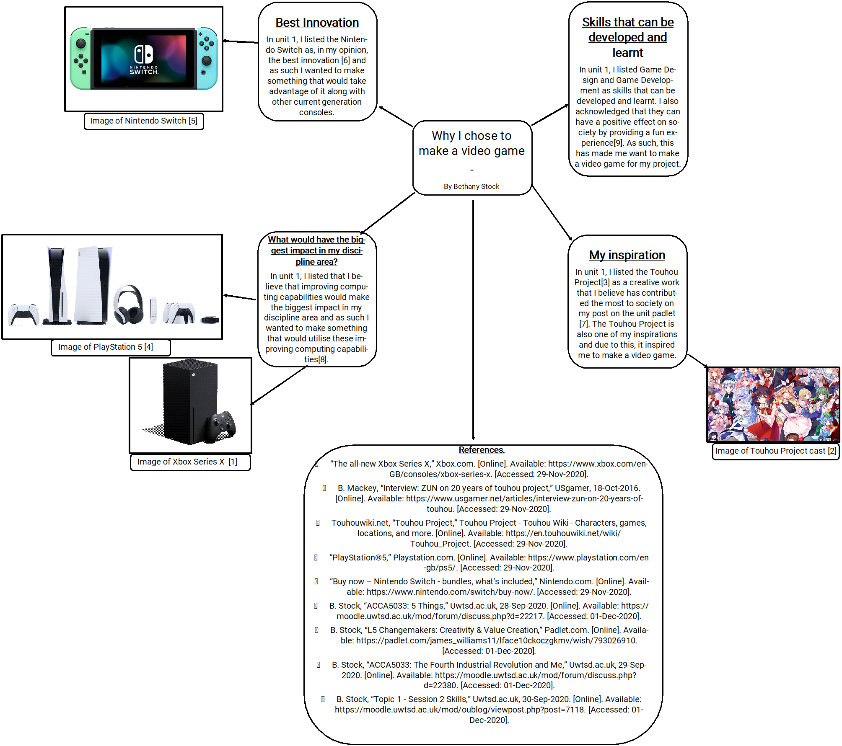

Task 2 – Image-based Video presentation

Link to task in e-portfolio: https://bs-portfolio.wixsite.com/website
Link to task online: https://www.youtube.com/watch?v=Wh0D0pQor5U

Task 3 – Video Presentation

Link to task in e-portfolio: https://bs-portfolio.wixsite.com/website
Link to task online: https://www.youtube.com/watch?v=OLp6pqOJDDA

Task 4 - Academic Poster

Link to task in e-portfolio: https://bs-portfolio.wixsite.com/website
Screenshot of task:


