The Metamorphosis

The book I was assigned for this project was called The Metamorphosis by Franz Kafka. This book is about a young man who lives with his family and is the main earner for the family’s income. In the unlikely and unfortunate event, the young man, Gregor, turns into a human sized cockroach.
His family is disgusted in him, he loses his job, and loses his ability to BE human in his mind as well as in his body. The only family member who cares for I him now is his younger sister. She feeds him twice every day. Once after she has finished her breakfast and once after she has finished her evening meal.
As a human, he enjoyed the little things in life like warm milk with bread. As his sister remembers this, she offered him some, but although his human mind wanted to enjoy this treat his body automatically revolted from the food and took him away. She then went on to put on a feast for him to figure out what his new body likes. Every time she would do this he always went for the left over, rotting foods. He is a cockroach after all.

From this part of the book, I took inspiration. I decided to do the rejection of food. The visual in my head that I had from reading this section of the book was food being pushed away. It was the idea of trial and error and repeating the process until he was happy. Which gave me the idea of creating small snippets of film and repeating them throughout the body of work.
As this project was given a very short period of time, I didn’t have a chance to read the book as well as researching different influential artists. So I let my imagination take over and allowed my first visual to come to life.
I did some experimenting with the food, and allowed the food to ferment underneath a radiator. This allowed the food to look more and more disgusting but what looks very appetising to bugs and insects. I then repeated the film snippets over and over as they were only roughly 3 seconds long and the brief was to fill the minute. This tied in with my book as well, because he only had a certain amount of time to adjust to the concept of the transformation into a bug, before his untimely death.
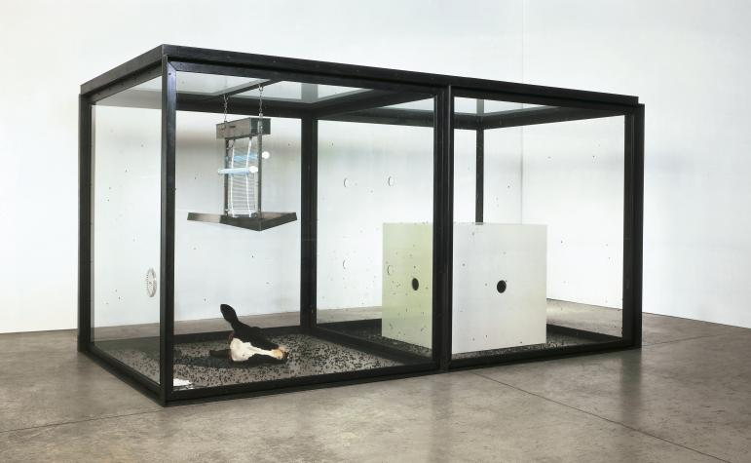
An inspiring artist for me is Damien Hirst with “a thousand years”. This installation piece is of a dead cow’s head with maggots, larvae, and flies inside a glass container. It is essentially the life cycle of the fly. This gave me ideas to reuse and recycle the leftover food in my food waste bin at home. It allowed me to get the desired outcome of my imagined ideas.
If this project was longer, I feel I could have improved the concept and the outcome of it, but I am happy with what I have presented.

