Module Code: LCLM4006
Module Title: Individual Written Business Plan

Name: Bozhidara Naydenova
Student ID: 2424540
Lecturer: Dr. Charles Oham

Executive Summary
Comfort Coffee is a niche cafe conceived to offer a hometown feel, laid-back and customized coffee, as opposed to the fast-paced nature of other large chain cafes in central London. The cafe is located as a third space to cater to office workers, students, and residents who would want to enjoy a good coffee, fresh pastries, and a comfortable atmosphere that allows them to be productive and relax at the same time. The fact that urbanization is on the rise and the need to have more comfortable, less noisy cafes is a clear indication of the presence of a promising market for the idea.
The business has an unmet need in the market by targeting comfort, personal-based service, and affordability- values that are not taken into consideration by the large chains. Its product menu consists of high-quality coffee using freshly ground coffee and delivered pastries on a daily basis, in addition to other value-added features like ample seating, cozy atmosphere, and free high-speed Wi-Fi. The characteristics stimulate extended stay periods, customer satisfaction, and repeat business.
The SMART framework fits the objectives of Comfort Coffee because the targets include reaching an average of 80 customers a day in six months, breaking even in month ten, and increasing the social media followers to more than 1,500 in the first year. Long-term objectives involve having a second outlet in the second year, operating on mobile ordering, and establishing corporate relationships with offices in the neighborhood.
An in-depth PESTEL and SWOT analysis reveals that there are strong opportunities that are given the growing coffee culture in the UK, the use of digital, and the desire of consumers to have a product that is ethically sourced. The major challenges are the high price of rental and the presence of other well-known brands. The marketing plan aims to introduce promotions at the time of launch, social media promotion, influencer partnerships, and reward programs to spread brand awareness and customer retention.
Comfort Coffee has the potential to grow sustainably and expand in the future with proper operational strategies, skilled employees, and high demand for comfortable independent cafes.

Table of Contents
Executive Summary 2
1. Introduction 4
2. Business Concept 5
3. Business Objectives (SMART Objectives) 6
4. Market Analysis and Marketing Plan 6
4.1 Market Analysis 6
4.2 PESTEL Analysis 7
4.3 SWOT Analysis 8
5. Marketing Mix 10
6. Management Team 11
7. Key Milestones 11
8. Financial Plan (One Year) 11
Sources of Finance: 11
Cash Flow Forecast (Narrative): 11
Sales Forecast: 12
Cost of Production Forecast: 12
Break-Even Analysis: 12
9. Operations and Management Plan 13
10. Conclusion 14
References 15

1. Introduction
Comfort Coffee will be a warm, relaxed specialty cafe in the center of London. It will be designed to provide a break to the busy and congested atmosphere in the mainstream coffee chains. Although more proven brands such as Starbucks, Costa, and Pret are efficient and large-scale, they tend to lack the comfort that is often personalized by many contemporary consumers (Mintel, 2023).
The company has established itself based on quality coffee, freshly baked pastries, and a comfortable atmosphere supported by the presence of trained baristas. The idea is consistent with the trend of increasing urbanization, in which customers are proactive in seeking a place that will not only be productive but also allow them to relax (ONS, 2022).
This report provides details of the entire business plan of Comfort Coffee, including business positioning, marketing mix, financial viability, operational framework, and SMART goals (Barringer&Ireland, 2020). The analysis can help illustrate how the cafe can shine in a competitive market in London.

2. Business Concept
Business Description
Comfort Coffee is a specialty coffee place that is an independent establishment in the central part of London, and it was created to offer a relaxing atmosphere in the middle of the London rush. The cafe occupies a gap by emphasizing comfort, offering a relaxing atmosphere with comfortable seats, low-key lighting, and a home-like atmosphere, an explicit opposite to the usually busy and cold atmosphere of chains such as Starbucks, Costa, and Pret. This emphasis on comfort is one of the distinguishing factors: a growing consumer trend is the urgency to find urban professionals, college students, and value seekers between age 20-60 to find welcoming third spaces that offer them a cup of coffee, but more than a cup of coffee, to have an experience that gives them productivity and relaxation (Oldenburg&Brissett, 2020).
Product Description
Its core products include high-quality coffee and specialty beverages, fresh pastries, and are prepared using freshly sourced coffee beans and ingredients under the supervision of trained baristas. In addition to the menu, Comfort Coffee adds value to the customers by providing a comfortable seating environment, spacious seating, a warm environment that can be used to work or relax, besides free high-speed internet (Wi-Fi). All these features are incorporated into a place where the customers can stay to conduct meetings, study, or relax, and keep them loyal and visit the place again (Harris&Reynolds, 2021).

3. Business Objectives (SMART Objectives)
Short-Term (Within 1 Year)
- Attain an average of 80 customers daily in 6 months.
- Attain operational break-even in month 10.
- Expand social media to more than 1,500 followers in 12 months.
Long-Term (Beyond 1 Year)
- By month 24, have the second Comfort Coffee outlet open.
- Introduce in-house mobile ordering in year 2.
- Partner with at least 10 local office buildings in 3 years.

4. Market Analysis and Marketing Plan

4.1 Market Analysis
Competitors
The coffee shop business in London is dominated by high-street chains (Starbucks, Costa, Pret), which are characterized by recognition of a strong brand, fast service, and the ability to maintain the same quality of coffee shop (Allegra World Coffee Portal, 2024). Nevertheless, these establishments are often crowded, costly, and not personalized. The local independents are varied and unique, but they do not necessarily have the scope and consistency some individuals desire.
Customers
The main target groups will be office employees, college students, local citizens, and value consumers who are in need of comfort, affordable quality, and quiet working or relaxing places. Employees working in offices in general prefer a close venue, fast service, and a relaxing environment to relax during the working day (PwC, 2022).
Target Groups
- Adults between 20-60 years, and middle-income.
- City workers have a hectic schedule.
- The customers who want peaceful breaks and budget-friendly options.

4.2 PESTEL Analysis
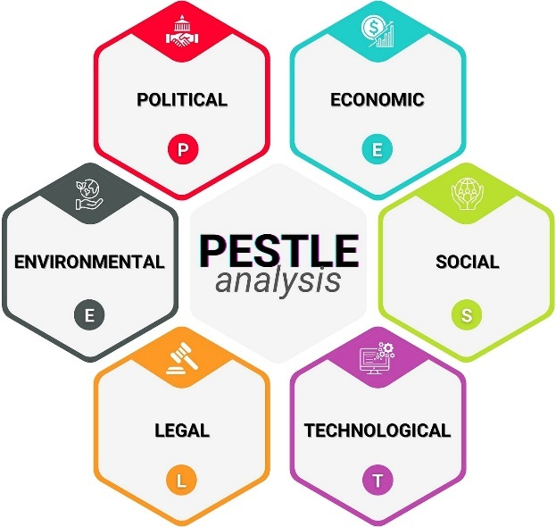
Figure 1: PESTLE (Medium, 2025)
Political:
The cafe is subject to the UK/EU food safety and hygiene regulations. As there will be trade and import changes post-Brexit, the coffee bean sourcing, packaging, labor laws, and allergen information must be addressed based on regulatory compliance. Any change in policies of the business rates or minimum wage influences the costs of operations.
Economic:
An increase in inflation influences ingredient, wage, and rental expenses. However, coffee does not surrender; the average revenue per shop in the UK is more than £788,000, and the London market shows an average growth of 4.1 percent/year and a sector worth £6.4 billion. Central locations will have higher rent but can bring a high volume of customers, which can support the volume targets (Bank of England, 2024).
Social:
The coffee culture in Britain is at the heart of urban living; 80 percent of Britons frequent a coffee shop at least once a week, and 16 percent do so every day. Third spaces have become the favorite spots to relax, work, and socialize, and people are increasingly demanding better quality and ethical sourcing, comfort rather than convenience.
Technological:
The contemporary cafes also employ powerful POS, contactless and mobile payments, and social media interactions. The book of the future: an ordering and loyalty mobile application will bring the business closer to the digital consumer behavior and workflow optimization.
Environmental:
Customers are becoming more demanding of environmentally friendly efforts: green coffee, socially responsible products, recycled packaging, and waste. The sourcing activities and the operational decisions of Comfort Coffee will be in line with these values.
Legal:
Food safety, employment, business licensing, and allergen labelling are to be followed strictly. Failure may result in fines or shutdown; hence, staff training and documentation are paramount.

4.3 SWOT Analysis
Strengths | Weaknesses
Comfort-driven concept | High London rent
Affordable pricing | New brand recognition
High London demand | Limited starting funds

Opportunities | Threats
Growth in café culture | Intense competition
Return of office workers | Inflation pressures
Social media engagement | Shifting consumer spending

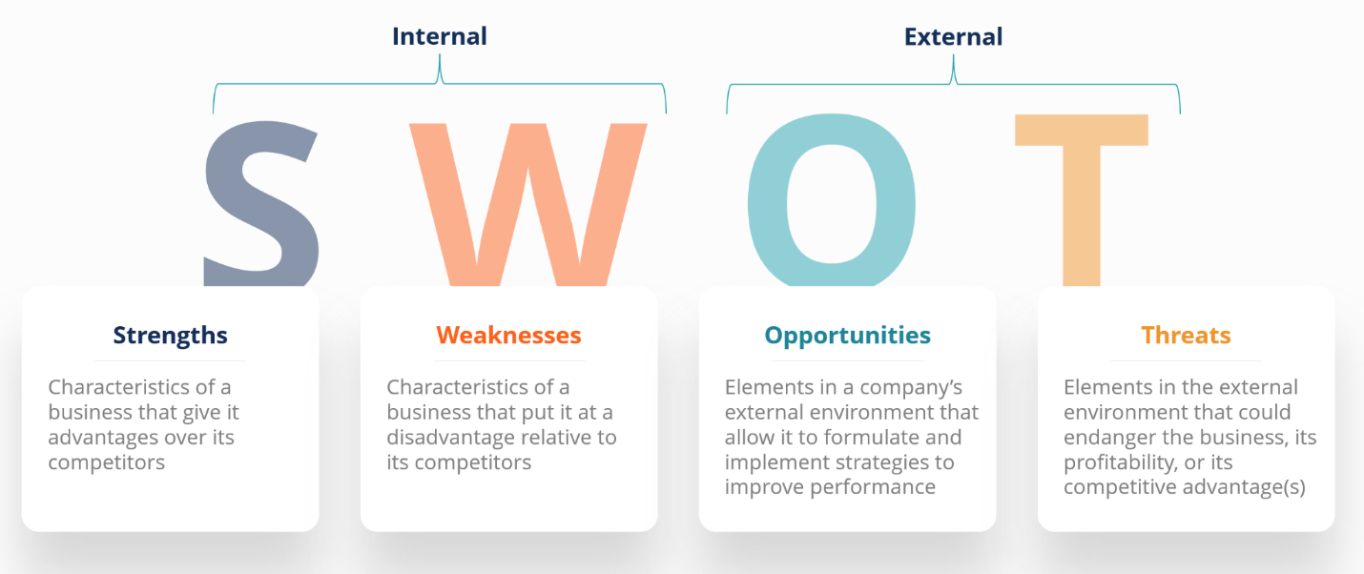
Figure 2: SWOT (Corporate Finance Institute, 2025)

5. Marketing Mix
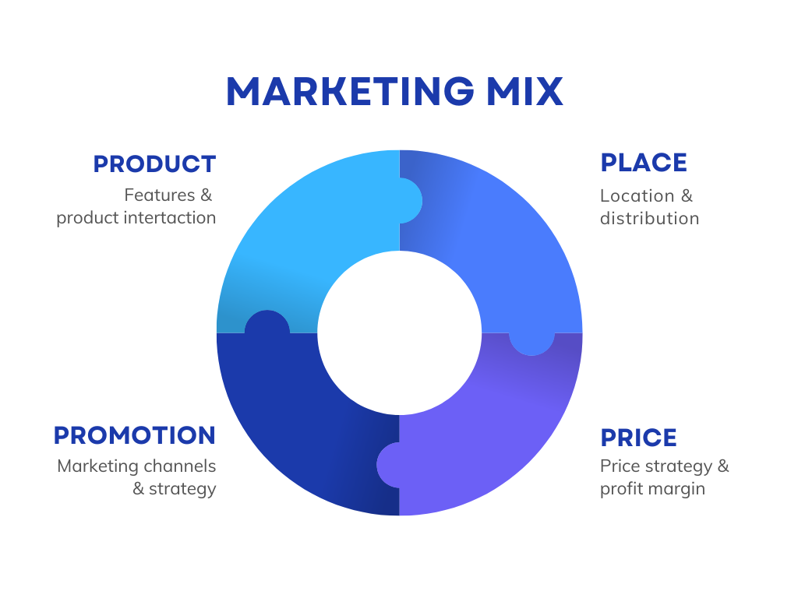
Figure 3:4P's of marketing (Business.org, 2025)
Product:
Exquisite bespoke coffee, freshly baked pastries, all in a relaxed and peaceful environment that helps in socialization and productivity.
Price:
Placed just slightly lower than premium chains in value, reaching out to customers who are price and quality-sensitive (Collins, 2021).
Place:
Shopfront on the ground floor with visibility in a central neighborhood in London, making the largest use of the accessibility to target markets.
Promotion:
A multi-pronged approach will be taken, which includes,
- Launch discounts
- Strategic media campaigns on social media.
- Cooperation with micro-influencers.
- Service loyalty programs to lure regulars and grant referral rewards.

6. Management Team
Its owner/operator manages the cafe, with prior experience in customer service and management of a small business. This is due to daily operations, which are managed directly with standards being met. Coffee professionals are recruited to serve as baristas and interact with the customers, and they also have the support staff to help with front-of-the-house and back-of-the-house work.

7. Key Milestones
- Secure premises (Month 1)
- Complete renovations (Month 2)
- Hire and train staff (Months 2-3)
- Soft launch with feedback loop (Month 3)
- Targeted promotions at the beginning of the month (Month 4)
- First financial performance analysis (Month 6)

8. Financial Plan (One Year)

Sources of Finance:
Comfort Coffee was started with £50,000 raised by the owner and a small business loan. These are appropriate sources of flexibility, low dilution, and manageable debt services.

Cash Flow Forecast (Narrative):
Main inflows are through drinks and pastries sales. Major outflows are through rent (central London), staff salaries, purchase of ingredients, utilities, loan repayments, and marketing costs. Location and audience (office workers and students guarantee footfall consistency) reduce the seasonality.

Sales Forecast:
Goal: 80 customers/day, £5.50 expenditure = £13,200/month. The revenue forecasts are estimated at a 20 percent increase in revenue after building the brand.

Cost of Production Forecast:
List of key expenses,
- Ingredient (beans, pastries, milk): 32% of the sales.
- Packaging/disposables: 8%
- Rent, utilities, wage, etc.: 50%

Break-Even Analysis:
Monthly fixed (rent, staff, loan): £8,000. Contribution margin/£5.50 sale = £3.30.
Break-even: approximately 2,425 clients/month or approximately 81 clients/day--this is doable by the standards of London and the location. Breakeven is achieved in most coffee shops within London settings of similar set-ups, with a span of 10-12 months, with proper management (IBISWorld, 2023).

9. Operations and Management Plan
Production of Goods and Services:
Goods and service Production: Orders are prepared by baristas with high-quality, ethically sourced beans and ingredients, and the pastries are delivered daily by local suppliers. Staff checklists and routine guarantee consistency of products and services.
Quality Control:
Staff training on a regular basis, customer feedback, and quality audit daily.
Technology Plan:
Contemporary POS system, cashless, robust social media presence, and mobile ordering platform in the future.
Human Resource Plan:
The staff will consist of full-time and part-time baristas and support personnel who will work in rotating shifts during peak (morning, lunch) and off-peak periods. The focus of training is on the quality of service, product knowledge, and safety. A Monthly review of customer care standards is done.
Expansion Plan:
Open a second location in year two, using site selection that is based on data. Vegan pastries, seasonal beverages. Enhance office relationships through catering of events or offers.

10. Conclusion
Comfort Coffee will be created to address the increasing need for comfortable, quality, and affordable coffee rooms in the middle of London. The business has an excellent opportunity to set itself apart when compared to other large chains, as well as unreliable independent cafes, using an excellent pricing and marketing strategy.
Equipped with transparent operational structures, trained employees, and a quality and technology adoption spirit, Comfort Coffee has the platform to sustainably grow. The five-year strategy, such as the second outlet and online opportunities, shows the desire of cafe to grow in a responsible way.
Comfort Coffee, in a nutshell, is not any other coffee shop, but rather meant to be a trusted third space of Londoners where all is guaranteed comfort, community, and a regular experience to ensure repeat customers.

References
- Allegra World Coffee Portal (2024) UK Coffee Shop Market Report 2024. London: Allegra Strategies.
- Bank of England (2024) Monetary Policy Report – Economic Outlook. Available at: https://www.bankofengland.co.uk
- Barringer, B. R. and Ireland, R. D. (2020). Entrepreneurship: Successfully Launching New Ventures. 6th edn. Harlow: Pearson.
- Business.org, 2025. Marketing 101: The 4P Matrix. [online] Available at: https://www.business.org/marketing/sales/marketing-101-4p-matrix/
- Collins, R. (2021) ‘Micro-influencers and hospitality marketing effectiveness’, Journal of Digital Branding, 9(2), pp. 45–59.
- Corporate Finance Institute (CFI) (n.d.) SWOT Analysis – How to Do It Properly. Available at:
https://corporatefinanceinstitute.com/resources/management/swot-analysis/
- Harris, L. and Reynolds, J. (2021) ‘Customer dwell time influences in coffee shops’, Service Industries Journal, 41(15–16), pp. 1101–1118.
- IBISWorld (2023) Coffee Shops in the UK (Report I5610). London: IBISWorld.
- Medium, 2025. PESTLE Analysis: The CEO’s Guide to Future-Proofing a Business. [online] Available at: https://medium.com/techno-preneurship/pestle-analysis-the-ceos-guide-to-future-proofing-a-business-877e6c4e20ea
- Mintel (2023) UK Coffee Shop Market – Consumer Report 2023. London: Mintel Group Ltd.
- Oldenburg, R. and Brissett, D. (2020) ‘The third place revisited: Community, comfort and urban social spaces’, Urban Sociology Review, 28(1), pp. 1–18.
- ONS (Office for National Statistics) (2022) Urbanisation and Lifestyle Trends in the UK. London: ONS.
- PwC (2022) Future of Work in London – Workplace Behaviour Report. Available at: https://www.pwc.co.uk

