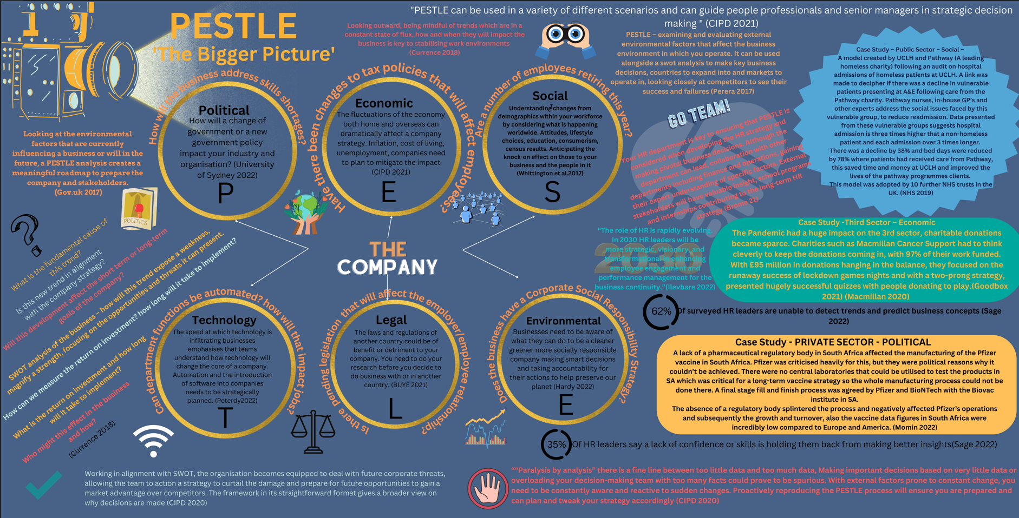

Victoria Jeffreys (1303685)
University of Wales Trinity St David
16th December 2022
Word Count: 1078

Pestle – The Bigger Picture

“PESTLE can be used in a range of different scenarios and can guide people professionals and senior managers in strategic decision making” (CIPD, 2021)
Looking outward, being mindful of trends which are in a constant state of flux, how and when they will impact the business is key to stabilising work environments. (Currence, 2018)
PESTLE – examining and evaluating external environmental factors that affect the business environment in which you operate. It can be used alongside a swot analysis to make key business decisions, countries to expand into and markets to operate in, looking closely at competitors to see their success and failures (Perera, 2017)
Your HR department is key to ensuring that PESTLE is considered when developing the HR strategy and making pivotal business decisions. ollaboration with other departments including finance and operations, gaining their expert understanding of specific factors. External stakeholders will have valuable insight, school programs and internships contributing to the long-term HR strategy (Brome, 2021)
Case Study – Public Sector –Social
A model created by UCLH and Pathway (A leading homeless charity) following an audit on hospital admissions of homeless patients at UCLH. A link was made to decipher if there was a decline in vulnerable patients presenting at A&E following care from the Pathway charity. Pathway nurses, in-house GP’s and other experts address the social issues faced by this vulnerable group, to reduce readmission. Data presented from these vulnerable groups suggests hospital admission is three times higher that a non-homeless patient and each admission over 3 times longer.
There was a decline by 38% and bed days were reduced by 78% where patients had received care from Pathway, this saved time and money at UCLH and improved the lives of the pathway programmes clients. This model was adopted by 10 further NHS trusts in the UK. (NHS, 2019)
Case Study -Third Sector – Economic
The Pandemic had a huge impact on the 3rd sector, charitable donations became sparce. Charities such as Macmillan Cancer Support had to think cleverly to keep the donations coming in, with 97% of their work funded. With £95 million in donations hanging in the balance, they focused on the runaway success of lockdown games nights and with a two-prong strategy, presented hugely successful quizzes with people donating to play. (Goodbox, 2021) (Macmillan Cancer Support, 2022)
Case Study – Private Sector - Political
A lack of a pharmaceutical regulatory body in South Africa affected the manufacturing of the Pfizer vaccine in South Africa. Pfizer was criticised heavily for this, but there were political reasons why it couldn’t be achieved. There were no central laboratories that could be utilised to test the products in SA which was critical for a long-term vaccine strategy so the whole manufacturing process was impossible. A final stage fill and finish process was agreed by Pfizer and BioNTech with the Biovac institute in SA.
The absence of a regulatory body splintered the process and negatively affected Pfizer’s operations and subsequently the growth and turnover, also the vaccine data figures in South Africa were incredibly low compared to Europe and America. (Momin, 2022) (Jerving, 2021)
“The role of HR is rapidly evolving. In 2030 HR leaders will be more strategic, visionary, and transformational in enhancing employee engagement and performance management for the business continuity.” (Ilevbare, 2021)

62% Of surveyed HR leaders are unable to detect trends and predict business concepts (Sage, 2022)
“35% Of HR leaders say a lack of confidence or skills is holding them back from making better insights” (Sage, 2022)

‘Paralysis by analysis’ there is a fine line between too little data and too much data, Making important decisions based on very little data or overloading your decision-making team with too many facts could prove to be spurious. With external factors prone to constant change, you need to be constantly aware and reactive to sudden changes. Proactively reproducing the PESTLE process will ensure you are prepared and can plan and tweak your strategy accordingly (CIPD, 2021)
Working in alignment with SWOT, the organisation becomes equipped to deal with future corporate threats, allowing the team to action a strategy to curtail the damage and prepare for future opportunities to gain a market advantage over competitors. The framework in its straightforward format gives a broader view on why decisions are made (CIPD, 2021)
What is the fundamental cause of this trend?
Is this new trend in alignment with the company strategy?
Will this development affect the short term or long-term goals of the company?
SWOT analysis of the business – how will this trend expose a weakness, magnify a strength, focusing on the opportunities and threats it can present.
How can we measure the return on investment? how long will it take to implement?
Who might this effect in the business and how?
(Currence, 2018)
Looking at the environmental factors that are currently influencing a business or will in the future, a PESTLE analysis creates a meaningful roadmap to prepare the company and stakeholders. (GOV.UK, 2017)
How will the business address skills shortages?
Political
How will a change of government or a new government policy impact your industry and organisation? (University of Sydney, 2022)
Have there been changes to tax policies that will affect employees?
Economic
The fluctuations of the economy both home and overseas can dramatically affect a company strategy. Inflation, cost of living, unemployment, companies need to plan to mitigate the impact (CIPD, 2021)
Are a number of employees retiring this year?
Social
Understanding changes from demographics within your workforce by considering what is happening worldwide. Attitudes, lifestyle choices, education, consumerism, census results. Anticipating the knock-on effect on those to your business and the people in it (Whittington, et al., 2017)

Can department functions be automated? how will that impact jobs?
Technology
The speed at which technology is infiltrating businesses emphasises that teams understand how technology will change the core of a company. Automation and the introduction of software into companies needs to be strategically planned. (Peterdy, 2022)
Is there pending legislation that will affect the employer/employee relationship?
Legal
The laws and regulations of another country could be of benefit or detriment to your company. You need to do your research before you decide to do business with or in another country. (Buye, 2021)
Does the business have a Corporate Social Responsibility Strategy?
Environmental
Businesses need to be aware of what they can do to be a cleaner greener more socially responsible company making smart decisions and taking accountability for their actions to help preserve our planet (Hardy, 2022)

References
Brome, A., 2021. SHRM - The HR Department in Planning Mode. [Online]
Available at: https://www.shrm.org/resourcesandtools/hr-topics/behavioral-competencies/pages/the-hr-department-in-planning-mode.aspx?_ga=2.121340040.1663357677.1671013980-1488801608.1671013979
[Accessed 14 December 2022].
Buye, R., 2021. Critical examination of the PESTEL Analysis Model, Berlin: ResearchGate.
CIPD, 2021. PESTLE analysis. [Online]
Available at: https://www.cipd.co.uk/knowledge/strategy/organisational-development/pestle-analysis-factsheet
[Accessed 14 December 2022].
CIPD, 2021. PESTLE Analysis. [Online]
Available at: https://www.cipd.co.uk/knowledge/strategy/organisational-development/pestle-analysis-factsheet?pdf=true
[Accessed 14 December 2022].
Currence, J., 2018. SHRM - Cultivate Critical Evaluation with a PESTLE Analysis. [Online]
Available at: https://www.shrm.org/hr-today/news/hr-magazine/0618/pages/cultivate-critical-evaluation-with-a-pestle-analysis.aspx?_ga=2.57380010.1663357677.1671013980-1488801608.1671013979
[Accessed 14 December 2022].
Goodbox, 2021. A guide to overcoming challenges in fundraising. [Online]
Available at: https://www.goodbox.com/2021/10/biggest-challenges-in-fundraising/
[Accessed 14 December 2022].
GOV.UK, 2017. Department for Digital, Culture, Media and Sport. [Online]
Available at: https://www.gov.uk/government/publications/libraries-alternative-delivery-models-toolkit/stage-2-the-case-for-change
[Accessed 14 December 2022].
Hardy, N., 2022. Breath HR. [Online]
Available at: https://www.breathehr.com/en-gb/blog/topic/performance-and-productivity/what-is-a-pestle-analysis-and-why-is-it-important-to-hr
[Accessed 15 December 2022].
Ilevbare, M., 2021. Sage HR in 2030- Human resources led the charge through the human crisis, Unknown: Sage Group PLC.

Jerving, S., 2021. devex - fizer outlines challenges in localizing vaccine manufacturing. [Online]
Available at: https://www.devex.com/news/pfizer-outlines-challenges-in-localizing-vaccine-manufacturing-102273
[Accessed 8 December 2022].
Macmillan Cancer Support, 2022. Donate To Macmillan. [Online]
Available at: https://www.macmillan.org.uk/donate
[Accessed 8 December 2022].
Momin, A., 2022. Pestle Analysis. [Online]
Available at: https://pestleanalysis.com/pfizer-pestle-analysis/
[Accessed 14 December 2022].
NHS, 2019. NHS - Stronger NHS action on helath inequlaities. [Online]
Available at: https://www.longtermplan.nhs.uk/online-version/chapter-2-more-nhs-action-on-prevention-and-health-inequalities/stronger-nhs-action-on-health-inequalities/
[Accessed 14 December 2022].
Perera, R., 2017. The Pestle Analysis. 1st ed. Sri Lanka: Nerdynaut.com.
Peterdy, K., 2022. Corporate Finance Institute - PESTEL Analysis. [Online]
Available at: https://corporatefinanceinstitute.com/resources/management/pestel-analysis/
[Accessed 14 December 2022].
Sage, 2022. Sage - HR in 2030, UK: Sage.
University of Sydney, 2022. Marketing: PESTLE Analysis. [Online]
Available at: https://libguides.library.usyd.edu.au/c.php?g=508107&p=5994242
[Accessed 14 December 2022].
Whittington, R. et al., 2017. Expolring Strategy ( Text and cases. 12th Edition ed. UK: Pearson.

