Bartosz Galantowicz

1700994

Part 1b

Games Architecture and Mechanics

ACCA5017

Gordon Dickers

Abstract
The report aims to research features and patterns used in developing games engines. Moreover, the studies are based on given game engine prototype, which can be extended and modified. Hence, the various programming approaches have been incorporated into the prototype, to analyse how game engines are built and how they work.
Contents
Abstract 2
Introduction 2
Patterns Implementation 2
Singleton Pattern 2
Timer 3
Game Loop Pattern 5
Command Pattern 8
Bitmap loader 12
Adding normals and texture coordinates 15
Bibliography 17
Appendix 18
Test Cases 18

Introduction
The given prototype game engine has been programmed in C/C++ language. Therefore, the same language was applied to achieve the designated goals of the assignment. Moreover, the SDL library was incorporated to provide low-level access to audio, input devices and graphic hardware via OpenGL.
Due to the research on games design patterns, the following examples have been studied:
- Singleton Pattern
- Timer
- Game Loop Pattern
- Command Pattern
Additionally, integration of the object loader tool and the game engine was required to read 3D meshes and modifying them. Also, it was managed to code a simple bitmap file loader, which is responsible for generating textures.

Patterns Implementation

Singleton Pattern
Singleton pattern is used when a single instance of the object is wanted over a full period of a program work time. Thus, one class based on the singleton pattern can be applied to coordinate events and actions across the program functionality. The idea for the program is to make sure if there is not any other object of that instance. Otherwise, the instance is deleted.
In games development, the singleton pattern is a handful to organises a game structure. Due to avoid incorrect behaviours of the software, objects like a timer or input manager should be initialised only once by an application. Moreover, they must be accessible globally in the program. Thereby the mentioned examples are perfect representations of singleton pattern implementation.
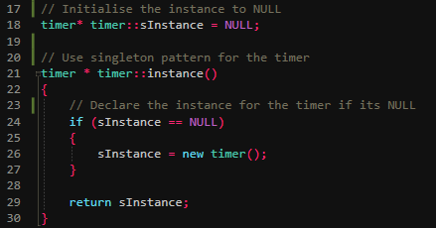
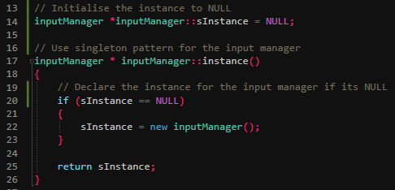
Fig.1 The examples of using the singleton pattern in the code.

Timer
The timer is the object of the class, which is in charge of keeping track of time in a computer program. There should be one instance of this object when it is used in runtime. Furthermore, it is the base for other patterns in games programming. Allowing to obtain framerate independence and to manage the time are the vast advantages of this method. Therefore, by calculation of time between frames, it is possible to run the program with the same speed on devices with various hardware specification.
The implemented timer for the purpose of the assignment is simple, and its main role is to count the time. The start of this process is possible due to SDL_GetTicks() method, which returns the number of milliseconds since the SDL library initialisation. Furthermore, arranging framerate independence is allowed by the computation of elapsed ticks and the difference between frames.
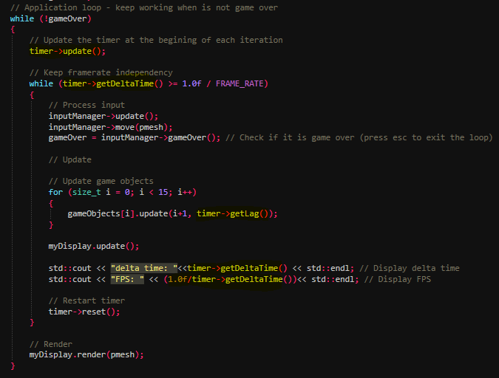
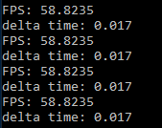
Fig.2 The example of using the timer by the main loop of the program.
Consequently, the properties of the timer are applied to the main game loop. If the delta time is equal or bigger than the time needed to generate one frame, then the update methods may be called.
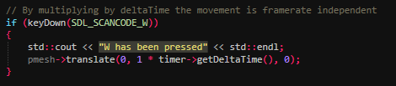
Fig.3 Delta time can be used to set framerate independence.
Delta time can also be used in other patterns. For instance, by multiplying the translate value of y by delta time, the growth in y will be constant.

Game Loop Pattern
Game loop pattern, also called the main loop, is fundamental for each game program. The idea is that the game is kept running by a continuous controlled loop until a quit is decided by a user. The structure of a game loop is:
- Process input
- Update states
- Render objects
- Repeat the above at a provided rate
The timer pattern can be used in the main loop, which results in framerates independence in the program. Namely, the elapsed time is taken into consideration by the loop to perform input, update and render methods over a specified amount of time. The program was set to display 60 frames per second.
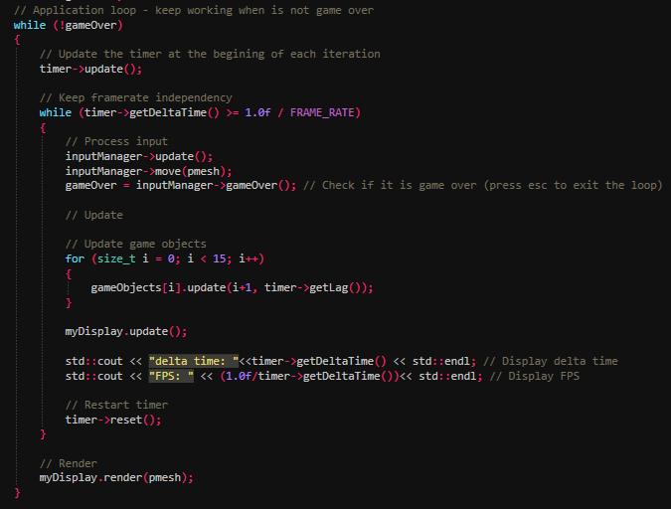
Fig.4 The main loop of the program.
The work of the coded game loop is dependent on the value in gameOver variable, which can be modified by the input of a user. Inside the loop, the timer is updated, and the delta time value checked that if it is true, the proceeding input begins. In result, the appropriate methods are updated. While all updates are done, the timer is reset, and the render functions can be called.
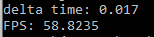
Fig.5 The program is set to display approximately 60 frames per second.
Testing the game loop was carried out by modification a mesh object during the work of the program. The mesh object has a form of a 3D cube model, and it is displayed in the application window. Nevertheless, the object can be manipulated by taking input from the user and updating its position on the screen.
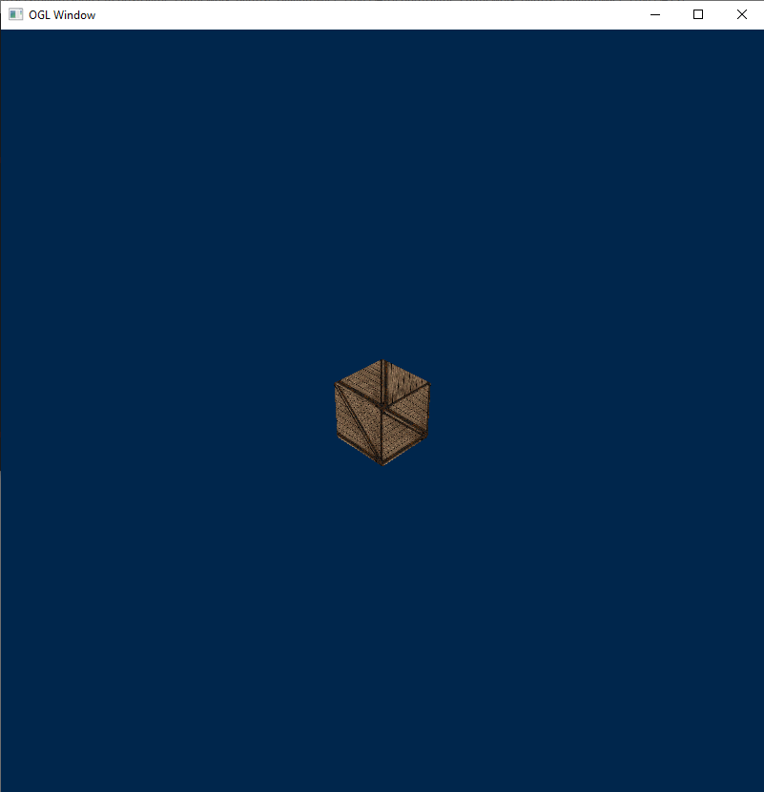
Fig.6 The example of a rendered object.
Another developed test is performed by updating multiple game objects in the game loop. The time of the update of a single object is displayed as a result of this operation.
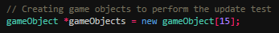
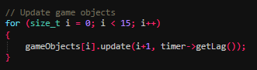
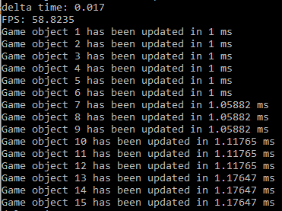
Fig.7 Creating game objects in the program and testing the time of their updates.

Command Pattern
The command pattern is designed to process requests by binding relevant actions. The example of using the command pattern is the implementation of a method which would allow for processing input from a user. Therefore, meaningful actions can be performed after pressing a button, which is assigned to the appropriate function.
Fig.8 The example of the process input implementation.
Furthermore, the simple translate() function has been added to existed mesh class to test the functionality of the object by transforming its position.
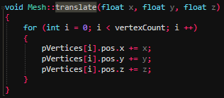
Fig.9 The translate() method is used to move a rendered object.
The command pattern approach has been incorporated into the game engine in the form of the simple input manager class, which the main task is to handle user input. This is accomplished by identifying the location of a pressed key, according to SDL scancode. Thus, the two basic methods have been programmed based on this pattern. This allows moving the object by pressing W, A, S, D keys and using ESCAPE key to stop the game loop and exit the program. Moreover, the ability to moving an object in the game engine could be a tool to test its functionality.
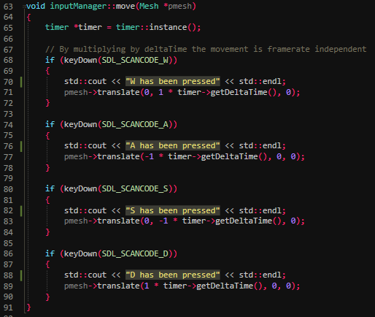
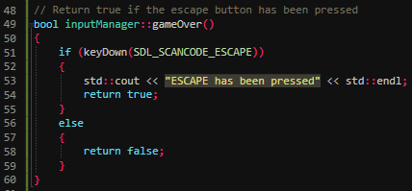
Fig.10 The input manager is responsible for reading input, which is obtained by the program to move rendered objects.
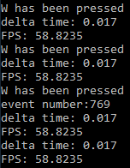
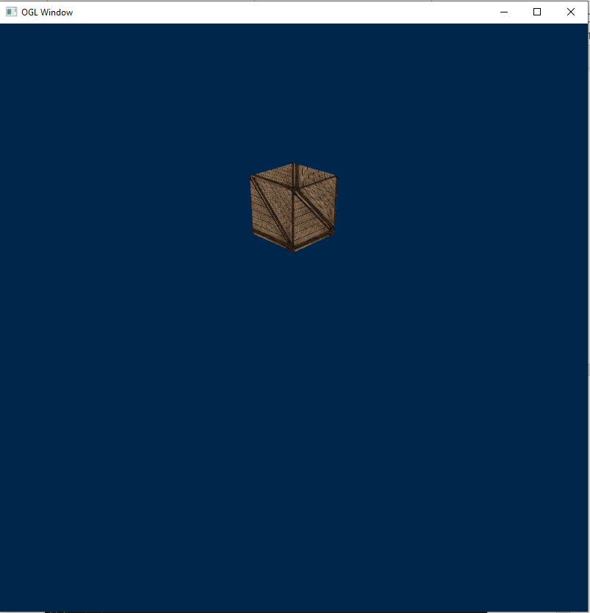
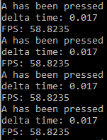
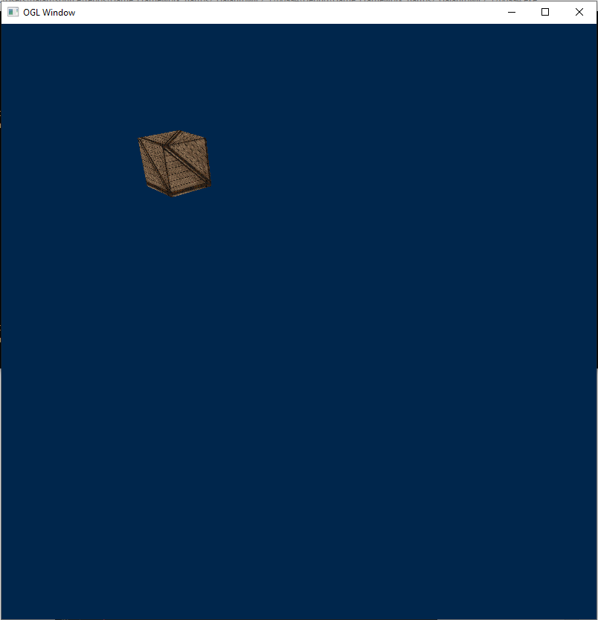
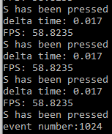
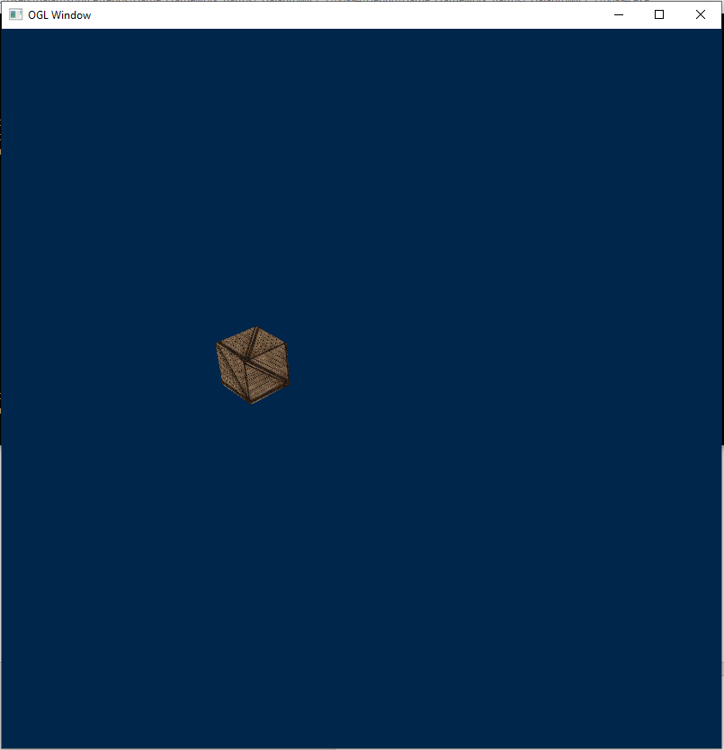
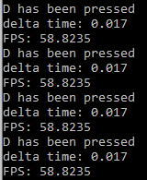
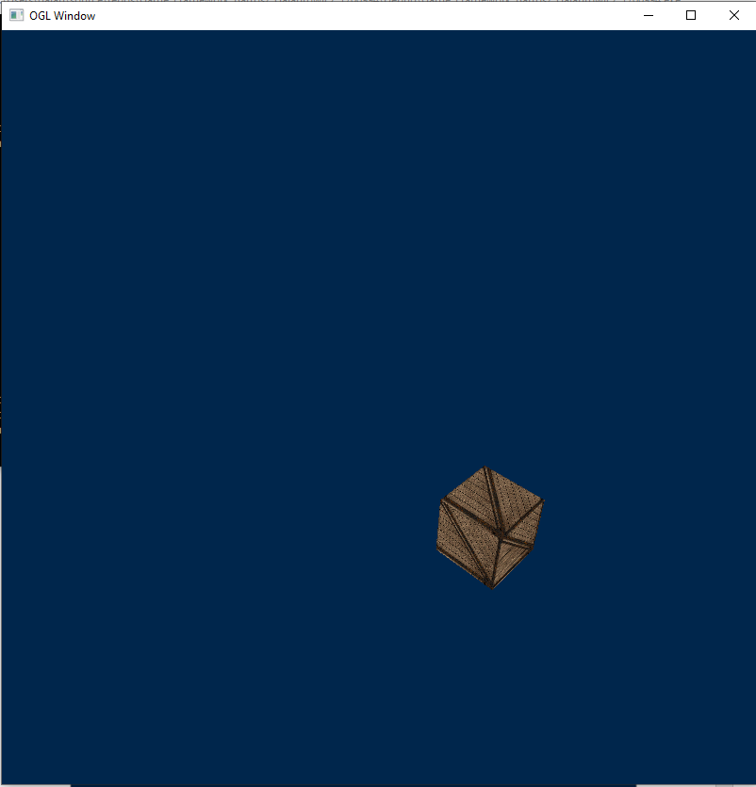
Fig.11 The examples of moving the rendered object in various directions.

Bitmap loader
It was tried to program a bitmap file loader to the application. In result, the simple texture loader was created for the mesh class. Thereby, it is allowed to initialise a mesh by providing the directory of the bitmap file.
The texture is loaded from a provided .bmp file and bind to a variable, which can be used to map the textures. Thereby, the draw function in the mesh class has been modified to drawing the textured object.
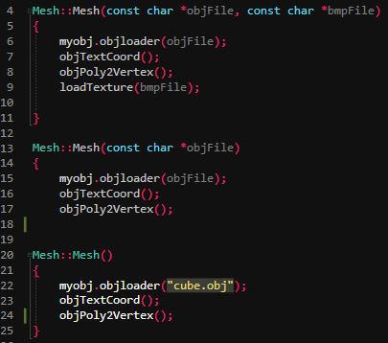
Fig.12 Various constructors have been created to allow a user to manipulate in generating meshes. The specific data can be set after providing object file data and relevant bitmap data. Also, if the argument is void type, the default object is set to "cube" object file.
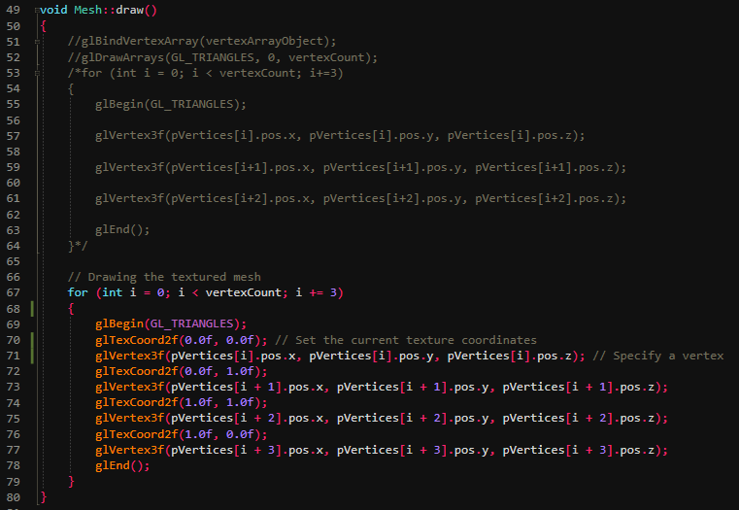
Fig.13 The example of drawing textured mesh function.

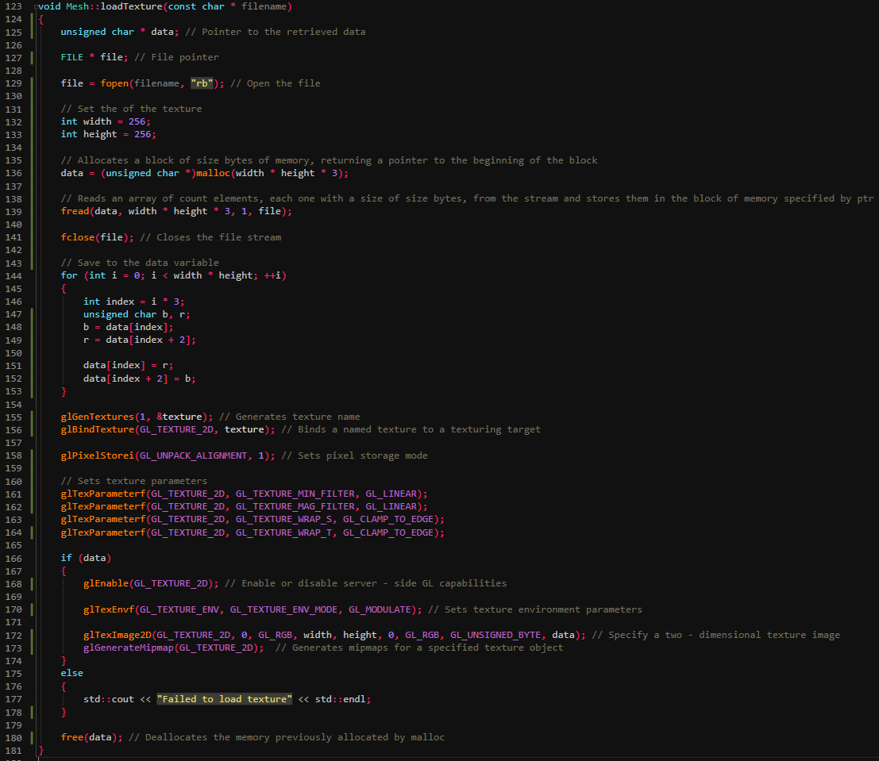
Fig.14 The designed bitmap loader allows for loading textures.
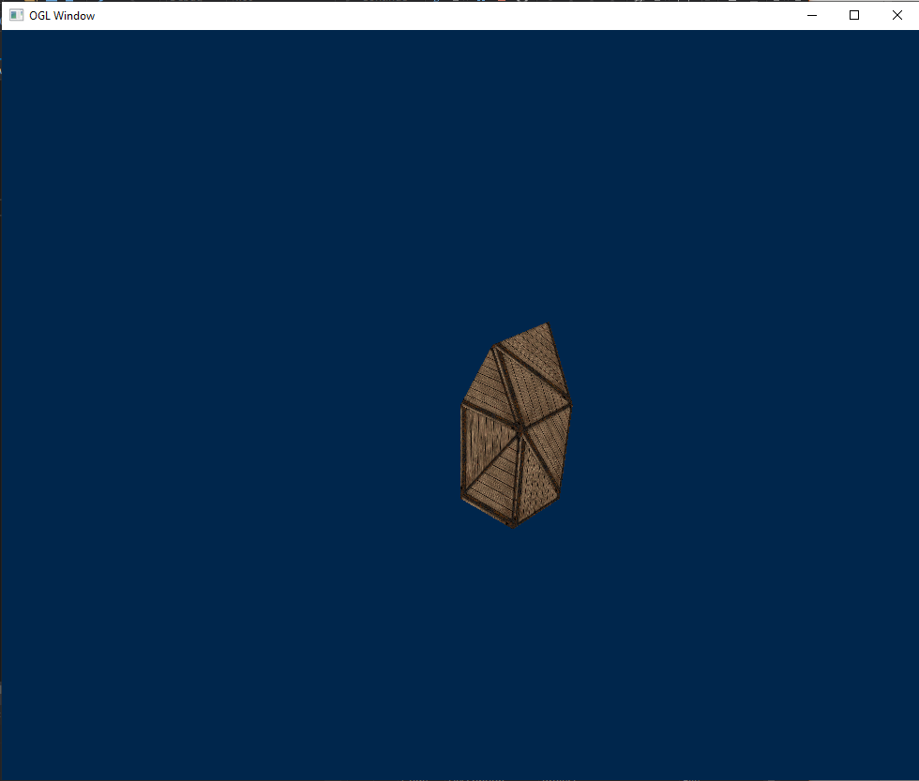
Fig.15 The example of the textured mesh object.

Adding normals and texture coordinates
Adding normals and texture coordinates have been implemented by creating specific methods in objectloader class and mesh class. Nevertheless, the object is not rendered correctly, when texture coordinates are applied to the textured mesh.
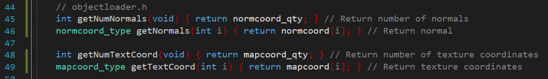
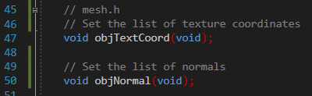
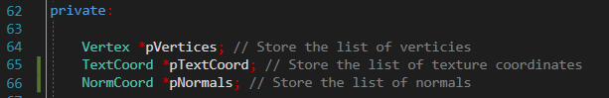
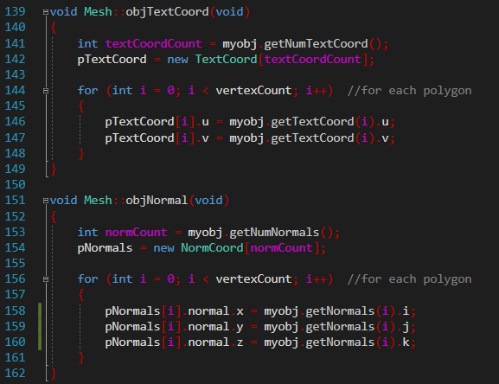
Fig.14 The initialised variables and function for storing texture coordinates and normals.
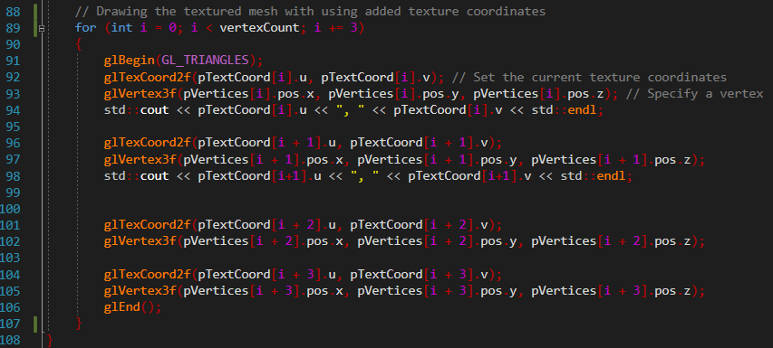
Fig.17 The example of function which renders a textured mesh involving previously added texture coordinates.

Bibliography

[1] | J. C. V. Scott Gordon, Computer Graphics Programming in OpenGL with C++, David Pallai, 2019, pp. 1-5, 27, 36-46, 68-82, 103-112.
[2] | E. Lengyel, Foundations of Game Engine Development, vol. 1, Lincoln, California: Terathon Software LLC, 2016, pp. 97-124.
[3] | R. Nystrom, Game Programming Patterns, Robert Nystrom, 2014, pp. 19-87, 123-139.
[4] | Lazy Foo' Productions, "Beginning Game Programming v2.0," [Online]. Available: Beginning Game Programming v2.0. [Accessed April 2020].
[5] | SDL, “SDL Library Documentation,” [Online]. Available: https://www.libsdl.org/release/SDL-1.2.15/docs/html/guidevideo.html. [Accessed April 2020].

Appendix

Test Cases
The test cases are presented in this section of the report as evidence of evaluation and testing the developed software.
Test Case Id:  ObjectRender |  | Test Purpose: To check if the cube and house objects can be rendered.
Environment:
Windows 10 Pro
Microsoft Visual Studio Community 2017 v.15.9.15
Preconditions: The program has been started.
Test Case Steps:
Step No | Procedure |  | Response | Pass/Fail
1 | Locate the Source.cpp and set mesh *pmesh object (Line 23) to "house.obj". |  | 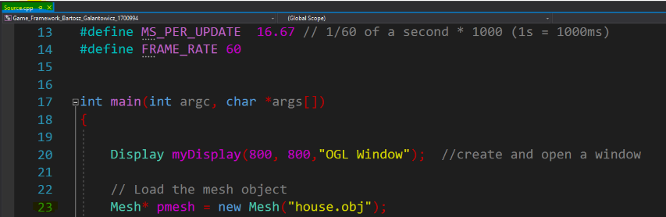  The new mesh object is going to load. | Pass
2 | Press "CTRL" + "F5" buttons to run the debug mode. |  | 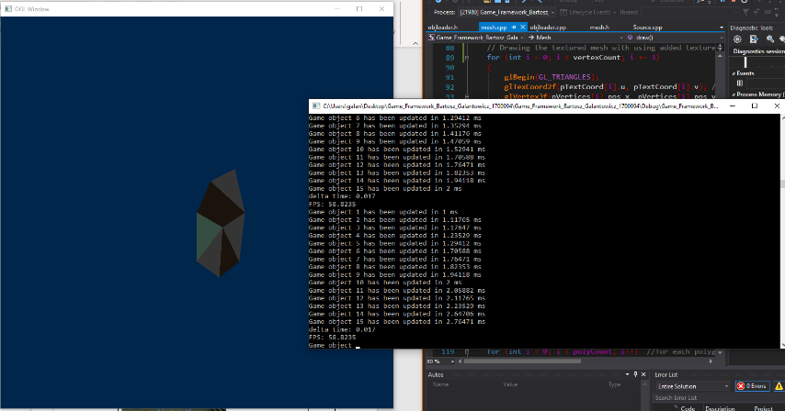  The application windows are displayed. The "house" is rendered in the OGL window. | Pass
3 | Locate the Source.cpp and set mesh *pmesh object (Line 23) to "cube.obj". |  | 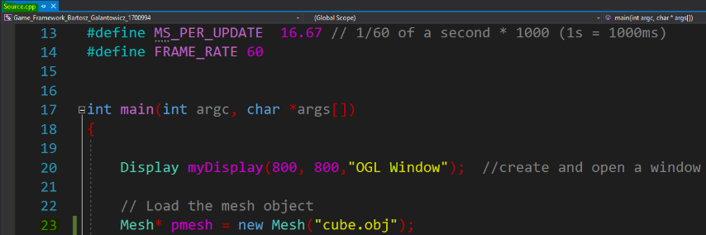  The new mesh object is going to load. | Pass
4 | Press "CTRL" + "F5" buttons to run the debug mode. |  | 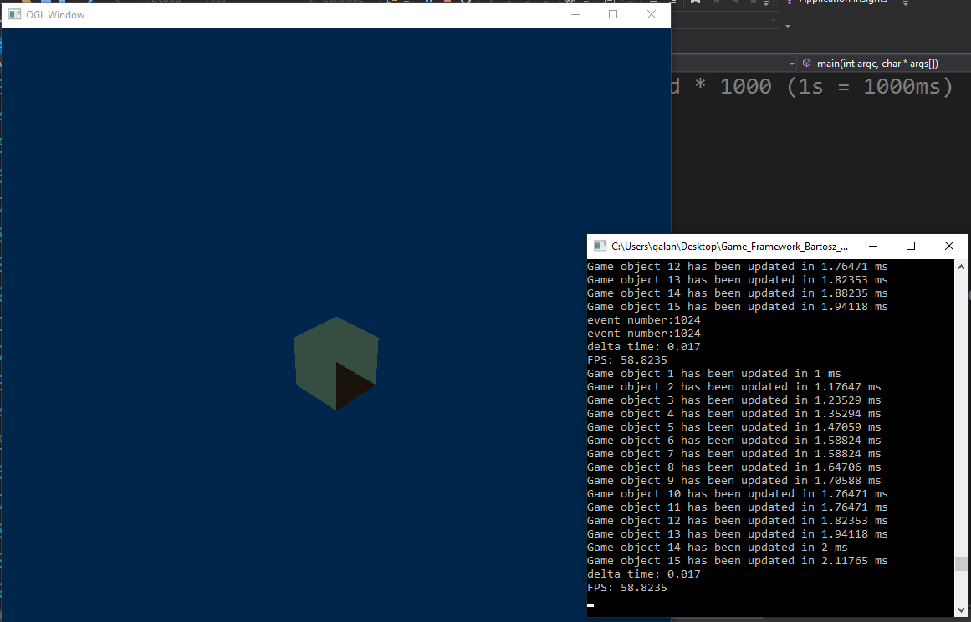  The application windows are displayed. The "cube" is rendered in the OGL window. | Pass
Comments:
All steps passed.
Author: Bartosz Galantowicz

Test Case Id:  ObjectTranslation |  | Test Purpose: To check if the rendered object can be moved.
Environment:
Windows 10 Pro
Microsoft Visual Studio Community 2017 v.15.9.15
Preconditions: The program has been started.
Test Case Steps:
Step No | Procedure |  | Response | Pass/Fail
1 | Press "CTRL" + "F5" buttons to run the debug mode. |  | The application windows are displayed. The "house" is rendered in the OGL window. | Pass
2 | Move the object up by pressing "w" on the keyboard |  | 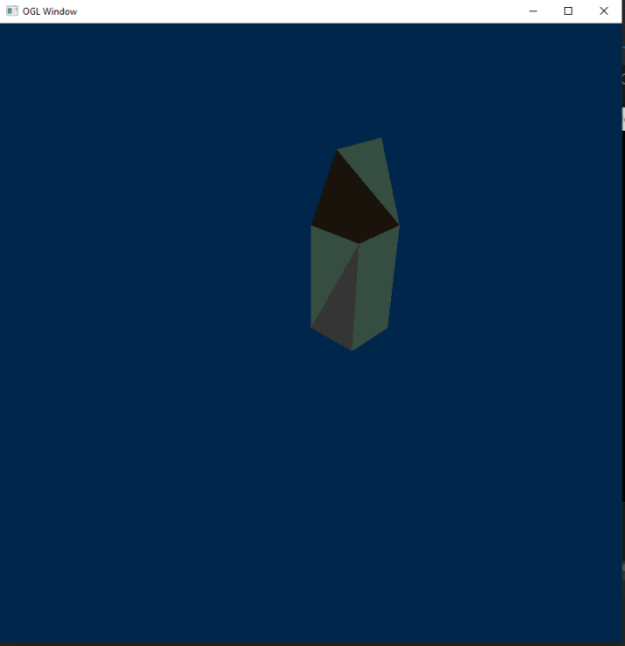  The object is moving up while "w" button is pressed. | Pass
3 | Move the object left by pressing "a" on the keyboard |  | 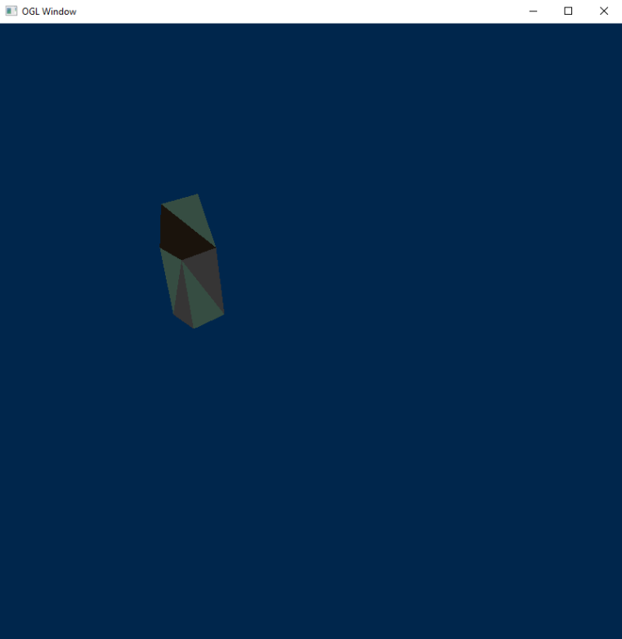  The object is moving left while "a" button is pressed. | Pass
4 | Move the object down by pressing "s" on the keyboard |  | 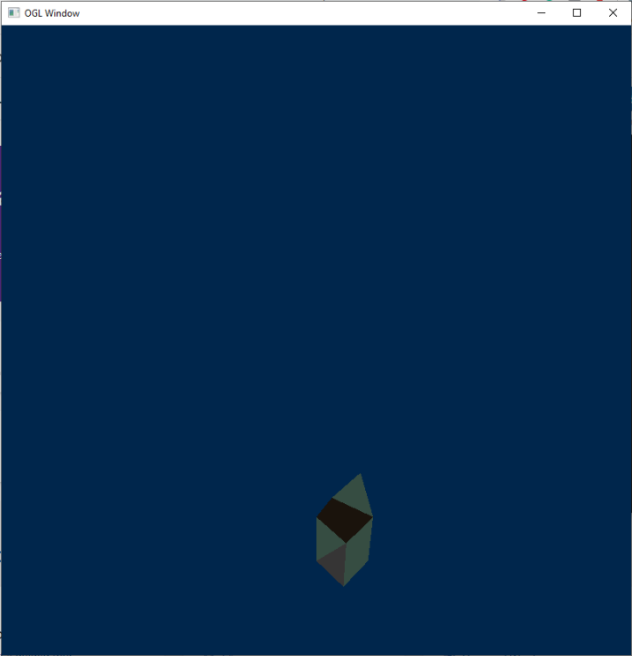  The object is moving down while "s" button is pressed. | Pass
 | Move the object right by pressing "d" on the keyboard |  | 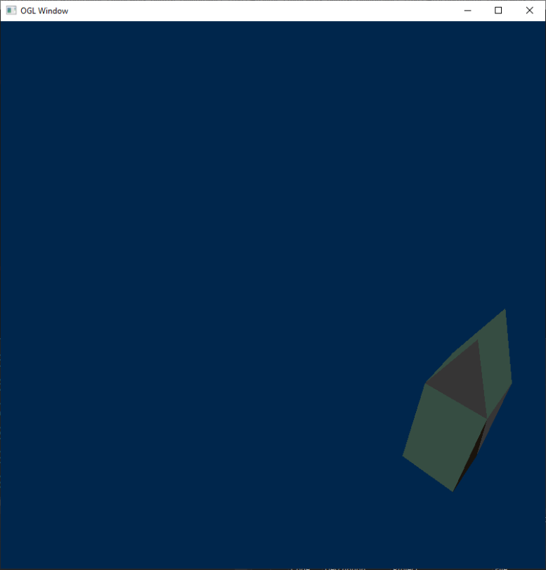  The object is moving right while "d" button is pressed. | Pass
Comments:
All steps passed.
Author: Bartosz Galantowicz

Test Case Id:  TextureLoader |  | Test Purpose: To check if various bitmaps can be load as textures.
Environment:
Windows 10 Pro
Microsoft Visual Studio Community 2017 v.15.9.15
Preconditions: The program has been started.
Test Case Steps:
Step No | Procedure |  | Response | Pass/Fail
1 | Locate the Source.cpp and set the argument of the loadTexture function (Line 24) to "test.bmp". |  | 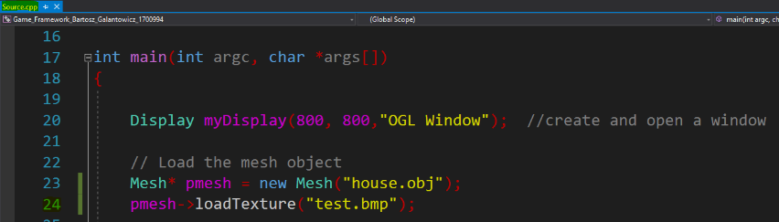  The new texture is going to load. | Pass
2 | Press "CTRL" + "F5" buttons to run the debug mode. |  | 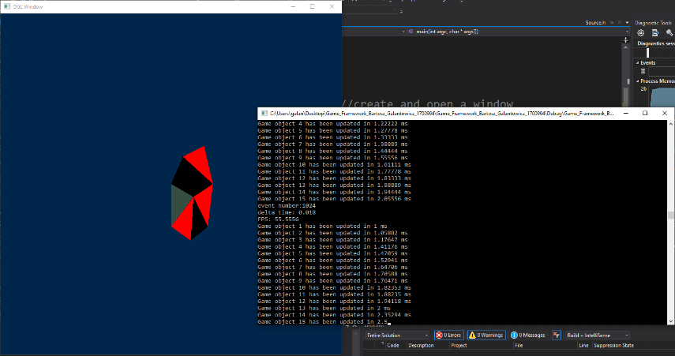  The application windows are displayed. The "house" is rendered in the OGL window. | Pass
3 | Check if the textures have been loaded properly. |  | 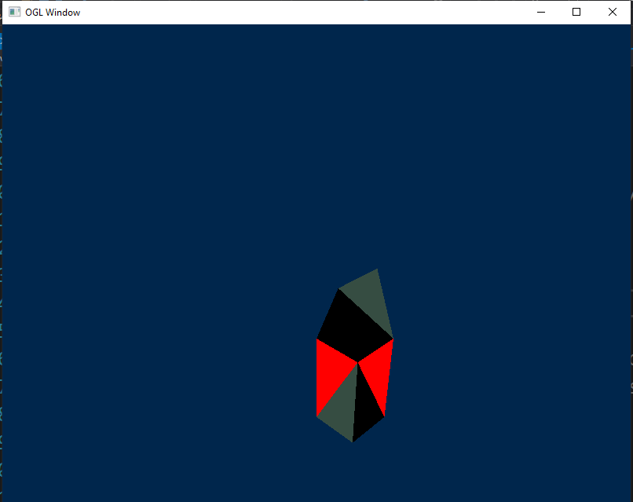  The textures have been loaded. Nevertheless, they were not loaded properly. | Fail
4 | Locate the Source.cpp and set the argument of the loadTexture function (Line 24) to "test.bmp". |  | 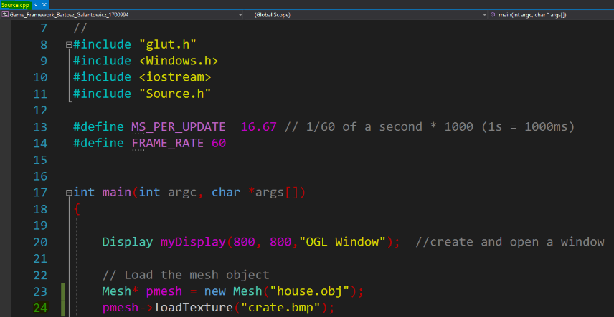  The new texture is going to load. | Pass
5 | Press "CTRL" + "F5" buttons to run the debug mode. |  | The application windows are displayed. The "house" is rendered in the OGL window. | Pass
6 | Check if the textures have been loaded properly. |  | 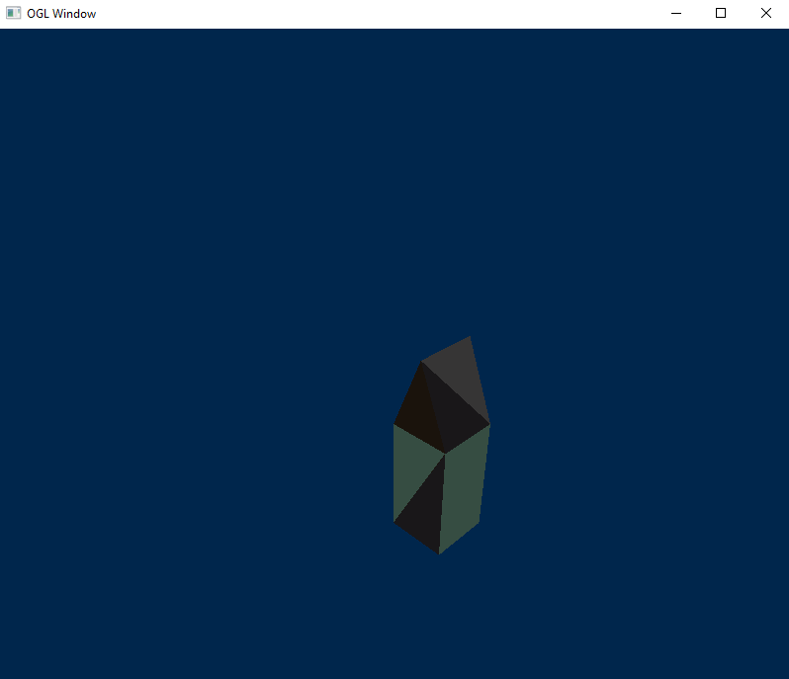  The textures have been loaded. Nevertheless, they were not loaded properly. | Fail
Comments:
Steps 1, 2, 4 and 5 have been passed.
Steps 3 and 6 have failed – the textures were not loaded properly.
Author: Bartosz Galantowicz

