Tutorial exercises and associated cases Answers
Exercise one
Read the case below
An own goal
The taxi arrived at the impressive mansion in Faqra and I made my way through the blistering sun towards the entrance. I was met by two servants and directed to Mr Haider's room. He had faxed me a contract, the terms of which were ridiculously low, and I was determined to get a better deal for my client.
A peek at my watch revealed it was 11.30. I'd arrived just in time, despite the flight delays at Frankfurt and the queues at Beirut airport. In front of Haider's door I cleared my throat, tightened my tie, gathered all my courage and entered the room. 'Mr Haider, I am delighted to meet you', I said, rather too exuberantly. `Ahlan Wilhelm, welcome my friend', said Haider. 'I just have to say goodbye to my important visitors. Please make yourself at home while you're waiting.'
A servant led me to a large room where there were two men and, in the far corner, a beautiful oriental woman. I sat down in a chair and waited for Mr Haider. An elaborate clock chimed twelve, but there was still no sign of him. By now the other three were thoroughly enjoying their lunch, which I had refused out of politeness. To keep my nerves steady I had only accepted a glass of arak. By 12.15 my patience had started to desert me. I was going to be too late for my next meeting. How could I trust Mr Haider if he had already broken his promise beforehand?
Eventually, at 12.30, Mr Haider entered the room. He looked extremely relaxed in his traditional dress and I jumped up to greet him. Before approaching me he first kissed both men and had a brief conversation with the woman. I had prepared myself well for this moment. I gave him a firm handshake and seated myself.
'Ahlan Wilhelm, welcome to Lebanon', he said. Looking at the table, he added: 'I hope you enjoyed your delicious lunch with my beloved sons, Alain and Elie, and of course with my habibi, Charlotte.'
'Mr Haider°, I replied, 'Thank you for your warm reception, but I ate on the plane. My client is extremely pleased about your interest and he is looking forward to playing for such an illustrious club as Al Ansar. Shall we come to terms as quickly as possible so we can finalise this matter in the best interest of both parties?'
'Shod Wilhelm', he retorted. 'Please call me Hashem. But why the rush? We have the time for business until the sun walks out on us! When will your client arrive?'
I told him that my client, a goalkeeper who had played for German, Italian and British teams, as well as for his home country, Denmark, would be unable to attend the negotiations. 'The thing is ...' (I hesitated: how could I call him by his first name and show my total respect?) 'It's usual for a player to leave such dealings to his agent.'
Mr Haider seemed disgruntled, but agreed to talk. He called his two sons over while his wife quietly headed for the door. As she passed by I respectfully looked her in the eye and wished her a pleasant day.
The bargaining process began and, quite disconcertingly, Mr Haider's sons joined in. Was he hoping to get the upper hand through force of numbers? Could I trust his sons to honour the confidentiality aspect of the
Answer the questions below based on the case you have just read
- What is the significance of the title of this case?
- How would you define the problem from your perspective?
- What do you think has caused the so-called stalemate? Refer to the culture values outlined in the lecture that have had an impact on the way the agent handled his encounter with Mr.Haider. Mention in particular:
- Time focus;
- Time Orientation;
- Space;
- Power;
- Structure;
- Communication;
- Action;
- Competition.
- How do you think Wilhelm can rescue the deal?
- How can Wilhelm best prepare for any future negotiations in the Middle East on behalf of his football clients?

Exercise two
Developing your cross-cultural effectiveness
The concepts presented in Part One have allowed a framework of reflection and knowledge to be developed about national cultures and businesses cultures. It has also shown how close the relations are between culture and management. Such insights are essential for working and succeeding in an environment different to one's own. However, it is not enough to learn the different styles of doing business inherent to certain culture(s). International managers or professionals also need to develop personal capabilities, particularly cultural analysis skills which will enable them to operate effectively in a variety of cultural contexts.
The aim of this activity is to help you to develop your cross-cultural effectiveness by enabling you to:
- gain insight into your own culture by defining your own management/professional style with respect to the eight cultural variables as represented in Figure 6.3: A model of culture.
- develop understanding of the national and business culture of another society/country by determining its preferences in terms of the same Figure 6.3.
- determine how you need to adapt your professional skills to the culture and working style of this other society or country.

Figure 6.3 Model of culture
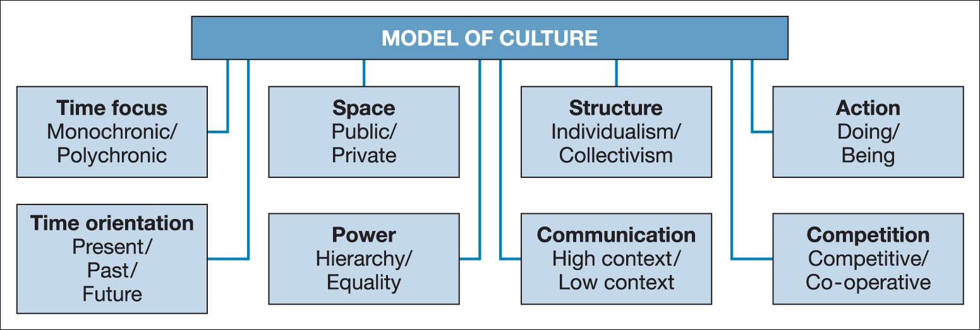
Task 1: developing your self-awareness
Identify your own cultural values by making a cultural profile of yourself.
1. Refer to Figure 6.3
2. Make your own cultural profile in Figure 6.5 by giving a score for each of the eight cultural parameters concerned. Enter a score in Table 6.9 against each parameter that reflects your own value on a range of 1 to 5.
Table 6.9 Make your own profile
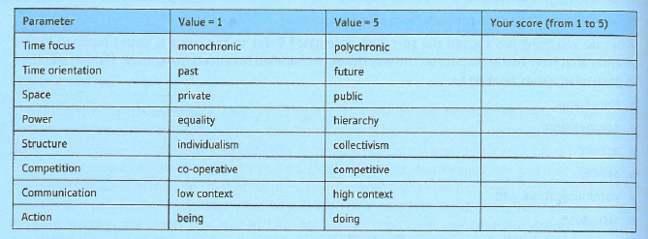

These values can be plotted on a 'Step-one profile' diagram (Figure 6.5).
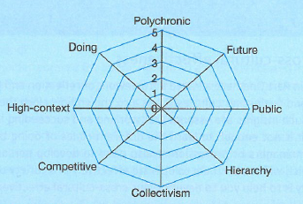
Task 2: developing cross-cultural understanding
Now you are asked to make a comparison of the differences between your own culture and another culture. This will involve preparing a profile of the culture in question.
- Choose a country where you know some of its inhabitants and/or where you intend to do business. Try to work out how you perceive the culture of this country.
- Make up the cultural profile of the country you have chosen in the same way as you did when preparing your own profile: giving a score for the eight cultural parameters in the same cultural profile document (Figure 6.5). Examples of completed cultural profiles are given below in Table 6.10 and Figure 6.6. Table 6.10 Example: your cultural profile score and that of chosen country Figure 6.6 Step two profile: own and chosen country
- Compare your own cultural profile with your chosen country’s cultural profile you have just completed and determine the difference and similarities in the parameters.
- Define what you believe are the critical issues when representatives of the two cultures profiled work together?
Table 6.10 & Figure 6.6


