Poppy Morrissey (2501786)

Deborah Jenkins
28/11/2025
Word Count: 1626
report reviewing a tourism destination that hosts a tourism event
Tourism, Events and Leisure Industry

Contents
AI Statement 2
Introduction 3
Destination and Event Overview 3
Impact of the Event 4
Short-Term Impacts 4
Long-term impacts 5
Visitor Typologies & Experiences 5
Contemporary Trends & Challenges 6
Conclusion & recommendations 6
References 7
Appendices 9
Figure 1 10
Figure 2 10
Figure 3 10

AI Statement
I confirm that I have not used any AI tools in the research and creation of this assignment. I confirm that I have not presented any AI generated materials as my own work. I confirm I have copies of my drafts, notes, and other resources I used, which I may be asked to provide in evidence.

Introduction
The purpose of this report is to critically review a UK tourism destination that hosts a recurring event, with a particular focus on Ironman Wales in Tenby, Pembrokeshire. The report will examine how Ironman Wales is influenced by and contributes to overtourism. The analysis explores short and long-term impacts on overtourism in Tenby, considering economic, social, cultural, environmental, and political impacts. It also focus’ on transport accessibility, destination event management, visitor profiles, and motivations, applying relevant visitor typologies and behavioural theories. Finally, the report provides recommendations for stakeholders, including local authorities, event organisers, businesses, communities, and visitors, to ensure that Ironman Wales and Tenby remain sustainable, competitive, and relevant in the future.

Destination and Event Overview
Ironman Wales is a triathlon which takes place once every year. The triathlon starts with a 2.4 mile sea swim along Tenby’s North beach and then a 112 mile bike ride up and down hills around the Pembrokeshire Coast and then finally a 26.2 mile run around Tenby town (British Triathlon, 2025). Iron Man Wales is known for the supportive atmosphere from spectators and the community (Ironman Group,2025a). The event is part of the global Ironman brand, which has expanded significantly over the past 34 years and now hosts races across the world. Ironman has expanded with IronKids for children to compete. Ironman Wales is described as the most demanding races in the world due to its challenging terrain and because of the intense levels of crowd support that plays a crucial role in motivating athletes to complete the course (Visit Wales, 2025).
Tenby is a picturesque town with beautifully coloured buildings, medieval walls, and sandy beaches. The small coastal town has a population of 3,546 residents (Nextdoor, 2025). During Ironman, Tenby hosts over 2,700 athletes alongside thousands of spectators, significantly increasing the number of people within the town which creates pressures on the local council and communities which are commonly associated with overtourism (Hart, 2022).
Tenby contains narrow streets, and its medieval architecture presents challenges for individuals with mobility issues. Many buildings are historic and therefore, not originally designed for modern accessibility standards. However, the council has introduced improvements, including ramps, dropped kerbs, and more accessible parking spaces, to enhance accessibility throughout the town (Around Tenby, 2025). In addition, Ironman has introduced a new Open Division including athletes with intellectual disabilities, providing a welcoming and inclusive environment for participants who wish to take part without competing in a traditional competitive race (Ironman Group,2023).
According to the Tenby Visitor Guide (2025) the town’s economy is reliant on tourism, particularly small businesses, which enhances Tenby’s overall appeal as a visitor destination. Ironman Wales increases visitor numbers during the event weekend and throughout the year as athletes travel to Tenby to train, generating business and revenue during the off-season months (Barnes, 2025).

Impact of the Event
Ironman Wales generates significant economic, social, environmental, and political impacts on Tenby, many of which intensify issues commonly associated with overtourism. As part of its host agreement with the Pembrokeshire Coast National Park Authority, Ironman aims to meet sustainable event standards and act as an example of good practice in delivering a large-scale sporting event (Pembrokeshire Coast National Park Authority, 2021). There are both short-term and long-term, positive and negative impacts for Tenby which are caused by overtourism.

Short-Term Impacts
The most immediate impacts relate to disruption for local residents and businesses. Road closures, diversions, parking restrictions, and limited access into Tenby create challenges for staff and customers who are unable to travel or cross key roads (Evans, 2022). During the event, access into Tenby is restricted from 7:30am-10:45am, and major car parks such as North Beach remain closed from Sunday morning until early Monday (Birt, 2025). These issues are intensified by Tenby’s narrow streets and limited transport infrastructure. Local businesses have expressed concerns about the scale of disruption, and nearly 100 businesses have signed petitions calling for the event to be moved to an earlier date in the year. Many have also criticised the lack of consultation from local councils regarding event planning and communication (Evans, 2023). These tensions highlight the growing political pressure caused by the event. Economically, the event increases employment opportunities, as many local residents work overtime and businesses such as cafés and shops extend their opening hours to accommodate the influx of visitors. The Pembrokeshire Coast National Park Authority estimates that Ironman Wales contributes over £3.5 million to the local economy during the event weekend (Herald Sport, 2025).
TALC is Butler’s Tourism Area Life Cycle which showcases 6 different stages of a destination including exploration, involvement, development, consolidation, stagnation and either decline or rejuvenation states Stainton, 2022. TALC is seen during the later stages in development, where tourism is economic significant and heavily marketed. This is seen during Ironman Wales as Tenby is recognised more significantly. The economic boost from Ironman allows Tenby to develop and expand on their products and services the town offers (Gomez et al., 2008).
Also, Doxeys Irritation Index is a theory used in tourism, the different levels of the theory can be found in Figure 3 in the appendices. Doxey’s Irritation Index applies to this destination and event during Apathy. This is where the athletes and spectators are seen as a source of income through economic boost (Stainton, 2022).

Long-term impacts
Ironman Wales brings a stronger destination reputation for Tenby. The event is held during a time where there is constantly different weather and jellyfish, for other races this maybe off-putting but for Ironman Wales it adds to the challenge. This means more athletes are encouraged to go to Tenby to compete and train. Tenby is known as the ‘unicorn host’ states Hemming, 2025. Tenby is a beautiful scenic seaside town with culture and some lovely businesses. When Tenby comes together for the event it shows a sense of community which entices people to go again. This creates repeat customers and generates more economy. Ironman Wales has raised concerns for the environment in Tenby. Previously, the Ironman event has been associated with sewage pollution alerts causing harm to marine life. It has been discussed that the event needs to have more sustainable practices (Sinclair, 2025). The event is known to cause disruption to coastal paths affecting the enjoyment of certain walking paths (Evans, 2024). Stagnation in TALC is seen in Tenby with the environmental issues Ironman causes. This has previously been mentioned in the long-term impacts Ironman has on Tenby (Gomez et al., 2008).

Visitor Typologies & Experiences
Visitor motivation for visiting Tenby can be understood through Maslow’s Hierarchy of Needs. The theory states that humans must be satisfied with lower-level needs before reaching higher-level needs (JC Pass, 2024). The needs from lowest to highest are physiological, safety, love and belonging, esteem, and self-actualisation (McLeod, 2025) (See Appendix 1). Tenby meets visitor motivations by providing basic requirements like food outlets and accommodation. In general, Tenby is a safe area, which also encourages athletes to participate in the race.
Ironman’s atmosphere and strong sense of community contribute to meeting the need for love and belonging, as athletes and spectators form friendships and companionships throughout the event. When athletes complete the race, they are congratulated and recognised for their achievement with a medal, fulfilling esteem needs. Furthermore, this sense of accomplishment contributes to self-actualisation, as athletes realise their personal potential.
From the start to finish athletes are supported through the process of registering for the race and on the race day. The visitor experience of the athlete starts when they choose their event, create an account and complete their registration form (ir3anrwwe3, 2024). Ironman Wales also provide a map for athletes to learn and train for shown in the appendices as figure 2. On the day of the race athletes check in, check their bikes in and go through mandatory briefings (Ironman Goup,2024).

Contemporary Trends & Challenges
A contemporary trend and challenge Tenby faces is overtourism. Overtourism has an effect on the quality of life for locals and the tourist’s experience. Overtourism creates environmental impacts on Tenby as mentioned previously. This leads to a growing demand in sustainable tourism practices (Alsharif et al., 2025).
Ironman Wales has an impact on road closures throughout Tenby and nearby areas. These road closures are either full or partially closed. (Ironman Group,2025c). These road closures are for the safety of athletes, spectators and road users. Ironman provides maps and letters showing and explaining road closures and times of day they are occurring. Ironman Wales offers a Park and Ride shuttle bus service for athletes and spectators during race days, operating from Carew Airfield Business Park running a circular route between Carew and Tenby many times throughout the day (Care Airfield, no date). This is due to the amount of tourists Ironman Wales brings in, in this case it isn’t sustainable for Tenby or locals. These trends occur leading up and during the race.

Conclusion & recommendations
In conclusion, Ironman Wales has many positive and negative impacts on Tenby and the surrounding areas. These impacts reflect on the economic activities, local businesses, environmental and political pressure. The event has a significant atmosphere creating a sense of community, the Ironman event extends the tourism season for Tenby. However, the event provides challenges which are linked to overtourism. There are road closures and limited access for residents which creates short-term disruption and then environmental issues like sewage pollution concerns.
To ensure that Ironman Wales remains sustainable, several recommendations are necessary. Local authorities and event organisers should improve communication with residents and businesses by providing earlier and clearer information about road closures and event planning. Sustainability measures also need to be improved to reduce environmental impacts, especially along the coastline. Businesses should continue adapting to increased demand and work with organisers to spread visitation throughout the year. Finally, visitors could use park-and-ride services and follow local guidelines to minimise pressure on the town.

References
Alsharif, A., Isa, S.M., Salleh, N.M., Aziz, N. and Murad, S.M. (2025) ‘Exploring the Nexus of Over-Tourism: Causes, Consequences, and Mitigation Strategies’, Journal of Tourism and Services, 16(30), pp.99–142. doi:https://doi.org/10.29036/fx6nef49.
Around Tenby (2025) A Guide for Individuals with Unique Needs. Available at; Accessibility in Tenby: A Guide for Individuals with Unique Needs - Around Tenby (Accessed: 25 November 2025)
Barnes, J. (2025). ‘Ironman Wales returns to Tenby with 2,700 competitors’, Western Telegraph, 31st August. Available at: https://www.westerntelegraph.co.uk/news/25422738.ironman-wales-returns-tenby-2-700-competitors/ (Accessed: 12 November 2025)
Birt, E. (2025). ‘IRONMAN Wales road closures and parking restrictions’, Western Telegraph, 18th September. Available at: https://www.westerntelegraph.co.uk/news/25474584.ironman-wales-road-closures-parking-restrictions/ (Accessed: 27 November 2025)
British Triathlon (2015) Ironman Wales. Available at: IRONMAN Wales – British Triathlon (Accessed: 12 November 2025)
Carew Airfield (no date) IRONMAN Park and Ride. Available at: Carew Airfield - IRONMAN PARK & RIDE (Accessed: 4 November 2025)
Evans, P. (2023). ‘Ironman ‘positives outweigh negatives’ - state Tenby councillors’, The Tenby Observer, 21st September. Available at: https://www.tenby-today.co.uk/news/ironman-positives-outweigh-negatives-state-tenby-councillors-639339.
Evans. P (2022) ‘Ironman debate continues - “businesses are uneasy and there is unrest” - states Tenby Councillor’, The Tenby Observer, 16th October. Available at: Ironman debate continues - “businesses are uneasy and there is unrest” - states Tenby Councillor | Tenby Observer (Accessed: 20 November 2025)
Evans, P (2024) Have your say on the impact of Ironman Wales. Available at: Have your say on the impact of Ironman Wales | tenby-today.co.uk (Accessed: 11 November 2025)
Hart, A. (2022). ‘Tenby, the Welsh town transformed by a decade of Ironman’, Wales Online, 10th September. Available at: https://www.walesonline.co.uk/whats-on/whats-on-news/tenby-welsh-town-transformed-decade-24978645 (Accessed:12 November 2025)
Heming, T. (2025). Tenby’s legacy: Why Ironman Wales stands alone. Available at: https://www.220triathlon.com/blog/why-ironman-wales-is-so-unique (Accessed: 13 November 2025).
Ir3anrwwe3 (2024) The Ultimate Guide to Ironman Registration. Available at: The Ultimate Guide to IRONMAN Registration (Accessed: 11 November 2025)
Ironman Group (2023) IRONMAN Announces Creation Of New And Modified Athlete Divisions And Further Rule Alignment With World Triathlon As Part Of Updated 2023 Global Competition Rules. Available at: IRONMAN Announces Creation Of New And Modified Athlete Divisions And Further Rule Alignment With World Triathlon As Part Of Updated 2023 Global Competition Rules | IRONMAN (Accessed: 10 November 2025)
Ironman Group (2025a) Ironman Wales. Available at: IRONMAN Wales | IRONMAN (Accessed: 12 November 2025)
Ironman Group (2025b) Series Partners. Available at: https://www.ironman.com/about/series-partners (Accessed:12 November 2025)
Ironman Group (2025c) Traffic Impact. Available at: Traffic Impact | IRONMAN Wales (Accessed: 11 November 2025)
Ironman Group (2024) Complete Guide to Ironman Race Week: Navigate Athlete Check-in, Transition, and More. Available at: Complete Guide to IRONMAN Race Week: Navigate Athlete Check-in, Transition, and More | IRONMAN (Accessed: 4 December 2025)
Lozano, J., Gómez, C. M. and Rey-Maquieira, J. (2008) ‘The TALC Hypothesis and Economic Growth Theory’, Tourism Economics, 14(4), 727-749. Available at: https://doi.org/10.5367/000000008786440166
McLeod, S. (2025). Maslow’s Hierarchy of Needs. Available at: https://www.researchgate.net/publication/383241976_Maslow. (Accessed: 03 December 2025)
Nextdoor (2025) Tenby, Tenby Community. Available at: Tenby, Tenby Community | Everything You Need to Know (Accessed: 24 November 2025)
Pass, J.C (2024) Maslow's Hierarchy of Needs: An Overview. Available at: Maslow's Hierarchy of Needs: An Overview — Simply Put Psych (Accessed: 20 November 2025)
Sinclair, T (2025) Sewage warning issued as Ironman Wales swim goes ahead in Tenby. Available at: Sewage warning issued as Ironman Wales swim goes ahead in Tenby – The Pembrokeshire Herald (Accessed: 1 December 2025)
Stainton, H. (2022) What is Doxeys Irritation Index and How Does It Work? Available at: What Is Doxey's Irritation Index And How Does It Work? - Tourism Teacher (Accessed: 5 December 2025)
Tenby Visitor Guide (2025) Places to Stay, Eat, Drink and Enjoy in Tenby. Available at:
Tenby Visitor Guide | Places to Stay, Eat, Drink and Enjoy (Accessed: 25 November 2025)
Visit Wales (2025) Swim, Bike and Run in Ironman Wales. Available at: https://www.visitwales.com/things-do/events/sport/ironman-wales#:~:text=IRONMAN%20Wales%2C%20Tenby,IRONMAN%20events%20in%20the%20world (Accessed: 12 November 2025)

Appendices

Figure 1
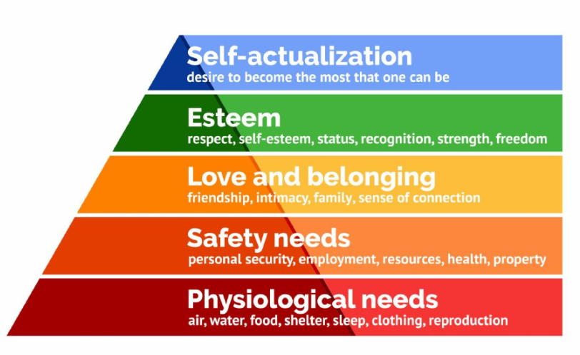
Figure 1 shows the different levels of Maslows Heirarchy of needs.

Figure 2
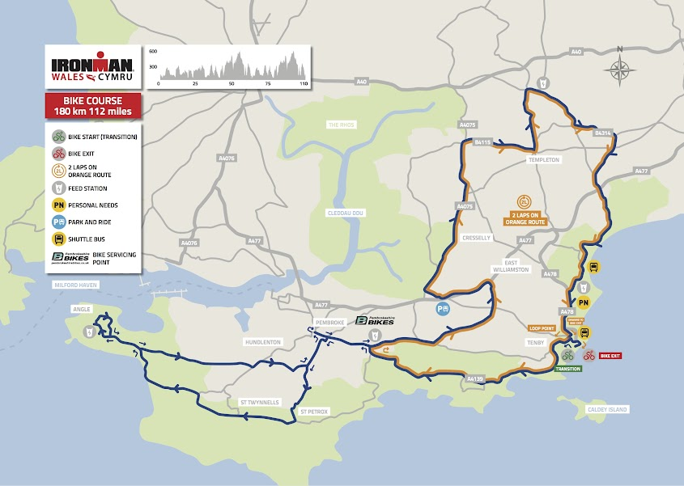
Figure 2 shows the map that is provided for athletes and spectators for training, viewing and course references.

Figure 3
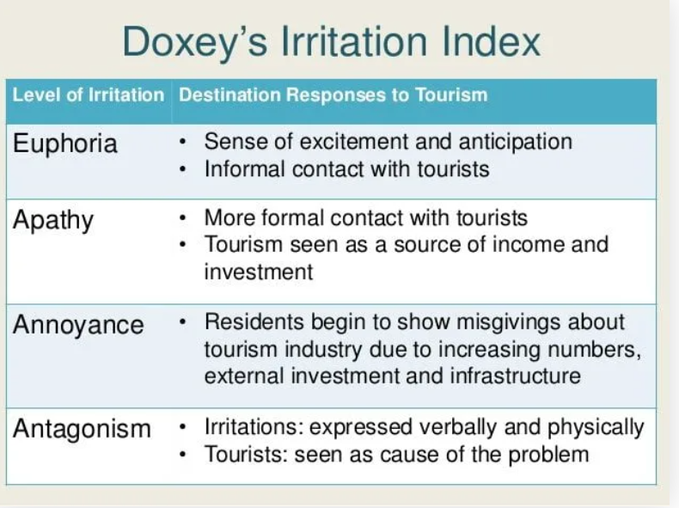
Figure 3 shows the levels of Doxeys Urritation Index.

