Table of contents

- A brief introduction to the history of the area 2
- Topographic mapping of the area for development 4
- Historical mapping 5
- Geographic maps of the area 6
- Local bore hole test results and their positions 7
- Suggested contents for site investigation 10
- Relevant building regulations/codes of practice and relevant local authorities 12
- Detail of proposed foundations for the building 13
- Referencing 14

Introduction
The City and Council have chosen to enter into a joint agreement with Marriot Hotels to create a new restaurant and ice-cream parlour (with manager’s apartment) on Swansea foreshore. The site is located between County Hall and the Marriot Hotel. The building which is to share parts of the carparks belonging to both adjacent facilities is to have a gross internal area at ground floor level of approximately 300 square meters.
The building is to contain the restaurant, café bar, ice-cream parlour, kitchen, food-stores etc. At second floor level, there is to be a self-contained managers apartment and staff welfare facilities. This project is procured via a design and build contract.
The goal of this assignment is to look at the history of the local area and relevant past testing that has taken place to piece together a preliminary study in preparation for a full site investigation as part of the feasibility stage of the project.

A brief history of the surrounding area.

For the most of Swansea’s history it was a small port town with its main industries being that of leather and wool production. It was not until the area began exporting coal in the 16th century that Swansea really began to grow and industries such as ship building began to take a hold.
This expansion continued through the 17th century when they began to export iron which was being mined in the area as well.
During the late 18th century, they began to smelt copper and a lead works opened leading Swansea into becoming a centre point for the metal working industry towards the turn of the century. By this time large quantities of copper, lead and zinc where all exported through the port of Swansea.
During the 19th century the port and surrounding town once again saw rapid growth and boom in trade due to the construction of Swansea canal, this canal meant that the transportation of vast quantities of raw materials to and from the port was easier and quicker than ever allowing the local industries to flourish like never before.
Between the late 19th and early 20th centuries 5 new docks had opened up in order to meet the ever-increasing demands from the tin plate, copper and steel industries. These industries however almost vanished entirely at the end of world war 2 as demand for these industries dwindled. This sudden loss of industry in the area led to the cities council having to diversify opening new industrial estates in the area.
During the second world war Swansea suffered devastating damage due to bombing runs carried out by German forces in an attempt to cut the British supply chain. These bombings included a particularly nasty stint which became known as the 3-day blitz, this blitz levelled much of the city centre and the immediate area to the east.
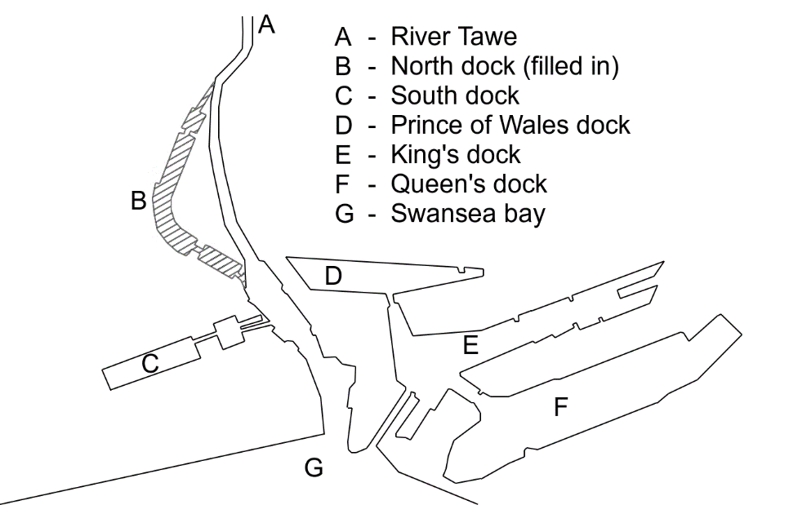
In 1969 due to a lack of trade the south dock was closed for commercial trading and was later reopened in 1982 as Swansea marina. (Localhistories.org )

(McCann 2020)

Topographic map of the site and surrounding area

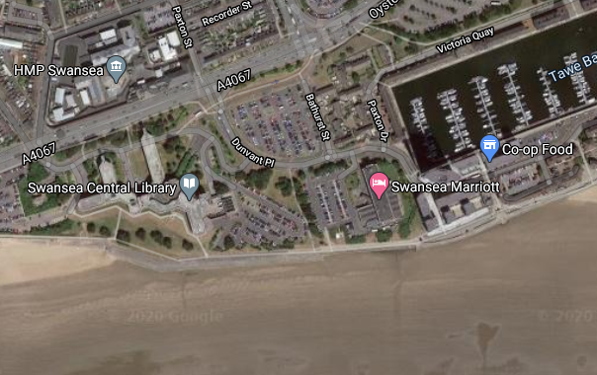

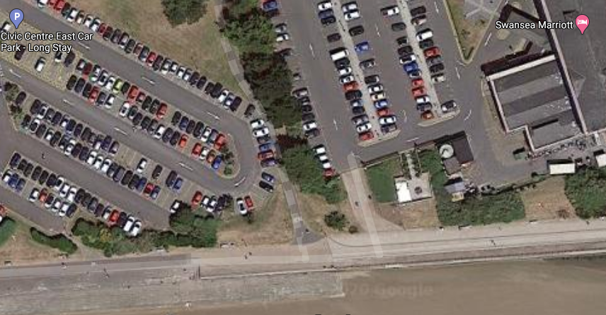

(googlemaps)

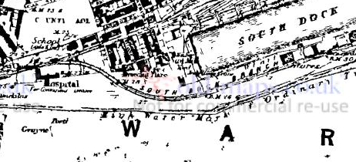
A map of the area dating back to 1879 shows an old hospital and the old access to South dock in close proximity to the site
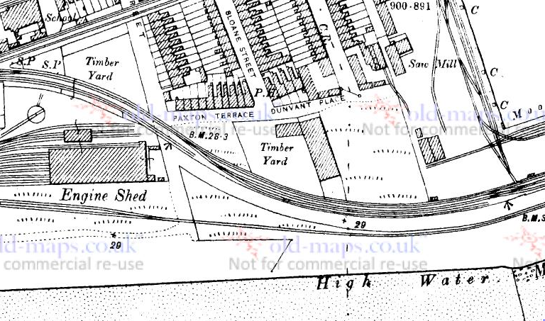
This map dating back to 1884 shows an old timber yard and Engine shed both also in close proximity to the site.
Both maps indicate reasonable evidence to suspect that contaminants may be present in the ground.
(oldmaps.co.uk)

Geological mapping of the area

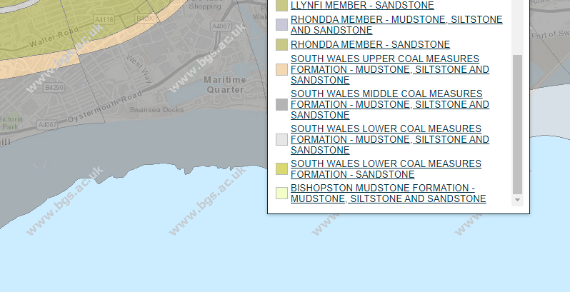
The bedrock in this area is part of the South Wales middle coal measures formation consisting of Mudstone, siltstone and sandstone. (BGS.ac.uk Geology of Britain)

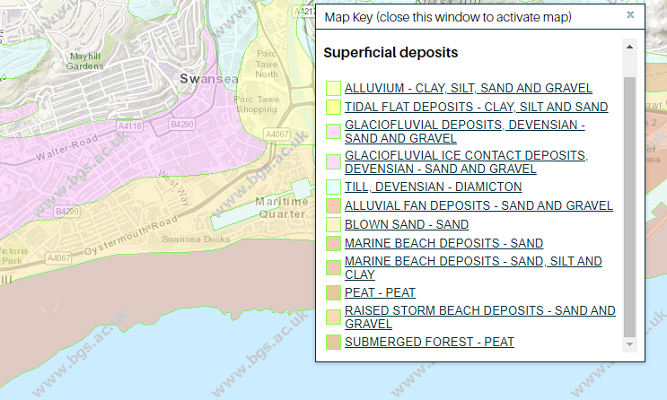The superficial geology in this area is made up of Blown sand. (BGS.ac.uk Geology of Britain)
Borehole test results
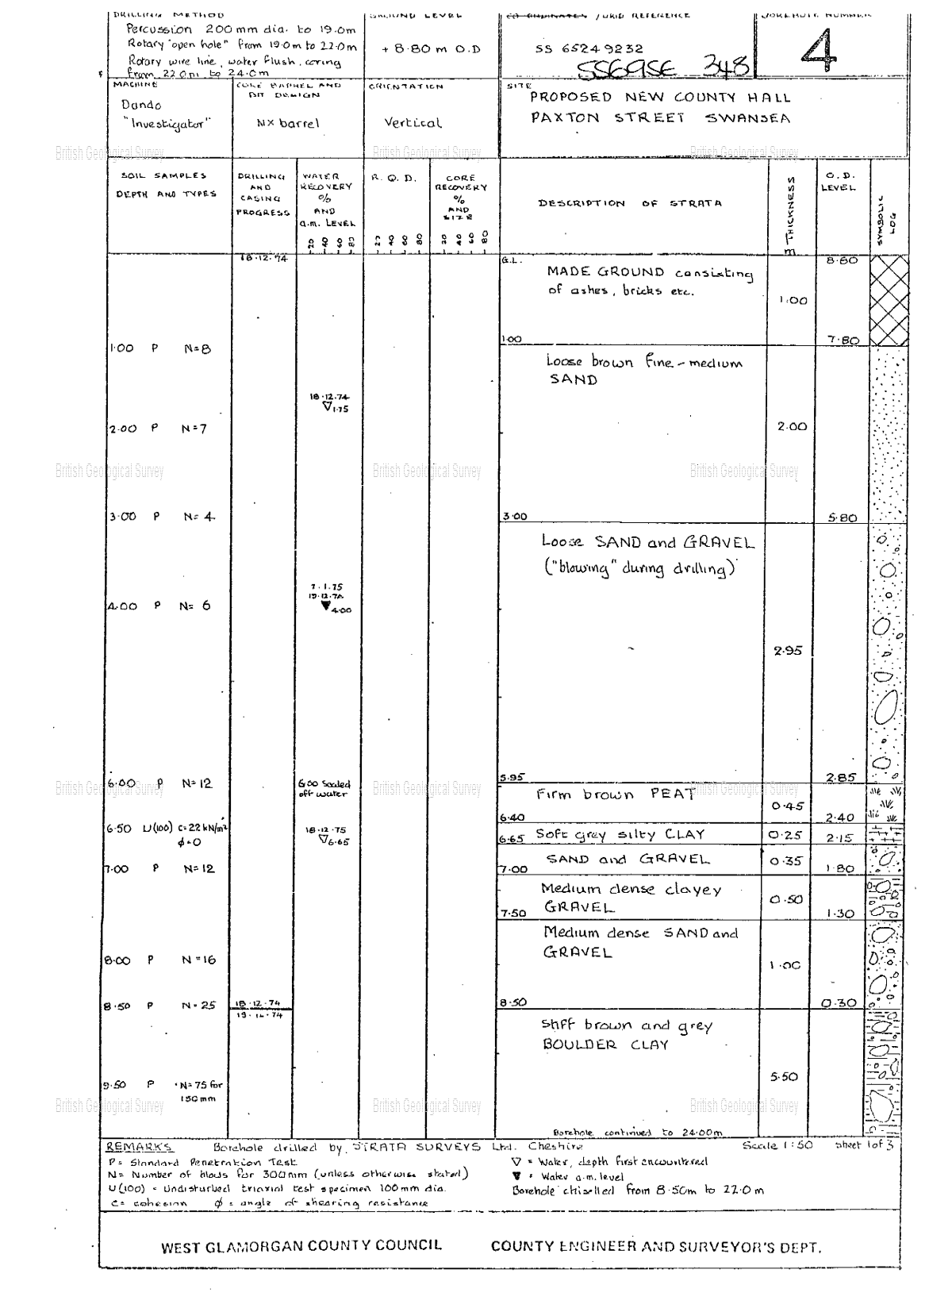

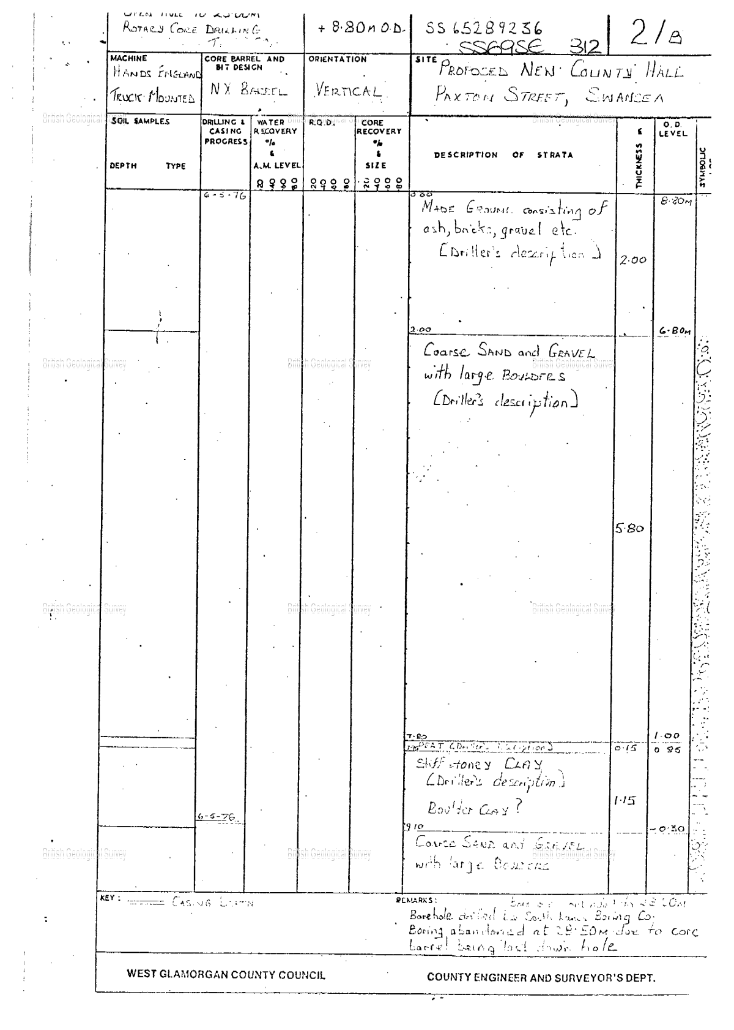
Nearby borehole results taken for a proposed new county hall on Paxton street went down to depths of 24m and 28.5m below ground level. (BGS.ac.uk)

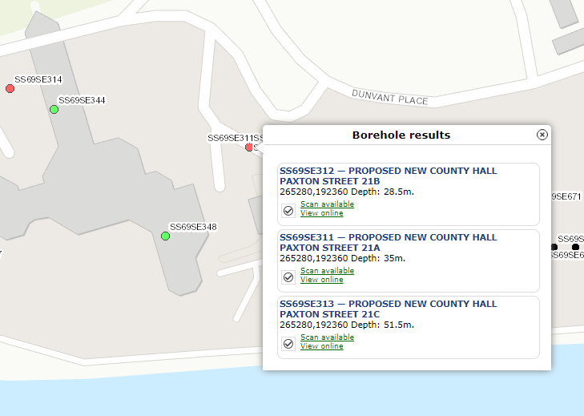

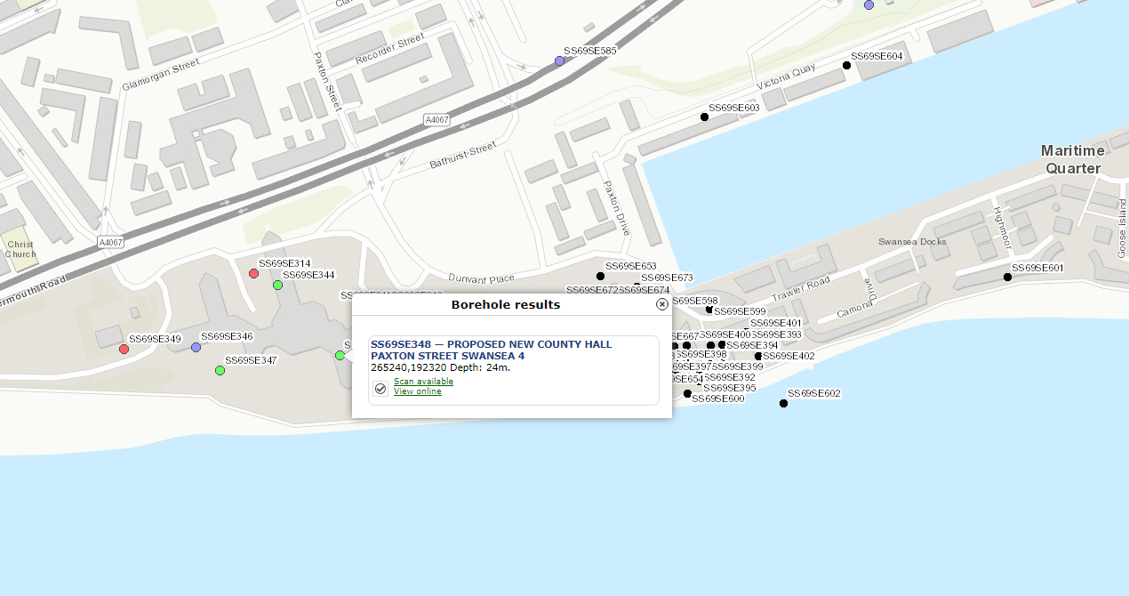

Positions of previous borehole scans taken in the area that have been used to reference the properties of the underlying strata. (BGS.ac.uk)

Relevant testing that should be carried out given the background history of the area and borehole findings prior to works commencing.

The findings of the bore hole scans in the area are inconclusive as there is not only a variation in the depth of the stiff brown boulder clay needed for the support of the building and its foundations but also in the composition of the overlying layers. In both boreholes it is clear to see that there is a fairly substantial depth of made ground though it does not specify the condition, make up or if there is a presence of contaminants within this layer. The depth we can expect on the site of the new building in question is somewhere between one and two meters. After this layer is passed in the previous borehole tests we come across some discrepancies, the first borehole test referenced (SS69SE348) showing a two meter layer of fine-medium sand and the second borehole referenced (SS69SE312) showing a layer of coarse sand and gravel with large boulders present at a thickness of 5.8 meters. Depending on the classification of the made ground this could mean that there is a potential possibility at a strip foundation may be able to be incorporated as long as the total load bearing of the structure does not exceed 30 KN/ linear meter (see table 10 on page 12)
The general consensus from looking at the borehole tests however show that decent firm ground will not be met until depth of around 7.5 to 8 meters are reached. This means that pile foundations may be the only option for this site at least until further testing has been carried out. Due to the variation in findings from past borehole tests in the area further bore hole tests should be carried out within the site boundaries, these tests should be located in areas on which the foundations are to be placed in order to clarify ground type and at what depths suitable ground for supporting traditional strip foundations occur if at all. A highway/off road drilling rig with a hollow stem auger attachment should suffice considering the sandy properties of the ground at shallower depths.
“Boreholes in sand are usually sunk by the light cable percussion method using a shell. This requires sufficient water in the borehole to cover the shell, as it is necessary to add water in dry ground. The addition of water to the borehole (so that the shell can be used) renders the moisture content of samples unrepresentative of the stratum. Below the water table, some sands tend to blow up the borehole, therefore loosening the ground below the bottom of it. Keeping the borehole full of water, and using an undersized shell carefully can reduce the tendency to blow, but may not completely eliminate it. Disturbed samples taken with the shell are likely to be deficient in fines owing to the action of water and due to this separate sampling shall have to take place In order to find the particle size and distribution on the site.” (bailey.persona-pi.com)
Also due to the presence of as of yet unclassified made ground and the close proximity of the site to the old south dock (now known as the marina) it is important to have the ground tested for contaminants including asbestos, lead, arsenic and selenium. This is due to the nature of industry in the area and the types of material and goods that where passing through this dock during its operation as a trading port. Further samples should be taken for the analysis of made ground for further classification. This is to determine whether the made ground can be classed as anthropogenic or not and subsequently whether or not it will need to be removed from or treated on site. Further plate bearing capacity tests should also be carried out to find the suitability of the ground for development. Therefore, I would recommend the geological contractor carry out Particle size distribution testing in order to classify the ground.
Particle size distribution testing involves taking samplers of soil from the site and soaking them in a 5% Calgon solution for between 15 and 20 hours, once this has been done the samples are then dispersed with a soil mixer running at a speed of around 16’000 rpm for a time of 2 minutes. (GJ Bouyoucos 1962 – Wiley Online Library)

There is a small possibility of unexploded ordinance within the site sure to the heavy bombing of Swansea during the second world war. Any ordinance that may be present should be identified and removed from site as soon as possible prior to any works taking place. This can be done with the aid of a magnetic scalar triangulation (STAR) technology. This technology system can be used to provide detailed real time point by point detection of unexploded ordinance, giving the range, bearing, elevation and magnetic signature of underlying metaling objects. (R.Wiegert 2008)

Though previous borehole testing in the area show that the water table is at a sufficient depth so as to not interfere with foundations work there can be great variation to this level depending on the time of year/ levels of rainfall. Thus, further tests and monitoring should be carried out to back up the previous findings prior to works commencing.
“It is most important to record accurately all information about the groundwater obtained during construction, so that this may be compared with information recorded during the investigation. The information should include the flow and static conditions in all excavations, any seepage from slopes, any seasonal variations, any tidal variations in excavations or tunnels near the sea or estuaries, suspect or known artesian conditions, the effect of weather conditions on groundwater, and any unforeseen seepage under or from water-retaining structures. The effect of groundwater lowering should also be recorded in observation holes to determine the extent of the cone of depression.” (bailey.persona-pi.com)

Relevant building regulations and codes of practice

During the ground investigation phase it is mandatory that all persons involved adhere to Building standards (BS5930:2015 Code of practice for ground investigations) published 31-07-2015.
“This British standard of guidelines sets out in broad terms and guides the sequence of a ground investigation from initial considerations through the phased design and implementation of an investigation and its reported findings. It also sets out guidelines for the continued investigation during and after construction.” (geotechnicaldesign.info)

During the design and construction of the structures foundations it is imperative that all persons involved conform to Building Standards (BS8004:2015 Code of practice for foundations) “This building standard gives guidance on designing and constructing foundations in accordance to the limits imposed by state principals using partial factors for the normal range of buildings.” (geotechnicaldesign.info) These factors take into account soil type and bearing capacities along with the materials chosen for the construction of the structure and proximity to the coast. These factors once taken into account following further testing will allow for a final design to be agreed upon for the foundations of the structure in question.

Involvement of local authorities
The findings of the up and coming site investigation are to be sent through to Swansea county borough council for planning approval. Once planning is attained the principal contractor will work closely with the one of the councils’ clerk of works to ensure that all works meet the standards outlined by the councils planning brief. It may also be necessary to work with the highways department to determine if any changes will need to be made to the nearby road and adjoining carparks to accommodate access to and from the building.

Proposed foundations for the project
“Table 10 Minimum width of strip footings
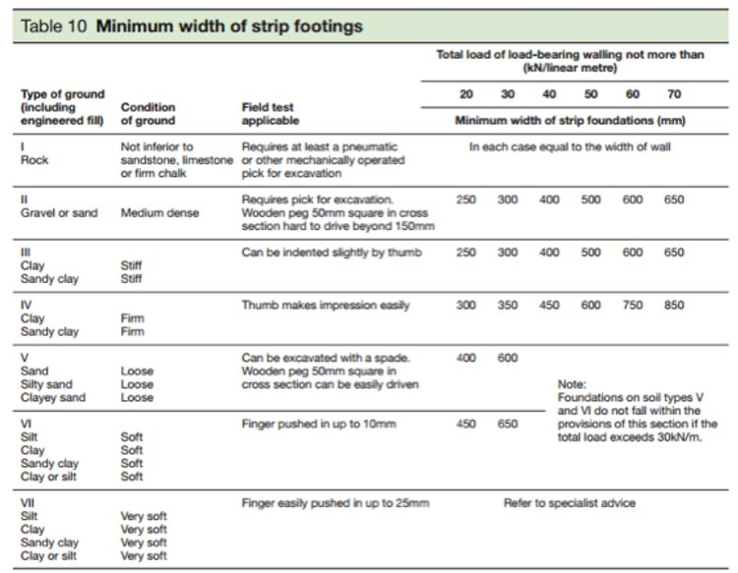
The table is applicable only within the strict terms of the criteria described within it.” (gov.wales building regs 2010)
(gov.wales building regs 2010)

“Minimum depth of strip foundations 2E4”
“Except where strip foundations are founded on rock, the strip foundations should have a minimum depth of 0.45m to their underside to avoid the action of frost. This depth, however, will commonly need to be increased in areas subject to long periods of frost or in order to transfer the loading onto satisfactory ground. In clay soils subject to volume change on drying (‘shrinkable clays’, with Plasticity Index greater than or equal to 10%), strip foundations should be taken to a depth where anticipated ground movements will not impair the stability of any part of the building taking due consideration of the influence of vegetation and trees on the ground. The depth to the underside of foundations on clay soils should not be less than 0.75m, although this depth will commonly need to be increased in order to transfer the loading onto satisfactory ground”. (gov.wales building regs 2010)

From looking at the information above on strip foundations taken from the gov.wales’ building regs approved document and comparing it to the borehole findings in the area it is safe to assume that they will be inadequate for supporting the structure. Therefore, the proposal for pile and beam foundation is to be put forward at this stage undergoing further investigation.

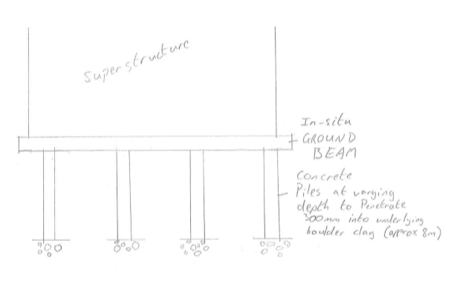

Piles are to be spaced along a 3m grid to provide sufficient support to the overlying superstructure.

References

www.localhistories.org 3-11-2020
www.maps.google.co.uk 3-11-2020
www.oldmaps.co.uk 5-11-2020
www.bgs.ac.uk 4-11-2020
www.bailey.persona-pi.com 9-11-220
www.geotechnicaldesign.info 17-11-2020
www.gov.wales.co.uk 11-11-2020
www.onlinelibrary.wiley.com 11-11-2020
www.ieeexplorer.ieee.org 10-11-2020

