Contextual Studies
Student Name: Harry Francis Phillips
P Number: 149639
Programme of Study: Creative Computer Games Design
Module: Ways of Perceiving (M4X01559)
Seminar Group Tutor: Scott. L. Smith

Introduction
My exhibition will be about counter-factualism, or in this case I will be focusing on counterfactual history. This terminology is a more sophisticated word for the question or idea of “What If”. For example, what if Hitler did not start world war 2, what if he was accepted into art school instead of heading into politics. What if Donald Trump did not become president and Hilary Clinton did instead. These kinds of questions everyone asks every day, maybe these thoughts are shared on a political scale or are asked concerning our own personal ideas and queries. My exhibition is a way for people to experience these ideas, so it may give people a clarity or idea of what could have been but also what could be.
What is Counter-Factualism
“When you’re a kid, the ‘What If” factor enters into your conscious during the questioning phase, cementing, during the age somewhere between 5 and 11, as the most annoying of your adolescence for people around you; when your whole life becomes the big “why?” it’s hard not to be exhausted with the endless possibilities for answering your questions.” [1]
As I briefly talked about before in the introduction as well as what this piece of text talks about is that counterfactualism means to ask the “What If” question and to apply this to history as the next piece of text will:
“Applying the what if factor to history and the minute details in events is the same way; except instead of calling it what if, we call it counterfactualism. And like your 5-year-old self, once the questions start, it’s hard to stop. It’s why among contemporaries, counterfactualism hardly has a place in intelligent discussion and reasoning.” [1]
There are good and bad factors to counterfactualism, one good factor would be that it keeps the imagination active for an individual, as well as allowing historians to be lawful, rational and to be analytic throughout their work. However, some people may argue how counterproductive it is to ponder on the thought, making it a waste of time. Also, another negative effect it has is there is no grounding to make claims or to justify someone’s idea, as they are all in the end opinions made up from someone’s imagination

Floor Plan
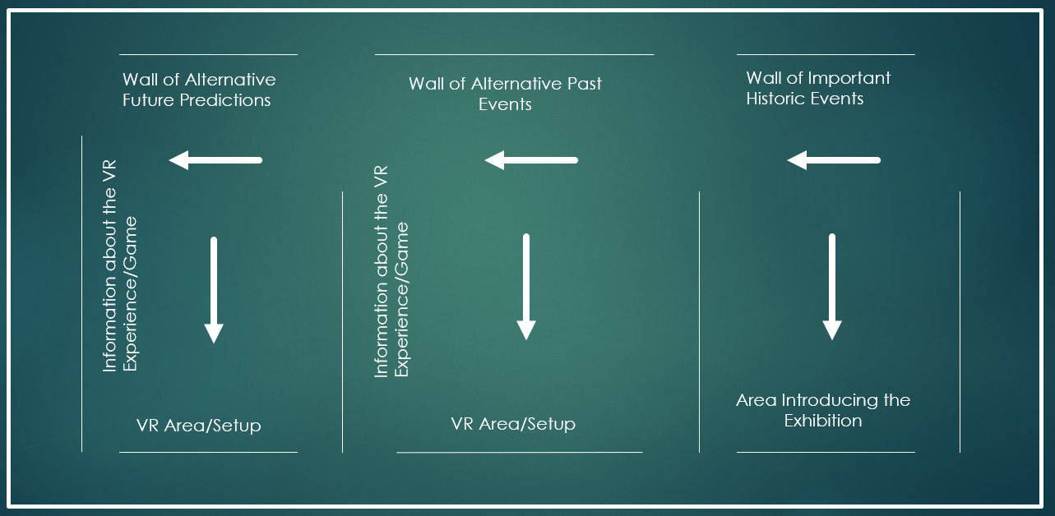
This is my imagined floor plan of my exhibition, it will involve areas where the audience/player will be able to use VR set ups to experience past and future events. The idea of using a virtual space or reality to experience past events has been used before with a video game, this game is Assassin’s Creed (created by Ubisoft Studios) and within the game the device used is called the Animus. The game is all about the player controlling a character who enters the Animus, which allows them to experience lives in the past, including all their emotions and physical attributes, making the experience more or a less a new reality to the player. The word animus comes from the theory of collective unconscious. The theory is self-explanatory as it is about a collective conscious acting as one, two minds put together to act as one. In the first section of my exhibition, the information about a collective mind as well as the theory/idea of counter-factualism and its history will be displayed for the public to properly introduce them to what the exhibition is about and what they will expect.
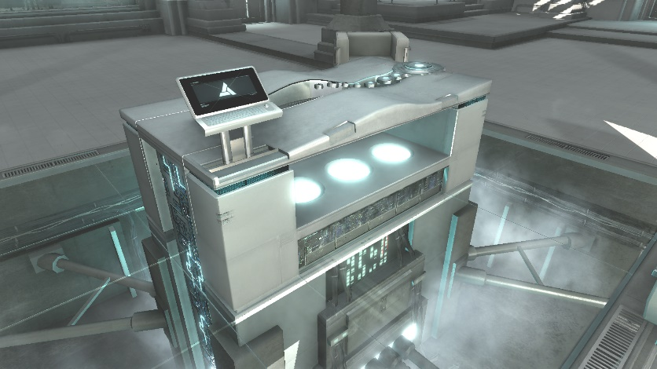
The next section within my exhibition will include an experience(s) of the past and will now challenge the idea of “What if”. The experience I have chosen to represent is the point where Hitler lost against the Brits and Americans in WW2, the player will experience or witness Hitler losing the war as this will be the historically accurate ending, however the ending which he won the war. Players will start to play the game ‘Wolfenstein’ as this game portrays a perfect example to how things would have happened if Hitler won the war. The event after Hitler won the war state that the Nazis, invaded Great Britain as well as America, the player will play as an American who must liberate and fight his way up to kill the main antagonist. I want this experience to make the player/audience think about what could have been if we lost the war and start to get people thinking about the bigger picture in our world. I will talk about this more in my conclusion.
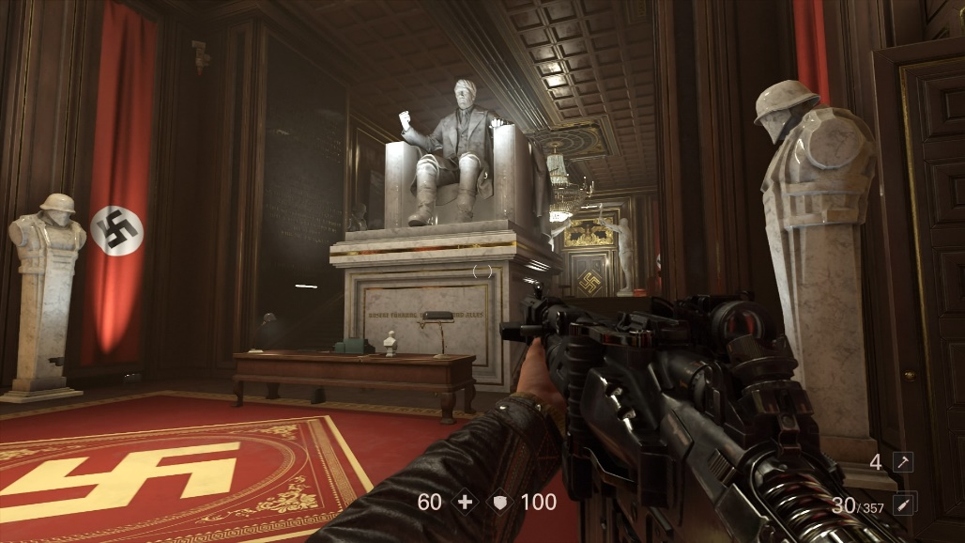

The final section is about the future, many people do ask what will happen in the future as much as they want this answered. The way I want to display this final section of the exhibition is to have the game Fallout 4 on exhibition as well as being on the VR setup as the game is based within a post-apocalyptic future where the world went into nuclear war. There are two turning points based in the game’s history, where history did change/alter. For example, the futuristic technology that can be found within the game is mainly due to when people decided to use nuclear fission energy as a source of power, rather than a weapon. This happened after when the Americans dropped the Hiroshima bomb on Japan, also there is also a point where people could argue that the world should not argue over energy sources and team up to secure a better and safer future. Sadly, this did not happen in the events of Fallout 4. I feel like this part of the exhibition will make the audience/player think more about their future and that small points in a person’s life could make a huge difference in the future. For example, when voting for the next dictator or president, to some people it may seem like a pointless vote, but many people are thinking this, making a huge majority of votes being wasted, and the wrong person may be put into power.
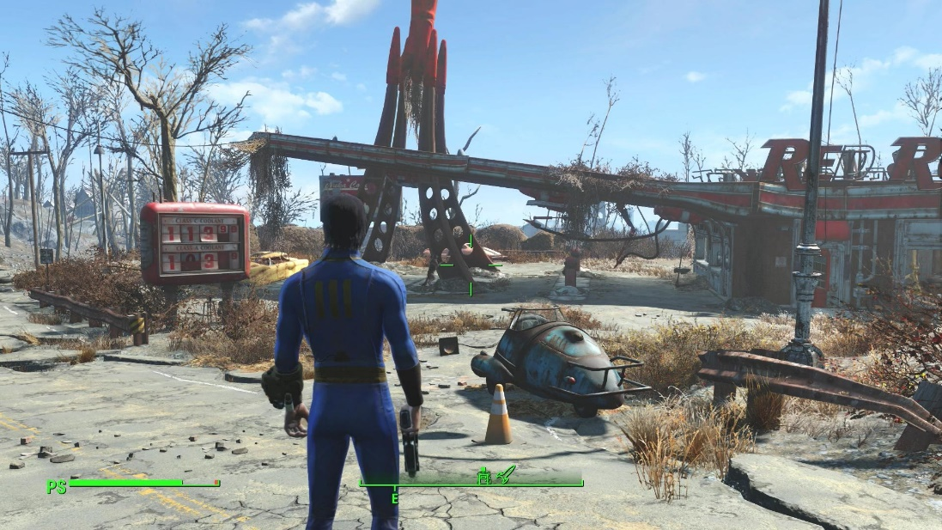
Conclusion:
To conclude, I believe counterfactualism is a great practice or idea which every individual should venture, as it keeps their imagination active as well as make them keep asking the big questions in life, such as ‘What if I vote for this person instead of the other?’ or for example ‘What if Einstein never invented the Hiroshima Bomb?’. These type of questions people can’t help to ask, and I hope my exhibition will allow them to answer said questions and to get people thinking. This exhibition is somewhat of an experiment, to see if I can get people to start thinking for themselves as well as how they would react to what the past or future would have looked like.

Bibliography:
[1] http://historycooperative.org/what-if-history-is-there-any-validity-to-counterfactualism/
Berger, J., 1999. After the end: Representations of post-apocalypse. U of Minnesota Press.
https://books.google.co.uk/books?hl=en&lr=&id=X_aI9HOkTXgC&oi=fnd&pg=PR9&dq=post+apocalypse&ots=Ah0nDpakW4&sig=xEEm-R6DqBNoBF42wk41J1MKWw0#v=onepage&q=post%20apocalypse&f=false
https://books.google.co.uk/books?id=Pr9gPkctBZkC&printsec=frontcover&dq=post+apocalyptic&hl=en&sa=X&ved=0ahUKEwjr05eOxcHZAhVKCMAKHWH2DE4Q6AEIQjAE#v=onepage&q=post%20apocalyptic&f=false
http://assassinscreed.wikia.com/wiki/Animus
https://en.wikipedia.org/wiki/Anima_and_animus
Bunzl, M., 2004. Counterfactual history: a user's guide. The American historical review, 109(3), pp.845-858.
http://www.jstor.org/stable/pdf/10.1086/530560.pdf?refreqid=excelsior%3Ae5936cce96b41d60862be5454351b683
Evans, R.J., 2014. Altered pasts: Counterfactuals in history. Brandeis University Press.
https://books.google.co.uk/books?hl=en&lr=&id=USxeAgAAQBAJ&oi=fnd&pg=PR4&dq=Altered+Pasts:+Counterfactuals+in+History&ots=UAks5EKNjt&sig=Z0MahLBnbOteWnldCvN20kuFd1g#v=onepage&q=Altered%20Pasts%3A%20Counterfactuals%20in%20History&f=false
http://thecounterfactualhistoryreview.blogspot.co.uk/

