Ways of Perceiving. (ADAD4010)
Explore curation, space and place Cover sheet.
Alyson Elizabeth Williams.
Student Number: 1706513
Course title: Bachelor of Arts: Design Crafts (1/AR09XX)
Word count: 1456
Tutors name: Julia Lockheart.

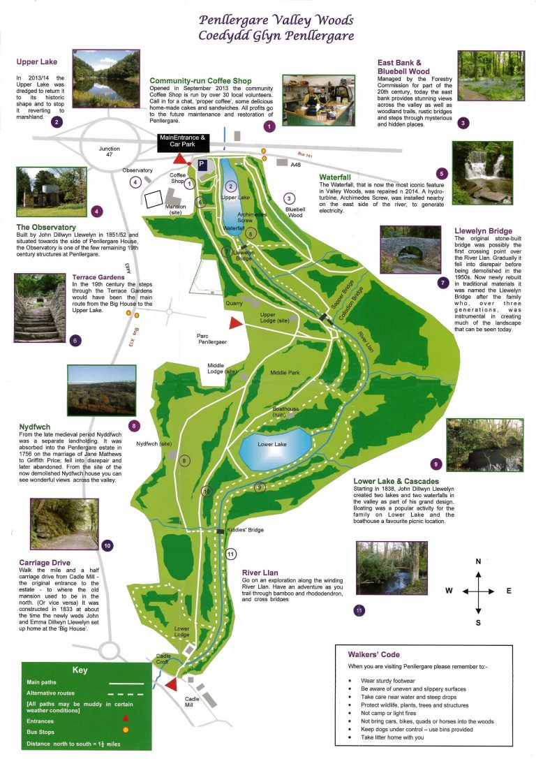
Figure 1 Map of Penllergare Valley woods
The space chosen for the exhibition is Penllergare Valley Woods. See map on page 2. Fig 1. It is a mysterious and magical place steeped in history and has a deep, personal significance to many people, and plays an important role in Swansea’s history. (Eyers, 2006)

Generations were born and raised in the area surrounding the estate. This place was all their playgrounds and informed the grounding of early education for many and the basis for my own love and respect of the natural environment. (Sampson, 2016)

Figure 2 outline map
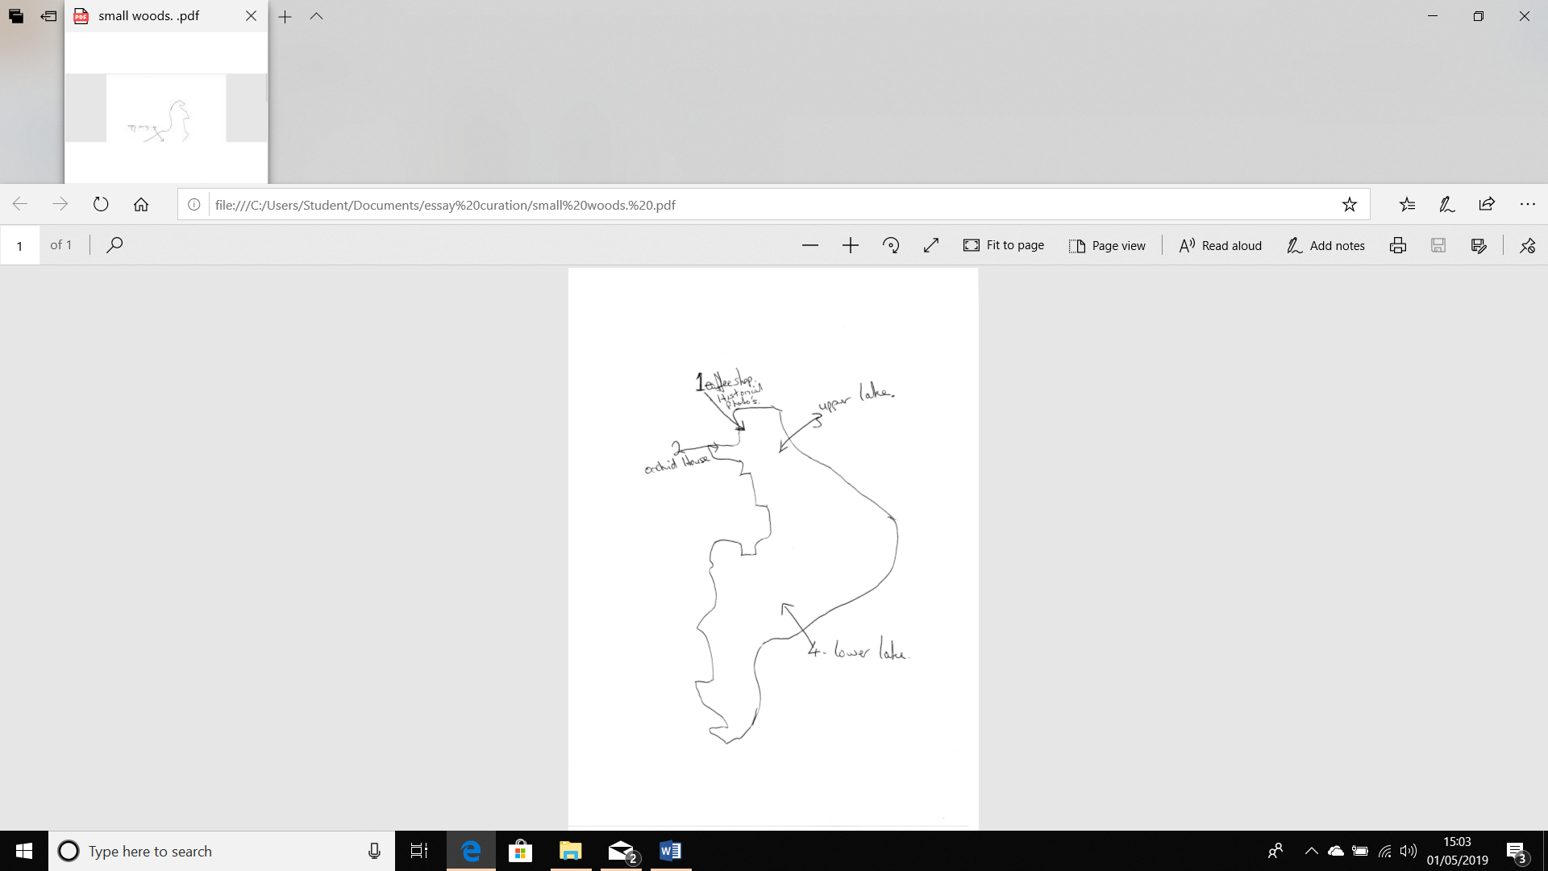
To do the size of the site justice, the vision is to have works from many high-profile environmental artists at every key point on the map. I will be discussing 4 of the exhibits which will be sited at the points on the map in figure 2.

The main reason for choosing this place for an exhibition is to help raise awareness of current dangers to its existence. There are myriads of dangers to the area, and ways that can be brought together to form an awareness of this historical place. e.g. Housing encroachment, Environmental concerns, importance to the history of Swansea, to name a few, but I am going to concentrate on highlighting the transient nature of the world, with the natural environment, and the links through photographic elements.

The exhibition will take place from mid-July to the end of August. The weather conditions will hopefully be more inclement at this time allowing a larger amount of, and more diverse visitors to access the valley and thereby experience the exhibition.

The artists will be commissioned to create new pieces that will highlight and relate directly to the environment and space that they will be exhibited in. A lot of the artists will need to work directly in the surroundings to do this. Photographs of each artists work are only for reference of the type of work they have completed previously to ascertain context and are not the final works that will be exhibited.
All artists will be prominent artists who have previously worked in the field of Environmental art or are currently working in the Natural Environment whose pieces are mainly Transient in nature, and for the most part we rely heavily on photographic images, traditional or modern to view their works.
Transient art are artworks that are not supposed to have longevity. Graffiti, computer generated art, land art, Guerrilla art, happenings, some installations and some elements of performance art can all be regarded as forms of transient art. (Hill, 2016) Red Earth Environmental Art Group will provide some performance art. (www.redearth.co.uk, n.d.) Agnes Denes will have an installation. the artist who created one of the most significant artworks in New York City history, “Wheatfield — A Confrontation (Jacobs, 2018). Edith Meusnier is another artist who will exhibit, she uses textiles for creating public installations dealing with sustainability and environment. (widewalls, n.d.)

Environmental art has the power to change the way we view our world. Some artists showcase the innate beauty in nature, while others such as Olafur Eliason (who will be another of the exhibitors) make a bold, often political, statement with controversial imagery. (Brown, 2014)
Environmental artists endeavour to investigate our human relationship with the environment through embedding their artistic practice within it. and seek to make you rethink your relationship with the Earth and its creatures, this changes the way we think about the site of artistic production. They engage the natural world in an active and immediate way and aim to work in harmony with the natural environment rather than disrupt it. This means they consider the impact that they have on nature. Often, but not always, using only the natural materials at hand to create something even more beautiful than nature itself, or something that will showcase what may be hidden. (Wallis, 2010)

The exhibition will start with an exhibition of John Dillwyn Llewelyn’s photographs in the Coffee shop. This is near to the main car park and is usually the first-place people see on arrival.

Viewed today his photographs give us not only the details of the landscape but something too of its unique atmosphere. (Eyers, 2006)
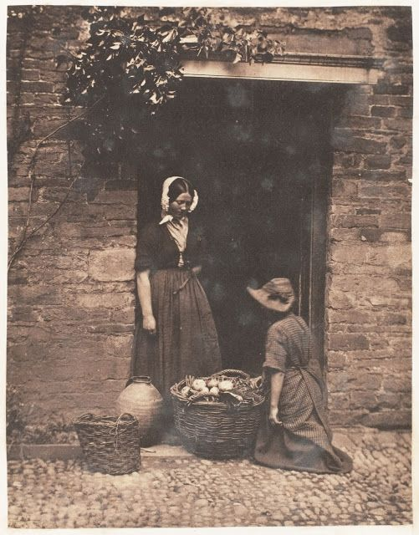

Stories passed down through the generations say whenever there were visitors to the Mansion House for hunting trips or entertainment the workers on the estate had to wear traditional Welsh Costume and were encouraged to speak welsh. Probably for tourists benefit rather than the workers. (Framen, 2015)
Figure 3. woman in doorway in Welsh Costume.

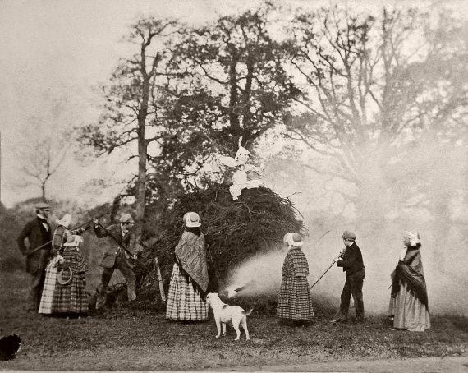
Figure 4. Remember, remember the 5th of November

.

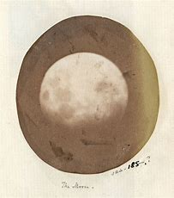

John Dillwyn Llewelyn (Anon., n.d.) who owned the estate was a well-respected and prominent photographer and botanist of the time and has been credited with the invention of the Oxymel Process. (DeLamotte, 2010) and with taking one of the first photographs of the moon from the observatory he built on site, and that has recently been rebuilt in the former estate. (Painting, 1982)
Figure 5. Moon

Azuma Makoto will be near the Orchid House which was built on the estate by John Dillwyn Llewelyn to further pursue his love of Botany. (Chanan, 2013)
Makoto is a flower artist who pioneered the genre of the 'botanical sculpture'. With an immense respect for nature and its preservation, he converts these fantastic elements into an aesthetic artwork. (Makoto, 2016) His 'iced flowers' exhibition documents and observes the changing life of flowers that have been placed in frozen water and displays the ever-evolving conditions, ephemerality, fragility and characteristics of flowers.
Makuto’s exhibition was live in Japan in January 2017. Luckily, we still have the photographs to look at. (Makoto, n.d.)
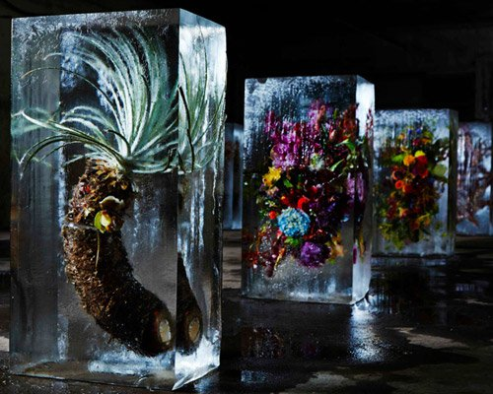
Figure 6. Iced Flowers.

Makoto’s encapsulation of flowers in ice will be thought provoking as John Dillwyn’s flowers were metaphorically encapsulated in a heated container.
James Brunt will be working in a few different locations in accessible clearings near to the main footpaths and the lower lake throughout the course of the exhibition to encourage collaboration and participation from the public.
Brunt creates elaborate ephemeral artworks using the natural materials he finds in the spaces he works in. This form of art, often associated with, and inspired by, the famous Emphereal artworks of Andy Goldsworthy, who will also be exhibiting (Goldsworthy, 2006) involves temporary works, which are made from carefully arranged natural objects like leaves, sticks, and stones into patterns, textures, and shapes. Brunt photographs his work for posterity before nature re-absorbs and reclaims it. He has a large social media following and frequently shares updates via Twitter and Facebook . (Anon., 2018)

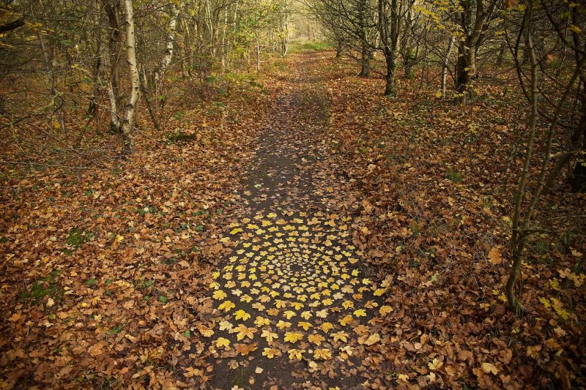
Figure 7. Holly Leaves.

Collaboration, Experiential education, (Kolb, 2014) and participation from others is important to him and he engages and introduces children to art, he is often inspired by his young helpers who he says “see things in a way I otherwise wouldn’t”. (rotherhamadvertise, n.d.)
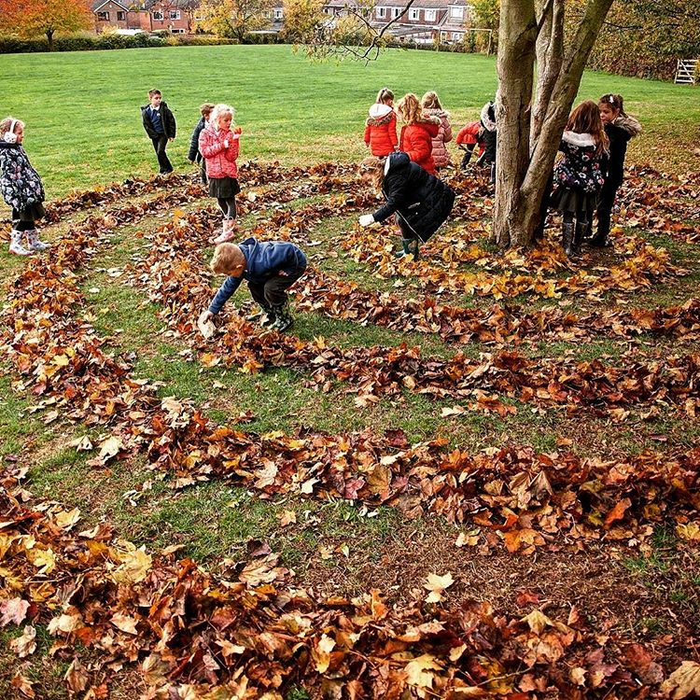
Figure 8. Spiralling at Todwick Primary

Bob Johnson will be near to the upper lake and along the river as it winds its way through the estate.
Johnson is another artist that worked with the participation of the general public to fish and pull litter and foreign objects from local rivers. This litter is then formed into sculptures by all involved and exhibited near to the its source. The sculptures are dirty, decaying and ugly monuments.
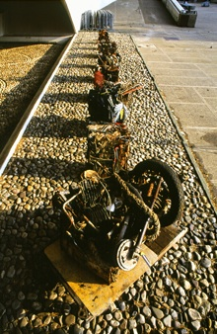
Figure 9. River Cubes.
The process of fishing for the litter and then seeing it presented at the riverside is designed to have a raw emotional effect on the viewer/participant and convey a powerful message of human’s thoughtless disregard to the way they dispose of the items they no longer want to use. Is this a realisation or an awakening of what we are doing to our environments or is it just another phenomenon? (Moran, 1999)
Throughout the whole area, and for the duration of the exhibition, there will be many stewards who are knowledgeable about the pieces of art, the area, the flora and fauna and wildlife that exist there, the history of the site and of the problems it faces to its future now. Most of the artists involved will also be present. These people will be able to provide in depth answers to any question’s viewers may have, thus, adding to the education of the viewer. (Pritchard, 2017)
The overall impact of the exhibition is intended to have an “Affect” on the viewers, and participants, enabling a deeply profound, spontaneous, and personal feeling or nonrational evocation, that can only be experienced through an intervention or an encounter with art. It is hoped that this “Affect” and any additional learning gleaned, will empower the viewer to have a deeper and clearer understanding of the fragility of existence, and raise awareness of our responsibilities towards our environment, not just locally to this beautiful Valley but globally.

References
Anon., 2018. james-brunt-cairns-and-mandalas/. [Online]
Available at: (https://www.thisiscolossal.com/2018/02/james-brunt-cairns-and-mandalas/)
Anon., n.d. [Online]
Available at: https://www.funnyhowflowersdothat.co.uk/iced-flowers
Anon., n.d. Biography: 19th Century Photographer John Dillwyn Llewelyn. [Online].
Anon., n.d. funny how flowers do that. [Online]
Available at: https://www.funnyhowflowersdothat.co.uk/iced-flowers
Brown, A., 2014. Art and Ecology Now. s.l.:Thames and Hudson Ltd.
Chanan, N., 2013. The Photographer ofPenllergare: A life of John Dillwyn Llewelyn 1810-1182. s.l.:Impress.
DeLamotte, P. H., 2010. The Oxymel process in Photography. s.l.:Kessinger Publishing.
Eyers, J., 2006. Penllergare: Echoes from Valley Woods.. swansea: Thr Penllergare Trust.
Goldsworthy, A., 2006. Hand to Earth: Andy Goldsworthy Sculpture 1976-1990. s.l.:Thames and Hudson Ltd.
Hill, C. S., 2016. This is Temporary: How transient projects are redefining architecture. s.l.:RIBA Publishing.
Kolb, D. A., 2014. Experiential Learning: Experience as the Source of Learning and Development. s.l.:Prentice Hall.
Makoto, A., 2016. Encyclopedia ofFlowers 111. s.l.:Seigensha Art Publishing.
Makoto, A., n.d. meet azuma Makoto. [Online]
Available at: https://iloboyou.com/meet-azuma-makoto-iced-flowers-exhibition
Moran, D., 1999. Introduction to Phenomenology. s.l.:Routledge.
Painting, D., 1982. Swanseas Place in the History of Photography. s.l.:The Royal Institution of South Wales.
Pritchard, M., 2017. Empowering Learning: The Importance of being Experiential. s.l.:John Catt Educational Ltd.
rotherhamadvertise, n.d. land-artist-james-brunt-inspires-the-next-generation. [Online]
Available at: https://www.rotherhamadvertiser.co.uk/news/view,land-artist-james-brunt-inspires-the-next-generation-with-allnatural-outdoo_30662.htm)
Sampson, P. S. D., 2016. How to raise a wild child. s.l.:Mariner Books.
Wallis, J. K. a. B., 2010. Land and Environmental Art (Themes and movements). s.l.:Phaidon Press.

Bibliography
Anon., 2018. james-brunt-cairns-and-mandalas/. [Online]
Available at: (https://www.thisiscolossal.com/2018/02/james-brunt-cairns-and-mandalas/)
Anon., n.d. [Online]
Available at: https://www.funnyhowflowersdothat.co.uk/iced-flowers
Anon., n.d. Biography: 19th Century Photographer John Dillwyn Llewelyn. [Online].
Anon., n.d. funny how flowers do that. [Online]
Available at: https://www.funnyhowflowersdothat.co.uk/iced-flowers
Brown, A., 2014. Art and Ecology Now. s.l.:Thames and Hudson Ltd.
Chanan, N., 2013. The Photographer ofPenllergare: A life of John Dillwyn Llewelyn 1810-1182. s.l.:Impress.
DeLamotte, P. H., 2010. The Oxymel process in Photography. s.l.:Kessinger Publishing.
Eyers, J., 2006. Penllergare: Echoes from Valley Woods.. swansea: Thr Penllergare Trust.
Goldsworthy, A., 2006. Hand to Earth: Andy Goldsworthy Sculpture 1976-1990. s.l.:Thames and Hudson Ltd.
Hill, C. S., 2016. This is Temporary: How transient projects are redefining architecture. s.l.:RIBA Publishing.
Kolb, D. A., 2014. Experiential Learning: Experience as the Source of Learning and Development. s.l.:Prentice Hall.
Makoto, A., 2016. Encyclopedia ofFlowers 111. s.l.:Seigensha Art Publishing.
Makoto, A., n.d. meet azuma Makoto. [Online]
Available at: https://iloboyou.com/meet-azuma-makoto-iced-flowers-exhibition
Moran, D., 1999. Introduction to Phenomenology. s.l.:Routledge.
Painting, D., 1982. Swanseas Place in the History of Photography. s.l.:The Royal Institution of South Wales.
Pritchard, M., 2017. Empowering Learning: The Importance of being Experiential. s.l.:John Catt Educational Ltd.
rotherhamadvertise, n.d. land-artist-james-brunt-inspires-the-next-generation. [Online]
Available at: https://www.rotherhamadvertiser.co.uk/news/view,land-artist-james-brunt-inspires-the-next-generation-with-allnatural-outdoo_30662.htm)
Sampson, P. S. D., 2016. How to raise a wild child. s.l.:Mariner Books.
Wallis, J. K. a. B., 2010. Land and Environmental Art (Themes and movements). s.l.:Phaidon Press.

Fig 1. Map of Penllergare Valley Woods Estate. Source
https://www.facebook.com/penllergare
Fig 2. Outline map of Penllergare. Alyson Williams.
Fig 3. Woman in doorway. National archives Swansea Museum.
Fig 4.. Nov 5th. Swansea’s place in the history of photography. David Painting. Printed by Mclays and company ltd. Cardiff. Published by the Royal Institution of South Wales 1982. ISBN 0-9508517-0-1
Fig 5. John Dillwyn Llewelyn’s photo of the moon. -museum. Wales › Collections › Articles
Fig 6. https://www.designboom.com

Fig 7. Holly leaves jamesbruntartist .

Fig 8. Spiralling at Todwick Primary with Classes 1 and 2. Jamesbruntartist.
Fig 9. River Cubes. Bob Johnson. https://sustainableartworkshop.weebly.com/artist-profiles.html

