Food & Beverage Operations – BMIH4002

MENU DEVELOPMENT
HOTEL TRINITY 4****

STUDENT’S NAME: TATIANA - ELENA BACALU
STUDENT ID NUMBER: 2224927
MODULE TITTLE: BMIH4002
LECTURER’S NAME: JALIYA DE SILVA
WORD COUNT: 444
The restaurant industry of the United Kingdom has been growing in relation to the demand for multi-cuisine services (Johnston, 2012). The multi-cuisine theme of the Hotel Trinity will primarily focus on addressing the different types of tastes of consumers present in Glasgow United Kingdom. Over the years the diversity in this particular location has been significantly enhanced with a greater number of individuals preferring to try out different types of restaurants (Cousins, 2020). The multi-cuisine elements of the restaurant industry are becoming highly popular as it is promoting the potential number of consumers and the chances of growth in the market (Boussard, 2021). The menu design will focus on including different types of cuisines in relation to the primary needs of the consumers in the market of the United Kingdom. This will include French, Italian, English, Mexican and other types of cuisines that are appreciated in the market in the United Kingdom (Brown et al., 2013).
The focus of the menu and the restaurant needs to attract consumers living in Glasgow United Kingdom (Wood, 2013). The target market of the restaurants will include individuals from every gender between the age of 15 to 55. This is because they are the best group of consumers interested in the type of products offered (Davis et al., 2018). Consumers who want to try out different types of food belonging to different cultures while maintaining the quality of their diet will be the primary psychological factor under the target market of the company. According to Zutshi (2019), it has become important for restaurants to focus on addressing the needs of the consumers not only in relation to the food but also in relation to beverages. Hence Hotel Trinity will also be focusing on addressing the needs of the consumers by offering them different types of beverages including hot and cold beverages (Motarjemi and Lelieveld, 2014). Consumers above the age of 18 can be provided with alcoholic beverages because the law of the United Kingdom supports any individual above the age of 18 to be sold or buy alcohol. Being a 4-star restaurant, the focus of the organization must not only be on the diversity of the cuisine but also on the quality of food (Walker, 2017). The restaurant will focus on ensuring that the raw materials are organic and of the best quality present in the market to offer the consumers the best possible products (Foskett et al., 2021). The development of the menu in relation to the justification and the needs of the consumers in the market will offer Hotel Trinity an opportunity to become one of the best possible 4-star restaurants in the market of Glasgow.
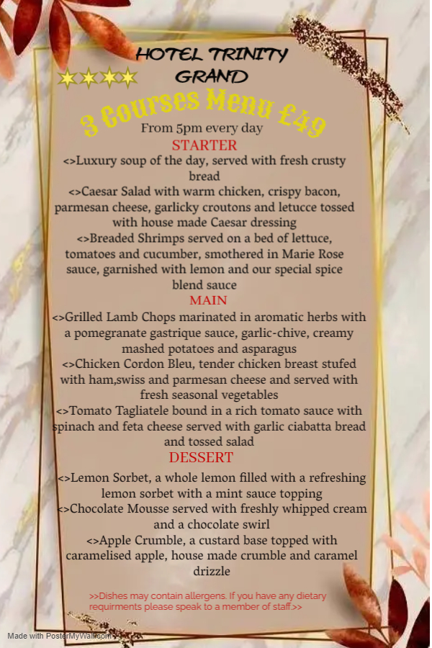 ‘/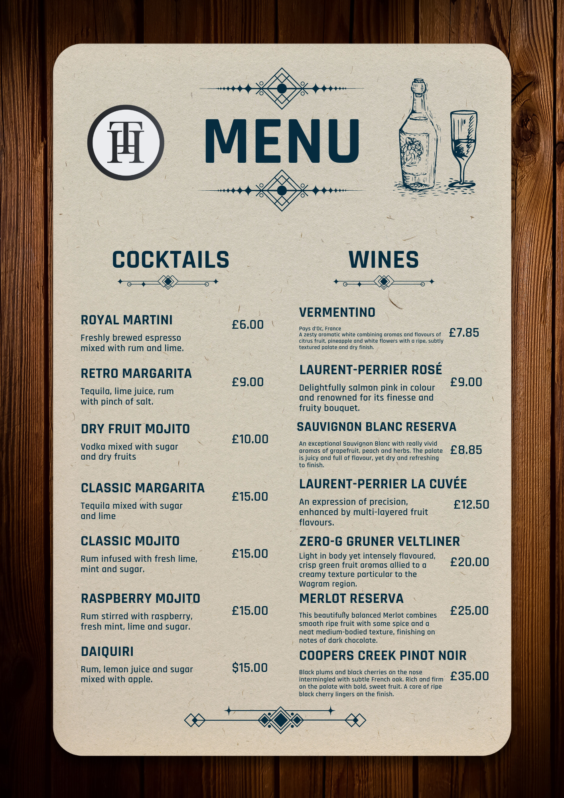
References
Boussard, S (2021). Food and Beverage Management in the Luxury Hotel Industry. New York: Business Expert Press
Brown, D. R., TotalBoox and TBX (2013). The Restaurant Manager’s Handbook: How to Set Up, Operate, and Manage a Financially Successful Food Service Operation. 4th Edition. Atlantic Publishing Group
Cousins, J. (2020). Food and beverage service. 9th ed. London: Hodder Education Group.
Davis, B et al. (2018). Food and Beverage Management. 6 edn London: Routledge.
Foskett, D. et al. (2021). The Theory of Hospitality and Catering. 14th Edition. London: Hodder Education Group.
Johnston, R. (2012). Service operations management: improving service delivery. 4th ed. Harlow, England: Pearson.
Motarjemi, Y and Lelieveld, H (2014). Food safety management: a practical guide for the food industry. Illustrated edition. Amsterdam: Academic Press.
Walker, J (2017). Introduction to Hospitality. Harlow: Pearson Education Limited.
Wood, R. (2013). Key Concepts in Hospitality Management. London: Sage
Zutshi, A. (2019). ‘How to develop well-informed and assured teams to embed food safety compliance in the UK catering and hospitality industry’, Perspectives in Public Health, 139(6), pp.294–295.

