Mechanical Engineering and Energy & Environmental Engineering

Control & Automation

ACMA5001

Application of automation in wastewater treatment

7th April 2025

Garin Mann

2115399

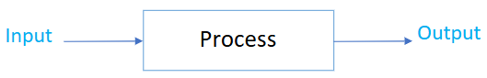

Contents
Introduction to Wastewater Treatment 3
Historical Context of ICA in Wastewater Treatment 4
Core Components of ICA Systems 6
Sensors 6
Process Controllers 7
Programmable Logic Controllers (PLCs) 7
Distributed Control Systems (DCS) 7
Actuators 8
Supervisory Control and Data Acquisition (SCADA) 9
1. Real-time Monitoring 9
2. Alarm Management 9
3. Historical Data Logging 9
4. Remote Access 9
Regulatory Standards and Compliance 10
Recent Technological Advancements 11
Artificial Intelligence and Machine Learning 11
Internet of Things (IoT) 11
Digital Twins 11
Advanced Sensors 11
Edge Computing 11
Case Studies and Practical Examples 12
Conclusion 13
References 14

Introduction to Wastewater Treatment

For engineers, the ability to understand and control systems goes hand in hand—effective control relies on a deep understanding and accurate modeling of the system in question.
Control engineering is a cross-disciplinary field, applied in various domains such as aeronautical, chemical, mechanical, energy, electrical, and environmental engineering.
A control system can be defined as a configuration of interconnected components designed to achieve a desired response or behavior from a system.
At the core of control system theory are principles of linear system behavior and feedback mechanisms. Systems or processes are typically represented using block diagrams to illustrate input-output relationships.
The concept of feedback is fundamental to the analysis and design of control systems. It enables autonomous operation through closed-loop control, where the system continuously self-regulates based on output performance.
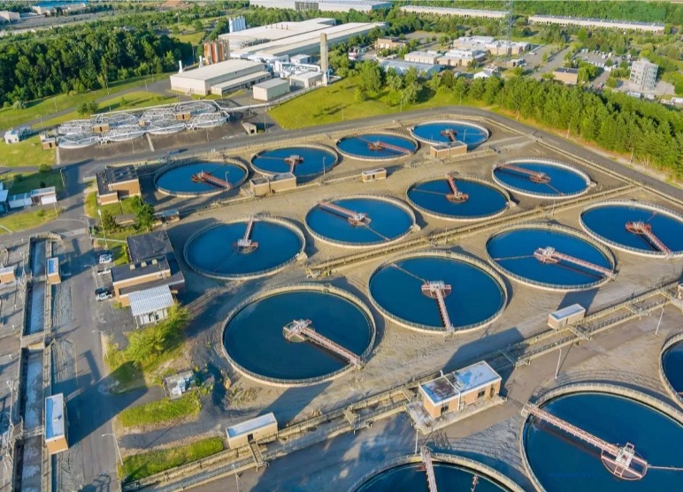
Wastewater treatment is a critical process in maintaining public health and protecting the environment. As the demand for cleaner water and stricter regulatory standards increases, the need for more efficient, reliable, and intelligent systems becomes essential. Instrumentation, Control and Automation (ICA) plays a vital role in modern wastewater treatment plants (WWTPs), enabling continuous monitoring, data-driven decision-making, and optimized process control.
This essay investigates the specific application of ICA in wastewater treatment, examining its historical development, the components that form the backbone of modern systems, regulatory standards that drive its adoption, and recent technological advancements that are shaping the future of the industry (Metcalf & Eddy, 2014).

Historical Context of ICA in Wastewater Treatment
The integration of ICA into wastewater treatment processes has evolved significantly over the past several decades. In the early days of wastewater management, treatment was largely manual, relying heavily on operator experience and routine checks to maintain operational performance. Control was limited to mechanical timers and basic level sensors, with minimal instrumentation.
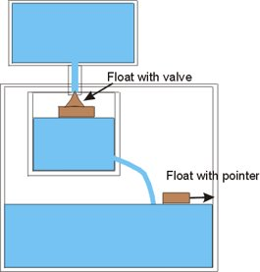
Liquid level control was one of the earliest control systems, also known as the water clock and was invented by Ktesibios in 300BC. The system would trickle water into a measuring container at a constant rate, the change in the water level in the container was used to then tell the time. In order for the water to trickle at a constant rate, the supply tank had to be kept at a constant level.

During the 1930s, considerable progress was made with the development of electrical feedback systems, particularly in long-distance telephone amplifiers, alongside the emergence of servomechanism theory. These advancements demonstrated how a small amount of power could be used to control a much larger force, enabling automatic corrections within systems.
Around the same time, the pneumatic controller became a key innovation, laying the groundwork for early automation in the petrochemical industry. This period also saw the rise of analog computers, both of which played pivotal roles in enhancing control-system theory. These technologies found critical applications during World War II, including in anti-aircraft targeting and fire-control systems.
The later introduction of both analog and digital computing technologies paved the way for managing far more complex systems. This evolution gave rise to what is now known as “modern control” theory—so named to differentiate it from the earlier, more straightforward “classical control” approaches. (IET, 2018).
During the 1970s and 1980s, the introduction of electronic instrumentation marked a turning point. Sensors for measuring pH, flow, and dissolved oxygen became increasingly common. However, the data from these instruments were typically logged manually, limiting real-time control capabilities (IWA, n.d.).
By the 1990s, the development of Supervisory Control and Data Acquisition (SCADA) systems and Programmable Logic Controllers (PLCs) allowed for real-time monitoring and control of wastewater processes. These systems significantly improved responsiveness and efficiency, setting the stage for the automation seen in today’s facilities (Metcalf & Eddy, 2014).
In recent decades, the evolution of digital technologies, internet connectivity, and data analytics has transformed wastewater treatment into a highly automated and data-driven operation. The ongoing adoption of smart technologies continues to improve process optimization and environmental compliance (SmartWater4Europe, 2016).

Core Components of ICA Systems
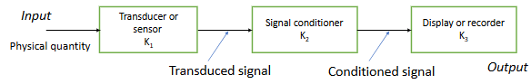
ICA systems in wastewater treatment rely on three fundamental components: sensors, controllers, and actuators. These elements work in concert to monitor process variables, make control decisions, and execute physical responses.

Sensors
Sensors are essential for measuring process variables and providing real-time data. Common types of sensors used in wastewater treatment include:
- pH sensors: Monitor the acidity or alkalinity of water to ensure optimal chemical dosing.
- Dissolved Oxygen (DO) probes: Crucial for biological treatment processes, particularly in aeration tanks.
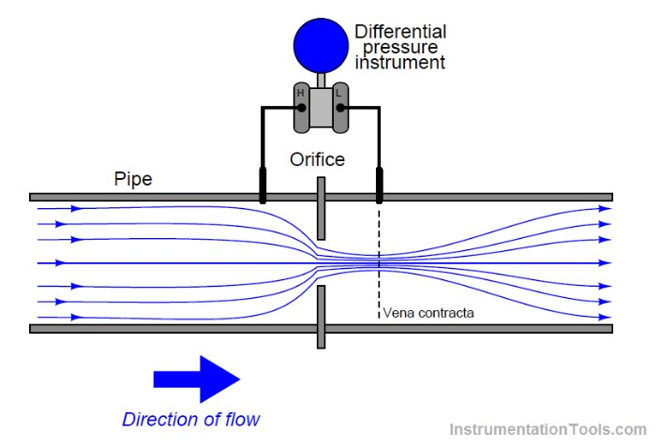
- Flow sensors: Measure the volume of water entering and exiting different parts of the plant. An orifice plate is a prime example of this. An Orifice plate is disc with central hole where pressure measurements are taken upstream & downstream as shown. Inexpensive (no moving parts) and useful for liquids, gases, corrosive and high temperature fluids. Has a non-linear relationship however and causes measurable pressure loss in system in which used.
- Potentiometer: Consists of a resistance element with a sliding contact which moves over length of the element. The further the wiper travels, the higher the resistance. Most potentiometers include three outputs – two outputs are connected to the resistor to keep a fixed resistance, whereas the third output is connected to the wiper to determine the distance it has travelled.
- Ammonia and nitrate analysers: Monitor nutrient levels to optimize nitrogen removal processes.
- Turbidity and suspended solids sensors: Assess water clarity and particle content.
These sensors are typically placed in influent channels, aeration tanks, clarifiers, and effluent discharge points, providing comprehensive monitoring of the treatment process (Metcalf & Eddy, 2014).

Process Controllers
Use of digital computers in the control loop has numerous advantages over analogue systems:​
- Reduced cost – significantly less analogue hardware required.​
- Flexibility in response to design modifications – analogue systems require numerous adjustments and associated hardware; software changes are inexpensive & quick.​
- Noise immunity – digital systems less vulnerable to signal noise compared to analogue.
Microprocessor-based controllers also have advantage of increased variety of control programs, one such being the programmable logic controller PLC. These use programmable memory to store instructions & implement functions such as logic, sequence, timing counting and arithmetic to control events.
Controllers interpret data from sensors and determine appropriate responses. The most common types include:
Programmable Logic Controllers (PLCs)
Industrial digital computers that perform control functions based on pre-programmed logic. Developed for relay replacement by Modicon in USA and applied to production lines by General Motors in late 1960s. Replaced thousands of hard-wired electronic relays.​Typical construction has largely remained unchanged, but in late 1970s the microprocessor truly emerged and greatly enhanced the role of a PLC. Allowed the PLC to evolve from simple relay replacement to sophisticated automated industrial controller it is today.
PLCs are like computers except they have dedicated features as a microprocessor-based controller. These are:​
- Rugged and designed to cope with vibrations, high temperatures, humidity & noise.​
- Interfacing with inputs & outputs are contained within the controller.​
- Programming is straightforward and primarily concerned with logic & switching operations.​
Distributed Control Systems (DCS)
Used in larger plants to distribute control tasks across multiple subsystems – we use DCS here at Cabot Carbon, Barry, which directly links our control system with Dow Corning, so that linked interfaces, pumps, motors and systems are easily accessible by both sides of the fence which helps with fluidity of running both chemical plants.
DCS was developed to replace PID controllers and is found most often in batch and continuous production processes, especially those that require advanced control measures, such as: ​chemical and petrochemical plants and refineries, boiler controls & power plant systems, nuclear power plants, environmental control systems, etc.​
DCS is a specially designed control system used to control geographically distributed applications in complex industrial processes, whereby controllers are distributed throughout the entire plant area.

Actuators
Actuators carry out the physical changes needed to control the treatment process. Examples include:
- Motorized valves: Regulate flow paths based on control signals.
- Pumps: Adjust the flow rate of liquids throughout the plant.
- Blowers: Provide aeration in biological treatment tanks.
- Chemical dosing units: Administer precise amounts of treatment chemicals.
Hydraulic or pneumatic cylinder is an example of a linear actuator. Principle of design and operation is similar, but size is a consequence based on operating pressure.​
Hydraulic actuators operate at much higher pressures, although pneumatic actuators are capable of greater speeds.
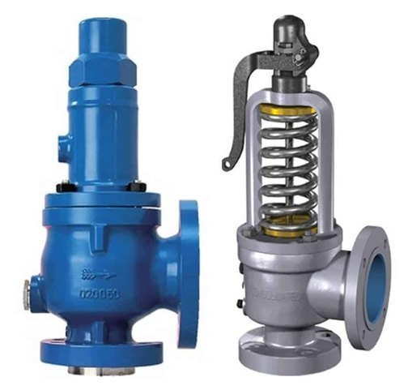
Pressure Relief Valves (PRV’s) are widely used within the mechanical industry, specifically at chemical plants. We use PRV’s as a safety measure and are widely discussed during annual Hazard Prevention meetings, where they are credited upon the safety they provide to the plant, considering the elements that they protect during their use (Hydrogen and Natural Gas are just some examples).
They can also be used as a sequencing valve, allowing flow to some parts of the system when the pressure rises to a required level.
Together, sensors, controllers, and actuators form closed-loop control systems that maintain optimal operational conditions (Metcalf & Eddy, 2014).

Supervisory Control and Data Acquisition (SCADA)
SCADA systems provide the central management layer for ICA in wastewater treatment. They offer a graphical interface for operators to monitor and control plant processes in real-time. Key features of SCADA systems include:

1. Real-time Monitoring
SCADA systems continuously collect and display live data from various field instruments, such as flow meters, pH sensors, dissolved oxygen probes, and level transducers. This real-time insight allows operators to make immediate decisions to optimize process efficiency, prevent overflows, and ensure consistent treatment quality. For instance, real-time flow measurements can help balance the load between different treatment tanks or processes, preventing bottlenecks and reducing energy use.

2. Alarm Management
SCADA systems are programmed with predefined thresholds for critical process parameters. If a sensor reading falls outside the acceptable range—such as a sudden drop in dissolved oxygen or a rise in ammonia concentration—the system triggers an alarm. These alarms are prioritized and displayed visually and audibly on the HMI. Operators are immediately notified, allowing for swift troubleshooting and corrective actions. In some cases, alarms can also trigger automated responses, such as starting backup pumps or opening emergency bypass valves.

3. Historical Data Logging
One of the most powerful features of SCADA is its ability to store vast amounts of historical process data. This includes trends in flow rates, chemical dosing levels, tank levels, and equipment runtimes. Historical data is invaluable for performance analysis, regulatory reporting, and identifying process inefficiencies. For example, trend graphs can reveal seasonal variations in influent quality or help pinpoint the root cause of a recurring issue, like fluctuating effluent turbidity.

4. Remote Access
Modern SCADA systems support secure remote access via VPNs, web interfaces, or mobile applications. This functionality is especially valuable for utility operators who manage multiple facilities or need to respond to off-hour emergencies. From a laptop or smartphone, an operator can view real-time data, acknowledge alarms, adjust setpoints, or even start and stop equipment. Remote access enhances responsiveness and reduces the need for on-site personnel during non-critical times, leading to improved operational efficiency and cost savings.
A typical SCADA architecture involves sensors and actuators connected to PLCs, which relay data to SCADA servers. Operators interact with the system through Human-Machine Interfaces (HMIs) to oversee operations and make manual adjustments when necessary (Thames Water, n.d.).

Regulatory Standards and Compliance
Wastewater treatment facilities must adhere to stringent regulatory standards to ensure environmental protection and public safety. ICA plays a crucial role in achieving and maintaining compliance. Relevant standards and regulations include:
- UK Environment Agency standards: Define effluent quality parameters and monitoring requirements (Environment Agency, 2021).
- MCERTS (Monitoring Certification Scheme): Ensures accuracy and reliability of monitoring instruments.
- EU Urban Wastewater Treatment Directive: Sets minimum requirements for treatment and discharge (European Commission, 1991).
- ISO 14001: Environmental management systems standard (ISO, 2015).
- ISO 55000: Asset management standard.
- IEC 62443: Cybersecurity standard for industrial control systems (IEC, 2018).
By integrating certified instrumentation and robust control systems, facilities can demonstrate compliance, avoid penalties, and improve public trust.

Recent Technological Advancements

The field of ICA in wastewater treatment continues to evolve with the adoption of cutting-edge technologies. Some of the most impactful developments include:

Artificial Intelligence and Machine Learning
AI and machine learning algorithms analyse historical and real-time data to optimize process control strategies. For example, predictive models can anticipate influent load changes and adjust aeration rates or chemical dosing in advance, improving energy efficiency and treatment performance (Gruber et al., 2020).

Internet of Things (IoT)
IoT devices enhance connectivity and data acquisition capabilities. Wireless sensors and cloud-based platforms enable real-time monitoring and diagnostics, even in remote or hard-to-access locations (SmartWater4Europe, 2016).

Digital Twins
A digital twin is a virtual replica of a physical wastewater treatment plant. It uses real-time data to simulate and predict plant behaviour, supporting scenario analysis, operator training, and process optimization (Water Research Foundation, 2022).

Advanced Sensors
Emerging sensor technologies, such as UV-Vis spectrometry and biosensors, provide more accurate and rapid analysis of nutrients and contaminants, supporting better control decisions (Metcalf & Eddy, 2014).

Edge Computing
Edge computing allows data processing to occur at or near the source of data generation. This reduces latency and bandwidth requirements, enabling faster and more autonomous control actions (Water Research Foundation, 2022).
These innovations collectively enhance the autonomy, efficiency, and resilience of wastewater treatment facilities.


Case Studies and Practical Examples

Thames Water (UK) has implemented ICA extensively across its operations, using SCADA systems and AI tools to optimize energy usage and chemical dosing. Predictive maintenance enabled by smart sensors has reduced downtime and operational costs (Thames Water, n.d.).

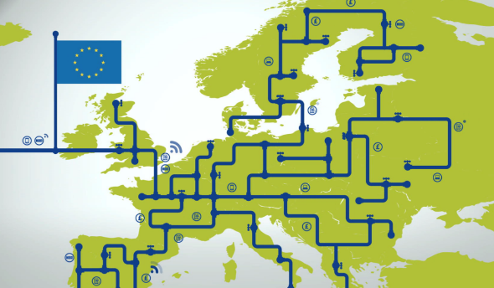
The SmartWater4Europe project demonstrated how integrated smart sensor networks, real-time analytics, and cloud computing can transform water and wastewater management. Facilities involved in the project reported significant improvements in performance and compliance (SmartWater4Europe, 2016).

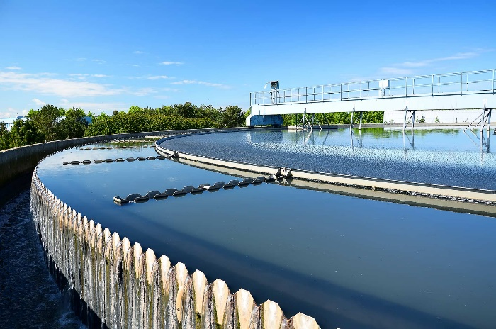
Nordic wastewater facilities have adopted machine learning-based control systems that continuously adjust aeration based on incoming nutrient loads, achieving both energy savings and improved effluent quality (Gruber et al., 2020).

These examples highlight the real-world benefits and increasing reliance on ICA in modern water infrastructure.

Conclusion
Instrumentation, Control, and Automation have revolutionized the wastewater treatment industry, turning labour-intensive and reactive processes into highly efficient, predictive, and autonomous operations. From early mechanical systems to AI-driven digital twins, the evolution of ICA reflects the sector’s commitment to sustainability, compliance, and innovation.
Through the integration of smart sensors, responsive controllers, and powerful supervisory systems, ICA enables wastewater treatment facilities to meet stringent regulatory requirements, optimize performance, and adapt to future challenges. As technology continues to advance, the role of ICA will become even more integral in safeguarding water resources for generations to come.
Personally, in my experience in both the steel-making and chemical industry, the inclusion and use of control & automation is critical. During my time at a steel works in Cardiff Bay, we would have direct access to Towns Water as well as East Bute Dock water via a VOLVO pumphouse if we lost our Unifloc supply of water. This was to ensure that our re-heat furnace could be cooled sufficiently if we lost our inhouse supply due to a pump failure etc. Control & Automation was used on our maintenance panel, a control pulpit and also the shift manager’s office, with other alarms directly linked to the Unifloc workshop. This would give us clear indication of tank levels and were tested on a frequent basis to ensure their function when required.

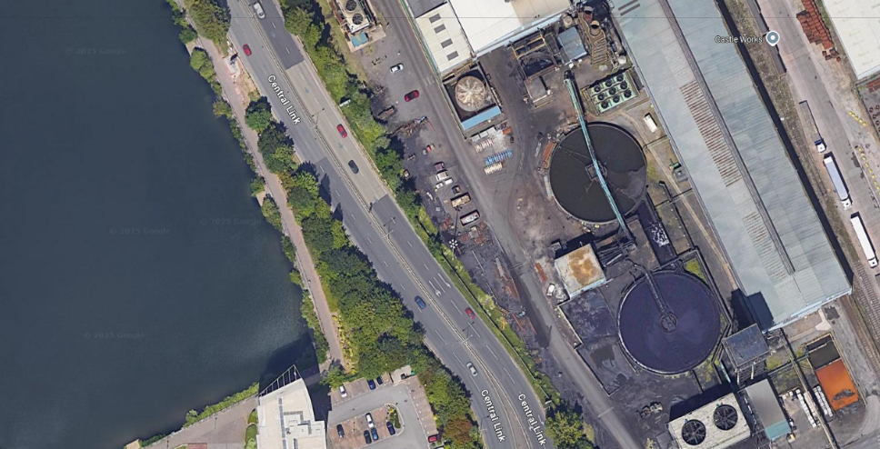

References
Environment Agency. (2021). Monitoring Certification Scheme (MCERTS). https://www.gov.uk/guidance/mcerts
European Commission. (1991). Urban Wastewater Treatment Directive (91/271/EEC). https://eur-lex.europa.eu/legal-content/EN/TXT/?uri=celex%3A31991L0271
Gruber, G., et al. (2020). Application of AI and Machine Learning in Wastewater Treatment: A Review. Water Research, 176, 115719.
IEC. (2018). IEC 62443 – Industrial communication networks – IT security for networks and systems. https://www.iec.ch/62443
IET, (2018). A History of Control Engineering, 1930-1955 - The IET
International Water Association (IWA). (n.d.). Instrumentation, Control and Automation Specialist Group. https://iwa-network.org/groups/instrumentation-control-and-automation/
ISO. (2015). ISO 14001: Environmental management systems – Requirements with guidance for use. https://www.iso.org/iso-14001-environmental-management.html
Metcalf & Eddy, Inc., Tchobanoglous, G., Burton, F.L., & Stensel, H.D. (2014). Wastewater Engineering: Treatment and Resource Recovery (5th ed.). McGraw-Hill Education.
SmartWater4Europe. (2016). Project Final Report. https://www.smartwater4europe.com
Thames Water. (n.d.). Our approach to smart water and ICA. https://www.thameswater.co.uk
Water Research Foundation. (2022). Digital Twin Applications in Wastewater Treatment. https://www.waterrf.org

