RRAS and ICMP Traffic

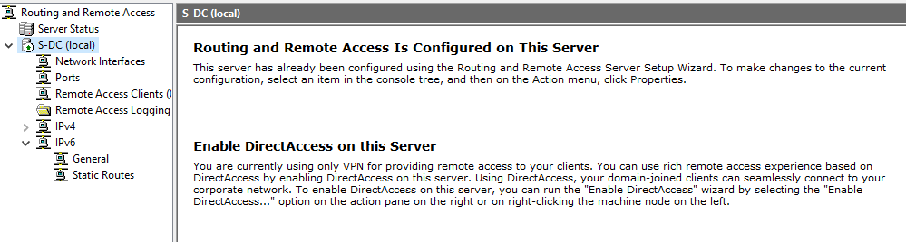
Figure 1: Routing and Remote Access configured on S-DC
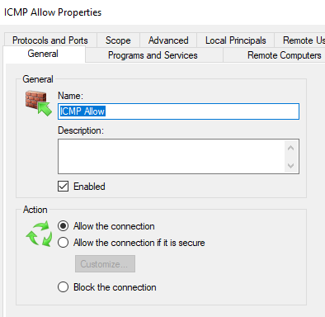
Figure 2: ICMP connection allowed, both S-DC and ClientS1
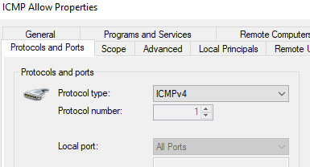
Figure 3: ICMP IPv4 Connection allowed

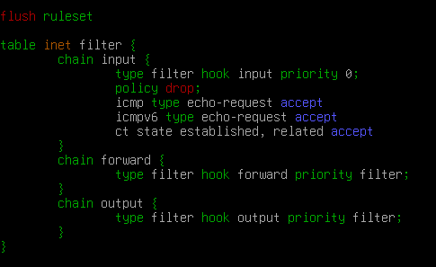
Figure 4: C-server and ClientS1 ICMPv4 allowed
Figure 5: C-server packet forwarding enabled

Mounted Disk to E:\SwanseaFiles
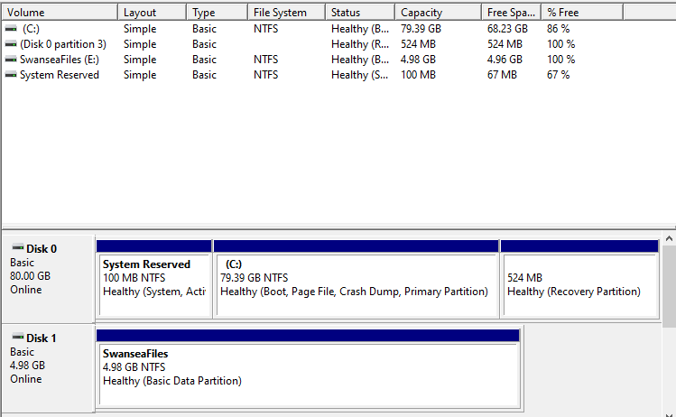
Figure 6: New disk recognised by S-DC
You may notice that the new disk has been named “E” rather than “D”. This is because the “D” drive is taken by the installation media for windows, and so if there are any problems, the installation media can be used to re-install windows if necessary. The fact it is an “E” rather than a “D” has no effect on the configuration

Wireguard VPN
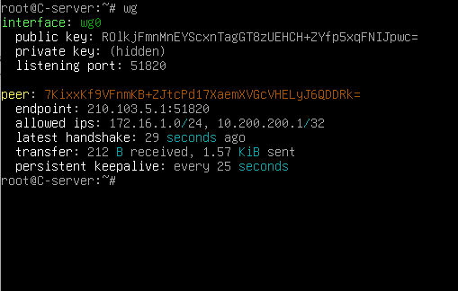
Figure 7: C-server wireguard set-up
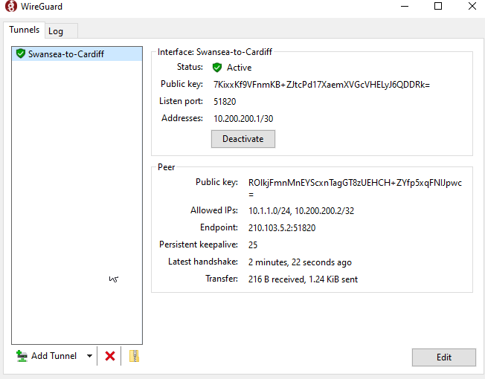
Figure 8: S-DC wireguard setup

DNS/Domain Services
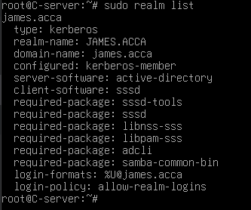
Figure 9: C-server joined james.acca domain
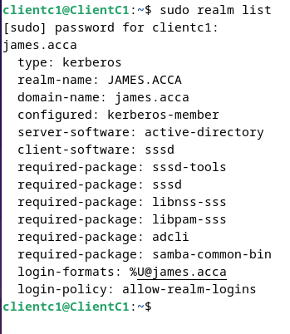
Figure 10: ClientC1 joined james.acca
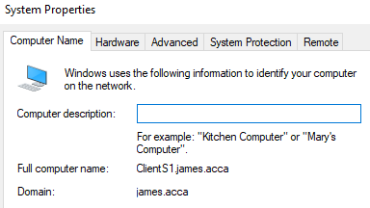
Figure 11: ClientS1 has joined james.acca domain
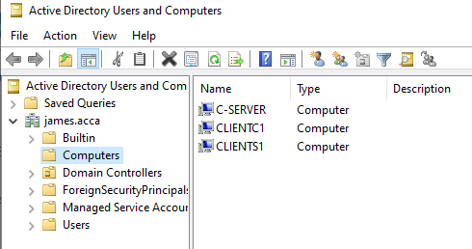
Figure 12: Confirmation from S-DC that all the computers have joined the domain

Pings So Far

ClientC1
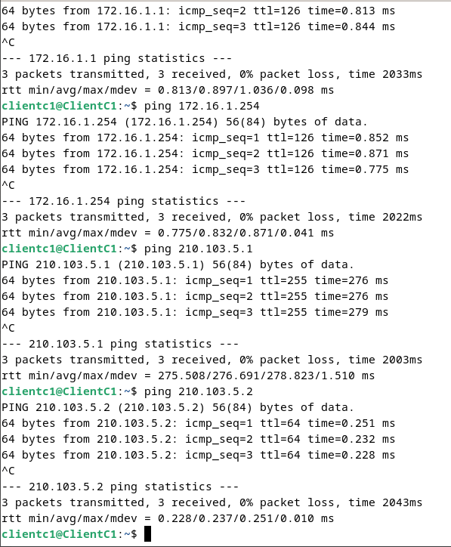
Figure 13: Current C1 pings, can ping each interface

C-server
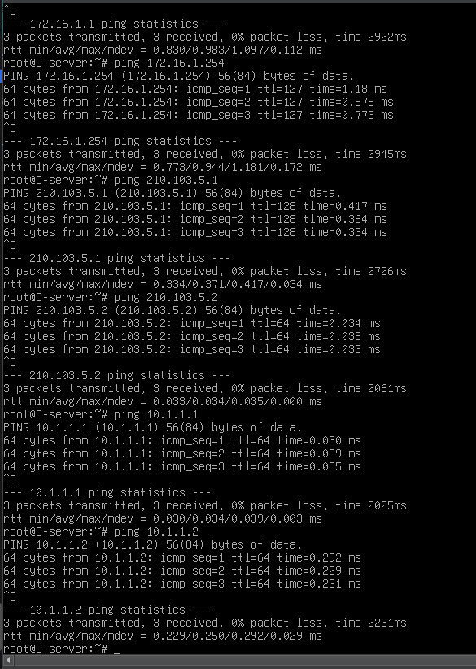
Figure 14: C-server, all pings go through

S-DC
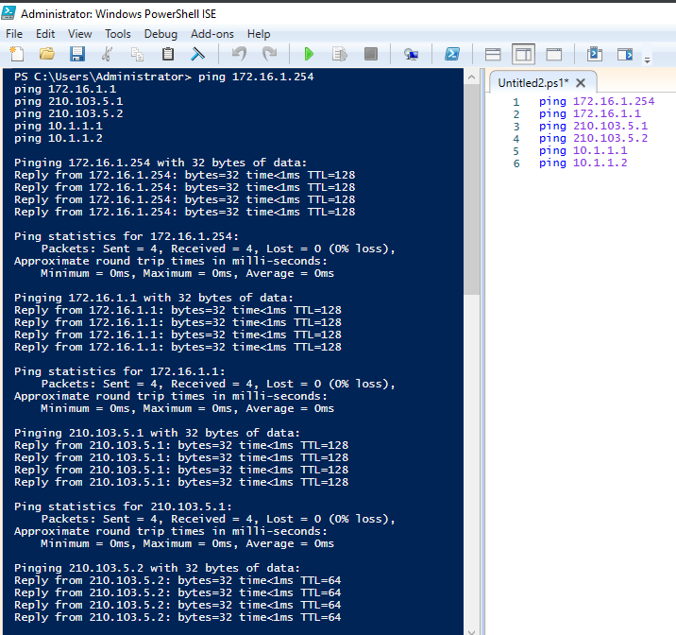
Figure 15: Ping from S-DC, all pings go through
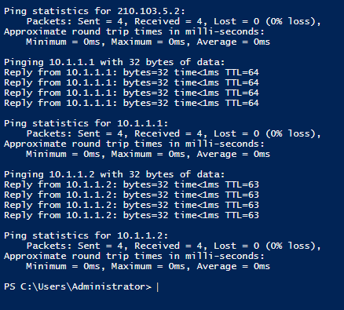
Figure 16: Continued Pings

ClientS1
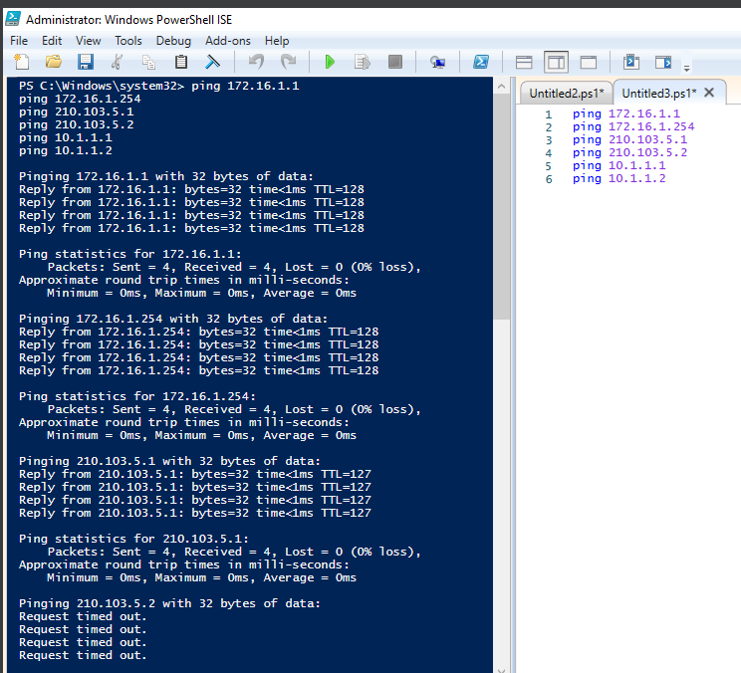
Figure 17: ClientS1 Pings except 210.103.5.2
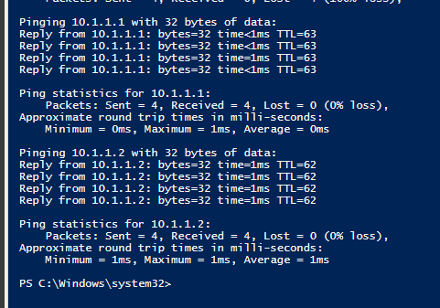
Figure 18:ClientS1 pings cont

DHCP Windows

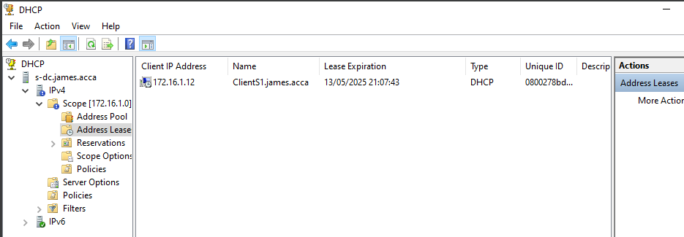
Figure 19: DHCP installed and configured on S-DC for windows devices
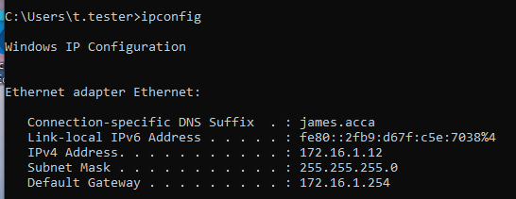
Figure 20: Example of automatic IP assignment and gateway from DHCP
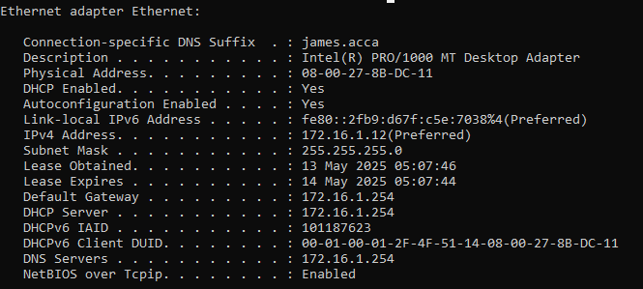
Figure 21: Extra information of DHCP in action

