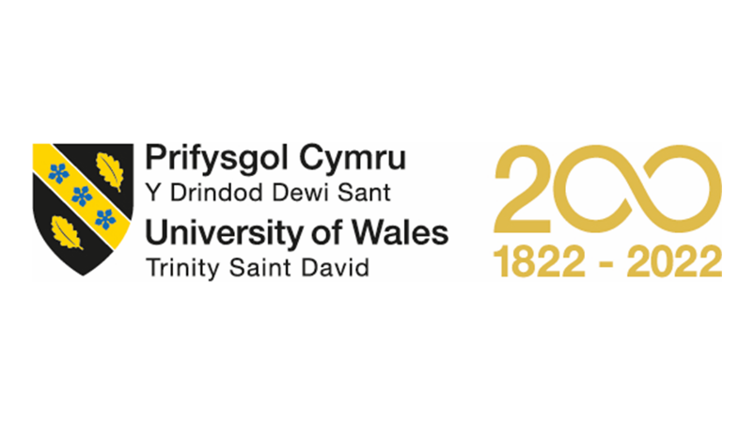
MBA – Master of Business Administration
Marketing Management
LCMB7001

Assessment – 1

Student Name: Aswathy Vadakkedath Appu
Student ID: 2217024

Table of Contents
Introduction 3
1. Importance of Communication in an Organization 3
2. Communication Model 3
3. Integrated Marketing Communications 5
3.1. Integrated Marketing Communication Strategy of Adidas 5
4. Marketing Strategy of Adidas 8
4.1. Product Strategy 8
4.2. Pricing Strategy 9
4.3. Place and Distribution Strategy 9
4.4. Promotion Strategy 9
4.5. People Strategy 9
4.6. Process Strategy of Adidas 10
4.7. Physical Evidence Strategy 10
5. Branding and Equity 10
5.2. Keller’s Brand Equity Model for Adidas 10
6. Customer Journey and Customer Touchpoints of Adidas 12
7. Total Engagement Model for Adidas 13
Conclusion 14
References 15
Appendix 19

Introduction
The three stripes that make up the Adidas emblem are instantly recognisable. When well-known players began endorsing the product, the company quickly rose to prominence in the sports industry. Athletes competing in a variety of sports might get cutting-edge equipment from Adidas. The footwear resulted in an improvement in the athletes' results. The most effective kind of marketing that Dassler used was having direct conversations with athletes about the requirements of the athletes. Because they were made to feel like they were being heard, Adidas was able to win the loyalty of the top athletes in the world. Because of its unwavering dedication to its clientele, Adidas is well recognised as a leading maker of sports apparel.

1. Importance of Communication in an Organization
The term "organisational communication" describes the many means through which a group of people inside a larger entity (such as a company, a charity, or a small business) may exchange information with one another. Worker productivity and happiness have been shown to be strongly correlated with open lines of communication inside a company. (Baena et al., 2016).
Any communication system needs managers who can send and receive messages. Managers must identify communication bottlenecks, study their origins, and design solutions. Managers must build and maintain an effective internal communication system. Large and small firms utilise many different avenues to communicate. Open communication inside a corporation increases worker productivity and pleasure. Formal or informal, bidirectional, multimodal communication occurs in organisations. (Aggerholm et al., 2015).

2. Communication Model
The proposed paradigm characterises organisational communication as a cognitive-social process. There are three components: the kind of message being sent, the mode of transmission, and the methods used to achieve the intended outcome. (Aggerholm et al., 2015). This communication mechanism, including its inputs and outcomes, is shown in Figure. 1.
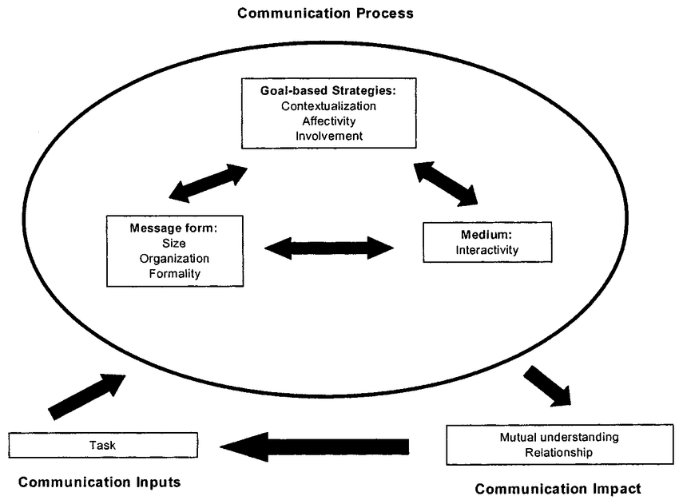
Figure 1 Model of Organizational Communication (Te’eni et al., 2000).

If the sender's intent is to share a product's pricing, for instance, then the intended result is for both parties to grasp the message. However, if the message's intended effect is to persuade the reader to buy the goods, it must not only be understandable but also convincing. Understanding and connection between people are the results of effective communication (Nothhaft, 2016). From the perspective of the sender, the steps outlined above may be seen as the deliberate selection of a specific set of communication tactics, a certain message type, and a specific media. (Those wishing to communicate effectively with little effort often look for tactics, messages, and mediums that seem compatible with one another. Better relationships are often the result of improved communication, as both parties benefit from a deeper knowledge of one another (Schoeneborn et al., 2014).
Due to logistical constraints, measurements of communication effect were omitted from this article. Instead, the focus is on the communication process itself, including the methods, messages, and media that individuals used (Torp, 2015). It has been shown that task factors, such as urgency, are significant inputs into the communication process, among others. To that end, we compare and contrast strategic responsibilities with their more mundane counterparts. Even though this research is applicable to all forms of formal organisational communication, such as email, the measurements of the primary variables in Figure. 1 have only been designed and evaluated for written (text-based) communication (Van Ruler, 2016)..

3. Integrated Marketing Communications
Since its inception in the 1980s, integrated marketing communication (IMC) has altered the dynamic between communicators and marketers. "a planning process to guarantee that all brand encounters received by a customer or prospect for a product, service, or organisation are relevant to that customer or prospect and consistent across time," as defined by the American Marketing Association (Bauer et al., 2005).
Integrated marketing communication refers to the process of coordinating all of this activity across many channels of communication. Note that this word places a premium on persuasion in all its forms, whether that means persuading people to share one's opinions or influencing their inclinations or even getting them to do some kind of action. (Braunstein et al., 2010). There is a higher chance of success when a company's marketing strategy and marketing communications are in harmony. Its purpose is to persuade individuals to change their behaviour via targeted communication. Integrated marketing communication (IMC) maximises the impact of advertising campaigns by disseminating a single, consistent message in a range of interesting forms across many channels of contact with target audiences. (Forbes, 2015).

3.1. Integrated Marketing Communication Strategy of Adidas
- Segmentation- The ability to foster specialisation is a key asset of Adidas' approach to market segmentation. However, segmentation isn't without its drawbacks, particularly in less convenient access situations, such as prices, dangers, and probable vulnerabilities. Markets are often defined and described in terms of export nations in export marketing. Adidas divides their consumer base into subgroups according on buyers' actions and personalities. Adidas cares about not only whether customers purchase and use its products, but how frequently and how much they consume. Additionally, psychographics features, which categorise individuals according to their perspectives, beliefs, and lifestyles, form the basis of marketing communication (Heere et al., 2011). The following factors are used by Adidas in their market segmentation. They all contribute to shaping how marketing communication evolves and what forms it takes. However, their relative significance changes depending on the kind of product or service Adidas is marketing. These include the desire to belong, to enjoy oneself, to make excellent friends, to discover one's purpose in life, to be respected and admired, to have a sense of accomplishment, to experience thrills and triumphs, to feel safe and comfortable, and to have a sense of accomplishment. There are a wide variety of applications for this and related schemas, including environmental scanning, product introduction and placement, and advertising. (Gratton et al., 2010).
- Intentional Audience- Adidas targets certain subsets of customers who have common interests and demographic characteristics. One definition of targeting is "the process of picking one or more of the identified groups as the prospect with the greatest potential via evaluation and comparison." The first demographic consists of 32-year-olds on average who are well educated, financially stable, and gainfully employed. Thirty percent of the market consists of brand loyalists, who are described as the least well-off in terms of income, age, education, and employment (Gummesson 2005). The final set of potential purchasers consists of those with significant disposable incomes. With the help of the marketing communication mix, Adidas is able to target affluent consumers, therefore increasing revenue, fostering brand loyalty, maintaining a commanding market position, and fending off new rivals. They are the most educated, wealthy, and discerning consumers, with a disproportionately high percentage of CEOs and other professionals. Fourth, there is the subset of sports professionals that are dedicated to the Adidas brand and are always looking for the best equipment the company has to offer. The need to narrow down on a certain demographic was especially pressing given the niche nature of the sportswear line. Adidas's initial mission statement made it quite obvious that the company believed the greatest room for growth and experimentation lay in the as-yet-underutilized "adult" market (Hollis, 2008).
- Placement Within the Market- A firm's ability to compete, meet customer demands, and adjust to new market conditions are all factors in determining whether or not it can survive in the long run within a dynamic marketplace. Given the present state of affairs, it's fair to argue that Adidas is forced to operate in the shadow of its chief rival, Nike. Positioning is a kind of strategic communication used by Adidas to reach their demographic. (Ioakimidis, 2020). Brands may be positioned in the minds of consumers by comparing and contrasting their features and advantages with those of competing brands. The idea behind international positioning is that items have diverse sets of traits that may be packaged together to benefit the consumer. The goal of marketing to niche audiences is to provide products with characteristics that provide advantages to buyers in such niches (Kaynak et al., 2008).
- The Psychology of Shopping- Adidas's marketing and public relations efforts are very responsive to feedback from buyers. Although the cognitive, affective, and conative components of attitude and behaviour tend to have a hierarchical relationship with one another, not all customers will react to marketing promotion in the same manner. Success, brand status, brand loyalty, and high quality are the primary motivators for most consumers. Indirectly, consumer behaviour might be affected by marketing messages. Marketers at Adidas aim their messages towards customers' better judgement by suggesting just high-quality products. Adidas's strategy is founded on rationality and appeals to the consumers' reason (Mattera et al., 2018).
- Importance of Branding- A solid reputation for Adidas as a brand has helped the corporation gain the respect and admiration of its target market. The pricing and purchasing procedures will back up this plan, but the most significant aspect of it is that it will assist clients visualise the goods. With the help of marketing, Adidas is able to conjure up a wide variety of mental pictures of its wares in the minds of potential buyers. Adidas is a symbol of assurance about the superiority of one's athletic gear; it serves as a quality seal of approval. Adidas' branding is vital since it helps consumers categorise their shopping experiences and locate the specific sports equipment they need. Maintaining Adidas' unique identity in the marketplace is crucial to the success of the Adidas brand. Adidas uses marketing communication strategies to build brand equity, which is the worth of a product that has increased due to the company's previous efforts in promoting the brand (Patwardhan et al., 2014).
- Analysis of the Effectiveness of the Communication Plan- Marketing Adidas's technique for spreading its message relies on both online and offline marketing and publicity. Adidas places a premium on developing an educational website. One positive aspect is that it aids Adidas in maintaining its brand image and providing enhanced services to its clientele. Adidas' need on effective communication grows as the company competes in an ever-more-tough market for the spending dollars of a far more selective and varied consumer base. This is crucial because modern customers have high standards, extensive knowledge, and the ability to defend their position in a negotiation or a purchase. Banner advertisements and online communities are a big part of online marketing, as are updates on new goods and services and other forms of up-to-date information (Agarwal, 2016).
- Integration- Adidas can reach a large audience of prospective buyers with traditional advertising immediately. You can reach as many people as you want with a great brand image and word-of-mouth campaign, regardless of how many catalogues or brochures you produce and ship out. Economic efficiency is enhanced, which in turn attracts millions of new job seekers and provides better service to existing consumers. Individual differences in Adidas's orientations are the result of socialisation and the factors that affect social behaviour in certain social environments (Fox Sports, 2017). Adidas' commitment to corporate social responsibility manifests itself in the company's usage of a range of advertising channels and influencing mechanisms. Adidas offers its consumers first-rate service and a pleasant online environment, which has resulted in widespread brand devotion. Competition maintains the market's vitality and sustains the drive to innovate and advance. In order to compete with Adidas, other companies must innovate new services, enhance current ones, reduce prices, create cutting-edge technology, and enhance quality and customer service (Badenhusen et al., 2018).

4. Marketing Strategy of Adidas
The 7Ps—product, pricing, promotion, place & distribution, people, process, and physical evidence—form the backbone of the marketing mix, the fundamental paradigm upon which every firm is built. For businesses, they serve as the basis for the plans and tactics they develop to get their message out to the right people and ultimately accomplish their marketing goals (Barker et al., 2017).

4.1. Product Strategy
Adidas sells a wide variety of products, such as shoes, clothes, accessories, sports gear (including soccer uniforms and golf clubs), and more. Adidas's online store also allows you to browse its wares by the many sports for which the brand provides uniforms and equipment. This company is the undisputed market leader in the production of uniforms for team sports throughout the globe, including but not limited to association football, baseball, basketball, cricket, gymnastics, ice hockey, lacrosse, running, skateboarding, tennis, kabaddi, and golf. Reebok, Runtastic, TaylorMade, and Rockport are just a few of Adidas's successful offshoots. Reebok footwear and apparel, one of Adidas Worldwide's approximately 110 subsidiaries, has become more successful than Adidas itself (Barnett et al., 2018). While Runtastic is an electronic fitness software, TaylorMade specialises on golf attire, and Rockport sells gear for the great outdoors. Although the firm sells a wide variety of items, footwear is where it really shines. Although the company has expanded into other product categories, Adidas is best known for their footwear, which is still among the most durable and sporty on the market (Barrabi et al., 2019).

4.2. Pricing Strategy
Adidas' marketing mix combines skimming and competitive price. Skimming pricing are utilised for freshly released items to compete with Nike and Puma. Under skimming pricing, freshly released items are priced high to preserve exclusivity and then progressively dropped till they meet market average. Because of its brand equity, Adidas skims prices on apparel. Adidas targets upper-middle-class and high-end clientele. Adidas' high-price approach makes them a premium brand. People buy Adidas despite high costs because they believe high prices signify excellent quality and authenticity (Beer et al., 2019)..

4.3. Place and Distribution Strategy
Adidas has 800 factories in 55 countries. Adidas stores are its main sales channel. It has 2800 stores worldwide. Adidas also distributes via multi-brand showrooms. Distributors provide showrooms. Showrooms exhibit brand merchandise. Online shops are a need for every serious company nowadays. Adidas has an online website and sells clothes via Myntra and Amazon (Erkilic et al., 2018).

4.4. Promotion Strategy
Adidas' TV advertisements are adrenaline-pumping. Since athletics are Adidas's forte, its ads tend to be brash and full of zeal. The vast majority of Adidas commercials air on television. Promote your brand through product placement as Adidas does. Products are "placed" in media when they are mentioned in fictional contexts. Because of their sponsorship deals with Messi and Ronaldinho, Adidas has risen to popularity (Foley et al., 2017).

4.5. People Strategy
Adidas has 4 primary sections that help it run smoothly (Grathoff et al., 2019):
- The first step that mediators do is to interact with suppliers in order to acquire raw materials and enhance the quality of the final product.
- The company's sales and marketing efforts are managed by the sales team. Client-facing staff are educated in the art of selling and persuasion.
- In-store employees provide assistance to customers by responding to their questions and making their shopping experience a pleasant one.
- When customers have problems with a product, customer support helps them out by communicating with them and finding solutions.

4.6. Process Strategy of Adidas
Adidas' order-to-delivery procedure is lengthy. They provide a system for retailers to alert suppliers when they are running short on goods. When customers place an order, the data is entered into a computer system that then processes and delivers the goods. The company conducts surveys and interviews with customers to learn about their needs and concerns in the market. (Holmes et al., 2018).

4.7. Physical Evidence Strategy
Adidas' user-friendly website features high-quality photos of their items. Their customer support section assists with any difficulties. In its retail outlets, the firm has specifically built shelves to make it simpler to find things. The items are also packaged in colourful ways to make them stand out (Holmes et al., 2016).

5. Branding and Equity
Using the "brand equity" notion from marketing, we can quantify the value of a brand. The value of a brand is based on how its consumers perceive and engage with it. Brand equity flourishes when patrons have a positive association with the product or service. When customers have unpleasant experiences with a firm or its products and actively dissuade their friends and family from giving them a try, the company's brand equity takes a hit (Kell et al., 2016).

5.2. Keller’s Brand Equity Model for Adidas
In the model, Keller's "differential influence that consumers brand awareness has on the marketing of that brand" is broken down into six "brand-added value" aspects. The six factors are as follows: brand salience, brand performance, brand imagery, consumer judgments, consumer feelings and brand resonance (Navellier et al., 2019).. The original diagram of model can be seen in the appendix. The following figure outlines the Kelly’s Brand Equity Model of Adidas.
- Salience- Adidas is a well-known brand that offers sports footwear, sports accessories, and personal care products, demonstrating its depth and breadth.
- Performance-Adidas is renowned for its high quality (reliability, sustainability, and durability) in the sportswear industry.
- Imagery- Adidas connects themselves with successful and popular athletes and significant sporting events, such as the world cup. Adidas is thus more closely associated with soccer than any other sport.
- Judgments: Consumers accord Adidas a high level of trust owing to its quality and performance.
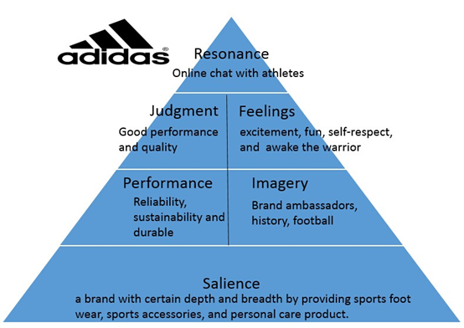
Figure 2 Kelly’s Brand Equity Model for Adidas (created by author).
- Feelings- Exhilaration, enjoyment, and self-respect are feelings that are associated with Adidas. And Adidas is more forceful in their approach. They prioritise supremacy, speed, energy, passion, strength, and command. They endeavour to rouse the warrior.
- Resonance- Adidas provides customers with the ability to communicate with one another and with athletes. Customers are the participants in its online discussion.
It's safe to assume that at 71 years old, Adidas is still a formidable and successful enterprise. Its creative team has produced some of the most innovative commercials, and the business has consistently won the hearts and minds of sports fans and young people throughout the world. Adidas has been successful because it continuously provides its core customers with products that meet or exceed their expectations for both form and function. With tens of thousands of locations, their products are easily available all over the globe. By creating a brand that is instantly recognisable, Adidas has risen to the top of their industry.

6. Customer Journey and Customer Touchpoints of Adidas
Adidas takes great pleasure in their dedication to sport and firmly believes that "sport is important to every culture and community and to the health and happiness of every person." The brand is committed to producing goods that provide clients with the finest experiences and service in an environmentally responsible manner (Perez et al., 2019).
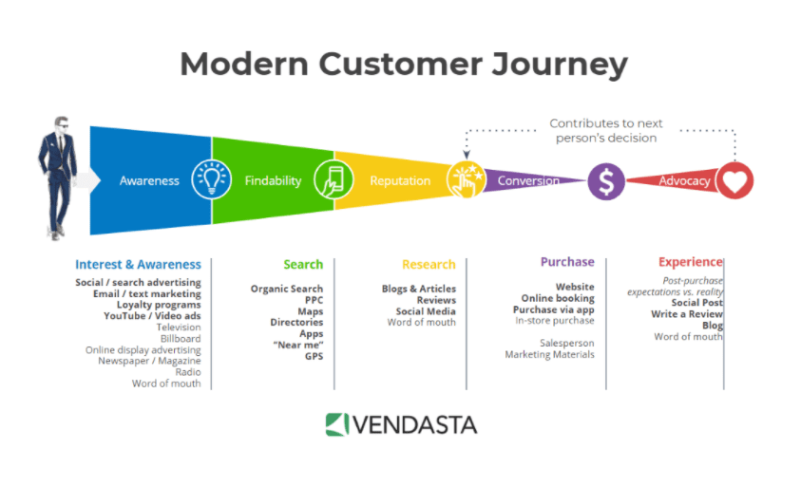
Customer Journey Map of Adidas
Figure 3 Customer Journey of Adidas (Created by author).
- The customer journey starts with product awareness, thus adidas must make it simple for consumers to locate their items. The proliferation of the internet has fundamentally altered the ways in which people learn about, investigate, and ultimately purchase goods. Search engines, social media, and review sites are just a handful of the numerous new options for learning about and exploring potential purchases. More payment options are now available for online shopping (Peterson et al., 2015).
- Consideration (Search, Research)- The majority of customers at this stage of the journey already know they need an adidas product and are looking online for further information (Ratner et al., 2017).
- Conversion- When it comes to today's customer journey, conversion is one of the trickiest parts. To prevent losing clients at this late point, Adidas has to make the digital route to buy as simple and straightforward as feasible. Think about the variety of payment methods they accept, the clarity of their purchasing instructions, and the overall user experience they provide (Rittenhouse et al., 2017).
- Consumers may advocate for adidas products by contributing their own material online about their experience with the brand. Reviews, ratings, product queries, images, and more fall under this category. If they've given their consumers a first-rate experience, it will pay off in the form of increased sales. It has been shown via studies that customers who have already made a purchase are open to marketing for related items (Santora et al.,2018).

7. Total Engagement Model for Adidas
Total engagement is a methodology that takes into account all of these factors and creates a comprehensive strategy. Focusing on harmonising advertising, service, products, and corporate culture with a consistent approach for consumer engagement is the key. (Taylor et al., 2018).

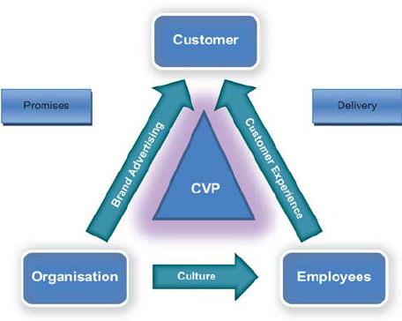
Figure 4 Total Engagement Model (Roberts et al., 2010).
In order to create loyal customers, adidas must link two other key components in addition to their distinct value proposition and customer experience. The first is the company's brand, which should always be ready to defend its merits. Second, the company's internal culture is the primary enabler of delivering a distinctive value proposition and a purposefully crafted customer experience by way of inspired employees (Wilson et al., 2019).
Brand advertising, company culture, the customer experience, and value propositions for customers are the four pillars around which the whole engagement strategy is built. (Peterson et al., 2019).
- Brand, in this context, refers to adidas as a company rather than just to its emblem or name. Branding that emphasises their value offer is essential.
- The term "culture" is used to describe the norms, beliefs, and practises that exist inside a company. The goal here should be to create conditions under which workers feel encouraged to deliver on the value proposition and experience designed for customers on a continuous basis.
- What Adidas really provides to its customers is a combination of the sensory and cognitive aspects of their interactions with the brand.
- In layman's terms, the value that Adidas offers its customers is their "customer value proposition." As a result of these reasons, customers are encouraged to buy from them rather than their rivals.

Conclusion
Consumer behaviour changes quickly. We live in a mobile-enabled world of rapid gratification, notwithstanding overstated claims about computers and email. This clearly affects how consumers and brands engage. Many firms, like adidas, have adopted live chat to meet customer demand. We stopped referring to internet as a single entity or customer channel in acknowledgment of the dispersion of consumer-facing channels and the development of mobile. The difficulty confronting companies today is how to comprehend this new multichannel customer, the kind that flits from one channel to another and who is so comfortable with it all, that to them, it's just'shopping'

References
- “Profile.” Adidas, Adidas AG, www.adidas-group.com/en/group/profile/. [Accessed on 3rd January, 2023]
- Aggerholm, H.K., &Thomsen,C, 2015, Strategic communication: The role of polyphony in management team meetings. In D. R. Holtzhausen & A. Zerfass (Eds.), The Routledge handbook of strategic communication (pp. 172–189).
- Agrawal, AJ. “How Marketing Will Save Reebok for The Third Time.” Forbes, Forbes Magazine, 15 Nov. 2016, www.forbes.com/sites/ajagrawal/2016/11/08/how-marketing-will-save-reebokfor-the-3rd-time/#44c0a04a7a49. [Accessed on 3rd January, 2023].
- Badenhausen, Kurt. “The 2018 NBA All-Stars: Players Who Earn The Most From Endorsements.” Forbes, Forbes Magazine, 17 Feb. 2018, www.forbes.com/sites/kurtbadenhausen/2018/02/17/the-2018-nba-all-stars-players-who-earnthe-most-from-endorsements/#17d7d34e1755. [Accessed on 3rd January, 2023].
- Baena, Verónica, 2016, Analyzing Online and Mobile Marketing Strategies as Brand Love Drivers in Sports Teams. Findings from Real Madrid’. International Journal of Sport Marketing & Sponsorship 17, no. 3: 1–18.
- Barker, Jeff. “Old Feels New as Adidas Makes American Comeback.” Baltimoresun.com, The Baltimore Sun, 28 Feb. 2017, www.baltimoresun.com/business/bs-bz-adidas-20170224story.html. [Accessed on 3rd January, 2023].
- Barnett, Zach. “Nike, Adidas or Under Armour? Who Wears What in FBS - 2018 Edition.” FootballScoop, FootballScoop, 31 May 2018, footballscoop.com/news/nike-adidasarmour-wears-fbs-2018-edition/. [Accessed on 3rd January, 2023].
- Barrabi, Thomas. “NCAA March Madness: Nike Dominates Under Armour, Adidas in One Key Facet.” Fox Business, Fox News Network, LLC., 20 Mar. 2019, www.foxbusiness.com/retail/ncaa-march-madness-nike-dominates-under-armour-adidas-in-onekey-facet. [Accessed on 3rd January, 2023].
- Bauer, H.H., N.E. Sauer, and P. Schmitt, 2005, Customer-based Brand Equity in the Team Sport Industry. Operationalization and Impact on the Economic Success of Sport Teams’. European Journal of Marketing 39, no. (5/6), 496–513.
- Beer, Tommy. “2019 NBA Draft Big Board: Top 50 Overall.” Forbes, Forbes Magazine, 21 Mar. 2019, www.forbes.com/sites/tommybeer/2019/03/21/2019-nba-draft-big-board-top- 50overall/#232d97895337. [Accessed on 3rd January, 2023].
- Braunstein, J.R., and S.D. Ross, 2010, Brand Personality in Sports. Dimension Analysis and General Scale Development’. Sport Marketing Quarterly 19, no. 1: 8–16.
- Erkilic, Gulsen. “6 Things You Should Know About Adidas' Digital Marketing Strategy.” Digital Agency Network, Digital Agency Network, 11 Dec. 2018, digitalagencynetwork.com/digitalmarketing-strategy-of-adidas/. [Accessed on 3rd January, 2023].
- Foley, Gregk. “Adidas Three Stripes Branding: A Full History.” Highsnobiety, TITEL MEDIA GMBH, 14 July 2017, www.highsnobiety.com/2017/07/12/adidas-three-stripes-history/. [Accessed on 3rd January, 2023].
- Forbes. ‘Most Popular Sport Team in Social Media Ranking’. 2015. https://www.msn.com/ en-in/money/personalfinance/most-popular-sports-teams-on-social-media/vp-AAd9TP0 Grant, N., B.
- FOX Sports AP. “For Adidas and Rivals, Sponsorships Are Good Business.” FOX Sports, Fox Sports Interactive Media, LLC., 4 Oct. 2017, www.foxsports.com/soccer/story/for-adidas-and-rivals-sponsorshipsare-good-business-100417. [Accessed on 3rd January, 2023].
- Grathoff, Pete. “Adidas Put up This Sign at Power & Light to Celebrate Patrick Mahomes' MVP Award.” Kansascity, The Kansas City Star, 5 Feb. 2019, www.kansascity.com/sports/sptcolumns-blogs/for-petes-sake/article225565930.html. “History.” [Accessed on 3rd January, 2023].
- Gratton, C., and I. Jones, 2010, Research Methods for Sports Studies, New York: Taylor and Francis.
- Gummesson, E, 2005, ‘Qualitative Research in Marketing. Roadmap for a Wilderness of Complexity and Unpredictability’. European Journal of Marketing, 39, no. 3/4,309–27.
- Heere, and G. Dickson. 2011, ‘New Sport Teams and the Development of Brand Community’. European Sport Management Quarterly 11, no. 1, 35–54
- Hollis, N, 2008, The Global Brand. How to Create and Develop Lasting Brand Value in the World Market. New York. Milward Brown.
- Holmes, Elena. “Nike vs Adidas: The Brand Battle of the 2018 World Cup.” SportsPro, SportsPro Media Limited, 11 June 2018, www.sportspromedia.com/analysis/nike-vs-adidas-brands-win2018-world-cup. [Accessed on 3rd January, 2023].
- Ioakimidis, M. 2010, ‘Online Marketing of Professional Sports Clubs. Engaging Fans on a New Playing Field’. International Journal of Sports Marketing & Sponsorship, 271–82.
- Kaynak, E., G. Gultekin, and E. Tatoglu, 2008, ‘An Integrative Framework Linking Brand Associations and Brand Loyalty in Professional Sports’. Journal of Brand Management 15, no. 5, 336–57.
- Kell, John. “Why Adidas Is Outperforming Nike, Under Armour.” Fortune, Fortune Media IP Limited, 4 Aug. 2016, fortune.com/2016/08/04/adidas-outperforming-nike-ua/. [Accessed on 3rd January, 2023].
- Keller, K. L. 2009. Building Strong Brands in a Modern Communica-tions Environment. Journal of Marketing Communications, 15(2-3), 139-155.
- Mattera, Marina, and Verónica Baena, (2014), ‘The Ball is in Your Court. Using Socially Responsible Actions as an Effective Marketing Tool’. In Strategies in Sports Marketing. Technologies and Emerging Trends, ed. M.A. Dos Santos. Chapter 6. (Pennsylvania (EE.UU.): IGI Global), 74–87.
- Navellier, Louis. 2019, “Lululemon Stock Proves the Athleisure Trend Is Alive and Well.” InvestorPlace, InvestorPlace Media, LLC.,, investorplace.com/2019/01/lululemon-stock-provesthe-athleisure-trend-is-alive-and-well/. [Accessed on 3rd January, 2023].
- Nothhaft, H. 2016. A framework for strategic communication research: A call for synthesis and consilience. International Journal of Strategic Communication, 10,69–86
- Patwardhan, H., and S.K. Balasubramanian, 2011 ‘Brand Romance. A Complementary Approach to Explain Emotional Attachment Towards Brands’. Journal of Product & Brand Management 20, no. 4: 297–308.
- Perez, A.J. “Zion Williamson's Injury from Rare Shoe Failure Puts Spotlight on Nike.” USA Today, Gannett Satellite Information Network, 21 Feb. 2019, www.usatoday.com/story/sports/ncaab/2019/02/20/zion-williamson-nike-shoefailure/2935941002/. [Accessed on 3rd January, 2023].
- Peterson, Hayley. “Adidas Is Making 5 Drastic Changes to Win Back Customers.” Business Insider, Insider Inc., 26 Mar. 2015, www.businessinsider.com/adidas-high-stakes-turnaround-plan-20153.
- Ratner, Jonathan. “Nike vs. Adidas: The Three Stripes Is Making Gains on the Swoosh - but That Doesn't Tell the Whole Story.” Financial Post, Financial Post, 24 Apr. 2017, business.financialpost.com/investing/trading-desk/nike-vs-adidas-the-three-stripes-is-makinggains-on-the-swoosh-but-that-doesnt-tell-the-whole-story. [Accessed on 3rd January, 2023]
- Rittenhouse, Lindsay. “Nike Just Revealed That Its Most Important Brand Is Raking in Billions of Dollars.” TheStreet, TheStreet, Inc., 1 July 2017, www.thestreet.com/story/14205252/1/nikejust-revealed-that-its-most-important-brand-is-raking-in-billions-of-dollars.html. [Accessed on 3rd January, 2023]
- Roberts, Christopher & Alpert, Frank. (2010). Total customer engagement: Designing and aligning key strategic elements to achieve growth. Journal of Product & Brand Management. 19.
- Santora, Nick. “The 50 Most Influential Sneaker Sponsorships in Sports History.” Complex, Complex, 1 June 2018, www.complex.com/sneakers/2012/10/the-50-most-influential-sneakersponsorships-in-sports-history. “Strategy.” Adidas, Adidas AG, www.adidas-group.com/en/group/strategy-overview/. “Supply Chain Approach.” Adidas, Adidas AG, www.adidasgroup.com/en/sustainability/compliance/supply-chain-approach/. [Accessed on 3rd January, 2023]
- Schoeneborn, D., & Blaschke, S. 2014. The three schools of CCO thinking: Interactive dialogue and systematic comparison. Management Communication Quarterly, 28, 285–316.
- Taylor, Glenn. “Adidas CEO: Brexit Is Harming The Business More Than U.S.-China Tariffs.” Retail TouchPoints, Retail TouchPoints, 10 Oct. 2018, www.retailtouchpoints.com/features/news-briefs/adidas-ceo-u-s-china-tariffs-worrisome-butbrexit-is-the-big-headache. [Accessed on 3rd January, 2023]
- Te'eni, Dov & Sagie, A. & Schwartz, David & Zaidman, N. & Amichai-Hamburger, Yair, 2001. The Process of Organizational Communication: A Model and Field Study. Professional Communication, IEEE Transactions on. 44. 6 - 20.
- Torp, S. M. 2015, The strategic turn in communication science: On the history and role of strategy in communication science from ancient Greece until the present day. In D. R. Holtzhausen & A. Zerfass (Eds.), The Routledge handbook of strategic communication (pp. 34–52).
- Van Ruler, B, 2016, Public relations: Too little emphasis on communication. Communication Management Review, 1, 6–27.
- Wilson, Ryan. “2019 NFL Draft: Here Are the 23 Players Who Will Attend the Draft in Nashville on April 25.” CBSSports.com, CBS Broadcasting Inc., 10 Apr. 2019, www.cbssports.com/nfl/draft/news/2019-nfl-draft-here-are-the-23-players-who-will-attend-thedraft-in-nashville-on-april-25/. [Accessed on 3rd January, 2023]

Appendix

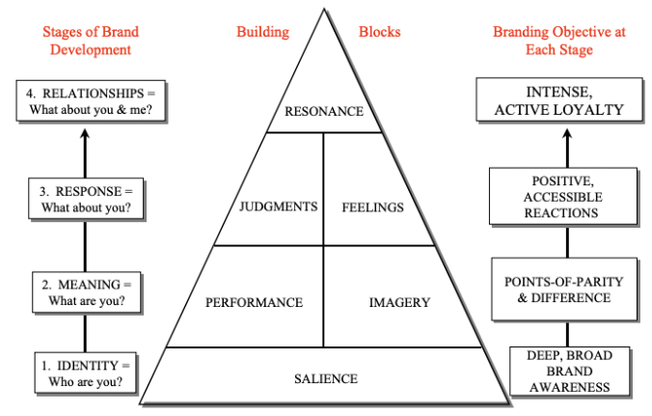
Figure 5 Customer-Based Brand Equity model pyramid (Keller, 2009)

