Florina Loredana Lupulescu 1922055
Date: 10/08/2020

University of Wales Trinity Saint David
Lecturer: Dr. Toyin Adisa

Academic and Employability Skills BMSW4001
Employability

Table of Contents

Executive Summary 2
Introduction 2
Article 1. Introducing Employability 3
ARTICLE 2. Soft is an Understatement: The Importance of Transferable Skills 4
Article 3. Student’s views on entering the labour market 5
ARTICLE 4. How to keep your job skills current 8
ARTICLE 5. Employability in a post - C0VID-19 World 9
analysis of own employability skills 10
CONCLUSION 10
REFERENCES 11
APPENDIX 1 13
APPENDIX 2 14
APPENDIX 3 15
APPENDIX 4 15
APPENDIX 5 16
APPENDIX 6 17

Executive summary
This report explores a few articles on employability and the skills a candidate needs to hold to gain employment and how these skills will have to be improved to keep up the pace with the everyday changes in the labour market and the environment. And the challenges faced by the graduates as different employers look for different skills.

Introduction
The aim of this report, in the next few pages, is to describe the skills, attributes and knowledge graduates will need to prove before entering the labour market. Also, what a graduate’s expectation is from the labour market and what steps will have to be considered to keep their skills updated. And lastly let us not forget about the pandemic and how this affected employability and graduate’s chances on searching for work.
Opinions and debates have been created by different authors on defining employability. Sanders and de Grip (2004) consider employability to be “an individual characteristic in terms of a worker’s capacity and willingness to remain attractive in the labour market, training participation and task flexibility may contribute to workers’ ability to remain attractive in the labour market and also signal a worker’s willingness to be employable”. According to Peter Knight and Mantz Yorke (2004) employability is defined as "a set of achievements, understandings and personal attributes that make individuals more likely to gain employment and to be successful in their chosen occupations which benefits themselves, the workforce, the community and the economy”.

Article 1. Introducing Employability
This article introduces and explains the concept of employability that developed on the labour market a century ago and the fact that it has been used as a labour supply and a labour demand approach
It argues that the narrow and wide viewpoints on employability apply to a ready-to-work person, or whether the person can get relevant jobs. The policies set show people trying to develop skills and abilities as well as help with the cycle of job searching that affects personal circumstances or deals with aspects of labour demand. (McQuaid et al, 2005).
Employability is implemented in industries and labour market policies with an emphasis on growing skills requirements and employer needs. Soft skills are more needed as communication takes centre stage in many jobs and interpersonal skills, attitude and appearance are just as important in obtaining and retaining employment.
Therefore, the emphasis of employers should be on an individual's past qualifications and job experiences and attitudes towards hiring long-term unemployed people otherwise there is a risk of social inclusion in the workplace (McQuaid et al, 2005).
Green, (2005) states that the central factor of employability relates to looking for a job and she focuses on the position overlooked by expectations of which area a person could look for work. Factors like lack of confidence and faith coincide in diverse ways to restrict perceived individual opportunities to find work in local areas. A policy providing adequate employment opportunities and jobs near where economically vulnerable people live does not allow residents to extend their travel horizons or lift their expectations. And that only providing clear and accessible information on the labour market will help.
McQuaid, Green, and Danson, A. (2005) conclude that a limited view of employability skills and characteristics in specific situations can help define appropriate skill sets and policies for some individuals. A wider definition of employability allows for the additional consideration of critical demand, personal circumstances and other factors influencing the employability of individuals on or at a specific time in a particular labour market, and is thus central to such individuals obtaining or changing jobs.

Article 2. "Soft" is an Understatement: The Importance of Transferable Skills
Webber (2019) advised one of his students that decided to change careers to focus on the skills she already had like communication, team management and creative thinking to overcome challenges. Explaining the fact that gaining a position is more than fulfilling all requirements of the job but is also about showing the soft skills that would make you a possible applicant around jobs and businesses. He argues that soft skills are underestimated in the economy and that skills like leadership, communication and problem-solving are the basis of the economy.
Jobs requiring good "soft" skills, such as interpersonal skills, management, and communication, have risen 83 per cent over the past 30 years, and are essential across various industries and jobs, which is why they should be referred to more broadly as "transferable." Regaining them can have a profound effect on the way they are viewed, and on the intensity with which we turn our attention to them (Webber, 2019).
Today the attention on “transferable skills” reduced benefiting the “hard skills” and so many believe that the solution to the current skills gap is to increase early exposure to hard skills and promote interest in STEM careers. This is extremely important, but building strong technical skills, only when combined with transferable skills, those skills are much more valuable (Webber, 2019).
Communication capabilities, innovation, leadership, teamwork, decision-making, critical thinking and problem-solving, are important, particularly beyond the increasing demand in today's workforce for strong, technical skills. They are used across professions and can be used throughout a lifetime of jobs in your career. And are learned from school years and used with friends and family and can be improved through new technologies in the workplace (Webber, 2019).
Improving soft skills may have an impact on the way employees are kept or evaluated and those with good transferable skills are likely to draw on a variety of skills that could help strengthen the workplace (Webber, 2019).

Article 3. Student’s views on entering the labour market.
This article is reviewing the perspective on getting into the labour market from the point of view of the students with opinions and data collected by the Higher Education Policy Institute.
The recognition of students has not entirely changed due to the widespread Covid-19. They remain positive for their future, maybe they see possibilities in the future changes. Two in 3 respondents have a career in mind. Over 70% of them selected it because it relates to their degree. 50% believe stability is a component of an effective career (Black, 2020).
This report shapes a valuable standard of how much the widespread is changing students' views of their career. Key data found: 79% of graduates feel confident that they will get a graduate job once they graduate. 28% cite anxiety as their number one feeling when asked about entering the labour market. 71 per cent say their feelings have not changed since the crisis and approximately three-quarters (72 per cent) intend to pursue a career directly related to their degree (Black, 2020).
The Covid-19 widespread, likewise as having important health impacts, has profoundly affected the economy. Over ¼ of entrepreneurs are lowering the number of graduates they are hiring this year. The Office for Budget Responsibility predicts unemployment may rise to ten per cent (Black, 2020).
Students answers on confidence when asked to pick their 3 best feelings for their future career, were: anxious was the most typical answer chosen in 1st place (28%), and confident put 1st by 23 per cent and unsure and excited were placed second, with a quarter selecting at least one as their second possibility. They also noted that work experience placements and internships were being cancelled because of the pandemic with a 13% decline in jobs publicised (Black, 2020).
When asked what employability means, most of them connected to the skills they achieve, a fraction related to experience and less than 1 per cent said they do not understand the term (Black, 2020).
Regarding their career path, four factors were highlighted: (1) doing something they are fascinated about; (2) being happy; (3) satisfied, and (4) higher wages. Wages were more relevant to men while security was more vital to ladies than men. When deciding on which path to pursue, most of the students say they will research online or investigate careers according to their degree (Black, 2020).
The length of time students expect to spend on their first job was between 1 and 2 years, 6 months and 1 year (18%) or between 2 and 3 years (Black, 2020).
Many graduates remain confident about entering the labour market even with the pandemic. They are eager to leave university with the skills and experience needed to move into their chosen career. The majority already know what career they will follow. But for the students to clear any misunderstandings before entering the labour force, universities and employers should collaborate (Black, 2020).

Article 4. How to keep your job skills current
In this article, Doyle ( 2019) job search expert at The Balance Careers is describing 10 ways on how to keep your skills up to date: (1) check out the most popular skills for your profession - check job descriptions for positions in your career area and explore the top qualities required by employers; (2) know what goes on - speak to someone from HR to gain further insight into your desired skills; (3) follow the company leaders on social network as it will help you recognise new paths in your career and learn what skills leaders are looking for and which one should you work on; (4) make an individual development plan after you have determined your desired skills; (5) visit workshops – there are online providers that offer free course classes on IT technology. (6) study - checking local colleges and adult education schemes as they offer courses or seminars to help employees improve their knowledge and skills; (7) visit social forums and other events, they are a perfect way to plan your skilled conference list and compare skills; (8) read on a regular basis, technical journals and trade magazines are the perfect way to keep your abilities up to date; (9) volunteer - your volunteer work will be used in your resume so taking on tasks or working in institutions where you can improve and apply your knowledge should be your aim of updating skill sets; (10) improve your hard and soft skills - if there are aspects where you find yourself lacking, concentrate on improving these skills.
Even, after following some of the listed skills, improving must continue because the technology is constantly evolving and you need to keep your skills up to date in order to keep pace with the market. (Doyle, 2019)

Article 5. Employability in a post - C0VID-19 World
Wolff (2020) argues that the consequences of the pandemic on graduates and their future in terms of employment are a multitude: (a) the job market has collapsed apart from grocery stores and online retailers, and will not recover any time soon; (b) competition for open positions with candidates having to differentiate their skill sets outside academic ability would be greater; (c) traineeship, once a key to jobs, have ceased this term and could be gone by the fall; (d) field placements have ended and will not be accessible for a while; (e) interviews will be online and involve a different way to present yourself than in person; (f) degrees may be less important than abilities, like soft skills.
For graduates to compete in this industry, efforts need to be made as these hardships will last for a few years at least with high rates of unemployment followed by low wages. It was found that few programmes tackle employability in an integrated manner with courses and services currently being adapted to run online. (Wolff, 2020).
Some steps to consider: (a) soft skills were confirmed to be as important as the hard skills; (b) written and oral communication skills are often mentioned as missing by employers; (c) if internships cannot be organised, it is important to establish virtual examples and case studies relating to the work; (d) assessment will consider the presentation of employability skills and the academic and technical results. (Wolff, 2020).

Analysis of own employability skills
The skills that I hold are diverse but not all perfected as every day I learn and add something new to my knowledge: (1) My communication skills improved while working and I can affirm that I relate well with people and liaise effectively with families and professionals in the work place; (2) Adaptive skills - I adapt very well to changes like when I moved to UK, got a job, met new people, changed environment, and now working from home online, I reacted positively to all changes faced; (3) My academic skills - I am very good at reading, writing, and taking notes. Also, I follow instructions, I know how to do research and take my time when doing homework; (4) Teamwork - I work well in a team and get involved without being told as in my workplace working in a team is crucial in supporting our students, their needs and safety; (5) My job-related skills improved not only having the knowledge to work within a school but also through lots of practice and on the job trainings; (6) IT skills - I am good with computers and can easily work with the common programmes from Microsoft Office.

Conclusion
Not only in the last few months, since the pandemic changed people’s lives but since always, employability has been an important issue for every employer and their lined-up candidates. Graduates are facing uncertainty regarding the set of skills they need to have when they apply for a job with employers not giving much back and expecting more from each candidate.
As a result, graduates need not only to consider their qualifications, but also their life’s experiences, adding all the skill learned together with the personal attributes, knowledge and trainings and continue to round them up for a better understanding of the actual times they find themselves in and the future of their career. And to all this adding the adaptation to this uncertain environment that in a way or another affects everyone’s life and is pulling us back from our purpose.

References
Black, J. (2020). Students’ View on Entering the Labour Market. Higher Education Policy Institute (HEPI). https://www.hepi.ac.uk/wp-content/uploads/2020/04/HEPI-Policy-Note-22.pdf . [Accessed July 2020].

Doyle, A.(2019). How to keep your jobs skills current.The Balance Careers. https://www.thebalancecareers.com/how-to-keep-your-job-skills-current-2063756. [Accessed July 2020].

McQuaid, R., Green, A. and Danson, M. (2005). “Introducing Employability.” Urban Studies 42 (2): 191–195. [Accessed August 2020].

Knight, P. and Yorke,M. (2004). Learning, Curriculum and Employability in Higher Education. Routledge Falmer, Taylor & Francis group. London and New York. Ch.1. pp.5-21. https://books.google.co.uk/books?id=4ttdrci-riQC&source=gbs_navlinks_s. [Accessed July 2020].

Sanders, J. and de Grip, A. (2004), "Training, task flexibility and the employability of low‐skilled workers", International Journal of Manpower, Vol. 25 No. 1, pp. 73-89. https://doi.org/10.1108/01437720410525009 [Accessed July 2020].

Weber, J.(2019). Forbes Human Resource Council. https://www.forbes.com/sites/forbeshumanresourcescouncil/2019/04/26/soft-is-an-understatement-the-importance-of-transferable-skills/#57659a215ea9. [Accessed August 2020].

Wolff, R. (2020). Employabikity in a Post-COVID-19 World. Real Clear Education. https://www.realcleareducation.com/2020/04/17/employability_in_a_post-covid-19_world_48454.html. [Accessed July 2020].

Appendix 1 - SWOT analysis

 SWOT Analysis (Personal)

Name…Florina Loredana Lupulescu.............

Student ID…1922055……………………………

Strengths  - Adapt very well to changes  - Communicate well with people and in difficult situations  - Very flexible and hardworking  - Good organisational skills  - Love to read and research information on the internet regarding news, weather, and health  - Besides my mother tongue (Romanian) and English, I am very fluent in Spanish.  - Good visual memory  - Very good IT knowledge | Weaknesses  - I am afraid of failure  - I am too shy  - Find too hard to say NO to something or someone  - Too good with people and they take advantage of me very easily  - Too kind and good with others when I should not be  - I find it hard to decide  - Afraid of losing dear ones.  - Stress and worries  - Thinking negatively about me and things in general
Opportunities  - Use own initiative when doing things  - Committed to develop my knowledge and skills  - Worry less and act more  - Open for discussion and network extension  - Always listening and paying attention to new things or unknown | Threats  - Uncertainty of tomorrow (concerning life, job, house, environmental changes)  - Any threat against the family  - Old and unexperienced in certain circumstances compared to others that are young

Appendix 2 Paraphrasing using synonyms
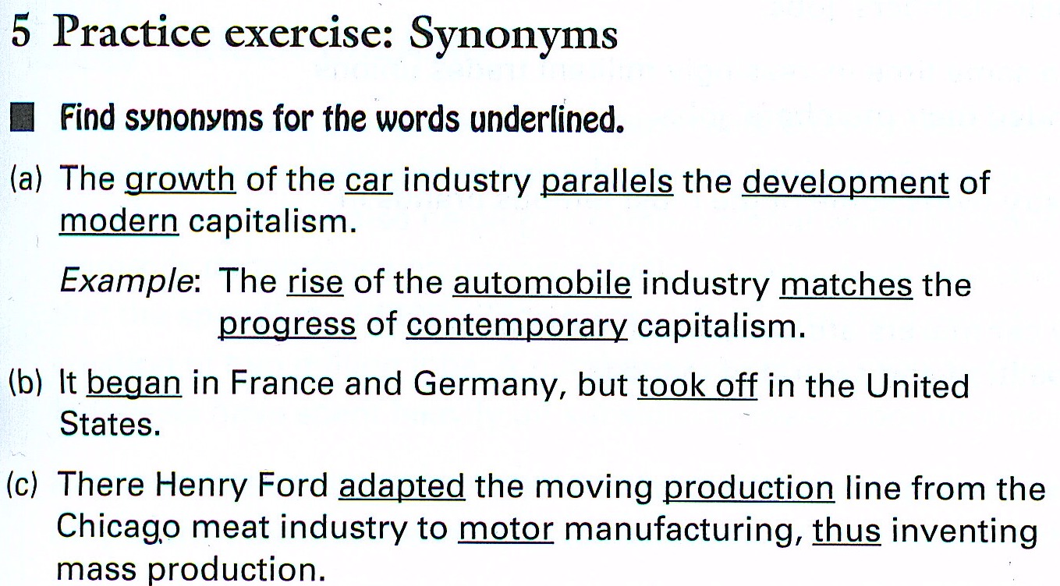
Answer:
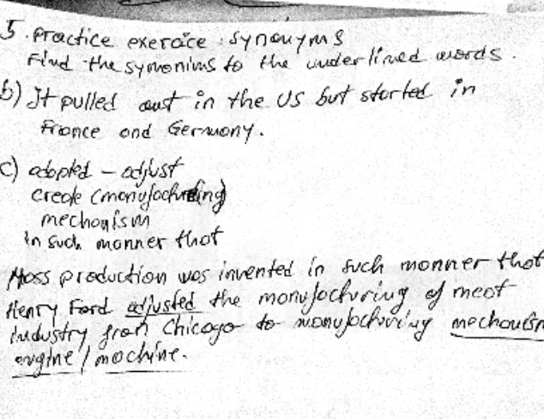

Appendix 3 -Word order
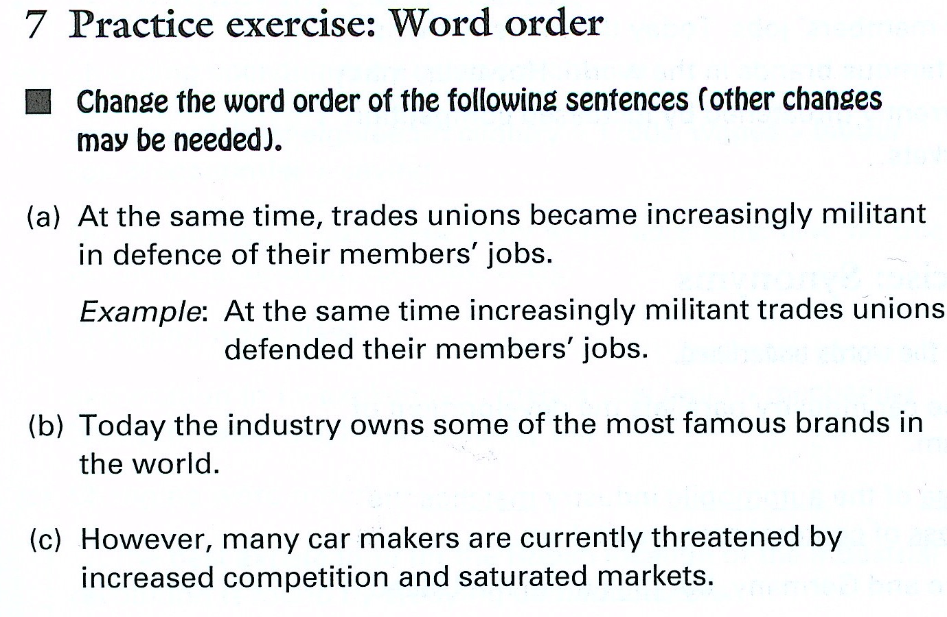
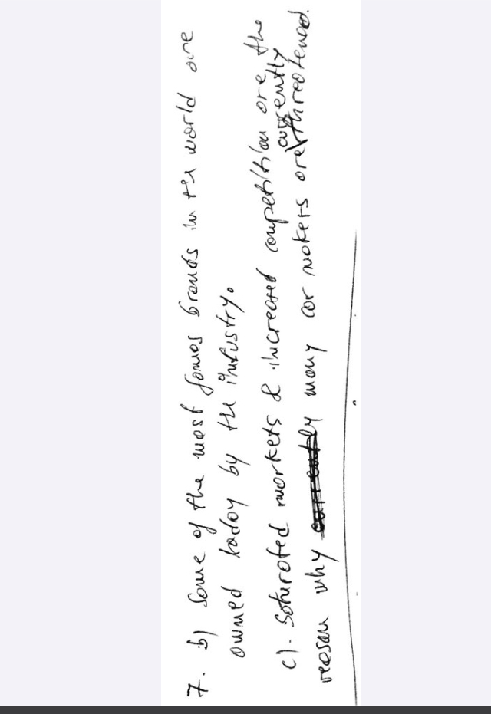

Appendix 4 – Paraphrasing Practice
2. Although poor training and inadequate resources have caused many plagiarism problems, the Internet has added to the challenges. At University of Toronto, plagiarism related to the Internet increased from 50% to 99% of cases between 2000-2001 and 2001-2002.
Source: Locker, Kitty and Findlay, Isobel. Business Communication Now. Toronto: McGraw-Hill, 2009. 251.
Source: http://highered.mcgraw-hill.com/sites/0070780412/student_view0/_____basic.html

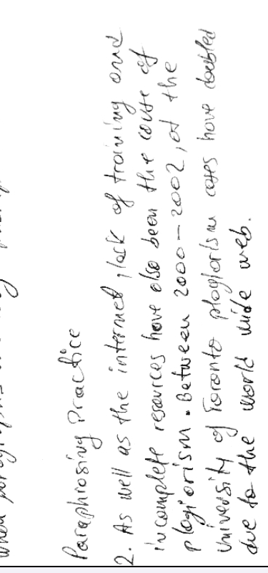

Appendix 5 – Referencing
HARVARD REFERENCING WORKSHOP

How would the following references be cited in your text, and formatted in your list of references?

Book
The Complete Guide to referencing and avoiding plagiarism by Neville, Colin
Book. English. 2nd ed. Published Maidenhead : Open University Press 2010
In text:
Neville. (2010).
In reference list:
Neville. (2010). The Complete Guide to referencing and avoiding plagiarism. Published Maidenhead: Open University Press. Colin Book. English, 2nd ed.

Chapter in an edited book
Cite a chapter by P Baty called Collaborative Learning from page 231 to page 248 contained in the following book: Study skills for Dyslexic students.
Hargreaves, Sandra
Book. English.
Published Los Angeles, Calif. ; London : SAGE 2007
In text: Baty. (2007).
In reference list:
Baty, P. (2007). Collaborative Learning. In Study skills for Dyslexic students.
Hargreaves, Sandra. Book. English. Published Los Angeles, Calif. , London : SAGE. Pp.231-248.

Journal articles
Putting the Defendant in Their Place: Why Do We Still Use the Dock in Criminal Proceedings? Mulcahy, Linda. British Journal of Criminology, volume 53, Issue 6 (2013): 1139-1156.
In text:
Mulcahy. (2013).
In reference list:
Mulcahy, L. (2013). Putting the Defendant in Their Place: Why Do We Still Use the Dock in
Criminal Proceedings? British Journal of Criminology, Vol. 53, Issue 6, pp.1139-1156.

Appendix 6 – Time management - two weeks calendar
- A normal working week
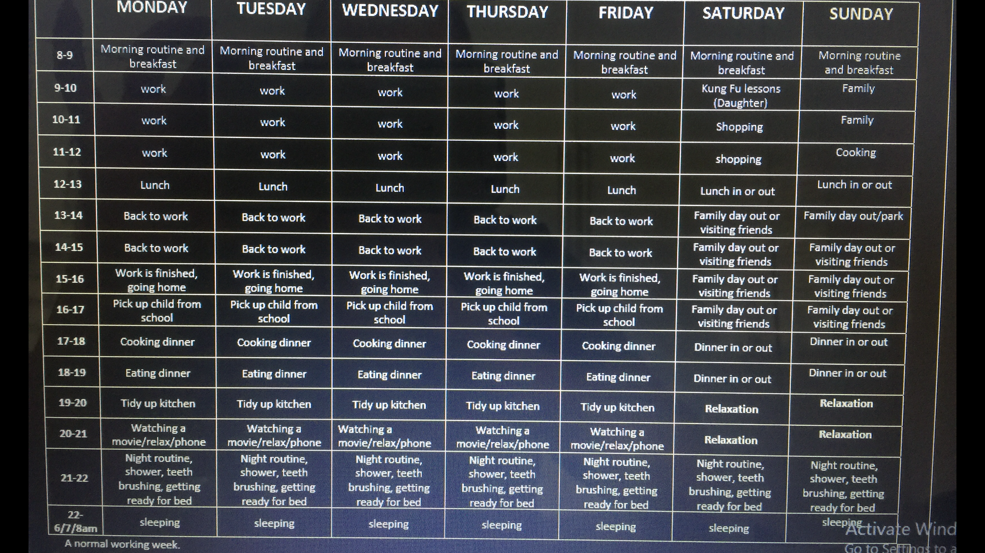

- A week in lockdown


