

Postgraduate/Distance Learning

Assignment coversheet & feedback form

THIS SHEET MUST BE THE FIRST PAGE OF THE ASSIGNMENT YOU ARE SUBMITTING (DO NOT SEND AS A SEPARATE FILE)

For completion by the student:
Student Name: Hilda Hermann

Student University Email: 1706721@student.uwtsd.ac.uk
Module code: HPCA7009  Module title: Skyscapes, Cosmology and Archaeology | Student ID number:  1706721 |  |  | Educational support needs:  No
Assignment title: Rock-art as celestial signposts? A skyscape study of rock-art at Tormain Hill, Ratho

Assignment due date: 29-07-2019
This assignment is for the 1st 2nd 3rd 4th 5th 6th module of the degree
I confirm that this is my original work and that I have adhered to the University policy on plagiarism.

Signed ……………………………………………………………………... Hilda Hermann

Email submission:if you are submitting this form via email, please tick this box □

(as a substitute for your signature) to confirm that you agree to the above declaration.
Assignment Mark
1st Marker’s Provisional mark
2nd Marker’s/Moderator’s provisional mark
External Examiner’s mark (if relevant)
Final Mark

NB. All marks are provisional until confirmed by the Final Examination Board.

For completion by Marker 1 :

Comments:

Marker’s signature: |  |  | Date:
For completion by Marker 2/Moderator:

Comments:

Marker’s Signature: |  | Date:
External Examiner’s comments (if relevant)

External Examiner’s Signature: |  | Date:

Rock-art as celestial signposts?
A skyscape study of rock-art at Tormain Hill, Ratho
Word count: 3 649

Introduction
The aim of this research is to explore Tormain Hill’s outcrop rock-art for any significant points of engagement with the skyscape that may indicate some form of intentional site selection and celestial signposting by its creators. While definitive dating of the rock-art is evasive, previous archaeological research indicates that the area was used by Neolithic and Bronze Age communities, which makes it contemporaneous with other rock-art sites. Using evidence from the literature review, the period 3500−3000 BCE was selected as the chronological baseline. The wider topic of spatial identity will also be addressed in terms of the external, infinite and continuous space in which the outcrop is set; the use of space on the rock, which is finite and non-continuous; and the structure and symmetry found in the engraved cup-and-ring marks.

Eight prehistoric carved rocks are sited on the summit of a knoll situated on a prominent whinstone ridge to the south-west of Ratho known as Tormain Hill, named possibly from the Gaelic tòrr meadhon, meaning ‘mid-/middle-hill’. The rocks are set on bedrock at ground level, or on boulders or outcrop bedrock above ground level, over an area approximately 10 x 5 m. The setting is in mature open woodland with grass cover, accessed by a footpath running the length of the ridge. Both the outcrop’s position in the landscape and the engraved stones’ near-horizontal aspect open up to the sky. As such, the stones do not appear to have an intervisibility role, and are obscure even from a short distance.
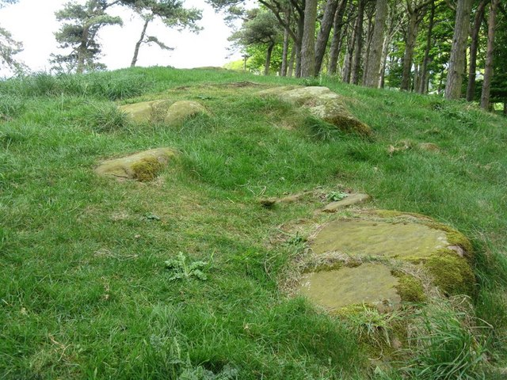

Figure 1: Tormain Hill rock-art site facing North. Tormain 1 is in the foreground. (Creative Commons, M.J. Richardson).
Literature review
In his book on the prehistoric rock-art of Galloway and the Isle of Man, Ronald Morris offers 104 possible explanations for the functions of rock carvings, of which only 11 are celestially related. This reflects the general tendency among the reviewed literature to overlook or dismiss the possibility of celestial connections. While Stan Beckensall contends that no-one can know what message rock-art conveyed to which group of prehistoric people, he has noted that, in some parts of the world, it offers a pictorial record of human activities, but that ‘in Britain rock-art consists almost entirely of abstract symbols’. He goes on to highlight the point that ritual and secular activities may not have been separated in earlier societies, and that the use of the same motifs to mark special places in the landscape, in graves and on standing stones may reveal different ways of thinking about them. Whereas cup-and-ring engravings on outcrop rock are common in many countries, Jackson suggests that it is only its context that most likely gives it a specific identity, and possibly meaning to its creator.

In Morris’s collation of his rock-art research findings from across Scotland, he identified that only one-in-eight of the carved surfaces sloped at an angle of over 20°, and that many are near-horizontal, which he suggests is noteworthy as carvings sloping at over 50° are common in other countries. However, he offers no explanation for this. Morris also highlights the tendency for rock-art sites to be situated at 100−200 m above sea-level, often with a sea view and ‘practically always in a very open situation’ – all criteria which are met by the Tormain Hill site. Listing 1 967 carvings from 270 sites, he claims these examples are more complex than the simple cup marks or dumb-bells (joined cups), and that ‘there are at least twice as many other sites where only cup marks or dumb-bells are to be found’.

Writing in 1864, the physician James Y. Simpson published one of the earliest works on rock engravings and provided recordings and observations of all the known engraved rocks in Scotland at that time. However, as Peter Jackson points out, Simpson merged his discussion of natural rock carvings with the quite distinct passage grave carvings, which are considered megalithic art. As mentioned in the introduction to this paper, dating rock-art is readily acknowledged to be elusive. Previously considered solely a Bronze Age phenomenon, it is now generally thought of as Neolithic, with its use extending into the Bronze Age. Simpson and Thawley, among others, acknowledge cup-and-ring markings in Irish passage graves as evidence for the origins of the carvings on natural rock. The cup-and-ring markings found at Newgrange give a date of 3200 BCE, which aligns with estimates made by James Simpson in the 1860s who, writing about those who ‘first sculpted our rocks and stones with rude and archaic cups and rings’ suggested that ‘the adoption and even more extended use of these form of ornamental and possibly religious symbols passed down in all likelihood … to the inhabitants of the Bronze Age with its era of cremation and urn burial, and thence onward to other and later times’. Baildon notes that the carvings show no evidence of Bronze Age ornament, thereby assuming they must have been created earlier and then adopted by the Bronze Age. Of interest to skyscape researchers is Jackson’s note of an absence of cup-and-ring symbols at Ballochroy and Calanais, both of which are acknowledged astronomical sites.

According to John Coles and A.F. Harding, many Bronze Age barrow graves reflect the cup-and-ring in their design and a similar spatial pattern in their grouping, and it is thought that this relation may also apply to other structures such as henges and stone circles. For Richard Bradley, in the context of monument building, ‘circular constructions reflect a perception of space that extends outwards from the individual and upwards into the sky’, suggesting that this could also be represented in cup-and-ring rock-art. This alludes to a three-level spatial identity: the external, infinite and continuous space in which the outcrop is set, in positions which frequently had a panoramic view (emphasising the infinite space); the use of space on the rock, which is finite and non-continuous; and high degree of structure and symmetry in the cup-and-ring marks. This circular concept suggested that it would be appropriate to investigate the Tormain site in a similar way, but from a skyscape perspective, since, as Ruggles points out, attempts to ascribe meaning to designs are speculative in the absence of contextual evidence.

The most recent survey of the Tormain Hill rock-art panels was completed in 2019 by the Scottish Rock Art Project (ScRAP), which is currently researching, identifying and recording rock-art sites across Scotland. With more verified data on Scottish rock-art becoming available, there will be opportunities for further skyscape analyses to add to the archaeological record.

Methodology
With the idea of exploring connections between the Tormain Hill rock-art and the sky, the methodology considered three aspects: (a) conducting a horizon survey of celestial rising and setting points in relation to the site, conscious of estimate dating; (b) identifying any linear relationships to other potentially meaningful sites located below the horizon line but within the observable viewshed; and (c) considering any potential connections between the site’s rock-art imagery and the skyscape.

Horizon survey
The methodology used followed Ruggles’s guidelines for horizon surveys. Before any data was recorded, several visits were made to Tormain Hill between April and June 2019 to observe the sky, the site and its situation within the landscape at different times of the day and in varying weather conditions. Photographs were taken at the site and sketches of the visible skyline were made where this was not obstructed by vegetation. Location and elevation co-ordinates were recorded using a handheld GPS, and a tandem compass-clinometer was used to determine azimuths and horizon-point altitudes. Ranging rods were used to mark out azimuths and, from a standing position, reverse measurements of the cardinal points were taken to check for magnetic anomalies before measuring the horizon at every 10° of azimuth (magnetic) where there were no visibility constraints. Data was also recorded for specific landscape features, and the aspect and slope of each rock-art panel was noted. A 360° panorama was generated using HeyWhatsThat (Appendix 1), which enabled parts of the horizon profile that had been obscured by vegetation to be identified, and data recorded at the site to be checked. Magnetic azimuths were corrected to true azimuths using the value obtained from the National Oceanic and Atmospheric Administration (NOAA) declination calculator. Horizon declination values were then calculated to be able to compare this data with known values for solar, lunar and first-magnitude star alignments for 3500 BCE and 3 000 BCE using Stellarium planetarium software, thereby bridging the estimated chronology for the rock-art panels informed by the literature review and contextualising the sky at that time.

Linear relationships to other sites
A brief desktop study was done to identify any possible alignments of the Tormain Hill site with other potentially relevant sites, including other rock-art sites, located within the observable viewshed that had been noted while undertaking fieldwork, the literature review, and from ScRAP and Canmore data. This was done using the HeyWhatsThat map’s line-of-sight function, for identification purposes only, as detailed investigation of each of these points was beyond the scope of this skyscape study.

Rock-art imagery
The dimensions, orientation and relational position of the rock-art panels were noted on site and verified against existing ScRAP data. Possible celestial symbolism of the engravings was considered using Stellarium alongside existing 3D models of the panels uploaded to Sketchfab. Images of the panels are presented in Appendix 1.

As a check on interpreting research results, Glyn Daniel’s reminder of ‘the inadequacy and incompleteness of the prehistoric record; the subjectivity of the art of historical interpretation; and the necessity to use parallels … in no deterministic way but as pointers to the possibility of interpretation’ was adopted, alongside Boas’s assessment that, not only do symbols have a variety of meanings, but that one meaning may have a variety of symbols.

Results
Significant range-of-visibility differences became apparent when comparing field data with the HeyWhatsThat-generated 360° panorama. This was primarily attributed to the often-variable weather conditions experienced in Scotland. It was noted that, given the time of year during which the observations and data recording took place (April−July 2019), there were also visibility constraints due to vegetation that would not have been a factor had the survey been conducted in winter months. Although higher accuracy could be achieved using the digital panorama and map data, the identification of potentially significant points of interest in relation to the site was found to be inadequate and referencing ordnance survey maps became necessary to identify some of the landscape features within the Tormain Hill viewshed.

Collating the horizon declination values with celestial declinations drew attention to several connections between landscape features, some of which are verified rock-art sites, and celestial events that would have been visible to the naked eye during the timeframe suggested for the creation of the Tormain Hill rock-art (3500 BCE to 3000 BCE). Notable associations included: the rising autumn equinoctial full moon (maximum declination) and Spica aligned with the Isle of May (Az. 53°, Alt. 0°); Altair with Arthur’s Seat (Az. 73°−76°, Alt. 1−2°); the rising spring equinoctial full moon (maximum declination) with Traprain Law (Az. 83°, Alt. 2°), which is another significant rock-art site; Sirius with Black Hill (Az. 136°, Alt. 2°); the winter solstice and Sirius with Scald Law (Az. 143°, Alt. 2°); Rigel with South Black Hill, East Kip, Hare Hill and Cap Law (Az. 145°−154°, Alt. 2°); and Spica aligned with Ben Cruachan (Az. 299°, Alt. 0°).

The aspect connections of Tormain Hill’s eight carved stones also seem to be particularly noteworthy: North (Tormain 4), East (Tormain 5); South (Tormain 6), South-South-West / the moon’s southern major limit (Tormain 7); South-West / winter solstice setting (Tormain 1), West-South-West / the moon’s southern minor limit (Tormain 2); West (Tormain 3); and North-West / summer solstice setting (Tormain 8). While one may be tempted to make the assumption that the emphasis towards solar and lunar setting points played a significant role, there is the possibility that other stones oriented to rising points may at some time have been removed or destroyed. What is clear from the layout, however, is that the most detailed rock-art (Tormain 1) engaged with the winter solstice setting. Matching this with the winter solstice rising over Scald Law, the highest hill in the Pentlands range, suggests that some discussion can be had about this celestial feature alongside its close connection to Sirius (lucida of Canis Minor) and Rigel (lucida of Orion).

Several intervisible linear relationships were identified between Tormain Hill and other sites of interest, most notably Corstorphine Hill (Az. 59°), Dalmahoy Hill (Az. 164°), Kaimes Hill (Az. 179°), Binny Craig (Az. 296°), Galabraes standing stone (Az. 270°), Cairnpapple Hill (Az. 276°), the Witches’ Stone (Az. 290°), and Huly Hill cairn (Az. 348°).
While no definitive celestial symbolism or interpretations could be made of the rock-art imagery through simple observation, a focused study of the stone markings within a skyscape context may reveal different results. It was, however, noted that the highest tonal contrast was achieved when the sun or moon was at its greatest oblique angle, in the early morning or evening.

Discussion
An early documenter of the Tormain Hill rock-art, J. Romilly Allen, rejected any celestial theory about the stones on the basis that no relation to star patterns could be found and considered religious symbolism most likely. However, as Jackson points out, ‘this does not need to be distinct from a stella theory, or other possible functions or explanations’. Martin Brennan, using diagrammatic relations to celestial activity, has demonstrated that the forms or designs do not need to equate to visual reality. While no literature could be found for astronomical associations with Tormain Hill, the results of this research indicates several landscape-skyscape connections for the winter solstice. This raises the question of whether the stones’ arrangement was intentional and, if so, how astronomical precision could have been achieved in prehistoric times? The answer to this can be found in simple astronomical observations and measurements that can be made using one’s hands and fingers.

Rock-art in the landscape is oriented to the sky, unlike rock-art used in burials, which was not intended to be seen. Despite a differing perception of use, this, as Beckensall suggests, indicates that a ritual/religious significance is retained. Despite the extensive views from the site and the visual proximity of the coast, the Tormain stones and their carvings cannot be seen until you are almost next to them and this lack of intervisibility, unlike that of standing stones, indicates that people may have had prior knowledge of where they were. The orientation to predominantly west (setting) facing is in distinct contrast with Morris’s observation that ‘perhaps those in Argyll tended to choose north-facing slopes, while those in Galloway and the rest of the west had a slight preference for south-facing ones’, suggesting that outcrop rock-art aspects require further research and may indicate a split in belief systems and the use of different sites.

Kate E. Sharpe has suggested that the carvings may represent topographical features of the landscape. Looking carefully at Tormain 1, there is vague resemblance of part of the horizon line and a crag-and-tail representation, which is a geomorphological feature of the prominent Arthur’s Seat and the closer Kaimes Hill and Binnie Craig. It is also not improbable to suggest that the cups and rings and curved dumb-bells indicate not only the above-horizon, but also the hidden-from-view beyond-horizon movement of celestial elements that could have been observed at different location. There are frequent references made to interruptions or parts of symbols being found on the edges of rock surfaces, which in a skyscape context may indicate celestial elements disappearing below the horizon, possibly suggesting some form of rock marginalia. Do the lines run into the earth or into the sky, or both, which may hold some funerary significance and offer an explanation for rock-art used as grave art? Why were carvings needed? Were they used as a form of storytelling to convey cyclic allegory? According to George Tate, ‘groups of concentric circles may show their ideas of the motion of the heavenly bodies … possibly the grooves passing from the centre of one system of circles to another might symbolise the passage of a soul from one state of being into another higher state’. This concept reflects, as Jackson has suggested, a spatial model which can be developed as an escalating continuum, from the finite cup mark, surrounded by delineated concentric space, expanding into the variability of the immediate surroundings, and on into the infinite. Beckensall’s reference to the ‘abstract designs’ that seemingly fell out of use may indicate that Neolithic symbolism became incompatible with the cosmology of the Bronze Age.

Conclusion
The aim of this research was to explore Tormain Hill’s outcrop rock-art for any significant links with the skyscape that may indicate some form of intentional site selection and celestial signposting by its creators, and the wider topic of spatial identity conveyed by cup-and-ring marks. Ruggles’s horizon survey methodology was adopted and, while acknowledging the issues surrounding definitive dating, the period 3500−3000 BCE was selected as the baseline for celestial data. The evidence suggests that Tormain Hill was used as a site for celestial observation and recording astronomical events, and served as some form of direction or route indicator, reflecting movement through the landscape. Although there has been no archaeological evidence for ritual activity at the site, this does not exclude the rock-art from being a cultural ingredient that gave meaning to the social dimension and held meaning for its Neolithic creators and audience. Whatever the date of the carvings, and whether scientific, symbolic or interpretive, the rock-art statements part of the landscape and conveys intention. The results from Tormain Hill cannot simply be extrapolated to other sites, which means there is a case to be made for conducting skyscape horizon surveys of other outcrop rock-art sites to gauge for any celestially-related similarities and provide scientifically valid data that can make a contribution to the archaeological record.

Appendix 1: Descriptive data

Tormain Hill Rock-Art
Latitude N 55° 54′ 44.0″
Longitude W 03° 23′ 41.7″
Elevation 151 m
GPS error 2 m

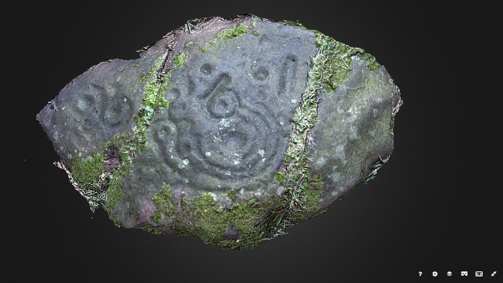
Figure A1: Tormain Hill 1
Canmore ID: 50365
ScRAP ID: 3121
Dimensions: 1.4 x 0.8 x 0.2 m
Aspect: SW
Approx. slope: 14 – 4°
Located at the extremity of the grouping to the SSE.
In relation to Tormain 1, Tormain 7 is the closest, lying 1.8 m to the NNE, Tormain 8 lying 2.5 m to the E, and Tormain 2 lying 2.2 m to the N.

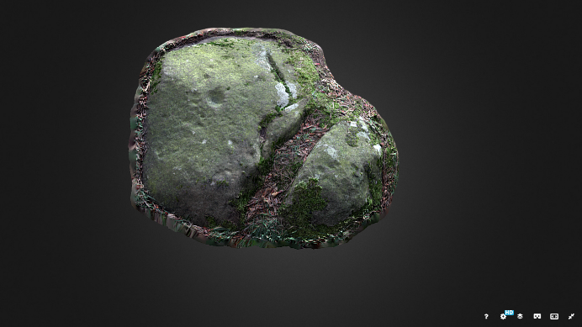
Figure A2: Tormain Hill 2
Canmore ID: 50365
ScRAP ID: 3122
Dimensions: 0.8 (l) x 0.6 (w) x 0.1 (h) m
Aspect: WSW
Approx. slope: 2 – 10°
Located at the extremity of the grouping to the E.
In relation to Tormain 2, Tormain 3 lies 0.9 m to the NNE, with Tormain 1 lying 2.2 m to the S.

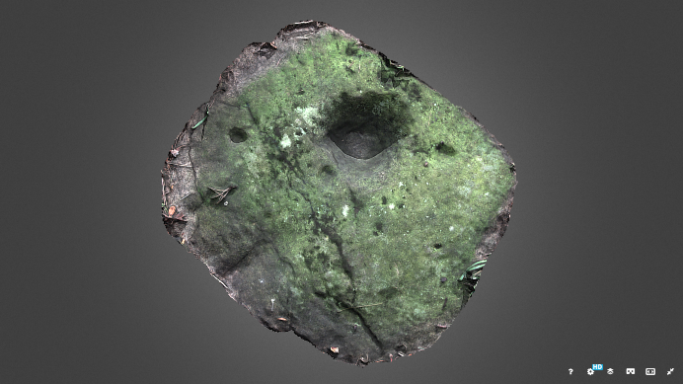
Figure A3: Tormain Hill 3
Canmore ID: 50365
ScRAP ID: 3123
Dimensions: 0.6 x 0.5 x 0 (h) m
Aspect: W
Approx. slope: 4 – 10°
Located at the outer edge of the grouping at the NNW edge
In relation to Tormain 3, Tormain 2 lies 0.9 m to the SW with Tormain 4 lying 4.5 m to the NEE.

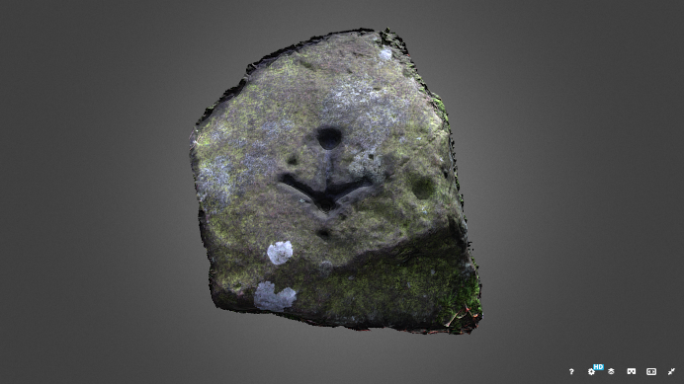
Figure A4: Tormain Hill 4
Canmore ID: 50365
ScRAP ID: 3125
Dimensions: 0.8 x 0.6 x 0.2 m
Aspect: N
Approx. slope: 5 – 1°
Located at the outer edge of the grouping at the NNE edge.
In relation to Tormain 4, Tormain 3 lies 4.5 m to the SWW with Tormain 5 lying 4 m to the S.

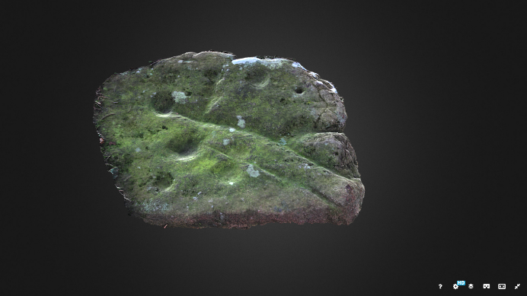
Figure A5: Tormain Hill 5
Canmore ID: 50365
ScRAP ID: 3127
Dimensions: 0.5 x 0.4 x 0.2 m
Aspect: E
Approx. slope: 4 – 1°
Located at the outer edge of the grouping at the EES edge.
In relation to Tormain 5, Tormain 4 lies 4m to the N with Tormain 6 lying 2.1m to the W.

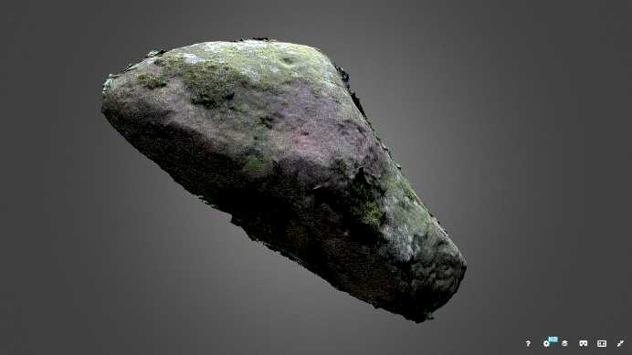
Figure A6: Tormain Hill 6
Canmore ID: 50365
ScRAP ID: 3128
Dimensions: 0.6 x 0.4 x 0.2−0.1 m
Aspect: S
Approx. slope: 4– 2°
Located at the centre of the grouping.
In relation to Tormain 6, Tormain 5 lies 2.1 m to the E, Tormain 3 lies 1.5 m to the NW, and Tormain 7 lies 0.1 m to the SSW.
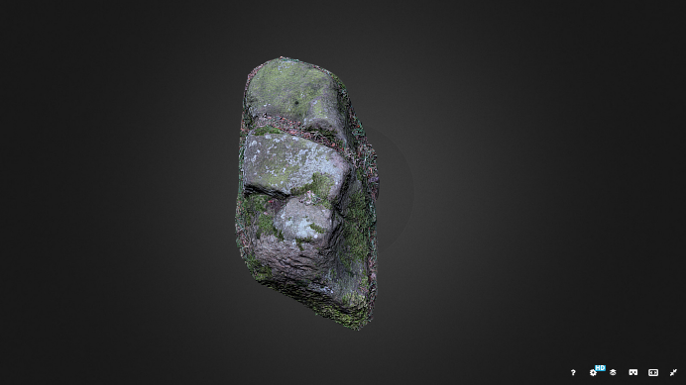
Figure A7: Tormain Hill 7
Canmore ID 50365
ScRAP ID 3129
Dimensions: 0.5 (l) x 0.3 (w) x 0.4 (h) m
Aspect: SSW
Approx. slope: 5 – 1°
Located at the centre of the grouping
In relation to Tormain 7, Tormain 6 lies 0.1 m to the NNE, Tormain 3 lying 0.5 m to the N, and Tormain 1 lying 1.8 m to the SSW.

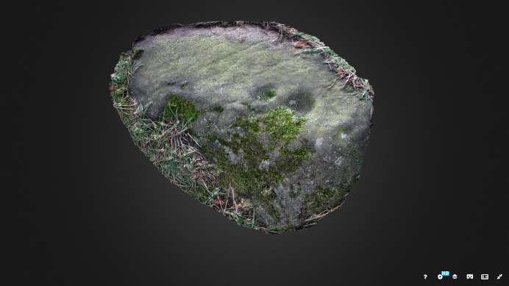
Figure A8: Tormain Hill 8
Canmore ID 50365
ScRAP ID 3130
Dimensions: 0.4 (l) x 0.3 (w) x 0 (h) m
Aspect: NW
Approx. slope: 9 – 18°
Located at the S extremity of the grouping
In relation to Tormain 8, Tormain 7 lies 0.1 m to the SSE, with Tormain 1 lying 2.5 m to the W.

Sketchfab/Tormain 3D models published by ‘mothyrockart’, March 2019.
https://sketchfab.com/search?q=tormain&sort_by=-pertinence&type=models

Additional data on the stones are available from the ScRAP rock-art database.
https://www.rockart.scot/

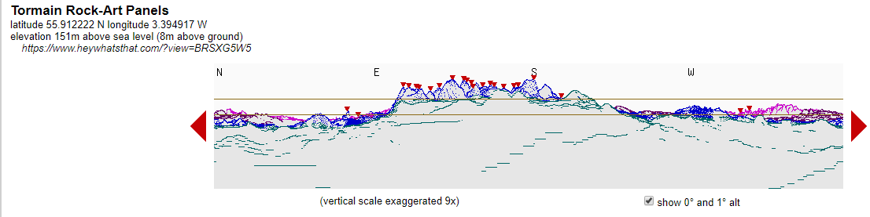
Figure A9: HeyWhatsThat 360 °panorama for Tormain Hill Rock-Art Panels.
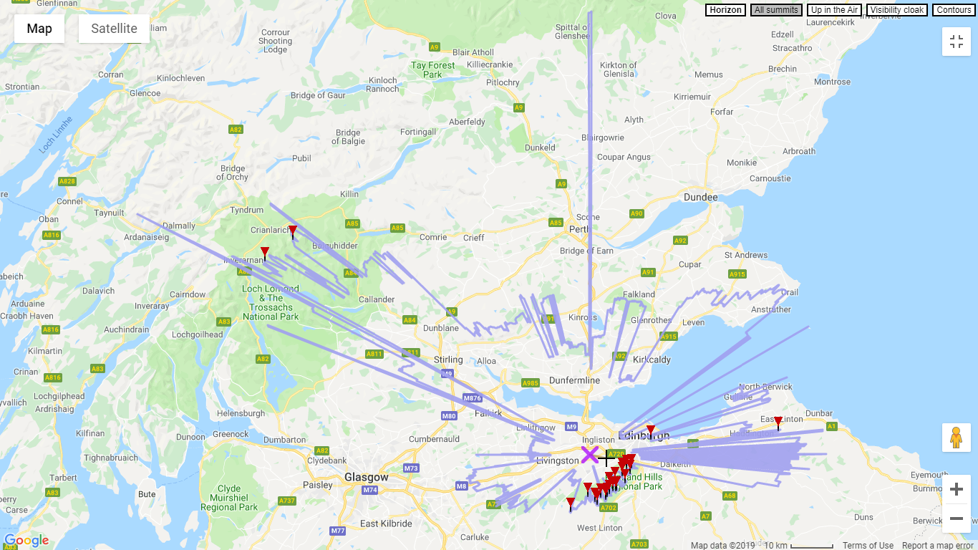

Figure A10: HeyWhatsThat horizon outline map for Tormain Hill Rock-Art Panels.

Appendix 2: Landscape and celestial data

Landscape
Magnetic anomaly 0°
Declination 1° 53′ W changing by 0° 13′ per year
Uncertainty 0° 24′

Table B1: Landscape and celestial data for the Tormain Hill Rock-Art Panels site.
Az. (°) | Alt.  (°) | Dec.  (°) | Landscape ID | Celestial ID | Celestial Dec. (°)
40 | 0 | 25.43 |  | Capella | 23.12 (3500 BCE)  25.91 (3000 BCE)
 |  |  |  | Summer solstice | 24
 |  |  |  | Regulus | 23.17 (3500 BCE)  23.83 (3000 BCE)
50 | 0 | 21.12 |  | Pollux | 20.61 (3500 BCE)  22.82 (3000 BCE)
 |  |  |  | Rising autumn EFM (max. dec.) | 17.69
59 | 0 | 16.78 | Isle of May  Corstorphine Hill | Spica | 17.03 (3500 BCE  15.08 (3000 BCE)
60 | 0 | 16.27 |  | Spica
70 | 0 | 11.05 |  | Altair | 11.55 (3500 BCE)  9.89 (3000 BCE)
74 | 1 | 10.21 | Arthur’s Seat (L) | Altair
77 | 2 | 9.40 | Arthur’s Seat (peak) | Altair
83 | 2 | 5.58 | Traprain Law | Rising spring EFM (max. dec.) | 5.48
 |  |  |  | Rising EFM (most frequent dec.) | 3.85
88° | 2 | 3.27 |  | Procyon | 1.21 (3500 BCE)  3.00 (3000 BCE)
 |  |  |  | Antares | −1.04 (3500 BCE)  −3.87 (3000 BCE)
 |  |  |  | Rising spring EFM (most frequent dec.) | −3.02
 |  |  |  | Rising autumn EFM (min. dec.) | −5.58
100 | 0 | −5.59 |  | Aldebaran | −7.84 (3500 BCE)  −5.03 (3000 BCE)
108 | 2 | −8.29 | Allermuir Hill | Betelgeuse | −10.22 (3500 BCE)  −7.34 (3000 BCE)
111 | 2 | −9.89 | Capelaw Hill | Betelgeuse
115 | 2 | −12.05 | Castlelaw Hill
117 | 2 | −13.03 | Harbour Hill
 |  |  |  | Rising spring EFM (min. dec) | −15.12
123 | 1 | −16.96 | Bell’s Hill
128 | 1 | −19.36 | Turnhouse Hill
136 | 2 | −21.96 | Black Hill | Sirius | −24.18 (3500 BCE)  −22.34 (3000 BCE)
 |  |  |  | Winter solstice | −24
143 | 2 | −24.74 | Scald Law | Sirius
145 | 2 | −25.46 | South Black Hill | Rigel | −28.48 (3500 BCE)  −25.47 (3000 BCE)
147 | 2 | −26.16 | East Kip | Rigel
148 | 2 | −26.49 | Hare Hill | Rigel
154 | 2 | −28.33 | Cap Law | Rigel
158 | 2 | −29.37 | Green Law
160 | 2 | −29.83 | Spittal Hill
163 | 1 | −31.45 | Dalmahoy Hill
166 | 2 | −30.97 | Cock Rig
172 | 2 | −31.72 | The Mount
174 | 2 | −31.88 | Wether Law
179 | 1 | −33.08 | Kaimes Hill
183 | 2 | −32.04 | East Cairn Hill
199 | 1 | −31.02 | Mealowther Hill
 |  |  |  | Winter solstice | −24
260 | 0 | −5.59 |  | Aldebaran | −7.84 (3500 BCE)  −5.03 (3000 BCE)
 |  |  |  | Antares | −1.04 (3500 BCE)  −3.87 (3000 BCE)
270 | 0 | 0 | Galabraes standing stone
 |  |  |  | Procyon | +1.21 (3500 BCE)  +3.00 (3000 BCE)
277 | 3 | 5.91 | Cairnpapple Hill
290 | 0 | 11.05 | Witches’ Stone | Altair | +11.55 (3500 BCE)  +9.89 (3000 BCE)
296 | 1 | 14.61 | Binny Craig
296 | 0 | 14.22 | Ben Vorlich
299 | 0 | 15.77 | Ben Cruachan | Spica | +17.03 (3500 BCE)  +15.08 (3000 BCE)
301 | 0 | 16.78 | Beinn Chabhair | Spica
306 | 0 | 19.23 | Am Binnein
307 | 0 | 19.71 | Ben More
310 | 0 | 21.12 |  | Pollux | +20.61 (3500 BCE)  +22.82 (3000 BCE)
 |  |  |  | Regulus | +23.17 (3500 BCE)  +23.83 (3000 BCE)
 |  |  |  | Summer solstice | +24
320 | 0 | 25.43 |  | Capella | +23.12 (3500 BCE)  +25.91 (3000 BCE)
324 | 1 | 27.56 | Ben Cleuch
326 | 1 | 28.30 | King’s Seat
342 | 0 | 32.21 | Knock Hill
348 | 0 | 33.24 | Hully Hill Cairn

References
Allen, J. Romilly. ‘Notes on some undescribed stones with cup-markings in Scotland’, Proceedings of the Society of Antiquaries of Scotland, 16 (1882), 79−143. Available at: http://journals.socantscot.org/index.php/psas/article/
view/6006 [Accessed 23 April 2019].
Baildon, W.P. ‘Cup and ring carvings: Some remarks on their classification and a new suggestion as to their origin and meaning’, Archaeologia, 61 (1909), 361−380.
Barclay, G.J. ‘Neolithic settlement in the lowlands of Scotland: a preliminary survey’, in Armit, I., Murphy, E., Nelis, E. and Simpson D.D.A. (eds). Neolithic Settlement (Oxford: Oxbow Books, 2003), 71−83.
Beckensall, Stan. British Prehistoric Rock Art (Stroud: Tempus Publishing, 1999).
Boas, Franz. Primitive Art (New York: Dover Publications, 1955).
Bradley, Richard. ‘Rock art and the perception of landscape’, Cambridge Archaeological Journal, 1 (1991), 77−101.
Bradley, Richard. The Significance of Monuments: in the shaping of human experience in Neolithic and Bronze Age Europe (London: Routledge, 1998).
Brennan, Martin. The Stars and the Stones: Ancient art and astronomy in Ireland (London: Thames and Hudson, 1983).
Brophy, Kenneth, MacGregor, Gavin and Ralston, Ian (eds). The Neolithic of Mainland Scotland (Edinburgh: Edinburgh University Press, 2016).
Burl, Aubrey. Prehistoric Astronomy and Ritual (New York: Bloomsbury, 2008).
Coles, Fred R. ‘Notice of the discovery of a cist with a double burial at Ratho Quarry’, Proceedings of the Society of Antiquaries of Scotland, 32 (1898), 44−50. Available at: http://journals.socantscot.org/index.php/psas/article/view/
6689 [Accessed 23 April 2019].
Coles, John M. and Harding, A.F. The Bronze Age in Europe (London: Methuen, 1979).
Daniel, Glyn. Some Small Harvest: The memoirs of Glyn Daniel (London: Thames and Hudson, 1986).
Dunkinfield Astley, H.J. ‘Cup- and ring-markings: Their origin and significance’, The Journal of the Royal Anthropological Institute of Great Britain and Ireland, 41 (1911), 83−100.
Edinburgh Geological Society. ‘Dalmahoy and Kaimes Hills’. Available at https://www.edinburghgeolsoc.org/geological-site/dalmahoy-and-kaimes-hills/ [Accessed 14 July 2019].
Fairén-Jiménez, Sara. ‘British Neolithic rock art in its landscape’, Journal of Field Archaeology, 32:3 (2007), 283−295.
Forum on International Standards in Heritage (FISH). ‘Periods List’ (Historic England). Available at http://heritage-standards.org.uk/wp-content/uploads/2015/08/Periods-List-HE-FISH-WP.pdf [Accessed 14 July 2019].
Historic Scotland. Carved Stones (Edinburgh: Historic Scotland, 2011).
Jackson, Peter J. ‘An investigation into the prehistoric cup and ring engravings of the British Isles, with reference to Galacia’ (PhD thesis, Middlesex University, 1989).
James, A.G. and Taylor, S., incorporating the work of A. Watson and E.J. Basden. ‘Index of Celtic and other Elements in W.J. Watson’s The History of the Celtic Place-names of Scotland’ (revised and corrected: 2017). Available at https://spns.org.uk/wp-content/uploads/2017/08/Index_of_Celtic_and_Other_Elements.pdf [Accessed 23 April 2019].
MacKie, E.W. ‘Archaeological tests on supposed prehistoric astronomical sites in Scotland’, Philosophical Transactions of the Royal Society of London. Series A, Mathematical and Physical Sciences, 276:1257 The Place of Astronomy in the Ancient World (1974), 169−194.
Mazel, A., Nash, G. and Waddington, C. (eds). Art as Metaphor: The prehistoric rock-art of Britain. (Oxford: Archaeopress, 2007).
McAdam, D. Edinburgh and West Lothian: A landscape fashioned by geology. (Perth: Scottish Natural Heritage, 2003).
Moffat, Alistair. Before Scotland: The story of Scotland before history (London: Thames and Hudson, 2005).
Morris, Ronald W.B. The Prehistoric Rock Art of Galloway & The Isle of Man (Poole: Blandford Press, 1979).
Morris, Ronald W.B. The Prehistoric Rock Art of Southern Scotland, BAR British Series 86 (Oxford: British Archaeological Reports, 1981).
Piggot, Stuart. ‘Excavation of the Dalladies long barrow, Fettercairn, Kincardineshire’, Proceedings of the Society of Antiquaries of Scotland, 104 (1971), 23−47. Available at: http://journals.socantscot.org/index.php/psas/article/view/8809 [Accessed 23 April 2019].
Ruggles, Clive. Astronomy in Prehistoric Britain and Ireland (New Haven and London: Yale University Press, 1999).
Ruggles, Clive (ed). Records in Stone: Papers in memory of Alexander Thom (Cambridge: Cambridge University Press, 2003).
Sharpe, Kate E. ‘Rock art and rough outs: Exploring the sacred and social dimensions of prehistoric carvings at Copt Howe, Cumbria’, in Mazel, A., Nash, G and Waddington, C. (eds). Art as Metaphor: The prehistoric rock art of Britain (Oxford: Archaeopress, 2007), 169.
Silva, Fabio. ‘Reference Tables for Skyscape Archaeology’. 22 January 2019. Available at: https://s3.eu-west-2.amazonaws.com/skyscape-archaeology/ReferenceTables.html [Accessed 16 July 2019].
Simpson, D.D.A., Gregory, R.A., Murphy, E.M., Clarke, A., Cram, L., Gormley, S., Holmes, N.M.McQ., Hunter, F., McCartney, M., McGill, C. and Nelis, E. ‘Excavations at Kaimes Hill, Ratho, City of Edinburgh, 1964−72’, Proceedings of the Society of Antiquaries of Scotland, 134 (2005), 65−118. Available at: http://journals.socantscot.org/index.php/psas/article/view/
9600 [Accessed 23 April 2019].
Simpson, D.D.A. and Thawley, J.E. ‘Single grave art in Britain’, Scottish Archaeological Forum, 4 (1972), 81−104.
Simpson, James Y. ‘On the ancient sculpturings of the cup and ring’, Proceedings of the Society of Antiquaries of Scotland,
6 (1864), Appendix.
Smith, Andrea N., Battley, N., Dixon, D., Finlay, N., Carter, S., Holden, T., Mills, C., Norton, A., MacSween, A., McSweeney, K. and Rankin, D. ‘The excavation of Neolithic, Bronze Age and Early Historic features near Ratho, Edinburgh’, Proceedings of the Society of Antiquaries of Scotland, 125 (1996), 69−138. Available at: http://journals.socantscot.org/index.php/
psas/article/view/9884 [Accessed 23 April 2019].
Smith, John A. ‘Notes of rock sculpturings of cups and concentric rings, and “The Witch’s Stone” on Tormain Hill; also of some Early Remains on the Kaimes Hill, &c., near Ratho, Edinburghshire’, Proceedings of the Society of Antiquaries of Scotland, 10 (1873), 141−151. Available at: http://journals.socantscot.org/index.php/psas/article/view/5658 [Accessed 23 April 2019].
Tate, George. The Ancient British Sculptured Rocks of Northumberland and Eastern Borders (Alnwick, 1865), 41.
Tilley, Christopher. A Phenomenology of Landscape (Oxford: Berg, 1994).
Vastokas, J. ‘Interpreting prehistoric art: method and theory’, Archaeology Notes, 78 (1978), 21−24.

Websites
Cairnpapple Archaeological Research Association, West Lothian, Scotland (CARA): http://www.cara.tgis.co.uk/
[Accessed 14 July 2019].
Canmore: https://canmore.org.uk/ [Accessed 14 July 2019].
Constellations of Words: http://www.constellationsofwords.com/ [Accessed 14 July 2019].
Ordnance Survey (OS) GB: https://osmaps.ordnancesurvey.co.uk/ [Accessed 14 July 2019].
Scottish Rock Art Project (ScRAP): https://www.rockart.scot/ [Accessed 14 July 2019].
Sketchfab: https://sketchfab.com/ [Accessed 14 July 2019].
Sketchfab/Tormain 3D models: https://sketchfab.com/search?q=tormain&sort_by=-pertinence&type=models. Published by ‘mothyrockart’ (March 2019) [Accessed 14 July 2019].

Software
Fabien Cherau, Stellarium v0.19.1. https://www.stellarium.org/
Fabio Silva, SkyscapeR v0.4b, https://archaeofsilva.shinyapps.io/skyscapeR-legacy/
HeyWhatsThat: https://www.heywhatsthat.com/
National Oceanic and Atmospheric Administration (NOAA): https://www.ngdc.noaa.gov/geomag/calculators/
magcak.shtml#declination

Gordon J. Barclay. ‘Neolithic settlement in the lowlands of Scotland: a preliminary survey’, in Armit, I., Murphy, E., Nelis, E. and Simpson D.D.A. (eds). Neolithic Settlement (Oxford: Oxbow Books, 2003), 71−83; Andrea N. Smith, Battley, N., Dixon, D., Finlay, N., Carter, S., Holden, T., Mills, C., Norton, A., MacSween, A., McSweeney, K. and Rankin, D. ‘The excavation of Neolithic, Bronze Age and Early Historic features near Ratho, Edinburgh’, Proceedings of the Society of Antiquaries of Scotland, 125 (1996), 69−138;
Peter J. Jackson. ‘An investigation into the prehistoric cup and ring engravings of the British Isles, with reference to Galacia’ (PhD thesis, Middlesex University, 1989), 258, 281−282; Ronald W.B. Morris. The Prehistoric Rock Art of Southern Scotland, BAR British Series 86 (Oxford: British Archaeological Reports, 1981), 169.
Norman Dixon. ‘The Placenames of Midlothian’ (PhD thesis, University of Edinburgh, 1947), 192.
Detailed descriptions of the site and the rock-art panels are available at https://www.rockart.scot/ [Accessed 22 July 2019].
Ronald W.B. Morris. The Prehistoric Rock Art of Galloway & The Isle of Man (Poole: Blandford Press, 1979).
Stan Beckensall. British Prehistoric Rock Art (Stroud: Tempus Publishing, 1999), 7, 34.
Beckensall, British Prehistoric Rock Art, 37.
Jackson, ‘An investigation into the prehistoric cup and ring engravings of the British Isles’, 218.
Morris, The Prehistoric Rock Art of Southern Scotland, 172.
Morris, The Prehistoric Rock Art of Southern Scotland, 173.
Morris, The Prehistoric Rock Art of Southern Scotland, 165.
James Y. Simpson. ‘On the ancient sculpturings of the cup and ring’, Proceedings of the Society of Antiquaries of Scotland, 6 (1864), Appendix.
Jackson, ‘An investigation into the prehistoric cup and ring engravings of the British Isles’, 37.
Forum on International Standards in Heritage (FISH). ‘Periods List’ (Historic England). Available at http://heritage-standards.org.uk/wp-content/uploads/2015/08/Periods-List-HE-FISH-WP.pdf [Accessed 14 July 2019]; Stuart Piggot. ‘Excavation of the Dalladies long barrow, Fettercairn, Kincardineshire’, Proceedings of the Society of Antiquaries of Scotland, 104 (1971), 23−47; Sara Fairén-Jiménez. ‘British Neolithic rock art in its landscape’, Journal of Field Archaeology, 32:3 (2007), 283−295.
D.D.A. Simpson and J.E. Thawley. ‘Single grave art in Britain’, Scottish Archaeological Forum, 4 (1972), 81−104.
James Y. Simpson, ‘On the ancient sculpturings of the cup and ring’, 110.
W.P. Baildon. ‘Cup and ring carvings: Some remarks on their classification and a new suggestion as to their origin and meaning’, Archaeologia, 61 (1909), 361−380.
Jackson, ‘An investigation into the prehistoric cup and ring engravings of the British Isles’, 107.
John M. Coles and A.F. Harding. The Bronze Age in Europe (London: Methuen, 1979), 266−7.
Richard Bradley. The Significance of Monuments: In the shaping of human experience in Neolithic and Bronze Age Europe (London: Routledge, 1998).
Jackson, ‘An investigation into the prehistoric cup and ring engravings of the British Isles’, 258, 281-282; Morris, The Prehistoric Rock Art of Southern Scotland, 169.
Clive Ruggles. Astronomy in Prehistoric Britain and Ireland (New Haven and London: Yale University Press, 1999), 140.
ScRAP, which is funded by the Arts and Humanities Research Council and hosted by Historic Environment Scotland, is the first major research project focusing on prehistoric rock-art in Scotland.
Ruggles, Astronomy in Prehistoric Britain and Ireland, 164−168.
Garmin Etrex 10 GPS locator (2 m accuracy); Eyeskey tandem compass-clinometer.
HeyWhatsThat: https://www.heywhatsthat.com/
National Oceanic and Atmospheric Administration (NOAA): https://www.ngdc.noaa.gov/geomag/calculators/ magcak.shtml#declination
Ruggles, Astronomy in Prehistoric Britain and Ireland, 57; Fabien Cherau, Stellarium v0.19.1. https://www.stellarium.org/
Scottish Rock Art Project (ScRAP): https://www.rockart.scot/; Canmore: https://canmore.org.uk/.
HeyWhatsThat: https://www.heywhatsthat.com/
Sketchfab/Tormain 3D models: https://sketchfab.com/search?q=tormain&sort_by=-pertinence&type=models. Published by ‘mothyrockart’ (March 2019) [Accessed 14 July 2019].
Glyn Daniel. Some Small Harvest: The memoirs of Glyn Daniel (London: Thames and Hudson, 1986), 362; Franz Boas. Primitive Art (New York: Dover Publications, 1955).
Descriptive data and images, and landscape and celestial data are presented in the appendices to this paper.
Ordnance Survey (OS) GB: https://osmaps.ordnancesurvey.co.uk/ [Accessed 14 July 2019].
J. Romilly Allen. ‘Notes on some undescribed stones with cup-markings in Scotland’, Proceedings of the Society of Antiquaries of Scotland, 16 (1882), 79−143.
Jackson, ‘An investigation into the prehistoric cup and ring engravings of the British Isles’, 45-46.
Martin Brennan. The Stars and the Stones: Ancient art and astronomy in Ireland (London: Thames and Hudson, 1983), 144.
Beckensall, British Prehistoric Rock Art, 111.
Morris, The Prehistoric Rock Art of Southern Scotland, 173.
Kate E. Sharpe. ‘Rock art and rough outs: Exploring the sacred and social dimensions of prehistoric carvings at Copt Howe, Cumbria’, in Mazel, A., Nash, G and Waddington, C. (eds). Art as Metaphor: The prehistoric rock art of Britain (Oxford: Archaeopress, 2007), 169.
George Tate, The Ancient British Sculptured Rocks of Northumberland and Eastern Borders (Alnwick, 1865), 41.
Jackson, ‘An investigation into the prehistoric cup and ring engravings of the British Isles’, 260−261.
Beckensall, British Prehistoric Rock Art, 9.
Solstice declinations: F. Silva, ‘Change in Solstice Declination through time’ in Reference Tables for Skyscape Archaeology (22/01/2019); Equinoctial full moon distribution (rising): F. Silva ‘Equinoctial Full Moon Distribution’ in Reference Tables for Skyscape Archaeology (22/01/2019); Declinations for first-magnitude stars: Stellarium.
National Oceanic and Atmospheric Administration (NOAA): https://www.ngdc.noaa.gov/geomag/calculators/ magcak.shtml#declination

