

MBA: Master of Business Administration
Entrepreneurship – LCMB7004

Business Plan for Solar refrigerator with Water purifier in the Rural Areas of the UK

Student Name: Muhammed Naeem Thumbath
Student Code: 2241475
Lecturer: Dr. Jayalakshmi Gopalkrishnan

Table of Contents

Overview of proposed business idea 3
Identification of a gap in the market and discussion on the way that the proposed business idea/plan aims to address it 5
The proposed location of your business and its legal entity, along with a justification for both 7
Clear understanding of the business’s strengths, weaknesses, opportunities and threats 8
Explanation of the target market and the strategies 10
Analysis of the budgeting or financial plan and determining the funding requirements and Identification of the potential external funding sources with justification 13
Conclusion 15
Reference 16

An overview of proposed business idea

According to Iskamto D. (2020) any product can be judged in 5 levels and the higher the levels go, the better the product is going to suit the market and grow despite having competitors.

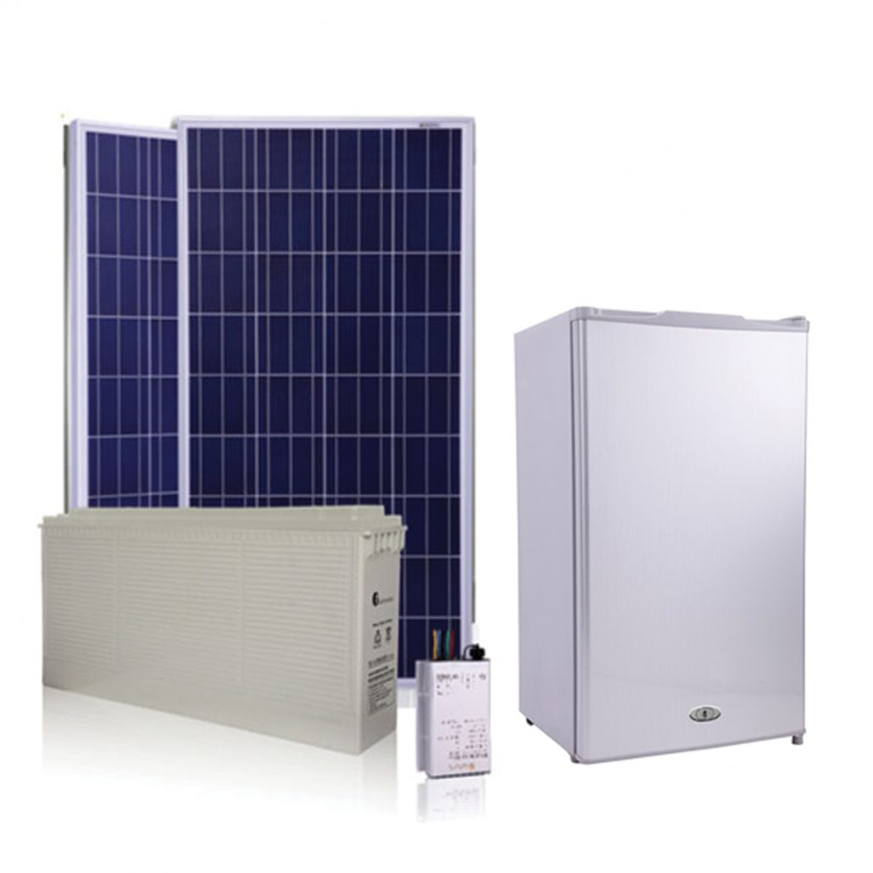
Figure 1: Solar panel operated refrigerator
Source: (Solar Fridge & Freezer, 2017)

Core Benefit
- The solar refrigerator and purifier shall guarantee clean and safe water along with safe storage of food without any external power source.
- It is highly beneficial for areas having high costs of electricity and low-income groups of people and families.

Basic Product
- A refrigeration unit powered by solar energy.
- An add-on water purifier with the refrigerator gives it multipurpose usability.
- Easy-to-use mechanism with a durable and long-lasting design.

Expected Product
- Consistency in cooling and efficient filtration of water.
- Sufficient storage for food and beverages for a couple of people and available in a few different sizes.
- Lasting battery life for the days when the sky is clouded or it's raining.
- Ample safety features like auto cut, voltage stabilization and quality insulation prevent food spoilage.

Augmented Product
- 3 free services within 2 years of purchase.
- An integrated mobile app support for monitoring the cooling remotely and controlling the levels of water remotely.
- Finance options/ EMI availability for customers that might face difficulty in affording the product.
- Campaigns in rural and semi-urban areas regarding the importance and benefits of solar panels and clean water consumption.

Potential Product
- Expansion into industrial sizes for use in restaurants, cafes and bars.
- Research and development regarding the efficiency of solar power being converted and improving the battery life for longer service during cloudy days.
- Customization options for sizes and capacities for consumers to truly suit the product in their kitchen.

A viable business concept that could meet important demands in off-grid communities and among
people who care about sustainability and health is the solar refrigerator with a water purifier.

Identification of a gap in the market and discussion on the way that proposed business idea/plan aims to address it

PESTLE

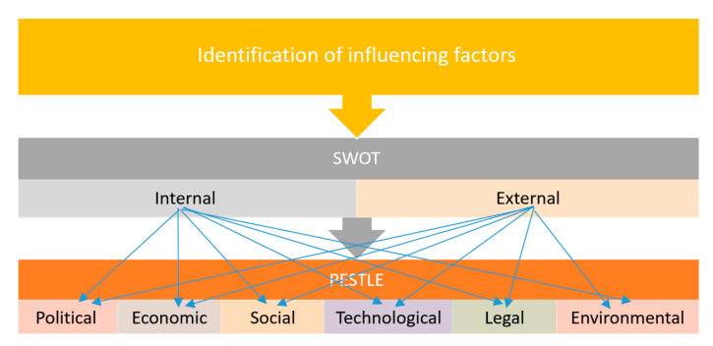
Figure 2: PESTLE analysis
Source: (Christodoulou A. and Cullinane K., 2019)

Political | - The UK has a strong political framework with a stable government and good international relations (House of Lords Library, 2023).  - Brexit has a negative impact on employment regulations and trade regulations within the UK (Spital T. and van Aerssen K. F., 2023).  - This indicates that the UK market is a prospective market for business, and gradually, when the brand gains traction due to good international relations, the brand might be able to export its products easily.
Economic | - The UK had a dramatic increase in the cost of living in 2021 and 2022; in October 2022, the annual rate of inflation hit a 41-year high of 11.1% (House of Commons library, 2023).  - The Consumer Prices Index (CPI) indicates that in October 2023, UK consumer prices were 4.6% higher than the previous year (House of Commons library, 2023).  - The fact that the cost of living is rising across the UK and consumers have to pay more for basic services; the Solar refrigerator and water purifier can utilize this opportunity as this product is highly cost-saving in nature and especially lower-economic bracket population shall benefit extensively from using this product.
Social | - The UK has a powerful sense of solidarity and sociable commitment among the population of the UK in times of adversity and crisis (Christodoulou A. and Cullinane K., 2019). The country is known for its donations and involvement in global growth and humanitarian problems such as poverty mitigation, disaster alleviation, and so on.  - The social factors of the UK can establish a positive reputation and image for this business and its product as it is targeting rural consumers who lack access to clean water sources and reliable electricity.
Technological | - The UK is investing in solar energy research and development and planning to increase the infrastructure and capacity of renewable energy (Essletzbichler J., 2016).  - The country is developing in technological advancements in water purification methods.  - These technological factors are building a favorable opportunity and environment for this business product.
Legal | - The UK has strict rules and regulations for product quality and safety standards (Suhanyiova L., Irwin A., and Flin R., 2023).  - The present business needs to follow these legal rules and regulations for getting permits, licenses, and other certificates for the business.
Environmental | - The UK is having difficulties with high levels of waste generation and pollution. The government of the UK has carried out actions to prevent and address waste generation and pollution (Mohan R., et.al. , 2006).  - This makes it suitable for this business to grow in the market as it also considers sustainability and eco friendliness.

The proposed location of your business and its legal entity, along with a justification for both

Cornwall County in the United Kingdom is the preferred rural site for a solar refrigerator and water purifier business. Cornwall, in southwest England, has a special set of attributes that make it an excellent location to start a project of this kind.

First of all, compared to other parts of the UK, Cornwall enjoys an abundance of sunlight. The company focuses heavily on solar energy, and Cornwall's days with a longer and generally milder climate make it possible to get continuous and sustainable solar electricity (Hamidinasab B. et al. 2023). This guarantees that the solar refrigerators run successfully and deliver the energy needs for water purification and refrigeration all year round.
Cornwall is renowned for its stunning natural beauty and dedication to sustainability. Because of the great concern for the environment of the local community, residents are more likely to support and adopt eco-friendly activities like solar-powered products. This is in accordance with the goal of a company that offers rural communities alternatives that are environmentally friendly.

Establishing a Limited Liability Company (LLC) would be a suitable manner for this firm. An LLC combines the advantages of a corporation and a partnership, providing its owners (members) with limited liability safeguards and preserving management and taxation freedoms (Mikalonienė, L. 2020). This legal framework preserves the founders' personal assets in the event of corporate difficulties or liabilities, which is especially important in the early phases of a venture.
Additionally, an LLC structure facilitates pass-through taxes, in which business gains and losses pass along from the LLC to each member's individual tax return. This might be helpful in the beginning stages of the business when earnings might not come in right away because members can deduct business losses from their personal earnings for tax purposes.

Selecting a legal form like an LLC additionally offers a more straightforward administrative structure, which minimizes regulatory obligations and enables compliance with UK local business legislation. This simplicity is also helpful for businesses which provide basic services in rural areas, where efficient procedures are critical, such as water purification and refrigeration.
Cornwall's abundance of direct sunlight, environmental consciousness along and pleasant surroundings make it an ideal rural site for a solar refrigerator and water purifier business. In addition to providing flexibility in operation and financial benefits, creating an LLC guarantees the business owners' protection under law. Collectively, these decisions establish an excellent foundation for a viable and compliant enterprise within the countryside of the United Kingdom.

Clear understanding of the business’s strengths, weaknesses, opportunities, and threats

As per the opinion of Phadermrod B., Crowder R.M. and Wills G.B., (2019), the strengths, weaknesses, opportunities, and threats of a business need to be analyzed while planning the business ideas as it helps to identify the internal aspects of the business. The analysis of the internal factors of the proposed business plan has been provided below.
Strength: The idea, being the first of its kind, has strength in the market. The proposed business is offering an innovative and unique product that combines the two most important functions: water purification and refrigeration. This business mainly leverages renewable and abundant solar energy to give power to the business product and reduce the environmental impact and the overall operational costs, which is the strength of this business (Thomas et al., 2021). On the other hand, the business can gain a competitive advantage in the UK market over other conventional water purifiers and refrigerators in terms of affordability, efficiency, and convenience.

Weakness: The major weakness of this proposed business is the high initial costs of production, marketing, distribution, and research and development of its product. On the other hand, it can face regulatory and legal hurdles while obtaining necessary certifications and permits for the development and distribution of its product in terms of safety and health standards (Phadermrod B., Crowder R.M. and Wills G.B., 2019). Because of its location, the business can have limited trust and awareness of its products among the customers which can build confusion in terms of reliability and functionality.
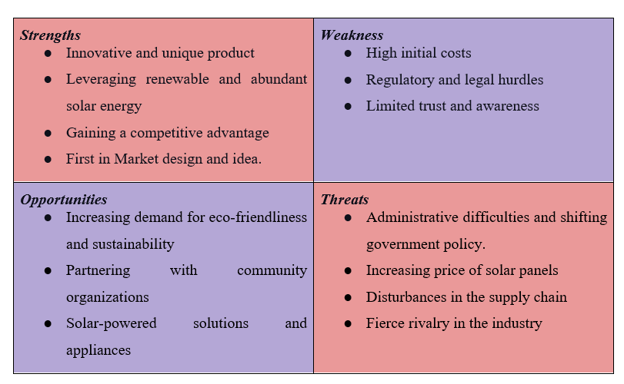

Figure 3: SWOT analysis
Source: (Self-made)

Opportunities: The business has the opportunity to tap into the increasing demand for eco-friendliness and sustainability in the business market among environmentally conscious consumers. On the other hand, this business has the opportunity to expand its customer base and market reach by partnering with community organizations, local NGOs, and governmental agencies (Christodoulou A. and Cullinane K., 2019). Also, the business can offer other solar-powered solutions and appliances such as heating, cooking, lighting, and so on and diversify its product portfolio.

Threats: The UK's solar refrigerator and water purification industry is threatened by a number of concerns. The future growth of the industry may be impacted by administrative difficulties and shifting government policy about funding for renewable energy. The accessibility and affordability of products can be impacted by changes in the price of solar panels and disturbances in the supply chain. The widespread use may be hampered by consumer perception issues with solar-powered products' trustworthiness and efficacy. Several competitors exist in the refrigeration market and hence, the threat of being a substitute is high. Furthermore, recessions may cause consumers to spend less on items that are not necessary, which could affect the market's total demand for solar refrigerators with water purifiers.

Explanation of the target market and the strategies

STP segmentation: According to the opinion of Bigo, C., Raj, A. and Situmeang, R.R. (2021), STP segmentation indicates the marketing strategy of a business that includes analysis of segmenting, targeting, and positioning the possible customers for the business product and service. This segmentation helps to recognize the profitable and attractive segments for the business. The STP segmentation for the business plan of solar refrigerator with water purifier in the rural areas of the UK is given below:
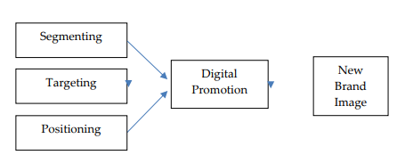
Figure 4: STP segmentation
Source: (Self-created)
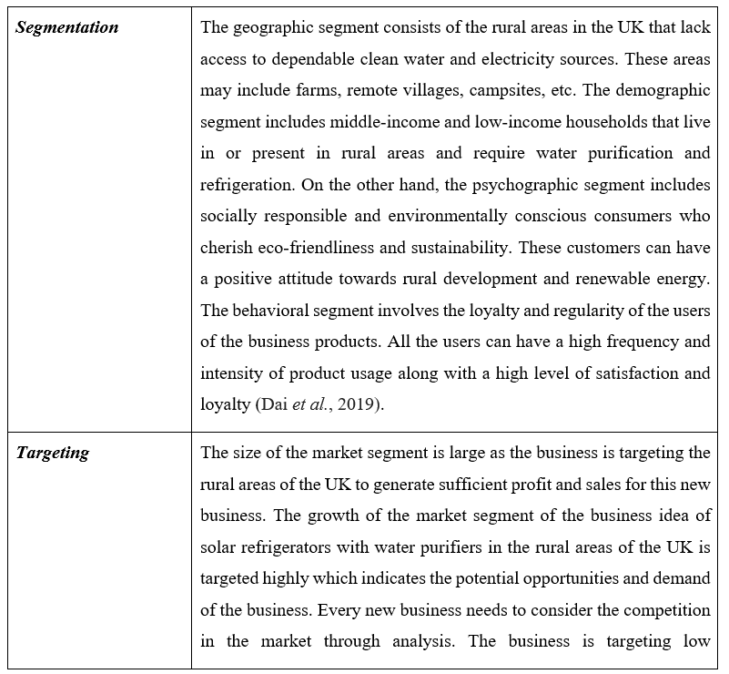
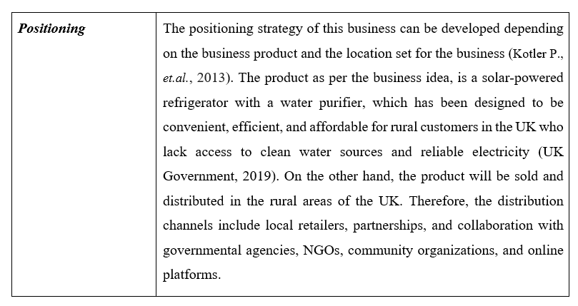

Pricing strategy: The pricing strategy indicates the way a business determines to charge for its products (Islam M.M., 2021). The pricing system of this proposed business product relies on many factors, such as the cost of distribution of the products, production, and advertisement of the product, along with its significance and quality. The penetration pricing strategy has been considered to specify the price of this business product in the UK market. Through this strategy, a low initial price is set, which is reasonable for the population in the rural regions of the UK. Through this strategy, the business is planning to achieve a high market share and entice customers in rural areas. This strategy can be advantageous for the business to establish customer trust and understanding and can prevent the potential competitors of the business from penetrating the market.

Promotion strategy: Promotion strategy is highly crucial for the triumph of the business plan. The promotion strategy for the current business plan is the marketing and communication activities that influence and inform possible customers concerning the business product. The business believes in advertising, sales, promotion, public relations, and personal selling strategy for the advertising purpose of its product. Through these, the business can emphasize the ingenious and outstanding features of its products along with the advantages for the surroundings and customers.

Analysis of the budgeting or financial plan and determining the funding requirements and Identification of the potential external funding sources with justification

Financial plan:
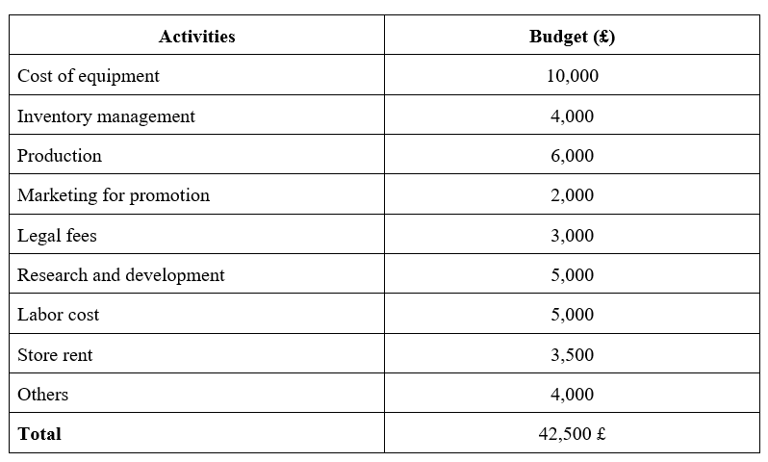
Table : Estimated initial set-up costs
Source: (Self-created)

The financial plan for the offered business plan of solar refrigerators with water purifiers in rural areas in the UK contains the cost of equipment and supplies, inventory management, marketing and advertising for product promotion, cost of production, legal expenses, research and development, store rent, labor charges, and so on. It has been evaluated that around 42,500 British pounds is needed to start the business.
The product is believed to be introduced at a price of 999 British pounds. Future service and setup costs are planned to be included in the same introductory price. The initial plan is to make the product available to all the people at Cornwall and slowly develop the market towards the whole of UK, once the product is determined successful and gains attention of foreign investment.
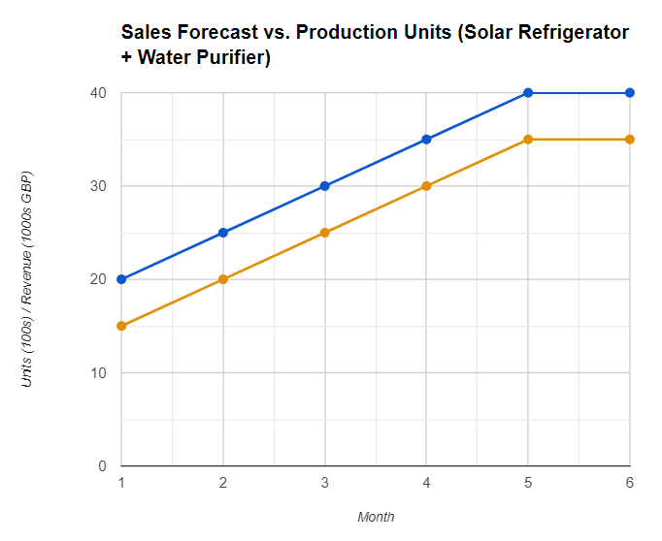
Figure 6: Sales vs Production forecast (6 month) (Forecast)
Source: Self-created

Funding requirements: Funding is a paramount necessity for any kind of business plan, as it supplies the financial help and resources to initiate and support the operations of the business (Damgaard M.T. and Gravert C., 2018). Funding can aid this business to protect its functional and initial expenses, such as research and development, distribution, production, legal and regulatory compliance, and promotion. Funding can be helpful for the business to leverage the chances and conquer the tribulations in the UK business market.

Potential external funding sources: There are many business banks in the UK that provide loans at a lower rate of interest for start-up initiatives (British Business Bank, 2023).The possible funding sources for the business plan of solar refrigerators with water purifiers in rural areas in the UK is collaboration and partnership with the organizations such as community association, local NGOs, and other big associations who are interested in sustainability and eco friendliness. Other than that, bank loans for forming the business and governmental subsidiaries and donations are some possible funding sources. On the other hand, some grants and crowdfunding can be considered to increase the funds of this business.

However, out of all these funding sources, collaboration and partnership with the associations can be advantageous as the outward funding source for this business. The funding through institutions and associations can help this business to extend the customer base and market reach and can also leverage the resources and expertise of the collaborators, supporter, and partners.

Conclusion

To conclude, the introduction of solar refrigerators with water purifiers are bound to have an excellent spot in the market as it is able to solve many issues at a single go. The use of renewable energy results in reduction of carbon footprints and leads to a sustainable environmental situation. Hence, the concept is believed to be a one-stop solution for water scarcity as well as sustainable development.

Reference

- Bigo, C., Raj, A. and Situmeang, R.R., (2021). ‘Segmentation, Targeting, Positioning (STP), Communication and Price Strategies on Consumer Purchasing Decisions at PT’. Alfa Scorpii Medan. Jurnal Mantik, 4(4), pp.2370-2375. Available at: https://doi.org/10.35335/mantik.Vol4.2021.1165.pp2370-2375 [Accessed on 7th December 2023]
- British Business Bank (2023) ‘Government loans UK - start up loans’, British Business Bank. Available at: https://www.british-business-bank.co.uk/ourpartners/start-up-loans/ (Accessed: 05 December 2023).
- Christodoulou, A. and Cullinane, K., (2019). ‘Identifying the main opportunities and challenges from the implementation of a port energy management system: A SWOT/PESTLE analysis.’ Sustainability, 11(21), p.6046. Available at: https://doi.org/10.3390/su11216046 [Accessed on 7th December 2023]
- Dai, D., Liu, Z., Yuan, F., Long, R. and Liu, W., (2019). ‘Finite time thermodynamic analysis of a solar duplex Stirling refrigerator’. Applied Thermal Engineering, 156, pp.597-605. Available at: https://doi.org/10.1016/j.applthermaleng.2019.04.098 [Accessed on 7th December 2023]
- Damgaard, M.T. and Gravert, C., (2018). ‘The hidden costs of nudging: Experimental evidence from reminders in fundraising’. Journal of Public Economics, 157, pp.15-26. Available at: https://doi.org/10.1016/j.jpubeco.2017.11.005 [Accessed on 7th December 2023]
- Essletzbichler, J., (2016). Renewable energy technology and path creation: A multi-scalar approach to energy transition in the UK. In Path Dependence and New Path Creation in Renewable Energy Technologies (pp. 63-88). Routledge.
- Hamidinasab, B., Javadikia, H., Hosseini-Fashami, F., Kouchaki-Penchah, H. and Nabavi-Pelesaraei, A., (2023). ‘Illuminating sustainability: A comprehensive review of the environmental life cycle and exergetic impacts of solar systems on the agri-food sector’. Solar Energy, 262, p.111830.Available at: https://doi.org/10.1016/j.solener.2023.111830 [Accessed on 7th December 2023]
- House of Commons library (2023). ‘Rising cost of living in the UK’. Available at: https://commonslibrary.parliament.uk/research-briefings/cbp-9428/#:~:text=The%20cost%20of%20living%20increased,from%206.7%25%20in%20September%202023. (Accessed: 7 December 2023).
- House of Lords Library (2023). ‘UK’s role in the world: Implications for foreign policy’. Available at: https://lordslibrary.parliament.uk/uks-role-in-the-world-implications-for-foreign-policy/ [Accessed on 7th December 2023]
- Iskamto, D., (2020). ‘Role of Products Element In Determining Decisions of Purchase.’ Inovbiz: Jurnal Inovasi Bisnis, 8(2), pp.200-207. Available at: http://ejournal.polbeng.ac.id/index.php/IBP/article/download/1424/791 (Accessed: 19 December 2023).
- Islam, M.M., (2021). ‘Segmenting, targeting and positioning in Islamic marketing’. Journal of Islamic Marketing, 12(7), pp.1385-1404. Available at: https://doi.org/10.1108/JIMA-10-2018-0181 [Accessed on 7th December 2023]
- Kotler P., Armstorng G., Harris L.C., and Piercy N. (2013) Principles of Marketing. 6th Edition, England: Pearson Education Limited.
- Lambert, D.M., (2009). Customer relationship management as a business process. Journal of Business & Industrial Marketing, 25(1), pp.4-17. Available at: https://doi.org/10.1108/08858621011009119 [Accessed on 7th December 2023].
- Mohan, R., Spiby, J., Leonardi, G.S., Robins, A. and Jefferis, S., (2006). Sustainable waste management in the UK: the public health role. Public Health, 120(10), pp.908-914. Available at: https://doi.org/10.1016/j.puhe.2006.05.021 [Accessed on 7th December 2023]
- Mikalonienė, L., (2020). Individual Owner Compensation in a Hybrid Limited Liability Entity in a Comparative Context: LLC (the USA), LLP (the UK) and the Small Partnership (Lithuania). European Business Organization Law Review, 21, pp.915-936. Available at : https://doi.org/10.1007/s40804-020-00199-4 [Accessed on 17th December 2023]
- Phadermrod, B., Crowder, R.M. and Wills, G.B., (2019). ‘Importance-performance analysis-based SWOT analysis’. International journal of information management, 44, pp.194-203.Available at: https://doi.org/10.1016/j.ijinfomgt.2016.03.009 [Accessed on 7th December 2023]
- Solar Fridge & Freezer (2017) ‘Green NRG Co.’ Available at: https://greennrgco.com/solar-fridge-freezer/ (Accessed: 19 December 2023).
- Spital, T. and van Aerssen, K. F., (2023). ‘The impact of Brexit on UK trade and labour markets.’ European Central Bank. Available at: https://www.ecb.europa.eu/pub/economic-bulletin/articles/2023/html/ecb.ebart202303_01~3af23c5f5a.en.html#:~:text=While%20on%20average%20the%20rise,supply%20in%20lower%2Dskilled%20sectors. (Accessed: 7 December 2023).
- Suhanyiova, L., Irwin, A. and Flin, R., (2021). Product safety culture: a preliminary study in the UK manufacturing industry. Journal of risk research, 24(8), pp.1030-1048. Available at: https://doi.org/10.1080/13669877.2020.1805637 [Accessed on 7th December 2023].
- Thomas, P.J.M., Sandwell, P., Williamson, S.J. and Harper, P.W., (2021). ‘A PESTLE analysis of solar home systems in refugee camps in Rwanda.’ Renewable and Sustainable Energy Reviews, 143, p.110872. Available at: https://doi.org/10.1016/j.rser.2021.110872 [Accessed on 7th December 2023]
- UK Government (2023). ‘UK government’s view on greenhouse gas removal technologies and solar radiation management, GOV.UK’. Available at: https://www.gov.uk/government/publications/geo-engineering-research-the-government-s-view/uk-governments-view-on-greenhouse-gas-removal-technologies-and-solar-radiation-management (Accessed: 12 December 2023).

