Human Resource Management Assignment

Table of Contents
Table of Contents 2
Part A: The Current State of Labour Market in the UK 2
Conclusion 6
Part B: Human Resource Management Strategies in Post-Covid and Post-Brexit Environment 8
Conclusion 10
References 12

Part A: The Current State of Labour Market in the UK

The UK labour markets show many commonalities during the post-pandemic recovery, albeit with different salary implications (Morando, 2021). This assessment discusses the post-pandemic changes to the UK labour market. It reveals that the high and unusual tightness at this early stage of recovery in both nations is caused by differences between the supply and demand of labour. Widespread wage pressures could come from this, endangering inflation. These forces are not as strong in the UK but are highly critical for the long-term economic recovery (Morando, 2021).

Despite having record employment rates right now and being rated 13th out of 35 nations, the UK performs only averagely. Switzerland, New Zealand, Germany, Japan, and Switzerland, which won the standings for a decade straight, are among the top performers (Statista, 2022).

When seeking to comprehend how far UK employment rates could climb over the coming years, it is more acceptable to compare Iceland to larger economies like Switzerland or Sweden, which rank second and third, respectively, and have employment rates of approximately 80 per cent. The employment rate in Iceland is 85 per cent. There is still room for employment to grow in the UK, as evidenced by Japan, which has a larger economy than the UK and an employment rate of more than 78 per cent.

As per the Labour Force Survey data from February to April 2022, there has been a significant increase in the employment rates along with a reduction in unemployment rates and economic inactivity rates for the same period. All these indicators point out that the trends have become a bit better than the previous period as the employment rate reached to 75.6% recently, which indicates good progress but can be seen that the figure is still lower than the pre-Covid numbers (Watson, 2022).

The summary of the factors for the critical age group has been provided in figure 1.0:
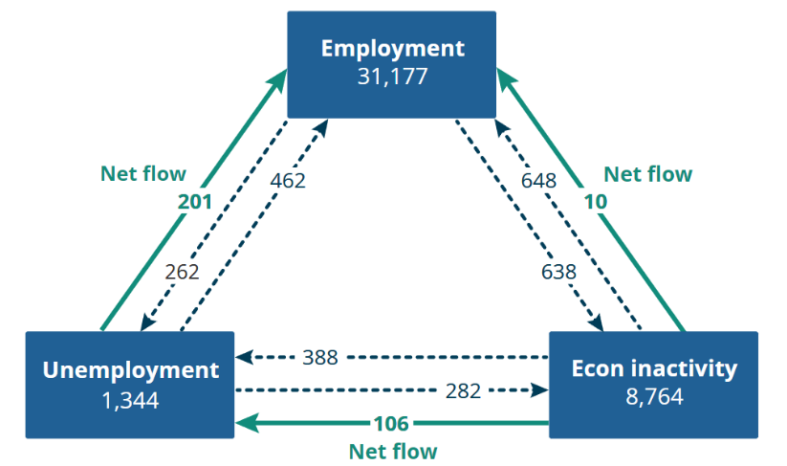
Figure 1.0: Figure showing net flows from unemployment to employment (Office of National Statistics, UK)

In addition to the statistics mentioned before, it is critical to mention that the total number of part-time workers in the same period have reduced and there has been an increase in the full-time employees hired by organisations. The trend for independent contractors has also been lower in the post-Covid period compared to the previous times (Watson, 2022).

Continuing the previous statistics, there has been a significant increase in the payroll employees in the UK which has reached an all-time high to close to 30 million people now in regular payrolls of different organisations across the country (figure 2.0)

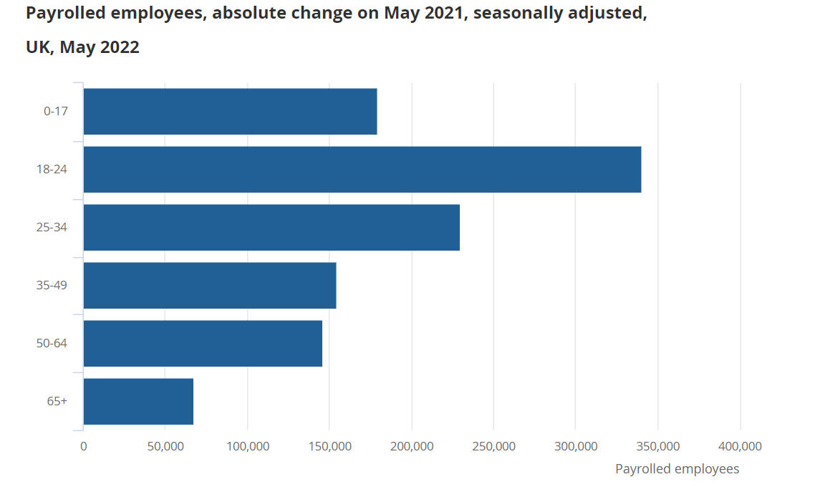
Figure 2.0: Payroll employees across different age groups in the UK (Office of National Statistics)

Along with an increase in the total number of payroll employees, the UK witnessed an increase in the total number of work hours (that reached to 1.04 billion hours) during May 2022. Even though the number of hours worked is still lower than the pre-pandemic numbers, the overall improvement is rather good. The average hour worked per individual has also increased by 0.6 hours in the current scenario.

Another significant improvement can be explained in the form of reduced unemployment rates. In the recent quarter (reported), there was a reduction of 0.2% in the unemployment rates which reduced to 3.8% (figure 3.0).

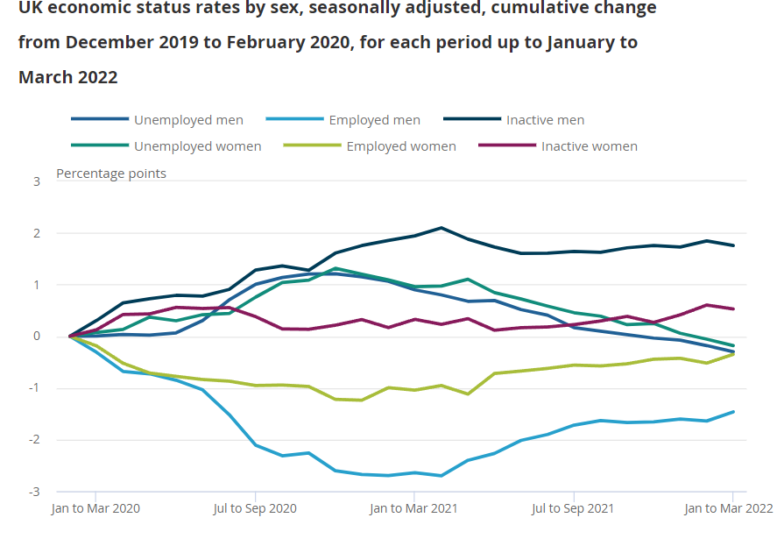
Figure 3.0: UK Unemployment Rates (Office of National Statistics)

The job wait periods had also reduced and the number of people being jobless for more than a year also fell down, demonstrating further improvement in the labour market in the UK. The total economic inactivity reduced to 21.3% in the given period (Watson, 2022). The total number of open vacancies in the UK were close to 1.3 million. However, the growth in increasing the number of vacancies was quite slow, thereby affecting the future growth trends.

There was further improvement in the total remuneration, compensation and salaries paid to the workers that increased by 6.8% in the current reported quarter as compared to the previous one. There was a reduction in regular pay by 2.2% as the bonus payments were higher and real pay growth went up by 0.4% in the same quarter.

These initial flimsy components are no longer present. We now compare the most recent period to one during which an increasing number of employees in several industries were placed on layoff as a result of the lockdown that took place in the winter of 2020-2021. There will therefore be very little foundation influence on these industries. We detected a difference but not to the same magnitude when comparing timeframes during the onset of the coronavirus epidemic.

Early discrepancies between countries can be explained by various governmental responses. A major focus of UK policy has been the Job Retention Plan (JRS) or "furlough" programme, under which employers get 80% (up to a maximum of £2,500 per month) of the income of workers who are temporarily suspended (Ewing and Hendy, 2020).

It attempts to avoid mass layoffs and the difficulties brought on by a large number of people looking for work. Other countries have adopted policies with the same general objective, whether through furlough plans, subsidised short-term work, or other compensation subsidies. The strength and specificity of different countries' policies vary. Even in the US, credit programmes for companies that lay off workers are available, but the policy's efficacy seems to be relatively limited, which largely explains the country's dramatic growth in unemployment.

Even while the JRS in the UK is one of the better answers to the current problem, it inevitably has serious flaws (Ewing and Hendy, 2020). An additional 5 million people in the UK work for themselves or on zero-hours contracts, temporary employment, or other arrangements. It took a few weeks to devise a distinct policy for the self-employed, and even that did not include many people since it excluded these groupings, leaving nearly 20% of the UK workforce uninsured.

There is a significant lack of information which makes it difficult for the government to decide the quantum and extent of help and assistance to be offered. However, for the short-term period, the efforts from the part of the government will be critical in attaining the goals of getting the labour market and economy back on track.

Unemployment will rise as a result of there not being a V-shaped recovery of the real economy. Just how high it will go will determine. A country that already has unequal income distribution will become even more unequal. At the very least, it would be reasonable to anticipate that the government would continue to offer social security benefits at their higher levels. Moreover, measures to decrease the intensity of unemployment trauma should be taken into account. Initiatives to put people off welfare and back into the workforce may do so fast, but all too frequently these jobs are low-paying dead-end jobs.

Conclusion
A completely fresh viewpoint is necessary for an active labour market policy. It would be important to try to change the nature of those positions and ensure that individuals applying are given the training necessary to do so in order to achieve this, rather than simply matching candidates with open positions. Its effectiveness of it will depend on the government's and its agencies' capacity to provide it.

Both extensive capacity building and interventionism that almost entirely departs from British policy thinking are crucial, but unusual circumstances demand unusual responses. In order to assure the efficient handling of the active personnel issue, capacity-building will be necessary in addition to creating a functional active personnel policy.

There are to be better and clearer rules about hiring and terminating policies. The concept of working from home and remote areas should be part of the human resource and labour management regulations of the country. The government should also be ready for dealing with similar issues in the future (such as the pandemic) and hence the success of the recovery process shall be largely dependent on the effective and collective efforts of the government along with other stakeholders (such as hirers, organisations, corporate sector and labour unions).

Part B: Human Resource Management Strategies in Post-Covid and Post-Brexit Environment

Covid-19 and Brexit have both affected labour market and HRM strategies in the UK in distinct manner. Whereas Brexit has resulted in disrupting the human resource supply chain for the UK-based businesses, the impact of Covid-19 has resulted in disruptions in the way employees have been traditionally managed. In order to ensure that the labour market, job generation, and economic activities recover at a faster pace, it shall be critical for the decision-makers to manage the employees and workers by introducing the best and well-suited HRM strategies for the current times.

To minimise employment gaps and create the best match possible between people's strengths and the skills that employers are seeking. Young people are more at risk, particularly those who quit attending school. As the UK rebounded from its most recent recession, real wages started to climb gradually. Shortly after the COVID 19 crisis, they reached levels last seen before it. Unsettling data is beginning to suggest that this crisis may expedite the secular spread of zero-hours contracts and other low-quality forms of work in the absence of greater legal protections and other types of government action.

Brexit was always expected to have a detrimental impact on the labour market. Some of the proponents of staying in the EU may have thought that the job market will be more competitive following Brexit. The COVID-19 report and other factors have combined to obfuscate the true effects of Brexit on employment when it comes to the probability of our complete exit from the EU at the end of 2021. In order to assess how the UK job market has changed since the EU withdrew, we will look at the current unemployment rate, the industries that have been most adversely affected, and the ones that offer greater prospects (Clarke and Gregg, 2018).

Brexit has resulted in restricting free movement of labours from the EU to the UK (Wadsworth, 2018). Hence, there is ought to have a significant impact on manufacturing sector which is labour-intense. Even other sectors would also witness the impact of the movement restrictions. However, with Covid-19 and the increased importance of remote working, there might be a slight improvement in this regard. However, there is no study yet which supports or rejects the claim that the ill-effects arising due to restricted movement of workers due to Brexit can be improved due to WFH and remote working.

Hence, some of the changes that might be introduced in HRM strategies in the Covid-19 and Brexit can be summarised in the following points:

- Improvement in usage of digital tools in recruitment, hiring, and training: Digitalisation shall be a critical part in ensuring that the employers have the best people working from them. The process of recruitment, hiring and even training of the employees shall be done through digital mediums. From interviews to employment tests can be carried out through digital modes. This can resolve a great deal of issues that the recruiters might face in the future.
- More emphasis on employee learning and skill development: In the US, the phenomenon of the great resignation has bewildered HRM experts and recruiters. At a time when the unemployment levels are high and economic activities are at all-time low, there is a large proportion of professionals who have left jobs for better opportunities and perquisites (Bayraktar, 2022). One of the factors from the phenomena is that the employees want to be associated with the organisations that show care and concern for their overall skill development. Hence, there can be an increased preference for learning organisations. In the context of UK, HRM professionals should realise the critical importance of training and development in retaining the best employees within the enterprise.
- Flexibility and accommodating the concerns of employees: Flexible timings and project-wise payments can be the norm for HRM in the future as the expectations of both employees and employers have transformed in the post Covid and Brexit period.
- Performance management and motivation of employees with a bigger role of leaders in the human resource management of the organisation: The existing and traditional performance management and motivation methods (financial and non-financial) will need a transformation in an entirely new environment. The critical importance of leadership in employee engagement shall be critical through consistent dialogues and making them the part of the long-term business goals (Lusiantoro, Purwanto and Rostiani, 2021).

There is a significant need for talent in the pharmaceutical, IT, and professional services sectors in addition to the hospital and social care businesses, both of which are experiencing COVID-19-related unprecedented stress. Thousands of EU workers in the UK are reportedly unaware that they must apply under the EU Settlement Scheme by the end of June 2021, which has caused the care business to become highly concerned that it may run out of staff.

The fact that the economy has been severely damaged in the hospitality sector should not come as a surprise. While the epidemic has periodically allowed for the operation of restaurants, cafes, and bars, all of them are currently shuttered as a result of the most recent lockdown (apart from those offering takeout). With 50,000 jobs eliminated, the manufacturing sector has also been seriously damaged. It's critical to remember that manufacturing employment in the UK has been drastically declining since 2008. Other factors contributing to the fall in manufacturing employment include a drop in demand for cars and aeroplanes, both of which have hurt the steel market (and hence steel production).

There are concerns about the additional repercussions of Brexit due to the sizeable number of EU citizens who have already left the UK. A total of 1.3 million individuals are said to have abandoned their houses, with the hotel and retail sectors being the most seriously affected.

Conclusion
Even if the workplace may appear to be depressing, there are still many opportunities. There is more optimism now, in fact, with our impending withdrawal from the EU and the vaccination deployment in full speed. It will be more important than ever to identify sectors where demand is increasing and staying constant. For individuals who are adaptable and prepared to retrain for a different trade, there will still be plenty of steady, well-paying employment available.

References
Atkinson, A., 2021. U.K. Unemployment Rate Rises to Highest in Almost Five Years. [online] Bloomberg.com. Available at: <https://www.bloomberg.com/news/articles/2021-02-23/u-k-unemployment-rate-rises-to-highest-in-almost-five-years> [Accessed 1 September 2022].
Bayraktar, M., 2022. The Great Resignation of US Labor Force. SSRN Electronic Journal,.
Clarke, S. and Gregg, P., 2018. The Prospects for the UK Labour Market in the Post‐Brexit Era. The Political Quarterly, 90(S2), pp.53-61.
Statista. 2022. Employment rate in OECD countries 2021 | Statista. [online] Available at: <https://www.statista.com/statistics/268127/employment-rate-in-selected-industrialized-countries/> [Accessed 1 September 2022].
Ewing, K. and Hendy, L., 2020. Covid-19 and the Failure of Labour Law: Part 1. Industrial Law Journal, 49(4), pp.497-538.
Lusiantoro, L., Purwanto, B. and Rostiani, R., 2021. The effect of small business leaders' organisational mindfulness and social learning on opportunistic behaviour to survive the COVID-19 pandemic. Journal of Small Business and Enterprise Development, 29(4), pp.627-644.
Morando, G., 2021. The Early Effect of the Covid-19 Pandemic on the Labour Market Outcomes of Natives and Migrants in the UK. SSRN Electronic Journal,.
Wadsworth, J., 2018. Off EU Go? Brexit, the UK Labour Market and Immigration. Fiscal Studies, 39(4), pp.625-649.
Watson, B., 2022. Employment in the UK - Office for National Statistics. [online] Ons.gov.uk. Available at: <https://www.ons.gov.uk/employmentandlabourmarket/peopleinwork/employmentandemployeetypes/bulletins/employmentintheuk/may2022> [Accessed 1 September 2022].
Statista. 2022. Working from home rate UK 2020 | Statista. [online] Available at: <https://www.statista.com/statistics/303589/working-from-home-in-the-united-kingdom-uk-y-on-y/> [Accessed 1 September 2022].

