

Cert HE in Business Skills

Module Title: Employability and Career Development

Module Code: LCLM4005

Assessment: Assessment II Portfolio of Written Task

Student Name: Serkalem Aylewe

Student Number: 2517705

Lecturer’s Name: Sukhpreet Grewal

Session: June 2026 Term
Submitted on: August 2026

Table of Contents
1. INTRODUCTION 2
2. TASK 1: JOB ADVERTS, COMPARISON AND KEY SKILLS 3
3. Task 2: Self-Assessment and Readiness for Work 6
4. Task 3: Work Goals and Development Plan 8
5. References Lists 11

1. INTRODUCTION

This portfolio looks at the skills needed for Document Controller and Administrative Assistant roles, two positions that match my studies and career interests. I will compare two recent real job adverts, complete a SWOT analysis to understand my own strengths and areas to improve, and create a clear Personal Development Plan (PDP) to reach my work goals. I also explain how my current education and activities have helped prepare me for these jobs, using trusted sources on employability (Cottrell, 2020).

2. TASK 1: JOB ADVERTS, COMPARISON AND KEY SKILLS

I selected two current job adverts from trusted UK recruitment websites in August 2026.

Job 1: Document Controller
Employer: Kenna Recruitment Ltd (Construction)
Location: Central London
Posted: 6 August 2026
Main duties: Manage technical project documents such as drawings and plans; keep accurate records and version control; use special software like Procore; check files for accuracy; share documents safely with teams and clients; follow strict industry standards and procedures.

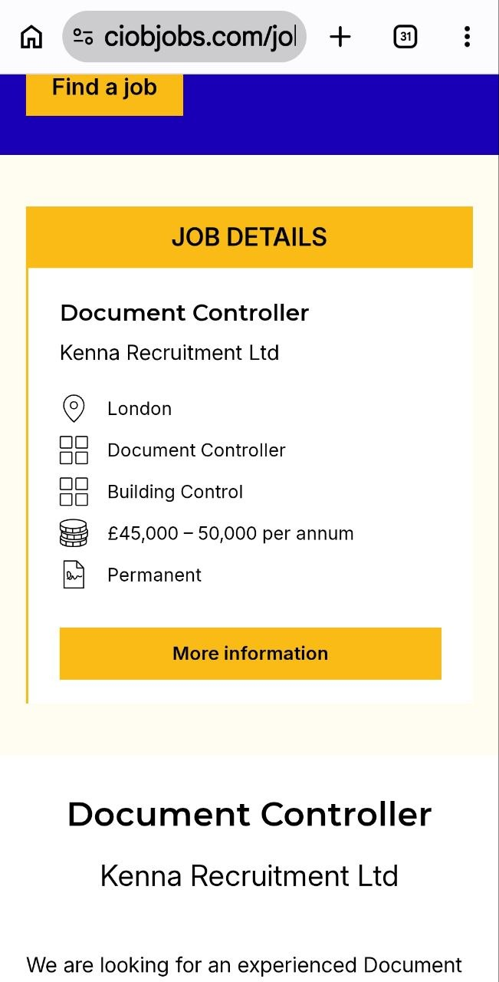
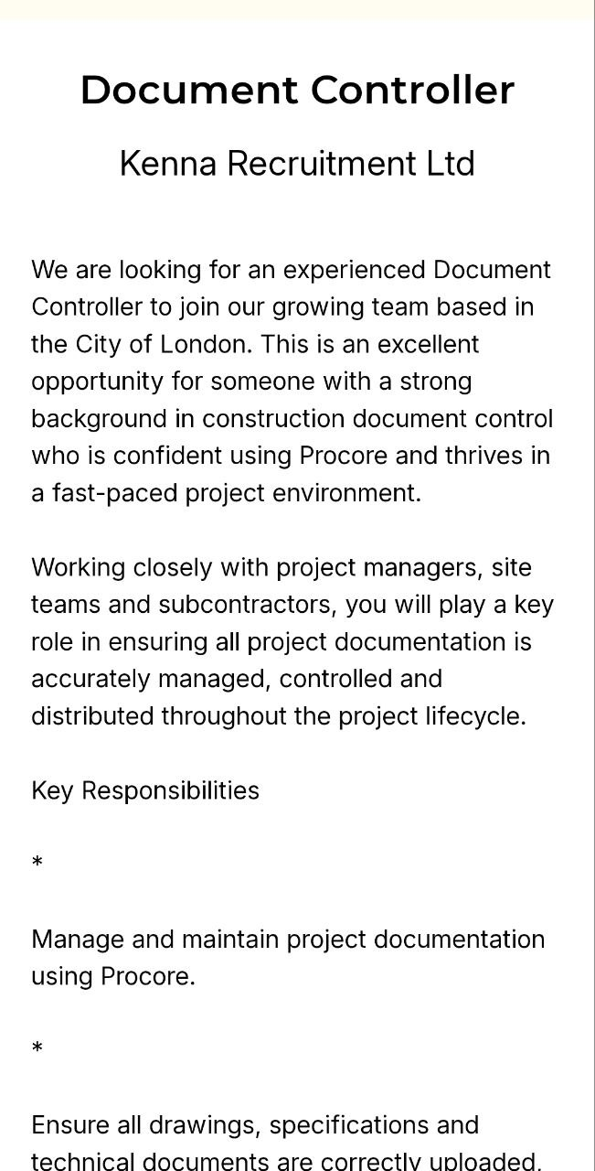

Job 2: Administrative Assistant
Employer: NHS Jobs — Central and Northwest London NHS Foundation Trust
Location: London
Posted: 6 August 2026
Main duties: Answer telephone calls and emails; arrange appointments and meetings; keep patient records safe and accurate; provide help to staff and visitors; use Microsoft Office; follow NHS confidentiality rules.
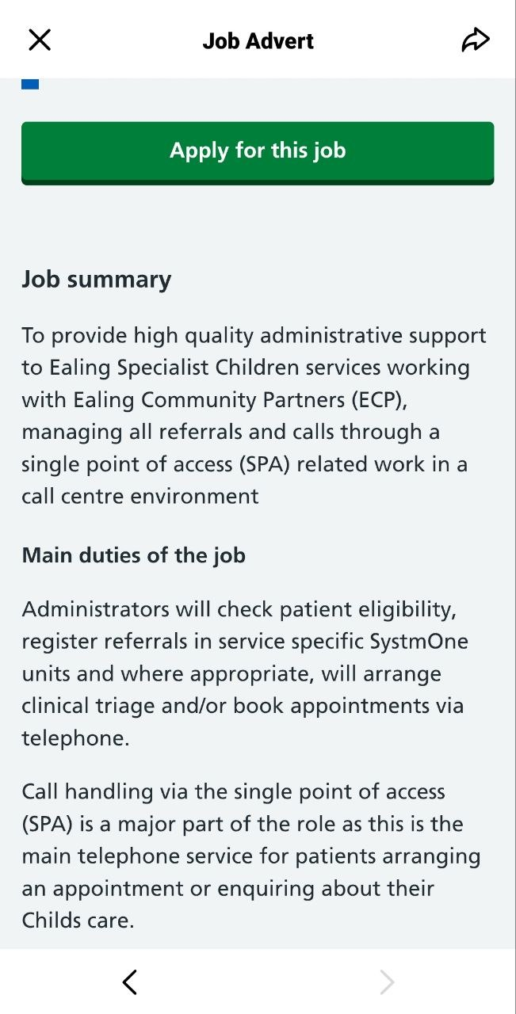
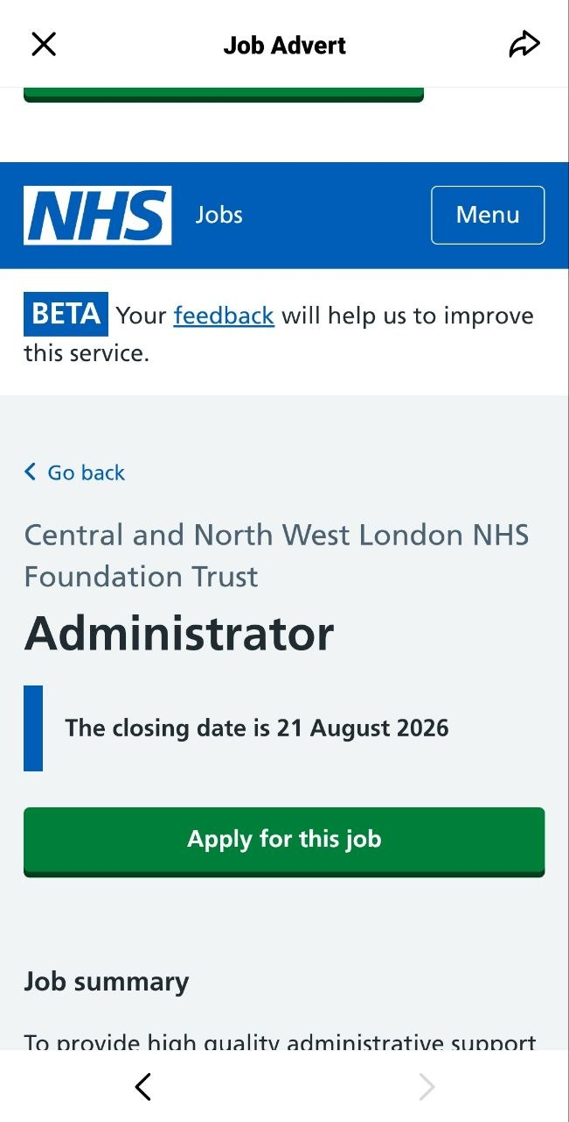
Similarities
Both roles need good organization and attention to detail. Both require computer skills and keeping information accurate. Both ask you to handle private information safely and follow rules. Both need clear communication and reliable work.

Differences
The Document Controller works in construction. They manage technical documents such as plans and drawings, using special industry software, and following construction standards. The Administrative Assistant works in healthcare. They provide general office support, help patients and visitors directly, and manage medical records under NHS rules. One focuses on specialist project documents; the other focuses on daily office tasks and people.

Applying Skills in Future Work
My current education has built exactly the skills employers look for in both Document Controller and Administrative Assistant positions (Prospects, 2026).

Beyond my learning, one very important, shared skill from job adverts is attention to detail. For example, as a Document Controller, I will use this to check that contract numbers and drawing versions are correct before saving them, so no wrong information is used on site (Jones, 2025). If I work as an Administrative Assistant, this skill will help me type letters or update meeting records without errors, so the office runs smoothly.

3. Task 2: Self-Assessment and Readiness for Work
SWOT Analysis
This looks at my strengths and areas to improve, as well as outside chances and challenges for a career as a Document Controller and Administrative Assistance.
Internal Factors
- Strengths
- I am well organized and like to keep information in order.
- I check my work carefully to make sure it is correct.
- I can use full Microsoft office suits like Word, Excel, PowerPoint and Outlook well.
- I express myself clearly in writing and when speaking.
- I am trustworthy and take care of private or sensitive information.
- I am reliable, arrive on time, and follow instructions well.
- Weaknesses
- I do not yet have much experience with specialist systems like SharePoint or Aconex.
- I have only basic knowledge of standards such as ISO 9001 or full GDPR rules.
- I sometimes spend a little extra time checking my work to avoid mistakes.
- I am not yet very confident when suggesting new ways of working to more experienced staff.
External Factors
- Opportunities
- There are many Document Controller and Administrative Assistance jobs in London and across the UK — in construction, business, and other sectors.
- There are many low-cost or free online courses to learn about GDPR, records management, and computer skills.
- There is a clear career path: Junior Document Controller → Document Controller → Senior Records Manager.
- My current course in Business Skills gives me a good start in office work and the following rules.

- Threats
- I will be competing with people who already have experience in this type of work.
- Technology and data laws change often, so I will need to keep learning new things.
- Some companies prefer people who have worked in their specific industry before or have certain qualifications.

Evidence I Am Ready for Work
Study Background
On my Cert HE Business Skills for the Workplace course, I have learned core abilities that apply directly to these jobs. I have developed strong organization and time management, planning my work carefully so I always meet assignment deadlines – essential for keeping documents up to date and running daily office tasks smoothly (Prospects, 2026). I have practiced clear professional communication by speaking respectfully with lecturers, university staff, and fellow students; I also built teamwork skills by contributing fairly to group assessments and presentations, listening well to others and sharing responsibility (Cottrell, 2020).
I now know how to prepare high-quality CVs, cover letters, and interview responses – all vital for applying for these roles and performing well in them (UWTSD, 2025).
I have learned a great deal about employment contracts and employee rights. I now understand what a proper contract includes — such as pay, working hours, and holiday entitlement — and the legal protections that every worker is entitled to (ACAS, 2026). This knowledge means I will always check and understand my contract before starting work, know my rights and responsibilities clearly, and be confident seeking help or advice if I need support in my future workplace.
I have also learned about carrier development and what brings job satisfaction. I now understand that growing skills, setting goals, and seeing clear progress make work more meaningful (Fahed-Sreih, 2019). This knowledge means I will plan my carrier step-by-step, keep learning, and aim for work that helps me grow and feel satisfied.

On my Cert HE Business Skills course, I learned to write clearly, organize information, manage my time to meet deadlines, and communicate well. These are key skills for any job (Cottrell, 2019). I also learned to follow rules properly — very important for both Document Controller and Administrative Assistant work.
I have learned to make sound decisions, such as choosing to continue my degree in Leadership and Management to build my career further.

Work Experience
In past admin jobs, I handled emails, kept paper and digital files tidy, and updated spreadsheets. I know records must be correct and easy to find. I also learned to do tasks step-by-step and keep private information safe — useful for both roles.

Feedback and Personal Qualities
My lecturers and old managers say I am organized, careful, and reliable. I do accurate work and learn fast. Being ready for work means being responsible and honest, not just having skills (AUA, 2021). I am ready to take good care of important information as a Document Controller and support the team well as an Administrative Assistant.

Understanding the Roles
Document control helps the business run smoothly and follow laws (ARMA, 2024). As an Administrative Assistant, I know I will help with daily office tasks, messages, and schedules. For both jobs, I am ready to follow systems, keep things correct, and help my team.

4. Task 3: Work Goals and Development Plan
 | Short-Term (3–6 Months) | Mid-Term (6 Months – 2 Years) | Long-Term (2–3 Years)
SECTION 1: MY GOALS | - Finish Cert HE Business Skills with good grades  - Secure first entry-level role: Admin Assistant or Junior Document Controller  - Build confidence speaking to new people  - Get fully ready to start 2nd year of Leadership & Management degree in September 2026 | - Complete Year 2 and Year 3 of Leadership & Management degree; finish whole course by August 2028  - Work reliably as Document Controller or Admin Assistant  - Gain industry certificate in document/records management  - Apply what I learn in my degree to my daily work | - Graduate with full Leadership and Management degree  - Become experienced Document Controller, ideally in construction  - Move up to senior admin or lead document control role  - Use my management skills to support and guide others
SECTION 2: SKILLS & KNOWLEDGE TO LEARN | - Improve communication, time management and meeting deadlines  - Learn basic construction admin rules, GDPR and Microsoft Excel  - Prepare for 2nd year modules: study methods, assignment planning | - Master tools like SharePoint, Procore and Aconex  - Learn construction health & safety and document standards  - Degree topics: leadership styles, team work, decision making, business planning  - Build confidence organising tasks and helping new colleagues | - Advanced construction document rules and quality checks  - Full knowledge of managing people, workflows and improvement  - Commercial awareness and problem solving for business  - Skills to lead small projects or teams
SECTION 3: NEXT STEPS | - Hand in all assignments on time  - Update CV, practice interviews, apply for suitable jobs  - Plan my study schedule ready for September 2026  - Do free short courses to boost Excel and admin skills | - Start Year 2 September 2026 → Finish full degree August 2028  - Attend all classes, complete all degree work and ask tutors for help when needed  - Ask for clear feedback at work to improve my performance  - Join ARMA or other relevant groups for industry updates | - Complete final year projects and pass all exams  - Apply for roles with more responsibility  - Attend extra training to keep my skills up to date  - Look for chances to lead small tasks or projects
SECTION 4: RESOURCES NEEDED | - University tutor support and learning materials  - Laptop, internet connection and quiet study space  - Free learning sites: LinkedIn Learning, Gov.uk resources  - Clear plan to balance work, study and rest | - Fixed weekly time set aside for degree study  - Course textbooks, online student portal and library access  - Support from employer to allow time for study  - Access to workplace systems to practice | - Time to finish final degree work by August 2028  - Opportunities to use leadership skills in real work  - Advice from experienced managers or document controllers  - Extra training for Managerial roles
SECTION 5: TIME SCHEDULE | 🔹 Start: Now🔹 Finish: August 2026 (before Year 2 begins) | 🔹 Start: September 2026 (Year 2 begins)🔹 Finish: August 2028 (Degree completed) | 🔹 Start: September 2028🔹 Finish: August 2029
SECTION 6: COMPLETION CHECKBOXES | □ Date: _______________□ Date: _______________□ Date: _______________ | □ Degree finished: □ August 2028□ Date: _______________□ Date: _______________ | □ Date: _______________□ Date: _______________□ Date: _______________

5. References Lists
​
- ACAS (2026) Employment contracts and what they include. Available at: https://www.acas.org.uk/employment-contracts-and-what-they-include (Accessed: 8 August 2026)
- Association of Chartered Certified Accountants (ACCA) (2025) Role and Competencies of Administrative Support Staff. London: ACCA Global.

- Association of Records Managers and Administrators (ARMA) (2024) Principles and Good Practice for Records Management. Available at: https://arma.org.uk (Accessed: 1 August 2026).

- Association of University Administrators (AUA) (2021) Personal Development Planning. Available at: https://aua.ac.uk (Accessed: 1 August 2026).

- Chartered Institute of Building (CIOB) (2024) Standards for Construction Document Management. 3rd edn. Bracknell: Chartered Institute of Building.

- Cottrell, S. (2019). The Study Skills Handbook. 5th edn. London: Red Globe Press.

- Cottrell, S. (2020). Skills for Success: Personal Development and Employability. 4th edn. London: Red Globe Press.
- Fahed-Sreih, J. (ed.) (2019) Carrier Development and Job satisfaction. IntechOpen. Availableat: https://intechopen.com/books/career-development-and-job-satisfaction (accessed: 15 August 2026)

- Information Commissioner’s Office (ICO) (2025) Guide to the General Data Protection Regulation. Available at: https://ico.org.uk (Accessed: 1 August 2026).

- Jones, R. (2025) Core Skills for Document Control and Office Administration. London: Business Skills Press.

- Kenna Recruitment Ltd (2026) Document Controller — Central London. CIOB Jobs, posted 6 August 2026. Available at: https://ciobjobs.com/job/143634/document-controller-873/
(Accessed: 8 August 2026).

- NHS Jobs (2026) Administrative Assistant — London. Central and Northwest London NHS Foundation Trust. Available at: https://www.jobs.nhs.uk (Accessed: 8 August 2026).

- Prospects (2026) Secretary / Administrator Job Profile. Available at: https://www.prospects.ac.uk/job-profiles/secretary-administrator (Accessed: 5 August 2026).

- University of Wales Trinity Saint David (UWTSD) (2025) Employability and Career Development: Course Learning Materials. Swansea: University of Wales Trinity Saint David.

