

Intercultural Competence Report

Module Name
Foreign Languages & Cultural Awareness (BMIH5003)

Lecturer’s Name: Giulia Chifari

Prepared by
Showkoth Choudhoury
Student ID: 2208181

Word Count
1,059 words

Executive Summary
The report discusses how important it is for people in charge of hotels and resorts to understand cultural differences, especially those between Turkey and England. Using what was discovered from the GLOBE Project’s culture study, it discusses important issues like different ways of speaking, making choices, and doing work. Some ways to deal with these issues that were looked at in the study are cultural sensitivity training, diversity programmes, and adaptive leadership. The Inclusivity Hotel & Spa wants to make the workplace a place where people from all walks of life can work together to finish the project. This study shows how important it is for the hotel business around the world to accept and use different cultures in order to keep doing great work.
Table of Contents
Executive Summary 2
Key cultural Differences 4
GLOBE project’s culture and leadership study 4
Challenges of Intercultural Leadership in Hospitality 7
Recommendation 7
Conclusion 8
References 9

Introduction
To be a good leader of a mixed team in the hospitality business, they need to know about the key cultural differences and what the GLOBE Project's study on culture and leadership taught them. It will discuss how hard it is to lead people all over the world and give good ideas for how to make groups work better and get more done as part of this study. Being a hotel manager means being able to lead people from all over the world and from different walks of life. People from different cultures will be talked about, along with what they learned from the GLOBE Project and how hard it is to lead people from different cultures in the hotel business.

Key cultural Differences
There are a few things they should think about if they want to understand how the society of England and Turkey is different. It is known that the English are independent, work quickly, and speak quietly. People in Turkey, on the other hand, might value community more and time less, and prefer indirect contact (BCCT, 2018). It is important to understand and value these differences so that people on a foreign team can talk and work together better. People from Turkey and London live in very different ways. Turkey cares about keeping old traditions and being friendly because of its long history and Islamic impact (Barysch, 2011). London is a very diverse city that accepts both new ideas and old ones. Turkish food is shaped by its past, while London’s food scene has tastes from all over the world. The cultural identities of these two places are different because of their different faith beliefs, social norms, and historical backgrounds.

GLOBE project’s culture and leadership study
Nine aspects of leadership and six aspects of society are found in the GLOBE Project. It will pay attention to the most important ideas and actions in this case.
- Power distance: Britain has less power distance, which makes the game more fair. There may be a bigger power gap in Turkey, which means that people value order and follow the rules (BCCT, 2018).
- Uncertainty: English people might not try to avoid confusion as much and instead might accept it. People in Turkey might be better at dodging doubt and seeking structure and order.
- Social Collectivism: People in England might be more focused on themselves and their achievements (Hanges and Dickson, 2022). There is a chance that Turkey will put a lot of value on group unity and collectivism.
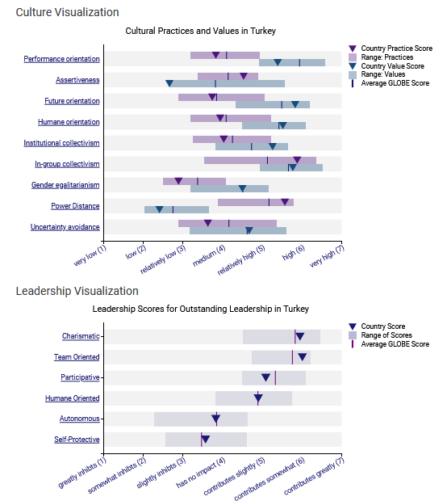
Figure 1: Score of Turkey from GLOBE project
Source: (Globeproject.com, 2020)
- In-group Collectivism: There could be a mix of both, but Turkey might value in-group unity more, which means trust and support (British Council, 2022). The people who run the hotel will also get some good ideas. This is what Turkey has chosen to do.
- Gender Equality: England wants equal rights for men and women and generally agrees with gender egalitarianism (House et al., 2014). Each level in Turkey may be different, and it is important to understand and accept them.
- Assertiveness: People in England are usually sure of themselves and put a lot of value on winning and competing (Hanges and Dickson, 2022). Turkey might care more about others and want to work together.
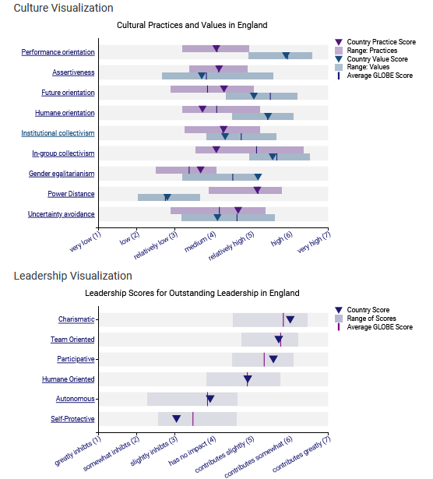
Figure 2: Score of England from GLOBE project
Source: (Globeproject.com, 2020)
Performance Orientation: Each country might value success a great deal, but Turkey might value tradition and security even more (British Council, 2022).
Future Orientation: There is a chance that England is more interested in the future and planning and spending for it more. How things are done now and, in the past, may be more important to Turkey (Kabasakal et al., 2012).
Human Orientation: Britain might have a good balance, but Turkey might put more weight on a humane method that values care and kindness.

Challenges of Intercultural Leadership in Hospitality
Communication styles: When people talk in different ways, they might not understand each other and get into fights. Some countries might think it is rude to talk straight to someone, while others might think it is rude to talk indirectly to someone (Abramson and Moran, 2018).
Decision-making processes: Power distance can make people make choices in different ways, which can be bad (Grobelna, 2019). There may not be an official way to do things in Turkey that would work with how decisions are made in England, where everyone works together.
Work ethic and time management: Stress can happen when people have different ideas about how to be on time and work hard (Maheshkar and Sharma, 2018). For example, if Turkey values getting to know people more than making tight deadlines, this could make it hard for England to focus on speed.

Recommendation
- They need to make sure that everyone on their team learns how to be sensitive to other cultures and how important it is to accept and understand different cultural views. Some examples of this are taking classes on how to talk to people from other cultures, learning a new language, and going on trips where they live with people from other cultures.
- By starting diversity and inclusion projects to make the workplace a better place for everyone. Enjoy cultural festivals and support programmes that bring people from different cultures together (Javidan et al., 2015). Also, make sure that everyone treats each other with respect and love.
- People in charge should change how they lead based on their culture (Grobelna, 2019). If they want to lead their team well, they should be able to adapt to their different cultural beliefs and tastes.

Conclusion
The success of Inclusivity Hotel & Spa's foreign growth depends on our ability to value and use different cultures. Drawing on the GLOBE Project's cultural aspects, the report stresses how important it is to understand the differences in culture between England and Turkey. In the hospitality business, intercultural leadership can be hard because of differences in how people talk to each other, make decisions, and work. However, by adopting the suggested strategies, such as cultural sensitivity training, diversity and inclusion initiatives, and adaptive leadership, they can create a workplace where individuals from diverse backgrounds thrive, collaborate, and contribute to the hotel's success. This will help Inclusivity Hotel & Spa stay a leader in excellence and acceptance in the global hotel industry.

References
Abramson, N.R. and Moran, R. (2018) Managing Cultural Differences: Global Leadership for the 21st Century. 10th Ed. Abingdon: Routledge.
Barysch, K. (2011) WHAT EUROPEANS THINK ABOUT TURKEY AND WHY. [online] Available at: https://www.cer.eu/sites/default/files/publications/attachments/pdf/2011/essay_turkey_barysch_25sept07-1392.pdf [Accessed 10 Feb. 2024].
BCCT. (2018) GBBC Istanbul Gathering: ‘Cultural Differences Between Turkey & the UK’» British Chamber of Commerce Turkey. [online] Available at: https://www.bcct.org.tr/chamber-news/gbbc-istanbul-gathering-cultural-differences-between-turkey-the-uk/65629 [Accessed 10 Feb. 2024].
British Council (2022) Cultural top tips for UK businesses working with Turkey. [online] British Council,. Available at: https://www.britishcouncil.org/sites/default/files/turkey_top_tips.pdf [Accessed 10 Feb. 2024].
Globeproject.com. (2020) Results - England GLOBE Project. [online] Available at: https://globeproject.com/results/countries/GBR%3Fmenu=list.html#list [Accessed 9 Feb. 2024].
Globeproject.com. (2020) Turkey Results - GLOBE Project. [online] Available at: https://globeproject.com/results/countries/TUR%3Fmenu=list.html#list [Accessed 9 Feb. 2024].
Grobelna, A., (2019) Intercultural challenges facing the hospitality industry. Implications for education and hospitality management. Journal of Intercultural Management, 7(3), pp.101-117.
Hanges, P.J. and Dickson, M.W., (2022) The development and validation of the GLOBE culture and leadership scales. Culture, leadership, and organizations: The GLOBE study of, 62, pp.122-151.
House, R.J., Hanges, P.J., Javidan, M., Dorfman, P.W. and Gupta, V. eds., (2014) Culture, leadership, and organizations: The GLOBE study of 62 societies. Sage publications.
Javidan, M., Stahl, G.K., Brodbeck, F. and Wilderom, C.P., (2015) Cross-border transfer of knowledge: Cultural lessons from Project GLOBE. Academy of Management Perspectives, 19(2), pp.59-76.
Kabasakal, H., Dastmalchian, A., Karacay, G. and Bayraktar, S. (2012) Leadership and culture in the MENA region: An analysis of the GLOBE project. Journal of World Business, 47(4), pp.519-529.
Maheshkar, C. and Sharma, V. (2018) Handbook of Research on Cross-Cultural Business Education. Hershey: IGI Global.

