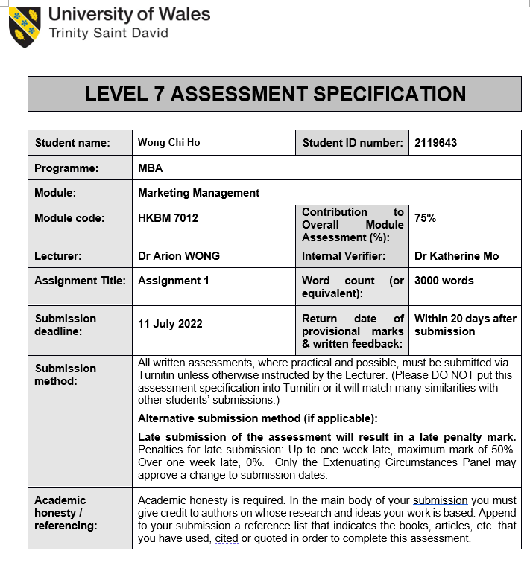
HKBM7012 – Marketing Management

Name: Wong Chi Ho, Joe
Student Number: 2119643

Executive Summary

The aim of this analytical report is to evaluate the marketing opportunities of the healthcare industry in terms of products, markets, and consumers. UMP healthcare limited would be selected as a case study to analyze its marketing plan for products and service offerings. Technology is a key enabler to enable the firm to further develop its Business to Customer (B2C) segment. Digital marketing plays a key role to tap the opportunities for new business development.

----- To be rewritten after finishing the whole report

Table of Contents
Introduction 5
Situation Analyst of UMP 5
Segmentation, Targeting and Positioning 9
Marketing Mix Strategy 9
Future Developments in the Area of Marketing. 9
Recommendation and Conclusion 9
References 10

Introduction

Healthcare industries has been growing in Hong Kong. The total health expenditures have been increased by twice from year 2009/10 to 2019/20 (Hong Kong’s Domestic Health Accounts (DHA), 2021). Besides, Hong Kong has the highest life expectancy in the world. The portion of elderly people aged 65 or above is expected to increase from 20% from 2021 to 33.3% in 2029 (HKTDC, 2022). The demand of healthcare is expected to further increase. However, healthcare staff is shortage at all levels and an under-developed primary care infrastructure has led to patient demand not being satisfied (Schoeb, 2016). There are many opportunities to develop the healthcare markets.

In this report, we are going to have a case study on a clinic chain provider in Hong Kong. Established in 1990, UMP healthcare holdings limited (stock code: 722.HK) is one of the leading medical and healthcare providers. The company becomes a corporate healthcare solution provider to insurance companies and direct corporate. Its B2B business model has increased medical visits since the 1990s. UMP focus on the outpatient primary healthcare industry. The vision of UMP is to give everyone access to trusted and affordable care, so that everyone can freely pursue their dreams without worrying about their health (UMP Website, n.d.).

Situation analysis would be performed. The company’s market segmentation, positioning and market mix strategy for healthcare delivery would be analysed. Further development in the marketing area would be recommended to create value with customer awareness and appreciation of the brand. The goal is to make a substantial increase in profits and market share to fulfill the company’s growth strategies.

Situation Analyst of UMP

This SWOT analysis combines internal & external views. Strengths and weaknesses represent the good and bad side of the internal view while opportunities and threats correspond to the positive side and negative issues that existed in the external environment (HKU, n.d.).

The factor includes market views on the healthcare system in HK, UMP’s digital & non-digital operation perspective, and UMP’s major competitor, Quality HealthCare Medical Services, also known as QHMS. They both focus on primary care in the healthcare ecosystem. Primary care is the first level of care in the whole healthcare system, while secondary and tertiary care may include hospitalization and specialist care (UMP, 2019). QHMS is owned by Bupa Insurance.

Strength

- Strong Business to Business (B2B) foundation with various insurance companies

UMP has worked closely with insurance companies in HK to provide tailored B2B healthcare services for their customers for over 30 years. They have partnered up with over 20 insurance companies, including major players like AIA, AXA, Manulife, etc. Besides, the company has invested in virtual care (Telemedicine) to provide unique service offers to B2B clients in HK delivered to AXA, AIA right after the COVID-19 outbreak. This fulfills the demand for insurance products and creates a win-win collaboration for the insurance and healthcare industries (Willis Towers Watson, 2021). Those strategic partnerships with insurers become major sources of income and have provided UMP with stable revenue that could be reinvested in other corporate development.

- Better leverage panel doctor network

To ensure the company is attractive to insurers, UMP had a union with panel doctors to form a network with over 1100 service points. This has been supported by strong medical administrative professionals, including healthcare relations, medical concierge service, referral arrangements, etc. Through B2B partnership with panel doctors, UMP has continued to record more than one million annual patient visits and insurance policy members in the fiscal years 2020 & 2021 (UMP, 2021). Compared to one of the biggest competitors, QHMS has recorded 3 million annual patient visits but it only provided 1500 service points (QHMS, 2020). It shows that UMP has better leveraged a broad range of associate partners to be more accessible to insurer members.

- Built up strong internal team to support growth strategy

UMP has expanded its senior management team during the year 2020/21 by an on-boarding professional with significant experience and knowledge in clinic chain management, information technology, finance, legal and HR. They are prepared to invest HK 50 million for clinic system digitalization and expansion projects in 2022. The board of directors of UMP strives to execute a growth strategy (UMP, 2021).

Weakness

- Too focus on one business segment (Corporate healthcare solution – B2B)

UMP focuses too much on the B2B business model. The major income, around 40%, is from corporate healthcare solution services (UMP, 2020). Insurance companies are expected to tighten cost control due to significantly higher medical trends over the next three years. One way is to reduce the claims loss ratio (Willis Towers Watson, 2021). As such, the doctor fee or agreed fee for the medical network provider would be further reduced. This will place a severe strain on the profit margin of the medical network provider.

- Lack of strategy for marketing B2C sectors

Although there is 54% increase in patient visits for primary care (B2C business sources), it relies heavily on immigration medical examination (IME) (UMP, 2021). IME business segment has significantly increased in the year 2021 due to the recent growing trend of emigration (The Standard, 2021). The growth engine is not sustainable once the IME business slows down.

Threat

- Fierce competition in private healthcare sector offering primary care services

One of the key primary care services player, QHMS, is backed by an insurance company. There is synergy and collaboration with the insurance customer directly and with better financial strength. On the contrary, UMP is unable to obtain operation synergies B2B insurance value chain under a single roof.

In the year 2020, QHMS has launched a new mobile app to provide a series of new virtual initiatives. This includes e-ticketing, e-booking and in-app virtual consultation functions (Marketing Interactive, n.d.)

- Needs and Wants changed in primary care service after COVID-19 pandemic

Whether people’s behavior will remain the same in a post-COVID environment could be a challenge to businesses. Digitalization on patient journey becomes the key. Virtual care has become a game-changer to healthcare industries. The possibility of living with a new normal in a continuous manner, e.g travel restriction.

- Costs for healthcare professionals are increasing

The COVID-19 pandemic has been a crisis for healthcare providers. Extra work has been done by healthcare professionals. The turnover rate is expected to increase. This threatens the supply of healthcare professionals globally (Mckinsey, 2021). On the other hand, some of the professionals, such as nurses, and doctors, are found to be leaving HK. This also affects the supply side (RTHK, 2021). As such, the wage of healthcare professionals would be increasing.

Opportunity

- Up growing trend in total health expenditure in Hong Kong
In figure 1, it shows that the health market is expanding. This is good sign to healthcare providers.

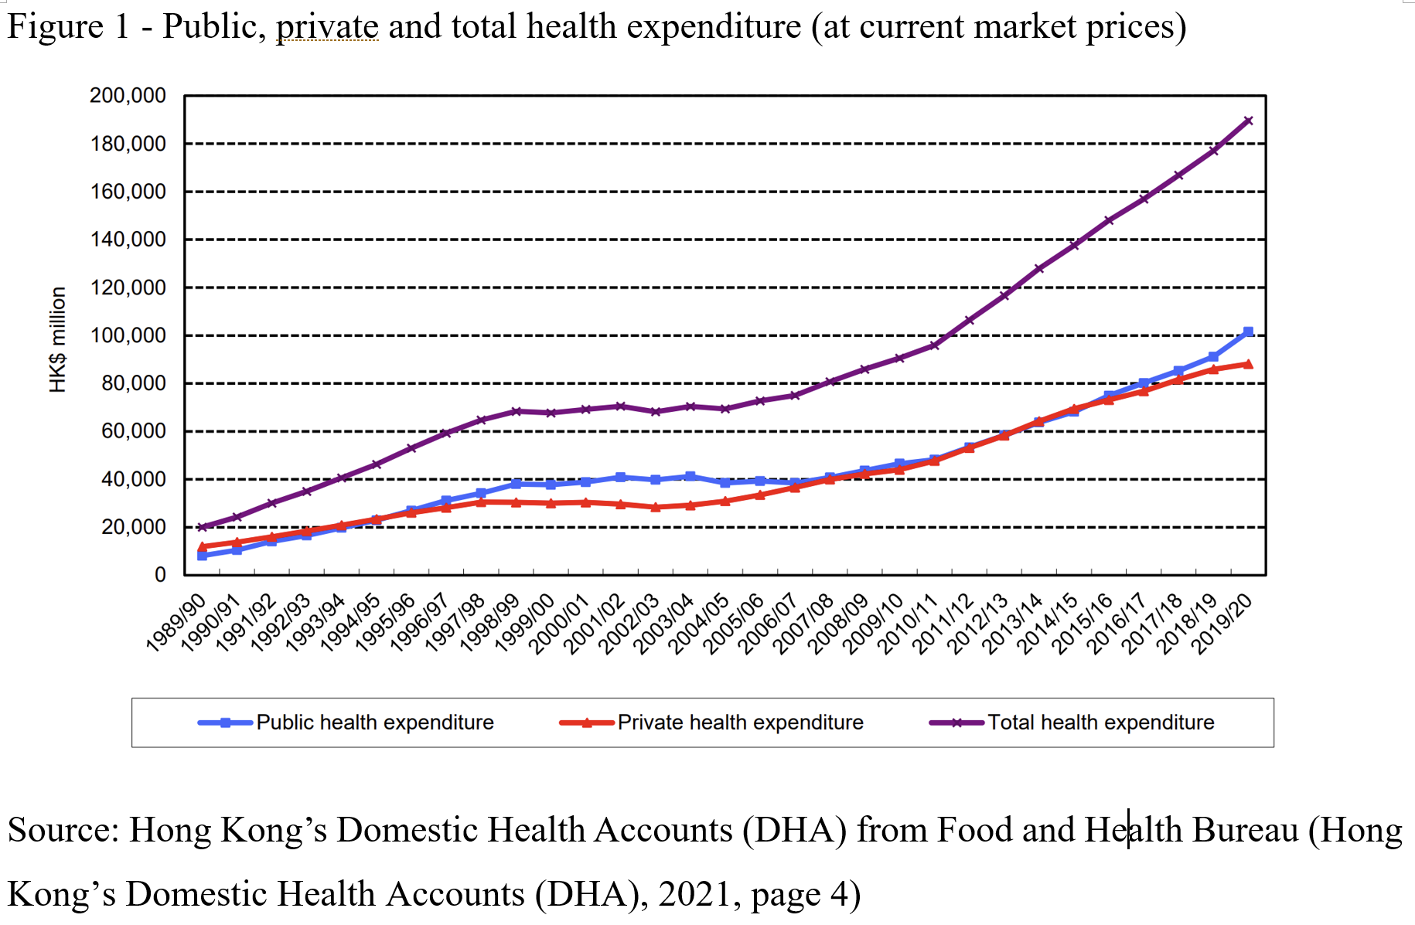

- Growing demand for privately purchase insurance schemes to finance the health expenditure

In figure 2, it shows a trend of an increasing portion of health expenditure being financed by private insurance. It outreached employer-based insurance scheme. There is a potential market if the healthcare player delivered products/services that suit this customer segment
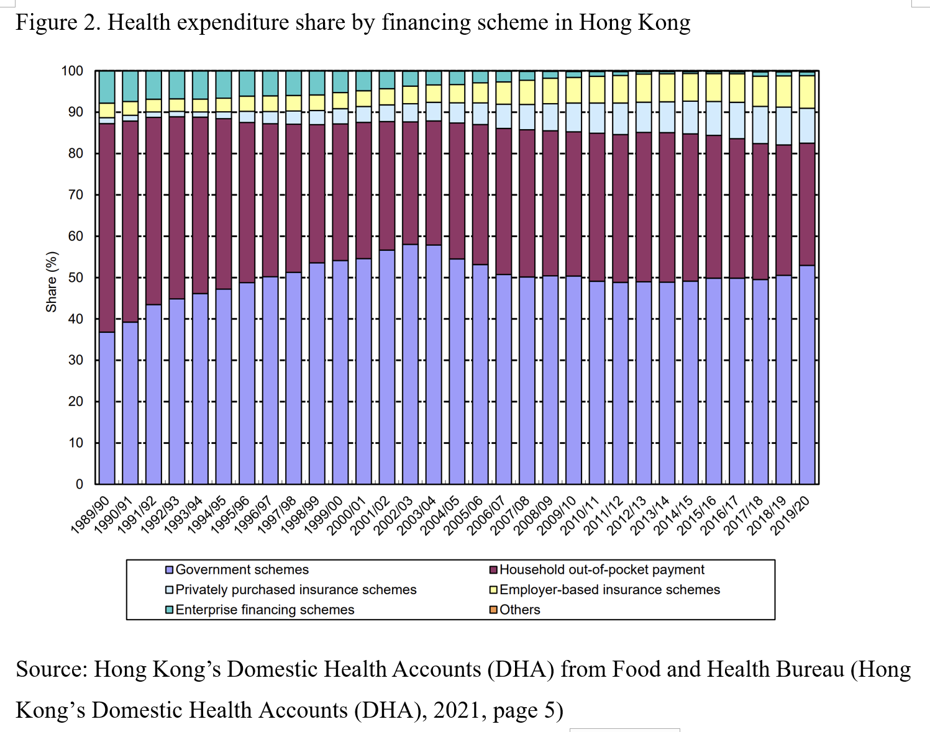

- Public healthcare service is overflow. More public-private partnerships (PPP) would be a solution to relieve public healthcare demand

In figure 3, it shows that the ratio of public health expenditure (54%) in the year 19/20 is higher than that previous 4 years (51%). It further proves that the consumption of public service in Hong Kong was relatively more during the COVID-19 pandemic period. There are opportunities for private healthcare providers to deliver services that could shift the demand from public healthcare. With the adoption of IT and internet, there were quite a lot of successful business to government (B2G) business models happened in Hong Kong, ESDLife is one example (Jain Palvia and Sharma, n.d.). The private healthcare sector could leverage technology to integrate with the government system so as to deliver the healthcare service.

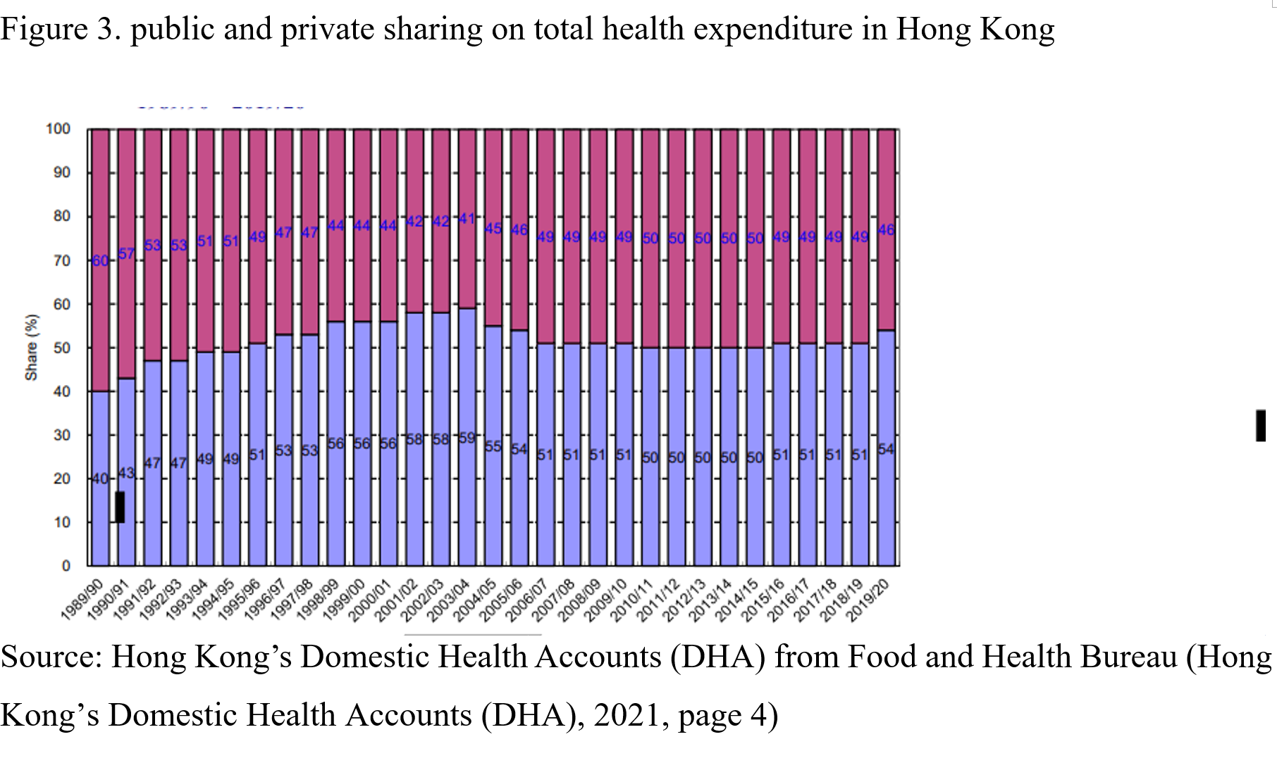

- Digital marketing on healthcare services/products

The healthcare industry is behind other industries in digital marketing (Grbic et al., 2019). There is room for development in healthcare providers in order to tap into the B2C channel for youngsters.

- Personalized preventive healthcare demand and chronic illness

Segmentation, Targeting and Positioning

Segmentation

Segmentation is the process by which a market is divided into distinct subsets of customers with similar needs and characteristics. UMP focus on two business segments. 1. Corporate scheme management. 2. Clinic management

Corporate scheme management refers to B2B. Its marketing segmentation includes

- Group insurance contract from the insurance company
- Individual insurance contract from the insurance company
- Corporate healthcare solutions are offered directly through UMP (UMP website, n.d.).

Clinic management refers to the service delivered to the patients. Like customer segmentation in other service industries, patient segmentation would be based on personal health conditions and characteristics. The objective is to divide the population into homogeneous groups based on similar needs for the service. Seven segments are listed below (Brommels, 2020).

- Healthy Person
- Persons with incidental needs, e.g common cold
- Persons with Chronic disease
- Persons with multiple health problems and illnesses (usually elderly and needed a case manager)
- Persons need precise elective interventions
- Persons needing qualified accident and emergency service (usual inpatient)
- Tertiary care patient – a complex health problem, a rare disease that needs expertise or expensive technology for treatment

Targeting

For B2B marketing, the company focuses mainly on the insurance business with group insurance business (UMP, 2019). The company has actively worked with insurance companies to provide virtual care during COVID-19.

The company started to work on individual contracts with insurance companies. To enable a more digital patient experience, UMP has opted to partner with a virtual insurance company, ZhongAn International, in the year 2021. The new initiative is to deliver a new health membership program to enjoy UMP’s professional healthcare network at an affordable price. (UMP Group News,2021).

For B2C, UMP’s main target is the persons with incidental needs. They provided individual services like family doctors, specialist practitioners, dental practitioners, physiotherapy, laboratory and imaging (UMP Website, n.d.). There is no comprehensive membership platform and case management program to increase patient recursive use of the service.

Immigration examination service has been one of the major income sources of B2C services since year 2021. UMP has put it on eShop to boost sales. This kind of product is also to address persons with incidental needs – emigration.

Positioning

UMP’s vision is “to give everyone access to trusted and affordable care so that everyone can freely pursue their dreams without worrying about their health” (UMP Website, n.d.). UMP pricing would be positioned in the middle to low so that it suits both corporate members and walk-in customers (B2C).

Marketing Mix Strategy

Future Developments in the Area of Marketing

Recommendation and Conclusion

References
‌Antosova, I., Hazuchova, N. and Stavkova, J. (2019). MARKET SEGMENTATION IN HEALTHCARE. Marketing and Management of Innovations, (3), pp.151–166. doi:10.21272/mmi.2019.3-12.

Brommels, M. (2020). Patient Segmentation: Adjust the Production Logic to the Medical Knowledge Applied and the Patient’s Ability to Self-Manage—A Discussion Paper. Frontiers in Public Health, 8. doi:10.3389/fpubh.2020.00195.

Consultancy in Healthcare and Life Sciences | Vintura Consultancy. (n.d.). Patient segmentation for the outpatient clinic of the future. [online] Available at: https://www.vintura.com/cases/patient-segmentation-for-outpatient-clinic-of-the-future/ [Accessed 2 Jun. 2022].

Grbic, M., Stimac Grbic, D., Stimac, L. and Sostar, Z. (2019). Digital marketing in healthcare. European Journal of Public Health, 29(Supplement_4). doi:10.1093/eurpub/ckz186.077.

‌HKTDC. (2021). HKTDC Research. [online] Available at: https://research.hktdc.com/en/article/MzEzOTQ1MjMz [Accessed 25 May. 2022].
HKU. (n.d.). [G06] SWOT analysis. [online] Available at: https://philosophy.hku.hk/think/strategy/SWOT.php. [Accessed 30 May. 2022].
‌Hong Kong’s Domestic Health Accounts (DHA). (2021). [online] Available at: https://www.fhb.gov.hk/statistics/download/dha/en/a_estimate_1920.pdf [Accessed 25 May. 2022].
Jain Palvia, S. and Sharma, S. (n.d.). E-Government and E-Governance: Definitions/Domain Framework and Status around the World. [online] Available at: http://governance40.com/wp-content/uploads/2019/06/E-Government_and_E-Governance_Definition.pdf. [Accessed 10 June. 2022].
Marketing Interactive (n.d.). Integrating tech into healthcare: Quality HealthCare revamps app to help Hongkongers stay healthy. [online] Available at: https://www.marketing-interactive.com/integrating-tech-into-healthcare-quality-healthcare-revamps-app-to-help-hongkongers-stay-healthy [Accessed 1 June. 2022].

Mckinsey (2021). Healthcare provider transformation | McKinsey. [online] Available at: https://www.mckinsey.com/industries/healthcare-systems-and-services/our-insights/emerging-stronger-from-the-crisis-whats-next-for-regional-providers [Accessed 3 Jun. 2022].

QHMS (2021) Quality HealthCare. [online] Available at: https://www.qhms.com/home/index.aspx?lang=en. [Accessed 1 June. 2022].
QHMS (2020) Partnering With Quality HealthCare - BOC Life Makes the First Move to Blend Self-Care Health Management Into Customers’ Lives | Quality HealthCare. [online] Available at: https://www.qhms.com/en/aboutus/media-centre/partner-boclife [Accessed 31 May 2022].
‌UMP Website (n.d.) UMP Healthcare Holdings Limited. [online] Available at: <https://www2.ump.com.hk/>. [Accessed 4 June. 2022].
UMP Group News (2021). UMP Healthcare Holdings Limited. [online] Available at: https://www2.ump.com.hk/news_show.php?id=157&main=13&lang_id=2 [Accessed 4 Jun. 2022].
‌
UMP (2019). UMP Annual Results and Strategy Update Presentation (FY19) [online] Available at: https://www2.ump.com.hk/investment.php?id=7&page_id=11 [Accessed 4 June. 2022].
UMP (2020). UMP Annual Results and Strategy Update Presentation (FY20) [online] Available at: https://www2.ump.com.hk/investment.php?id=7&page_id=11 [Accessed 1 June. 2022].
UMP (2021). UMP Annual Results and Strategy Update Presentation (FY21) [online] Available at: https://www2.ump.com.hk/investment.php?id=7&page_id=11 [Accessed 1 June. 2022].
RTHK (2021). Doctors and nurses leaving HK a concern: Henry Fan - RTHK. [online] Available at: https://news.rthk.hk/rthk/en/component/k2/1605747-20210813.htm. [Accessed 3 June. 2022].
Schoeb, V. (2016). Healthcare Service in Hong Kong and its Challenges. China Perspectives, 2016(4), pp.51–58. doi:10.4000/chinaperspectives.7118.

The Standard (2021). Almost 90,000 citizens leave Hong Kong in mid-2021. [online] The Standard. Available at: https://www.thestandard.com.hk/breaking-news/section/4/178758/Almost-90. [Accessed 1 June. 2022].
‌Willis Towers Watson. (2021). 2022 Global Medical Trends Survey report. [online] Available at: https://www.wtwco.com/en-US/Insights/2021/11/2022-global-medical-trends-survey-report. [Accessed 28 May. 2022].
‌

‌

