

Enabling and Supporting staff in a Hybrid Era

BMHR7014
Daniel Owen 2106804
Word Count Poster – 920 Report - 2400

Executive summary

I aim to identify through literature review and qualitative and quantitative research the best use and practices of Hybrid working and how to engage a workforce to move towards this change.
I will engage the team through 1-2-1’s, team meetings and a survey to understand their needs and how this can be applied to Hybrid working theory’s, I aim to move the team to a 60% (Office) 40% (Home) Hybrid system to start with further engagements based on their feedback as a team and individuals.
Team feedback suggests they will be open to moving to a hybrid framework, understanding the positives and negatives along with governance and safety/risk issues will lead to a working hybrid system.
Ensuring the team feel supported and have the work life balance required along with meeting the needs of the business, I am hoping this paper will create a basis for hybrid working in the future within Hywel Dda.

Contents
Executive summary 2
Introduction 4
Literature review 5
Research Design 8
Findings/Results 11
Conclusion 14
Appendix 1 – Survey Outcomes 15
References 16

Introduction
I aim to critically evaluate the impact and effects of Hybrid working on the bank and roster team within Hywel Dda University Health Board.
53% of employees are likely to prioritise health and wellbeing over work than before the pandemic and 52% of Gen Z and Millennials are likely to consider changing employers this year, up 3% year over year. Understanding and meeting employee’s expectations requires a mind shift change. Creating a culture that embraces flexibility and prioritises employee well-being will provide a competitive advantage (Microsoft, 2022).
83% of workers prefer a hybrid work model, but other factors also matter to whether they thrive onsite or off. Leaders must move beyond physical locations to shape the future of workforce. (SMITH et al., 2021)
I have been tasked with introducing Hybrid Working within my teams.
Through the introduction of hybrid working, I aim to:
- Critically evaluate literature on Hybrid Working
- Identify suitable survey techniques in gaining employee opinions
- Critically analyse, present, and discuss the findings of the survey
- To make a recommendation on how Hybrid working can be implemented within Hywel Dda
The outcome of this work is not only to introduce hybrid working within my teams, but to ensure they are supported and have the resources needed to improve their work/life balance.

Literature review
The aim is to introduce Hybrid working practice to not only provide additional flexibility to employees but also support them with the challenges and struggles, understanding these and empowering employees through training and resource provisions (Microsoft, 2022).
The benefits to employees include (CIPD, 2021):
- Improved work/life balance
- More time with family and friends
- Reduction of commuting time and costs associated
- IT upskilling
- Higher level of motivation
Research is still ongoing on the impact of Hybrid working, initial research suggests that Hybrid working offers employees the ‘best of both worlds’ – greater work life balance while still maintaining social connection and bonds with employees (CIPD, 2021)
The need to remember the basics, what does it mean to work hybrid for staff? Setting out the eligibility for hybrid working and expectation on attending work vs remote working, everyone will have a different viewpoint and need Simpson (2021).
Introduction of Hybrid working has taken place during the pandemic, this is putting pressure on people teams as there is no template to follow, so most teams are living in a live test environment, so it is important to remember that and ensure review’s take place to ensure this works for employees and the business. Creating a framework to follow, allows managers and employees to understand the requirements Penny (2022).
Creating a unique and employee led model can lead to better uptake Brand (2022).
- Listen to employees
- Delve into the data
- Make a plan
- Communicate
- Test, Learn, iterate, and evolve
Hybrid working will mean different things to different people, ensuring that they are listened to will provide a better engagement, asking employees how they want to work, creating a questionnaire to ensure these issues are covered is something I will implement to improve Hybrid working within the team Penny (2022).
Understanding the benefits there are also negatives to Hybrid Working, poor relationships being one, it can be difficult to form good working relationships with colleagues Haas (2022).
This can lead to poor team performance. Communication can also be challenging moving to a virtual discussion than face to face. Division within the team with certain staff only working in the office or having not as many home days could impact also (HRRevolution, 2021).
Some roles might not be suitable to hybrid working at even part time hours, managing staff due to productivity could also be challenging for managers, ensuring there is a way of monitoring this if productivity drops, also not all staff will want to be a hybrid worker and this may demotivate staff (www.hr-inform.co.uk, 2021).
Understanding this from a business perspective, of 1,500 executives surveyed 42% now believe most of their organisation will move to hybrid that is up from 16% a year previous, the same risks are highlighted, virtual culture can make it easy for employees to hide and feel passed over, ensuring technology is used to implement hybrid working can prove beneficial McKendrick (2021).
Key findings from CMI (Chartered Management Institute) shows that the majority of workers prefer to spend their working week combining days on site and working from home. Managers also have an impact on how well Hybrid working can be implemented, they can either be enabling or limiting (Taylor, Florisson and Hooper, 2021).
Modelling behaviour, ensuring managers have the skills and training needed to manage Hybrid teams, if managers are not set up to support how can we expect teams to work effectively (Taylor, Florisson and Hooper, 2021a)
Understanding the above positive and negatives within my work will help me create a hybrid system that allows staff to benefit from the positives and work through the negatives as needed ensuring that staff feel supported and not monitored.

Research Design
Deciding on the research method and how the data will be collected will have the biggest impact on the research project, the choices are:
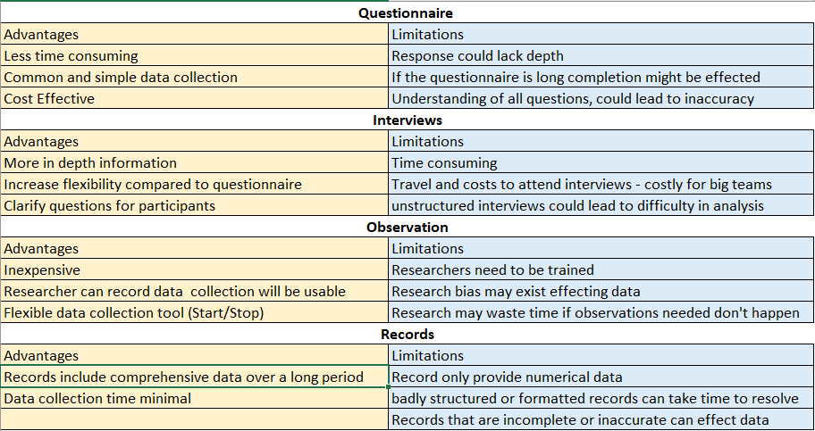
Bhatia (2022)
I have decided to use a survey/questionnaire, this is the most easily accessible tool for my team to feedback, it also allows the team to respond anonymously. The data accuracy also being a benefit of using a survey/questionnaire Cleave (2021). I will discuss this ahead of time in 1-2-1’s and Team Meetings, it is also easy to implement and share with the teams using Microsoft Forms, the questions have been checked ahead of time to ensure it can be completed quickly but with the information needed to inform decisions needing to be taken in reference to the above positives and negatives mentioned (Appendix 1).
Understanding how the survey will look from a participant viewpoint is vital to improve engagement, the survey I have created is in relation to the current work around Hybrid working and what we can do to further support the team in its introduction permanently, I also included the rational and privacy info in the email I shared with the team Parrott (2022)
Choosing between qualitative or qualitative data will need to be something I consider also; I have included a simple breakdown below:
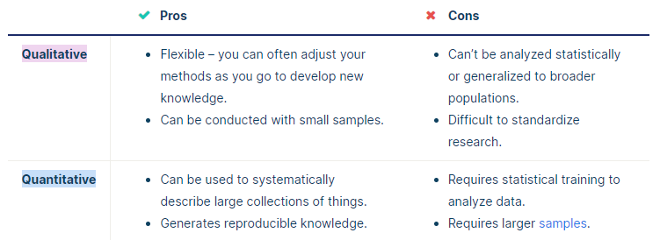
(Scribbr, 2019)
I will be using a mix of primary and secondary data to conclude my research, I will be using secondary data from trusted sources that include CIPD, Personal Management through my literature review, this will be supplemented with Primary data from my team and how they feel Hybrid working effects and impacts them using a Survey (Scribbr, 2019).
I have decided to use a questionnaire with both qualitative and quantitative data to allow a better understanding and more rounded data collection (mixed research method). This will also allow analysis of the data from closed and open questions to provide additional insight into answers from the team Osbaldeston (2021).
A questionnaire but with open and closed questions can help reduce the limitations of the findings, I will carry out some pre-work with the team and engaging with them while the questionnaire is live to support them with any questions, they are not sure of, this will involve discussion in 1-2-1 session and team meetings to communicate the changes ahead of time to the team but ensure they know they will have an input also (SurveyMonkey, 2018).
To understand the changes that need to be made I have used Lewin’s force field analysis to understand the forces acting on the change needed, this will allow me to understand the complexity and impact of the change (Cameron and Price, 2009, p.131).
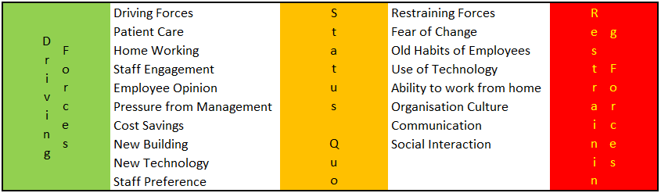
Force Field Analysis – Hybrid Working

Findings/Results
I have completed a Hybrid Survey within my teams achieving a response rate of 100% (14 out of 14) this is positive and should provide good outcomes for the questions asked.
The survey consisted of 16 questions to cover Hybrid working based on the research methodologies mentioned above, this is to ensure the introduction of Hybrid working benefits the business and the employees within the team. This survey is in line with Penny (2022) recommendation to ensure Hybrid working is employee led.
The want for Hybrid working – The first question set out the requirement of how staff wanted to work in a Hybrid office, 60% office working was the preferred choice with six respondents the rest of the questions were answered evenly with 100% office work receiving zero votes. This finding is in line with (CIPD, 2021), that found that staff find Hybrid working to provide a greater work/life balance, Simpson (2021) was also correct, reviewing the findings staff want different things so ensuring that is considered when planning Hybrid working.
Systems and digital tools – The team feel they have the hardware (Laptops/Monitors) needed to support them working from home with all fourteen respondents reporting this, digital tools email, roster systems and call systems are in place also to support Hybrid working with one team member stating they have issues accessing this from home, I will ensure this is reviewed and tested with staff to ensure issues like this are resolved prior to move to a full Hybrid system (MindTools, 2022).
Home office set up – ensuring staff are compliant with HSE guidance (Health and Safety Executive, n.d.) for home working making sure they are safe and secure is important to the business the good news is the majority of the team have access to a home desk with nine respondents reporting this with the remaining reporting to be able to use a kitchen table, employees also reported that they have the required office space to work from home with two responding they do not, further work will be needed to engage with staff to ensure this can be accompanied or a risk assessment undertaken to minimise any risk to the employee.
Finally, a list of additional physical tools needed to support Hybrid working with most staff selecting other, these including a mix of, laptop risers, work mobile, or none required.
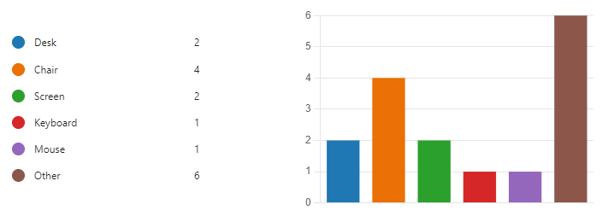
Additional Physical Tools
There is a budget set aside to support staff with these requirements, the table above will be used as a guide to the required hardware needed for employees.
Working together and social connections – Employees were asked to provide feedback as to what they would like to improve team connections and business updates. Team Briefs and regular catch ups were mentioned in the survey. Simple additions, noting who is working from home and when so the team have sight, using technology so we can understand how we use our digital body language with each other Robson (2021). Microsoft teams was mentioned as a favoured tool to support the team. As discussed previously (HRRevolution, 2021) poor communication can be a challenge in the virtual environment which is supported by the employees want to engage with each other.
Concerns about Hybrid working – most of the team had no concerns to raise, the outliers where isolation and communication levels, understanding how the social and working connections can be used to mitigate this for employees. There is a lack of data though and plenty of opinions so hybrid working will need to continue being reviewed Chamorro-Premuzic (2022).
Development and Wellbeing – Twelve staff felt that Hybrid working would have no impact on their development with two feeling it would, Wellbeing was also a similar trend with thirteen staff feeling hybrid working would have no impact on their wellbeing at work. The team are also happy with the number of meetings they must attend virtually with 13 respondents answering ideal number, this does not take away from Colombo (2021) who mentions that stresses have increased since the pandemic, these will need to be continually monitored.
What would you like hybrid working to look like? – Staff would like to choose or be given notice of their home working days, allowing staff to plan their personal lives around home working, due to the pandemic staff no have the power to leave their jobs and find another that suits them financially and flexibly Colombo (2021).
Governance and Risk – The health board have a home working guidance with all staff reporting that they have read the guidance, thirteen staff have completed a home working risk assessment to ensure any risks identified can be mitigated for the business and employee.
Other Suggestions – Employees reported they feel home working offers a better work life balance vs purely office working

Conclusion
The teams are happy to undertake Hybrid working, understanding what that means to them will be a part of the implementation plan, as discussed (Microsoft, 2022) employees are likely to prioritise their health and wellbeing over work since the pandemic. The aim is to provide the team (CIPD, 2021) with the benefits discussed previously. The team have the hardware and digital systems needed to work from home with a few underlying issues identified to be resolve prior to implementation. Following a plan based on employee feedback as mentioned by Penny (2022) is supported by employees wanting to undertake hybrid working. Ensuring employees can communicate effectively links back to (HRRevolution, 2021) employees feel they need a platform to communicate which is supported by the research. Understanding the risks around reduced visibility, staff missing development, these challenges will need to be proactively addressed to avoid rolling back progress made towards greater inclusion in the workforce (Taylor, Florisson and Hooper, 2021a)
The next step will be to implement the changes required to allow employees to move to a hybrid working structure, starting with 60% of the time in the office, I will then engage with the team throughout the next 3 months to take further feedback on how staff feel, this will be undertaken through 1-2-1 meetings and team meetings that will be ongoing as an agenda item until March next year, this will also monitor productivity of staff working from home.

Appendix 1 – Survey Outcomes

References
Brand, A. (2022). Hybrid Working Needs Different Employee Engagement Methods. [online] HRreview. Available at: https://www.hrreview.co.uk/hr-news/hybrid-working-needs-different-employee-engagement-methods/141131 (Accessed 01 Sep. 2022).
Cameron, S. and Price, D. (2009). Business Research Methods : a Practical Approach. London: Chartered Institute of Personnel and Development, p.131.
Chamorro-Premuzic, T. (2022). The Challenges of Hybrid Work. [online] Forbes. Available at: https://www.forbes.com/sites/tomaspremuzic/2022/01/26/the-challenges-of-hybrid-work/?sh=1f989797286a (Accessed 26 Sep. 2022).
CIPD (2021). Planning for hybrid working. [online] CIPD. Available at: https://www.cipd.co.uk/knowledge/fundamentals/relations/flexible-working/planning-hybrid-working (Accessed 19 Sep. 2022).
Cleave, P. (2021). Advantages of Questionnaires in Online Research. [online] SmartSurvey. Available at: https://www.smartsurvey.co.uk/blog/advantages-of-questionnaires-in-online-research (Accessed 29 Sep. 2022).
Colombo, L. (2021). Council Post: Hybrid Working Models: Why Employees’ Well-Being Must Remain a Priority. [online] Forbes. Available at: https://www.forbes.com/sites/forbeshumanresourcescouncil/2021/12/06/hybrid-working-models-why-employees-well-being-must-remain-a-priority/?sh=42bf683d315b (Accessed 26 Sep. 2022).
Haas, M. (2022). 5 Challenges of Hybrid Work — and How to Overcome Them. [online] Harvard Business Review. Available at: https://hbr.org/2022/02/5-challenges-of-hybrid-work-and-how-to-overcome-them (Accessed 05 Sep. 2022).
Health and Safety Executive (n.d.). Managing Home workers’ Health and Safety - Overview - HSE. [online] www.hse.gov.uk. Available at: https://www.hse.gov.uk/home-working/employer/index.htm (Accessed 19 Sep. 2022).
HRRevolution. (2021). The pros and cons of hybrid working | HR Revolution. [online] Available at: https://hrrevolution.co.uk/the-pros-and-cons-of-hybrid-working/#:~:text=Cons%20of%20hybrid%20working%20Poor%20relationships%20Working%20from (Accessed 19 Sep. 2022).
Manu Bhatia (2019). A Complete Guide to Quantitative Research Methods - Atlan | Humans of Data. [online] Atlan | Humans of Data. Available at: https://humansofdata.atlan.com/2018/06/quantitative-research-methods/ (Accessed 19 Sep. 2022).
McKendrick, J. (2021). Business Leaders Are Changing Their Minds About Hybrid And Remote Work. [online] Forbes. Available at: https://www.forbes.com/sites/joemckendrick/2021/11/07/business-leaders-are-changing-their-minds-about-hybrid-and-remote-work/?sh=510090c8d4c8 (Accessed 19 Sep. 2022).
Microsoft (2022). Great Expectations: Making Hybrid Work. [online] 2022 Work Trend Index: Annual Report. Available at: https://clouddamcdnprodep.azureedge.net/gdc/gdc3Ps8ze/original (Accessed 19 Sep. 2022).
MindTools (2022). Hybrid Working: Finding the Right Mix of Remote and Office Working. [online] www.mindtools.com. Available at: https://www.mindtools.com/pages/article/hybrid-working.htm (Accessed 26 Sep. 2022).
Osbaldeston, A. (2021). 5 Reasons to Combine Qualitative and Quantitative Research. [online] www.questback.com. Available at: https://www.questback.com/blog/5-reasons-to-combine-qualitative-and-quantitative-research/ (Accessed 03 Sep. 2022).
Parrott, C. (2022). Best Practices for a Survey Introduction. [online] SurveyMonkey. Available at: https://www.surveymonkey.com/curiosity/survey_introduction (Accessed 19 Sep. 2022).
Penny, C. (2022). Hybrid Working in 2022: an Ultimate Guide for HR Leaders. [online] Sage Advice United Kingdom. Available at: https://www.sage.com/en-gb/blog/hybrid-working-hr-guide (Accessed 19 Sep. 2022).
Robson, D. (2021). The Digital Body Language Cues You Send – or don’t Send. [online] www.bbc.com. Available at: https://www.bbc.com/worklife/article/20210617-the-digital-body-language-cues-you-send-or-dont-send (Accessed 4 Sep. 2022).
Scribbr (2019). Research Methods | How to Collect and Analyze Data. [online] Scribbr. Available at: https://www.scribbr.com/category/methodology/ (Accessed 19 Sep. 2022).
Simpson, S. (2021). Writing a hybrid working policy: a guide for HR. [online] Personnel Today. Available at: https://www.personneltoday.com/hr/hybrid-working-policy-hr-guide/ (Accessed 19 Sep. 2022).
SMITH, C., SILVERSTONE, Y., WHITTALL, N., SHAW, D. and MCMILLAN, K. (2021). The Future of Work | Accenture. [online] www.accenture.com. Available at: https://www.accenture.com/us-en/insights/consulting/future-work (Accessed 19 Sep. 2022).
SurveyMonkey (2018). Open-Ended Vs Closed-Ended Questions | SurveyMonkey. [online] SurveyMonkey. Available at: https://www.surveymonkey.com/mp/comparing-closed-ended-and-open-ended-questions/ (Accessed 24 Sep. 2022).
Taylor, H., Florisson, R. and Hooper, D. (2021). Making Hybrid Inclusive - Key Priorities for Policymakers. [online] Available at: https://www.managers.org.uk/wp-content/uploads/2021/10/wf-cmi-making-hybrid-inclusive-policy-brief.pdf (Accessed 3 Sep. 2022).
Taylor, H., Florisson, R. and Hooper, D. (2021a). Making Hybrid Inclusive - a Guide for Employers. [online] Available at: https://www.managers.org.uk/wp-content/uploads/2021/10/wf-cmi-making-hybrid-inclusive-employer-guide.pdf (Accessed 5 Sep. 2022).
www.hr-inform.co.uk. (2021). Hybrid working - the benefits and drawbacks | CIPD HR-inform. [online] Available at: https://www.hr-inform.co.uk/news-article/hybrid-working-the-benefits-and-drawbacks (Accessed 19 Sep. 2022).

