written report
STUDENT NAME AND NUMBER: MARCELA MANOLE 2111927 MODULE NAME AND CODE: MANAGEMENT AND ORGANISATIONAL BEHAVIOUR BMIH5004
LECTURER NAME: LOLA VILLARD-COLES

Table of Contents
Introduction 2
Organisation structure, culture and goals 2
Recent change initiatives 3
Impact of changes 5
Way of management 6
Organisation's Strategic Direction 10
Current business performance 10
Conclusion 12
Reference List 13

Introduction
The audit analysis is significant for understanding the financial position of an organisation. The report will examine the organisational structure of Hilton Group, its goals and culture at corporate and individual levels. The discussion will take place about Hilton Group's recent changes and its current performance of the business. Additionally, the report will examine the way management has encompassed the change initiatives.

Organisation structure, culture and goals
The organisational structure of the Hilton group is considerably hierarchical. At the corporate level, the hierarchical structure has allowed management of its expansion business functions (Rhou and Singal, 2020). The concerned structure is dependent on the authority for dissemination of hospitality operations and managing its stakeholders, such as employees, customers and investors. However, the organisational structure is reliant on divisions of work procedures into different portfolios. This allows coordination among the departments under centralised surveillance. The integration of the portfolios is done under the guidance of Christopher Nassetta (Hilton, 2023). This guidance allows the organisation to undertake development for expanding its hotel and resort services.
The organisational culture of the Hilton Group highly values inclusion, diversity and innovation at both corporate and individual levels. The company has been ranked second in 2019 as the best Multinational Workplace (Hilton, 2023). It has been possible by creating better opportunities for work and avenues for career development for human resources. The team management works to inculcate a culture of discipline and cooperation in the company. It has allowed the workforce to easily coordinate with each other without any inhibitions (Sota, Chaudhry and Srivastava, 2020). The management simultaneously functions to provide world-class services to its customers by operating in approximately 750 hotels (Hilton, 2023). Furthermore, the company provides perks and benefits to its workforce. This enhances their brand in working with an international hospital brand, Hilton.
The organisational goal of the Hilton group is to offer exceptional services to the guests at the corporate level (Hilton, 2023). The company aims to prioritise its hospitality services by enhancing hotel amenities that can readily attract guests internationally. Apart from its regular hospitality services, the organisation has incorporated goals of sustainability. The sustainable goals have focussed on destination stewardship, enhancing transparency, integrity and valuing human rights. For instance, at the individual level, the Hilton group has created around 5 million career opportunities through corporate involvement. (Hilton, 2023)

Recent change initiatives
The concerned organisation has undertaken recent change initiatives to influence its business functions at corporate and individual levels. The Hilton group has undertaken a change initiative regarding supporting employees who have been furloughed. The organisation has undertaken partnerships with different companies for channelling its recruitment procedures (Hilton, 2023). The company has opened different job positions from the elementary to the upper level to encompass the global workforce in the industry.
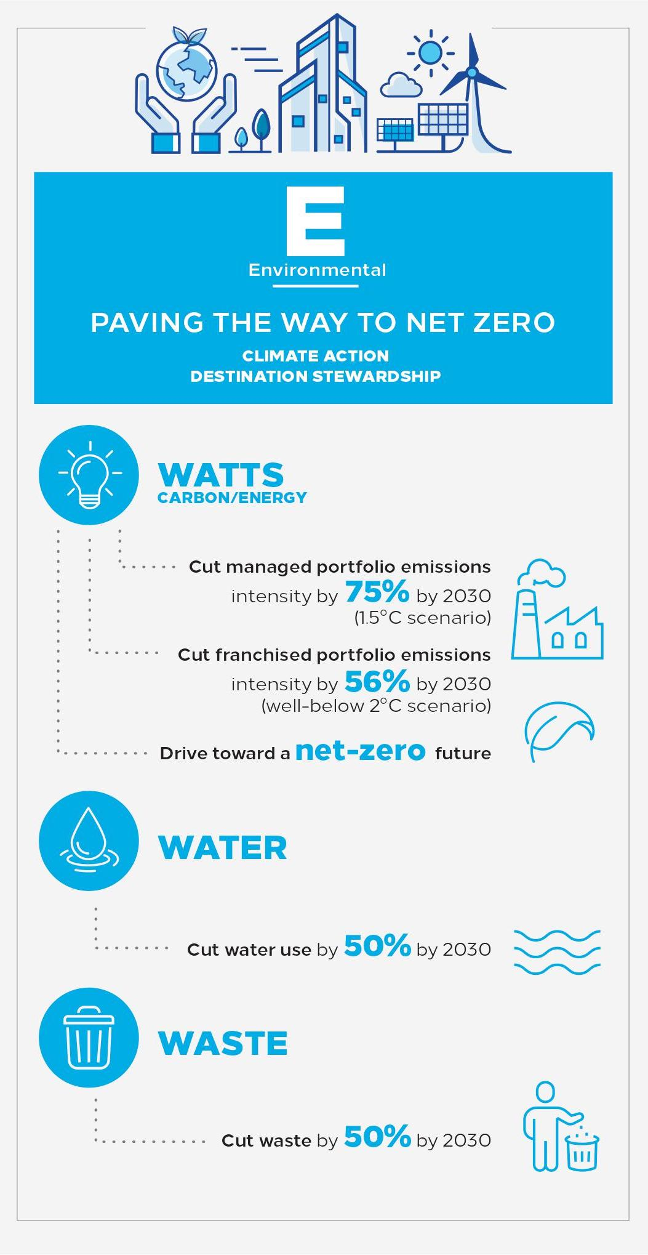
Figure 1: Environmental Initiatives
Source: (Hilton, 2023)
The company has undertaken green initiatives to promote its sustainable practices (Hilton, 2023). These practices are fostered both through the corporate and individual activities. For instance, at the corporate level, initiatives have been taken to reduce carbon emissions by 56% from the portfolio (Hilton, 2023). The initiatives have been supported by the actions of individuals in the form of cooperation and execution by the present organisational workforce. The initiatives of sustainability further focus on the reduction of waste generation. The generation of waste has been eliminated by decreasing the use of plastic considerably. For instance, the utilisation of plastic straws has been eliminated from the premises of the resorts and hotels managed by the Hilton Group. Each of the human resources is responsible for reinforcing its applicability in the industry functioning (Pham, Tučková and Jabbour, 2019). The initiatives of sustainability additionally promote activities of recycling and reusing resources.

Impact of changes
The change initiatives of sustainability have positively impacted the functioning of the Hilton Group. The adoption of green initiatives such as management of waste, recycling and reusing of waste has enhanced the cost efficiency. The inclusion of technology in sustainability has ensured that a maximum of the resources are utilised and re-utilised (Pham, Hoang and Phan, 2020). Therefore, at the corporate level, the company has harnessed financial benefits by reducing operational costs. The increase in cost efficiency attunes to the values of the enterprise in the conduction of responsible businesses.
The integration of the sustainability practices had perpetrated the brand awareness and reputation of the Hilton Group. It enhances positivity among the stakeholders such as guests, investors and employees who are eco-conscious (Shafaei, Nejati and Yusoff, 2022). The inclusion of such practices has increased loyalty among the customers along with an accelerated rate of occupancy. The adoption of sustainability initiatives has conformed to its goals, such as a reduction of carbon emissions and reception of waste generation. The intensity of the recycling and reusing process has ensured that fewer landfills are occupied with waste generated from daily operations. It has allowed the concerned organisation to maintain as well as preserve the natural environment. Additionally, the integration of sustainability practices has ensured Hilton Group can easily adhere to change environmental compliance.
The initiatives of assisting the furloughed human resources have positively impacted the organisation. At the individual level, employees feel highly motivated and remain loyal to an enterprise due to the inclusion of such initiatives (Rhou and Singal, 2020). It has increased their responsibility towards the concerned group, decreasing costs of employee training along with turnover. Similarly, the initiative to include dismissed workers has created a positive public image of the group.

Way of management
Hilton group has appropriately managed its sustainable initiatives and initiatives of including furloughed workers. The sustainable practice has focussed on ethical sourcing by procurement of services and goods in a responsible manner (Hilton, 2023). The corporate level has focussed on sourcing materials from local suppliers in areas of Hilton's operation. This has adequately assisted the local communities and put forward a responsible approach through the maintenance of cooperation, transparency and integrity.
The theory of Triple Bottom Line (TBL) can be applied in comprehending the initiatives undertaken by the Hilton Group.
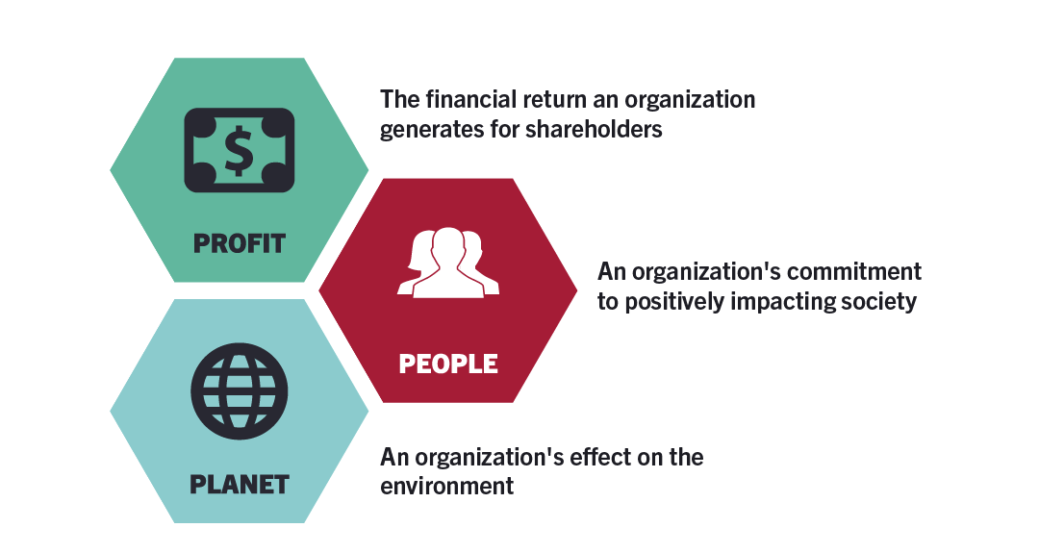
Figure 2: Aspects of TBL
Source: (HBS, 2020)
It can be stated from the above figure that TBL theory focuses on the aspects of the planet, profits and people. An organisation can be considered responsible and ethical after incorporating these aspects in balance. Hilton Group is recognised as a pioneer organisation in the hospitality industry (Hilton, 2023). The brand reputation and recognition of the organisation have been feasible through its adherence to corporate social sustainability dimensions. The dimensions of CSR include economic growth, environmental protection and community participation. These aspects are given equal importance in the TBL theory (Khan, Yu and Farooq, 2023). The concerned organisation has integrated the aspect of the planet by evaluation of environmental impact. The negative impact on the environment has been minimised by the adoption of destination stewardship as well as an action plan for positively impacting the climate. The inclusion of efforts such as the reduction of water, watts and waste in the hotels has incorporated the environmental aspects. The foundation focuses on philanthropic activities by helping the local communities in adopting practices of environmental protection. Moreover, the local community is given financial and learning resources for channelling their participation in environmental protection (Hilton, 2023). Therefore, the adoption of the practice of the foundation supports the Group corporate and individual level activities and reinforces a positive impact on the people element of TBL theory. Consecutively, the selected Group has adopted initiatives that aim at enhancing workforce participation and engagement. It has ensured that Hilton Group has encompassed elements of people as per TBL theory.
The adoption of appropriate training and development programs has managed the practice of including furloughed workers. The human resources are given appropriate training that can enhance their existing skills as well as expertise. The selected organisation has managed staff by adopting practices of inclusion and diversity. The human rights of the individuals are protected thereby ensuring they are safeguarded against any inappropriate activities (Hoang et al., 2021). Both the corporate and individual decisions facilitate the actions. The corporate level guides the Group in specifying the corporate objectives, goals and values. Concurrently, the individual performs the activities of monitoring and measuring the regular performance against the expected business standards.
The CSR Pyramid of Carroll is pertinent in understanding the position of Hilton Group in the international hospitality industry. The pyramid of Carroll Examines the CSR elements that an organisation can encompass.
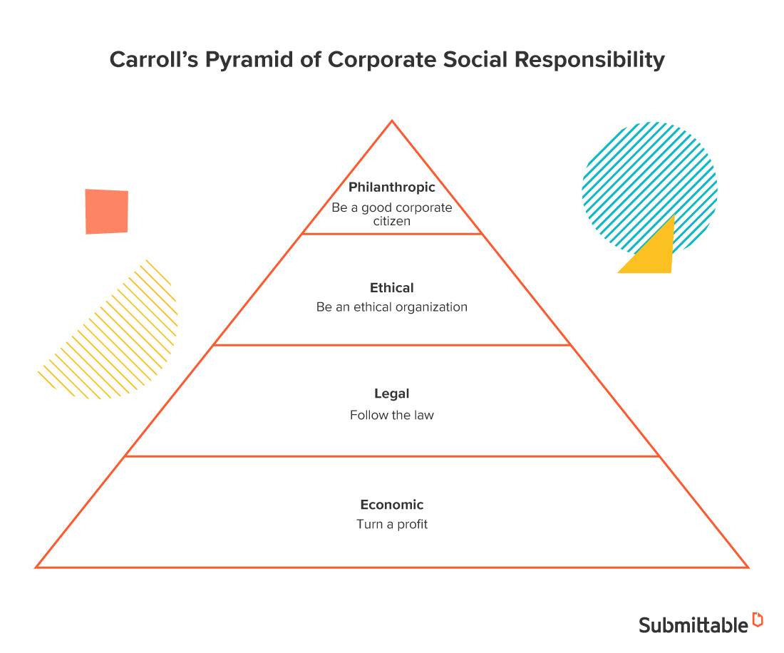
Figure 3: Aspects of Carroll's Pyramid
Source: (Perry, 2020)
It can be examined from the above that the chief elements of Carroll's pyramid are legal, environmental, discretionary and ethical practices. The integration of these aspects needs to be reinforced by the daily functioning of an organisation (Talonen et al., 2021). The Hilton Group has adequately adopted these aspects to consolidate its position in the hospitality market. The legal aspects have for instance been managed by adhering to environmental regulations and rules. The management of this aspect has allowed for diminishing the adverse impact on the environment. The promotion of community services has managed the philanthropic aspect. For example, WaterAid, which is recognised as a Grantee of the Hilton Foundation, has installed a local water point in Tanzania. It has helped the local community members to save time in procuring water for drinking and household chores (Hilton, 2023).

Organisation's Strategic Direction
The strategic direction of the Hilton Group is directed towards developing premium hospitality services for its customers (Hilton, 2023). The concerned group had included online platforms such as social media sites for informing and showcasing its amenities to international customers. At the individual level, customer care representatives have been appointed to establish a reciprocal connection with the guests. Simultaneously, at the corporate level, professional tactics have been integrated to give the Hilton Group goals and objectives a strategic direction. This has been possible by considering initiatives of sustainability and employee retention and engagement (Madanaguli et al., 2022).
The guests favour hotels and resorts that promote value to the environment and help in the protection of biodiversity. These aspects have been effectively highlighted in the communication and advertising policy. The communication takes place by making the guest aware of the initiative, such as recycling and reusing resources. The social media posts on Facebook and Instagram showcase the hotel room and amenities that have been offered. Apart from these, videos and short reels have been posted on social media sites to make the consumer aware of the sophisticated services. The visual appeal creates an immediate effect on the guests, facilitating its strategic direction of offering premium hospitality services.

Current business performance
The present business performance of Hilton Group has perceived a profitable journey by initiatives of sustainability and employee participation. The revenue from the Holdings of Hilton Group has seen a rise of 8.77 billion USD in 2022 (Statista, 2023). The revenue has increased from 5.79 billion USD in 2021. Similarly, the value of the hotel brand of Hilton Group has increased to 12.04 billion as of 2022 (Statista, 2023). This value is considered the highest for any hotel brand internationally in 2022 (Statista, 2023). The business performance of the Hilton group further facilitated new tactics for supplementing its business reputation. For instance, the concerned organisation has saved approximately 1 billion dollars from energy through the Light stay. Therefore, the Hilton Group has effectively managed its hospitality services to maintain and accept its present business performance.
The theory of stakeholders can be useful for understanding the position of the Hilton Group.
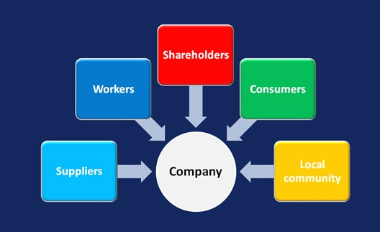
Figure 4: Aspects of Stakeholders Theory
Source: (Mashigo, 2020)
The theory upholds the importance of giving value to the stakeholders apart from the shareholders (Freeman, Dmytriyev and Phillips, 2021). The business performance of the Hilton Group has strengthened the relationship between the organisation and the stakeholders. The profitable position of the concerned group, as seen from the revenue and brand value, shows its prospect among the stakeholders. Concurrently, the theory focuses on adopting appropriate practices, such as green initiatives and employee retention, for engaging stakeholders. Both at individual and corporate levels, the Hilton group is aiming to imagine tots relationship with the stakeholders.

Conclusion
It can be summarised from the above discussion, the prospective position that is enjoyed by Hilton Group in the international hospitality industry. The concerned group has undertaken new initiatives for sustainability and inclusion of furloughed employees. These initiatives have created a positive impact on the organisational operations and strengthened its relationship with the stakeholders.

Reference List
Freeman, R.E., Dmytriyev, S.D. and Phillips, R.A., (2021) ‘Stakeholder theory and the resource-based view of the firm’, Journal of Management, 47(7), pp.1757-1770.
HBS (2020) The triple bottom line: What it is & why it’s important, Business Insights Blog. Available at: https://online.hbs.edu/blog/post/what-is-the-triple-bottom-line (Accessed: 30 October 2023).
Hilton (2023) 2030 goals: Travel with purpose: Hilton ESG, Travel With Purpose | Hilton ESG. Available at: https://esg.hilton.com/2030-goals/ (Accessed: 30 October 2023).
Hilton (2023) 2030 goals: Travel with purpose: Hilton ESG, Travel With Purpose | Hilton ESG. Available at: https://esg.hilton.com/2030-goals/ (Accessed: 30 October 2023).
Hilton (2023) Company management, Investors. Available at: https://ir.hilton.com/corporate-governance/management (Accessed: 30 October 2023).
Hilton (2023) Develop a hotel, Hilton Corporate Site. Available at: https://www.hilton.com/en/corporate/development/hilton-performance-advantage/ (Accessed: 30 October 2023).
Hilton (2023) Environmental impact: Travel with purpose: Hilton ESG, Travel With Purpose | Hilton ESG. Available at: https://esg.hilton.com/environment/ (Accessed: 30 October 2023).
Hilton (2023) Social: Travel with purpose: Hilton ESG, Travel With Purpose | Hilton ESG. Available at: https://esg.hilton.com/social/ (Accessed: 30 October 2023).
Hilton (2023) Welcome to Hilton, Hilton Brands | Global Hospitality Company. Available at: https://www.hilton.com/en/corporate/#:~:text=To%20fill%20the%20earth%20with%20the%20light%20and%20warmth%20of,%2C%20every%20guest%2C%20every%20time. (Accessed: 30 October 2023).
Hoang, G., Wilson-Evered, E., Lockstone-Binney, L. and Luu, T.T., (2021) ‘Empowering leadership in hospitality and tourism management: a systematic literature review’, International Journal of Contemporary Hospitality Management, 33(12), pp.4182-4214.
Khan, S.A.R., Yu, Z. and Farooq, K., (2023) ‘Green capabilities, green purchasing, and triple bottom line performance: Leading toward environmental sustainability’, Business Strategy and the Environment, 32(4), pp.2022-2034.
Madanaguli, A., Srivastava, S., Ferraris, A. and Dhir, A., (2022) ‘Corporate social responsibility and sustainability in the tourism sector: A systematic literature review and future outlook’, Sustainable Development, 30(3), pp.447-461.
Mashigo, R. (2020) The relevance of stakeholder theory and strategic communication management in current organisations, LinkedIn. Available at: https://www.linkedin.com/pulse/relevance-stakeholder-theory-strategic-communication-current-mashigo/ (Accessed: 30 October 2023).
Perry, P. (2020) Understanding & Applying Carroll’s Pyramid of Corporate Social Responsibility, Submittable Blog. Available at: https://blog.submittable.com/carrolls-pyramid-of-corporate-social-responsibility/ (Accessed: 30 October 2023).
Perry, P. (2023) Understanding & Applying Carroll’s Pyramid of Corporate Social Responsibility, Submittable Blog. Available at: https://blog.submittable.com/carrolls-pyramid-of-corporate-social-responsibility/ (Accessed: 30 October 2023).
Pham, N.T., Hoang, H.T. and Phan, Q.P.T., (2020) ‘Green human resource management: a comprehensive review and future research agenda’, International Journal of Manpower, 41(7), pp.845-878.
Pham, N.T., Tučková, Z. and Jabbour, C.J.C., (2019) 'Greening the hospitality industry: How do green human resource management practices influence organisational citizenship behavior in hotels? A mixed-methods study’, Tourism management, 72, pp.386-399.
Rhou, Y. and Singal, M., (2020) ‘A review of the business case for CSR in the hospitality industry’, International Journal of Hospitality Management, 84, p.102330. Shafaei, A., Nejati, M. and Yusoff, Y.M., (2020) ‘Green human resource management: A two-study investigation of antecedents and outcomes’, International Journal of Manpower, 41(7), pp.1041-1060.
Sota, S., Chaudhry, H. and Srivastava, M.K., (2020) ‘Customer relationship management research in hospitality industry: a review and classification’, Journal of Hospitality Marketing & Management, 29(1), pp.39-64.
Statista (2023) Hilton Worldwide Hotels by region 2022, Statista. Available at: https://www.statista.com/statistics/297754/number-of-hilton-worldwide-hotels-by-geographical-region/ (Accessed: 30 October 2023).
Statista (2023) Topic: Hilton Worldwide Holdings, Statista. Available at: https://www.statista.com/topics/1880/hilton-worldwide/ (Accessed: 30 October 2023).
Talonen, A., Jussila, I., Tuominen, P. and Ruuskanen, O.P., (2021) ‘Refining the economic dimension of carroll's CSR pyramid by taking organisation form into account', Electronic Journal of Business Ethics and Organization Studies, 26(1), pp.45-67.

