THE IMPACT OF MULTILINGUAL DIGITAL ADVERTISING ON CONSUMER ENGAGEMENT AND TRUST IN GLOBAL FMCG BRANDS IN INDIA

AI Use Acknowledgement
This research proposal was not made with any artificial tools of generating academic contents using any artificial intelligence. All search, research, writing has been done individually, and with regard to pertinent academic materials. The contents, representations and discussions developed in this proposal are independent academic research based on the analysis of academic writings. All references employed in the proposal are cited accordingly in accordance with the necessary guidelines of referencing.

TABLE OF CONTENTS
1. Introduction 3
1.1 Background of the Study 3
1.2 Research Aim and Objectives 3
Research Aim: 4
Research Objectives: 4
1.3 Research Questions 4
2. Literature Review 4
2.1 Digital Advertising in the FMCG Sector 4
2.2 Multilingual and Localised Marketing Strategies 5
2.3 Consumer Engagement in Digital Marketing 5
2.4 Consumer Trust and Brand Communication 6
2.5 Research Gap 6
3. Methodology 7
3.1 Research Approach and Design 7
3.2 Data Sources 7
3.3 Data Collection Strategy 7
3.4 Data Analysis Method 7
3.5 Ethical Considerations 8
4. Expected Findings 8
5. Limitations 8
6. Timeframe 9
7. Conclusion 10
8. Reference List 11

1. Introduction

1.1 Background of the Study
Digital advertising has grown significantly in India due to increased internet penetration and smartphone adoption. According to Dwivedi et al. (2021), the development of digital and social media platforms has markedly changed the marketing communication approach, as brands can now interact with consumers through personalised, interactive content. India is a linguistically diverse market, as different languages such as Hindi or regional languages such as Telugu, Kannada, and Malayalam and to shape communication with consumers and the effectiveness of marketing activities, brands need to focus on multilinguistic marketing. According to Devi (2025), the development of the so-called vernacular internet has enabled users of particular languages to be more active in the digital space. As a result, FMCG brands are making extensive use of digital marketing channels to reach diverse audiences. Moreover, digital communication via regional languages enhances accessibility to information and engagement in Indian markets (Kale et al. 2023), which facilitates the adoption of digital marketing by the whole FMCG sectors (Chowdhury et al. 2024). According to Ankush (2022), regional-language digital marketing enables a brand to focus on consumers likely to consume content in their local languages. As such, multilingual communication has become necessary to enhance interaction in India amid a growing digital consumer market. Additionally, multilingual advertisements improve the relevancy of the brand and communication possibilities (Al-Tarawneh and Al-Badawi, 2025).
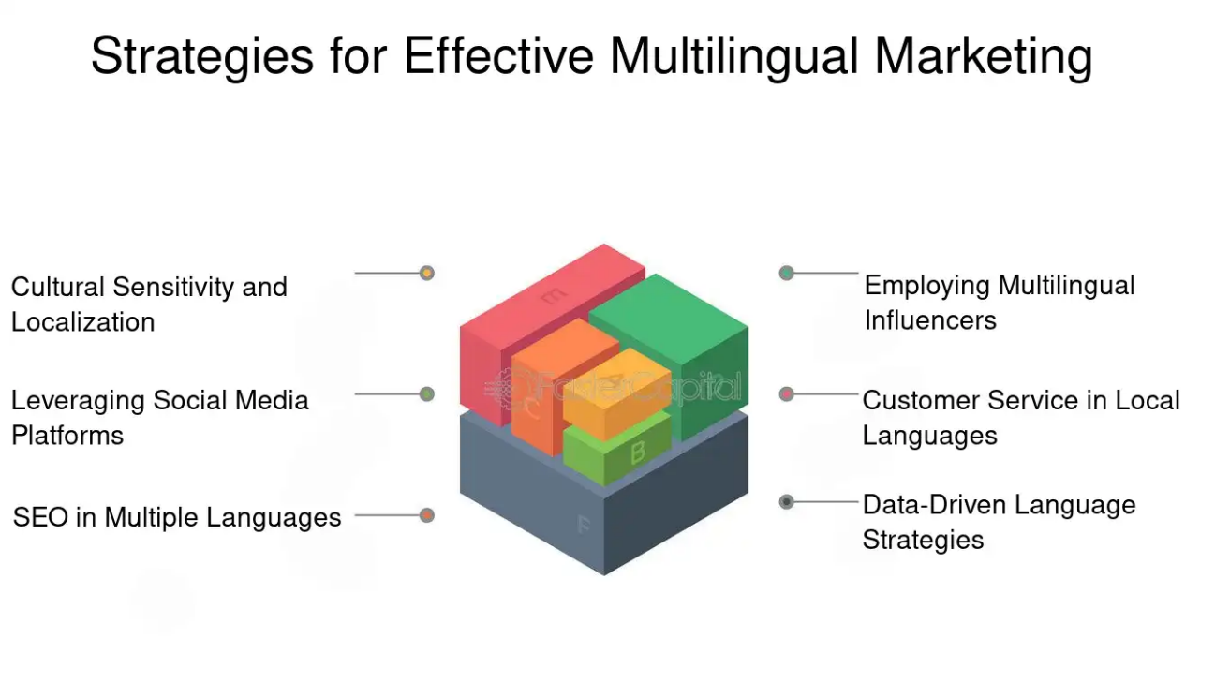
Figure 1: Effectiveness of Multi-lingual Marketing
(Source: Fastercapital, 2025)
Local language customer care and multilingual SEO policy enhance the search results, increase consumer interest, and boost confidence in international FMCG online marketing. Multimedia digital marketing helps enhance the interaction process with consumers because the brand can speak to consumers in the language they understand. Emotional attachment between the consumer and the brands is also enhanced by the localisation strategies (Fazli-Salehi et al. 2024). Besides that, digital marketing technologies enhance efficiency in the areas of FMCGs (Chowdhury, 2024).

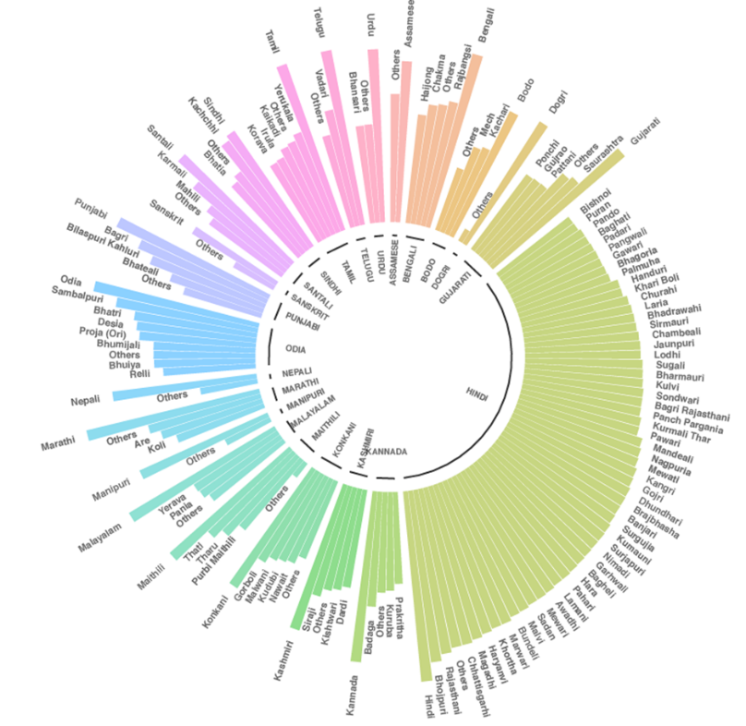
Figure 2: India’s Linguistic Diversity
(Source: Flame, 2021)
Digital multilingual advertising allows the establishment of a successful communication method by a brand in culturally diverse markets. Localisation approaches guide marketing communications in accordance with its cultural anticipations of the consumers, enhancing brand proximity (Singh and Pipaliya, 2024).

1.2 Research Aim and Objectives

Research Aim:
- The study will examine the effects of multilingual digital advertising on consumer involvement and perceived credibility among consumers interacting with global FMCG brands present in India's increasingly diverse digital market.

Research Objectives:
- To analyse the impact of digital marketing technology including multilingual search engine optimization and search engine ranking in consumer behaviour and online presence in the case of brands in the FMCG sector in India.
- To analyse the role of regional language advertising in reducing linguistic barriers and improving consumer reach in Tier-2 cities.
- To evaluate how localised language communication strategies affect consumer trust in global FMCG brands in the Indian market.

1.3 Research Questions
- What is the effect of multilingual online advertisement on consumer response in the Indian FMCG market?
- How does regional language advertising lower linguistic barriers in Tier-2 markets?
- Is there any relation between localised communication strategy and consumer trust towards global FMCG brands?

2. Literature Review

2.1 Digital Advertising in the FMCG Sector
Digital marketing has emerged as a critical strategic instrument for firms operating in the fast-moving consumer goods industry. According to Chowdhury (2024), the adoption of digital marketing technologies is also becoming common among multinational FMCG companies to enhance consumer interaction and improve the efficiency of brand communication. There has been a significant transformation in how consumer goods brands communicate with their audiences across social media networks and online advertising channels. According to Dwivedi et al. (2021), the digital media spaces enable organisations to place promotional messages specifically and reinforce consumer share by exploiting interactive content. Moreover, the development of online shopping and fast commerce systems has further increased the use of digital marketing in the FMCG industry. Chowdhury et al. (2024) indicated that digital platforms affect consumer purchase decisions by influencing contact with the product and by providing consumption information and customised advertising experiences. Therefore, digital advertising has been central to shaping consumer behaviour in the modern FMCG market.

2.2 Multilingual and Localised Marketing Strategies
Multilingual advertising has become a major strategy adopted by organisations operating in diverse cultural markets. According to Al-Tarawneh and Al-Badawi (2025), multilingual advertising campaigns are effective in enhancing communication because they present brand information in languages known to the target audience. Another aspect of international marketing strategies is language adaptation. In their argument, Singh and Pipaliya (2024) suggested that, through localisation, organisations can align marketing communications with cultural expectations, thereby enhancing consumer perceptions and brand relevance. Moreover, the use of culturally appropriate language may develop emotional relationships between consumers and brands. Fazli-Salehi et al. (2024) found that multicultural advertising enhances consumers' sense of belonging and strengthens their bond with the brand. In multilingual markets such as India, consumer engagement is increasing, with vernacular advertising campaigns used to amplify the global brand message and adapt it to local market preferences.

2.3 Consumer Engagement in Digital Marketing
Consumer engagement in digital marketing refers to the level of dynamic interaction and emotional responsiveness that consumers exhibit toward brand content on digital platforms. According to Dwivedi et al. (2021), online spaces enable brands to establish interactive communication channels that enhance consumer engagement and brand equity. The level of engagement depends on several factors, such as language familiarity, cultural relevance, and individualised marketing content. Familiarity with the language enables consumers to respond more effectively to marketing messages, and culturally friendly advertisements enhance consumers' emotional attachment to brands. In addition, individualised material conveyed by data-driven brand promotion can raise customer engagement and responsiveness. Social media networks and mobile applications provide an interactive platform for the exchange of advertising messages and consumer responses. This means that the relationship between advertising messages and consumer choices significantly shapes online interactions in contemporary marketing societies.

2.4 Consumer Trust and Brand Communication
Consumer trust is a very important aspect in long-term relationships of the brand in competitive markets. According to Fazli-Salehi et al. (2024), positive brand communication fosters emotional connections and enables consumers to engage more closely with brands. The demeanour of promoting credibility and reliability in marketing messages, through transparent and culturally appealing communication, plays a role in building them. In multilingual markets, language is relevant to enhancing brand authenticity because familiarity in communication reduces perceived barriers between consumers and organisations. Thus, the use of culturally significant language in advertising aids the creation of consistent consumer confidence and brand loyalty.

2.5 Research Gap
Although there is growing research interest in various aspects of the multilingual marketing process, there is a dearth of literature specifically examining multilingual digital advertising in the Indian FMCG industry. The available literature pays little attention to Tier-2 markets and often examines how language localisation affects consumer engagement and trust simultaneously.

3. Methodology

3.1 Research Approach and Design
The research paper employs a qualitative inquiry to examine the impact of multilingual online advertising on consumer responses and confidence in purchasing within the FMCG industry. Qualitative research gives an opportunity to analyse the trends of communication and marketing in highly social situations. According to Singh and Pipaliya (2024), qualitative methods are particularly effective for analysing cultural and linguistic effects in a marketing-centred setting. The study design focuses on secondary data analysis, thereby enabling the research to draw on the existing literature, industry reports, and marketing case studies. The methodology provides access to numerous documented marketing practices and enables the detection of trends in multilingual advertising practices.

3.2 Data Sources
The study draws on secondary sources, including academic and industry materials that are credible with respect to digital marketing and multilingual communication as well as primary sources will include peer-reviewed academic journals, marketing and advertising research books, and reports on trends in digital media. Kale et al. (2023) said that the analysis of available research on digital languages helps to gain a new understanding of communication patterns in regional language markets. Additionally, consulting organisations' reports and marketing case studies of leading FMCGs have practical implications for advertising strategies in actual market conditions. All these are organised towards the holistic interpretation of multilingual practises in digital marketing.

3.3 Data Collection Strategy
The data collection process will aim to identify academic and industry-related literature through recognised scholarly databases. According to Ankush (2022), a systematic review of studies on digital marketing indicates the existence of patterns in multilingual communication. In this regard, sources on the following topics in the digital marketing context are selected: multilingual advertising, consumer engagement, consumer trust, and academic sources, including the Google Scholar database, the Scopus database, and marketing reports.

3.4 Data Analysis Method
The study employs thematic analysis to investigate trends in the collected secondary data. With this type of analysis, it is possible to identify common themes related to multilingual digital marketing practises. According to Al-Tarawneh and Al-Badawi (2025), communication strategies that enhance audience contact can be identified by examining multilingual advertising campaigns. Therefore, it can be analysed in terms of the localisation of language, a digital approach to customer engagement, and brand communication as a means of building trust.

3.5 Ethical Considerations
Strict academic ethics are observed in the research, including proper citation of sources, prevention of plagiarism, and use of credible scholarly sources to ensure transparency and reliability.

4. Expected Findings
It is likely that the study will demonstrate that multilingual online advertising is an important element that reinforces consumer activity in the Indian FMCG industry. According to Devi (2025), the growth of so-called vernacular digital platforms has made the users of the regional languages more active in the online space. Therefore, advertising strategies that use regional languages can enhance communication for brands in Tier-2 cities, where the local language remains a dominant medium of communication. Moreover, by using localised marketing messages, consumer trust is likely to increase, as the brand's communication will sound more natural. Singh and Pipaliya (2024) claimed that localisation strategies enhance consumers' belief in the brands' relevance across various markets. Thus, by applying multilingual communication strategies, global FMCG companies can enhance their competitiveness in marketing. The results will also provide findings that can support effective multilingual digital advertising methods in India.

5. Limitations
Although it has analytical value, the research has a few limitations. The research is also based only on secondary information instead of primary feedback obtained through direct interviews with consumers. Chowdhury (2024) explained that secondary research can provide ample information on digital marketing practices, although it may not capture the actual state of consumer perceptions. Additionally, there is a paucity of case studies that examine regional language advertising in greater detail. Biases present in prior studies may also affect interpretations of multilingual marketing strategies. In addition, the study is specifically aimed at the FMCG industry, which may limit the generalisability of the conclusions to other industries. The research, however, is not in vain and provides valuable insights into the concept of multilingual digital marketing in developing markets.

6. Timeframe
Stage | Key Activity | Duration | Start Date | End Date
Stage 1 | Literature review and research gap identification | Weeks 1–3 | 24 March 2026 | 13 April 2026
Stage 2 | Collection of academic and industry data sources | Weeks 4–6 | 14 April 2026 | 04 May 2026
Stage 3 | Thematic analysis of collected literature | Weeks 7–9 | 05 May 2026 | 25 May 2026
Stage 4 | Writing methodology and findings discussion | Weeks 10–12 | 26 May 2026 | 15 June 2026
Stage 5 | Final writing, editing, and dissertation preparation | Weeks 13–16 | 16 June 2026 | 13 July 2026
Table 1: Proposed Research Timeline for Dissertation Activities
(Source: Self-Created)

7. Conclusion
The recommended study proposal will be an investigation into the effects of multilingual online advertising on consumer interest and confidence in brands of multinational FMCG producers in the Indian market. These aim to examine the role of regional language communication in enhancing marketing coverage and brand associations. According to Dwivedi et al. (2021), current marketing research on digital marketing continues to emphasise the role of interactive communication in shaping consumer behaviour in contemporary markets. This approach is especially relevant in linguistically diverse contexts, such as India, where the impact of multilingual advertising strategies on engagement and trust is particularly salient. The research will employ a qualitative secondary research approach to review the scholarly literature and industry evidence systematically. The study will therefore be valuable for generating knowledge on effective multilingual online advertising practices and for assisting international FMCG brands operating in culturally diverse markets.

8. Reference List
Al-Tarawneh, A. and Al-Badawi, M., 2025. Speaking the Consumer’s Language: Effectiveness of Multilingual Advertising Campaigns. In From Machine Learning to Artificial Intelligence: The Modern Machine Intelligence Approach for Financial and Economic Inclusion (pp. 939-949). Cham: Springer Nature Switzerland. https://www.researchgate.net/profile/Bakhit-Al-Dajeh/publication/388622700_The_Transformations_and_Evolutions_Enhancing_the_Civil_Liability_A_Comparative_Study/links/67f2ef0876d4923a1afb259a/The-Transformations-and-Evolutions-Enhancing-the-Civil-Liability-A-Comparative-Study.pdf#page=933
Al-Tarawneh, A. and Al-Badawi, M., 2025. Speaking the Consumer’s Language: Effectiveness of Multilingual Advertising Campaigns. In From Machine Learning to Artificial Intelligence: The Modern Machine Intelligence Approach for Financial and Economic Inclusion (pp. 939-949). Cham: Springer Nature Switzerland. https://www.researchgate.net/profile/Bakhit-Al-Dajeh/publication/388622700_The_Transformations_and_Evolutions_Enhancing_the_Civil_Liability_A_Comparative_Study/links/67f2ef0876d4923a1afb259a/The-Transformations-and-Evolutions-Enhancing-the-Civil-Liability-A-Comparative-Study.pdf#page=933
Ankush, M.S.N., 2022. Digital Marketing in Indian Regional Languages: An Overview. International Journal of Advance and Applied Research (IJAAR), 9(3), pp.580-586. https://ijaar.co.in/wp-content/uploads/2022/05/090385.pdf
Chowdhury, M., Ara, S. and Nath, A., 2024. Exploring the challenges and opportunities of digital marketing adoption in the multinational FMCG sector. Avishek, Exploring the Challenges and Opportunities of Digital Marketing Adoption in The Multinational FMCG Sector (May 20, 2024). https://papers.ssrn.com/sol3/Delivery.cfm?abstractid=5086494
Chowdhury, S.A., 2024. Navigating the Challenges and Opportunities of Digital Marketing Adoption in the Multinational FMCG Sector. https://www.preprints.org/frontend/manuscript/0c84276b7650b65f061ab5706eadf3e7/download_pub
Devi, S.N., 2025. Vernacular Voices in Digital India: Empowering Local Languages through Technology. भारतीय भाषाओं की आवश्यकता और उपयोग, p.204. https://www.researchgate.net/profile/Shabina-Fatima/publication/401065134_The_Need_and_Use_of_Indian_Languages_Diversity_Vernacularity_and_the_Future_of_Knowledge/links/699c1925ca66ef6ab99617c7/The-Need-and-Use-of-Indian-Languages-Diversity-Vernacularity-and-the-Future-of-Knowledge.pdf#page=205
Dwivedi, Y.K., Ismagilova, E., Hughes, D.L., Carlson, J., Filieri, R., Jacobson, J., Jain, V., Karjaluoto, H., Kefi, H., Krishen, A.S. and Kumar, V., 2021. Setting the future of digital and social media marketing research: Perspectives and research propositions. International journal of information management, 59, p.102168. https://www.sciencedirect.com/science/article/pii/S0268401220308082
Fazli-Salehi, R., Torres, I.M., Madadi, R. and Zúñiga, M.Á., 2024. Multicultural advertising: Impact of consumers’ need to belong and brand use on self-brand connection and communal-brand connection. Journal of Marketing Communications, 30(1), pp.74-101. https://www.researchgate.net/profile/Miguel_Zuniga2/publication/362904700_Multicultural_advertising_Impact_of_consumers'_need_to_belong_and_brand_use_on_self-brand_connection_and_communal-brand_connection/links/6383a434c2cb154d2932a2e9/Multicultural-advertising-Impact-of-consumers-need-to-belong-and-brand-use-on-self-brand-connection-and-communal-brand-connection.pdf
Kale, S.D., Prasad, R., Potdar, G.P., Mahalle, P.N., Mane, D.T. and Upadhye, G.D., 2023. A comprehensive review of sentiment analysis on Indian regional languages: Techniques, challenges, and trends. International Journal on Recent and Innovation Trends in Computing and Communication, 11(9s), pp.93-110. https://www.researchgate.net/profile/Sunil-Kale-2/publication/373524494_International_Journal_on_Recent_and_Innovation_Trends_in_Computing_and_Communication_A_Comprehensive_Review_of_Sentiment_Analysis_on_Indian_Regional_Languages_Techniques_Challenges_and_Trends/links/64f081754a2a2214db28369c/International-Journal-on-Recent-and-Innovation-Trends-in-Computing-and-Communication-A-Comprehensive-Review-of-Sentiment-Analysis-on-Indian-Regional-Languages-Techniques-Challenges-and-Trends.pdf
Singh, H. and Pipaliya, S., 2024. Cross Cultural Behavior and Product Localization (adapting to diverse market for global success). https://www.theseus.fi/bitstream/handle/10024/862715/Thesis_Singh_Harpreet_YBB23S1and_Pipaliya_Sanket_YBB23S1.pdf?sequence=2
Websites
Fastercapital, 2025. Language economic development: Marketing Strategies in Multilingual Environments: Leveraging Language Economic Development - FasterCapital. [online] FasterCapital. Available at: https://fastercapital.com/content/Language-economic-development--Marketing-Strategies-in-Multilingual-Environments--Leveraging-Language-Economic-Development.html [Accessed 10 Mar. 2026].
Flame, 2021. India’s Linguistic Diversity | In The Media - FLAME University. [online] Flame.edu.in. Available at: https://www.flame.edu.in/in-the-media/indias-linguistic-diversity.
‌

‌

