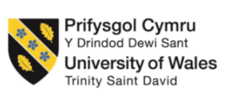

Programme: BA (Hons) International Hotel Management
Module: Organisational Consultancy
Module code: BMIH6005

Executive Summary
This consultancy report addresses the primary challenge faced by The Lanesborough, a luxury hotel in London due to the current pandemic situation that saw the reduction of the international high-end clientele. The Lanesborough is one of the favourite hotels in London which has been providing luxurious services and the facilities to the high-class travellers from different parts of the world. However, due to the covid-19 crises and the consequent changes in the travel industry the hotel is struggling to attract its target guests’ group which resulted in fewer bookings and income (Brandon-Jones et al., 2016). The Covid-19 is changing people’s perception and attitude to travel, and they are now more conscious on the destinations and the accommodations which they prefer; those that are more focused on health and safety and more personalized, sustainable luxury (Niewiadomski, 2017). Thus, to maintain its competitiveness in the context of current tendencies, The Lanesborough has to implement certain critical changes concerning these threats and become a popular hotel for upscale foreign visitors again (Guillet, 2020).
To start with, the report also examines the causes of the reduced number of international clienteles. In this regard, the customers of the hotel have been receiving negative impacts including travel restrictions, economic instability, and shifting from international to local tourists (Sharifovich, 2021). Further, increase competition from other luxury hotels in London as well as other parts of the world has made the challenge even harder. Therefore, to complement the external assessment, the hotel’s internal analysis is done using PESTEL, SWOT, and TOWS analyses to check on the broad trends within the industry and weakness or opportunities that are unique to the hotel business. For example, during recession there is little money left over for upper scale clients to splurge on their lavish experiences. Also, due to the COVID-19 pandemic, restrictions on traveling have been put in place while governments keep on changing their polices on COVID-19 precaution measures keeping the international guests from visiting the UK (Wynn and Jones, 2022). Other socio-cultural factors like wellness health and safety have also played a role in the targeting of the specific market by The Lanesborough. Moreover, trends, especially those linked with technology and digital marketing, also substantially define the consumer perception of luxury brands, and thus the improvement of the hotel’s digital platform is also vital (Niewiadomski, 2016).
The second tool, SWOT analysis assesses the internal strength and weakness of The Lanesborough together with the external opportunities that it might be able to exploit as well as the threats that the organization faces. The major assets of the hotel are good service delivery, international standard equipment plus it is strategically located in London. Nevertheless, some areas which have been deemed problematic include ineffective digital marketing which may have been adopted long time ago, low personalization of guest experiences, and weak sustainability plan. Some opportunities include relying on the image and experience which has already been created to penetrate other markets, increasing the focus on sustainable tourism, and increasing usage of information technologies to reach the clients globally. The former include competition from the other luxury hotels, shift in consumer perception and times of economic fluidity in the hospitality sector.
In the next section, the TOWS analysis leverages the findings from the SWOT analysis and presents the strategies to deal with the challenges. For instance, the hotel has strength such as a dominant brand image and can extend the opportunity of marketing into usage of advanced digital techniques to target the high-end international clients. Furthermore, The Lanesborough can also mitigate the threats of focusing too much on the organisational weakness in sustainability by leveraging on the threats of an increased consumer interest in the use of environmentally friendly facilities. Finally, increasing the level of personalization of services for the guests will help to reduce the impact of competitive threats of rivals that can provide a more individual approach to guests. From the analyses made above, the following recommendations were developed to assist The Lanesborough to successfully eliminate current challenges and restore its market position. The first suggestion is to improve on the current digital marketing campaigns. The hotel should launch an extensive digital campaign that incorporates a social media, influencer, and SEO strategy; it should focus on targeting niche luxury travellers from the hotel’s primary source markets. It is planned to spend £180000 during a six-month campaign; the result should be an increase in international bookings by 10-15%, which should bring additional revenue of £150000.
The second recommendation is on enhancing guest experiential marketing strategy which refers to a customer experience strategy. By employing its employees and enhancing the guest preference database the hotel could be able to provide guest services that will suit individual clients. This will enhance customers satisfaction and thereby increase more bookings, target market customers and high spenders. This promotional plan is expected to raise repeat customer ratio by 5 percent with £100000 budget which is likely to accrue £75,000 from repeat guests. The third recommendation therefore is, to enhance measures of health and safety due to the existing pandemic. This ranges from upgrading air conditioning systems with HEPA filters with optimized cleaning protocols for the health care setting as well as the general orientation of all employees on guidelines of infection control. These upgrades are critical in the process of trying to regain the confidence of the guests more so with regards to health-conscious consumers.

Contents
Executive Summary 2
1. Introduction 7
2. Analysis 8
2.1 Issue Description 8
2.2 Impacts 8
2.3 Data and Statistics 9
2.4 PESTEL Analysis 11
2.4.1 Political Factors 11
2.4.2 Economic Factors: 12
2.4.3 Social Factors: 12
2.4.4 Technological Factors: 13
2.4.5 Environmental Factors: 14
2.4.6 Legal Factors: 14
2.5 SWOT Analysis 14
2.5.1 Strength 14
2.5.2 Weakness 15
2.5.3 Opportunities 15
2.5.4 Threats 16
2.6 TOWS Analysis 16
3. Recommendations and Change Management 19
3.1.1 Enhancing Digital Marketing for international Clientele 19
3.1.2 Introducing Personalised Guest Experience 19
3.1.3 Upgrading Health and Safety Measures 20
3.1.4 Expanding Sustainable Luxury Initiatives 20
3.2 Change Management Strategies 21
3.2.1 Training programs 21
3.2.2 Communication with staff and stakeholders 21
3.2.3 Employee engagement strategies. to manage resistance. 22
3.3 Cost-Benefit Analysis 22
4. Action Plan 23
5. Conclusion 24
6. References 27

Introduction
The Lanesborough is one of the finest hotels in London; it’s situated in the Central Westminster and is famous for luxurious amenities, charming staff, lavish furnishing, and perfect location. It is a five-start facility which over the years has achieved what can be termed as class status and targets mainly the international tourists, political dignitaries and other celebrities. The hotel includes 93 stylish accommodations that were created to give the guests the ambiance of the British Empire with the facilities of a contemporary world (Baum, 2019). As a hotel with a Michelin star restaurant, exceptional spa services and a high touch customer experience, The Lanesborough has always been a favourite of travellers. Continuing, like many hotels in the luxury segment, it must overcome the new difficulties resulting from the COVID-19 crisis and shifts in the hotel industry’s tendencies.
The first present problem that The Lanesborough faces now is the decrease in the number of international customers after the pandemic. It has been dominated by HNWI from different regions including the Middle East, North America, and Asia. Yet, the new world health conditions have adversely affected the international tourism, due to long closures, restricted movements, and increasing concern for health and hygiene reducing the rate of international travels (Bera, 2021). Also, the shift in customer needs for the future world after the pandemic, that has increased the stakes in wellness, safety, and sustainability, has removed the luxury hotels from their comfort zone of operation and made them rethink about the value they deliver to the customers. The new dynamics have set new challenges which the Lanesborough needs to meet while always keeping in mind the core value that it creates luxurious experiences.
This consultancy report has therefore been developed by Visionary Consulting, for The Lanesborough, as part of a considerate effort to help the organization address this strategic issue. Visionary Consulting is a consultancy firm with a focus on change management and strategic development across the hospitality industry. The main competitive advantage is that we have subject knowledge, industry trends, customer analysis, and organisational effectiveness. Our company’s core idea is to provide guidelines for luxury hotels to overcome the contemporary challenges, staying true to themselves, If we say we offer professional services for our customers, it means that the team of consultants cooperates with the clients only and guarantees the result. The Lanesborough has hired us to help respond to the loss of its traditional international guests and set a multi-year plan that will bring the hotel back to its pre-pandemic occupancy levels while also preparing it for a post-pandemic future where guests care much more about health and sustainability.
To reach this goal, the report bases on the key theoretical concepts and methodological approaches applied to the hospitality and luxury service industries. Hence, the first framework is the PESTEL analysis through which it analyses the industry forces that impact The Lanesborough’s performance. Using the PESTEL analysis on the political, economic, social, technological, environmental, and legal factors the following are understood as the external forces affecting the hotel’s marketing environment. This analysis will prove useful in determining some of the macro issues that are affecting The Lanesborough, for instance, changes in the regulations controlling the travel industry or changes in the expectations of the customers.

Analysis

Issue Description
The COVID-19 pandemic's worldwide effects are to blame for the notable fall in high-end foreign visitors that the Lanesborough Hotel is presently experiencing. Several connected reasons are contributing to this discount. Major rotten, the epidemic's extensive travel restrictions greatly restricted the mobility of foreign visitors (Bera, 2019). It makes visits far less possible. There have been changes in consumer tastes, which include more demands for sustainable luxury experiences and higher standards for health and safety procedures. Furthermore, high-end customers' buying habits have become more frugal due to the uncertainties surrounding the global cheap. It made the luxury hotel market in London more modest, with both new and established hotels fighting for the same declining number of foreign visitors. This has made the task more difficult. The Lanesborough, which is well-known for its affluent international clientele, runs the risk of losing a great deal of cash if these difficulties are not resolved.

Impacts
The Lanesborough Hotel is impacted by the fall in high-end foreign visitors in several ways, including its market positioning and financial performance. The most pressing issue is revenue since the hotel's earnings are immediately impacted by fewer misgivings for upscale suites, business meetings, and longer stays (Labor, 2023). Revenue sources are further eroded by a decline in foreign consumers, which further limits expenditure on upscale food and amenities. Lanesborough's position as one of the most exclusive luxury travel destinations is in danger. It could no longer be seen as a top option for affluent explorers if it doesn't meet changing visitor expectations. Such as providing individualized, health-conscious, and environmentally responsible services (Lo et al., 2020). Future difficulties drawing in affluent visitors may result from this reputational downturn. There's also the problem of the evolving visitor experience. The hotel could lag rivals that have adapted more quickly as the request for personalized, sustainable, wellness-focused luxury increases (Otegui Carles, 2024). A poor visitor experience and disapproving reviews might follow from not meeting these new requirements, which would make it harder for the hotel to draw in new commercials (Hayes et al., 2019). Lanesborough's range of services might need to be reconsidered. To make up for the departure of foreign explorers, the hotel might have to offer new packages to local explorers that are in line with contemporary trends, such as wellness travel. The hotel may be able to attract a wider range of clients and lessen the effects of fewer foreign corporations by expanding its offers.

Data and Statistics
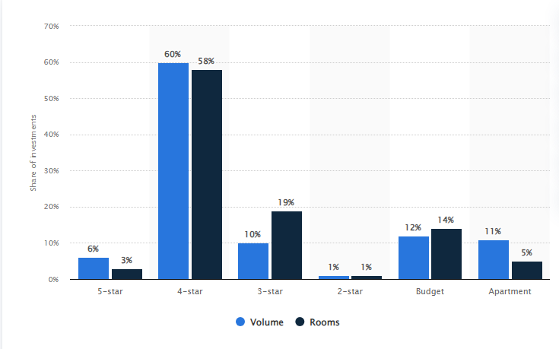
Figure 1: Distribution of hotel investment in the United Kingdom (UK) in 2021, by hotel grade
Source: Statista, 2020a
‌In contrast to the UK hotel market of 2021, when investments were dominated by 4-star hotels (60 per cent by volume), Lanesborough is a five-star luxury hotel. Although ultra-luxury hotels get less investment, The Lanesborough draws wealthy visitors by providing first-rate experiences and placing a strong emphasis on exclusivity, sustainability, and health to preserve its competitiveness and charge higher room prices (Xu et al., 2020).
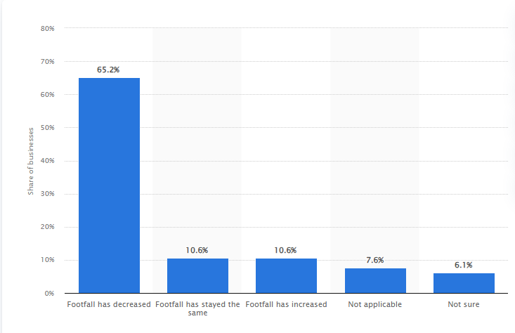
Figure 2: In the last two weeks, how has the coronavirus (COVID-19) pandemic affected your business's footfall, compared with normal expectations for this time of year?
Source: Statista, 2019b
‌The COVID-19 epidemic negatively impacted 65% of companies, including the Lanesborough Hotel and many others in the UK's lodging industry, which witnessed a sharp decline in business. However, Lanesborough's high-end clientele was harder to draw because it was a luxury hotel, which had an additional negative effect on income and occupancy.
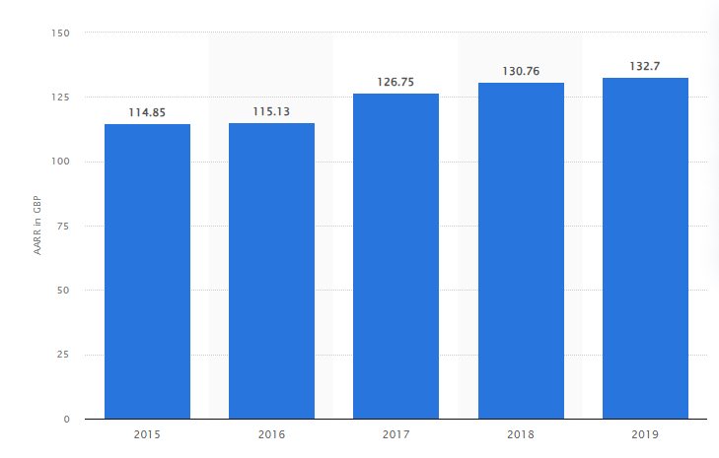
Figure 3: Average achieved room rate (AARR) in hotels in the United Kingdom (UK) from 2015 to 2019
Source: Statista, 2023
‌The five-star Lanesborough Hotel is a luxurious establishment that probably charges more than the average achievable room rate (AARR) of £132.70 in the UK for 2019. The Lanesborough fetches substantially higher rates, indicating its premium positioning and unique services catered to rich clients, whereas the broader market enjoyed a consistent rise from £114.85 in 2015.

PESTEL Analysis

Political Factors
- The ease of travel for tourists from outside, especially those from the EU, has changed due to new immigration rules.
- The hotel's capacity to draw in and host visitors from abroad depends on how stable and foreseeable political conditions remain (Khan et al., 2020).
- Travel limitations put in place by the government during the pandemic drastically decreased the number of foreign corporations (Rybakova et al., 2020).
Generally, tourism depends on foreign customers, therefore it's important to keep an eye on political developments. That can have an impact on the industry and adjust accordingly (Stone et al., 2019).

Economic Factors:
- Luxury vacationers' disposable money has decreased due to inflation and unstable economies.
- Value for money is becoming more important to wealthy clients during downturns in the hotel sector (Shi et al., 2021).
- Budget cuts brought on by economic downturns may affect reservations at fashionable hotels.
- The purchasing habits of affluent customers on upscale travel are showing signs of caution (Soni, 2023).
- To adapt to changing consumer expectations, price and service strategies must be reevaluated in response to changes in expenditure patterns.

Social Factors:
- Explorers now prefer trips that put well-being first because of the pandemic's increased health consciousness.
- Tailored luxury experiences that satisfy specific tastes are becoming more and more general (Ushakov et al., 2020).
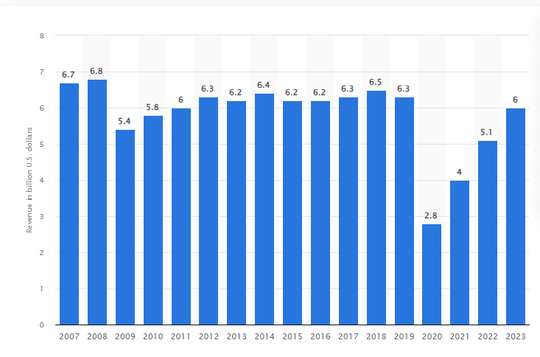Figure 2:Gross revenue of Holiday Inn hotels worldwide from 2007 to 2023
Source: Statista, 2021e
- The visitor experience may be improved, and current needs can be met by collaborating with nearby companies and wellness providers (Majeed and Ramkissoon, 2020).
- To draw in and keep visitors, tailored offerings that cater to health-conscious explorers will be crucial.

Technological Factors:
- Expectations for smooth, technologically advanced encounters have increased among modern tourists.
- Improved communication via digital channels is essential for supporting and engaging visitors (Molinillo et al., 2019).
- In addition to increasing convenience, technology also makes it easier to follow guest-important health and safety rules.
- A seamless and productive visitor experience that caters to the needs of modern explorers requires the integration of cutting-edge technology (Vinnakota et al., 2023).
- A faster and more effective arrival procedure is made possible by the postulation of mobile registration choices.

Environmental Factors:
- There is a growing expectation among guests of luxury hotels to adopt eco-friendly practices.
- If hotels don’t live up to sustainability standards, guests who care about the environment could look for another lodging (Calisto et al., 2021).
- To draw and keep visitors, it's critical to figure out how to offer a luxurious experience while maintaining ecological standards.
- Plummeting waste, procuring sustainably, and cutting carbon emissions are common demands.

Legal Factors:
- Laws about health and safety are among the many that apply to the hotel industry.
- It's important to manage capacity restrictions to maximize income and adhere to health laws.
The hotel must manage shifting work laws that may affect workforce numbers and service prospects (Baum, 2019).
- Improved hygienic practices are necessary to guarantee a secure atmosphere for both tourists and employees.
- Maintaining operational effectiveness and service quality requires adherence to certain laws (Bondarenko et al., 2020).

SWOT Analysis

Strength
- The strength of Lanesborough is that it is rich in history, superb service, and cultured design.
- The Lanesborough Hotel has earned a reputation as a prominent treat brand drawing in affluent guests.
- Explorers of business or pleasure will find it more appealing due to its ideal location in Knightsbridge, London (Stockley, 2019). That puts it close to important landmarks like Buckingham Palace and Hyde Park.
- Positive ratings and client loyalty are generated by the hotel's outstanding service.
- To further enhance the guest knowledge and differentiate, it also provides premium extras including a wellness centre, upscale dining selections, and adapted caretaker services (Wang and Zhang, 2021).

Weakness
- Its luxury character comes with expensive running expenses. That includes facility upkeep and high employee pay. These can put pressure on success, especially when there are times of low tenancy (Chisholm et al., 2020).
- The hotel is also susceptible to geopolitical events, travel restrictions, and economic downturns. That negatively influences tourism because of its significant reliance on foreign visitors.
- A strategic benefit, of focusing on the luxury market has the drawback of restricting the hotel's clientele which might lower spending in this area and lower occupancy rates.
- Additionally, to maintain the high standards of luxury that customers demand, some elements of the hotel may need upgrades (Yılmaz et al., 2022). If these ageing facilities are not swiftly rectified, prospective visitors may believe that the quality is deteriorating.

Opportunities
- The possibility of a large increase in foreign tourism arises from the relaxation of travel restrictions worldwide. That enables the hotel to focus on attracting repeat business from rich customers who desire exclusive experiences (Wu et al., 2019).
- Its increasing spa and fitness services might draw in a new clientele of health-conscious visitors because of the growing emphasis on wellness and health (Sharifovich, 2021).
- Explorers who care about the environment may find the hotel more appealing. If it invests in sustainability projects and indorses eco-friendly features, helping to strengthen its standing (Kulshreshtha et al., 2019).
- By utilizing front-line technology to provide individualized guest experiences. The Lanesborough can become a pioneer in contemporary luxury hospitality by increasing operational effectiveness and inspiring client happiness.

Threats
- The Lanesborough must constantly innovate to stay ahead of the highly competitive London luxury hotel. Which is home to both established and emerging competitors.
- Another difficulty is economic instability that downturns can cause potential visitors to cut spinal on their travel expenditures, which can damagingly impact occupancy rates and income. Inflation and geopolitical tensions can also make this a hazard (Papagianni et al., 2019).
- The emergence of alternative lodging replacements such as luxury rentals and boutique hotels, provides explorers with a wider range of choices. It is another indication of shifting consumer tastes.
- It is persistent health worries associated with pandemics or outbreaks may discourage explorers from selecting hotels (Ghasempour Ganji et al., 2023). Therefore, The Lanesborough must maintain the highest levels of cleanliness and security to reassure potential clientele.

TOWS Analysis
TOWS Analysis | Strengths  • The strength of Lanesborough is that it is rich in history, superb service, and cultured design.  • The Lanesborough Hotel has earned a reputation as a prominent treat brand drawing in affluent guests.  • Explorers of business or pleasure will find it more appealing due to its ideal location in Knightsbridge, London (Stockley, 2019). That puts it close to important landmarks like Buckingham Palace and Hyde Park. | Weaknesses  • Its luxury character comes with expensive running expenses. That includes facility upkeep and high employee pay. These can put pressure on success, especially when there are times of low tenancy (Chisholm et al., 2020).  • The hotel is also susceptible to geopolitical events, travel restrictions, and economic downturns. That negatively influences tourism because of its significant reliance on foreign visitors.
Opportunities  SO Strategies  - Utilize the hotel’s premium facilities to introduce the wellness programs.  - Leverage existing strengths in hospitality to enhance the sustainability practices to introduce the wellness programs.  • The possibility of a large increase in foreign tourism arises from the relaxation of travel restrictions worldwide. That enables the hotel to focus on attracting repeat business from rich customers who desire exclusive experiences (Wu et al., 2019).  • Its increasing spa and fitness services might draw in a new clientele of health-conscious visitors as a result of the growing emphasis on wellness and health. | WO Strategies  - Create the tailored packages for local and domestic travelers, which reduces the reliance on foreign tourists.  - Invest in modernizing facilities to meet the various luxury expectations.
Threats  ST Strategies  - Use the historical significance hotels and their reputation for exceptional service, which help to differentiate from emerging boutique hotels, it also enhance the brand loyalty (Iyengar and Venkatesh, 2024).  - Maintain the high service standards and invest in staff training.  • The Lanesborough must constantly innovate to stay ahead of the highly competitive London luxury hotel. Which is home to both established and emerging competitors.  • Another difficulty is economic instability that downturns can cause potential visitors to cut spinal on their travel expenditures, which can damagingly impact occupancy rates and income. Inflation and geopolitical tensions can also make this a hazard (Papagianni et al., 2019). | WT Strategies  - Implement the measures of cost-saving and the operational efficiencies to mitigate high running costs (Gamal et al., 2024).  - Develop the robust health and safety protocols to build the customer confidence and address health concerns.
External Factors

Recommendations and Change Management
To address the decline in international clientele post-pandemic, Lanesborough should implement a multi-faceted strategy. This focuses on operational changes. This should also enhance the customer service initiatives, by adopting the new marketing strategies and investing in the technological upgrades.

Enhancing Digital Marketing for international Clientele
In response to the increasing demand for wellness tourism, The Lanesborough should develop bespoke wellness packages. These could involve luxury treatments, meditation retreats and partnerships with fitness and nutrition experts (Latour and Joy, 2022). The offering of curated experiences that are aligned with health-conscious travel trends would make The Lanesborough a desirable destination. This is for affluent travellers, who are seeking relaxation and rejuvenation. The eco-conscious travellers are increasingly prioritising sustainability. To meet this demand, The Lanesborough should launch a sustainability program that focuses on reducing the emissions of the carbon and minimising the waste (Kuo, 2022). This promotes the locally sourced, organic ingredients in its Michelin-starred restaurant. This might include retrofitting the hotel with energy-efficient systems, water-saving fixtures and plastic-free initiatives (Tong-On et al., 2021).
- The Cost Estimate is 180,000.
- The Expected Benefit: This initiative aims to increase the brand visibility, potentially attracting the 10-15% more high-end international guests. The estimated additional revenue is approximately of £150,000 from the 100 additional room nights annually.

Introducing Personalised Guest Experience
The Lanesborough should implement AI-driven guest experience platforms. This provides personalised recommendations for dining, activities and for room preferences. This system could track the guest preferences over time. This offers seamless, bespoke service upon repeat visits. For instance, luxury amenities such as personalised welcome gifts and tailored itineraries could be part of the offering (Duric et al., 2021). The given post-pandemic health concerns, the hotel should offer contactless services such as mobile check-ins, digital room keys and virtual concierge services. This would reduce the physical contact. It enhances convenience and aligns with health and safety protocols. This making guest to feel more comfortable during their stay.
- The Cost Estimate is £100,000
- The Expected Benefit: Improved the satisfaction of guest and retention of the high-value clientele could increase the guest retention by 5%, which leading to a potential revenue increase of the £75,000 from repeat bookings.

Upgrading Health and Safety Measures
By investing in the air filtration systems, sanitation upgrades and comprehensive staff training to enhance the health and safety protocols. This ensures the compliance with the latest COVID-19 standards. Lanesborough should implement targeted marketing campaigns, this aimed at high-net-worth individuals in key regions. This includes the Middle East, Asia and the United States (Knowles, 2022). These campaigns should emphasise the commitment of hotel to the wellness, sustainability and luxury. A special emphasis on post-pandemic health and safety measures will further entice cautious travellers (Denysenko and Yurynets, 2021). The Lanesborough could rebrand itself as an eco-friendly luxury hotel. By highlighting the sustainability initiatives across digital platforms and collaborating with the influencers who advocate for the responsible luxury travel.
- The Cost Estimate is £50,000
- The Expected Benefit: Enhanced guest confidence will attract safety-conscious luxury travellers, helping retain business from health-conscious guests, and preventing the potential revenue loss valued at approximately of £50,000.

Expanding Sustainable Luxury Initiatives
Upgrade the rooms, which are eco-friendly and form partnerships with sustainable brands. This helps to align with the shifting consumer preferences towards eco-conscious luxury. Implement the features of smart rooms, such as voice-activated controls for lighting, temperature, and entertainment, to meet the expectations of tech-savvy guests. Additionally, by integrating in-room tablets for booking the various services and requesting amenities would enhance the experience of guests. To attract the international clientele before they arrive, The Lanesborough could offer virtual reality tours of their rooms and dining facilities (Hoare, 2021). This allows the potential guests to immerse themselves in the hotel’s luxury experience virtually. This can be integrated into their website and the marketing efforts to appeal to tech-forward travellers.
- The Cost Estimate is £80,000
- The Expected Benefit: This initiative could lead to a 10% increase in eco-tourism-related bookings. This generates an additional revenue of about £100,000.

Change Management Strategies
The transition to these new various initiatives will require a structured change management approach. This helps to ensure smooth implementation and minimal resistance from staff and stakeholders. The following strategies will help to facilitate these changes:

Training programs
Conduct the various comprehensive training sessions for all staff on new service protocols, personalised guest interaction and health and safety measures. This will help the staff to feel equipped and confident in delivering the enhanced services. All the staff, particularly those in the guest-facing roles, should be trained on the hotel’s new wellness programs and the initiatives of sustainability (Priya et al.,). This could involve the multiple workshops, which led by external consultants specialising in the wellness tourism and sustainability. By ensuring that, the staff understand the importance of these changes and can communicate them effectively to the guests. The staff should also receive training in the use of the new digital tools. These tools involve AI platforms and contactless service technologies. This might include ongoing workshops and certification programs to ensure seamless service delivery and consistent experience of guests.

Communication with staff and stakeholders
Maintain open lines of communication, or transparent throughout the implementation process. The regular updates about the changes, expected benefits and various roles of staff will help to mitigate uncertainty and foster buy-in (Martinez and Farooqi, 2023). The monthly meetings or newsletters can be used to keep all the key stakeholders informed. The clear and transparent communication with staff and stakeholders is important. Regular meetings and updates should be provided, which are used to explain the rationale behind these changes. This also involves the benefits for the hotel and how they are aligned with, The Lanesborough’s overall vision and strategy. Engaging with the key stakeholders, which including the owners and board members, is essential or important for gaining support for the initiatives (Banerjee and Schuitema, 2022). Presenting a well-researched business case, which highlights the long-term benefits, this involves revenue growth and brand enhancement. This will ensure buy-in from the senior leadership.

Employee engagement strategies. to manage resistance.
Involve staff in the process of changing by seeking their input on the operational changes. Implementing a feedback loop, this will encourage staff to voice their concerns and suggestions. This fosters a sense of ownership and commitment to the changes. Involving staff in the process of change, this will reduce resistance and increase engagement (Bezkorovafana et al., 2021). The employees can participate in workshops where they contribute the various ideas and feedback on how to improve guest services or adapt to various new technologies. This sense of the ownership will help them to embrace the changes more readily (Gupta, 2024). To encourage the participation of the staff, in the successful implementation of these changes, a recognition and rewards program should be also introduced. The employees who exemplify the hotel’s new values of sustainability, personalized service and the technology adaptation could be rewarded with the incentives such as bonuses or various career advancement opportunities.

Cost-Benefit Analysis
Proposed Change | Cost Estimate (£) | Expected Financial Benefit (£) | Financial Impact
Enhancing Digital Marketing for International Clientele | £180,000 | £150,000 | Increased international bookings by 10-15%
Introducing Personalized Guest Experience | £100,000 | £75,000 | 5% increase in guest retention from repeat bookings
Upgrading Health and Safety Measures | £50,000 | £50,000 | Retained business from health-conscious guests
Expanding Sustainable Luxury Initiatives | £80,000 | £100,000 | 10% increase in eco-tourism-related bookings

Action Plan
No. | Problem | Solution | Desired Outcome | Time Scale | Completion Date | Planned Budget
1 | Decline in international high-end clientele post-pandemic | Launch a targeted digital marketing campaign aimed at high-end international luxury travellers. | Increase in international bookings by 10-15%. | 6 months | 30th April 2024 | £180,000
2 | Lack of personalized guest experiences | Implement personalized service training and install guest preference tracking technology. | Improve guest satisfaction and retain high-value clientele. | 4 months | 31st March 2024 | £100,000
3 | Concerns over health and safety measures | Upgrade health and safety protocols, including air filtration systems, sanitation measures, and staff training. | Enhance guest confidence and attract health-conscious guests. | 3 months | 28th February 2024 | £50,000
4 | Growing demand for sustainable luxury initiatives | Expand sustainable practices, including eco-friendly room upgrades and partnerships with sustainable brands. | Increase eco-conscious guest bookings by 10% and improve brand reputation. | 5 months | 30th May 2024 | £80,000

Conclusion
Therefore, it can be concluded that The Lanesborough now stands at the crossroads in the context of its vast history as one of London’s greatest luxury landmarks. The current global pandemic has affected not only the fundamental aspect of the hotel business that is international tourism but also changed the customers’ expectations and needs in the new world affected by Covid-19. Challenges that relate to health and safety, sustainability, and changes in the marketing and customer relations have emerged to define the new realities needed for competitiveness in luxury hospitality. In this consultancy report, it is understood that there are certain problems associated with The Lanesborough, and detailed suggestions have been provided as how can these problems be addressed and how can more opportune can be availed.
From the PESTEL analysis, weaknesses, threats, opportunities, strengths, and threats were also revealed which helped in trying to explain the current situation of the hotel. Combined with the acronym PESTEL, the organization’s related political, economic, social, technical, environmental, and legal environments were also highlighted. They include the continued instability in the global economy, the dynamic measure such as the travel restrictions, and the shifting customers’ tastes and preferences. On the other hand, strengths that came out of the SWOT analysis have shown that though The Lanesborough has one of the best brands within this chain of hotels and has the best location, it has not engaged much with upcoming digital marketing trends or incorporate sustainable measures. These findings informed us on the TOWS analysis, which served as the framework as to how to transform threats into opportunities for growth.
The report has made principal recommendations focusing on some central themes and they include. First, by going through digital transformation this hotel can better interact with both global and domestic audiences. Incorporation and expansion of the branding and publishing to online media marketing, the utilization of data analysis for arrivals profiling and guest accommodation, as well as employing a hassle-free, integrated, and easy-to-navigate technological reservation system shall ensure that the hotel continues to have the luxurious feel that it currently offers while at the same time providing the new generation of guests with what they deem worthy and efficient in the contemporary world. Second, environmental sustainability has become mandatory for businesses in the modern world, and implementing GREEN principles will also enhance the company’s strategic position in the sector as well as correspond to the tendencies of making the hospitality industry more environmentally friendly. Strategy like updating energy efficient measures or decreasing the use of plastics and providing more environment friendly food services are some of the possible ways that the hotel can appeal to the green consumers without having to compromise the luxurious elements of the hotel.

References
Abduraximov, S.N., 2020. THE ROLE OF THE HOTEL BUSINESS IN THE MODERN ECONOMY. Theoretical & Applied Science, (12), pp.355-358.
Banerjee, A. and Schuitema, G., 2022. How just are just transition plans? Perceptions of decarbonisation and low-carbon energy transitions among peat workers in Ireland. Energy Research & Social Science, 88, p.102616.
Baum, T., 2019. Does the hospitality industry need or deserve talent? International Journal of Contemporary Hospitality Management, 31(10), pp.3823-3837.
Bera, R.K., 2021. COVID-19 catalysed disruptions to life and livelihood. Available at SSRN 3935942.
Bezkorovafana, L., Makovetskaya, N., Sydoruk, A., Korolenko, K. and Naumchuk, V., 2021. Professional training of future specialists in tourism and hotel and restaurant business in European countries.
Bondarenko, S., Robul, Y., Dyshkantiuk, O., Mohylova, A., Salamatina, S. and Komarnitskyi, I., 2020. The dynamic model of customer focus management in the hotel business based on markov chains. International Journal of Scientific & Technology Research, 9(3), pp.1132-1139.
Brandon-Jones, A., Lewis, M., Verma, R. and Walsman, M.C., 2016. Examining the characteristics and managerial challenges of professional services: An empirical study of management consultancy in the travel, tourism, and hospitality sector. Journal of operations management, 42, pp.9-24.
Calisto, M.D.L., Umbelino, J., Gonçalves, A. and Viegas, C., 2021. Environmental sustainability strategies for smaller companies in the hotel industry: doing the right thing or doing things right? Sustainability, 13(18), p.10380.
Chisholm, E., Howden-Chapman, P. and Fougere, G., 2020. Tenants’ responses to substandard housing: Hidden and invisible power and the failure of rental housing regulation. Housing, Theory and Society, 37(2), pp.139-161.
Denysenko, M. and Yurynets, Z., 2021. Modern hotel management principles and methods for providing a quality product. Економіка та держава, (3), pp.28-33.
Duric, Z. and Potočnik Topler, J., 2021. The role of performance and environmental sustainability indicators in hotel competitiveness. Sustainability, 13(12), p.6574.
Francis, H. and Baum, T., 2018. HR transformation within the hotel industry: building capacity for change. Worldwide Hospitality and Tourism Themes, 10(1), pp.86-100.
Gamal, H., Albahri, S., Essa, H., Srivastava, M., Alghamdi, N. and Shaikh, W., 2024, February. Driving Operational Excellence: Cost Savings and Performance Optimization Through Tripping and Connection Time Optimization. In International Petroleum Technology Conference (p. D021S077R002). IPTC.
Ghasempour Ganji, S.F., Johnson, L.W., Kazemi, A. and Sadeghian, S., 2023. Negative health impact of tourists through pandemic: hospitality sector perspective. Tourism and Hospitality Research, 23(3), pp.344-360.
Guillet, B.D., 2020. Online upselling: Moving beyond offline upselling in the hotel industry. International Journal of Hospitality Management, 84, p.102322.
GUPTA, R., 2024. Managing hotels: nuts & bolts of hotel management. Notion Press.
Hayes, D.K., Hayes, J.D. and Hayes, P.A., 2021. Revenue management for the hospitality industry. John Wiley & Sons.
Hoare, S., 2021. Piccadilly: London's West End and the Pursuit of Pleasure. The History Press.
Iyengar, M.S. and Venkatesh, R., 2024. A brief report on building customer loyalty in luxury hotels: a universal approach. Management (Montevideo), 2, pp.32-32.
Kennedy, H., Kunkel, T. and Funk, D.C., 2021. Using predictive analytics to measure effectiveness of social media engagement: A digital measurement perspective. Sport Marketing Quarterly, 30(4), pp.265-277.
Khan, N., Hassan, A.U., Fahad, S. and Naushad, M., 2020. Factors affecting tourism industry and its impacts on global economy of the world. Available at SSRN 3559353.
Knowles, C., 2022. Serious Money: Walking Plutocratic London. Penguin UK.
Kulshreshtha, K., Bajpai, N., Tripathi, V. and Sharma, G., 2019. Consumer preference for eco-friendly appliances in trade-off: a conjoint analysis approach. International Journal of Product Development, 23(2-3), pp.212-243.
Kuo, C.M., 2022. Constructing the index of professional competencies of college students in the hotel management department in Taiwan. Instruction Design in Hospitality: Teachers and Practitioners, p.11.
Labor, J.K., 2023. “And They Were Bed mates!”: Travel and the Development of Privacy in Colonial America (Doctoral dissertation, University of Maryland, College Park).
Latour, K.A. and Joy, A., 2022. The ratification of hospitality: Elevating service to luxury status. The future of luxury brands: Ratification and sustainability. Walter de Gruyter GmbH & Co KG.
Lo, A., King, B. and Mackenzie, M., 2020. Segmenting Chinese millennial restaurant customers: A lifestyle and health and environmental consciousness approach. Journal of China Tourism Research, 16(2), pp.183-213.
López-Sánchez, J.Á. and Santos-Vijande, M.L., 2022. Key capabilities for frugal innovation in developed economies: Insights into the current transition towards sustainability. Sustainability science, 17(1), pp.191-207.
Majeed, S. and Ramkissoon, H., 2020. Health, wellness, and place attachment during and post health pandemics. Frontiers in psychology, 11, p.573220.
Martinez, J. and Farooqi, M.A., 2023. Change Management Strategies in Organizational Restructuring: Navigating Uncertainty for Sustainable Success. Abbottabad University Journal of Business and Management Sciences, 1(01), pp.31-42.
Molinillo, S., Anaya-Sánchez, R., Morrison, A.M. and Coca-Stefaniak, J.A., 2019. Smart city communication via social media: Analysing residents' and visitors' engagement. Cities, 94, pp.247-255.
Mulvey, K., 2020. Just transition progress report. Dublin: Department of Environment, Climate and Communications.
Nieves, J. and Segarra-Ciprés, M., 2015. Management innovation in the hotel industry. Tourism Management, 46, pp.51-58.
Niewiadomski, P., 2016. The globalisation of the hotel industry and the variety of emerging capitalisms in Central and Eastern Europe. European Urban and Regional Studies, 23(3), pp.267-288.
Niewiadomski, P., 2017. Towards an economic-geographical approach to the globalisation of the hotel industry. In New Research Paradigms in Tourism Geography (pp. 48-67). Routledge.
Otegui Carles, A., 2024. Hotel housekeepers in family hotel business: a perspective article. Journal of Family Business Management, 14(4), pp.771-774.
Papagianni, E., Evgenii’s, A., Tsakane’s, A. and Megalooikonomou, V., 2023. Tourism Demand in the Face of Geopolitical Risk: Insights from a Cross-Country Analysis. Journal of Travel Research, p.00472875231206539.
Priya, N., Satpathy, I., Patnaik, B.C.M. and Thaichon, P., Transforming Workplace Wellness in the Next-Generation Hospitality Industry by Leveraging Transformational Digital Technologies and Tools. In Technology and Luxury Hospitality (pp. 295-313). Routledge.
Rybakova, S.S., Myronov, D.A. and Rogova, N.V., 2020. Areas for Improvement of the Hotel Management Efficiency in Ukraine Through the Implementation of Communication Policy. Scientific Bulletin of Mukachevo State University. Series “Economics, 7(2), pp.117-125.
Sharifovich, Y.K., 2021. Ways to improve information and consulting services in the field of tourism. International Journal of Business, Technology and Organizational Behavior (IJBTOB), 1(2), pp.98-104.
Shi, F., Shi, D., Weaver, D. and Samaniego Chavez, C.E., 2021. Adapt to not just survive but thrive resilience strategies of five-star hotels at difficult times. International Journal of Contemporary Hospitality Management, 33(9), pp.2886-2906.
Soni, J., 2023. The critical hotel attraction factors of lower middle-class families. A case studies.
Statista (2015). Hotel occupancy rate UK 2015-2019 | Statista. [online] Available at: https://www.statista.com/statistics/473271/occupancy-rate-hotels-uk/ [Accessed 20 Sep. 2024].
Statista (2019). Hotel average achieved room rate UK 2019 | Statista. [online] Available at: https://www.statista.com/statistics/1121885/hotel-average-achieved-room-rate-uk/ [Accessed 20 Sep. 2024].
Statista (2023). Holiday Inn hotels gross revenue worldwide 2023 | Statista. [online] Available at: https://www.statista.com/statistics/223345/holiday-inn-hotels-revenue/ [Accessed 20 Sep. 2024].
Statista b (2020). COVID-19 impact on hospitality industry footfall UK | Statista. [online] Available at: https://www.statista.com/statistics/1168471/covid-19-impact-on-hospitality-industry-footfall-uk/ [Accessed 20 Sep. 2024].
Statistaa (2021). UK hotel investments by star rating 2021 | Statista. [online] Available at: https://www.statista.com/statistics/1117065/hotel-investments-by-grade-uk/ [Accessed 20 Sep. 2024].
Statistad (2022). Hotel business turnover 2022 | Statista. [online] Available at: https://www.statista.com/statistics/558099/hotel-business-turnover-uk-united-kingdom/ [Accessed 20 Sep. 2024].
Stockley, S., 2019. Buzz and the creative city: Traversing atmospheres of the urban creative & cultural industries in Leeds (Doctoral dissertation, University of Leeds).
Stone, L.S. and Nyaupane, G.P., 2019. The tourist gaze: Domestic versus international tourists. Journal of travel research, 58(5), pp.877-891.
Tong-On, P., Siripipatthanakul, S. and Phayaphrom, B., 2021. The implementation of business intelligence using data analytics and its effects towards on performance in the hotel industry in Thailand. International Journal of Behavioral Analytics, 1(2).
Ushakov, R.N., Kryukova, E.M., Khetagurova, V.S., Mukhomorova, I.V. and Zelenov, V.V., 2020. Efficiency of hotel management. Training of specialists in hotel industry field. Journal of Environmental Management and Tourism, 11(2), pp.388-395.
Vinnakota, S., Mohan, M.D., Boda, M.J., Askarzai, W., Devkota, M.P., Shetty, M.S., Wangmo, M.T. and Choden, M.T., 2023. Venturing into virtuality: exploring the evolution, technological underpinnings, and forward pathways of virtual tourism. Educational Research (IJMCER), 5(6), pp.08-49.
Wang, Q. and Zhang, B., 2021. Research and implementation of the customer-oriented modern hotel management system using fuzzy analytic hiererchical process (FAHP). Journal of Intelligent & Fuzzy Systems, 40(4), pp.8277-8285.
Wu, S.H. and Gao, Y., 2019. Understanding emotional customer experience and co-creation behaviours in luxury hotels. International Journal of Contemporary Hospitality Management, 31(11), pp.4247-4275.
Wynn, M. and Jones, P., 2022. IT strategy in the hotel industry in the digital era. Sustainability, 14(17), p.10705.
Xu, S., Stienmetz, J. and Ashton, M., 2020. How will service robots redefine leadership in hotel management? A Delphi approach. International Journal of Contemporary Hospitality Management, 32(6), pp.2217-2237.
Yılmaz, Ö., Ferguson, M., Pekgün, P. and Shang, G., 2022. Strategic behavior for hotel standby upgrade programs: Empirical evidence and pricing implications. Journal of Operations Management, 68(6-7), pp.675-701.
Yulianti, N.M.D., 2024. Implementing The Static Rates to Increase Room Revenue at Archipelago International Indonesia Hotels Group (Doctoral dissertation, Politeknik Negeri Bali).

