

Emma Biggs
Student Number: 2308431

Fundamentals of Electrical and Electronic Systems Lab Notebook
ACDA4018

School of Applied Computing

Ordinance Munitions and Explosives

BEng
Academic Year: 2023 - 2024

Table of Contents
Table of Figures 3
1 Introduction 4
1.1 Description of an Astable Multivibrator 4
1.2 Function of a 555 Timer IC 4
2 Proteus Simulation 5
2.1 Description 5
2.2 Measurements 7
2.2.2 Resistance Measurements and Calculations 7
2.2.2 Timing Measurements and Calculations 8
2.2.3 Voltage Measurements 9
3 Bread Board Circuit 10
3.1 Description 10
3.2 Measurements 11
3.2.1 Timing Measurements and Calculations 11
3.2.2 Voltage Measurements 12
4 Conclusions 13
5 References 14

Table of Figures
Figure 1 - Proteus Schematic of a 555 Timer IC circuit after calculation of R3 and R4 5
Figure 2 - Menu screen showing both the forward current and voltage used to calculate the resistance of R3 6
Figure 3 - Menu screen showing both the forward current and voltage used to calculate the resistance of R4 6
Figure 4 - A schematic of a 555 timer circuit with an oscilloscope 7
Figure 5 - Oscilloscope reading showing the on time and period of the output waveform produced by the 555 timer circuit 7
Figure 6 - A graph showing capacitor voltage against time 8
Figure 7 - A photo showing the Bread Board Circuit 9
Figure 8 – A photo of an oscilloscope connected to the bread board circuit 10
Figure 9 - An oscilloscope showing the graph of capacitor voltage output against time. 11

1 Introduction
This lab notebook details the simulation and subsequent building and testing of a 555 Timer IC circuit. The software Proteus was used to simulate the circuit which facilitated digital readings of on and off time to be taken. These were then compared to readings taken from testing the physical circuit built on a bread board.

Description of an Astable Multivibrator
The circuit described in this lab notebook is an Astable Multivibrator. Multivibrator circuits produce square or pulse outputs (acting as non-sinusoidal oscillators) which are then fed back into the input of the circuit (known as regenerative feedback) [1]. Astable multivibrators continually alternate between two different unstable states (voltage outputs) based on an internally generated pulse which in the case of this circuit is created by the 555 Timer IC [2].

Function of a 555 Timer IC
A 555 Timer is an integrated circuit which is commonly used in pulse generation and as an oscillator [3]. In the circuit described in this lab notebook the 555 Timer IC is used as an astable oscillator to generate the clock pulse used to trigger the continuous switching of the Astable Multivibrator between its two unstable states [4]. The frequency of the pulses generated by the 555 Timer IC is controlled by external components which in this case are Resistor 2 and Capacitor 1 [5].

2 Proteus Simulation

2.1 Description
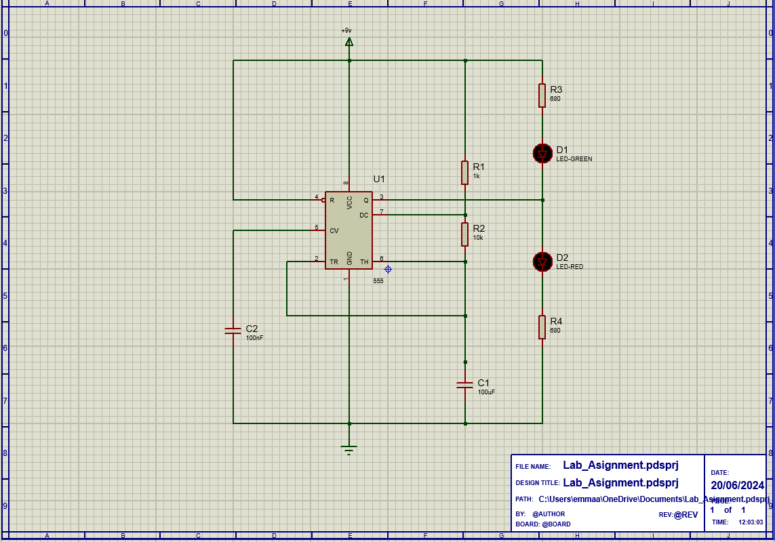
Figure 1 - Proteus Schematic of a 555 Timer IC circuit after calculation of R3 and R4
The circuit shown in Figure 1 is powered by a 9 Volt power supply directly connected to pins 4 and 8 (respectively reset and supply pins) of the 555 Timer IC. The supply pin is the voltage supply terminal for the IC. When a low voltage is applied to the reset pin it causes the output to be constantly low meaning it is connected to the voltage supply to prevent this from occurring [1].
This power supply also feeds into Resistor 1 and subsequently Resistor 2 creating a potential divider, lowering the voltage entering pins 2 and 6 (trigger input and threshold input respectively). During this time, voltage traveling through the potential divider is used to charge Capacitor 1 assuming it is fully discharged. When the voltage across the threshold pin exceeds 2/3 of the supply voltage, the output becomes low causing Capacitor 1 to discharge via pin 7 (the discharge pin) which internally connects to ground (pin 1) [5]. When the voltage across the trigger input pin is less than 1/3 of the supply voltage, the output is high, causing Capacitor 1 to resume charging and the discharge pin to internally disconnect from ground [6].
When the output of the 555 timer IC through pin 3 (output pin) is high, the red LED (2) will light up. When the output is low, the green LED (1) will light up as voltage will flow from the initial power source through Resistor 3 to the green LED. Due to the continual alternation of high and low voltage outputs created by the charging and discharging cycle of Capacitor 1, the LEDs flash in an alternating pattern. The duration of the on time for each LED can be altered by varying the resistance value of Resistor 2 and capacitance level of Capacitor 1 [7].
Capacitor 2 is attached to the control voltage pin (5) of the 555 Timer IC and subsequently to ground to ensure voltage in the circuit remains constant. The circuit is grounded with pin 1 of the IC being connected directly.

2.2 Measurements

2.2.2 Resistance Measurements and Calculations
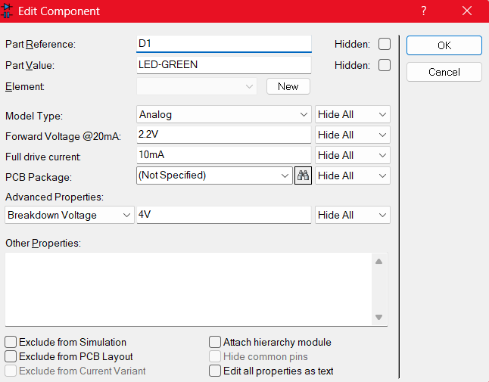
Figure 2 - Menu screen showing both the forward current and voltage used to calculate the resistance of R3
Resistance of R3 = (Closed Circuit Voltage – Forward Voltage) / Forward Resistance
= (9 – 2.2) / 0.001
= 680 ohms
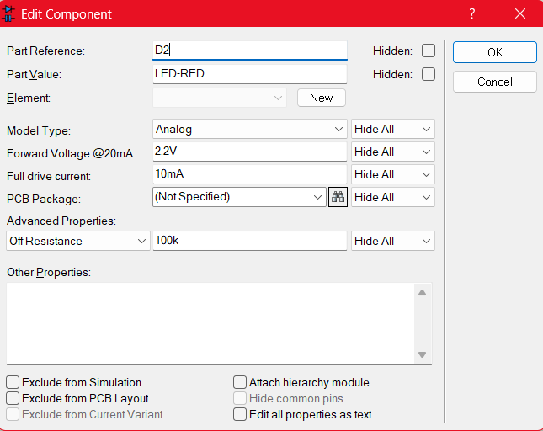
Figure 3 - Menu screen showing both the forward current and voltage used to calculate the resistance of R4
Resistance of R4 = (Closed Circuit Voltage – Forward Voltage) / Forward Resistance
= (9 – 2.2) / 0.001
= 680 ohms

2.2.2 Timing Measurements and Calculations
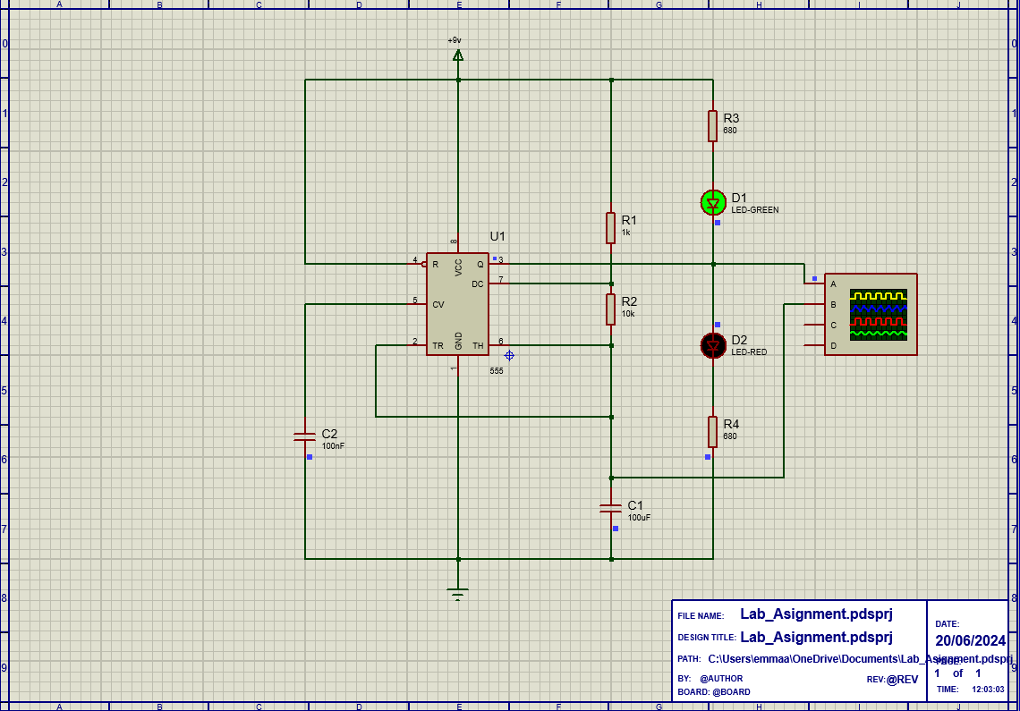
Figure 4 - A schematic of a 555 timer circuit with an oscilloscope

Timing Measurement | Value
On Time | 760 mS
Off Time | 700 mS
Period | 1.46 S
Frequency | 068 Hz

Using the oscilloscope shown in Figure 4, the on time of the circuit and period of waveform produced were measured as 760 mS and 1.46 S respectively. These values were obtained using the curser feature of the oscilloscope in Proteus as shown in Figure 5. Using these measured values, the off time was calculated as 700 mS by subtracting the on time from the period. Using the measured value of period, the frequency of the waveform was calculated as 0.68 Hz.
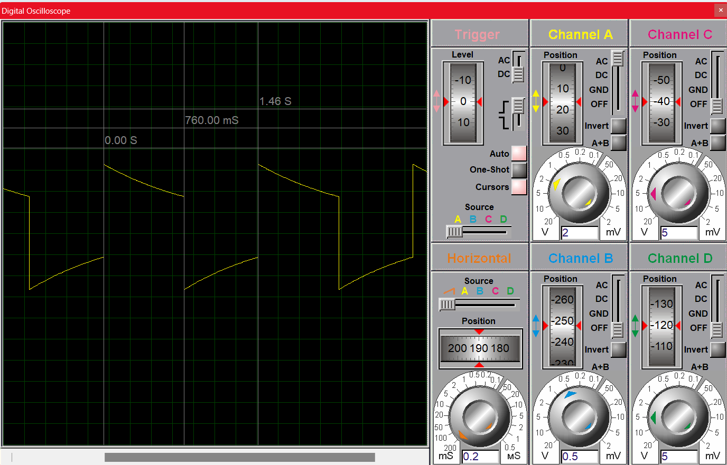
Figure 5 - Oscilloscope reading showing the on time and period of the output waveform produced by the 555 timer circuit

2.2.3 Voltage Measurements
The oscilloscope shown in Figure 4 was also used to produce a graph of capacitor voltage against time as shown in Figure 6. This demonstrates the charging and discharging cycles required for the astable multivibrator circuit to function.
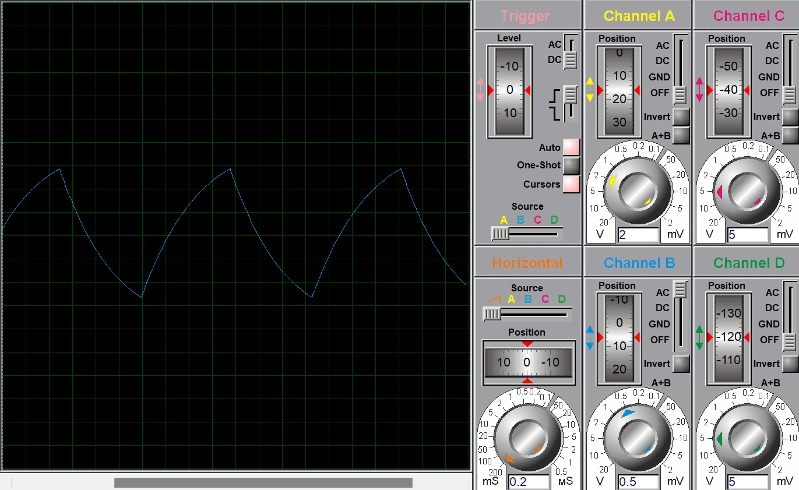
Figure 6 - A graph showing capacitor voltage against time

3 Bread Board Circuit

3.1 Description
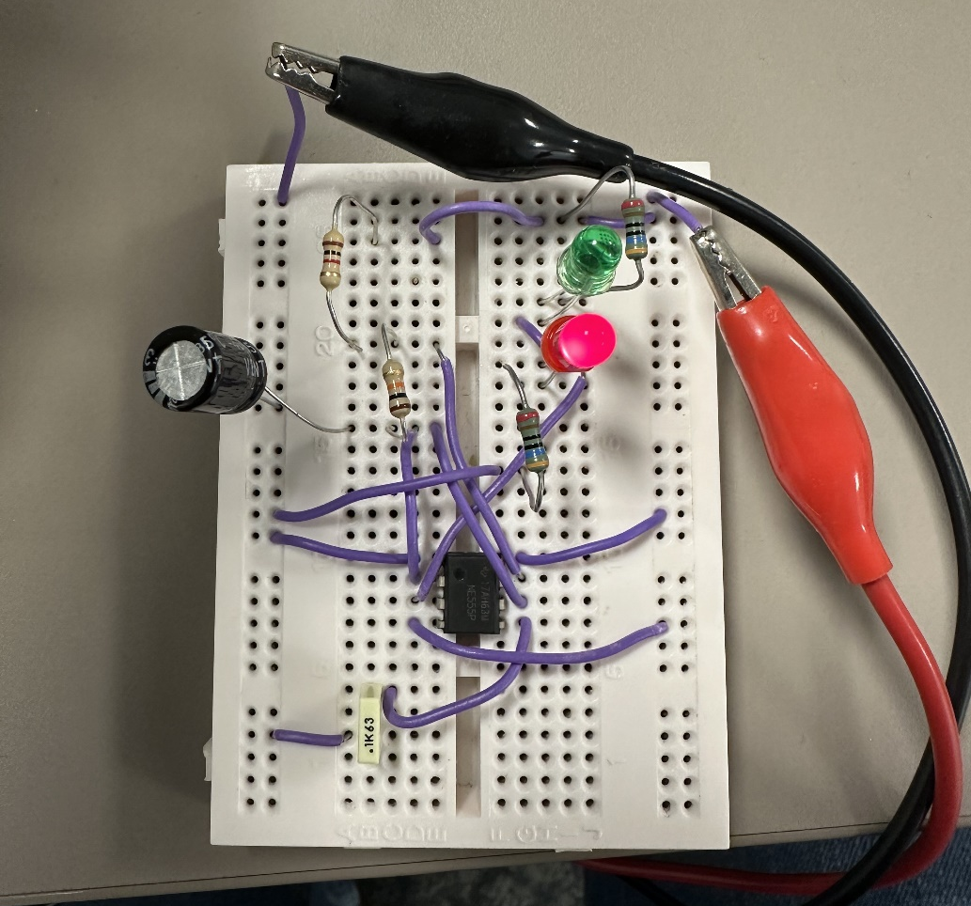
Figure 7 - A photo showing the Bread Board Circuit
The circuit shown in Figure 7 is powered by a 9 Volt power supply connected to the right-hand power rail via the red crocodile clip. This is then fed into the initial bus strip by a wire where it flows through the components in the same way as described for the proteus simulation. The left-hand power rail is connected to ground using the black crocodile clip.
In order to maximise space and prevent overcrowding when using the bread board, Resistors 1 and 2, as well as both capacitors were placed on the left-hand side of the IC. These were connected by wires to both the power source and ground as they were in the proteus simulation.
Due to the different layout of components when building the circuit on a bread board, more wires were used to create connections between components, bus strips and power rails than used in the proteus simulation. However, all the pins on the 555 Timer IC were connected to the same components and operated following the same procedures as previously described.

3.2 Measurements

3.2.1 Timing Measurements and Calculations
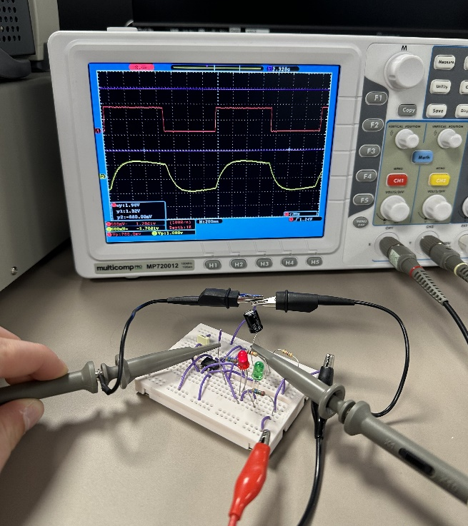
Figure 8 – A photo of an oscilloscope connected to the bread board circuit
In order to ascertain the voltage output graphs of both Capacitor 1 and the 555 Timer IC, an oscilloscope was used. This connected to the output pin of the IC and the positive terminal of the capacitor using metal prongs. Both of these prongs were subsequently attached to the ground power rail of the circuit. Connecting the oscilloscope to Capacitor 1 produced a graph demonstrating the charging and discharging cycle used to trigger the output of the Timer IC. Connecting the oscilloscope to the output pin of the IC generated a graph showing the IC’s function as a clock pulse generator.
Timing Measurement | Value
On Time | 760 mS
Off Time | 700 mS
Period | 1.46 S
Frequency | 0.68 Hz

Using the oscilloscope shown in Figure 8, the on time of the circuit and period of waveform produced were measured as 760 mS and 1.46 S respectively. These values were obtained approximately using the 200mS grid on the oscilloscope as shown in Figure 9. Using these measured values, the off time was calculated as 700 mS by subtracting the on time from the period. Using the measured value of period, the frequency of the waveform was calculated as 0.68 Hz.

3.2.2 Voltage Measurements
The voltage output of the 555 Timer IC (shown in red on the oscilloscope in Figure 9) shows the square pulse generated by the bread board circuit. This is a different shape to that produced by the oscilloscope in the Proteus simulation due to real time behaviour differing between the components in the simulated and physical circuits [8]. This is the same for the output voltage graph of the capacitor (shown in yellow on the oscilloscope in Figure 9).
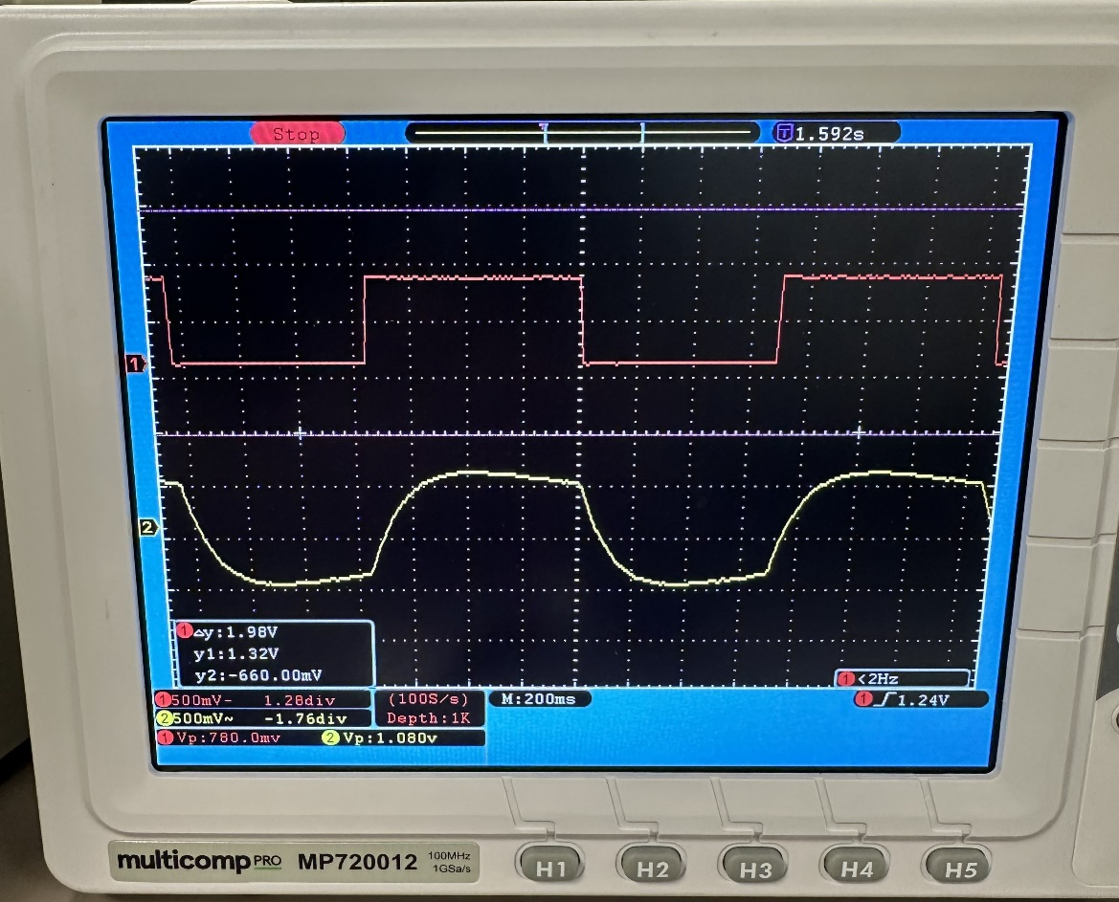
Figure 9 - An oscilloscope showing the graph of capacitor voltage output against time.

4 Conclusions
The wires used to connect components on the bread board were only temporary connections which increases the likelihood of shorts within the circuit. This could be improved by reducing the number of wires used by redesigning the lay out of the circuit on bread board.
Due to the proximity of components on the breadboard, the likelihood of shorts caused by the metal of components touching is far higher than in the proteus simulation. This could have been improved by redesigning the bread board lay out to accommodate more space between components.
Differences in the voltage output graphs of Capacitor 1 and the 555 Timer IC in Proteus compared to on the breadboard were due to the real time behaviour differences between the physical and simulated circuit [8]. These include time delays and voltage irregularities.

5 References
[1] M. Abrar, “Design and Implementation of Astable Multivibrator using 555 Timer”, IOSR – JEEE, vol. 12, no. 1, ver. II, pp. 22-29, 2017
[2] N. Sivasankari and R. S. S. Kumari, “Reliable set of random number generation using Astable Multivibrator PUF,” Analog integrated circuits and signal processing, vol. 112, no. 1, pp. 29–48, 2022.
[3] P. Niranatlumpong, M. A. Allen, “A 55 Timer IC Chaotic Circuit: Chaos in a Piecewise Linear System with Stable but No Unstable Equilibria”, IEE Transactions on Circuits and Systems I: Regular Papers, vol. 69, no. 2, pp. 798-810, 2022.
[4] M. H. Tooley, Electronic Circuits: Fundamentals and Applications, Oxford: Newnes, 2006, pp. 174 – 176.
[5] H. R. Camenzind, “Redesigning the old 555 [timer circuit]”, IEE Spectrum, vol. 34, no. 9, pp. 80-85, 1997.
[6] H. Goyal, “Understanding of IC555 Timer and IC 555 Timer Tester”, IJIES, vol. 3, no. 2, pp. 4-6, 2015
[7] T. Valerie, D. Garinto, M. Alaydrus, T. Taufik and E. S. Ma'arif, "Modified 555 Timer IC Using Only Two Comparators," 2021 1st International Conference on Electronic and Electrical Engineering and Intelligent System (ICE3IS), Yogyakarta, Indonesia, 2021, pp. 91-96
[8] D. Ćika and D. Grundler, "Proteus Virtual System Modelling used for microcontroller education," The 33rd International Convention MIPRO, Opatija, 2010, pp. 1034-1038.

