Student Name: Jabir Ahsan | Student ID – 2132612
Module Code: | BMSW 4002
Module: | Effective Team Working And Communication
Module Lead: | Dami Pokubo
Lecturer: | Dr.Hafiz Rahmani

Summary
This report starts off with what the project is about, where about it is based and the issues the supposed team leader faces with his workforce. Tom needs some suggestions on how he can resolve these issues of employee commitment and bring success to this global expansion. Therefore, this is a detailed report about the case study and the possible resolutions surrounding the ongoing issues. This report refers to various team development models such as Belbin’s team roles, Bruce Tuckman’s model of 1965, Susan Wheelan’s model of 2005 and Coyle’s model of 2018.

Contents Page:
- Introduction – Page 4
- Overview of Team Working – Page 5
- Models of Team Development – Page 6
- Team Roles – Page 8
- Discussion – Page 9 & 10
- Conclusion and Recommendations – Page 11
- Reference list – Page 12 & 13

Introduction
This Case Study talks about Amazon, who are a worldwide e-commerce business who are a dominant force in their market. They plan to expand into new foreign markets based in London, Paris and Berlin. They aim to achieve enhanced delivery services across the European globe and have a team leader in Tom Jackson. However, this project is faced with difficulties within the workforce; some being: Interaction, Conflict of interests, channels/chains of communication and commitment. Tom is struggling to find methods to improve the lines of collaboration in order to be successful in this big project. Given Amazon are a mass market and are dominant, their organisational structure is very big whilst also having good economies of scale. The chains of communication will no doubt be lengthy. Working on these key issues may be tricky but for an industry as big as Amazon, who also run online, may be beneficial in this aspect of finding solutions. Inn this case study, there will be a mention of various models in helping to create an effective team. For example: Belbin’s team roles, Tuckman’s model of 1965 and Wheelan’s model of 2005.

What Exactly Is A Team?
It is no doubt that a retail business such as Amazon will require teamwork across the organisational structure. But what exactly is teamwork? Teamwork refers to a group of people who work together to achieve one goal as defined by Morgan, 2017, pg204. A team is formed for employees to communicate with one another and hold mutual knowledge and understanding as labelled by Belbin, R.M – Beyond the Team, Butterworth-Heinemann (2000). It is clear from the case study that there is a problem within this team in multiple aspects. For a team to be known as a team, they must be collective with each other in terms of agreeing with each other and being able to work well together as a group. There is no I in team, everybody works together to achieve goals and outcomes set by Amazon (More specifically Tom Jackson) to achieve the goals aspired; in this case to enhance their services. If there were to be mistakes, a group should not let an individual take full accountability for it; they should all be together and hold themselves responsible alongside the individual. Being in a team means you should be able to voice your opinions and feel supported at the same time; in Amazon’s case, we can see that due to the multitude of issues within the group, there is a lack of chemistry, which would form a domino effect, as mentioned by Michelle, (June 6,2019) “What is the importance of chemistry among people within a workplace?” [ONLINE].

Models of Team Development
There are a variety of models Tom can use to bring his team together. One being the Tuckman Model of 1965. This consists of 5 stages: Forming, Storming, Norming, Performing and Adjourning. This would be one appropriate in multiple aspects. One being the conflict of interests; as team leader, Tom must break the ice and create a surrounding that allows every employee involved to voice their concerns. These issues can be countered and the chemistry between the workforce can be enhanced. The issues fall under the chain of communication; by following Tuckman’s model, new chains of contact can be found that suits everybody’s interests. While doing this Tom must be very precautionary of the productivity of employees as they may become lazy; he can hold regular meetings to set targets for individual employees. Through this, Tom can also find who is committed and who is not. It may involve costs such as redundancy but in the long term it may be seen as a beneficial cost in the long term. The success of this model is shown by Obiri-Yeboah, James & Tobbin, Peter; “Team Work as a Vital Element for Outstanding Outcome: A Case Study in a Ghanaian Mine,” Open Journal of Business and Management, Vol.5 No.2, (April 30, 2017) [ONLINE]. However, it is worth noting to Tom that this model has no fixed time stage as aims and objectives tend to fluctuate overtime, so he may have to go back a few stages in this model from time to time and he may have to reconsider the number of people in his group as this model is timely to develop with a large number of employees. This is the most favourable model for Tom to use in my opinion. There are also other models such as Wheelan’s Model of 2005. This consists of 4 stages: Dependency & Inclusion, Counter-dependency & Fighting, Trust & Structure and Work & Productivity. Quite like Tuckman’s model, but it is arguable different conflicts are solved. More reliant on the team leader, Tom would have to make employee feel they can trust him and that they agree with the aims and objectives he sets. However, the fact that employees being able to coexist with one another remains common. Overtime, as concerns are voiced, the group is a team again and are more productive while communication is more open, and the team leader can be relied upon less after meeting stages. However, this doesn’t really fall into theme of what the main issues are within this project. However, both link to similar stakeholders. It also goes with Tuckman and Wheelan’s quote, which states, “Groups that function at the higher stages of each model of group development tend to be more productive,” found in Wheelan S.A., (2009), “Group size, Group development and Group Productivity,” Small Group Research, 40(2), pg 247-262.

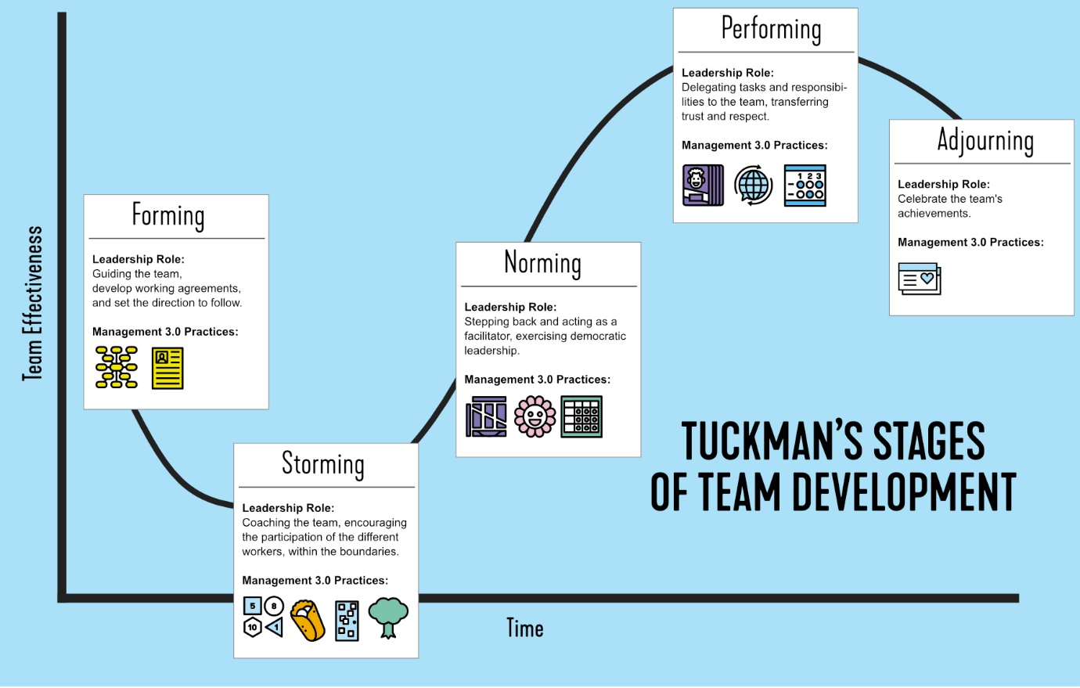
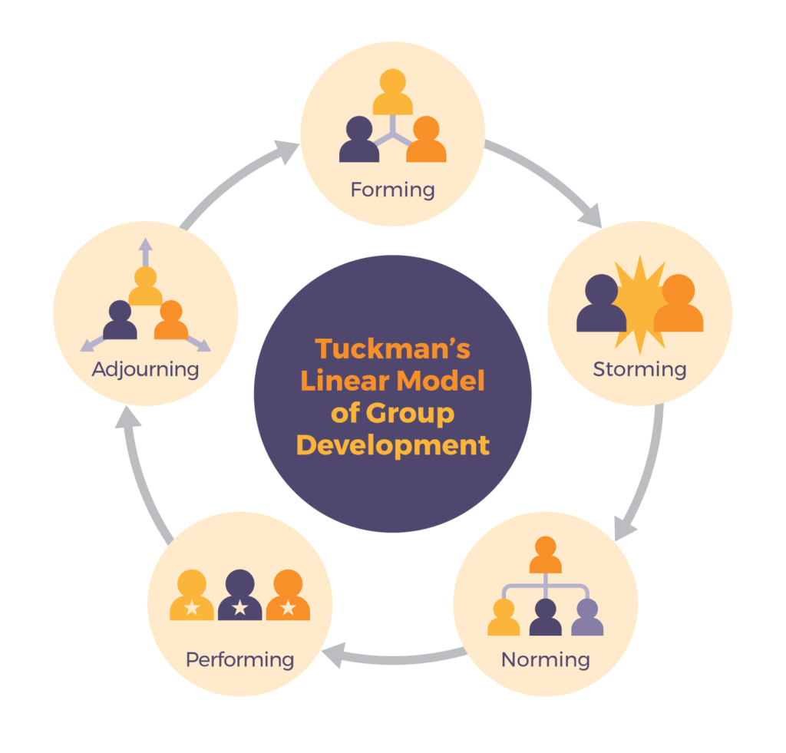

Team Roles

In a team, everyone will be at different stages of production. It is very important every employee knows what their job is to enhance capacity utilisation and in practical use, be able to give the best delivery services possible. This provides a much better balance as there is present diversity within the teams’ knowledge of their roles and the criteria of each role, as quoted by Belbin (1981). It makes it easier for Amazon to deliver success as each member is aware of how to fulfil their role to the optimum; It links to a concept called Team composition. This links to Senior, Barbara’s Article (17th August 2011), “Team roles and team performance: Is there ‘really’ a link?”, [ONLINE]. However, Tom must consider the individuals in his workforce and think of possibly looking for recruitment internally or externally if he feels his resources at hand aren’t suitable to the roles that are vacant. For example, looking at specialists in customer convenience and in packaging. Otherwise, he could possibly face limited success by putting his resources to the wrong use. One model that can link to this topic is Belbin’s Team Roles model. Belbin segregates Team Roles into 3 categories: Action-Orientated, People-Orientated and Thought-Orientated. This would involve delegation in Amazon. Through delegation, Tom can look at giving the committed workers roles such as managers and leaders, to help show how rewarding he and this concept is. Through this, he sends a message out to those with second thoughts over this project; in this case, Mihaela and Spencer. Seeing that their co-workers are being somewhat promoted to different or higher roles may make them feel more committed and that they are being cared for and that the business does not mainly define itself on profits, as shown by their proposed objectives. Furthermore, it would enhance inclusion and possibly improve interaction and commitment as they feel this would be something like promotion and that staff are treated as an asset. Having an impact on motivation and satisfaction, both also having a positive link to commitment. This links to an article written by Ruch, Willibald, Gander, Fabian, Platt, Tracey and Hofmann, Jennifer, (4th April 2016); “Team roles: Their relationships to character strengths and job satisfaction”, Pg 190-199 [ONLINE]. This model does have its cons: In practical case, Tom will also have to manage himself well but also give critical judgements but not be cruel at the same time. Furthermore, Over-delegation could possibly happen given the large scale of the project. In short words, it will require serious precaution.

Discussion

The fact that an effective team defines success cannot be undermined especially when going into foreign markets. Since Amazon operates in e-commerce, effective teams is an absolute necessity in providing the best of deliveries for consumers who shop online. It is reported by, Leonard, M, Graham, S and Bonacum, D (1st October 2004), “The human factor: the critical importance of effective teamwork and communication in providing safe care”, [ONLINE], that building safety within the workforce to voice concerns if there are any. This links to Coyle (2018). He identified secrets of how groups are successful and how this forms effective teams. He found 3 key skills: Build Safety, Share Vulnerability and Establish Safety. Building Safety means to be welcoming to each other’s thoughts and concerns and always understanding no one is perfect. The second skill links to vulnerability; in Coyle’s Model, it would mean to listen well and listen carefully. In addition, to be clear when there are mistakes and move on and acknowledge failure is a part of success. Finally, there is always one more step employees can take to develop their skillset. It is important for businesses that Vulnerability can sometimes be shown as a strength. The final skill is to establish a purpose. This means Tom, as the project leader must be extremely clear about what he prioritises and what his aims and objectives are. Success does not come in a day, so Tom will have to explain the steps of his strategy in order to attain this success.

There are several benefits to having effective teamwork; one example is boosted morale. This comes from employees feeling more included and feeling more valued within a business. Referring to Amazon, this would lead to more productivity from those who prepare deliveries and create the aspired faster and efficient delivery service as mentioned in the case study as consumers would like their orders to be received as soon as possible. In addition, this would provide more flexibility; in terms of sharing skills, this would be easier as there is a good bond between the workforce. This would also help deal with issues such as an overload in deliveries or if someone is off sick. This links to the blog “How to build and manage an effective team,” [ONLINE].

However, Tom highlights several issues within the personnel involved in the workforce. This hugely limits the ability for the project to reach its full potential and being able to meet its aims and objectives. One key issue we can use is the conflict of interest. If the group cannot have only one goal in common, then the level of commitment is negatively impacted. This would have an impact on productivity and therefore the quality of deliveries may deteriorate. The lack of commitment would make team workers feel less comfortable to interact and communicate with each other, possibly leading to higher probabilities of human error. Linking to production and finance, Amazon would probably have less capacity utilisation, meaning they would be less able to breakeven and meet profit margins. Linking to real life, it would provide more clarity on what each group’s roles are and they feel more included in a project/presentation, resulting in better efforts and commitment.

Conclusion & Recommendations

In conclusion, effective teamworking is extremely significant, especially for an e-commerce business such as Amazon, who have an extremely wide product range that attracts many markets. Not having an effective team would lead to Amazon being less able to compete with increasing demand and changes in the retail market. Linking to the case study, not having a well bonded team will make it near impossible to provide an enhanced delivery service as there is no chemistry, people will work on deliveries independently rather than a group, possibly leading to less productivity from the deterioration in morale. Tom will have to look at what perspective these issues root from and consider the solutions available with his resources. From the case study, we see an issue rooting from two employees, Mihaela and Spencer, who have an issue with commitment over the objectives of Amazon from this project. Tuckman would be the best model to use to find where these issues have stemmed from and how this can be resolved as every employee is different and have different preferences of working. Through Tuckman’s model, Tom would be able to brainstorm his ideas and objectives but to reconsider how to enter this project with the right resources. However, if he were to use Belbin’s team roles, he would have to explore the different roles available in this project to possibly gain more dedication from these two specific stakeholders.

Reference List
- “How to build and manage an effective team,” [ONLINE] Available at: https://www.nibusinessinfo.co.uk/content/advantages-effective-teamwork
- Belbin (1981)
- Belbin, R.M – Beyond the Team, Butterworth-Heinemann (2000)
- Senior, Barbara’s Article (17th August 2011), “Team roles and team performance: Is there ‘really’ a link?”, [ONLINE] Available at; https://doi.org/10.1111/j.2044-8325.1997.tb00646.x
- Leonard, M, Graham, S and Bonacum, D (1st October 2004), “The human factor: the critical importance of effective teamwork and communication in providing safe care”, [ONLINE], Available at; https://qualitysafety.bmj.com/content/13/suppl_1/i85.info
- Michelle, (June 6,2019) “What is the importance of chemistry among people within a workplace?” [ONLINE] Available at; https://letstalksupplychain.com/what-is-the-importance-of-chemistry-among-people-in-the-workplace/#:~:text=Chemistry%20makes%20workplace%20teams%20more,%2C%20educational%20background%2C%20and%20personalities.
- Obiri-Yeboah, James & Tobbin, Peter , “Team Work as a Vital Element for Outstanding Outcome: A Case Study in a Ghanaian Mine” , Open Journal of Business and Management, Vol.5 No.2, (April 30, 2017) [ONLINE] Available at;
https://www.scirp.org/(S(lz5mqp453edsnp55rrgjct55))/journal/paperinformation.aspx?paperid=75976
- Ruch, Willibald, Gander, Fabian, Platt, Tracey and Hofmann, Jennifer (4th April 2016); “Team roles: Their relationships to character strengths and job satisfaction”, Pg 190-199 [ONLINE] Available At: https://www.tandfonline.com/doi/abs/10.1080/17439760.2016.1257051
- Wheelan S.A., (2009), “Group size, Group development and Group Productivity,” Small Group Research, 40(2), pg 247-262.
Images:
- Last, Suzan “4.2: Five models for understanding team dynamics”, [ONLINE] Available at; https://pressbooks.bccampus.ca/technicalwriting/chapter/understandingteamdynamics/

- Mello, Juan, (November 30th, 2021) “Forming, Storming, Norming, Performing, & Adjourning: Tuckman’s stages of team development explained” Leadership Blog [ONLINE] Available at; https://management30.com/blog/tuckman-model/

